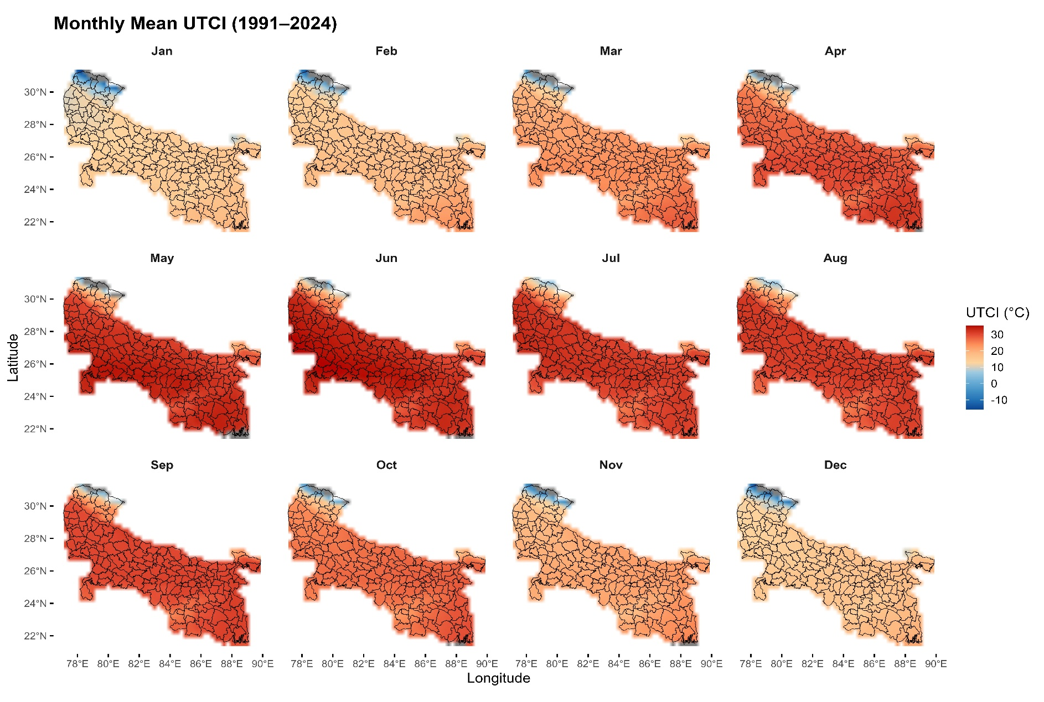
Figure S1: Spatial distribution of monthly mean UTCI across the Ganga River Valley (1991-2024)
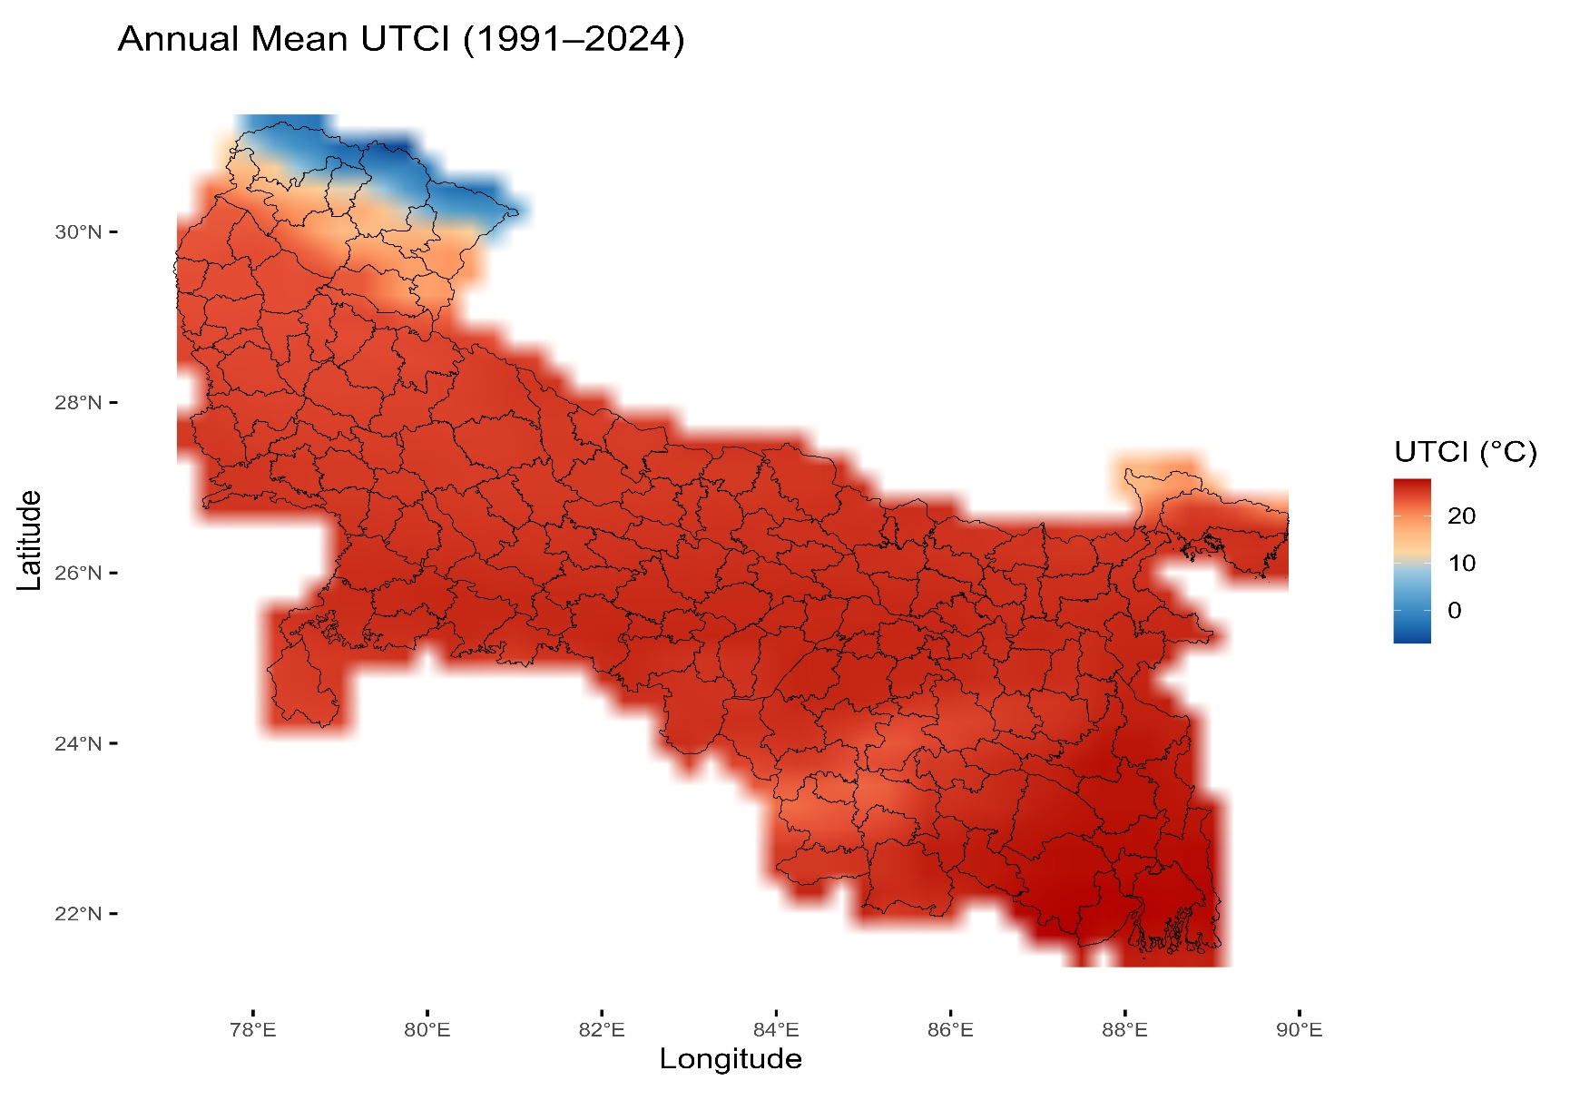
Figure S2: Spatial distribution of annual mean UTCI across the Ganga River Valley (1991-2024)

Figure S3: Trends and magnitude (Sen’s slope) of monthly UTCI across districts showing statistically significant trends at p < 0.05.

