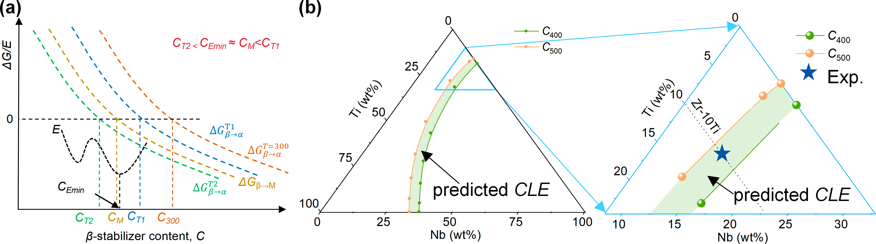

Extended Data Fig. 1 | Schematic diagram of the correlation. (a) Difference in Gibbs free energy between α and β phases (ΔG_{β-α}) at various temperatures (T = 300 K, T1, TM, and T2, respectively) or Young’s modulus (E) as a function of β stabilizer content (C). (b) Calculated ΔG_{β-α} of the Zr-Ti-Nb system at temperatures of 300, 400, and 500 K, predicted composition window for low-modulus (Predicted CLE), and the location of the selected Zr-10Ti-15Nb composition (Exp.).

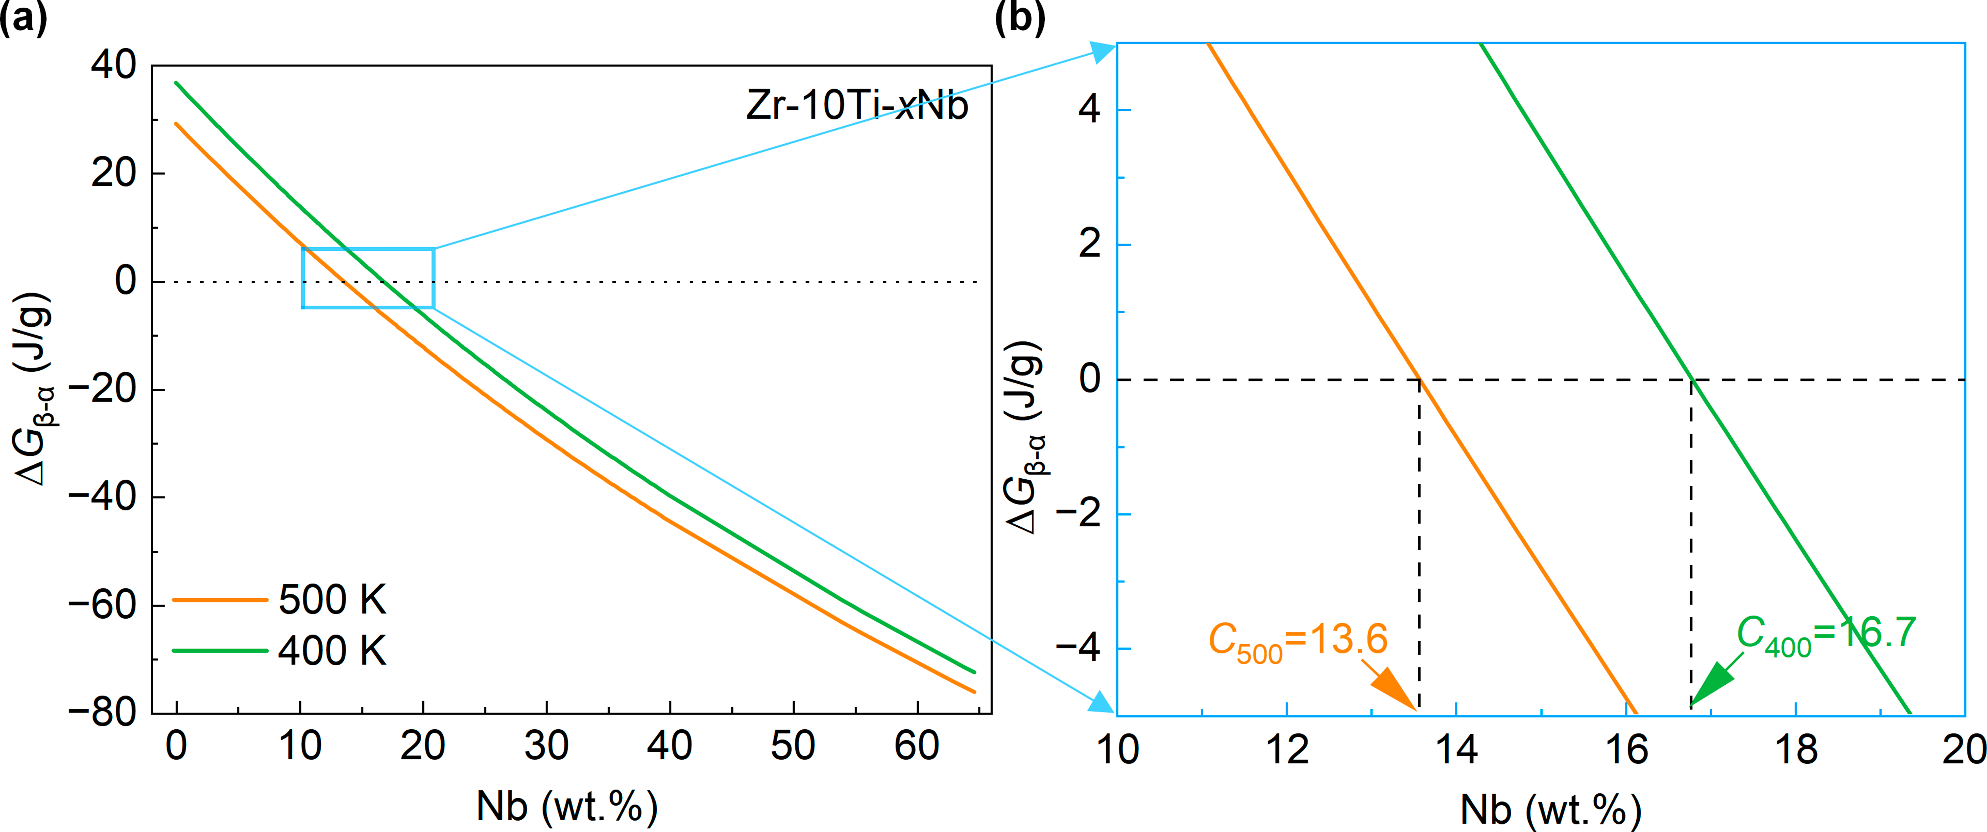
Extended Data Fig. 2 | Determination of the experimental composition of Zr-10Ti-xNb. (a) $\text{∆}{\text{G}}_{\text{β}\text{→}\text{α}}$at temperatures of 400 and 500 K. (b) Enlarged view of the box region in a.

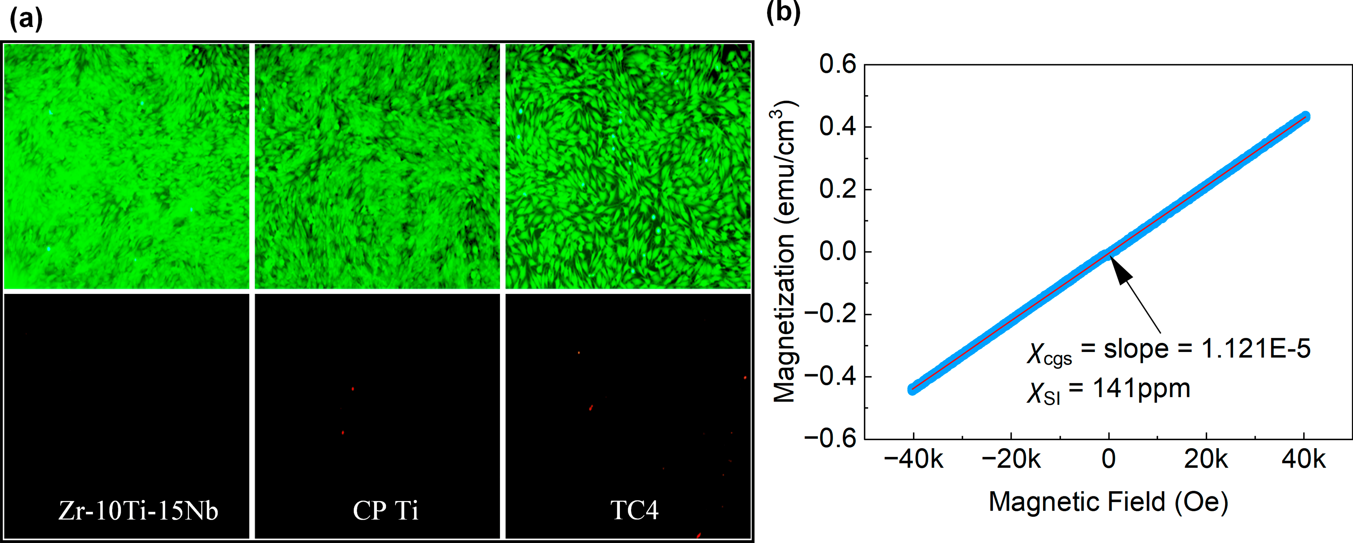
Extended Data Fig. 3 | Biological performance of Zr-10Ti-15Nb. (a) Live/dead cell fluorescence staining analysis. (b) Magnetization versus magnetic field curve.

Extended Data Fig. 4 | Calculated results for Zr-10Ti-xNb. (a) Pseudo-binary phase diagram. (b) Phase constitution of the Zr-10Ti-15Nb alloy as a function of temperature.

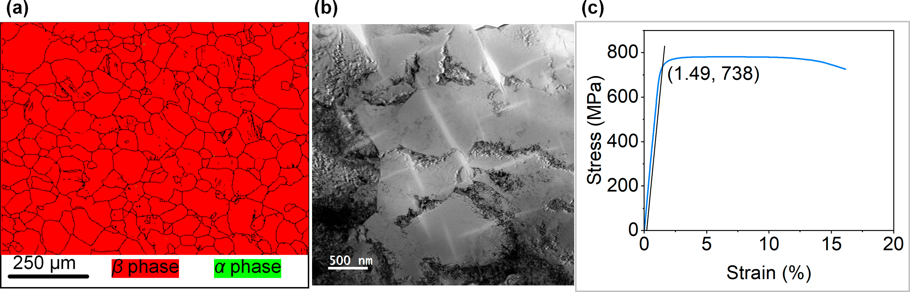
Extended Data Fig. 5 | Results for Zr-10Ti-15Nb after rolling at 600 °C. (a) EBSD image. (b) TEM bright field image. (c) Representative stress–strain curve.

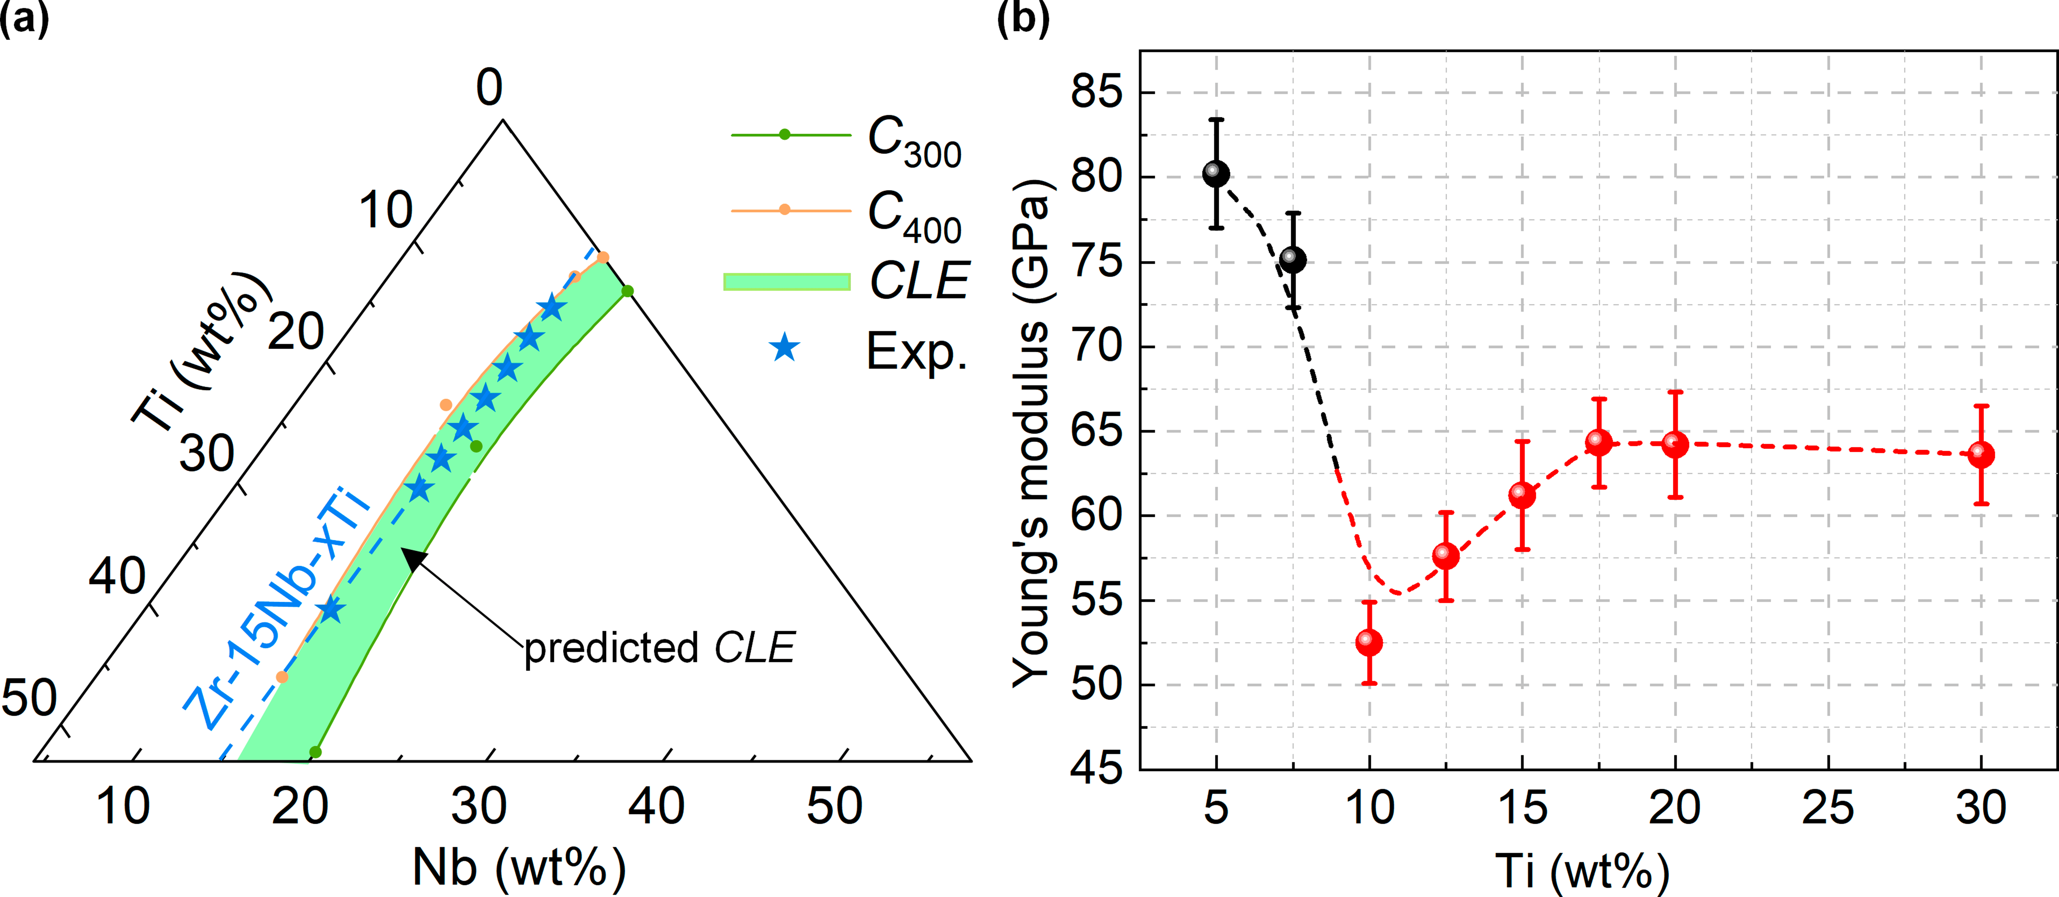
Extended Data Fig. 6 | Verification of the generality of the proposed strategy. (a) Selected experimental composition points (Exp.) located near or within the predicted low-modulus composition region, CLE, of the Zr-Ti-Nb system. (b) Young’s modulus as a function of Ti content of selected compositions.

