<Supplementary Information for>

Geometry-dependent monolayers for efficient inverted perovskite solar cells
Suhao Yan,^{1,2,5} Xiaojun Yin,^{1,5,*} Bo Xiao,^{2,5} Xuefeng Chen,¹ Jisheng Xu,¹ Ming Yang,¹ Tiankai Zhang,^{3,*} Cheng Zhong,^{4,*} Yang Sun,² Bo Zhang,² Xiyang Li,³ Zhenxu Wang,³ Zhengming Sun,³ Haipeng Yin,^{2,*} Zi Ouyang,^{2,*} Chuluo Yang^{1,*}
¹Shenzhen Key Laboratory of New Information Display and Storage Materials, College of Materials Science and Engineering, Shenzhen University, Shenzhen 518060, P. R. China. E-mail: xiaojunyin@szu.edu.cn, clyang@szu.edu.cn.
²Research and Development Center, JA Solar, Yangzhou, 225131, P. R. China. E-mail: yinhp@jasolar.com, ouyangzi@jasolar.com.
³School of Materials Science and Engineering, Southeast University, Nanjing, 211189 P. R. China. E-mail: tiankai.zhang@seu.edu.cn.
⁴College of Chemistry and Molecular Sciences, Hubei Key Lab on Organic and Polymeric Optoelectronic Materials, Wuhan University, Wuhan, 430072, P. R. China. E-mail: zhongcheng@whu.edu.cn.
⁵These authors contributed equally: Suhao Yan, Xiaojun Yin, and Bo Xiao.

Table of Contents
Supplementary Note 1: Synthesis and characterizations of these benzothienocarbazole-based SAMs 2
Supplementary Note 2: Theoretical Calculation Details 22
Supplementary Note 3: Electrochemical properties 26
Supplementary Note 4: Photophysical properties 27
Supplementary Note 5: Photoelectron spectroscopy analysis 30
Supplementary Note 6: Surface topography analysis 32
Supplementary Note 7: Photovoltaic performance 34
Supplementary Note 8: Certified performance report of a small-area PSC based on DBT34ID 36
References 47

Supplementary Note 1: Synthesis and characterizations of these benzothienocarbazole-based SAMs
1. General information for materials and characterizations
All commercially available reagents and solvents were used as received unless otherwise noted. The ¹H, ³¹P and ¹³C nuclear magnetic resonance (NMR) spectra were recorded at room temperature on a Bruker AV 400 or 500 MHz spectrometer using CDCl₃ or DMSO-d₆ as the solvent and tetramethylsilane (TMS) as the internal standard. High-resolution mass spectrometry (HRMS) was performed on a Thermo Scientific LTQ Orbitrap XL mass spectrometer equipped with an electrospray ionization (ESI) source.
2. Synthesis and characterization
Synthesis of 5-(4-bromobutyl)-5H-benzo[4,5]thieno[3,2-c]carbazole (DBT21ID'): A mixture of 5H-benzo[4,5]thieno[3,2-c]carbazole (1.00 g, 3.66 mmol) and sodium hydride (440 mg, 18.31 mmol) was placed in a 100 mL dry Schlenk flask. The flask was subjected to three cycles of evacuation and argon purging. Anhydrous and deoxygenated N,N-dimethylformamide (DMF, 20 mL) was added via syringe and the mixture was stirred at 0 ºC for 30 min. Subsequently, 1,4-dibromobutane (2.3 mL) was added dropwise, and the reaction mixture was stirred at room temperature for 4 h. After the reaction was complete, the mixture was quenched with ice-water and extracted with dichloromethane and water. The organic layer was separated, with saturated aqueous NaCl solution (3 × 20 mL), dried over anhydrous Na₂SO₄, and concentrated under reduced pressure. The crude product was adsorbed onto silica gel (200-300 mesh) and purified by flash column chromatography (eluent: petroleum ether/dichloromethane = 5:1 to 4:1, v/v) to afford the target compound as a white solid (1.27 g, 85% yield). ¹H NMR (500 MHz, CDCl₃, ppm) δ 8.28 (d, J = 7.5 Hz, 1H), 8.26 (d, J = 8.5 Hz, 1H), 8.21 (d, J = 7.8 Hz, 1H), 7.97 (d, J = 7.8 Hz, 1H), 7.58 – 7.51 (m, 3H), 7.51 – 7.49 (m, 1H), 7.46 – 7.39 (m, 2H), 4.48 (t, J = 7.0 Hz, 2H), 3.40 (t, J = 6.5 Hz, 2H), 2.17 – 2.10 (m, 2H), 1.98 – 1.93 (m, 2H). ¹³C NMR (126 MHz, CDCl₃, ppm) δ 139.98, 139.29, 138.59, 136.10, 133.05, 128.26, 125.50, 125.19, 124.61, 123.00, 122.10, 121.80, 120.82, 119.76, 119.12, 116.51, 108.82, 106.42, 42.55, 33.10, 30.19, 27.81.
Synthesis of (4-(5H-benzo[4,5]thieno[3,2-c]carbazol-5-yl)butyl)phosphonic acid (DBT21ID): DBT21ID' (1.00 g, 2.44 mmol) was charged into a 100 mL dry Schlenk flask. The flask was subjected to three cycles of evacuation and argon purging. Anhydrous and deoxygenated triethyl phosphite (10 mL) was then added via syringe. The mixture was heated to 160 ºC under an argon atmosphere and stirred for 24 h. After cooling to room temperature, the extra triethyl phosphite was removed by reduced pressure distillation to give light-yellow oil. Without further purification, the light-yellow oil was transferred to a dry 100 mL Schlenk flask. After three evacuation-argon purging cycles, anhydrous and deoxygenated 1,4-dioxane (10 mL) was added via syringe to ensure complete dissolution. Bromotrimethylsilane (3.73 g, 24.57 mmol) was added dropwise under an argon atmosphere. The reaction mixture was then stirred at room temperature for 18 h. After the reaction was complete, the 1,4-dioxane was removed with rotary evaporator to give a white solid. The white solid was dissolved in methanol (10 mL) at room temperature, and then deionized water was added dropwise until the mixture became opaque and stirred for additional 12 h. The crude product was collected by filtration and washed with deionized water (3 × 5 mL). The crude product was dissolved in tetrahydrofuran (THF) and reprecipitated in cyclohexane, collected by filtration, and dried to give the target product as a white solid. (850 mg, 85% yield). ¹H NMR (500 MHz, DMSO, ppm) δ 8.45 (d, J = 8.7 Hz, 1H), 8.41 (d, J = 7.8 Hz, 1H), 8.14 (t, J = 7.9 Hz, 2H), 7.86 (d, J = 8.6 Hz, 1H), 7.80 (d, J = 8.2 Hz, 1H), 7.57 (q, J = 7.7 Hz, 2H), 7.52 – 7.47 (m, 1H), 7.41 (t, J = 7.4 Hz, 1H), 4.57 (t, J = 7.1 Hz, 2H), 1.96 – 1.91 (m, 2H), 1.62 – 1.54 (m, 4H). ¹³C NMR (126 MHz, DMSO, ppm) δ 140.23, 139.67, 137.88, 136.19, 131.98, 128.00, 126.10, 125.91, 125.46, 123.66, 121.68, 121.35, 121.19, 120.15, 120.08, 115.68, 110.45, 108.25, 42.99, 30.30, 30.18, 28.35, 27.26, 20.94, 20.90. ³¹P NMR (202 MHz, DMSO, ppm) δ 26.20. HRMS (ESI) m/z calcd for C₂₂H₂₀NO₃PS⁺ [M]⁺ 410.09743, found 410.09668.
Synthesis of 11-(4-bromobutyl)-11H-benzo[4,5]thieno[3,2-b]carbazole (DBT32ID'): Following an analogous procedure to that of DBT21ID', a mixture of 11H-benzo[4,5]thieno[3,2-b]carbazole (250 mg, 0.92 mmol), NaH (110 mg, 4.58 mmol), and 1,4-dibromobutane (0.6 mL) was reacted in DMF (5 mL) to afford the crude product. The crude product was purified by silica gel column chromatography (200-300 mesh, eluent: petroleum ether/dichloromethane = 5:1 to 4:1, v/v) to afford the target compound as a white solid (320 mg, 86% yield). 1H NMR (500 MHz, CDCl3, ppm) δ 8.50 (s, 1H), 8.28 – 8.24 (m, 1H), 8.15 (d, J = 7.7 Hz, 1H), 8.09 (s, 1H), 7.86 (dd, J = 6.2, 2.6 Hz, 1H), 7.53 – 7.49 (m, 1H), 7.49 – 7.45 (m, 2H), 7.41 (d, J = 8.2 Hz, 1H), 7.27 (d, J = 7.4 Hz, 1H), 4.45 (t, J = 7.0 Hz, 2H), 3.42 (t, J = 6.5 Hz, 2H), 2.17 – 2.13 (m, 2H), 2.01 – 1.95 (m, 2H). ¹³C NMR (126 MHz, CDCl₃, ppm) δ 141.62, 140.23, 139.10, 135.71, 134.18, 130.65, 126.61, 126.48, 124.12, 122.99, 122.13, 121.37, 120.63, 119.09, 114.00, 108.48, 100.45, 42.37, 33.20, 30.23, 27.44.
Synthesis of (4-(11H-benzo[4,5]thieno[3,2-b]carbazol-11-yl)butyl)phosphonic acid (DBT32ID): Following an analogous procedure to that for DBT21ID, a mixture of DBT32ID' (300 mg, 0.74 mmol) and triethyl phosphite (3 mL) was reacted to afford the light-yellow oily intermediate. This intermediate was then reacted with bromotrimethylsilane (1.12 g, 7.37 mmol) in 1,4-dioxane (5 mL). After removal of the solvent, the mixture was treated with methanol (5 mL) and deionized water, followed by recrystallization with tetrahydrofuran and cyclohexane. The product was isolated as a white solid (250 mg, 83% yield). ¹H NMR (500 MHz, DMSO, ppm) δ 8.76 (s, 1H), 8.65 (s, 1H), 8.58 – 8.53 (m, 1H), 8.25 (d, J = 7.7 Hz, 1H), 8.03 – 7.97 (m, 1H), 7.65 (d, J = 8.2 Hz, 1H), 7.65 – 7.51 (m, 3H), 7.24 (t, J = 7.4 Hz, 1H), 4.53 (t, J = 7.2 Hz, 2H), 1.98 – 1.92 (m, 2H), 1.67 – 1.55 (m, 4H). ¹³C NMR (126 MHz, DMSO, ppm) δ 141.79, 139.59, 139.39, 136.00, 134.18, 129.73, 127.30, 126.96, 124.82, 123.83, 123.47, 122.66, 121.75, 121.11, 119.22, 114.44, 109.74, 102.47, 42.73, 29.86, 29.73, 28.37, 27.28, 20.96, 20.92. ³¹P NMR (202 MHz, DMSO, ppm) δ 26.12. HRMS (ESI) m/z calcd for C₂₂H₂₀NO₃PS⁺ [M]⁺ 410.09743, found 410.09643.
Synthesis of 1-(2-nitrophenyl)dibenzo[b,d]thiophene (DBT34ID'''): A mixture of dibenzo[b,d]thiophen-1-ylboronic acid (1.00 g, 4.39 mmol), 1-bromo-2-nitrobenzene (969 mg, 4.82 mmol), tetrakis(triphenylphosphine)palladium(0) (Pd(PPh₃)₄, 253 mg, 0.22 mmol), potassium carbonate (K₂CO₃, 1.38 g, 10.00 mmol) was placed in a dry 100 mL two-necked round-bottom flask equipped with a condenser. The flask was subjected to three cycles of evacuation and argon purging. Deoxygenated toluene (20 mL), ethyl alcohol (5 mL) and deionized water (5 mL) was then added via syringe. The mixture was heated to 90 ºC under an argon atmosphere and stirred for 12 h. After cooling to room temperature, the reaction mixture was extracted with dichloromethane and water. The organic layer was separated, with saturated aqueous NaCl solution (3 × 20 mL), dried over anhydrous Na₂SO₄, and concentrated under reduced pressure. The crude product was adsorbed onto silica gel (200-300 mesh) and purified by flash column chromatography (eluent: petroleum ether/dichloromethane= 4:1 to 3:1, v/v) to afford the target compound as a white solid (1.25 g, 93% yield). ¹H NMR (400 MHz, CDCl₃, ppm) δ 8.19 (d, J = 8.0 Hz, 1H), 7.92 (d, J = 8.0 Hz, 1H), 7.84 (d, J = 8.0 Hz, 1H), 7.78 – 7.67 (m, 2H), 7.53 – 7.45 (m, 2H), 7.39 – 7.32 (m, 1H), 7.19 (d, J = 7.3 Hz, 1H), 7.08 (t, J = 7.7 Hz, 1H), 6.82 (d, J = 8.2 Hz, 1H). ¹³C NMR (126 MHz, CDCl₃, ppm) δ 148.83, 140.14, 139.88, 136.00, 135.08, 134.09, 133.27, 132.64, 132.34, 129.23, 126.45, 125.91, 125.32, 124.68, 124.18, 123.62, 122.87, 122.75.
Synthesis of 8H-benzo[4,5]thieno[2,3-c]carbazole (DBT34ID''): A mixture of DBT34ID''' (300 mg, 0.98 mmol) and triphenylphosphine (PPh₃, 644 mg, 2.46 mmol) was placed in a 100 mL dry two-necked round-bottom flask equipped with a condenser. The flask was subjected to three cycles of evacuation and argon purging. Anhydrous and deoxygenated 1,2-dichlorobenzene (o-DCB, 10 mL) was then added via syringe. The mixture was heated to 180 ºC under an argon atmosphere and stirred for 36 h. After cooling to room temperature, the extra o-DCB was removed by reduced pressure distillation. The crude product was adsorbed onto silica gel (200-300 mesh) and purified by flash column chromatography (eluent: petroleum ether/dichloromethane= 4:1 to 3:1, v/v) to afford the target compound as a white solid (0.20 g, 75% yield). ¹H NMR (500 MHz, CDCl₃, ppm) δ 9.17 (d, J = 8.1 Hz, 1H), 8.91 (d, J = 8.2 Hz, 1H), 8.45 (s, 1H), 7.99 (d, J = 7.9 Hz, 1H), 7.89 (d, J = 8.5 Hz, 1H), 7.63 – 7.61 (m, 2H), 7.58 (d, J = 8.0 Hz, 1H), 7.55 – 7.50 (m, 2H), 7.39 (t, J = 7.6 Hz, 1H). ¹³C NMR (126 MHz, CDCl₃, ppm) δ 140.07, 139.37, 138.14, 136.26, 132.01, 130.64, 125.83, 125.57, 124.96, 123.84, 123.79, 123.02, 122.60, 120.43, 119.44, 118.30, 111.01, 110.88.
Synthesis of 8-(4-bromobutyl)-8H-benzo[4,5]thieno[2,3-c]carbazole (DBT34ID'): Following an analogous procedure to that for DBT21ID', a mixture of DBT34ID'' (600 mg, 2.20 mmol), NaH (264 mg, 10.99 mmol), and 1,4-dibromobutane (1.5 mL) was reacted in DMF (10 ml) to afford the crude product. The crude product was purified by silica gel column chromatography (200-300 mesh, eluent: petroleum ether/dichloromethane = 5:1 to 4:1, v/v) to afford the target compound as a white solid (790 mg, 88% yield). ¹H NMR (500 MHz, CDCl₃, ppm) δ 9.18 (d, J = 8.2 Hz, 1H), 8.94 (d, J = 8.1 Hz, 1H), 8.00 – 7.93 (m, 2H), 7.64 – 7.52 (m, 5H), 7.39 (t, J = 6.6 Hz, 1H), 4.48 (t, J = 6.9 Hz, 2H), 3.39 (t, J = 6.3 Hz, 2H), 2.15 – 2.10 (m, 2H), 1.98 – 1.93 (m, 2H). ¹³C NMR (126 MHz, CDCl₃, ppm) δ 140.20, 139.98, 138.86, 136.22, 131.69, 130.75, 125.91, 125.44, 125.00, 123.89, 123.85, 123.07, 122.07, 120.26, 118.94, 117.90, 108.95, 108.81, 42.32, 33.12, 30.21, 27.63.
Synthesis of (4-(8H-benzo[4,5]thieno[2,3-c]carbazol-8-yl)butyl)phosphonic acid (DBT34ID): Following an analogous procedure to that of DBT21ID, a mixture of DBT34ID' (750 mg, 1.84 mmol) and triethyl phosphite (8 mL) was reacted to afford the light-yellow oily intermediate. This intermediate was then reacted with bromotrimethylsilane (2.80 g, 18.42 mmol) in 1,4-dioxane (10 mL). After removal of the solvent, the mixture was treated with methanol (10 mL) and deionized water, followed by recrystallization with tetrahydrofuran and cyclohexane. The product was isolated as a white solid (650 mg, 86% yield). ¹H NMR (500 MHz, DMSO, ppm) δ 9.13 (d, J = 8.1 Hz, 1H), 8.87 (d, J = 8.1 Hz, 1H), 8.17 – 8.09 (m, 2H), 7.97 (dd, J = 8.7, 1.8 Hz, 1H), 7.82 (d, J = 8.2 Hz, 1H), 7.70 (t, J = 7.8 Hz, 1H), 7.61 – 7.56 (m, 2H), 7.38 (t, J = 7.6 Hz, 1H), 4.58 (t, J = 7.3 Hz, 2H), 1.92 – 1.88 (m, 2H), 1.63 – 1.51 (m, 4H). ¹³C NMR (126 MHz, DMSO, ppm) δ 140.16, 139.72, 139.19, 135.89, 131.18, 129.99, 126.58, 125.94, 125.00, 124.89, 123.81, 123.71, 121.34, 120.94, 119.43, 117.06, 110.75, 110.41, 42.76, 30.12, 30.00, 28.49, 27.40, 21.00, 20.97. ³¹P NMR (202 MHz, DMSO, ppm) δ 26.03. HRMS (ESI) m/z calcd for C₂₂H₂₀NO₃PS⁺ [M]⁺ 410.09743, found 410.09637.
Synthesis of 12-(4-bromobutyl)-12H-benzo[4,5]thieno[3,2-a]carbazole (DBT43ID'): Following an analogous procedure to that for DBT21ID', a mixture of 12H-benzo[4,5]thieno[3,2-a]carbazole (250 mg, 0.92 mmol), NaH (110 mg, 4.58 mmol), and 1,4-dibromobutane (0.6 mL) was reacted in DMF (5 ml) to afford the crude product. The crude product was purified by silica gel column chromatography (200-300 mesh, eluent: petroleum ether/dichloromethane = 5:1 to 4:1, v/v) to afford the target compound as a white solid (310 mg, 83% yield). ¹H NMR (400 MHz, CDCl₃, ppm) δ 8.39 (d, J = 8.1 Hz, 1H), 8.14 (t, J = 8.4 Hz, 2H), 7.97 (d, J = 7.9 Hz, 1H), 7.73 (dd, J = 8.2, 1.1 Hz, 1H), 7.61 (d, J = 8.2 Hz, 1H), 7.58 – 7.46 (m, 3H), 7.34 (t, J = 7.4 Hz, 1H), 4.78 (t, J = 7.3 Hz, 2H), 3.21 – 3.11 (m, 2H), 1.92 – 1.85 (m, 2H), 1.53 – 1.49 (m, 2H). ¹³C NMR (126 MHz, CDCl₃, ppm) δ 142.56, 139.42, 139.34, 138.65, 134.27, 125.50, 125.37, 125.34, 124.62, 124.11, 123.10, 122.49, 120.90, 120.64, 119.83, 119.17, 115.07, 111.50, 46.79, 32.79, 29.65, 27.62.
Synthesis of (4-(12H-benzo[4,5]thieno[3,2-a]carbazol-12-yl)butyl)phosphonic acid (DBT43ID): Following an analogous procedure to that of DBT21ID, a mixture of DBT43ID' (250 mg, 0.61 mmol) and triethyl phosphite (3 mL) was reacted to afford the light-yellow oily intermediate. This intermediate was then reacted with bromotrimethylsilane (933 mg, 6.14 mmol) in 1,4-dioxane (5 mL). After removal of the solvent, the mixture was treated with methanol (5 mL) and deionized water, followed by recrystallization with tetrahydrofuran and cyclohexane. The product was isolated as a white solid (230 mg, 92% yield). ¹H NMR (500 MHz, DMSO, ppm) δ 8.47 (d, J = 8.2 Hz, 1H), 8.33 (d, J = 8.2 Hz, 1H), 8.24 (d, J = 7.6 Hz, 1H), 8.13 (d, J = 7.6 Hz, 1H), 7.86 (d, J = 8.2 Hz, 1H), 7.83 (d, J = 8.2 Hz, 1H), 7.67 – 7.61 (m, 1H), 7.55 (t, J = 7.4 Hz, 1H), 7.53 – 7.49 (m, 1H), 7.31 (t, J = 7.4 Hz, 1H), 4.75 (t, J = 7.7 Hz, 2H), 1.79 – 1.73 (m, 2H), 1.44 – 1.35 (m, 2H), 1.34 – 1.27 (m, 2H). ¹³C NMR (126 MHz, DMSO, ppm) δ 142.51, 138.98, 138.81, 138.05, 134.10, 126.15, 126.09, 125.14, 125.07, 124.59, 123.75, 122.38, 120.84, 120.57, 120.24, 120.09, 115.38, 112.28, 47.36, 30.24, 30.12, 27.98, 26.90, 20.60, 20.57. ³¹P NMR (202 MHz, DMSO, ppm) δ 25.82. HRMS (ESI) m/z calcd for C₂₂H₂₀NO₃PS⁺ [M]⁺ 410.09743, found 410.09655.

Supplementary Fig. S1. The detail synthetic routes of the involved four SAMs.

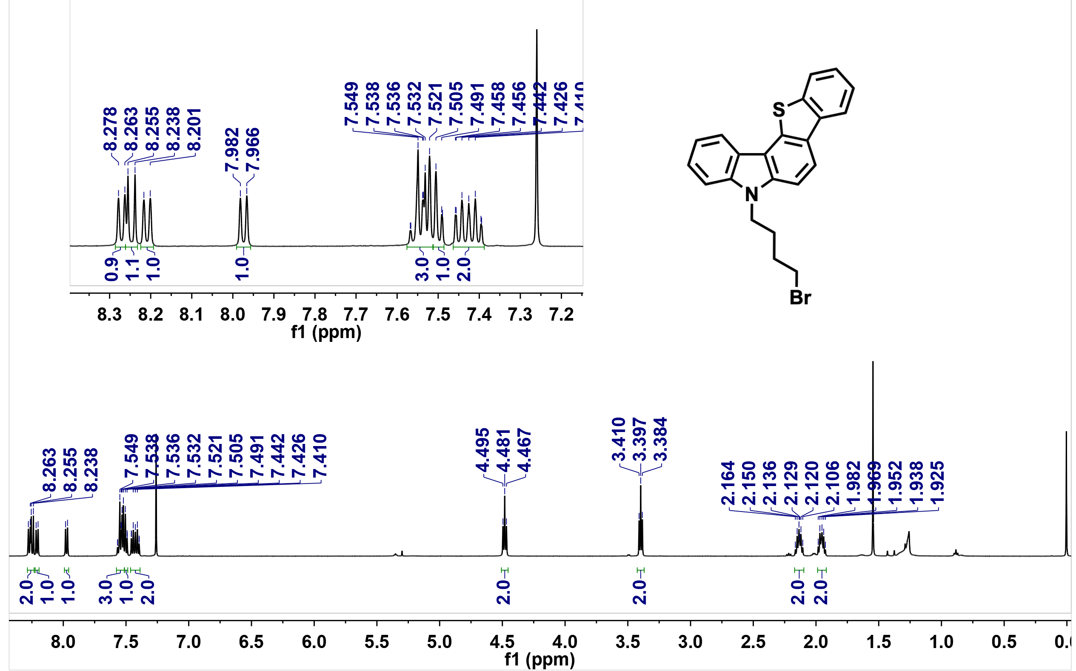
Supplementary Fig. S2. ¹H NMR spectrum of DBT21ID' in Chloroform-d (500 MHz, 25 ºC).

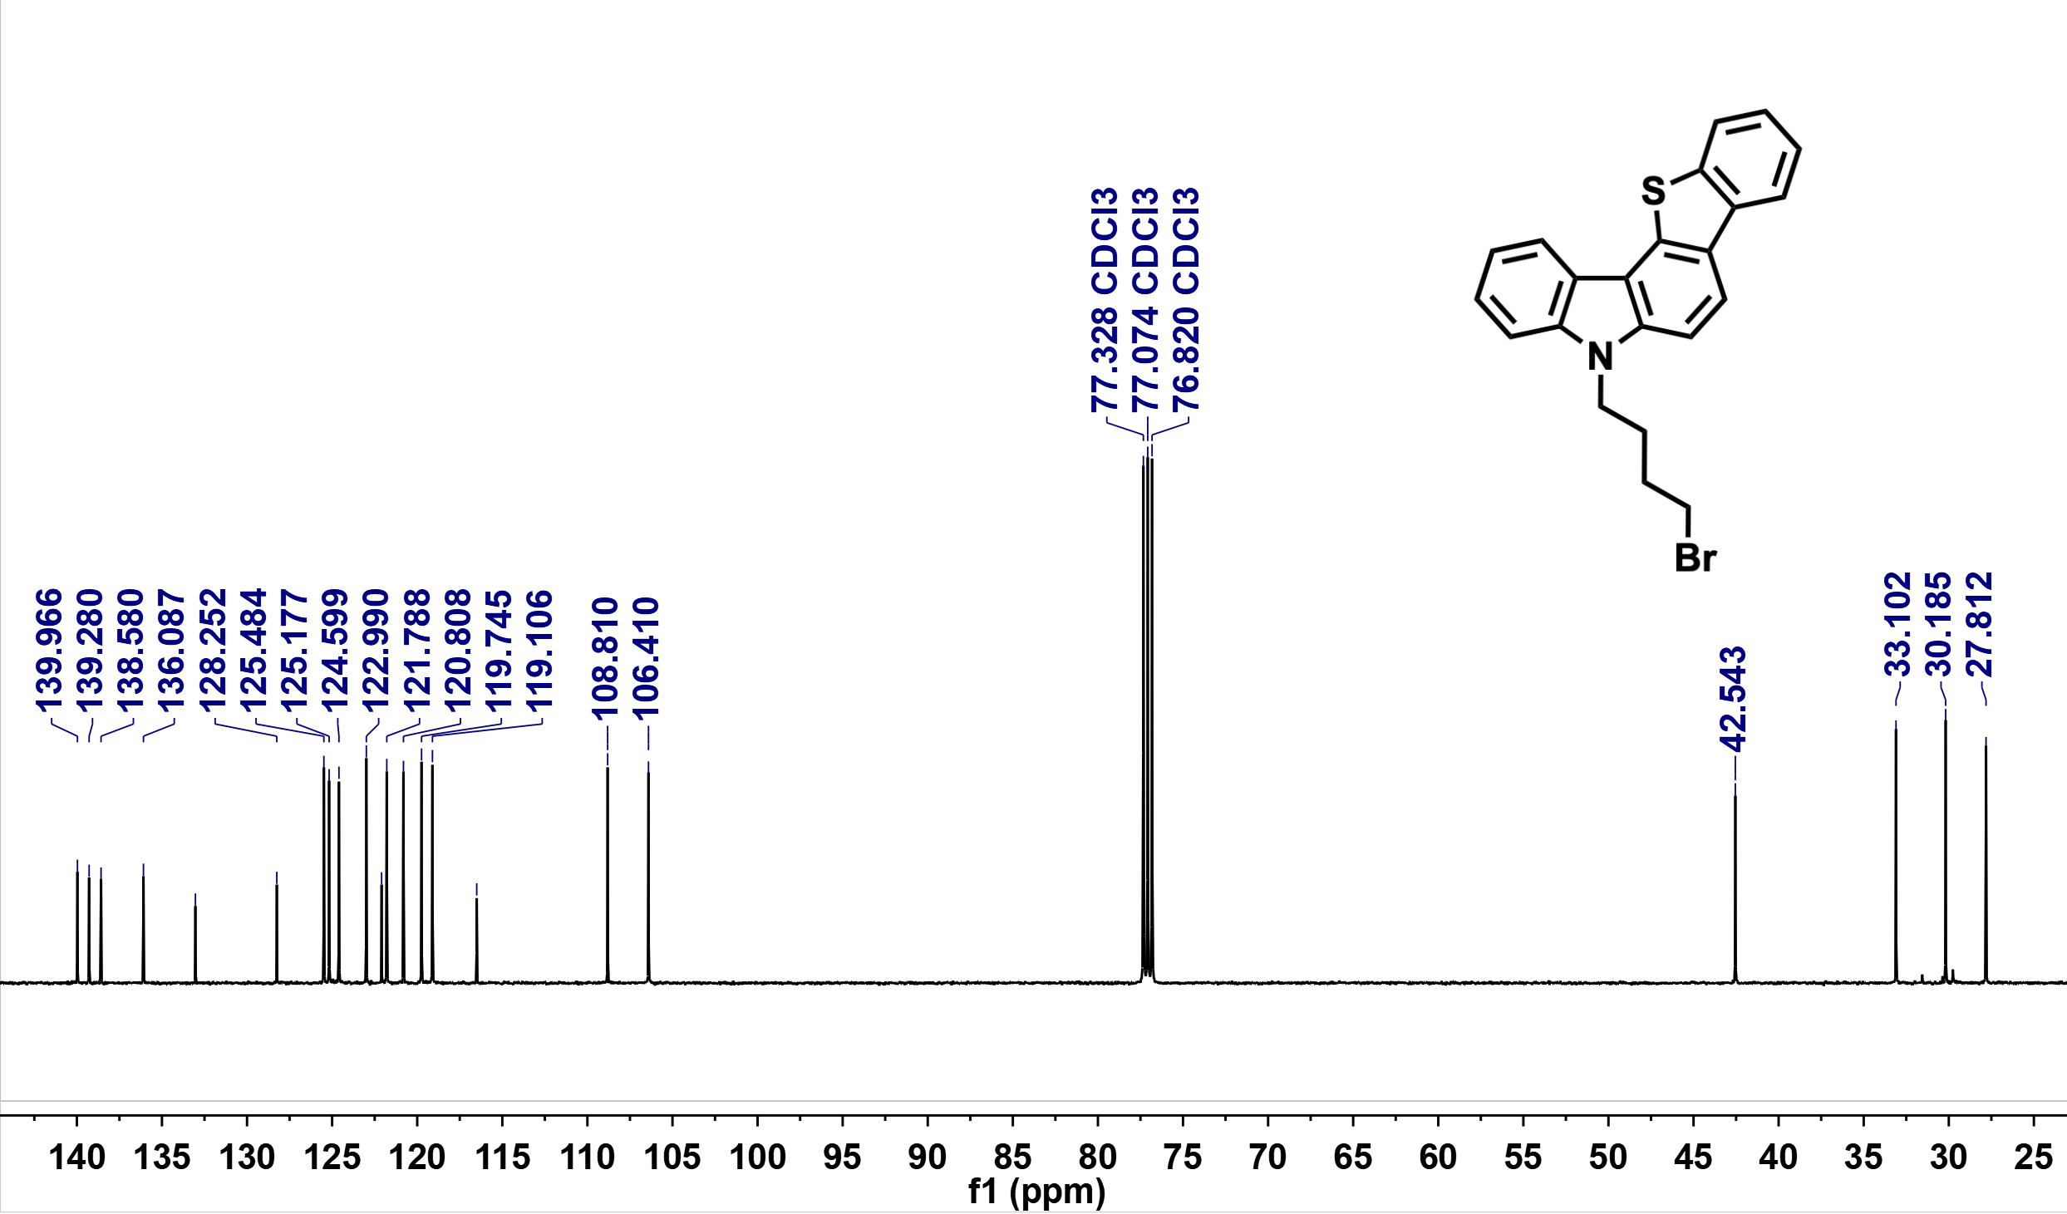

Supplementary Fig. S3. ¹³C NMR spectrum of DBT21ID' in Chloroform-d
(126 MHz, 25 ºC).

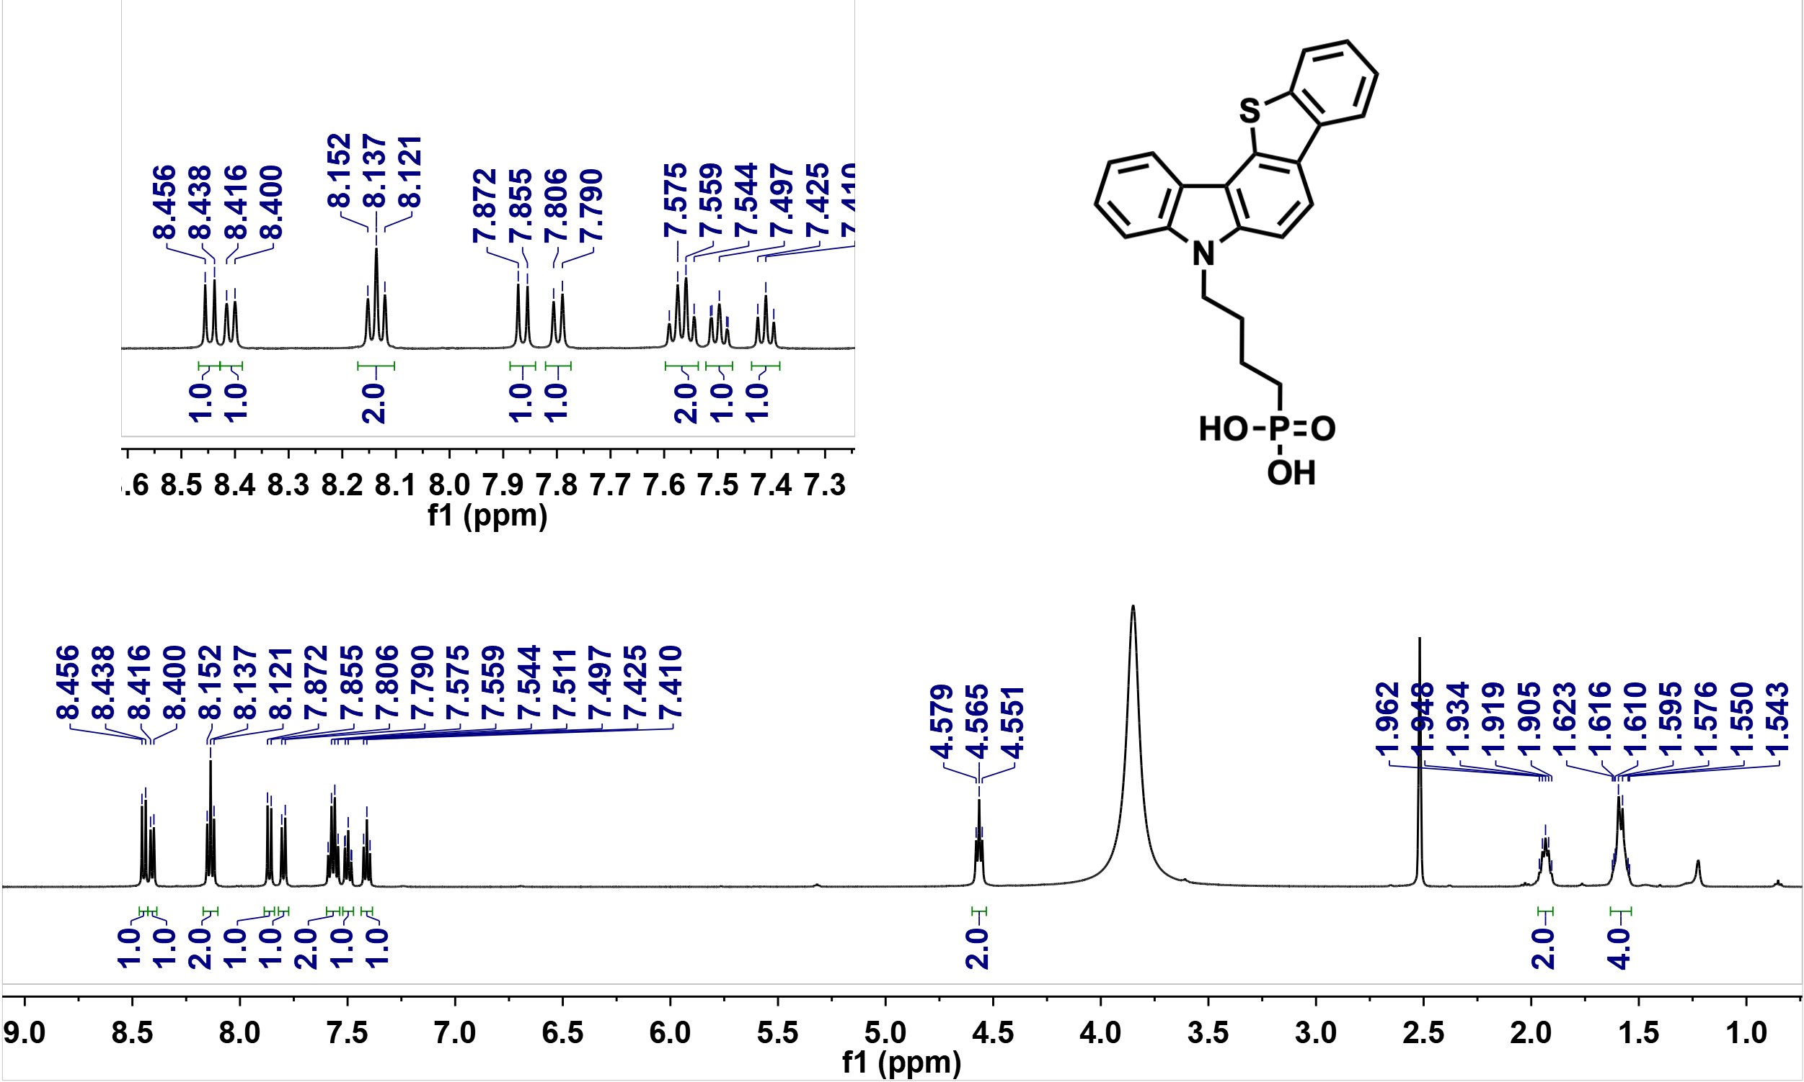

Supplementary Fig. S4. ¹H NMR spectrum of DBT21ID in DMSO-d₆ (500 MHz, 25 ºC).

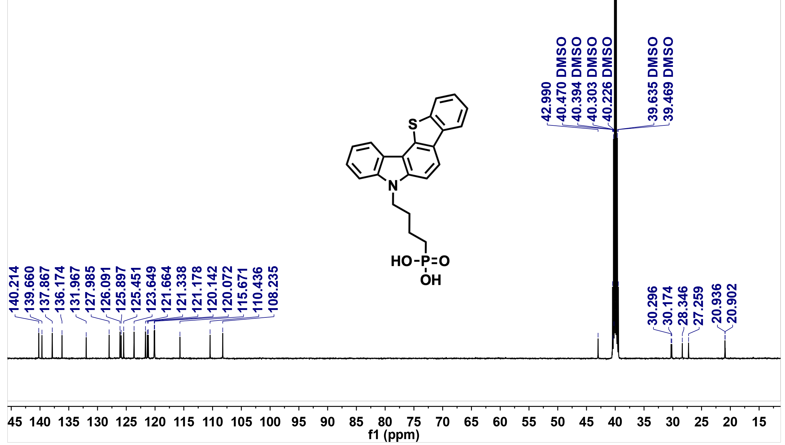

Supplementary Fig. S5. ¹³C NMR spectrum of DBT21ID in DMSO-d₆ (126 MHz, 25 ºC).

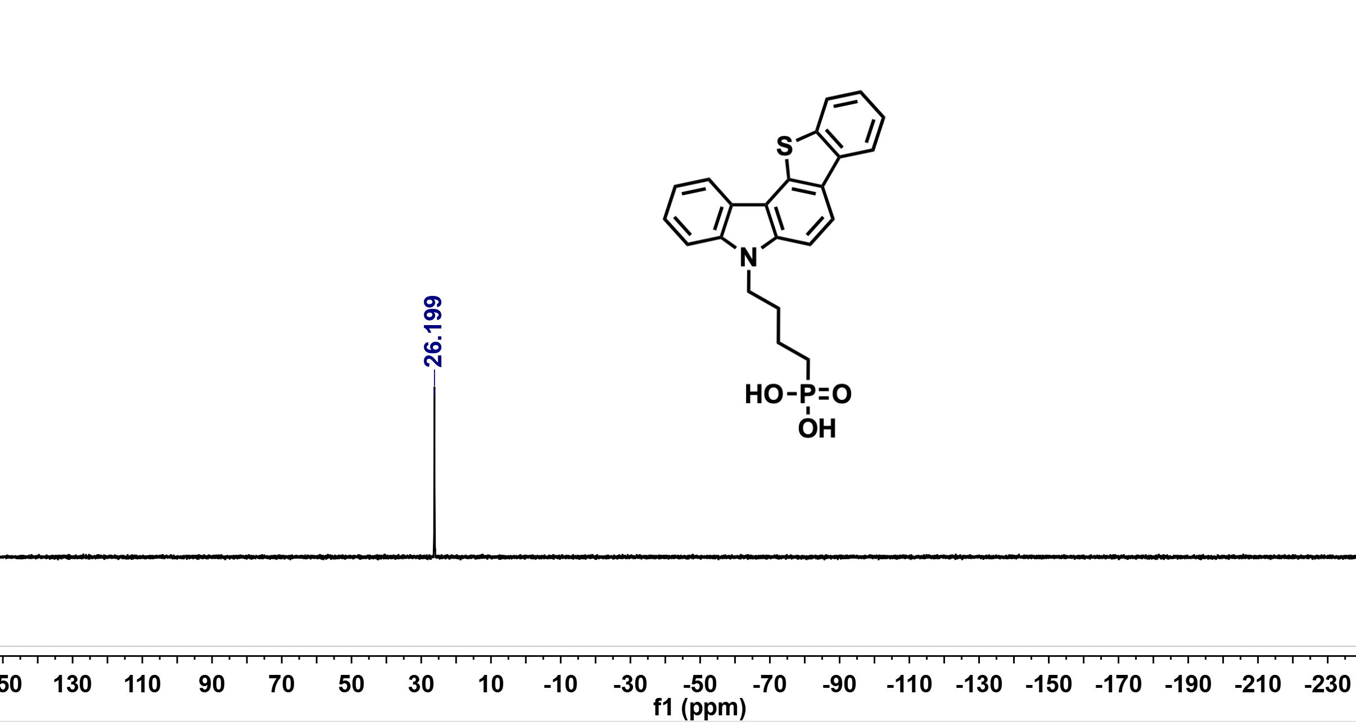

Supplementary Fig. S6. ³¹P NMR spectrum of DBT21ID in DMSO-d₆ (202 MHz, 25 ºC).

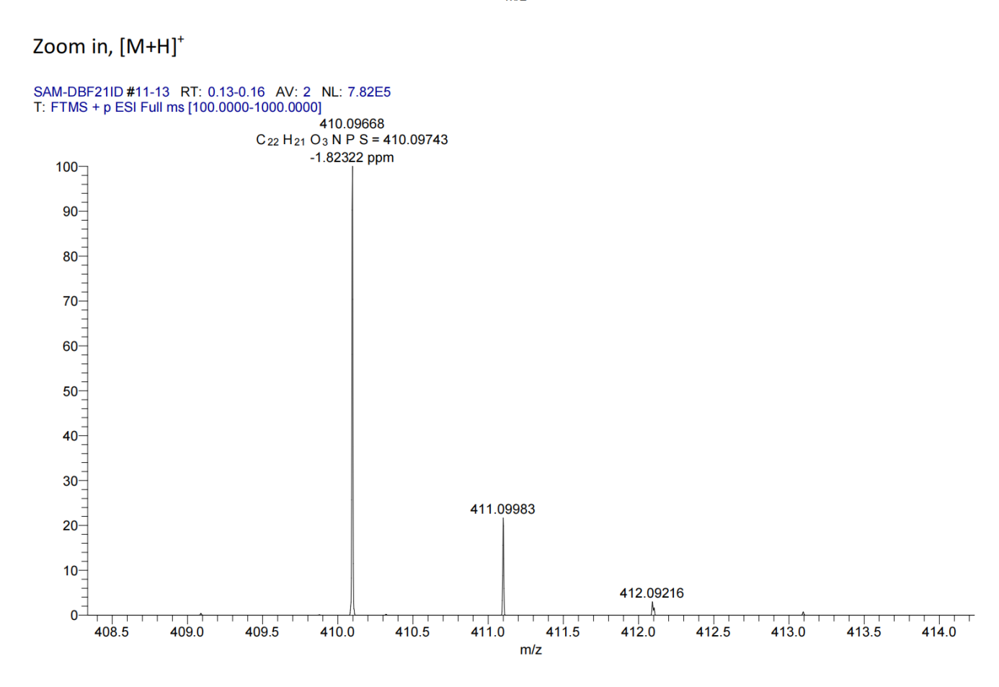
Supplementary Fig. S7. HRMS spectrum of DBT21ID.

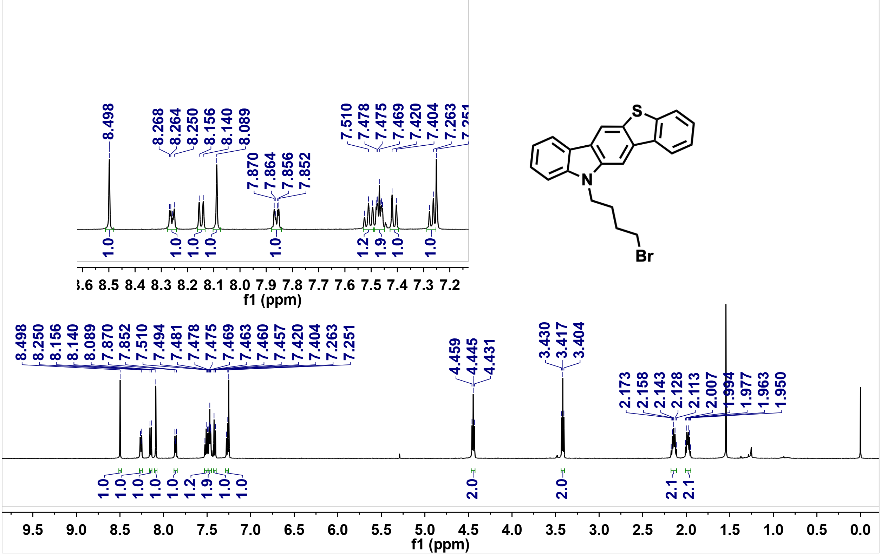

Supplementary Fig. S8. ¹H NMR spectrum of DBT32ID' in Chloroform-d (500 MHz, 25 ºC).

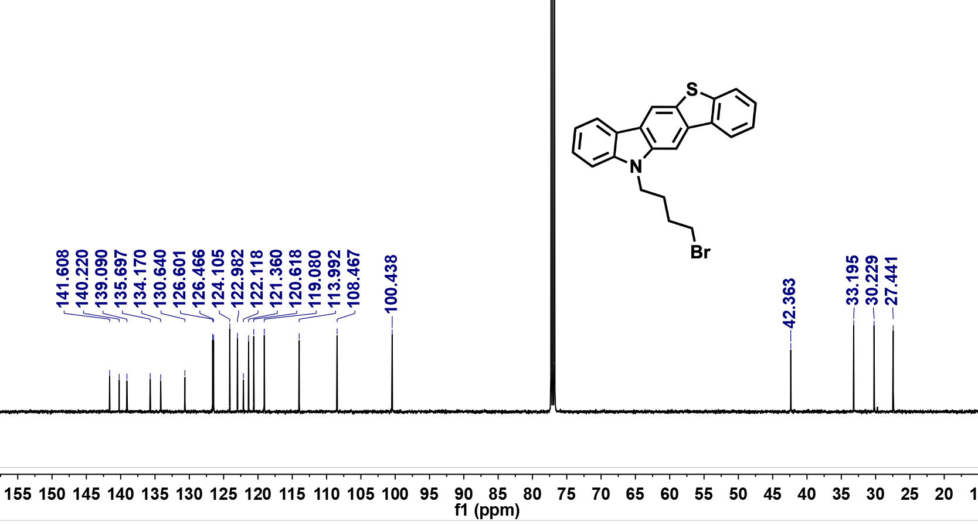

Supplementary Fig. S9. ¹³C NMR spectrum of DBT32ID' in Chloroform-d
(126 MHz, 25 ºC).

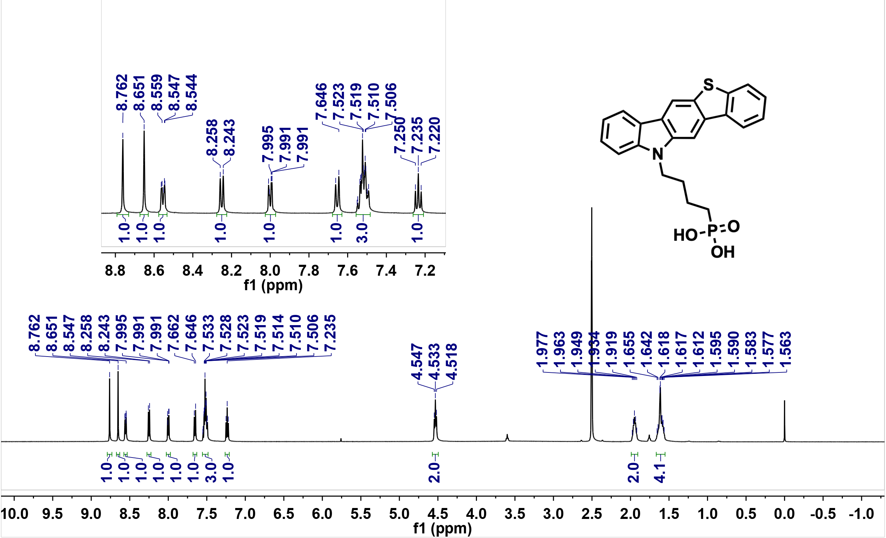

Supplementary Fig. S10. ¹H NMR spectrum of DBT32ID in DMSO-d₆ (500 MHz, 25 ºC).

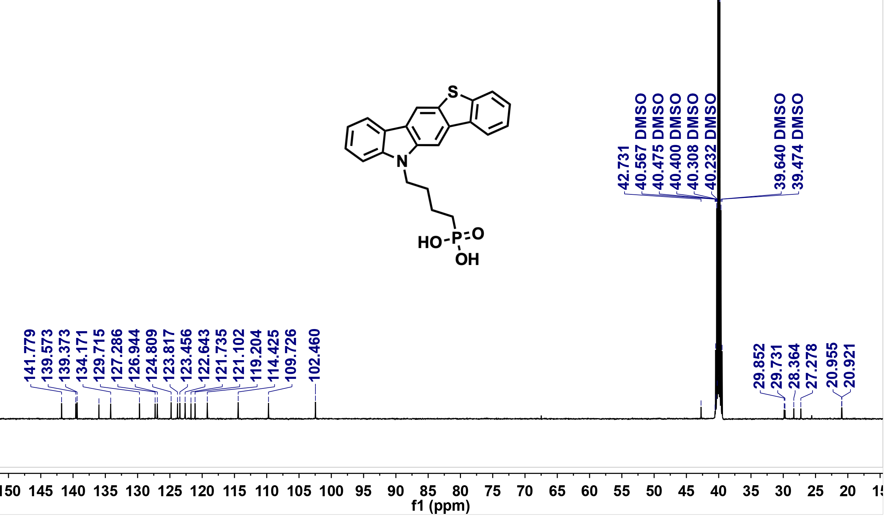

Supplementary Fig. S11. ¹³C NMR spectrum of DBT32ID in DMSO-d₆ (126 MHz, 25 ºC).

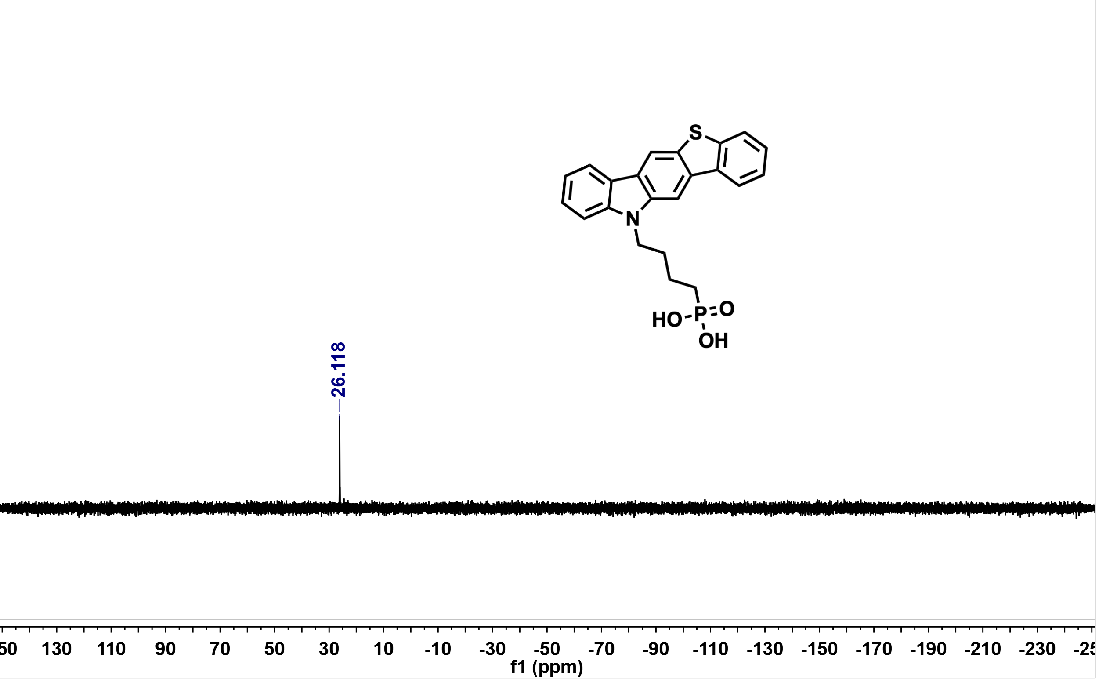

Supplementary Fig. S12. ³¹P NMR spectrum of DBT32ID in DMSO-d₆ (202 MHz, 25 ºC).

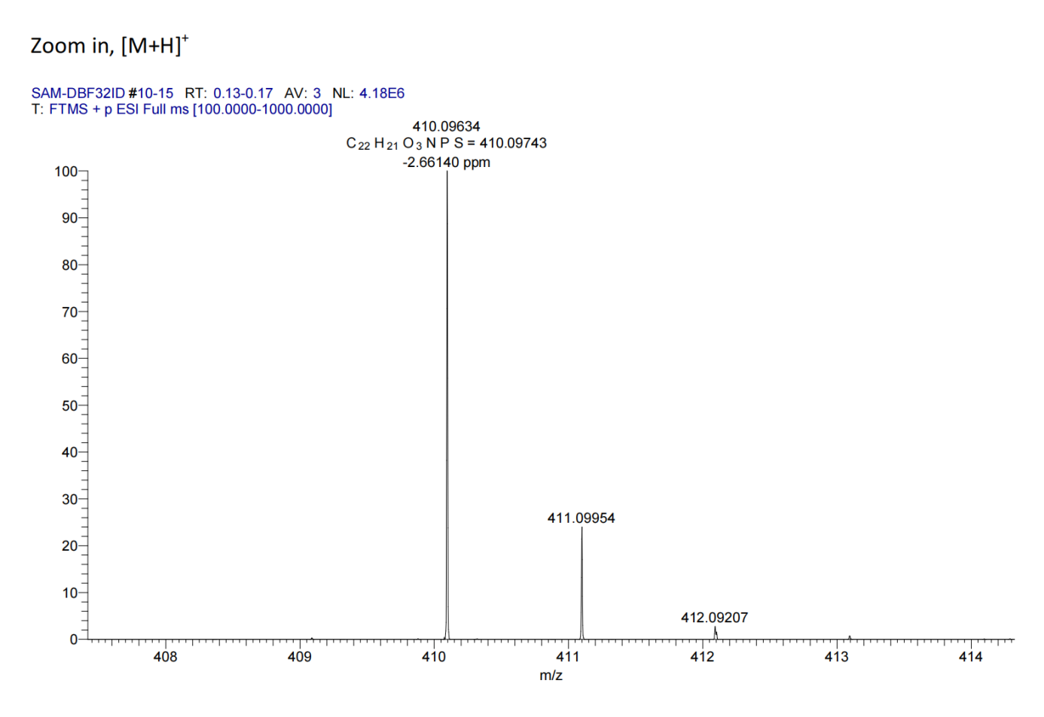

Supplementary Fig. S13. HRMS spectrum of DBT32ID.

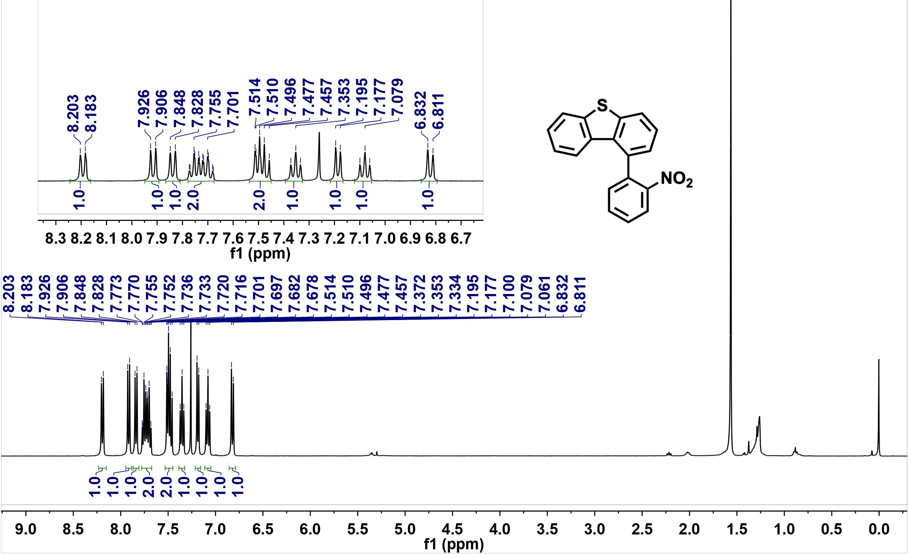

Supplementary Fig. S14. ¹H NMR spectrum of DBT34ID''' in Chloroform-d
(400 MHz, 25 ºC).

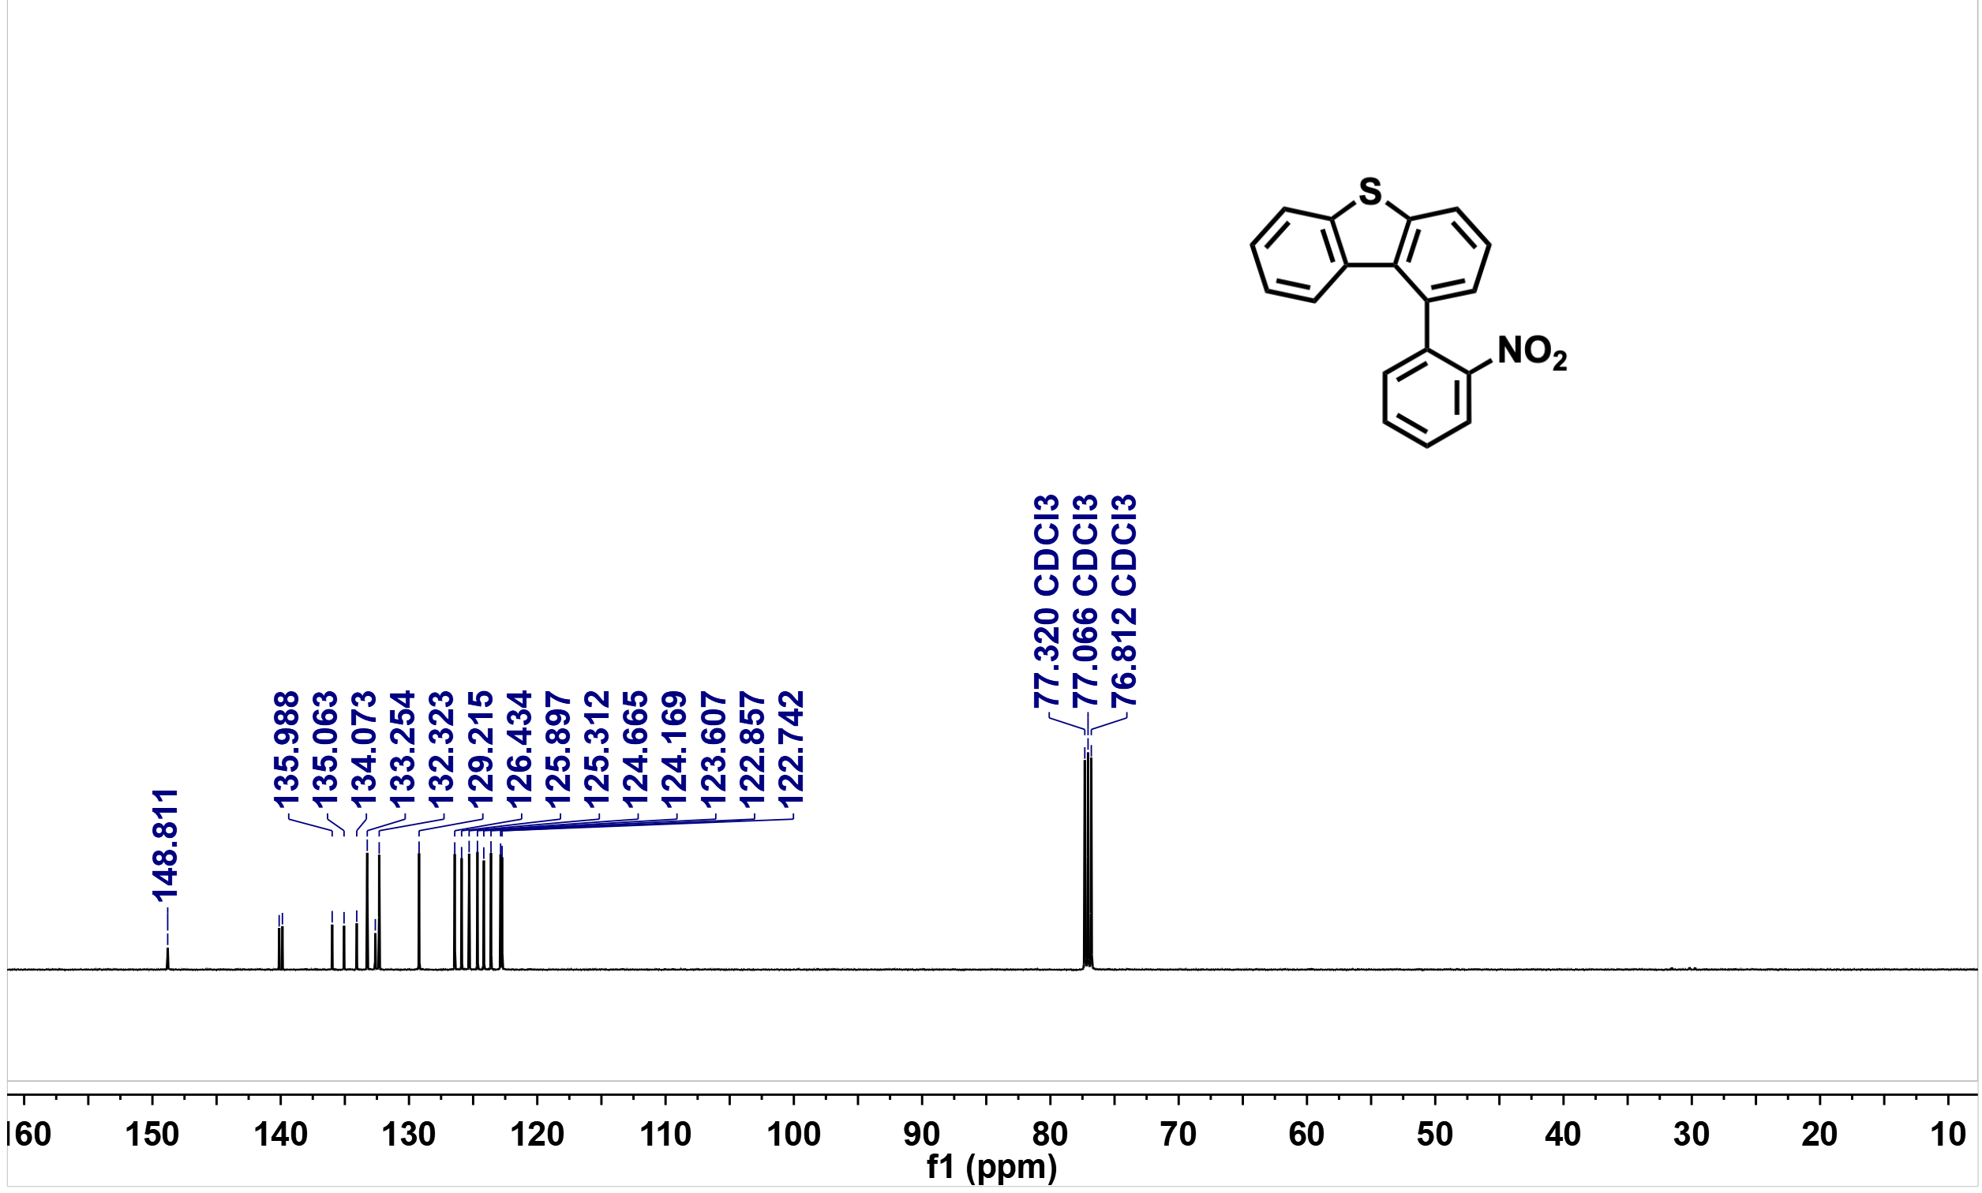
Supplementary Fig. S15. ¹³C NMR spectrum of DBT34ID''' in Chloroform-d
(126 MHz, 25 ºC).
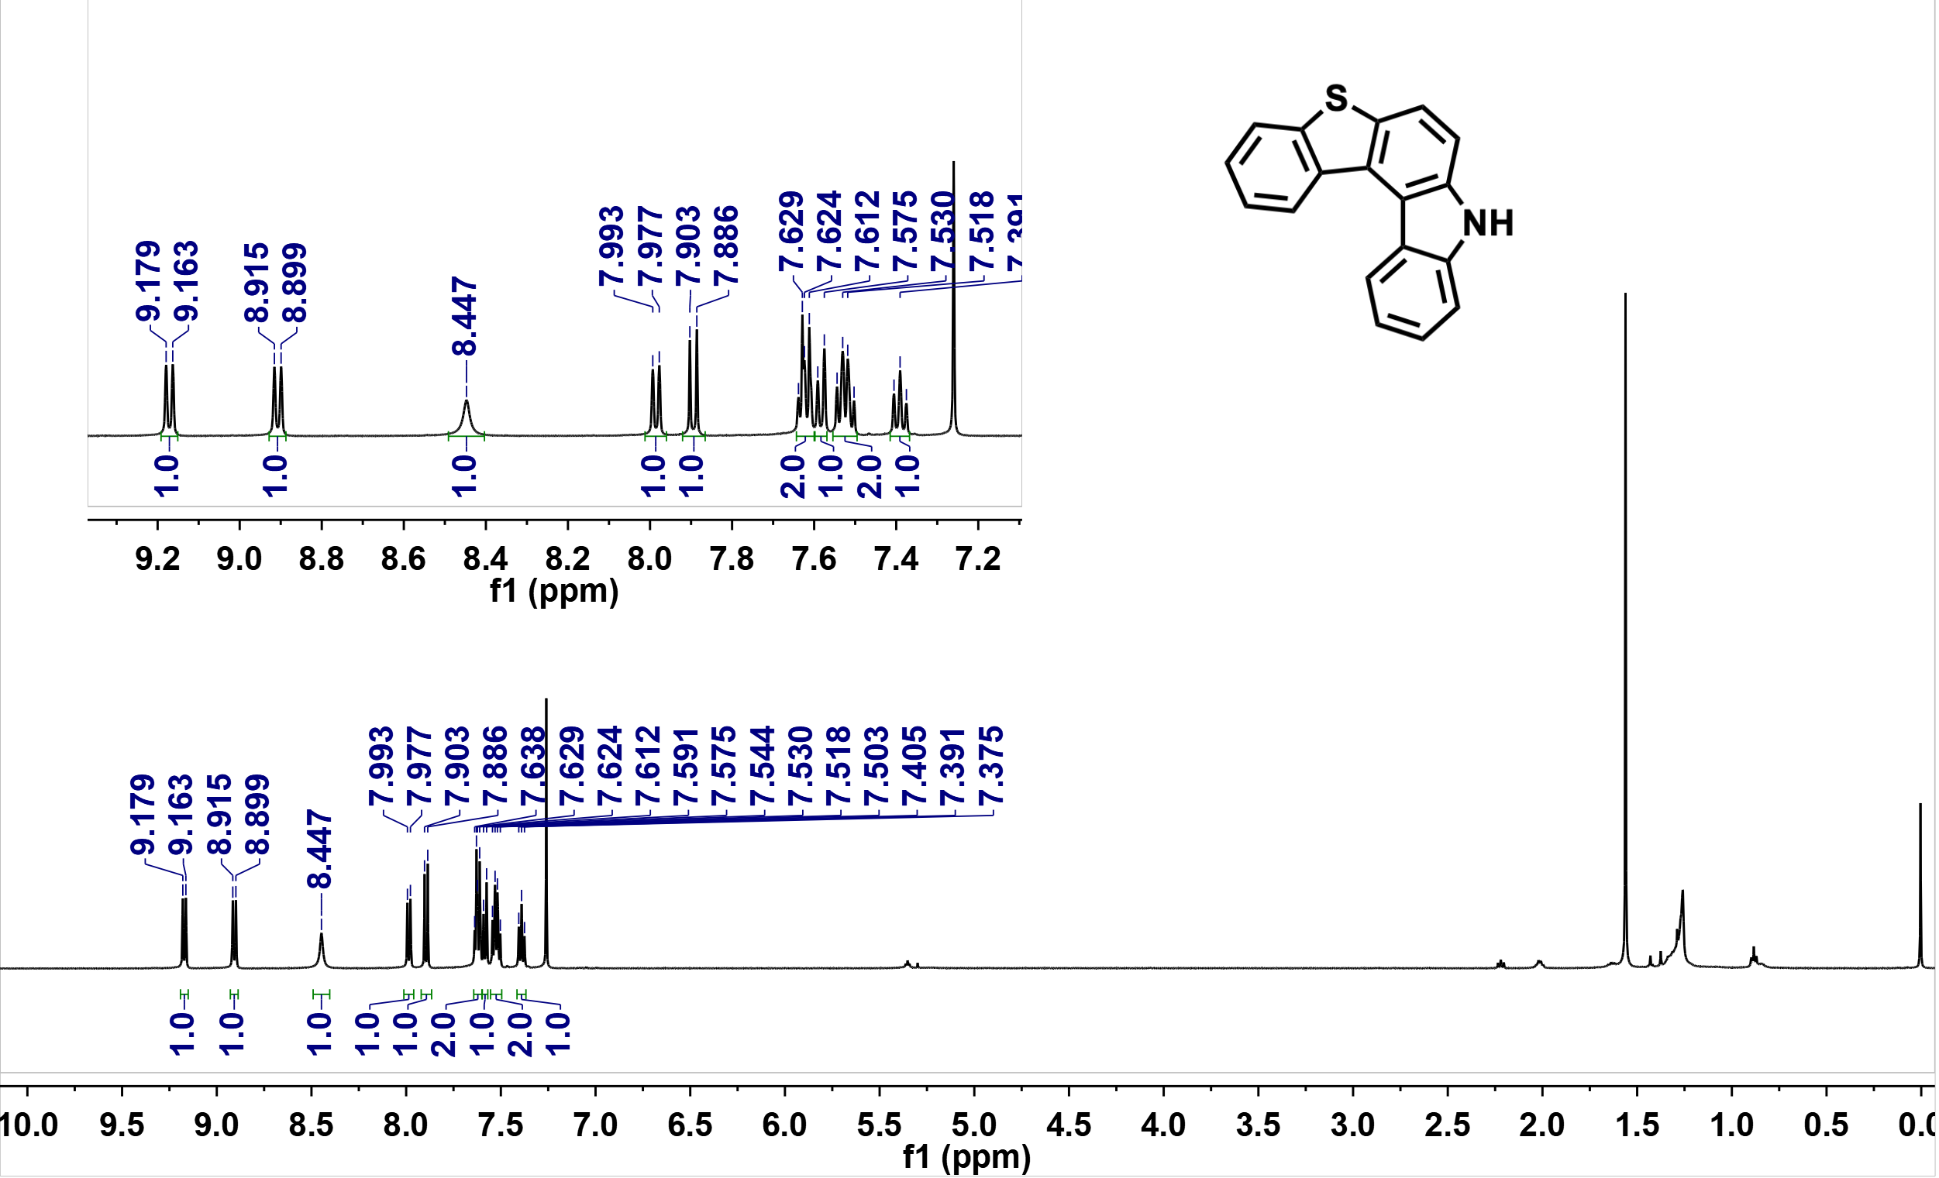

Supplementary Fig. S16. ¹H NMR spectrum of DBT34ID'' in Chloroform-d
(500 MHz, 25 ºC).

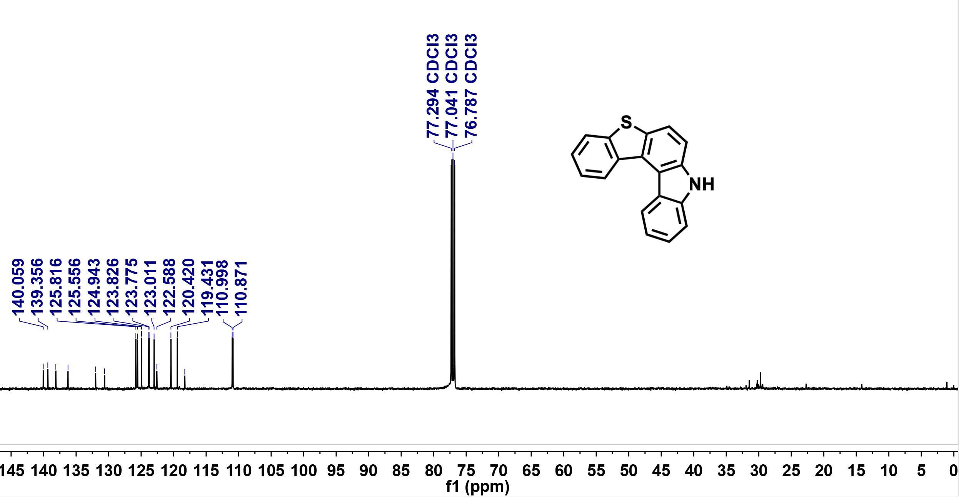

Supplementary Fig. S17. ¹³C NMR spectrum of DBT34ID'' in Chloroform-d
(126 MHz, 25 ºC).

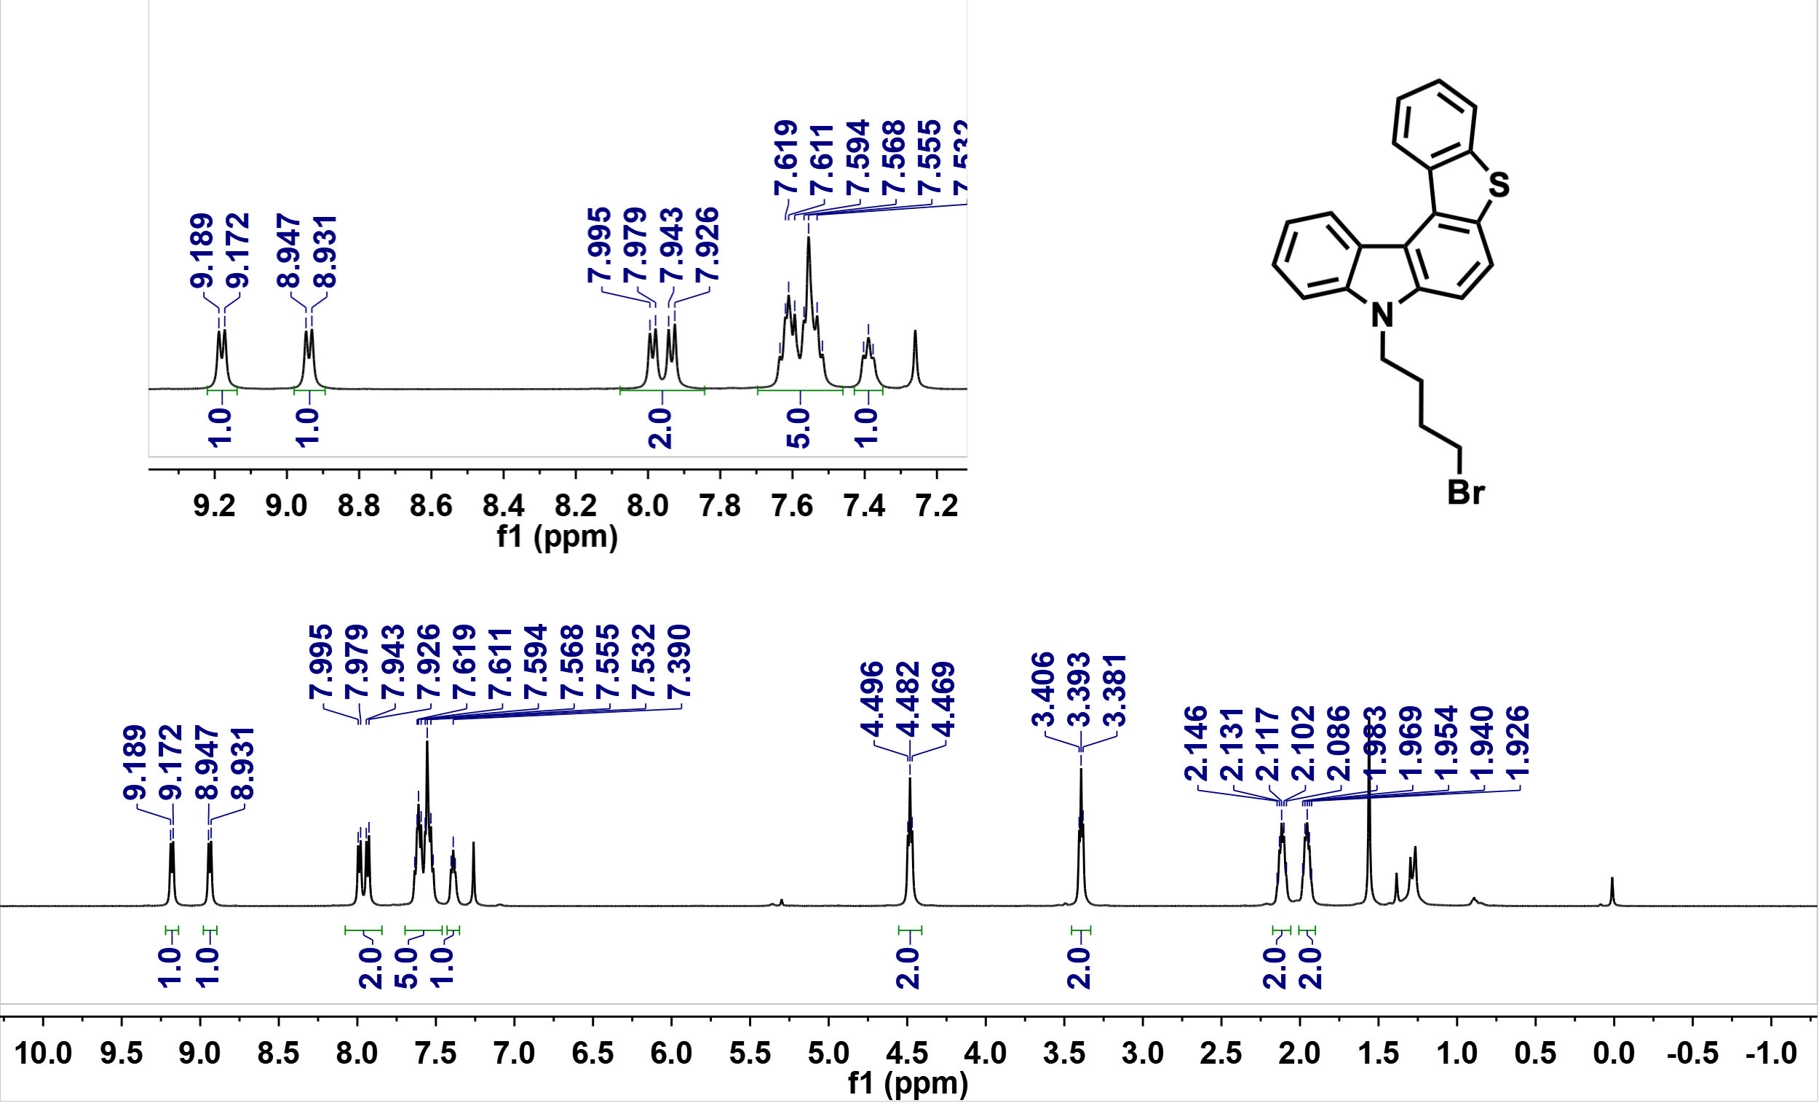

Supplementary Fig. S18. ¹H NMR spectrum of DBT34ID' in Chloroform-d
(500 MHz, 25 ºC).

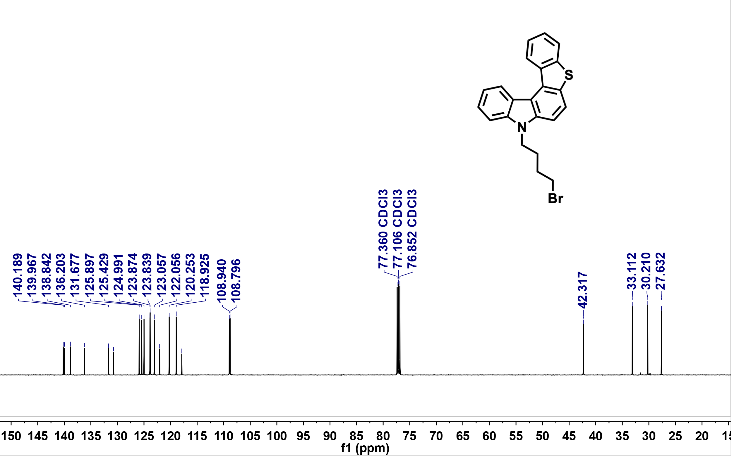
Supplementary Fig. S19. ¹³C NMR spectrum of DBT34ID' in Chloroform-d
(126 MHz, 25 ºC).
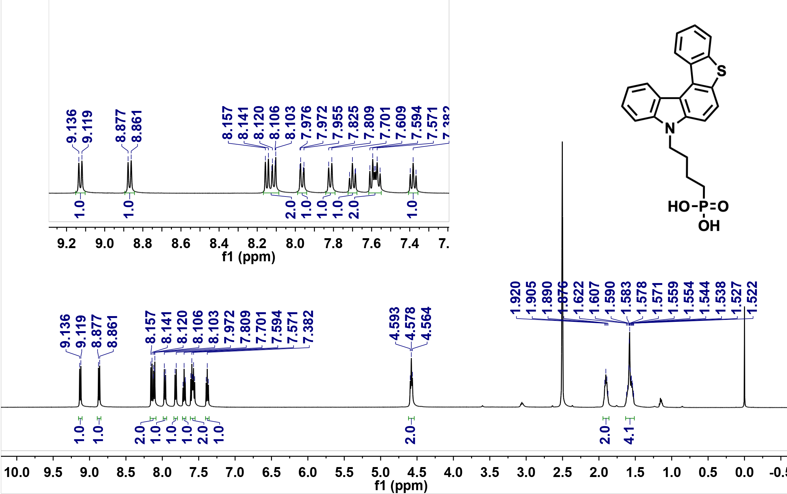

Supplementary Fig. S20. ¹H NMR spectrum of DBT34ID in DMSO-d₆ (500 MHz, 25 ºC).

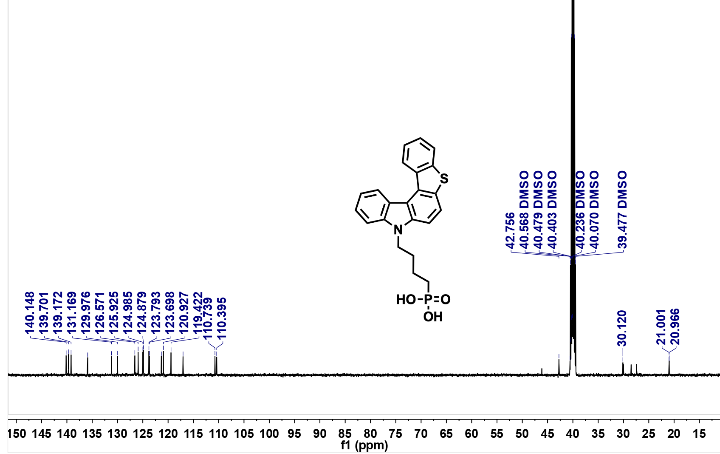

Supplementary Fig. S21. ¹³C NMR spectrum of DBT34ID in DMSO-d₆ (126 MHz, 25 ºC).

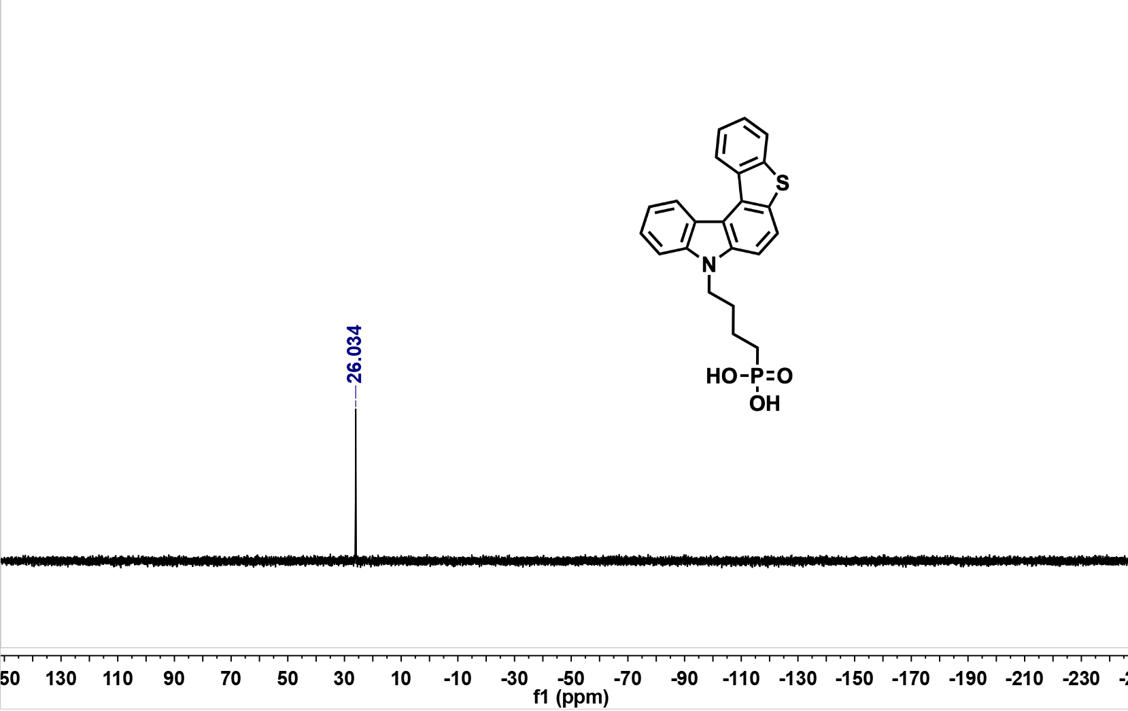

Supplementary Fig. S22. ³¹P NMR spectrum of DBT34ID in DMSO-d₆ (202 MHz, 25 ºC).

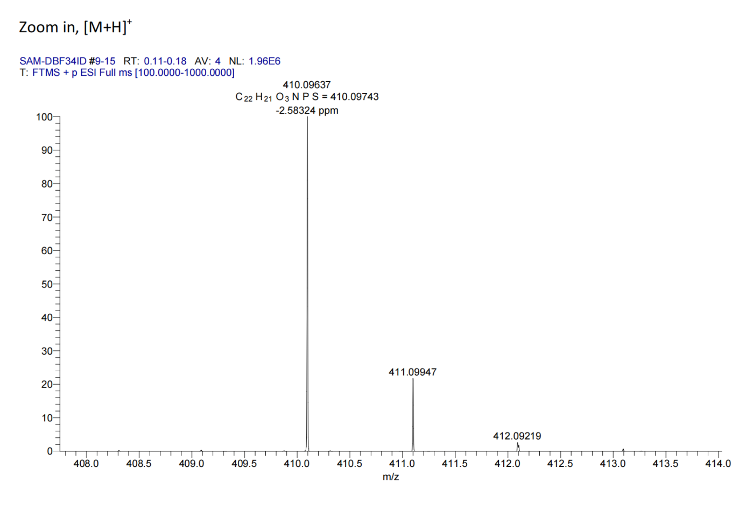
Supplementary Fig. S23. HRMS spectrum of DBT34ID.

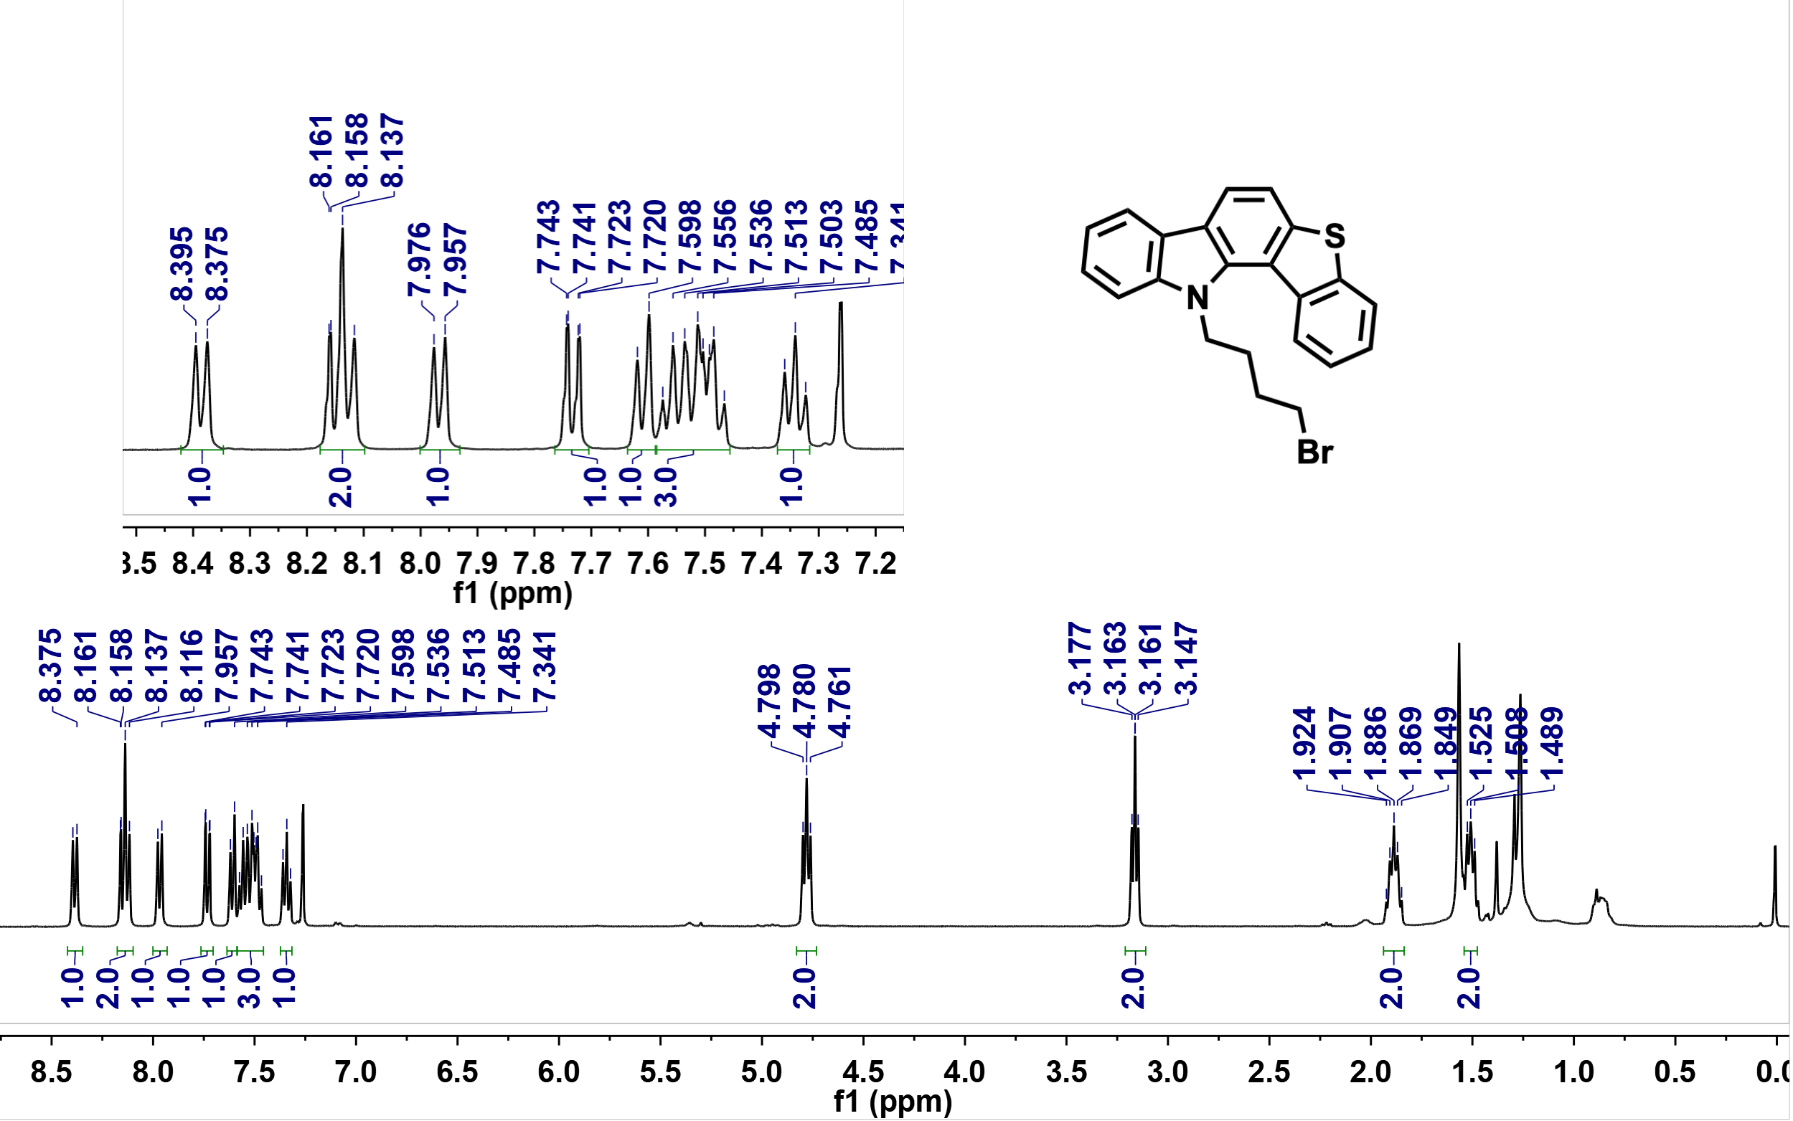

Supplementary Fig. S24. ¹H NMR spectrum of DBT43ID' in Chloroform-d (400 MHz, 25 ºC).

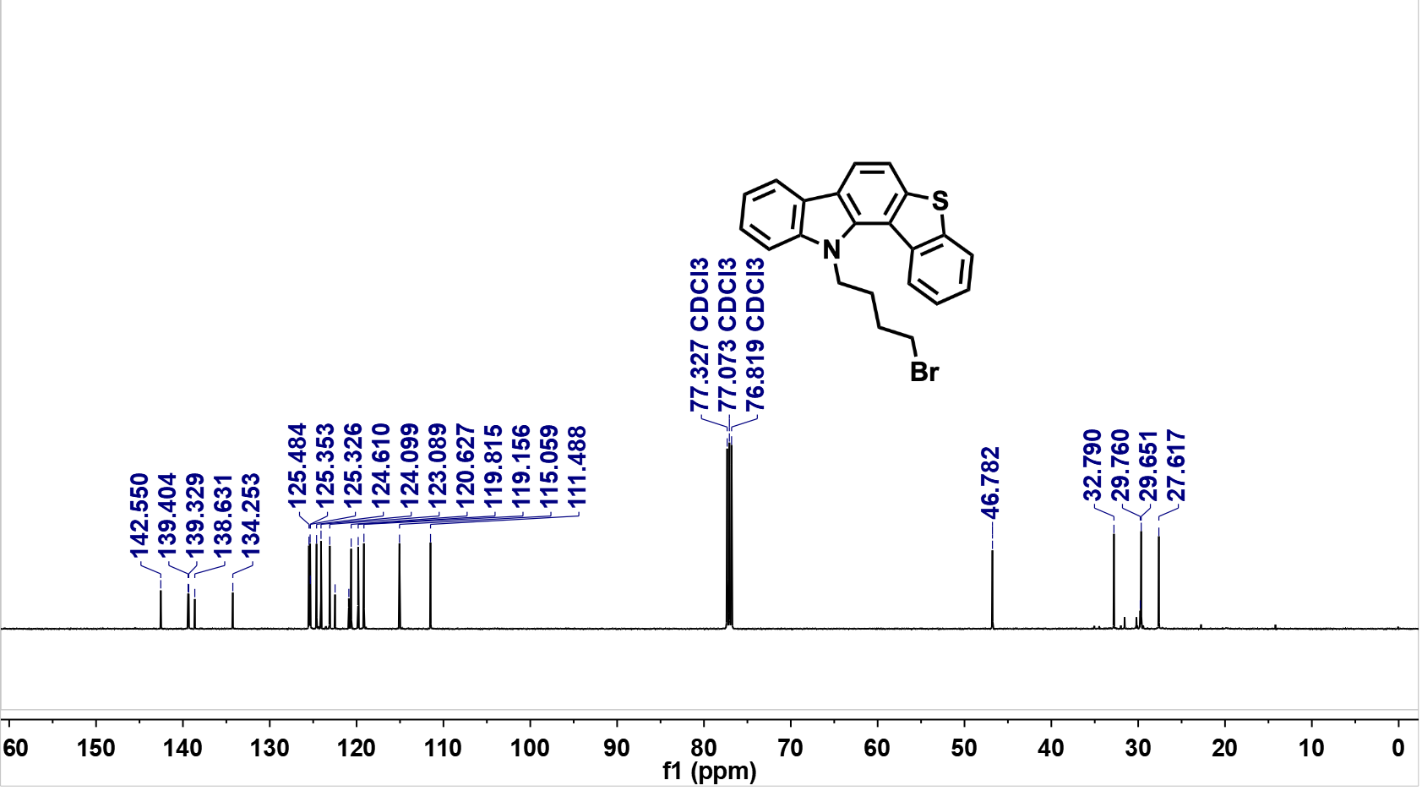

Supplementary Fig. S25. ¹³C NMR spectrum of DBT43ID' in Chloroform-d
(126 MHz, 25 ºC).
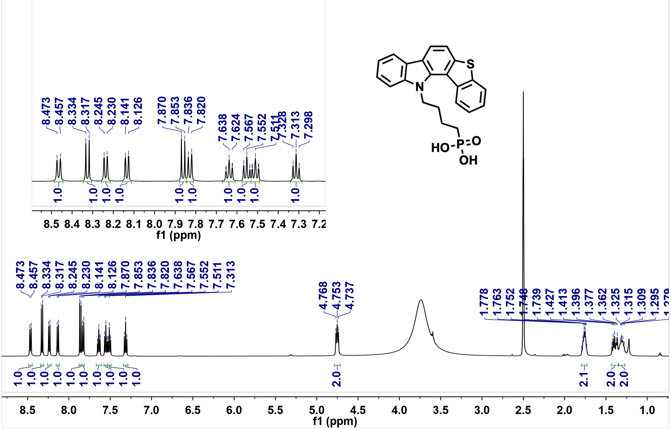

Supplementary Fig. S26. ¹H NMR spectrum of DBT43ID in DMSO-d₆ (500 MHz, 25 ºC).

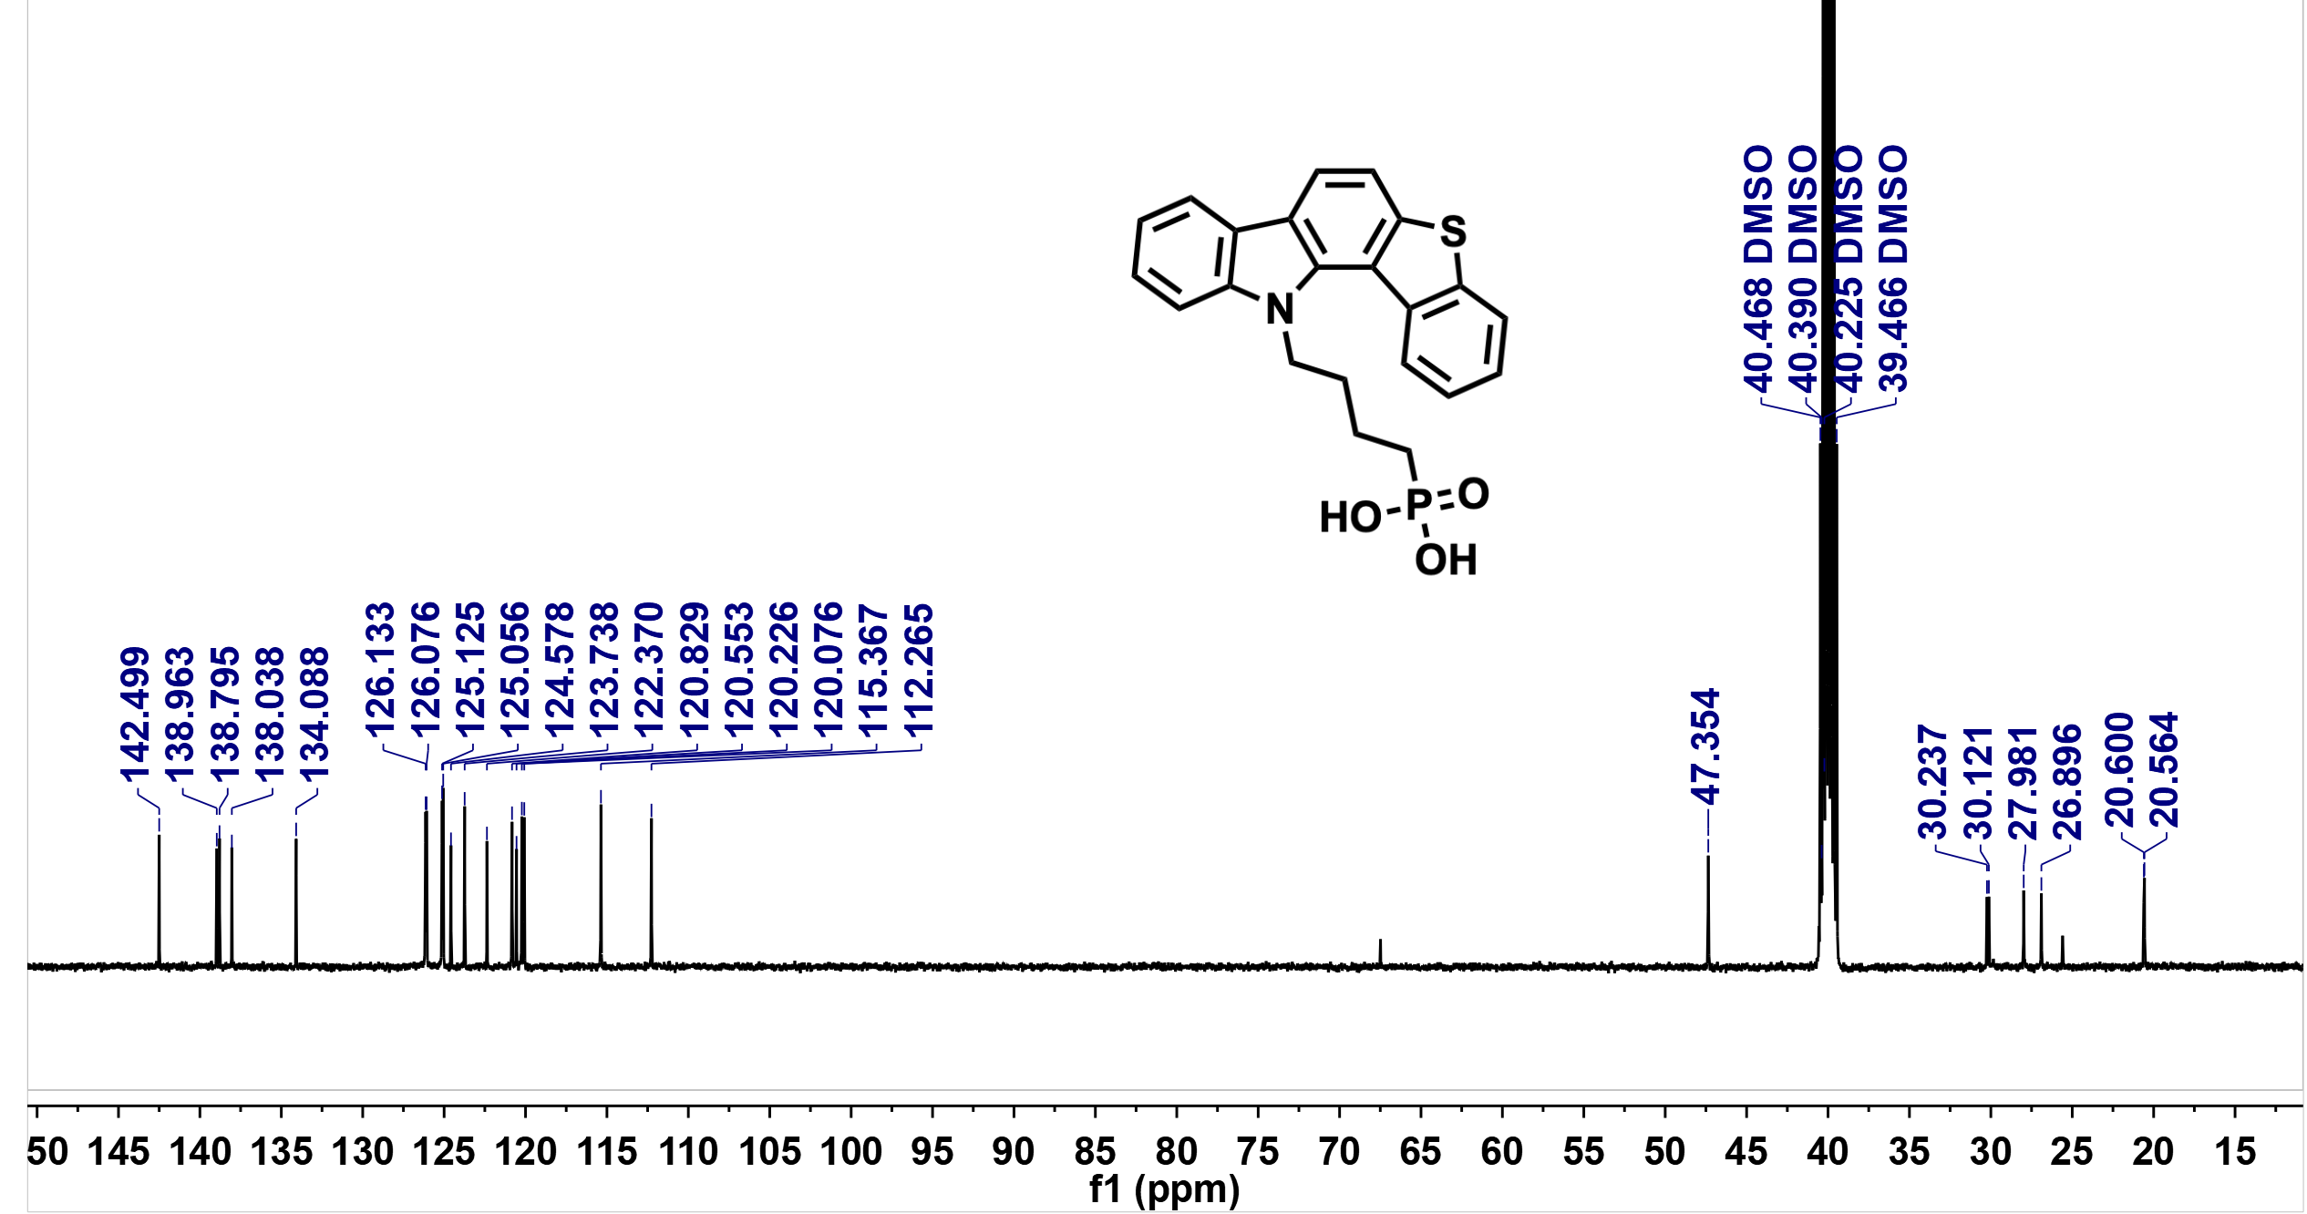

Supplementary Fig. S27. ¹³C NMR spectrum of DBT43ID in DMSO-d₆ (126 MHz, 25 ºC).

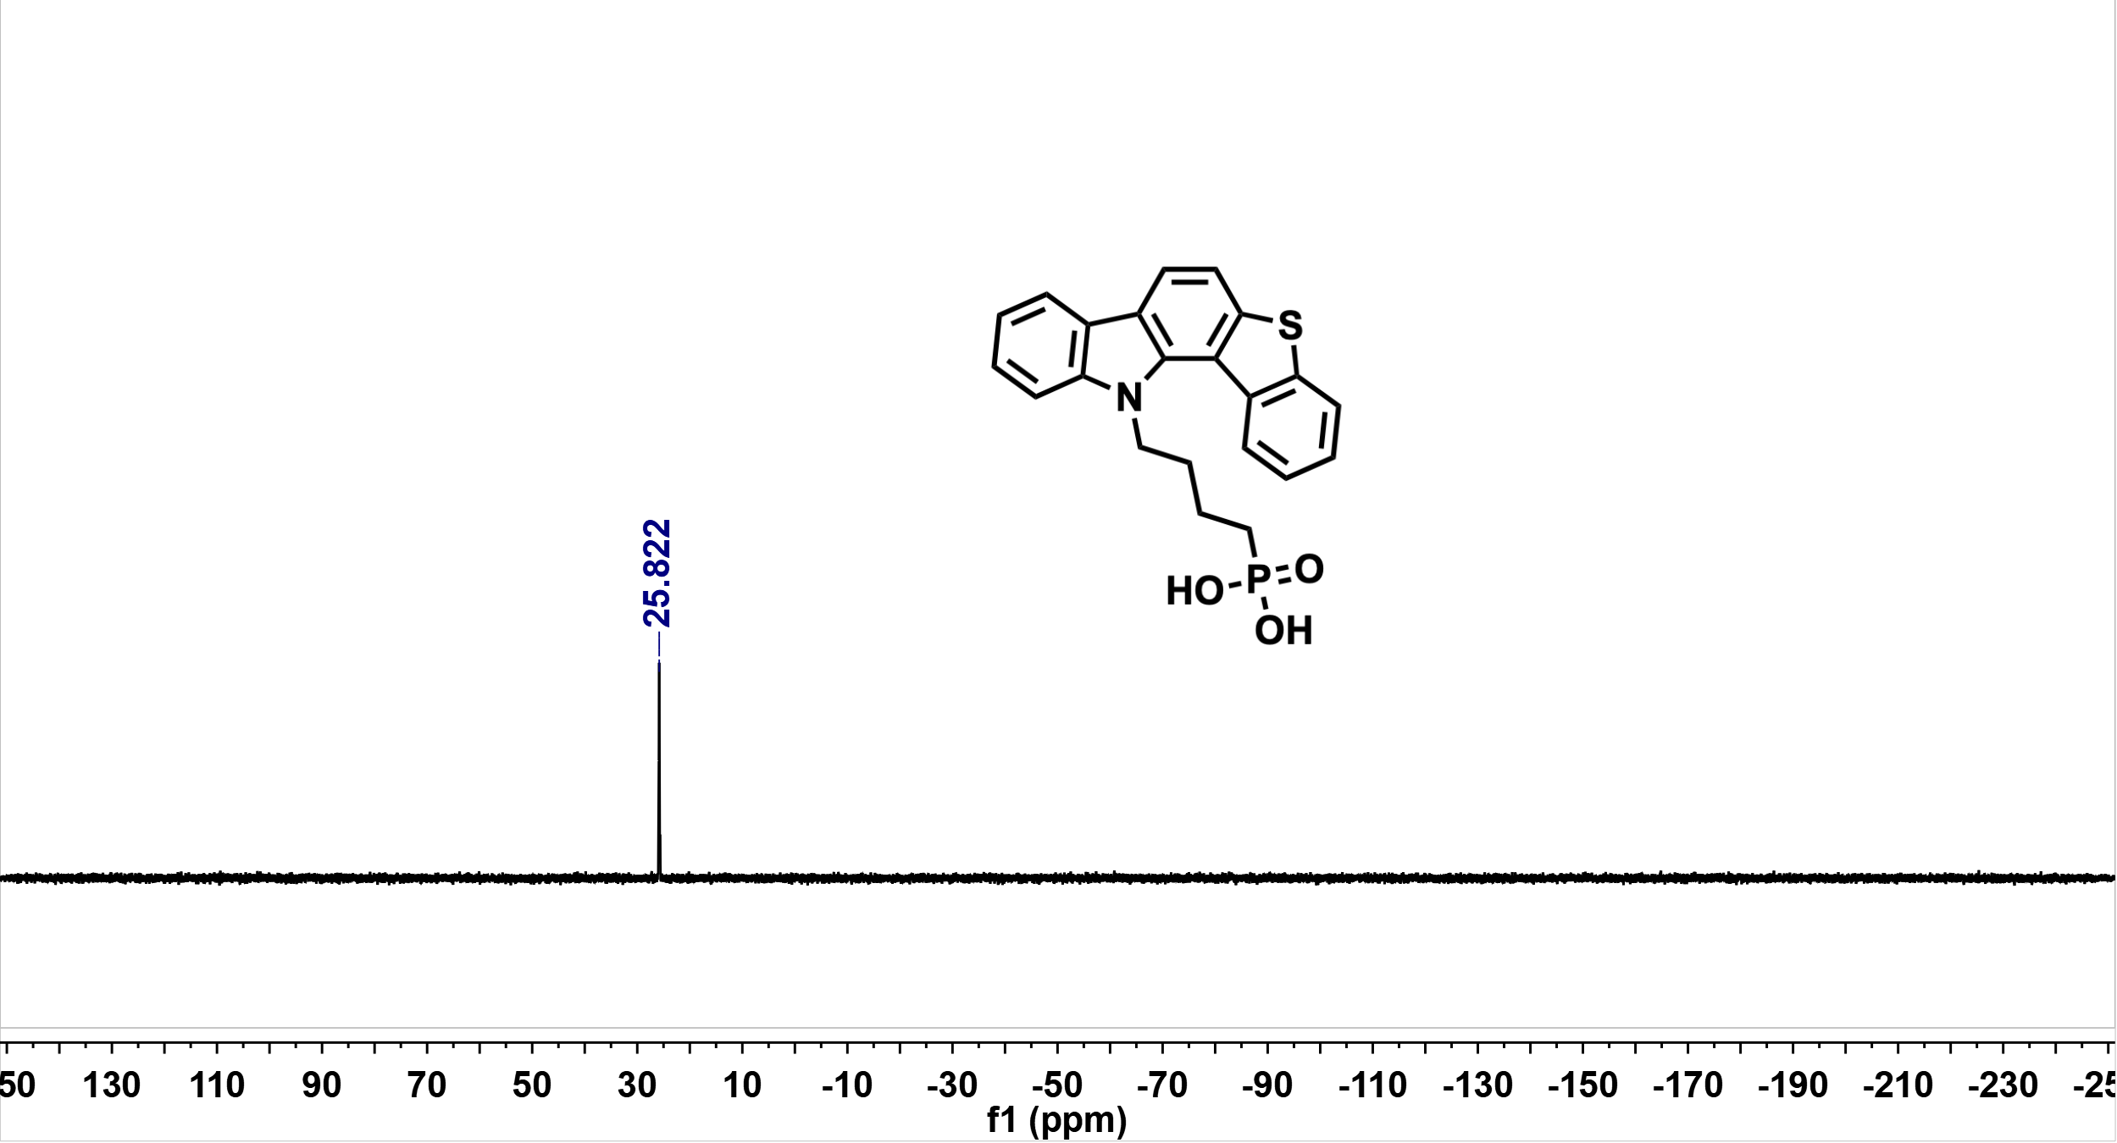

Supplementary Fig. S28. ³¹P NMR spectrum of DBT43ID in DMSO-d₆ (202 MHz, 25 ºC).

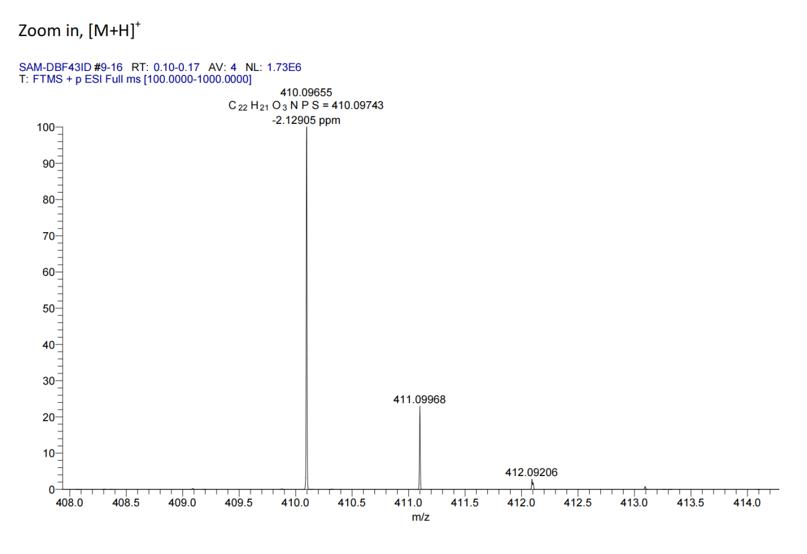
Supplementary Fig. S29. HRMS spectrum of DBT43ID.

Supplementary Note 2: Theoretical Calculation Details
1. Theoretical calculations for single-molecule models
The electronic properties of the isolated molecules provide the basis for understanding both intermolecular aggregation within the SAM and the interactions of the SAM with the adjacent interfaces. Given that conformational variations of the alkyl chains have only a minor effect on the molecular potential-energy surface, geometry optimization was performed together with vibrational frequency analysis to ensure that the reported structures correspond to energetically favourable conformations.¹⁻³ Because SAMs function as hole-injection and hole-transport layers, our single-molecule calculations focused primarily on molecular geometry, HOMO energy levels, frontier-orbital distributions and surface electrostatic-potential maps. In addition, because the dipole moment of the conjugated building block can contribute to the interfacial dipole of the anchored SAM layer,⁴ we separately optimized the phosphonic-acid-free conjugated fragment under the same conditions and calculated its molecular dipole moment. The corresponding dipole distributions were visualized using VMD 1.9.3.²
Supplementary Fig. S30. Optimized gas-phase geometries of the isolated SAM molecules. Top and side views are shown in the upper and lower panels, respectively. DBT21ID and DBT32ID exhibit nearly planar conjugated scaffolds, whereas DBT34ID and DBT43ID show moderate helical distortion. This degree of non-planarity preserves conjugation for intramolecular hopping while suppressing excessive intermolecular aggregation, which is expected to favour more complete phosphonic-acid anchoring on ITO and lower interfacial defect density.

Supplementary Fig. S31. HOMO and LUMO distributions of the SAM molecules. Under the N-𝜋-S electronic effect, pronounced HOMO density is localized on the embedded sulfur atom in all molecules except DBT21ID, with the strongest contribution observed for DBT34ID. Such orbital localization is expected to promote interfacial S–Pb coordination and enhance defect passivation at the perovskite interface.^{5,6}

Supplementary Fig. S32. Calculated dipole moments (μ_{D}) of the four SAM molecules with the alkyl phosphonic-acid group removed. Regioisomerization of the π-scaffold produces only modest changes in dipole moment, with differences below 0.75 Debye. Notably, although DBT21ID shows the largest calculated dipole for the isolated π-scaffold, it does not deliver the strongest interfacial modification, indicating that SAM performance is governed more by interfacial orientation and packing than by intrinsic dipole magnitude alone. This highlights the importance of treating the electrode-SAM-perovskite junction as an integrated system.

2. The geometry-dependent three-layer molecular-contact model
To model the buried interface in inverted perovskite solar cells, we constructed a three-layer molecular-contact framework (i.e., ITO/SAM/perovskite structure) in a stepwise manner. The oxide substrate was generated from the (111) surface of In₂O₃, using a three-layer slab (In₄₈O₇₂; a = b = 14.31 Å, α = β = 90°, γ = 120°), in which five In atoms were uniformly replaced by Sn to mimic ITO. The perovskite slab was cleaved from FAPbI₃ along the (001) plane, with both surfaces terminated by AX(FA-I) layers and containing two BX₂(PbI₂) layers separated by one central AX layer. The ITO and perovskite slabs were lattice matched, and a vacuum region was added along the z direction to avoid spurious interactions. The final supercell parameters were a = 13.45 Å, b = 14.22 Å, c = 50.00 Å, α = β = 90°, γ = 120°. Before introducing the perovskite slab, adsorption models of the SAM molecules on ITO were constructed. The terminal phosphonic-acid group was deprotonated to represent chemisorption, with the resulting O atoms bonded to exposed In atoms on ITO and the removed protons transferred to surface lattice O atoms to preserve charge neutrality. The SAM conformation was adjusted so that the sulfur atom at the opposite end of the conjugated scaffold pointed away from the substrate. After preliminary optimization of the ITO/SAM structure with the bottom ITO layer fixed, the perovskite slab was placed above the SAM layer. To model interfacial defect passivation, one I atom bonded to Pb was removed from the bottom AX layer to generate an undercoordinated Pb site, and one proton was removed from a nearby FA⁺ cation to maintain overall charge neutrality. The exposed Pb atom was initially aligned with the sulfur site of the SAM. Because of the complex potential-energy surface of the full interface, interfacial configuration sampling was accelerated using the MACE-MPA-0 machine-learning potential. The perovskite slab was translated along the a, b and z directions to generate a three-dimensional search grid, and the lowest-energy configuration was selected as the starting point for first-principles optimization. The first-principles calculations were performed using CP2K within the PBE generalized-gradient approximation with DFT-D3(BJ) dispersion correction. The Gaussian and plane waves (GPW) scheme were used with the DZVP-MOLOPT-SR-GTH basis set and corresponding GTH pseudopotentials. The plane-wave cutoff and relative cutoff were set to 400 Ry and 55 Ry, respectively. Because the model contained five Sn dopants, the total spin multiplicity was set to 6, and calculations were performed using the unrestricted Kohn-Sham formalism. Self-consistent-field iterations were accelerated using the orbital transformation method with an energy convergence threshold of 1.0 × 10⁻⁶ a.u. Geometry optimizations were carried out with the BFGS algorithm until the maximum atomic force was below 4.5 × 10⁻⁴ Hartree Bohr⁻¹. To mimic substrate and bulk constraints, the bottom ITO layer and the topmost perovskite atomic layer were fixed during structural relaxation.

Supplementary Fig. S33. Electron-density-difference plots for optimized ITO/SAM interfaces within the geometry-dependent three-layer molecular-contact framework.

Supplementary Note 3: Electrochemical properties
Cyclic voltammetry (CV) measurements were carried out at room temperature on a CHI600 electrochemical workstation (Chenhua, China) at a scan rate of 100 mV s⁻¹. A conventional three-electrode configuration was used, comprising a glassy carbon working electrode, a platinum wire counter electrode and an Ag/AgCl reference electrode. The electrolyte was 0.1 M tetrabutylammonium hexafluorophosphate (Bu₄NPF₆) in anhydrous dichloromethane, with ferrocene added as an internal calibrant. Each sample was subjected to 20 consecutive scan cycles to evaluate its electrochemical stability. The HOMO energy levels were calculated using the equation: E_{HOMO} (eV) = - [4.8 + (E_{1/2(ox/red)} - E_{1/2(Fc+/Fc)}] (eV).

Supplementary Fig. S34. CV curves of the SAM molecules, with estimated HOMO levels of -5.17, -5.13, -5.12 and -5.18 eV for DBT21ID, DBT32ID, DBT34ID and DBT43ID, respectively. The CV-derived energy levels follow the same overall trend as the DFT results, indicating only a modest effect of π-scaffold regioisomerization on molecular energetics. The largely unchanged oxidation features after 20 consecutive cycles further indicate good electrochemical oxidation stability for all four SAMs.

Supplementary Note 4: Photophysical properties

Supplementary Fig. S35. a) UV-vis absorption and b) fluorescence spectra of the SAM molecules in dilute THF solution (1 × 10⁻⁵ M). Absorption spectra of perovskite active-layer films deposited on c) SAM/quartz and d) ITO/SAM substrates. Notably, all samples exhibit nearly identical absorption spectra and optical bandgaps on different SAM-modified substrates, with a slight red shift relative to the pristine perovskite film.

Supplementary Fig. S36. TRPL decay curve of a perovskite film deposited on bare quartz.

Supplementary Fig. S37. FTIR spectra of the SAM molecules, showing the characteristic absorption bands of the phosphonic-acid anchoring group.

Supplementary Fig. S38. Normalized FTIR spectra of the SAMs in the 550-1050 cm⁻¹ region on ITO before and after perovskite deposition. This window was selected because C-S stretching modes are typically located in this range. Comparison of the ITO/SAM and ITO/perovskite/SAM spectra reveals clear spectral changes after contact with perovskite, consistent with passivation of Pb-related defect sites by the embedded sulfur atom. The changes are most pronounced for DBT32ID, DBT34ID and DBT43ID, in agreement with the theoretical predictions.

Supplementary Note 5: Photoelectron spectroscopy analysis
To clarify interfacial energy-level alignment, we additionally measured the UPS spectra of pristine perovskite films spin-coated on ITO under identical conditions, with the perovskite layer prepared in the same manner as in the devices. To isolate the passivation effect of the embedded sulfur atom in the SAM π-scaffold on Pb-related defect sites in the perovskite, we also synthesized phosphonic-acid-free analogues of the SAM molecules. Because of the limited probing depth of XPS, these molecules were deposited separately on ITO and ITO/perovskite substrates, and the resulting spectra were compared by tracking the signals of the relevant elements.
Supplementary Fig. S39. UPS spectra of perovskite films deposited on ITO, showing the a) secondary-electron cutoff and b) Fermi-edge regions. The Fermi level and valence-band maximum were estimated to be -4.75 and -5.65 eV, respectively.

Supplementary Fig. S40. Comparative I 3d spectra of ITO/perovskite/SAM samples. Relative to DBT21ID, the other three SAMs show I 3d peaks shifted to lower binding energy, with the largest shift observed for DBT34ID, indicating the strongest coupling with the perovskite layer and, by implication, the most effective interfacial passivation.

Supplementary Note 6: Surface topography analysis

Supplementary Fig. S41. Atomic force microscopy (AFM) topography of perovskite films on SAM-modified substrates. AFM height images of perovskite films deposited on ITO/SAM substrates modified with DBT21ID, DBT32ID, DBT34ID and DBT43ID. The corresponding root-mean-square roughness (Rq) values are 30.6, 28.7, 28.4 and 28.8 nm, respectively.

Supplementary Fig. S42. Three-dimensional AFM topography of perovskite films on SAM-modified substrates. The 3D AFM images confirm that all films exhibit closely comparable grain-like topographies, but the DBT21ID-derived film shows more pronounced height fluctuations and sharper protrusions. By comparison, DBT34ID displays a slightly more compact and homogeneous surface relief, consistent with its lower roughness and improved film uniformity.

Supplementary Note 7: Photovoltaic performance

Supplementary Fig. S43. Stabilized power output measured at the maximum power point (MPP) for a representative perovskite solar cell incorporating DBT34ID as the SAM, corresponding to a fitted steady-state power-conversion efficiency of 27.84%.

Supplementary Fig. S44. Dark current density-voltage (𝐽-𝑉) characteristics of perovskite solar cells incorporating different SAMs. Dark 𝐽-𝑉 curves of devices based on DBT21ID, DBT32ID, DBT34ID and DBT43ID, measured under identical conditions to evaluate leakage current and non-ideal diode behaviour in the absence of illumination. Compared with the other SAMs, the DBT34ID-based device shows the lowest dark current over the low-bias region, indicating suppressed leakage and reduced non-radiative recombination at the buried contact. This result is consistent with more effective interfacial passivation and improved charge-selective contact formation.

Supplementary Fig. S45. Light-intensity-dependent open-circuit voltage (V_{OC}) of devices with different SAMs. V_{OC} as a function of light intensity for devices based on different SAMs. The ideality factor (n_{id}) was obtained from the slope of the V_{OC}-light-intensity relation using the equation below: ⁷

$$n_{id}= \frac{q}{k_{B}×T}×\frac{dV_{OC}}{d(In(I))}$$
where q, k_{B} and T denote the elementary charge, Boltzmann constant and absolute temperature, respectively. The larger slope for DBT21ID indicates a higher ideality factor and stronger non-ideal, trap-assisted recombination, whereas the smaller slope for DBT34ID suggests reduced trap-mediated recombination and a more nearly ideal photovoltaic response.

Supplementary Note 8: Certified performance report of a small-area PSC based on DBT34ID
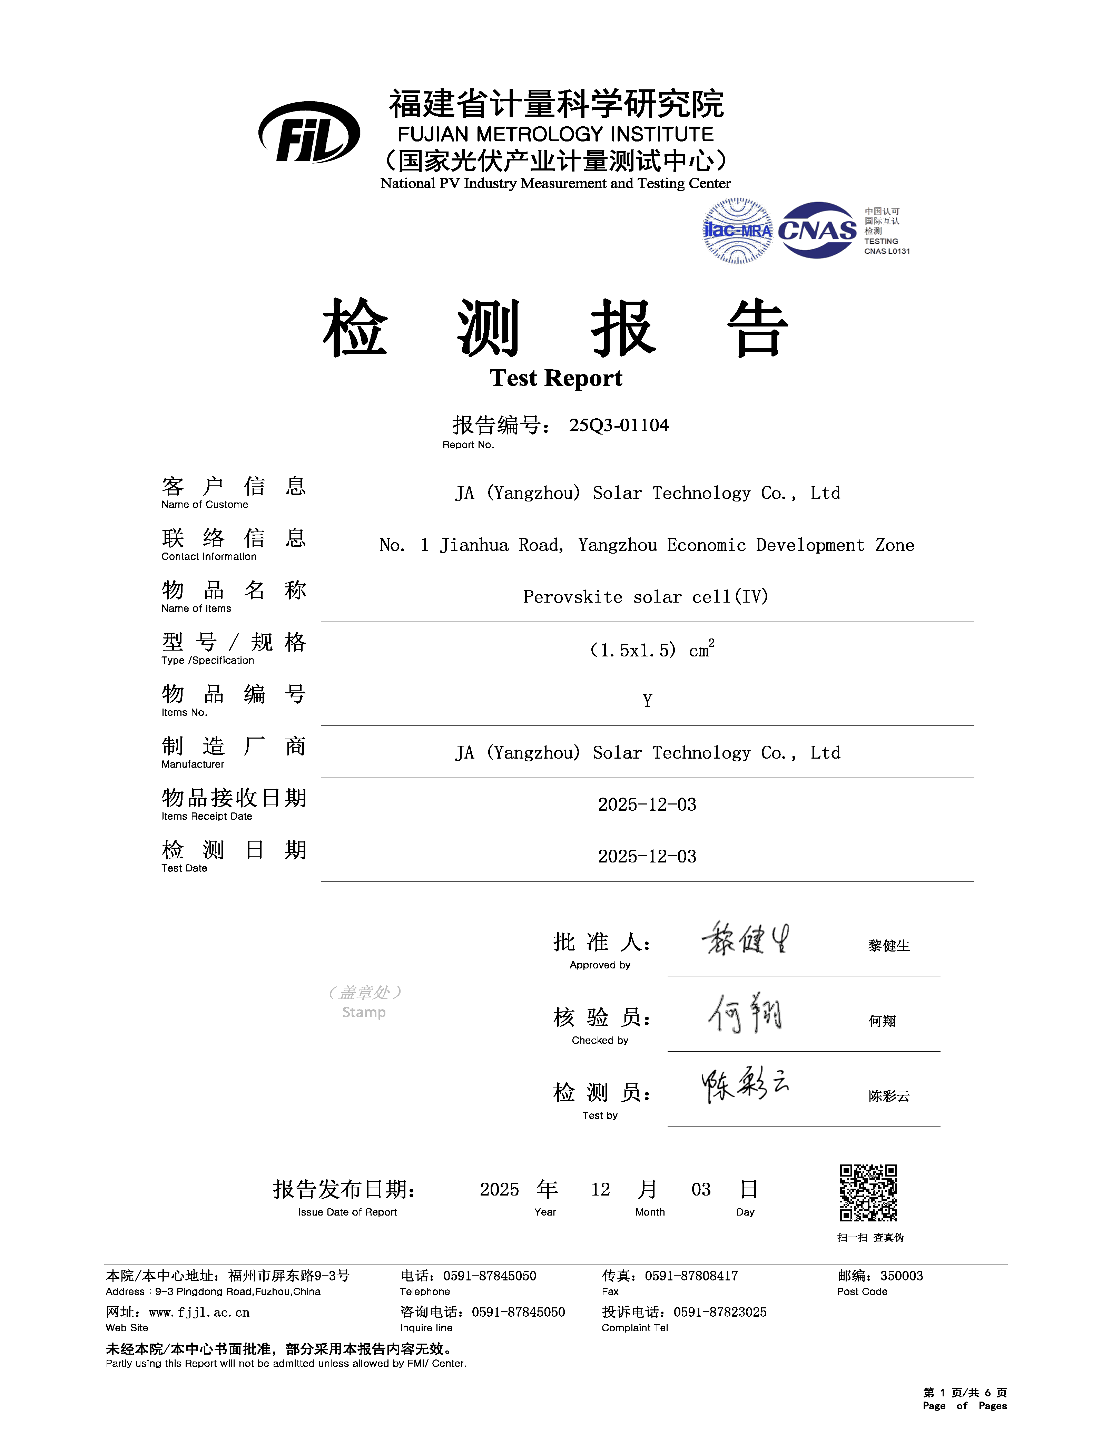
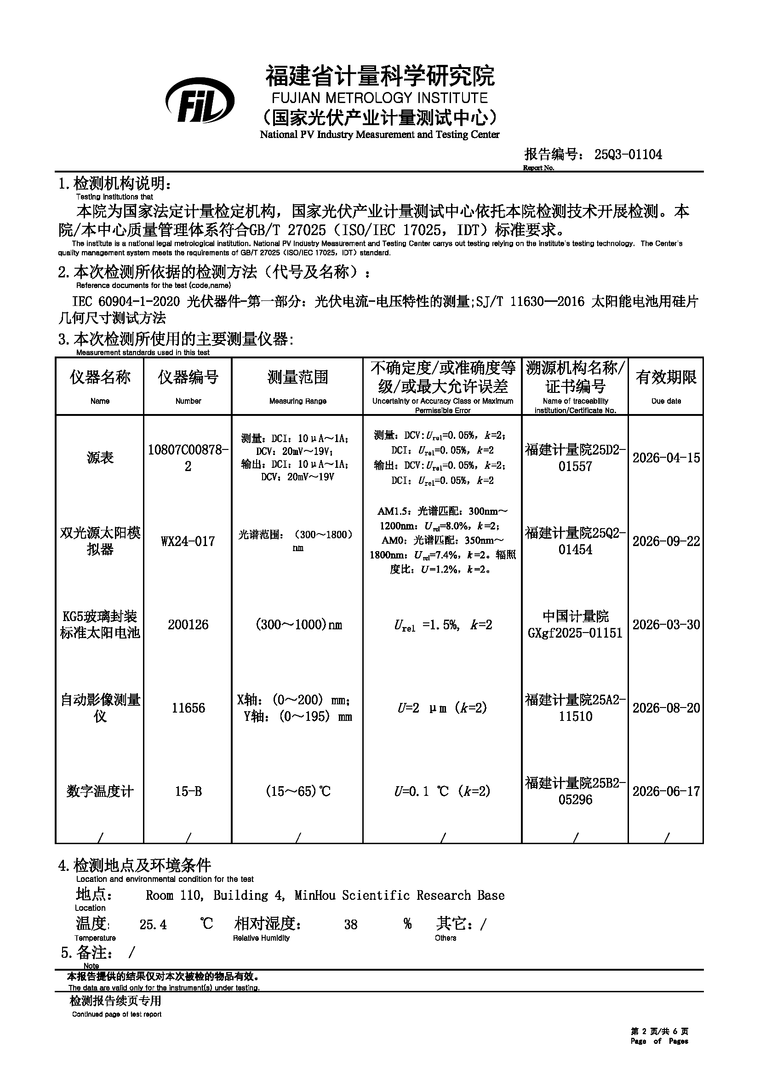

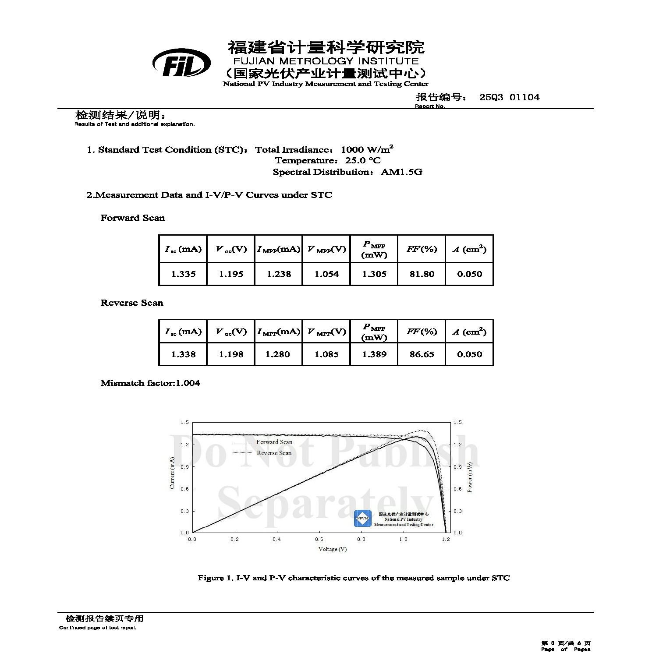

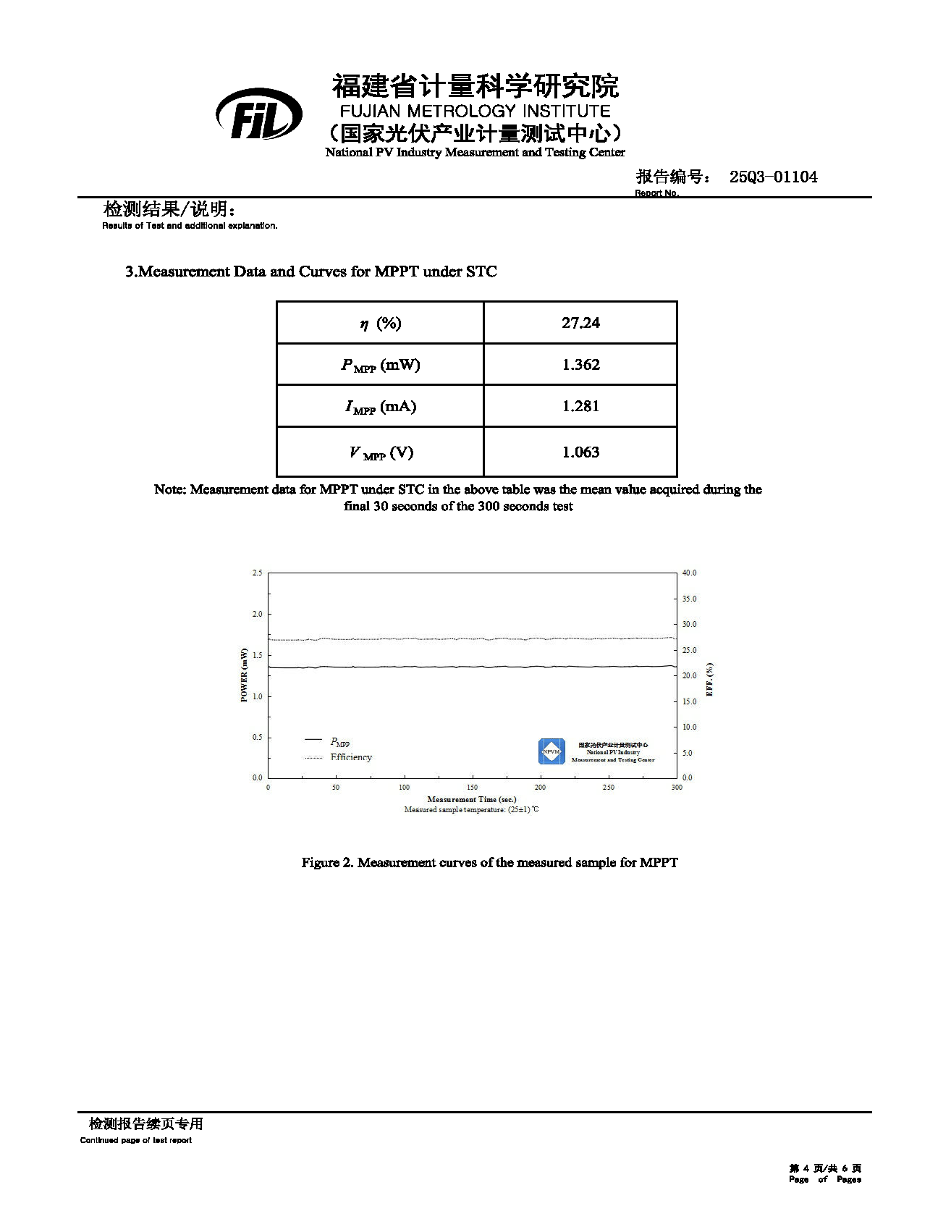
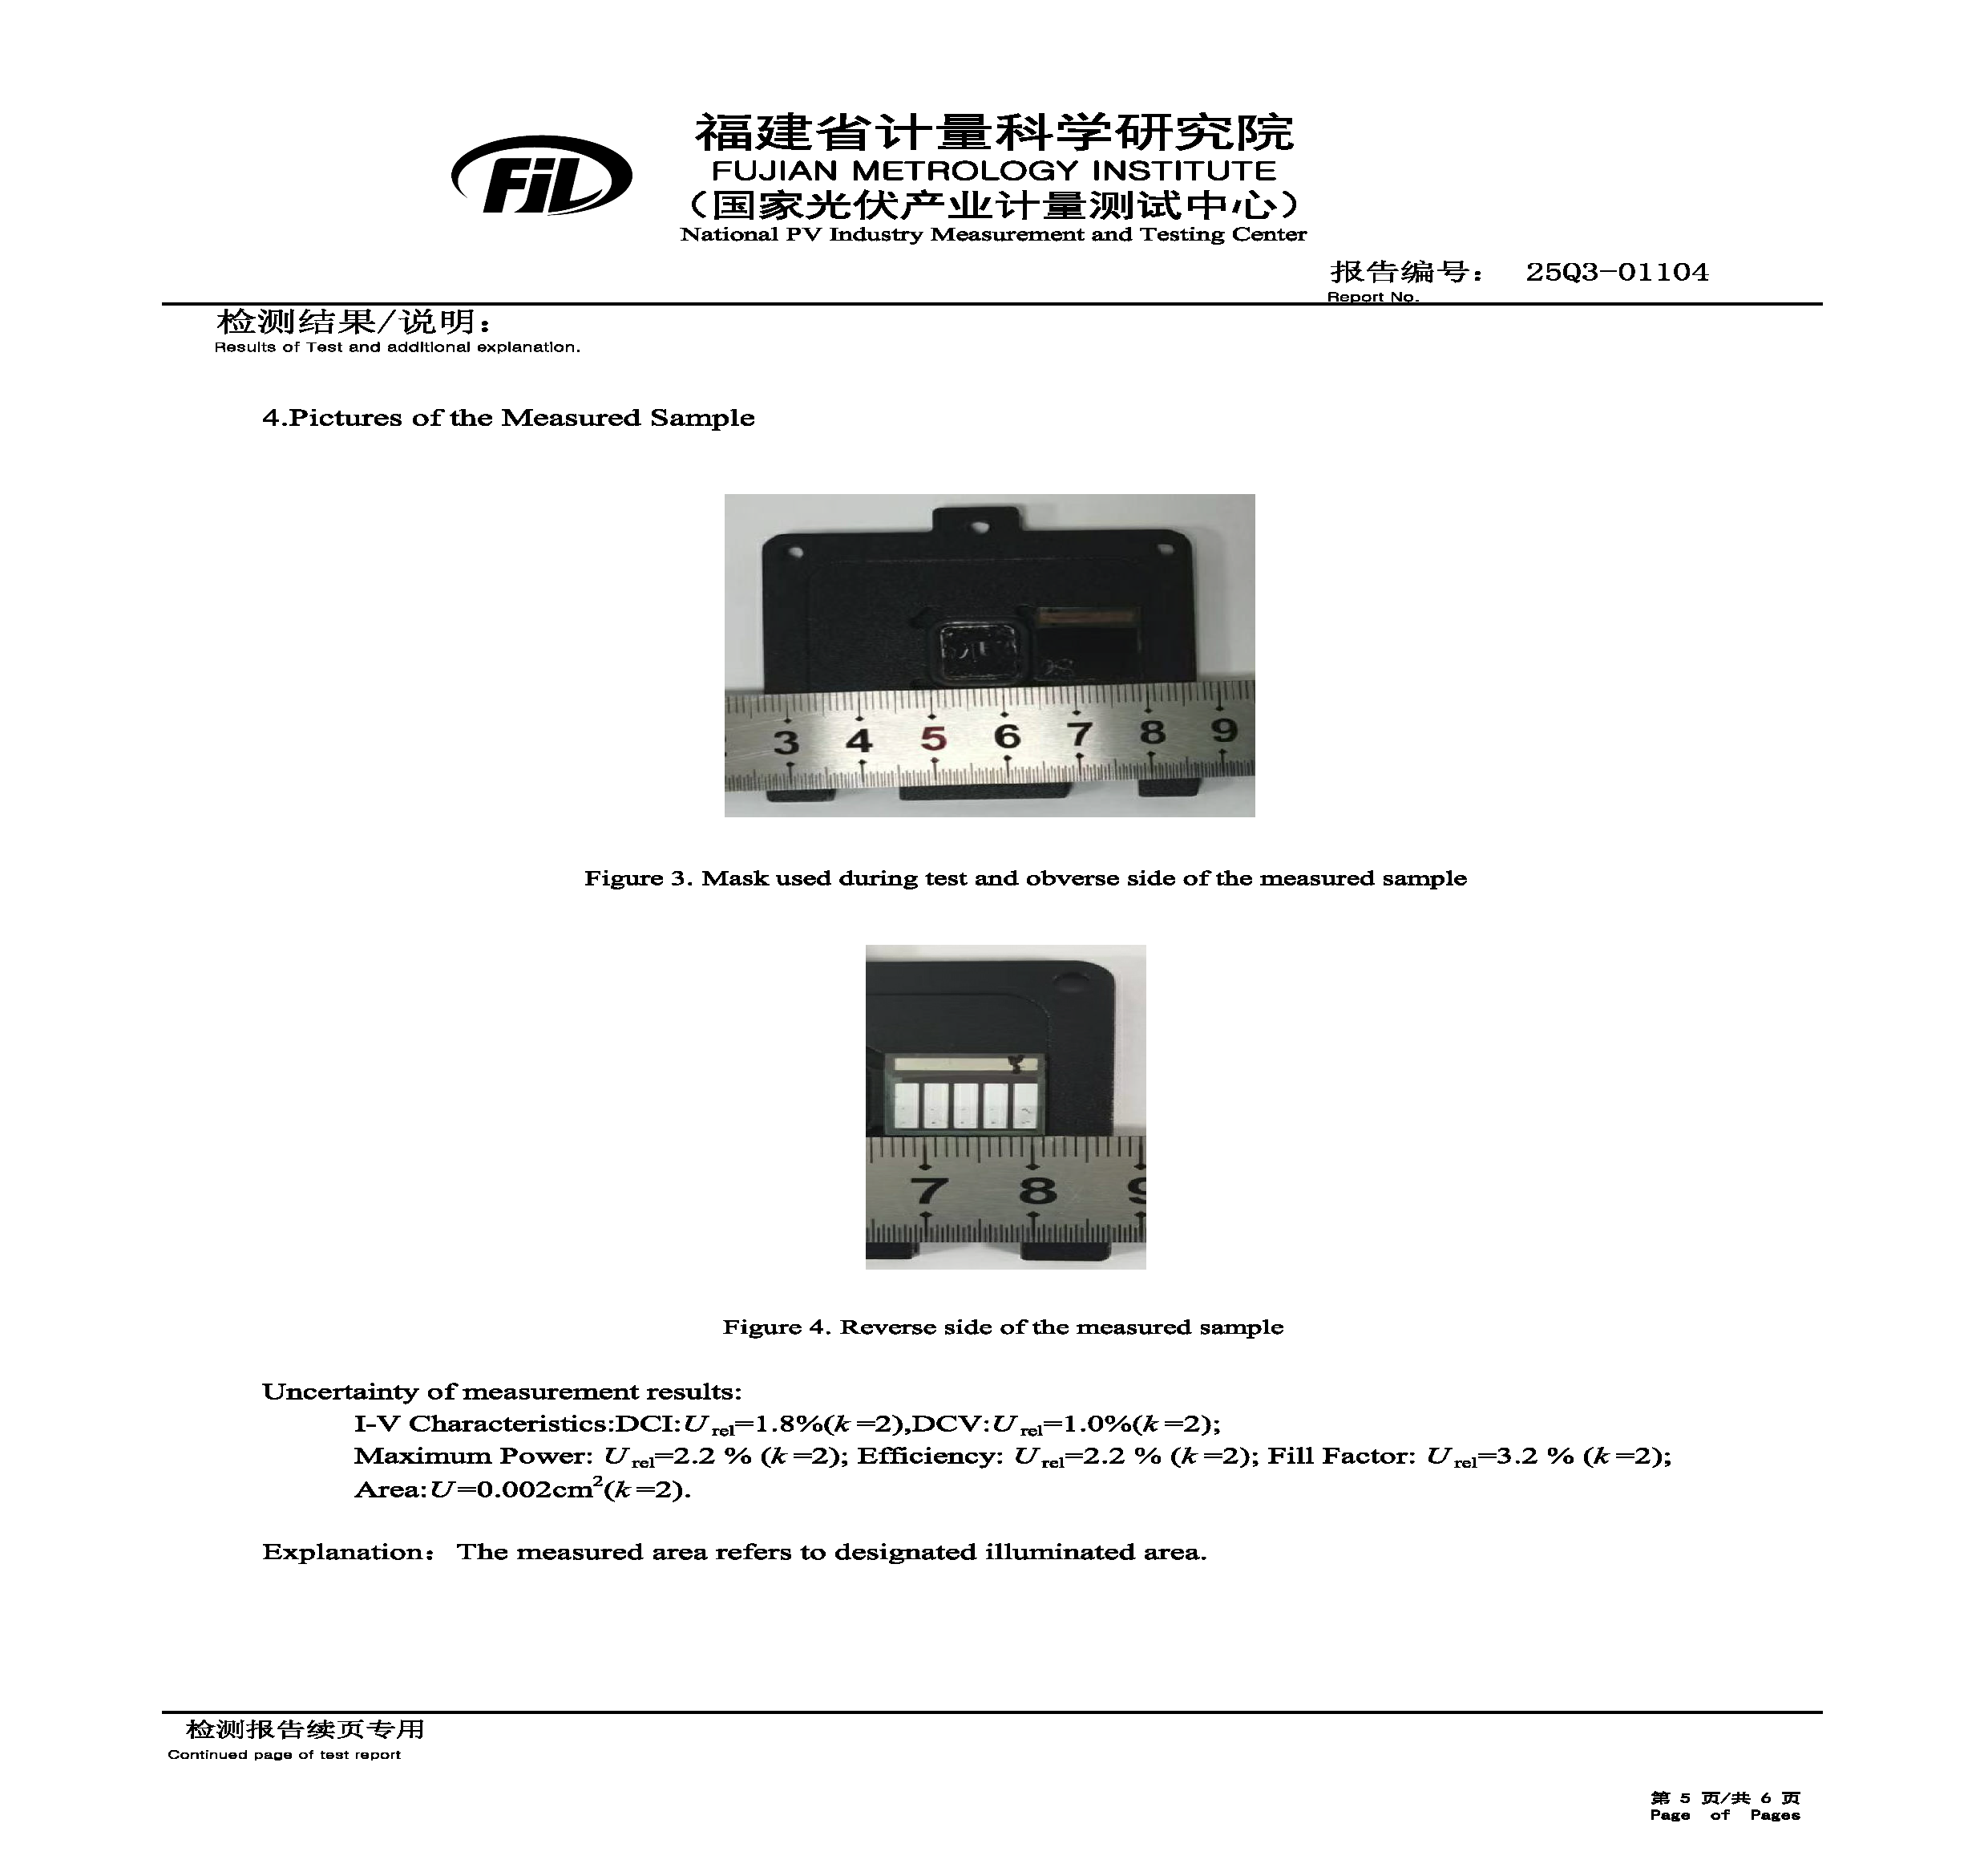
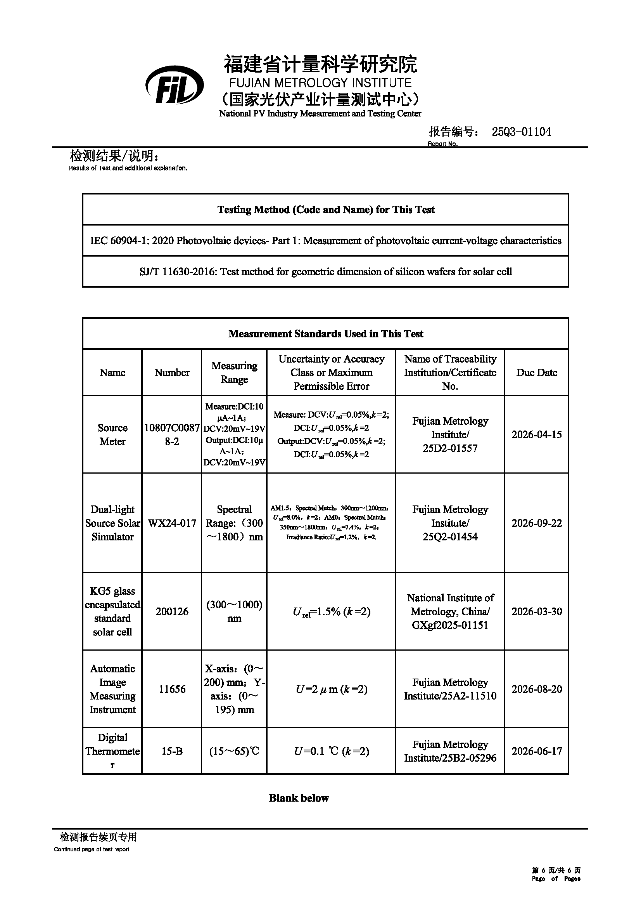
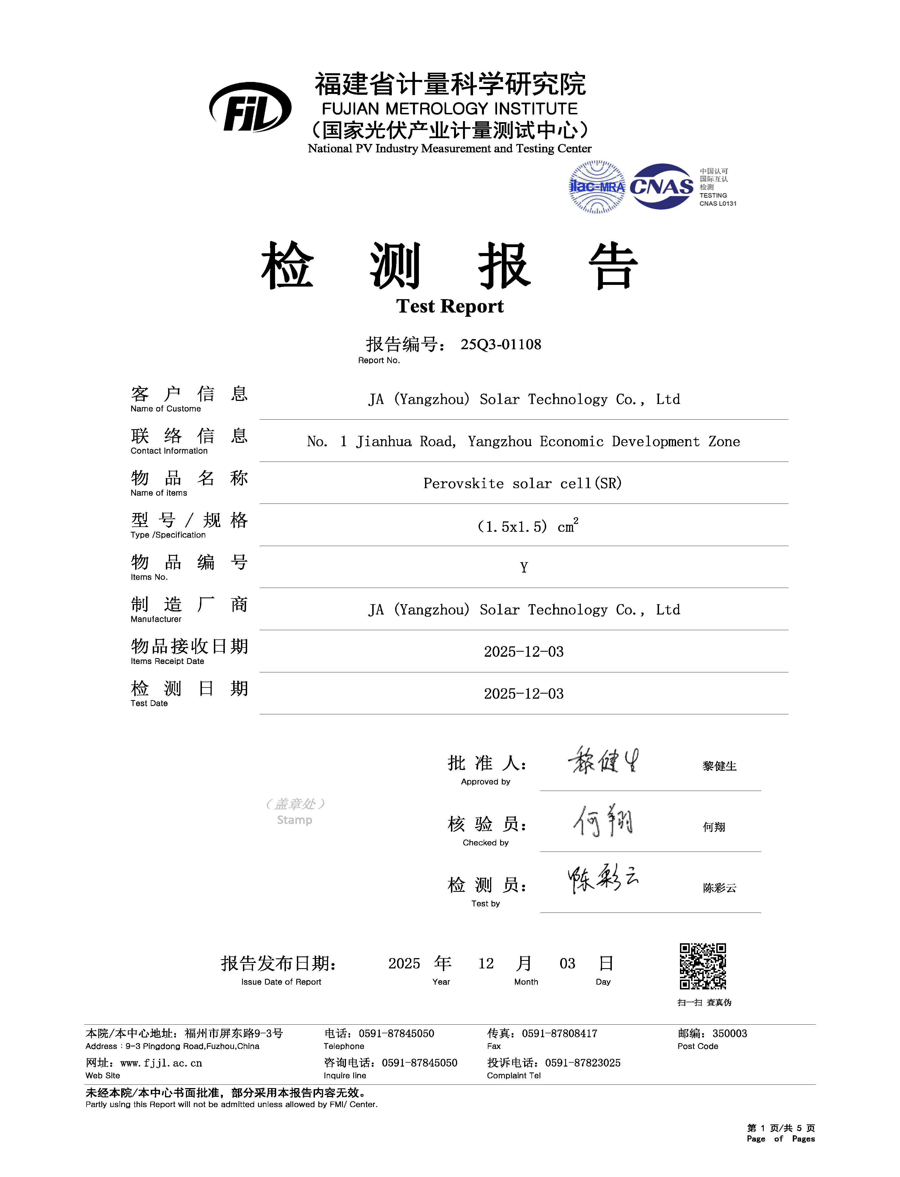
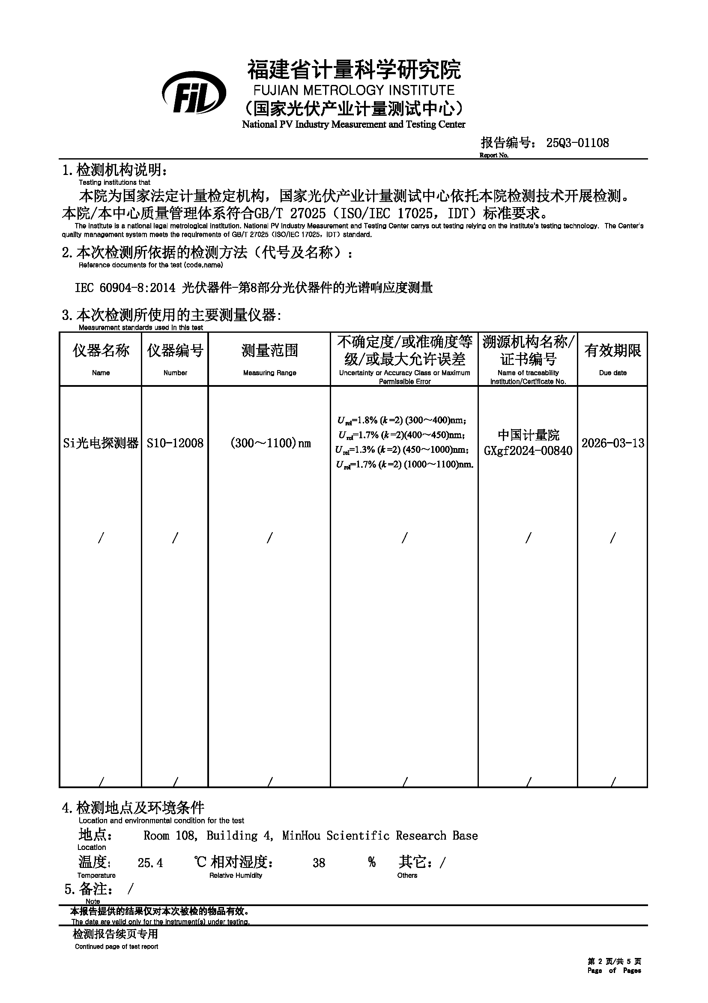
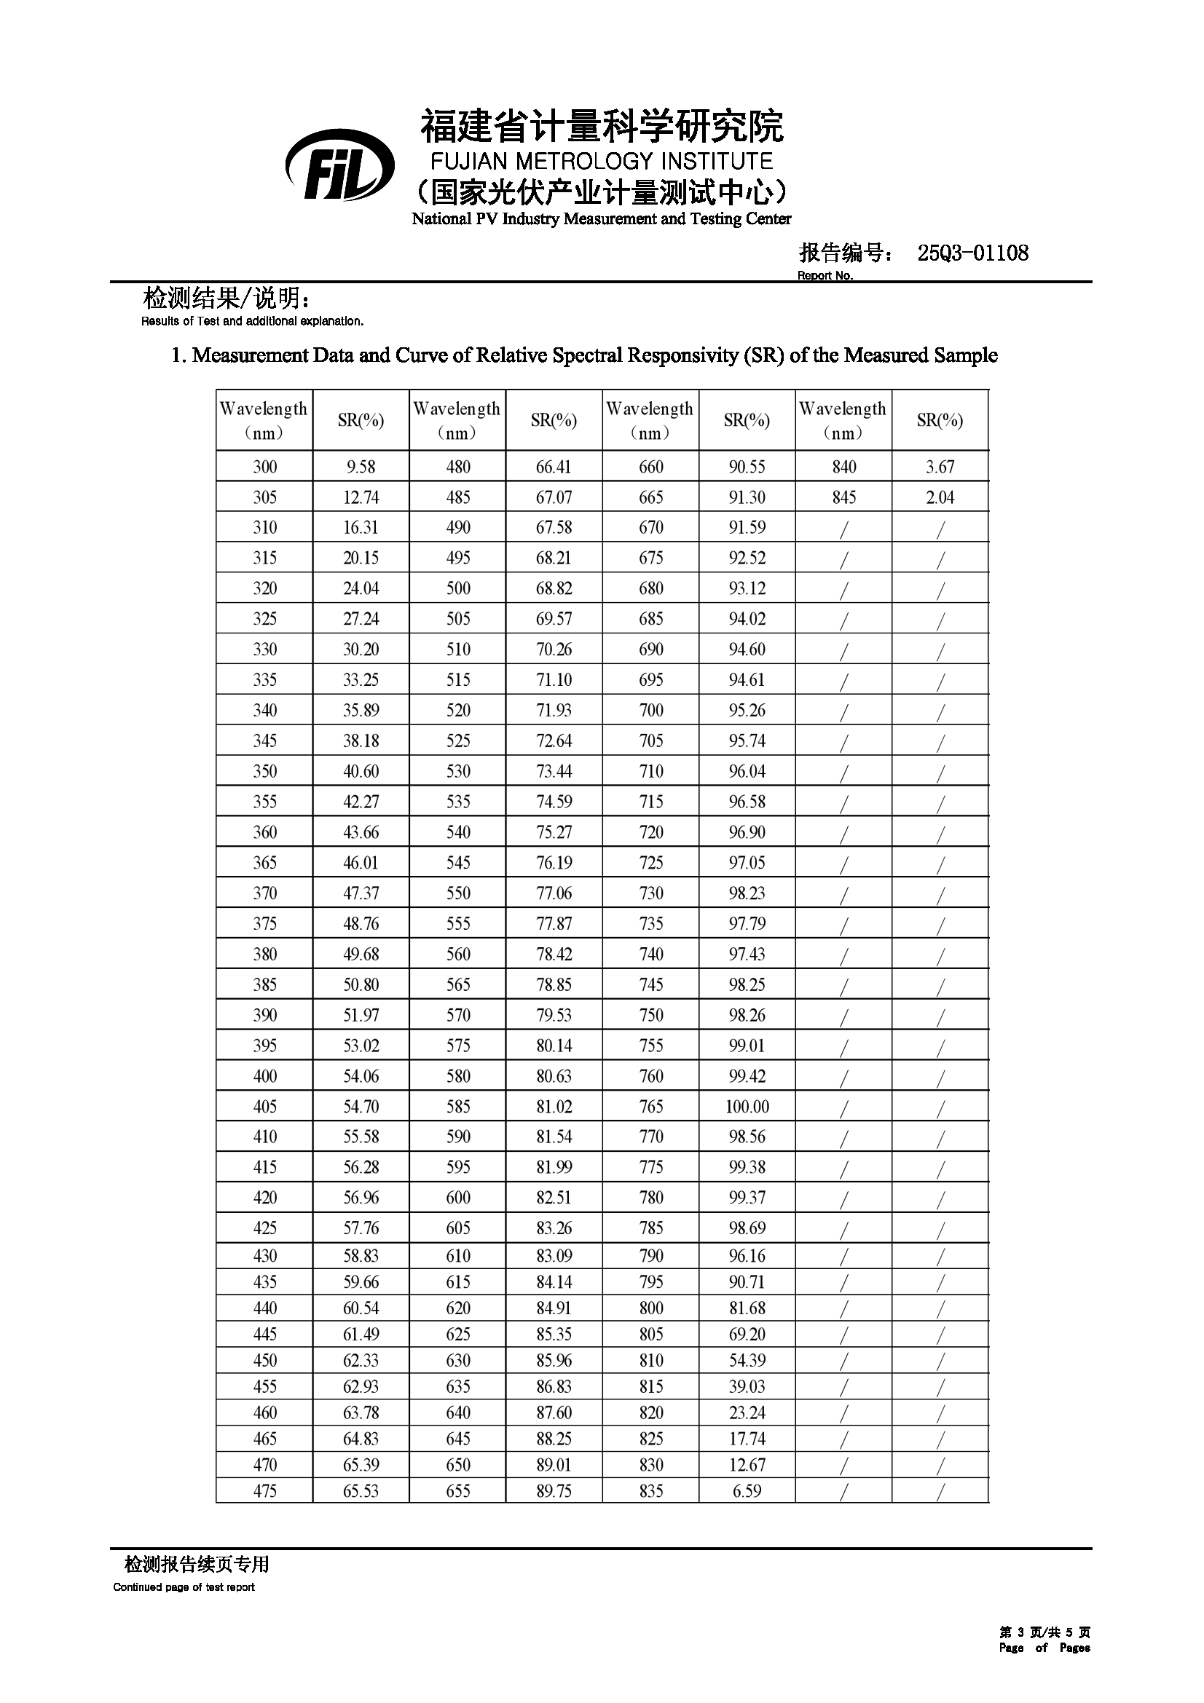
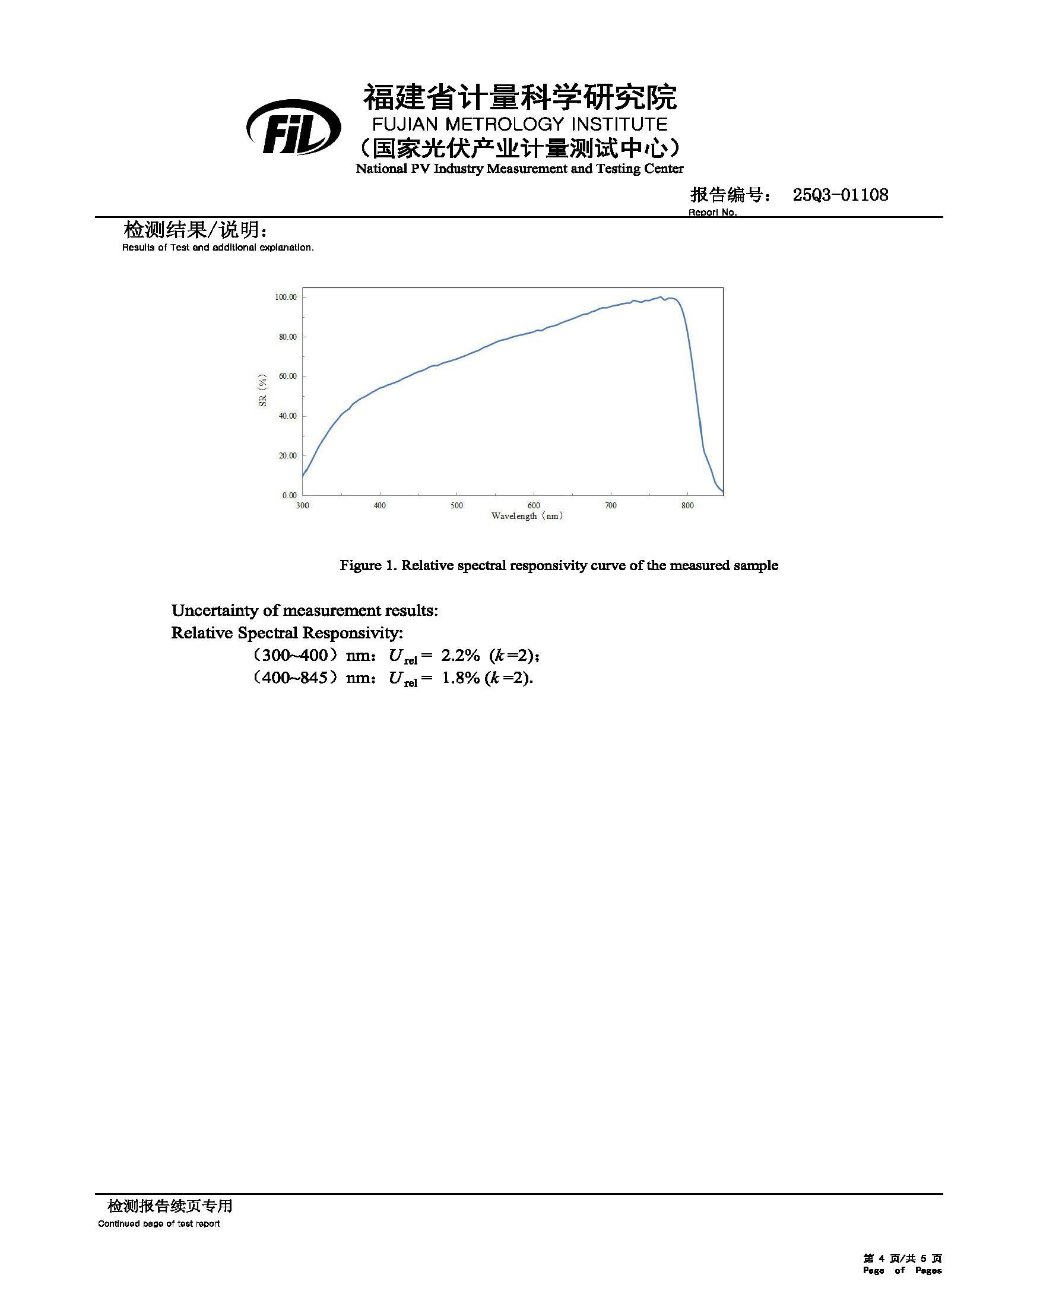
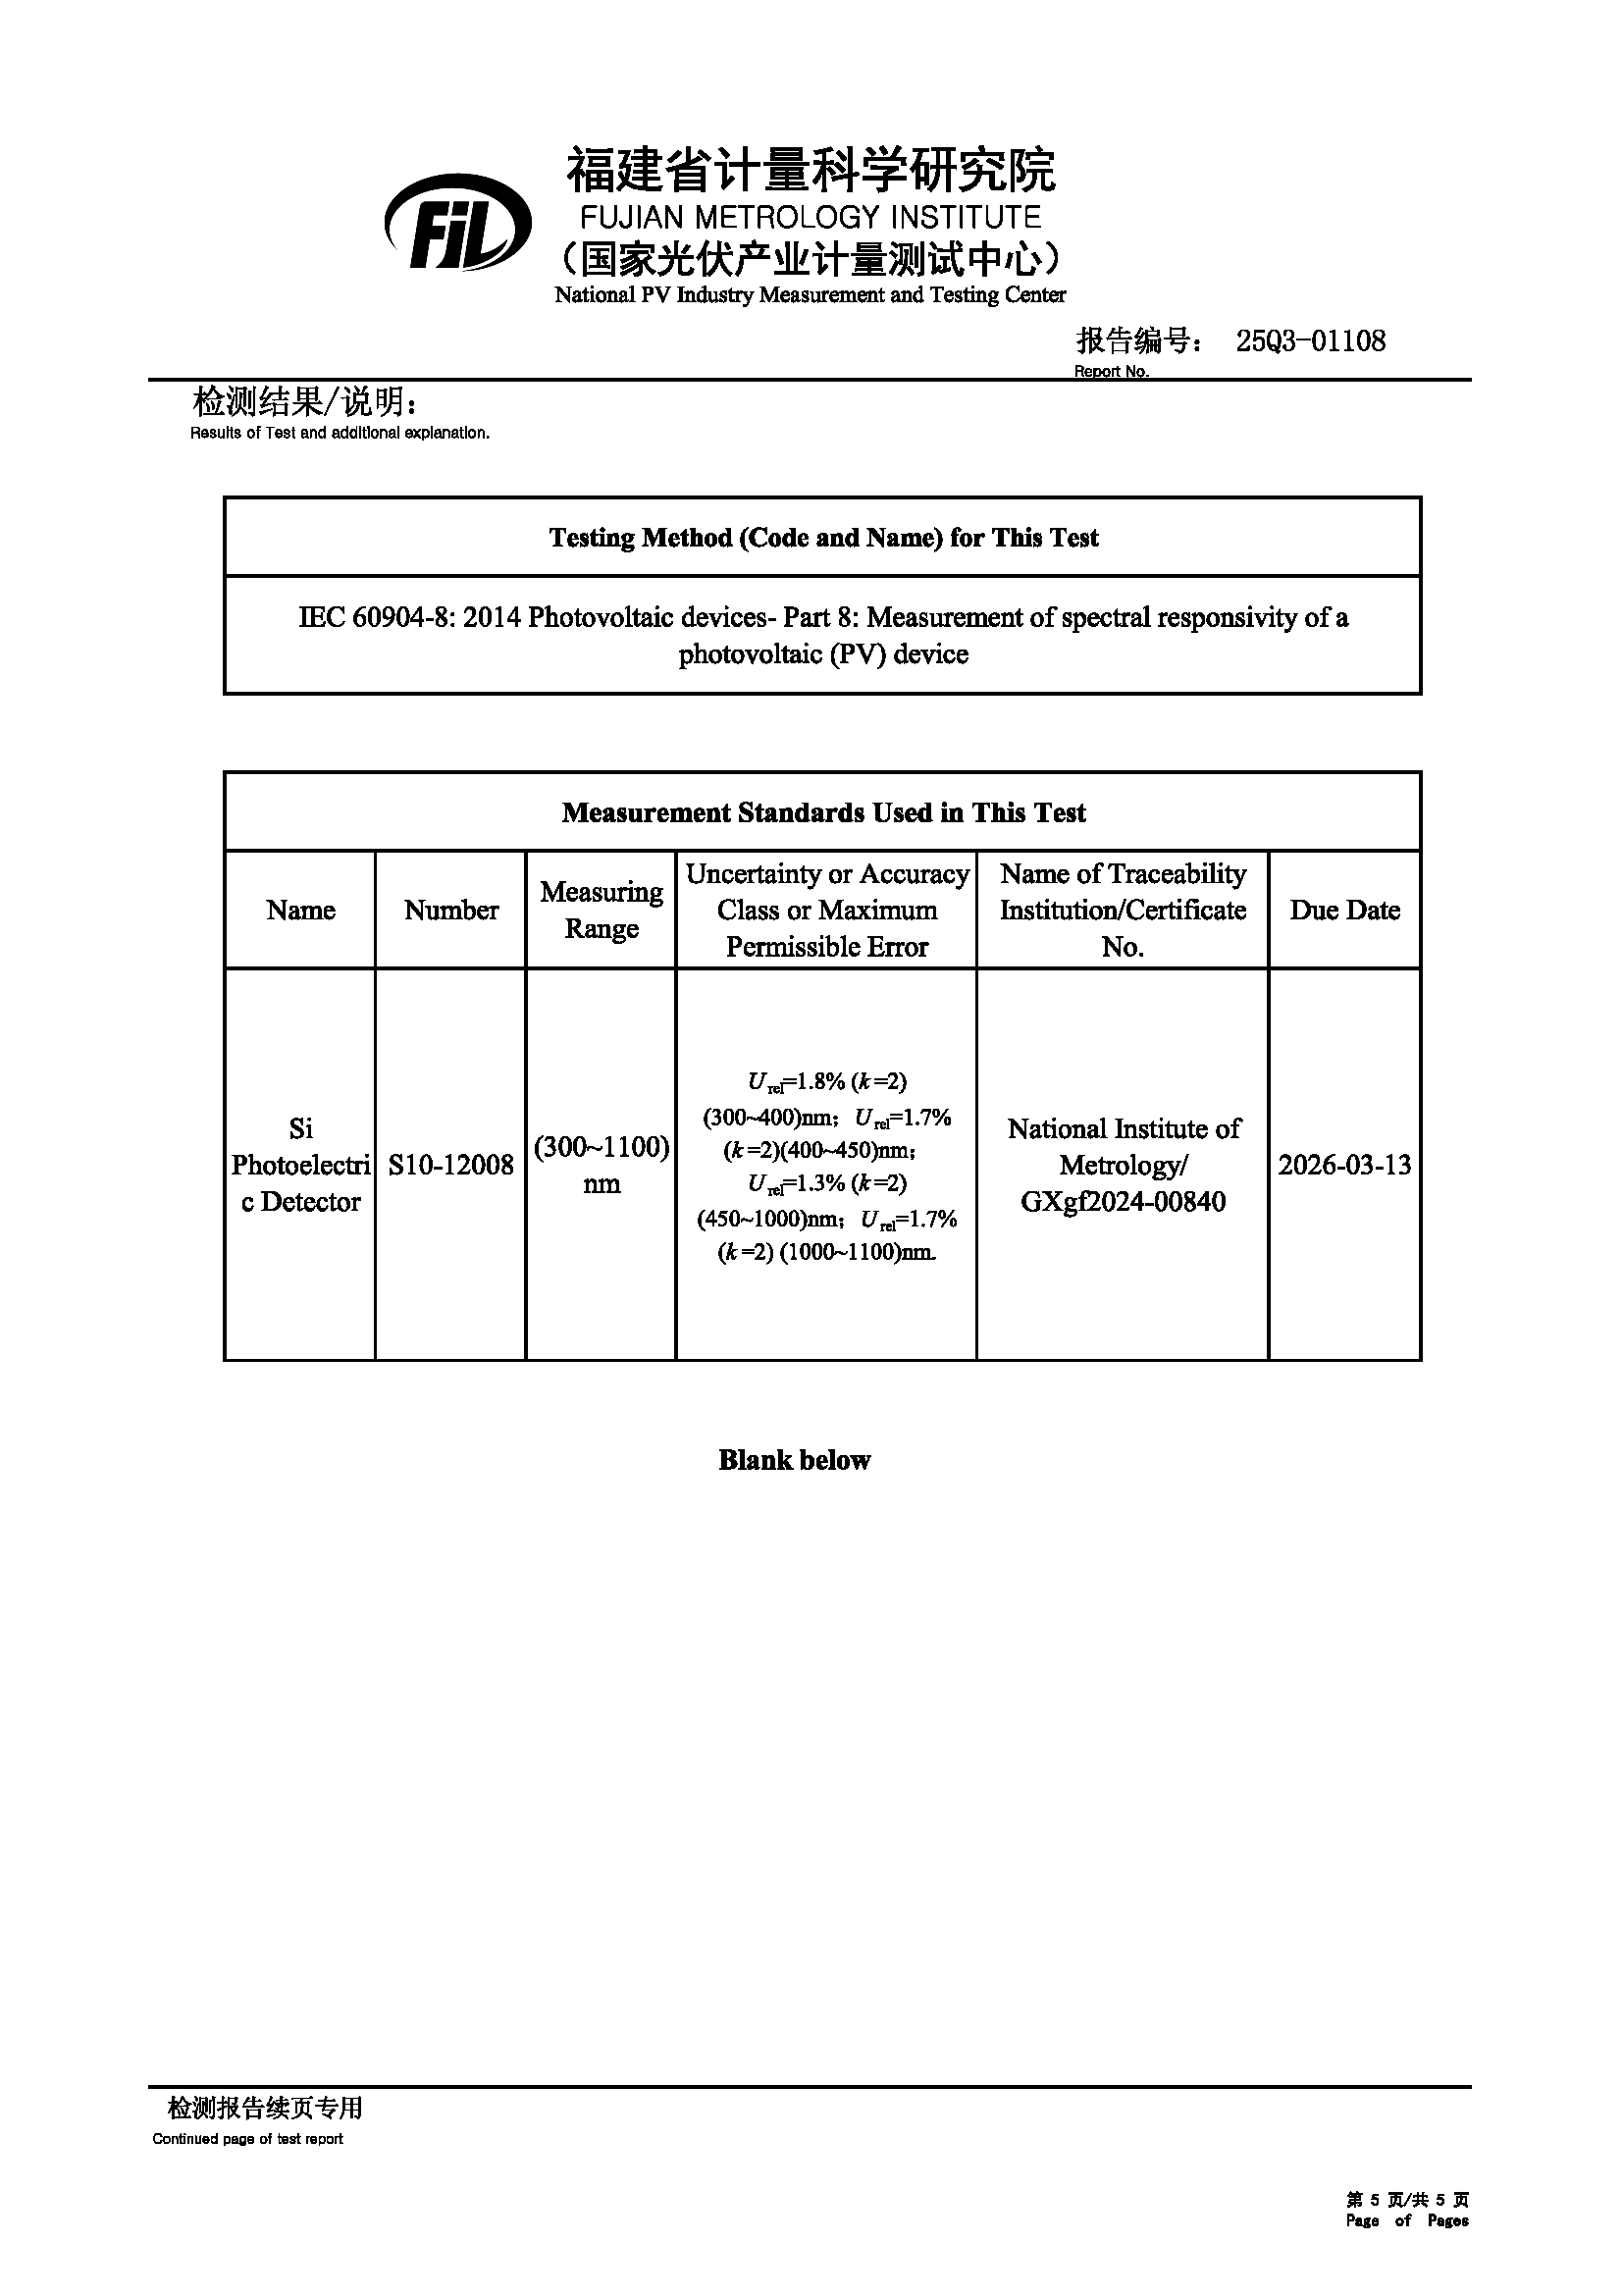

References
1. M. J. Frisch, G. W. T., H. B. Schlegel, G. E. Scuseria, et al. Gaussian 16, Revision A.03 (Gaussian, Inc.: Wallingford CT, 2016).
2. Liu, Z. et al. An sp-hybridized all-carboatomic ring, cyclo[18]carbon: Electronic structure, electronic spectrum, and optical nonlinearity. Carbon 165, 461-467 (2020).
3. Lu, T. & Chen, F. Multiwfn: A multifunctional wavefunction analyzer. J. Comput. Chem. 33, 580-592 (2012).
4. Li, Z. et al. Stabilized hole-selective layer for high-performance inverted p-i-n perovskite solar cells. Science 382, 284-289 (2023).
5. Shao, G. et al. Reducing Interface Energy Loss of Perovskite Solar Cells by Molecular Engineering of Hole‐Transporting Materials. Angew. Chem. Int. Ed. 65, e23799 (2026).
6. Yao, S. et al. Sulfur‐Modulated Fully‐Conjugated Self‐Assembled Monolayers for Synergistic Dual‐Interface Optimization in Inverted Perovskite Solar Cells. Angew. Chem. Int. Ed., DOI: 10.1002/anie.5319815 (2026).
7. Jiang, W. et al. Toughened self-assembled monolayers for durable perovskite solar cells. Nature 646, 95-101 (2025).

