Systems-Level Design of a Multi-Epitope Immunotherapeutic Vaccine Targeting EBV-Associated Oncogenesis

Ssemuyiga Charles^{1,2*}, and Naddamba Assumpta²

¹PharmaQsar Bioinformatics Firm, Kampala, Uganda. ²Department of Microbiology, Kampala International University, School of Natural and Applied Sciences (SONAS), Kansanga, Kampala, Uganda.

Correspondence.
(charles.ssemuyiga@kiu.ac.ug)

Table S1: Summary of the roles of different EBV proteins in different cancers.
Cancer Type | EBV Association | Dominant EBV Latent Proteins | Mechanistic Role of EBV | Major Oncogenic Pathways | Latency Program | Key References
Nasopharyngeal Carcinoma (NPC) | ~100% in endemic regions | LMP1, LMP2A, EBNA1, BART miRNAs | LMP1 constitutively activates CD40 signaling; LMP2A mimics BCR; BART miRNAs suppress apoptosis and immune recognition | NF-κB, PI3K/AKT, JAK/STAT, EMT, p53 suppression | Latency II | ^{1,2}
Hodgkin Lymphoma (HL) | 40–50% (higher in developing regions) | LMP1, LMP2A, EBNA1 | LMP1 substitutes CD40 signaling; LMP2A replaces BCR signaling; supports Reed–Sternberg cell survival | NF-κB, JAK/STAT, immune evasion | Latency II | ³
Endemic Burkitt Lymphoma (BL) | ~95% (endemic); ~15–30% sporadic | EBNA1, EBERs, BART miRNAs | MYC translocation; EBNA1 maintains episome; limited immune visibility | MYC activation, apoptosis resistance | Latency I | ⁴
EBV-Associated Gastric Carcinoma (EBVaGC) | ~9% globally | EBNA1, LMP2A, BART miRNAs | Epigenetic reprogramming; CpG island hypermethylation; immune checkpoint upregulation | DNA methylation, PI3K/AKT, PD-L1 upregulation | Latency I or II | ^{5,6}
Extranodal NK/T-Cell Lymphoma | ~100% | LMP1, LMP2A | LMP1 drives NF-κB; promotes proliferation and immune escape | NF-κB, JAK/STAT, apoptosis suppression | Latency II | ⁷
Post-Transplant Lymphoproliferative Disorder (PTLD) | >90% (early PTLD) | EBNA2, LMP1, LMP2A, EBNA3s | EBNA2 transactivates host oncogenes; LMP1 survival signaling | NF-κB, JAK/STAT, B-cell activation | Latency III | ⁸
EBV-positive Diffuse Large B-Cell Lymphoma (DLBCL) | Subset (~10%) | LMP1, EBNA1 | Survival signaling; immune evasion | NF-κB, BCR signaling | Latency II/III | ⁹
Primary Effusion Lymphoma (PEL) | EBV co-infection common (~70%), HHV-8 required | EBNA1, LMP1 (variable) | Cooperative oncogenesis with KSHV; anti-apoptotic signaling | NF-κB, PI3K/AKT | Latency I/II | ¹⁰
Plasmablastic Lymphoma (PBL) | 70–80% (HIV-associated) | EBNA1, LMP1 (variable) | Supports MYC-driven proliferation | MYC activation, NF-κB | Latency I/II | ¹¹
Systemic EBV-positive T/NK-cell lymphoproliferative disorders | Rare; geographic clustering | EBNA1, LMP1 (variable), EBERs | Clonal proliferation of EBV-infected T/NK cells; immune dysregulation | NF-κB, JAK/STAT (Variable) | Often Latency II | ¹²

Table 2: Shows the role of different proteins in immune modulation if any, and the latency stage it works in.
EBV Gene/Product | Immune Function | Immune Pathway Targeted | Cell Type Affected | Molecular Mechanism | Latency Stage | Key Reference
BCRF1 (vIL-10) | Suppresses antiviral immune responses | Th1 cytokine signaling, NK activity | B cells, macrophages, T cells | Viral IL-10 homolog inhibits IFN-γ and IL-12 production | Lytic | ¹³
BNLF2a | Inhibits antigen presentation | MHC class I processing | B cells | Blocks TAP peptide transporter | Latency III | ¹⁴
BILF1 | Downregulates HLA class I | Antigen presentation | B cells | Induces lysosomal degradation of HLA-A and HLA-B | Lytic | ¹⁵
BZLF2 (gp42) | Blocks CD4⁺ T cell recognition | MHC class II presentation | B cells, APCs | Interferes with TCR–MHC II interaction | Lytic | ¹⁶
BGLF5 | Host shutoff; inhibits IFN signaling | mRNA stability, TLR9 sensing | DCs, epithelial cells | Viral RNase degrades host mRNAs and TLR9 | Lytic | ¹⁷
BGLF2 | Inhibits type I interferon signaling | JAK/STAT pathway | Multiple immune cells | Interacts with Tyk2, suppresses STAT1 activation | Lytic | ¹⁸
BORF2 | Antagonizes intrinsic immunity | APOBEC3B antiviral restriction | Infected cells | Relocalizes APOBEC3B from nucleus | Lytic | ¹⁹
BRLF1 (Rta) | Suppresses innate signaling | TLR/NF-κB pathways | Monocytes, DCs | Disrupts MyD88/TRAF6 signaling | Lytic | ²⁰
EBNA1 | Evades CD8⁺ T cell recognition | Proteasomal processing, NK activation | B cells | Gly-Ala repeat blocks proteasomal degradation; downregulates NKG2D ligands | Latency I/II/III | ^{21,22}
LMP1 | Alters innate immune sensing | TLR9, NF-κB signaling | B cells | Constitutive CD40 signaling represses TLR9 transcription | Latency II/III | ²³
LMP2A | Suppresses IFN signaling | IFN receptor signaling | B cells | Promotes degradation of IFN receptors; mimics BCR | Latency II/III | ²⁴
EBER1/2 | Modulates cytokine production | TLR3, RIG-I signaling | DCs, monocytes | Activates TLR3 and induces IL-10 and IFN | Latency I/II/III | ²⁵
miR-BART6-3p | Suppresses antiviral sensing | RIG-I pathway | Epithelial & B cells | Targets DDX58 (RIG-I) mRNA | Latency | ²⁶
miR-BART15 | Inhibits inflammasome | NLRP3 inflammasome | Monocytes, macrophages | Targets NLRP3 mRNA | Latency | ²⁷

Table S3: The list of the top 10 epitopes predicted for MHC Class I and MHC Class II, based on rank values (where lower rank indicates better binding affinity)
MHC I TOP 10 EPITOPES
Peptide | Rank | Score | Protein
GTYKRVTEK | 0.01 | 0.89547 | GP350
DPYQVPFV | 0.01 | 0.933071 | BZLF1
AYQAYAAPQLF | 0.01 | 0.932468 | BZLF1
ATVKGMQSY | 0.01 | 0.864779 | GP350
IALYLQQNW | 0.01 | 0.989273 | LMP2 (Type 1)
HTFQVPQNY | 0.01 | 0.936329 | LMP1 (Type 1)
MTNTLLSAW | 0.01 | 0.990361 | LMP2 (Type 2)
TYGPVFMSL | 0.01 | 0.977763 | LMP2 (Type 2)
TEWGSGNRTY | 0.01 | 0.974501 | LMP2 (Type 2)
RVAAAAITW | 0.01 | 0.978999 | LMP1 (Type 1)
MHC II TOP 10 EPITOPES
Peptide | Rank | Score | Protein
PPMVEGAAAEGDDGD | 0.01 | 0.0642 | EBNA1 (Type 1)
SDREVRGSALYEAST | 0.01 | 0.8806 | gH
TSSFVTNTTVGIELP | 0.01 | 0.9503 | gB
ELEIKRYKNRVASRK | 0.01 | 0.9726 | BZLF1
GTLNNPATVQIQFAY | 0.03 | 0.8616 | gB
SSIYGKAVAAKRLGD | 0.03 | 0.8942 | gB
NYKIVDYDNRGTNPQ | 0.03 | 0.9581 | gB
GNEIHVYNDYHHFKT | 0.04 | 0.0971 | gB
PAPENAYQAYAAPQL | 0.04 | 0.4262 | BZLF1
VYNDYHHFKTIELDG | 0.05 | 0.4073 | gB

Table S4: The top 10 epitopes based on MHC I immunogenicity scores are summarized below.
Rank | Peptide | Immunogenicity Score
1 | VTVTAFWAW | 0.41056
2 | YTIPWTELM | 0.36230
3 | NVFDLEGIFR | 0.35964
4 | GTDNEIFLTK | 0.35131
5 | ESLWVGVYR | 0.32407
6 | ALAEPVDIPAV | 0.30323
7 | IFLIGFALF | 0.30006
8 | VEIPEFPFY | 0.29878
9 | KLPHWTPTL | 0.29451
10 | SLEREDRDAW | 0.29398

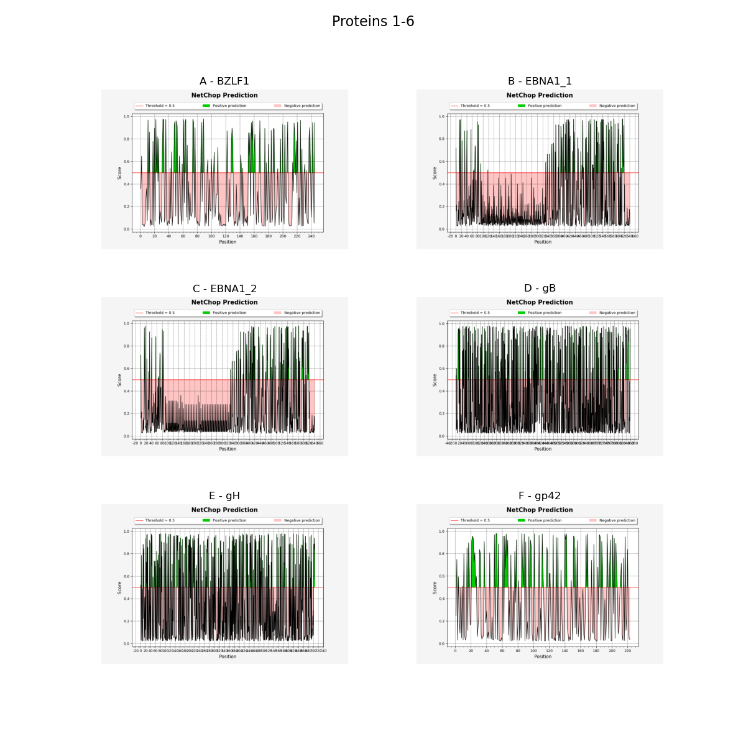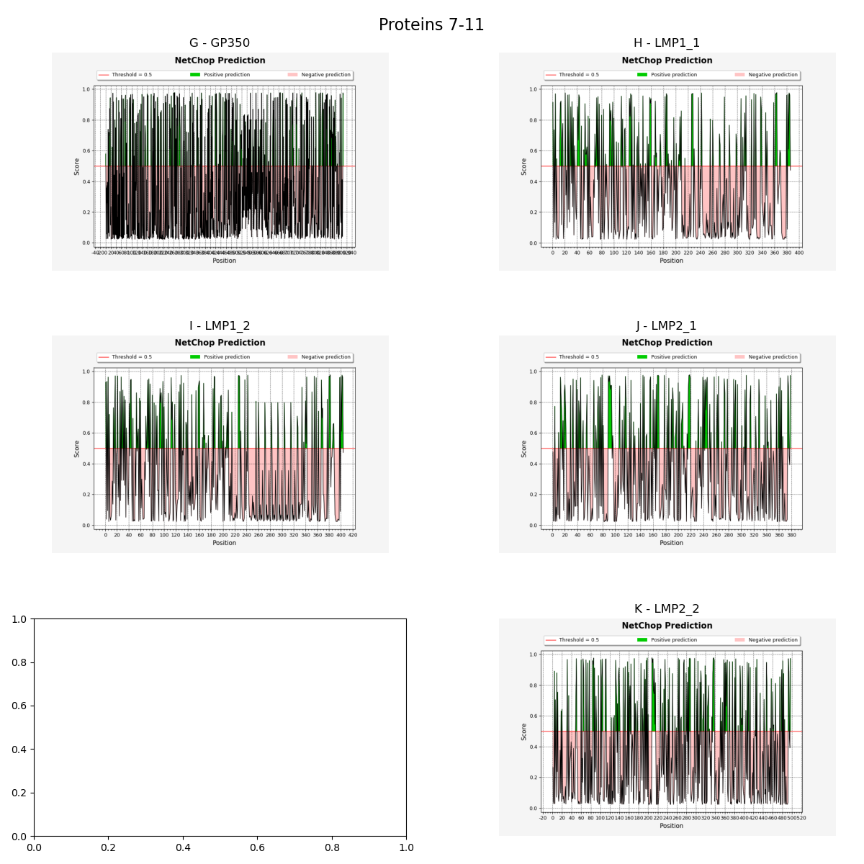
Figure S1: Cleavage prediction results. Each figure shows the NetChop prediction score vs. residue position, where green represents positive predictions, and red represents negative predictions. These figures provide a clear overview of where cleavage sites are likely to occur in the protein sequences.

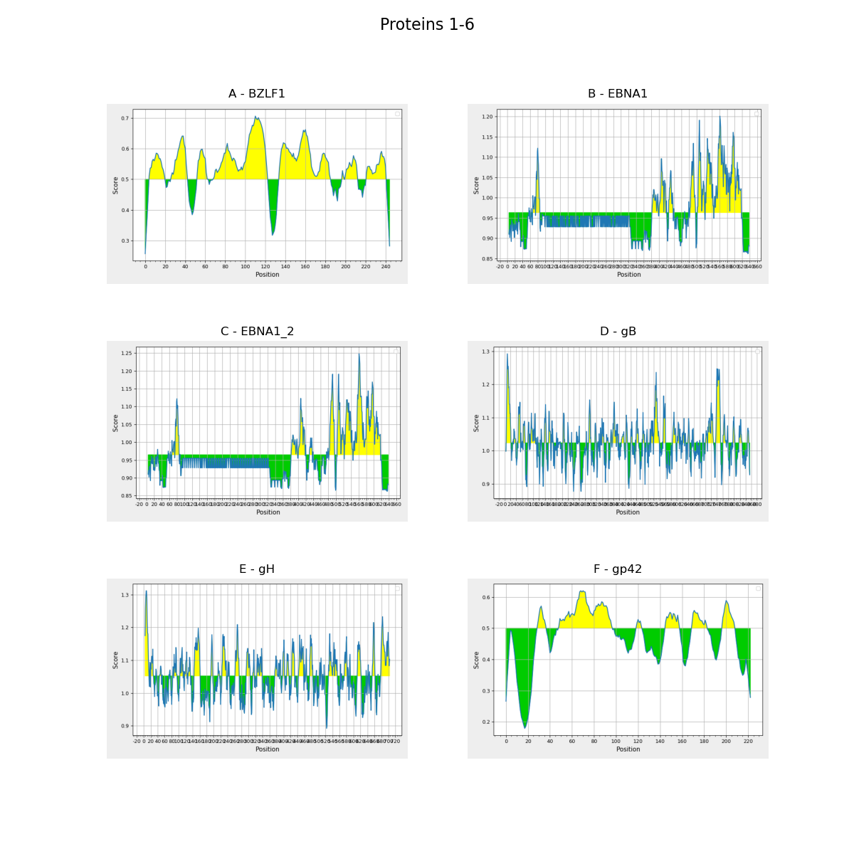

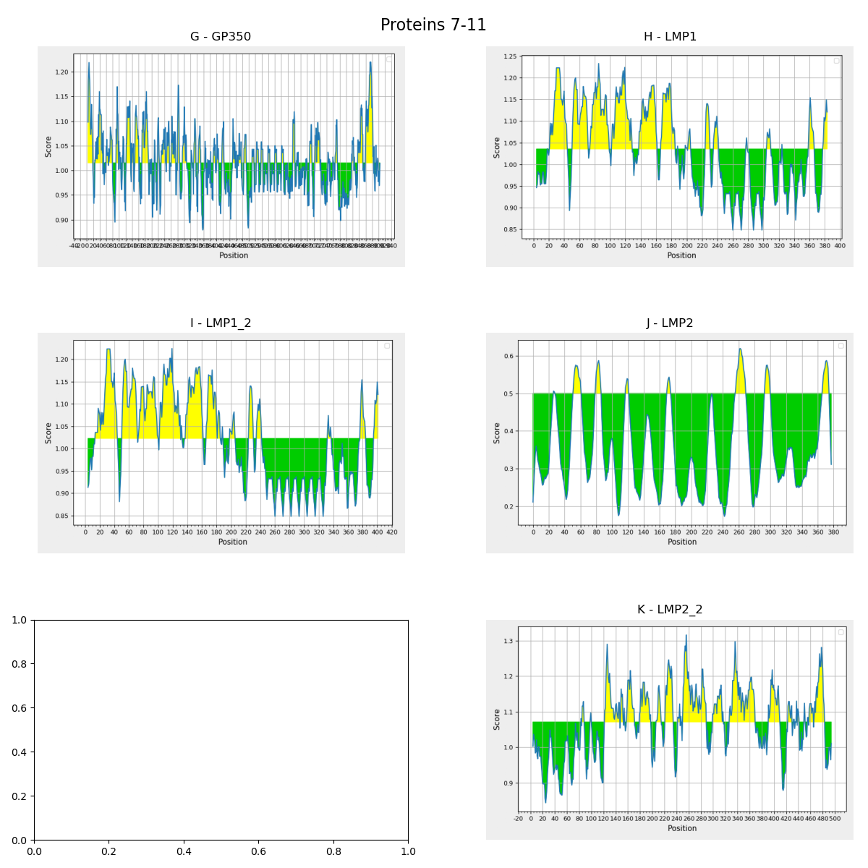

Figure S2: Residue-wise linear B-cell epitope prediction profiles for EBV proteins analyzed using BepiPred-2.0 (BZLF1 and gp42) and the Kolaskar–Tongaonkar antigenicity method (remaining proteins). Yellow regions indicate residues exceeding method-specific antigenicity thresholds, while green regions represent sub-threshold scores.

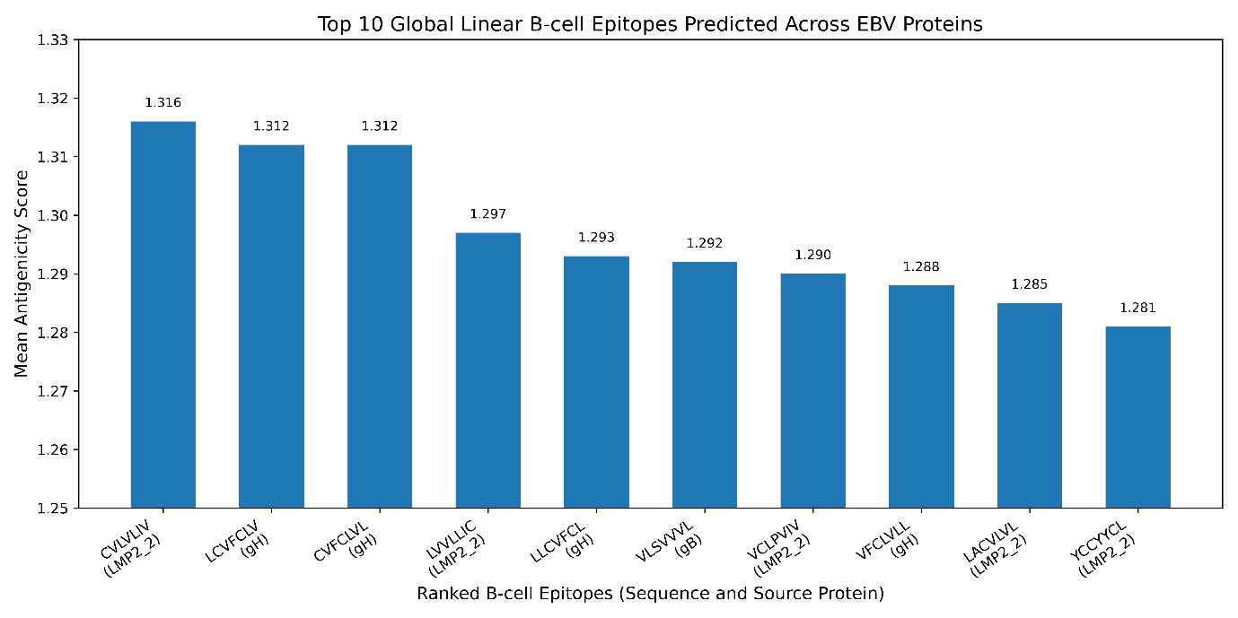

Figure S3: Top 10 global linear B-cell epitopes predicted across EBV proteins.

Table S5: Summary of stereochemical and geometric quality metrics for the 16 multi-epitope vaccine constructs assessed before and after Rosetta-based structural refinement.
 | Before |  |  |  |  |  |  | After
Vaccine | Ramachandran Outliers | Ramachandran Favored | Rotamer Outliers | Clashscore | RMS Bonds | RMS Angles | MolProbity Score | Ramachandran Outliers | Ramachandran Favored | Rotamer Outliers | Clashscore | RMS Bonds | RMS Angles | MolProbity Score
Vaccine_10 | 39.17 | 33.44 | 10.4 | 13.77 | 0.0208 | 6.13 | 3.47 | 1.91 | 90.76 | 1.16 | 6.01 | 0.0302 | 6.33 | 1.90
Vaccine_11 | 42.32 | 26.59 | 13.29 | 27.69 | 0.0237 | 6.90 | 3.85 | 2.25 | 89.14 | 2.80 | 13.71 | 0.0353 | 6.65 | 2.56
Vaccine_12 | 38.98 | 31.36 | 13.04 | 24.79 | 0.0210 | 5.84 | 3.79 | 1.69 | 91.53 | 0.87 | 3.74 | 0.0318 | 6.17 | 1.67
Vaccine_13 | 6.85 | 85.89 | 10.26 | 27.60 | 0.0269 | 3.18 | 3.34 | 0.40 | 94.35 | 0.00 | 0.86 | 0.0237 | 3.02 | 1.15
Vaccine_14 | 7.11 | 85.38 | 13.46 | 24.09 | 0.0255 | 3.14 | 3.38 | 0.40 | 96.44 | 0.00 | 4.26 | 0.0254 | 3.93 | 1.44
Vaccine_15 | 13.89 | 74.07 | 19.80 | 39.06 | 0.0282 | 4.30 | 3.86 | 0.62 | 92.90 | 0.50 | 3.99 | 0.0191 | 4.00 | 1.64
Vaccine_16 | 20.74 | 66.25 | 19.31 | 34.02 | 0.0256 | 4.94 | 3.86 | 0.62 | 89.78 | 0.00 | 4.89 | 0.0177 | 4.63 | 1.81
Vaccine_1 | 44.81 | 26.95 | 9.09 | 14.94 | 0.0219 | 6.59 | 3.48 | 0.97 | 90.26 | 0.61 | 3.93 | 0.0279 | 6.15 | 1.72
Vaccine_2 | 38.96 | 30.19 | 8.98 | 13.17 | 0.0274 | 5.71 | 3.41 | 2.27 | 87.01 | 0.00 | 2.84 | 0.0242 | 5.67 | 1.69
Vaccine_3 | 43.18 | 27.27 | 8.38 | 12.16 | 0.0275 | 5.89 | 3.37 | 2.27 | 88.64 | 0.00 | 4.14 | 0.0253 | 5.88 | 1.78
Vaccine_4 | 43.18 | 31.17 | 10.84 | 10.35 | 0.0262 | 6.03 | 3.38 | 1.62 | 87.34 | 0.60 | 5.17 | 0.0231 | 5.90 | 1.89
Vaccine_5 | 41.88 | 28.90 | 9.52 | 17.86 | 0.0267 | 5.97 | 3.56 | 2.92 | 84.74 | 2.38 | 6.73 | 0.0247 | 5.87 | 2.32
Vaccine_6 | 41.88 | 28.90 | 9.52 | 17.86 | 0.0267 | 5.97 | 3.56 | 1.30 | 84.42 | 2.38 | 6.73 | 0.0247 | 5.86 | 2.33
Vaccine_7 | 41.88 | 34.42 | 6.71 | 19.39 | 0.0310 | 6.26 | 3.45 | 2.92 | 88.31 | 0.61 | 5.76 | 0.0329 | 6.34 | 1.91
Vaccine_8 | 40.26 | 26.95 | 10.24 | 19.22 | 0.0326 | 6.60 | 3.62 | 2.60 | 83.77 | 2.41 | 13.50 | 0.0315 | 6.51 | 2.61
Vaccine_9 | 38.54 | 38.54 | 8.62 | 11.61 | 0.0240 | 5.68 | 3.32 | 1.91 | 86.94 | 0.00 | 3.46 | 0.0229 | 5.66 | 1.76

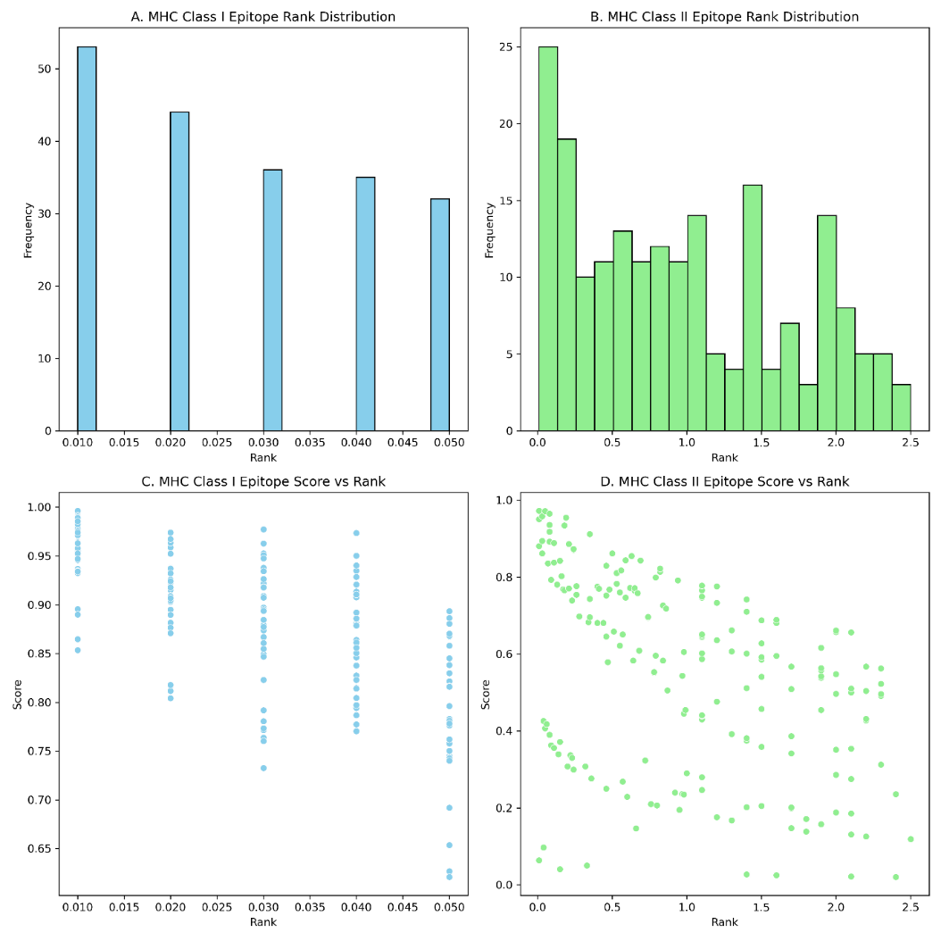
Figure S4: Summary of epitope features.

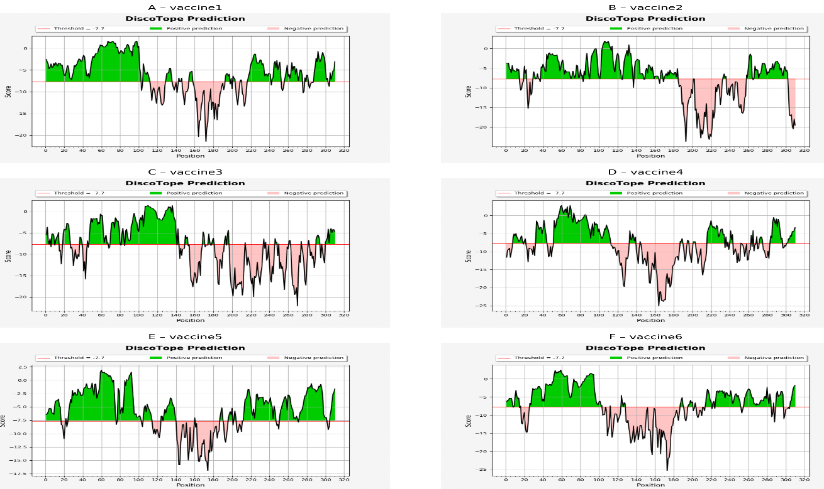

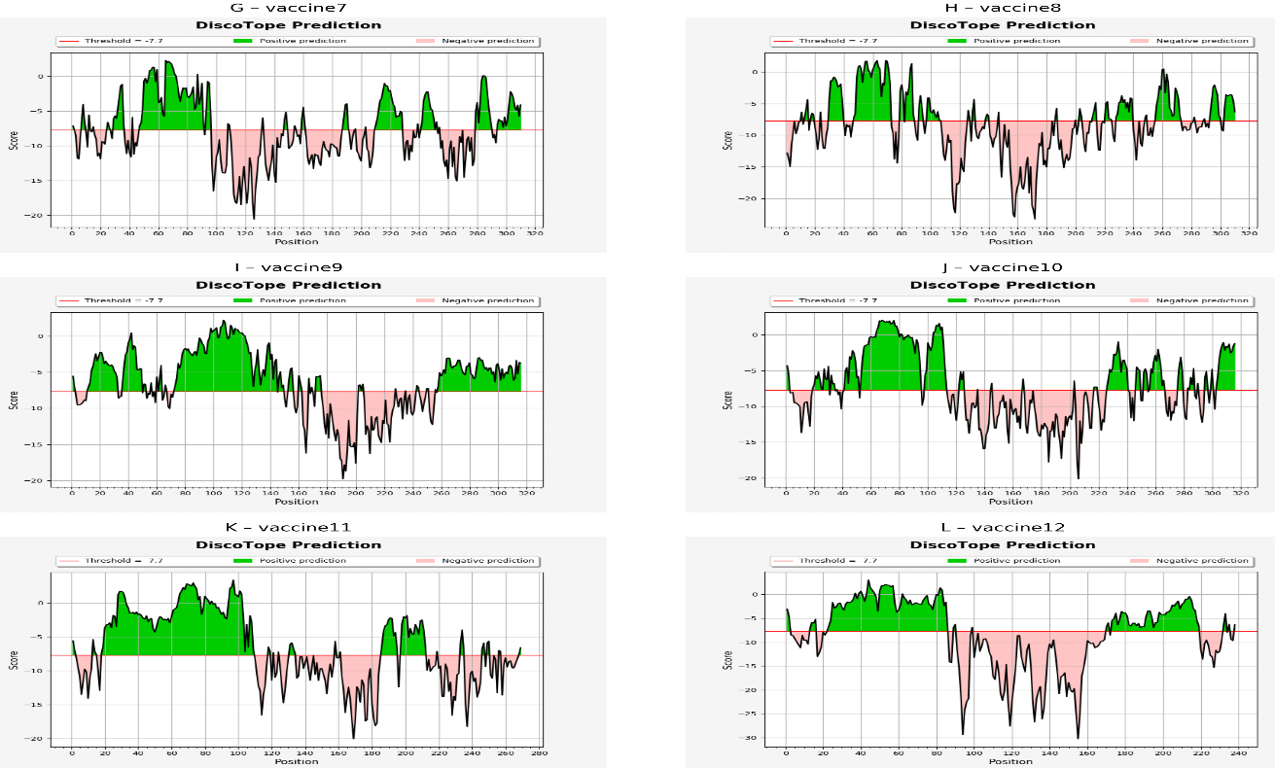

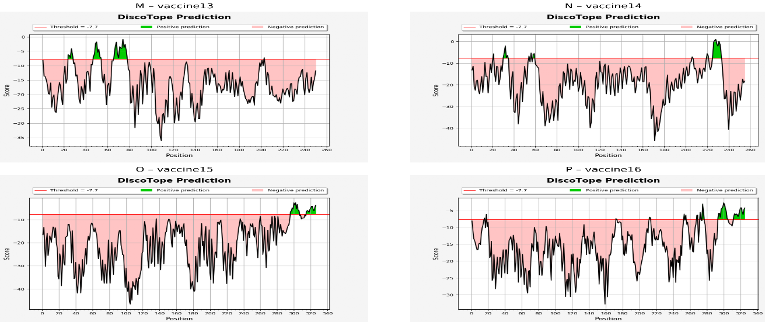

Figure S5: The results of DiscoTope prediction for All constructs.

Table S6: Top vaccine constructs ranked by DiscoTope conformational B-cell epitope scores
Rank | Vaccine ID | Mean DiscoTope Score | Max DiscoTope Score | Mean Propensity Score | Structural Epitope Coverage | Interpretation
1 | Vaccine6 | High | Very high | High | Broad | Strong, surface-exposed conformational epitopes
2 | Vaccine5 | High | High | High | Broad | Stable epitope clusters above threshold
3 | Vaccine3 | Moderate–High | High | Moderate | Broad | Balanced surface exposure
4 | Vaccine2 | Moderate–High | Moderate | Moderate | Moderate | Consistent epitope regions
5 | Vaccine1 | Moderate | Moderate | Moderate | Moderate | Localized epitope peaks
6 | Vaccine8 | Moderate | Moderate | Moderate | Moderate | Good surface distribution
7 | Vaccine4 | Moderate | Moderate | Lower | Moderate | Mixed positive/negative regions
8 | Vaccine7 | Lower–Moderate | Moderate | Lower | Limited | Sparse conformational epitopes
9 | Vaccine10 | Lower | Moderate | Lower | Limited | Isolated surface residues
10 | Vaccine9 | Lower | Lower | Lower | Limited | Weak conformational signal

Table S7: Top vaccine constructs ranked by ElliPro protrusion index
Rank | Vaccine ID | Highest PI Score | Number of Linear Epitopes | Number of Discontinuous Epitopes | Epitope Type Dominance | Interpretation
1 | Vaccine6 | ≥0.90 | Multiple | Multiple | Discontinuous | Highly protruding, antibody-accessible
2 | Vaccine5 | ≥0.88 | Multiple | Multiple | Discontinuous | Strong structural exposure
3 | Vaccine3 | ≥0.85 | Moderate | Multiple | Mixed | Balanced linear & conformational
4 | Vaccine2 | ≥0.83 | Moderate | Moderate | Mixed | Surface-accessible regions
5 | Vaccine1 | ≥0.80 | Moderate | Few | Linear | Accessible but localized
6 | Vaccine8 | ≥0.78 | Few | Few | Linear | Moderate exposure
7 | Vaccine4 | ≥0.75 | Few | Few | Linear | Limited protrusion
8 | Vaccine7 | ≥0.73 | Few | Rare | Linear | Weak structural epitopes
9 | Vaccine10 | ≥0.70 | Few | Rare | Linear | Minimal exposure
10 | Vaccine9 | ≥0.68 | Few | Rare | Linear | Poor epitope protrusion

Table S8: Scores derived from relative peak magnitude, persistence, and kinetic quality across immune dimensions.
Rank | Vaccine | Innate Activation | Humoral Response | Cellular Immunity | Epitope Quality | Immune Durability | Total
1 | Vaccine 4 | 5 | 5 | 5 | 5 | 5 | 25
2 | Vaccine 7 | 5 | 4 | 5 | 5 | 5 | 24
3 | Vaccine 10 | 4 | 5 | 5 | 5 | 4 | 23
4 | Vaccine 15 | 4 | 4 | 4 | 4 | 4 | 20
5 | Vaccine 8 | 3 | 4 | 4 | 3 | 4 | 18
6 | Vaccine 14 | 3 | 4 | 4 | 3 | 3 | 17
7 | Vaccine 5 | 3 | 4 | 3 | 3 | 3 | 16
8 | Vaccine 16 | 3 | 3 | 3 | 3 | 3 | 15
9 | Vaccine 1 | 3 | 3 | 3 | 2 | 3 | 14
10 | Vaccine 12 | 2 | 2 | 3 | 2 | 2 | 11

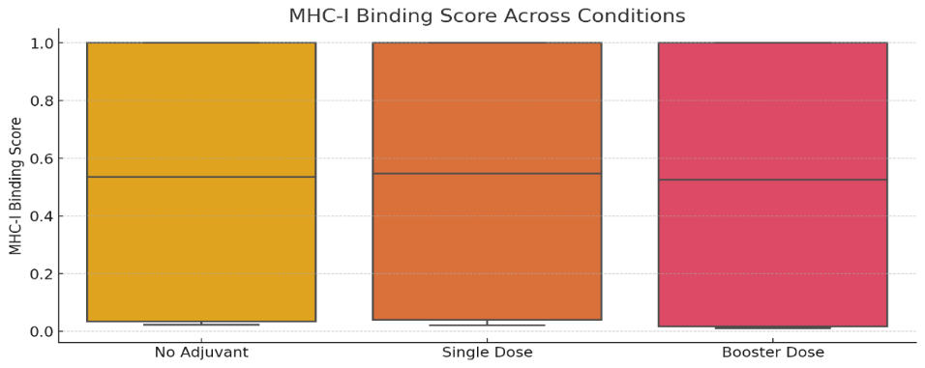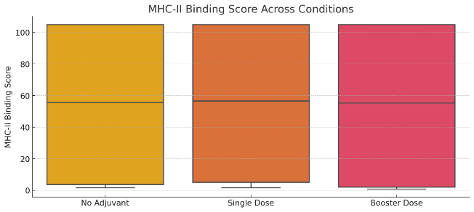
Figure S6: Immune modulation analysis for MHC binding scores under different adjuvant and dosing conditions.

Table S9: Extended analysis of immune modulation in adjuvanted vaccine constructs, showing enhanced MHC-I binding following booster doses. Statistical significance was noted in MHC-I but not in MHC-II binding across dosing conditions.
Comparison | t-test p-value | Wilcoxon p-value
MHC-I No Adjuvant vs. Single Dose | 0.1911 | 0.1441
MHC-I No Adjuvant vs. Booster Dose | 0.0374 | 0.0679
MHC-I Single Dose vs. Booster Dose | 0.0628 | 0.0679
MHC-II No Adjuvant vs. Single Dose | 0.0870 | 0.0679
MHC-II No Adjuvant vs. Booster Dose | 0.0614 | 0.0679
MHC-II Single Dose vs. Booster Dose | 0.0542 | 0.0679

Table S10: Correlation Analysis Between MHC-I and MHC-II Binding.
Condition | Pearson Correlation (MHC-I vs. MHC-II)
No Adjuvant | 0.882 (Strong positive correlation)
Single Dose | 0.915 (Stronger correlation)
Booster Dose | 0.879 (Slightly weaker than single dose)

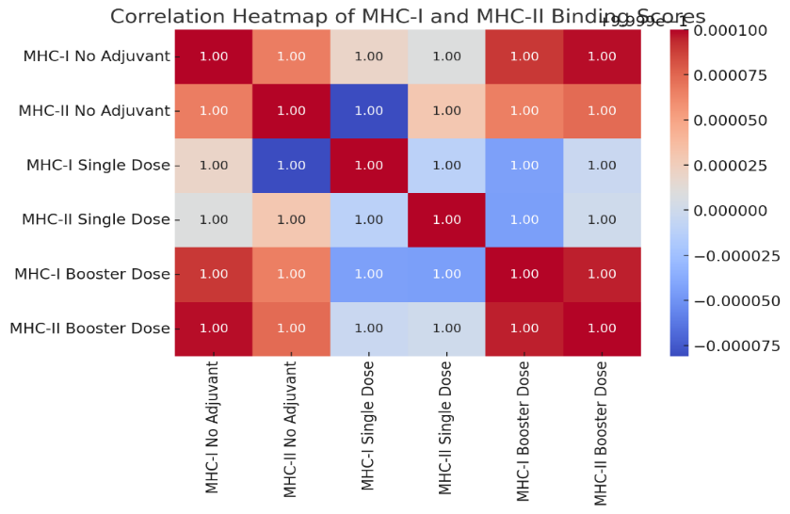
Figure S7: Pearson correlation analysis of MHC-I and MHC-II binding scores across experimental conditions. Strong positive correlation observed, especially under single-dose adjuvant conditions.
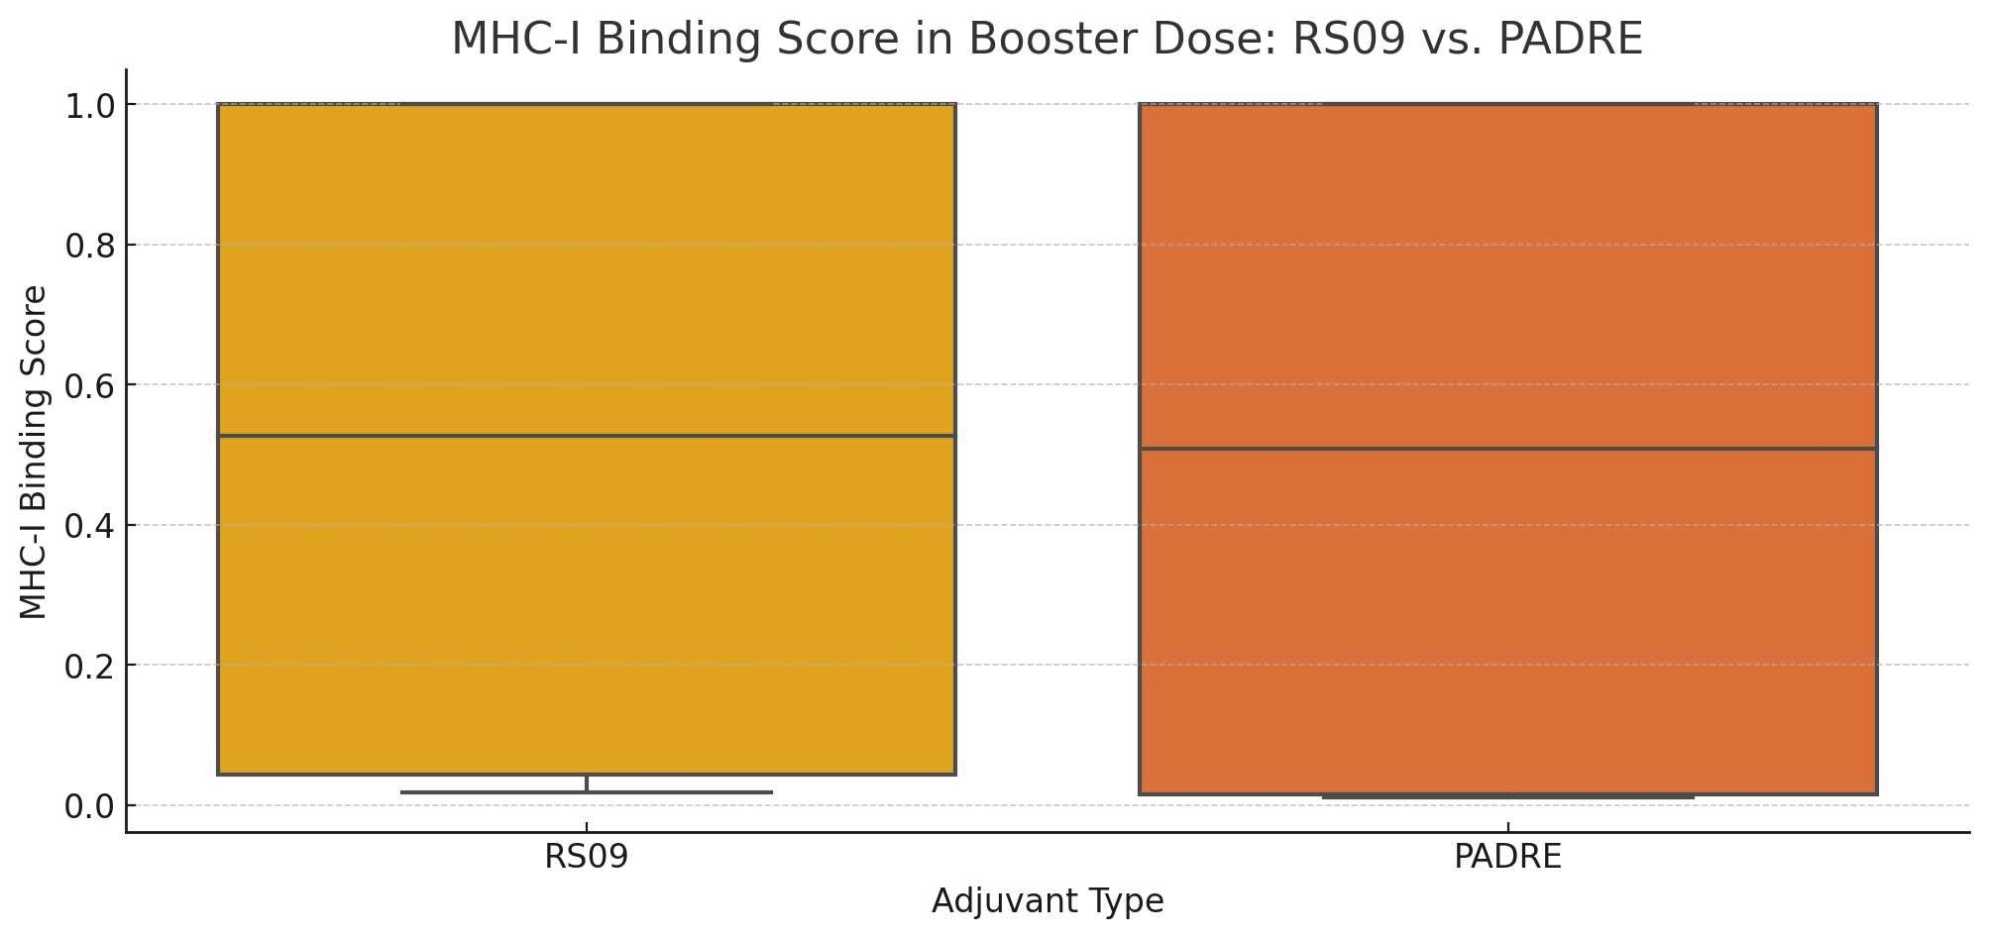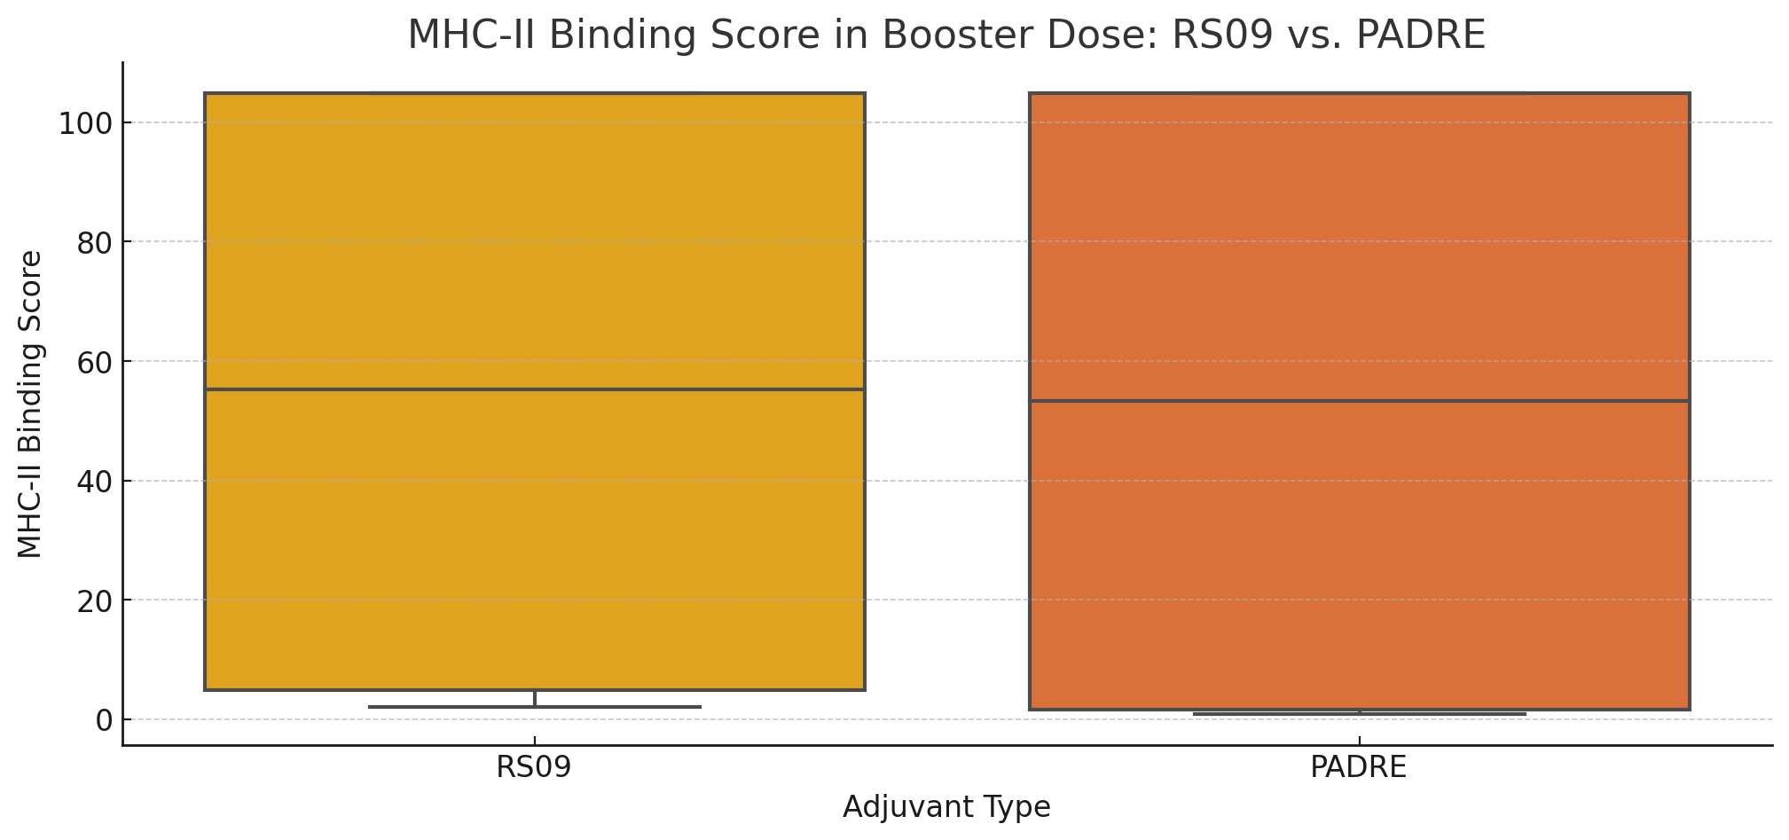
Figure S8: Comparison of RS09 and PADRE adjuvants across single-dose and booster-dose conditions, showing no significant differences in MHC-I and MHC-II binding scores. Both adjuvants demonstrated comparable immunostimulatory performance
Table S11: Comparison of RS09 and PADRE adjuvants in booster doses, with no significant differences in MHC-I or MHC-II binding scores. This highlights the robustness of the vaccine design to adjuvant selection.
Comparison | t-test p-value | Wilcoxon p-value
MHC-I RS09 vs. PADRE (Booster) | 0.9809 | 0.5929
MHC-II RS09 vs. PADRE (Booster) | 0.9779 | 0.5929
MHC-I RS09 vs. PADRE (Single Dose) | 0.9653 | 0.5929
MHC-II RS09 vs. PADRE (Single Dose) | 0.9679 | 0.5929

Table S12: Statistical comparison of T-cell activation between different dosing conditions, showing significantly enhanced activation in booster-dose groups compared to single-dose or no-adjuvant conditions.
Comparison | t-test p-value | Wilcoxon p-value
T-Cell Activation No Adjuvant vs. Single Dose | 0.0796 | 0.0833
T-Cell Activation No Adjuvant vs. Booster Dose | 0.0411 | 0.0588
T-Cell Activation Single Dose vs. Booster Dose | 0.0331 | 0.0455

Table S13: Docking scores of vaccine constructs against four immune-relevant receptors, showing adjuvanted vs non-adjuvanted configurations.
Receptor | vaccine | Adjuvant_score | Nonadjuvant_score
8WTA | Vaccine15 | -1613.45 | -1483.71
8WTA | Vaccine14 | -1477.2 | -1337.16
8WTA | Vaccine16 | -1437.75 | -1433.14
8WTA | Vaccine13 | -1409.85 | -1378.85
8WTA | Vaccine4 | -1283.26 | -1276.44
8WTA | Vaccine8 | -1274.51 | -1220.27
8WTA | Vaccine3 | -1273.16 | -1273.45
8WTA | Vaccine10 | -1272.34 | -1254.72
8WTA | Vaccine2 | -1259.65 | -1275.42
8WTA | Vaccine7 | -1243.02 | -1208.53
8WTA | Vaccine9 | -1241.47 | -1242.85
8WTA | Vaccine6 | -1236.46 | -1238.12
8WTA | Vaccine5 | -1216.5 | -1264.4
8WTA | Vaccine1 | -1216.04 | -1247.04
8WTA | Vaccine12 | -1207.21 | -1215.82
7M8S | Vaccine15 | -1184.55 | -1060.86
4ZQK | Vaccine15 | -1094.43 | -962.021
7M8S | Vaccine14 | -1060.86 | -915.42
7M8S | Vaccine16 | -1014.92 | -1016.88
7M8S | Vaccine13 | -1006.56 | -968.613
1KCG | Vaccine15 | -1003.9 | -868.7
4ZQK | Vaccine14 | -968.879 | -817.903
4ZQK | Vaccine16 | -913.986 | -923.815
4ZQK | Vaccine13 | -899.199 | -865.314
7M8S | Vaccine4 | -885.653 | -855.431
1KCG | Vaccine14 | -875.7 | -732.649
7M8S | Vaccine3 | -875.667 | -874.899
7M8S | Vaccine10 | -866.125 | -852.811
7M8S | Vaccine8 | -866.006 | -813.457
7M8S | Vaccine2 | -847.916 | -868.261
7M8S | Vaccine7 | -845.099 | -811.004
7M8S | Vaccine6 | -838.334 | -830.231
7M8S | Vaccine9 | -834.301 | -845.502
1KCG | Vaccine16 | -827.638 | -849.443
7M8S | Vaccine11 | -827.329 | -797.873
7M8S | Vaccine5 | -818.732 | -852.723
1KCG | Vaccine13 | -812.274 | -779.385
7M8S | Vaccine1 | -809.632 | -844.339
7M8S | Vaccine12 | -805.146 | -802.321
4ZQK | Vaccine4 | -786.435 | -765.155
4ZQK | Vaccine3 | -779.125 | -770.672
4ZQK | Vaccine2 | -767.307 | -771.716
4ZQK | Vaccine8 | -762.979 | -712.507
4ZQK | Vaccine10 | -761.152 | -755.459
4ZQK | Vaccine7 | -745.268 | -714.968
4ZQK | Vaccine6 | -742.697 | -739.906
4ZQK | Vaccine9 | -734.841 | -749.971
4ZQK | Vaccine11 | -730.452 | -703.447
4ZQK | Vaccine5 | -720.485 | -754.535
4ZQK | Vaccine1 | -711.779 | -747.419
4ZQK | Vaccine12 | -706.383 | -701.469
1KCG | Vaccine3 | -698.051 | -691.232
1KCG | Vaccine4 | -695.245 | -684.359
1KCG | Vaccine10 | -684.267 | -669.171
1KCG | Vaccine8 | -679.817 | -627.14
1KCG | Vaccine2 | -670.656 | -681.411
1KCG | Vaccine7 | -656.427 | -625.886
1KCG | Vaccine6 | -654.573 | -646.014
1KCG | Vaccine9 | -654.546 | -655.426
1KCG | Vaccine11 | -643.19 | -612.036
1KCG | Vaccine5 | -633.305 | -665.884
1KCG | Vaccine1 | -631.003 | -655.106
1KCG | Vaccine12 | -614.053 | -616.043

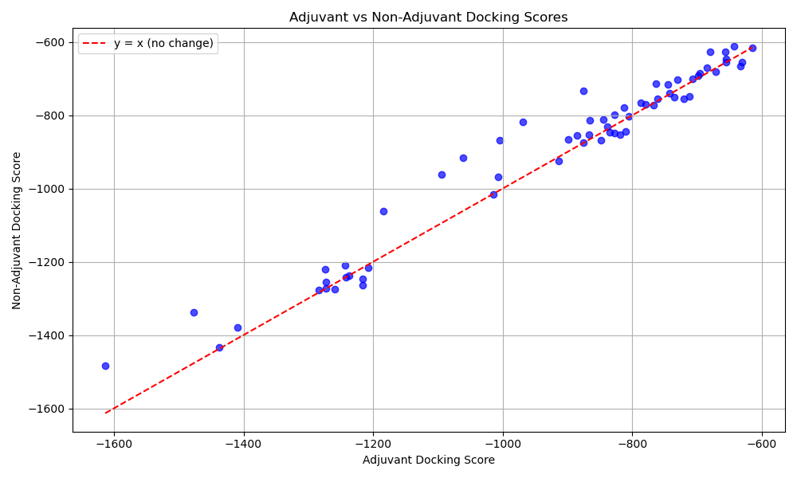
Figure S9: Comparison of Adjuvanted to Non-Adjuvanted Binding Affinities Across Receptors.
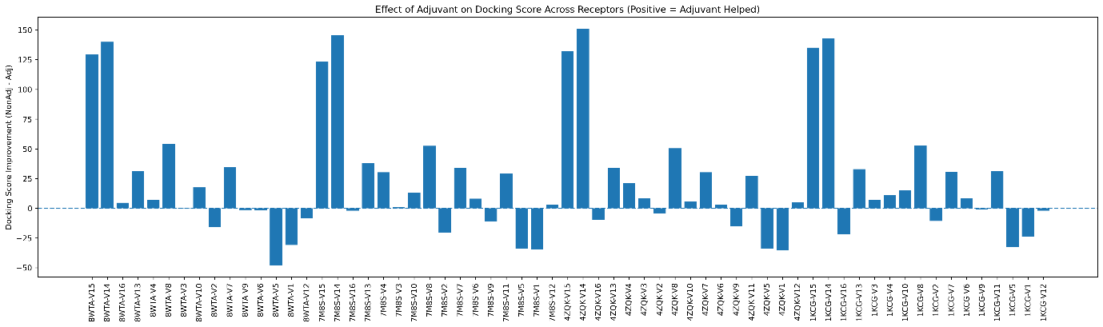
Figure S10: Effect of adjuvants on docking scores obtained as a difference between adjuvant and adjuvant scores.

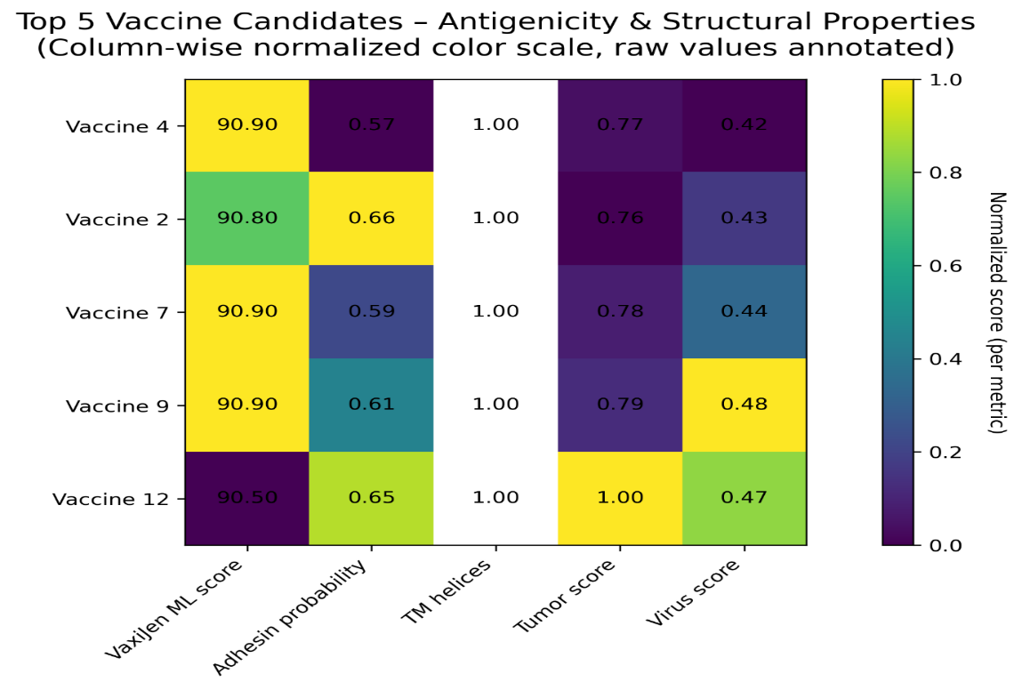
Figure S11: The Antigenic properties of the best 5 constructs.

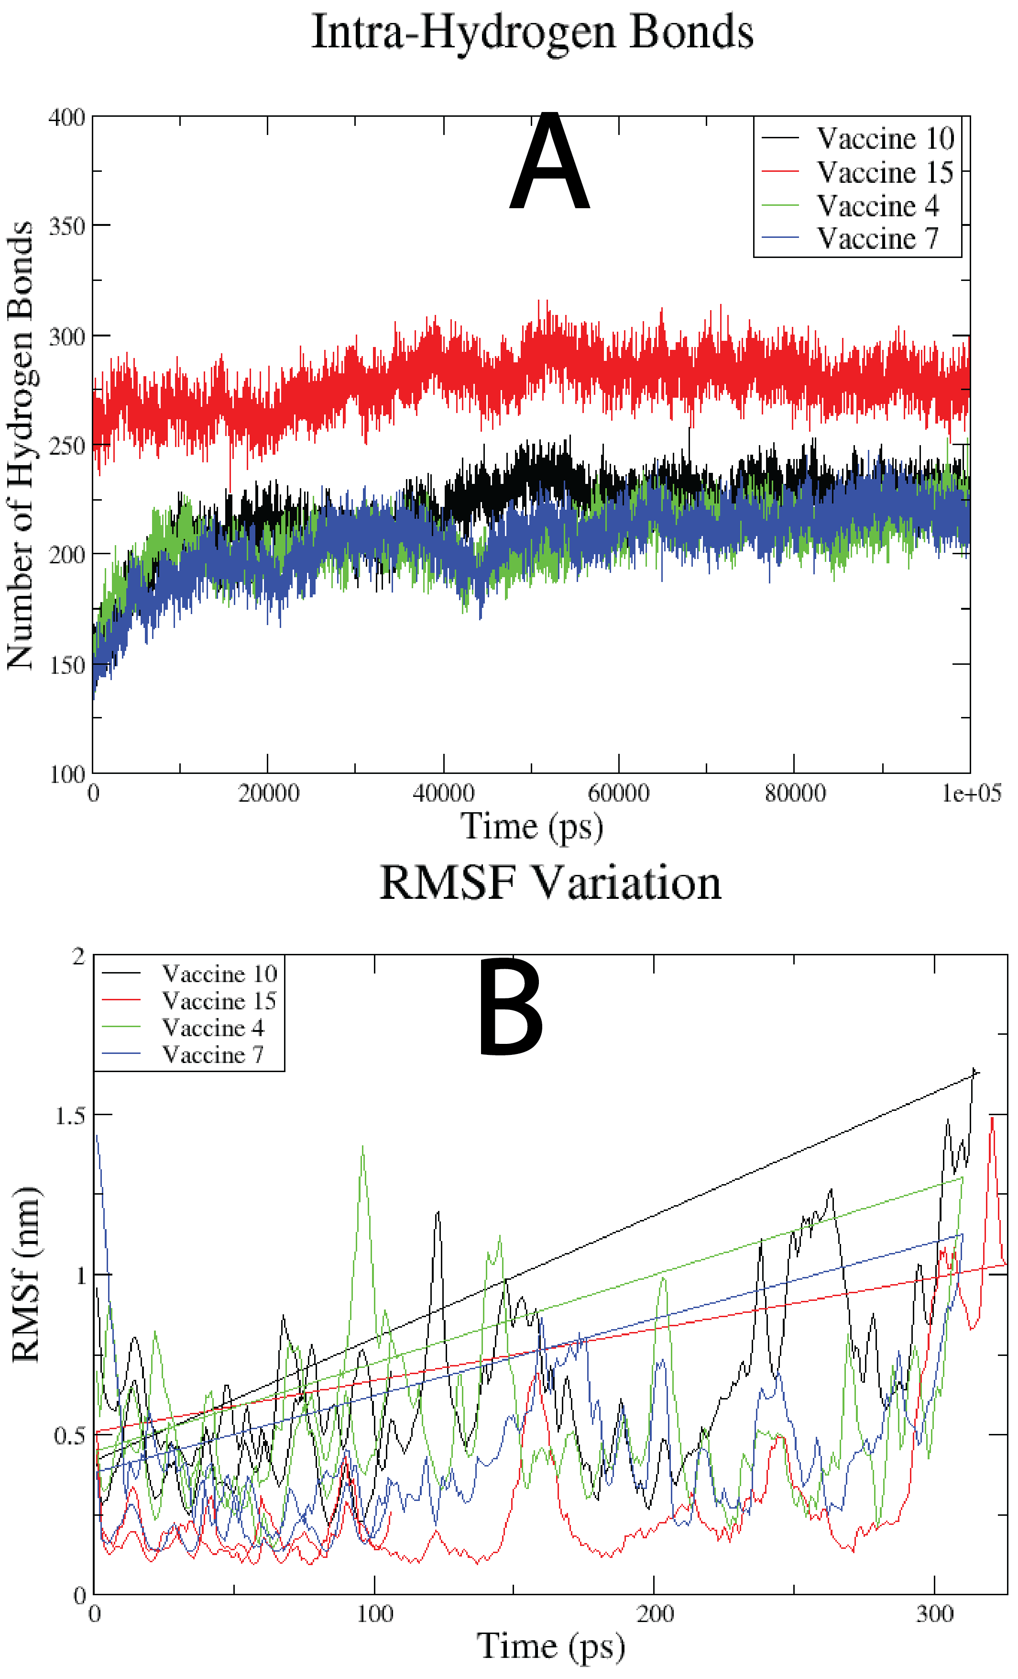
Figure S12: Compactness and internal stabilization metrics of vaccine–PD-1 complexes. (A) RMSF profiles indicating residue-level flexibility. (B) Total intra-complex hydrogen bonds across simulation time, reflecting internal structural stabilization.
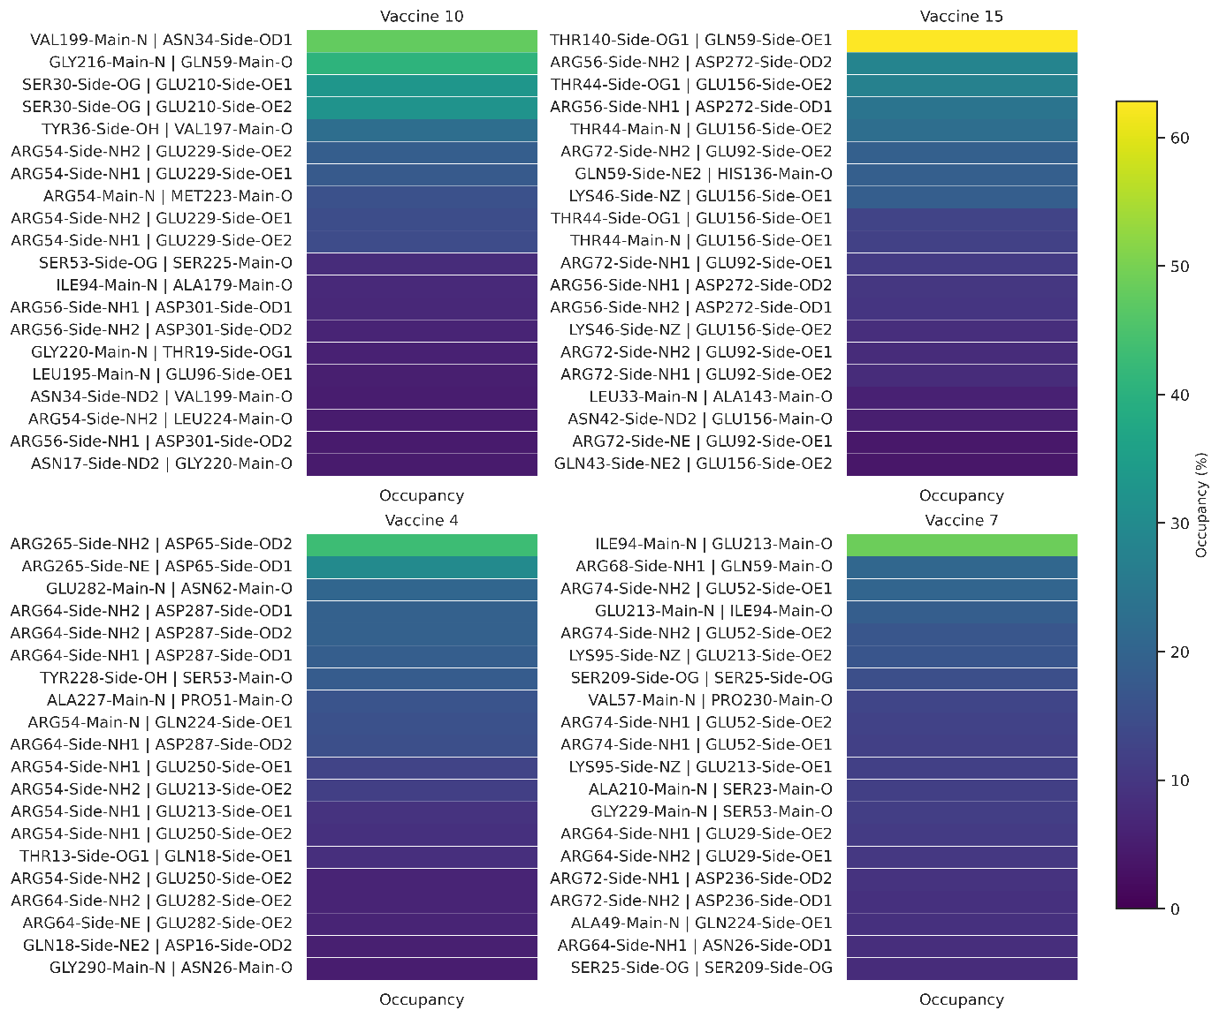
Figure S13: Hydrogen bond occupancy maps of vaccine-PD-1 complexes over 100-ns molecular dynamics simulations. Heatmaps display the percentage occupancy of specific donor-acceptor hydrogen bond interactions across the trajectory for Vaccines 4, 7, 10, and 15. Warmer colors indicate higher interaction persistence.

References
1. Young, L. S., & Dawson, C. W. (2014). Epstein-Barr virus and nasopharyngeal carcinoma. Chinese Journal of Cancer, 33(12), 581. https://doi.org/10.5732/cjc.014.10197
2. Tsao, S. W., Tsang, C. M., & Lo, K. W. (2017). Epstein-barr virus infection and nasopharyngeal carcinoma. Philosophical Transactions of the Royal Society B: Biological Sciences, 372(1732). https://doi.org/10.1098/rstb.2016.0270
3. Küppers, R. (2008). The biology of Hodgkin’s lymphoma. Nature Reviews Cancer 2009 9:1, 9(1), 15–27. https://doi.org/10.1038/nrc2542
4. Thorley-Lawson, D. A. (2015). EBV Persistence—Introducing the Virus. Epstein Barr Virus, 1, 151–209. https://doi.org/10.1007/978-3-319-22822-8_8
5. Giordano, T. J. (2014). The Cancer Genome Atlas Research Network: A Sight to Behold. Endocrine Pathology 2014 25:4, 25(4), 362–365. https://doi.org/10.1007/s12022-014-9345-4
6. Bass, A. J., Thorsson, V., Shmulevich, I., Reynolds, S. M., Miller, M., Bernard, B., Hinoue, T., Laird, P. W., Curtis, C., Shen, H., Weisenberger, D. J., Schultz, N., Shen, R., Weinhold, N., Kelsen, D. P., Bowlby, R., Chu, A., Kasaian, K., Mungall, A. J., … Liu, J. (2014). Comprehensive molecular characterization of gastric adenocarcinoma. Nature 2014 513:7517, 513(7517), 202–209. https://doi.org/10.1038/nature13480
7. Tse, E., & Kwong, Y. L. (2017). The diagnosis and management of NK/T-cell lymphomas. Journal of Hematology & Oncology 2017 10:1, 10(1), 85-. https://doi.org/10.1186/s13045-017-0452-9
8. Allen, U. D., & Preiksaitis, J. K. (2019). Post-transplant lymphoproliferative disorders, Epstein-Barr virus infection, and disease in solid organ transplantation: Guidelines from the American Society of Transplantation Infectious Diseases Community of Practice. Clinical Transplantation, 33(9), e13652. https://doi.org/10.1111/ctr.13652
9. Ok, C. Y., Ye, Q., Li, L., Manyam, G. C., Deng, L., Goswami, R. R., Wang, X., Montes-Moreno, S., Visco, C., Tzankov, A., Dybkaer, K., Zhang, L., Abramson, J., Sohani, A. R., Chiu, A., Orazi, A., Zu, Y., Bhagat, G., Richards, K. L., … Young, K. H. (2015). Age cutoff for Epstein-Barr virus-positive diffuse large B-cell lymphoma–is it necessary? Oncotarget, 6(16), 13933. https://doi.org/10.18632/oncotarget.4324
10. Pekkonen, P., Järviluoma, A., Zinovkina, N., Cvrljevic, A., Prakash, S., Westermarck, J., Evan, G., Cesarman, E., Verschuren, E. W., & Ojala, P. (2014). KSHV viral cyclin interferes with T-cell development and induces lymphoma through Cdk6 and notch activation in vivo. Cell Cycle, 13(23), 3670–3684. https://doi.org/10.4161/15384101.2014.964118
11. Castillo, J. J., Bibas, M., & Miranda, R. N. (2015). The biology and treatment of plasmablastic lymphoma. Blood, 125(15), 2323–2330. https://doi.org/10.1182/blood-2014-10-567479
12. Kimura, H., Ito, Y., Kawabe, S., Gotoh, K., Takahashi, Y., Kojima, S., Naoe, T., Esaki, S., Kikuta, A., Sawada, A., Kawa, K., Ohshima, K., & Nakamura, S. (2012). EBV-associated T/NK–cell lymphoproliferative diseases in nonimmunocompromised hosts: prospective analysis of 108 cases. Blood, 119(3), 673–686. https://doi.org/10.1182/blood-2011-10-381921
13. Moore, K. W., Vieira, P., Fiorentino, D. F., Trounstine, M. L., Khan, T. A., & Mosmann, T. R. (1990). Homology of cytokine synthesis inhibitory factor (IL-10) to the Epstein-Barr virus gene BCRFI. Science, 248(4960), 1230–1234. https://doi.org/10.1126/science.2161559
14. Ressing, M. E., Horst, D., Griffin, B. D., Tellam, J., Zuo, J., Khanna, R., Rowe, M., & Wiertz, E. J. H. J. (2008). Epstein-Barr virus evasion of CD8+ and CD4+ T cell immunity via concerted actions of multiple gene products. Seminars in Cancer Biology, 18(6), 397–408. https://doi.org/10.1016/j.semcancer.2008.10.008
15. Zuo, J., & Jin, D.-Y. (2025). Immune Evasion by Epstein–Barr Virus. 1–39. https://doi.org/10.1007/82_2025_311
16. Ressing, M. E., van Leeuwen, D., Verreck, F. A. W., Keating, S., Gomez, R., Franken, K. L. M. C., Ottenhoff, T. H. M., Spriggs, M., Schumacher, T. N., Hutt-Fletcher, L. M., Rowe, M., & Wiertz, E. J. H. J. (2005). Epstein-Barr Virus gp42 Is Posttranslationally Modified To Produce Soluble gp42 That Mediates HLA Class II Immune Evasion. Journal of Virology, 79(2), 841–852. https://doi.org/10.1128/jvi.79.2.841-852.2005
17. Feederle, R., Bannert, H., Lips, H., Müller-Lantzsch, N., & Delecluse, H.-J. (2009). The Epstein-Barr Virus Alkaline Exonuclease BGLF5 Serves Pleiotropic Functions in Virus Replication. Journal of Virology, 83(10), 4952–4962. https://doi.org/10.1128/jvi.00170-09
18. Liu, X., Sadaoka, T., Krogmann, T., & Cohen, J. I. (2020). Epstein-Barr Virus (EBV) Tegument Protein BGLF2 Suppresses Type I Interferon Signaling To Promote EBV Reactivation. Journal of Virology, 94(11). https://doi.org/10.1128/jvi.00258-20
19. Cheng, A. Z., Yockteng-Melgar, J., Jarvis, M. C., Malik-Soni, N., Borozan, I., Carpenter, M. A., McCann, J. L., Ebrahimi, D., Shaban, N. M., Marcon, E., Greenblatt, J., Brown, W. L., Frappier, L., & Harris, R. S. (2018). Epstein–Barr virus BORF2 inhibits cellular APOBEC3B to preserve viral genome integrity. Nature Microbiology 2018 4:1, 4(1), 78–88. https://doi.org/10.1038/s41564-018-0284-6
20. Chen, Y. L., Chen, Y. J., Tsai, W. H., Ko, Y. C., Chen, J. Y., & Lin, S. F. (2009). The Epstein-Barr virus replication and transcription activator, Rta/BRLF1, induces cellular senescence in epithelial cells. Cell Cycle, 8(1), 58–65. https://doi.org/10.4161/cc.8.1.7411
21. Nikiforow, S., Bottomly, K., Miller, G., & Münz, C. (2003). Cytolytic CD4 + -T-Cell Clones Reactive to EBNA1 Inhibit Epstein-Barr Virus-Induced B-Cell Proliferation . Journal of Virology, 77(22), 12088–12104. https://doi.org/10.1128/jvi.77.22.12088-12104.2003
22. Smith, D. W., Chakravorty, A., Hayes, M., Hammerschmidt, W., & Sugden, B. (2021). The Epstein-Barr Virus Oncogene EBNA1 Suppresses Natural Killer Cell Responses and Apoptosis Early after Infection of Peripheral B Cells. MBio, 12(6). https://doi.org/10.1128/mBio.02243-21
23. Fathallah, I., Parroche, P., Gruffat, H., Zannetti, C., Johansson, H., Yue, J., Manet, E., Tommasino, M., Sylla, B. S., & Hasan, U. A. (2010). EBV Latent Membrane Protein 1 Is a Negative Regulator of TLR9. The Journal of Immunology, 185(11), 6439–6447. https://doi.org/10.4049/jimmunol.0903459
24. Guasparri, L., Bubman, D., & Cesarman, E. (2008). EBV LMP2A affects LMP1-mediated NF-κB signaling and survival of lymphoma cells by regulating TRAF2 expression. Blood, 111(7), 3813–3820. https://doi.org/10.1182/blood-2007-03-080309
25. Swaminathan, S., Huneycu1t, B. S., Reiss, C. S., & Kieff, E. (1992). Epstein-Barr virus-encoded small RNAs (EBERs) do not modulate interferon effects in infected lymphocytes. Journal of Virology, 66(8), 5133–5136. https://doi.org/10.1128/jvi.66.8.5133-5136.1992
26. Lu, Y., Qin, Z., Wang, J., Zheng, X., Lu, J., Zhang, X., Wei, L., Peng, Q., Zheng, Y., Ou, C., Ye, Q., Xiong, W., Li, G., Fu, Y., Yan, Q., & Ma, J. (2017). Epstein-Barr Virus miR-BART6-3p Inhibits the RIG-I Pathway. Journal of Innate Immunity, 9(6), 574–586. https://doi.org/10.1159/000479749
27. Choi, H., & Lee, S. K. (2016). TAX1BP1 downregulation by EBV-miR-BART15-3p enhances chemosensitivity of gastric cancer cells to 5-FU. Archives of Virology 2016 162:2, 162(2), 369–377. https://doi.org/10.1007/s00705-016-3109-z

