Figure 4.
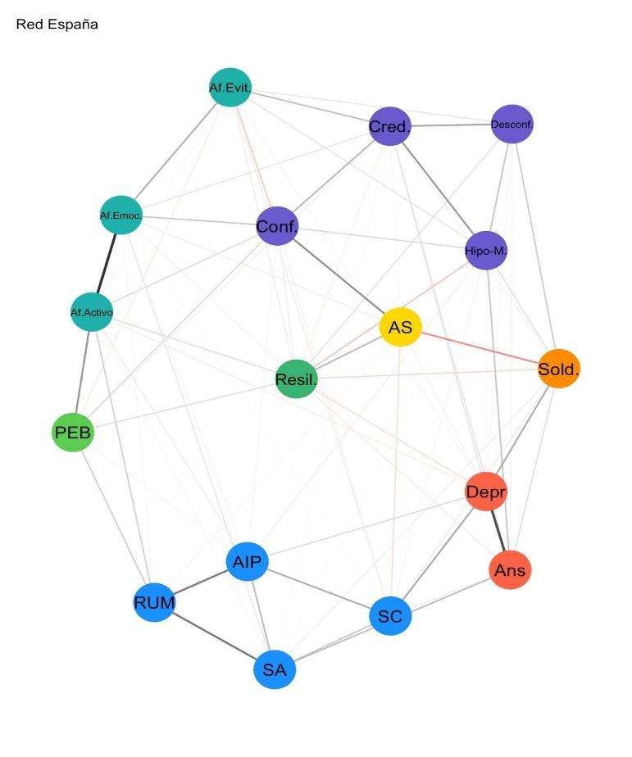
Network of Argentina and Spain
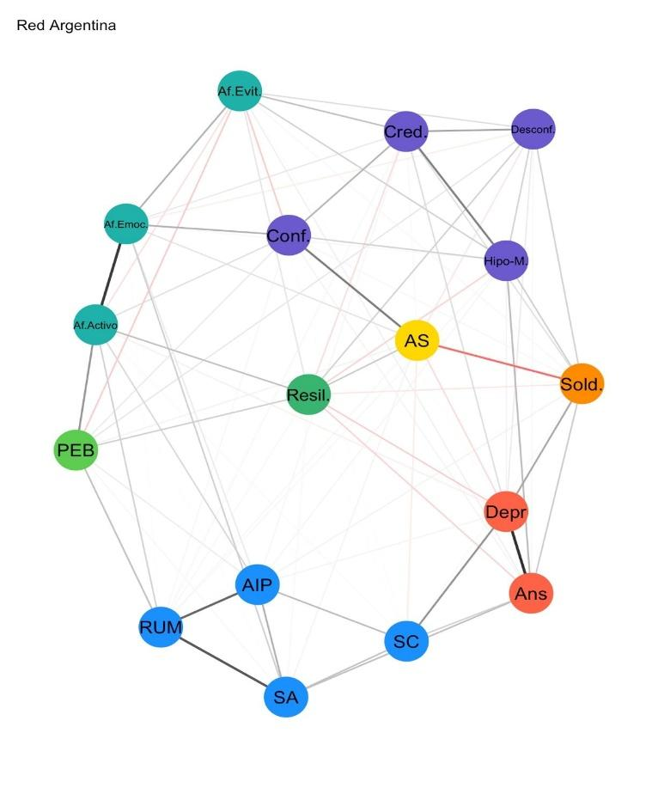
Note: the figure on the left corresponds to Argentina, and the figure on the right to Spain.

