Figure S2
Comparison of centrality (strength) between Argentina and Spain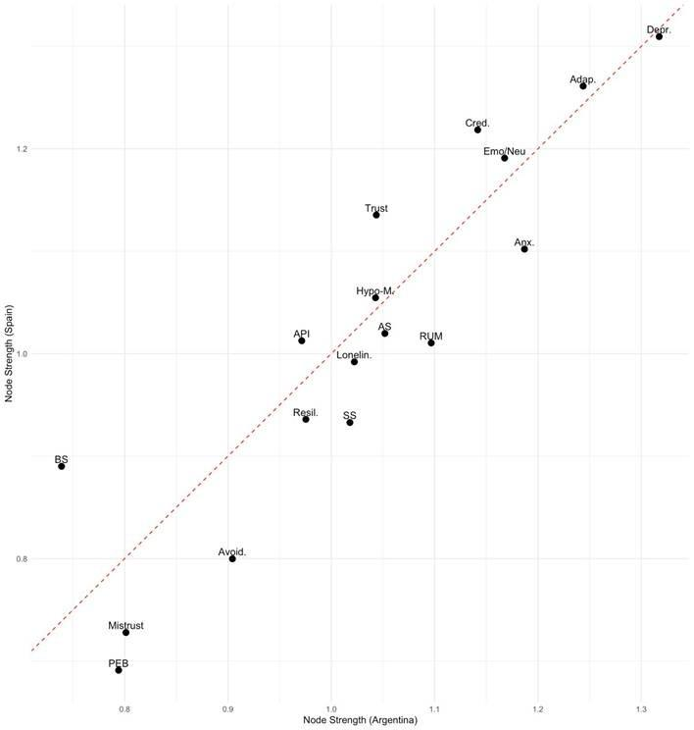
Note: Anx. = anxiety, Depr. = depression, BS = behavioral symptoms; Avoid. = avoidant coping, Cred. = epistemic credulity, Trust = epistemic trust, Mistrust = epistemic mistrust, Hypo-M. = hypomentalization, SS = social support, Lonelin. = loneliness, Resil. = resilience; API = anxiety due to personal impact, RUM = rumination, AS = affective symptoms; Emo/Neu = emotional coping, Adap. = active coping, PEB = pro-environmental behavior.

