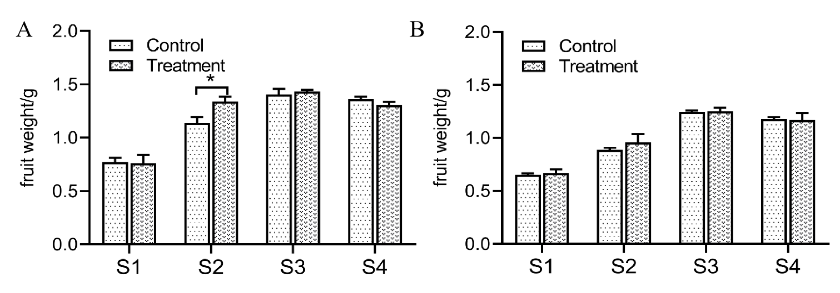Fig. S1. Difference analysis of the weight of a single grape at different growth stages of the two consecutive years: (A), 2023; (B), 2024. S1, Berries pea size; S2, early veraison; S3, maturity; S4, on-tree-strorage. * represent significant differences (* P < 0.05).
Fig. S2. LEfSe analysis of the bacterial from rhizosphere (AB) and grape skin (CD) from Marselan wine grapes at different growth stages under normal conditions (AC) and root zone waterproof treatment (BD). S1, Berries pea size; S2, early veraison; S3, maturity; S4, on-tree-strorage.
Fig. S3. Prediction and difference analysis of the functions prediction by PICRUSt at level 3 of the microbiota between the normal conditions and the root zone waterproof treatment.
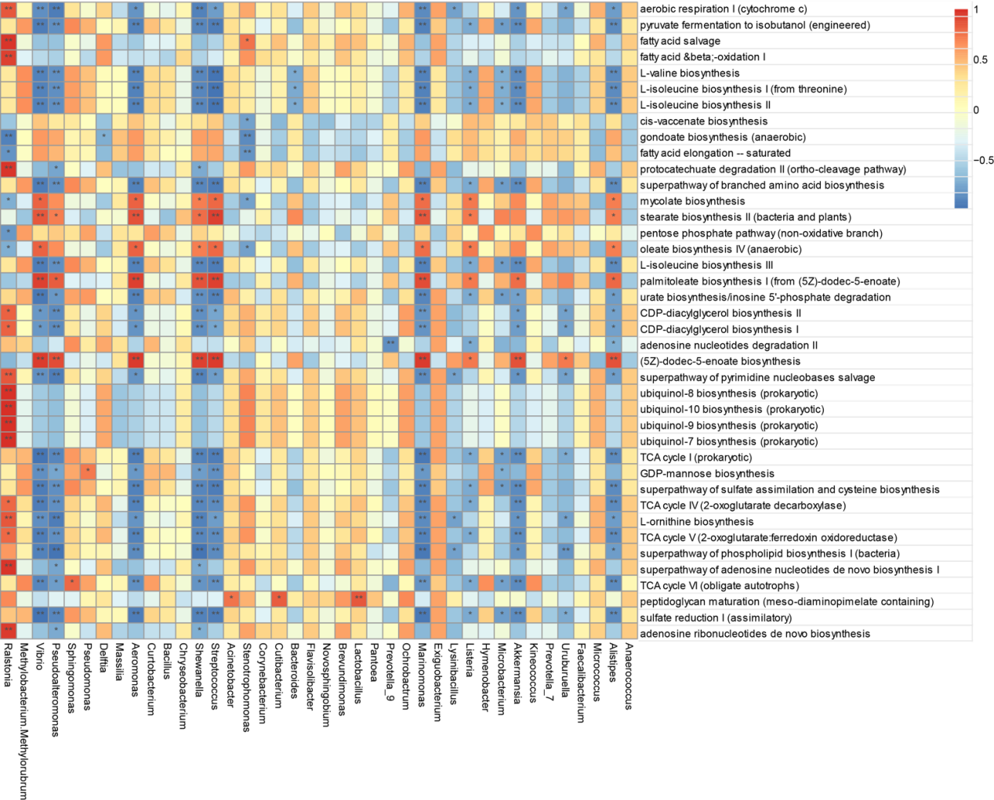Fig. S4. Heatmap showing the spearman correlation between the top 40 genera and the metabolic pathway. Significance thresholds are represented as follows: * for p<0.05, ** for p<0.01, and *** for p<0.001.
Fig. S5. Mantel test analysis between the bacterial community at S2 (A) and S3 (B) stages and the metabolites the S2 and S3 metabolites.
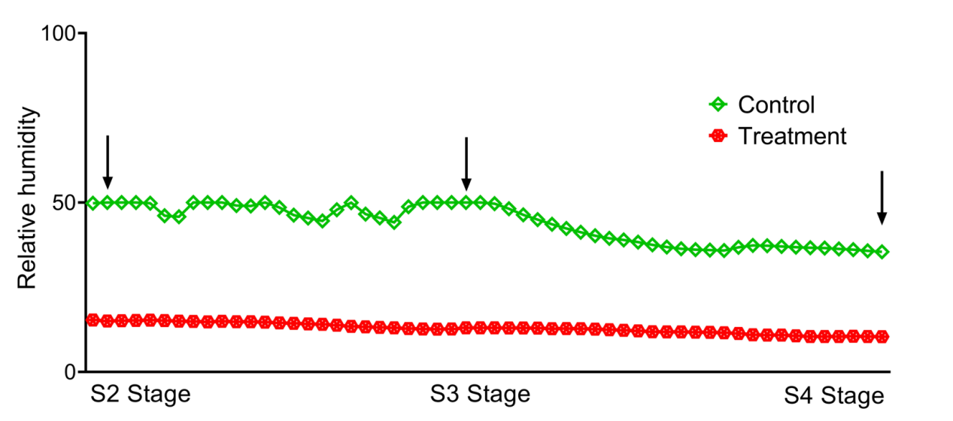Fig. S6. The relative humidity of the soil under normal conditions and root zone waterproof treatment.

