Supplementary
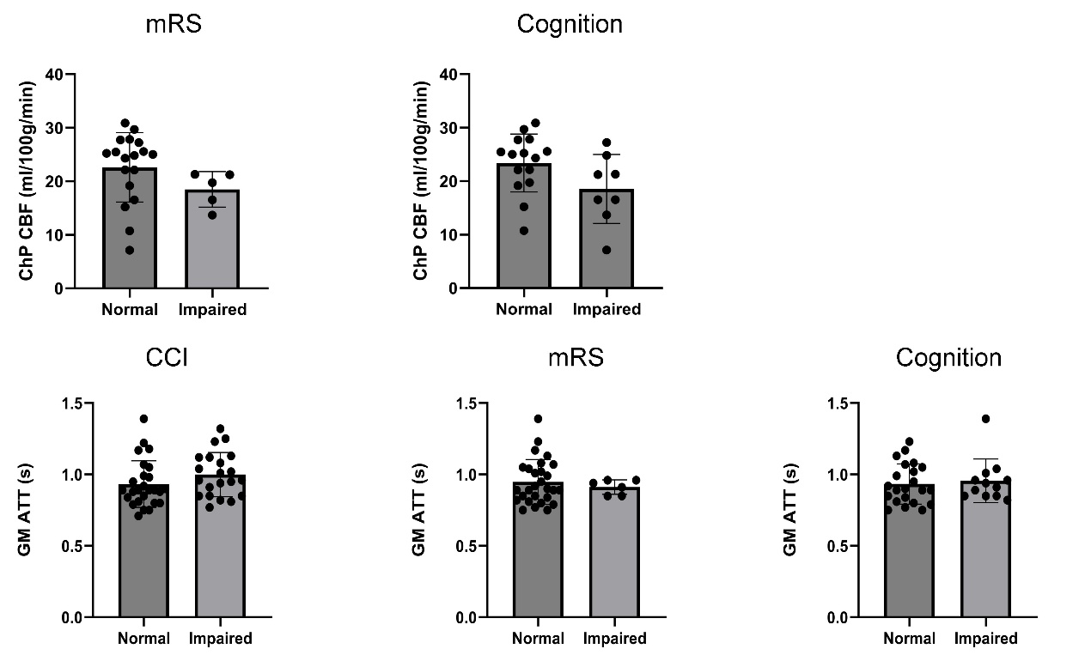
Figure S1. The relationship between cerebral hemodynamic metrics and clinical symptom severity.

