Supplementary Information

High-Accuracy Method for Measuring the Specific Heat Capacity of Molten Salts: Application to the FLiNaK and NaCl-MgCl₂ Eutectics
Juliano Schorne-Pinto^{1*}, Aiswarya Padinhare Manissery¹, Ronald E. Booth¹, Annabelle Husek¹, Zachary Gardiner¹, Jorge Paz Saldan Palma¹, Jacob A. Yingling², and Theodore M. Besmann¹
¹ Nuclear Engineering Program, Department of Mechanical Engineering, University of South Carolina, Columbia, SC 29208, USA
² Advanced Technology of Molten Salts Department, Idaho National Laboratory, Idaho Falls, ID 83415, USA
*Corresponding author: julianos@mailbox.sc.edu (Juliano Schorne-Pinto).

Verifying a semi-micro balance used to weight crucibles
Capturing the uncertainty in the measured weights (crucibles, lids, reference and samples) is considered of interest to reduce sources of errors in the specific heat capacity measurements. To ensure that our scale produced reliable measurements, calibrants were purchased and used to benchmark the scale. The measurements were analyzed and the results evaluated following the Guide to the Expression of Uncertainty of Measurement (GUM) with the standard uncertainty (u) obtained from the experimental standard deviation (SD) of the data set. The student’s coverage factor (t_{(ν,p)}) for a two-tailed t-distribution was used to obtain a 95% confidence level (p) as described in Annex G of GUM,[1] which depends on the degree of freedom (ν = N − 1) for N tests.
A conservative assumption of [U] = ±0.02 mg was used to represent the typical accuracy of the measurements. Samples were between 50 and 100 mg, and crucibles with lids were in the 300 mg range.
Table S1: Measurements of certified weights in the Mettler Toledo XPR105 semi-micro balance with statistical analysis to determine the extrapolated uncertainties.

IGF measurements
At least three samples of each salt were measured and listed in Table S2.
Table S2: Oxygen content of the salts determined by IGF:
 | NaCl  (wppm) | MgCl₂  (wppm) | FLiNaK (wppm) | LiF  (wppm)
Sample#1 | 49 | 24 | 71 | 917
Sample#2 | 72 | 26 | 76 | 842
Sample#3 | 52 | 72 | 113 | 972
Sample#4 |  | 50 | 111 | 1108
Sample#5 |  | 53 | 95 | 1105
Sample#6 |  | 30 | 112
Sample#7 |  |  | 153
Sample#8 |  |  | 140
Sample#9 |  |  | 173
Sample#10 |  |  | 209
Sample#11 |  |  | 84
Sample#12 |  |  | 104
Sample#13 |  |  | 78
Mean | 58 | 42 | 117 | 989
Mean in mol% | 0.021% | 0.025% | 0.030% | 0.160%
Exp. stand. deviation [SD] | 12.6 | 18.9 | 41.4 | 116.9
Stand. Uncertainty [u]¥ | 7.3 | 7.7 | 11.5 | 52.3
Student's coverage factor t_{(n,p)}* | 4.303 | 2.571 | 2.179 | 2.776
Expanded uncertainty [U] | 31 | 20 | 25 | 145
[U] with the usual coverage factor k = 2 | 15 | 15 | 23 | 105
¥ u= SD /√N, N = 3
* with ν = N-1 = 2 and p = 95%

Temperature Calibration of the Tian-Calvet Heat-Flow Microcalorimeter
The calorimeter was calibrated using high-purity metallic samples. Samples were loaded into quartz ampoules inside an argon glovebox and flame-sealed under vacuum using an H₂/O₂ torch. The maximum deviation from the fitted calibration equation (Figure S1) is less than 0.5 K. This calibration was applied to measurements performed using nickel crucibles. Due to the crucible change, the temperature uncertainty increased to ±2 K, as validated by measuring FLiNaK (Section 2.6).
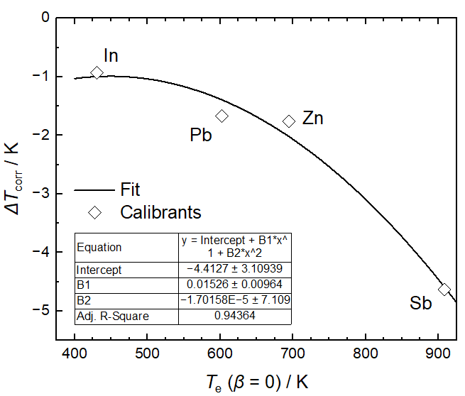
Figure S1: Plot of the temperature correction ΔT_{corr} vs. experimental extrapolated onset temperatures at zero heating rate T_{e} (β=0) determined with In_{s-l}, Pb_{s-l}, Zn_{s-l}, and Sb_{s-l} on heating.

References
1. Joint Committee for Guides in Metrology (2008) JCGM 100:2008, Evaluation of measurement data — Guide to the expression of uncertainty in measurement (GUM 1995 with minor corrections)

