Supplementary Documents
Supplementary Table 1. Sensitivity analyses: off-hours cohort performance across pre-specified subgroups and alternative analysis strategies.
Sensitivity analysis | n | Events, n (%) | AUC (95% CI) | Calibration intercept | Brier | vs primary
Primary (off-hours, full cohort) | 2,133 | 305 (14.3) | 0.830 (0.805-0.855) | -0.352 | 0.101 | Ref.
SA1: Original serial troponin complete | 1,681 | 243 (14.5) | 0.841 (0.815-0.867) | -0.294 | 0.098 | +0.011
SA2a: hsTnI assay | 1,458 | 211 (14.5) | 0.821 (0.791-0.851) | -0.391
SA2b: Conventional TnI assay | 675 | 94 (13.9) | 0.848 (0.804-0.892) | -0.263
SA3: Resident-interpreted ECG | 663 | 103 (15.5) | 0.824 (0.781-0.867) | -0.335
SA3: Specialist-interpreted ECG | 1,183 | 162 (13.7) | 0.833 (0.802-0.865) | -0.360
SA3: Cardiologist-interpreted ECG | 287 | 40 (13.9) | 0.827 (0.743-0.911) | -0.361
SA4: 6-week MACE endpoint | 2,133 | 332 (15.6) | 0.818 (0.793-0.843) | -0.211 |  | -0.012
SA5: First visit only (= primary; all first-presentation flag=1) | 2,133 | 305 (14.3) | 0.830 (0.805-0.855) | -0.352 |  | 0.000
SA6: MICE-imputed (HEART_MICE) | 2,133 | 305 (14.3) | 0.835 (0.810-0.859) | -0.360 |  | +0.005
Complete case (all secondary variables present) | 1,529 | 219 (14.3) | 0.837 (0.809-0.865) | -0.296 | 0.100 | +0.007
All analyses restricted to off-hours group unless noted. SA = sensitivity analysis; hsTnI = high-sensitivity troponin I; MICE = multiple imputation by chained equations (20 imputation sets; 50 iterations; seed=2024). Calibration intercept estimated by offset logistic regression (H₀: intercept=0); Reference cohort risk-group probabilities used as fixed offset for all analyses.. For SA6, predicted probabilities were derived from MICE-imputed HEART score risk group assignments (20 imputation sets; 50 iterations; seed=2024; Rubin's rules applied). "vs primary" = difference in AUC point estimate from primary analysis. Brier score on original reference cohort predicted probabilities where applicable.

Supplementary Table 2. AUC by time stratum with Cochran Q omnibus test results.
Time stratum | n | MACE events, n (%) | AUC (95% CI) | ΔAUC vs on-hours | FDR q
On-hours (reference) | 667 | 97 (14.5) | 0.821 (0.778-0.865) | Ref. | Ref.
Evening | 450 | 71 (15.8) | 0.855 (0.810-0.899) | +0.034 | N/A
Night | 700 | 91 (13.0) | 0.840 (0.797-0.883) | +0.019 | N/A
Weekend daytime | 650 | 95 (14.6) | 0.799 (0.747-0.850) | -0.022 | N/A
Public holiday | 333 | 48 (14.4) | 0.835 (0.779-0.891) | +0.014 | N/A
Cochran Q statistic = 2.991, df=4, p=0.559. Global test is not significant; pairwise comparisons and FDR correction are not performed (pre-specified decision rule). AUC computed by DeLong method within each stratum independently. MACE = major adverse cardiac event; FDR = false discovery rate.

Supplementary Table 3. 30-day MACE rates by HEART risk group and shift assignment.
Risk group | n | Off-hours MACE, n (%) | n | On-hours MACE, n (%) | p
Low (HEART 0-3) | 574 | 13/574 (2.3) | 196 | 3/196 (1.5) | 0.740
Intermediate (HEART 4-6) | 1,223 | 123/1,223 (10.1) | 360 | 43/360 (11.9) | 0.353
High (HEART 7-10) | 336 | 169/336 (50.3) | 111 | 51/111 (45.9) | 0.493
Mantel-Haenszel pooled OR | 2,800 | 0.989 (95% CI: 0.752-1.302) | 667 |  | 0.995
Chi-square with continuity correction per risk stratum. Mantel-Haenszel pooled OR: off-hours vs on-hours, HEART risk group as stratification variable. CI estimated by Robins-Breslow-Greenland variance method. Global p-value from Cochran-Mantel-Haenszel chi-square test (df=1).

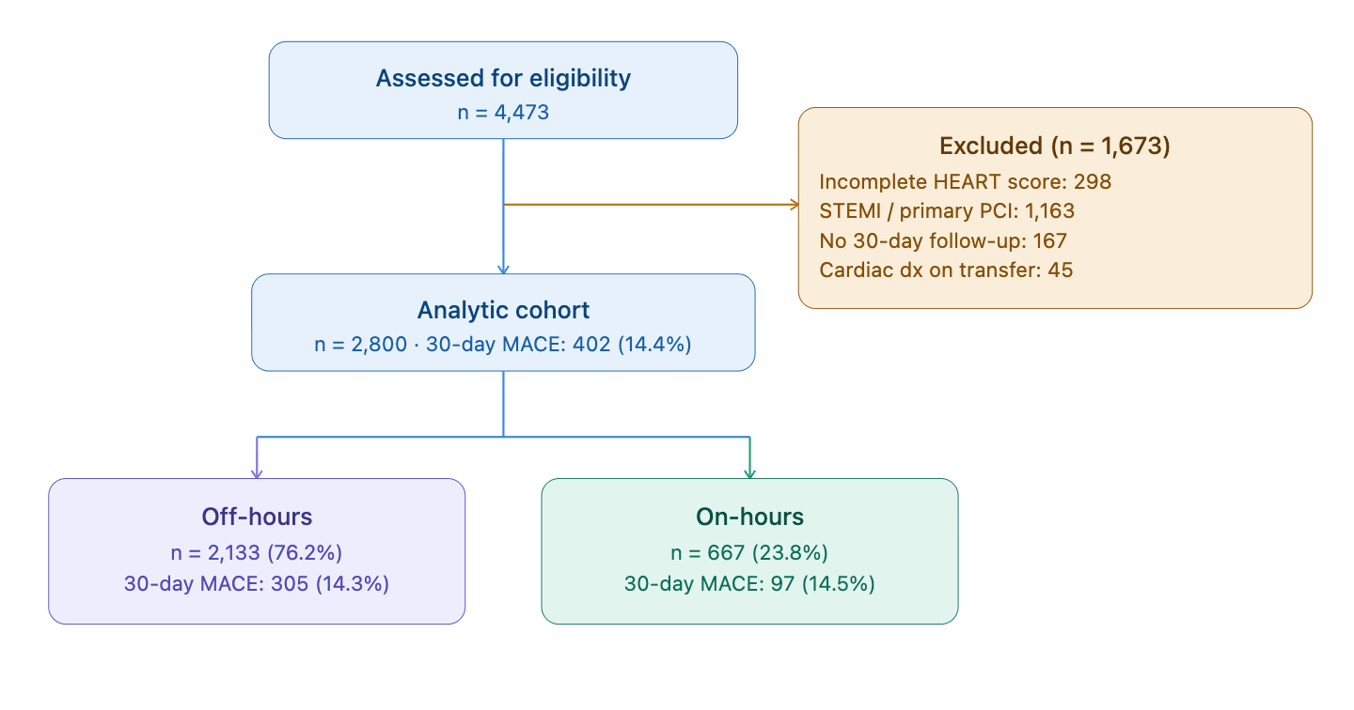
Supplementary Figure S1. Flow of participants through the study. Patients presenting with acute non-traumatic chest pain were screened consecutively from January 2020 through December 2025. Off-hours encompassed evenings (18:00-23:59), nights (00:00-07:59), weekends, and public holidays; on-hours encompassed regular weekday working hours (08:00-17:59). MACE = major adverse cardiac event (composite of acute myocardial infarction, unplanned coronary revascularization, cardiac arrest, or all-cause death within 30 days); dx = diagnosis.

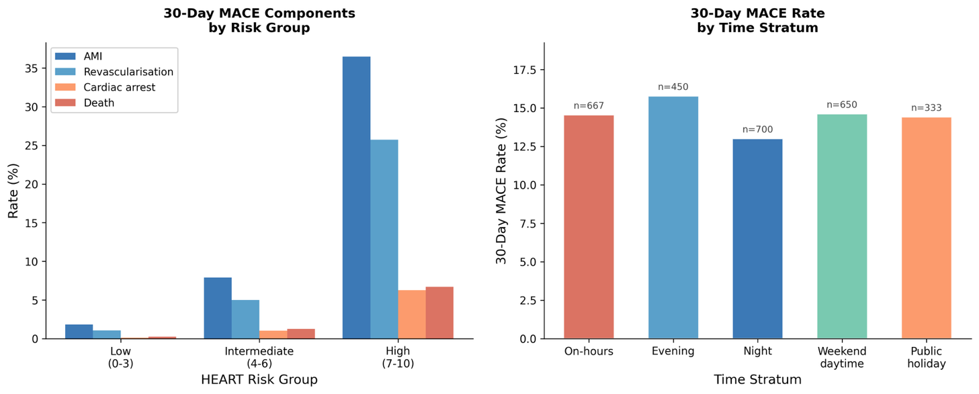

Supplementary Figure S2. Left: 30-day MACE component rates by HEART risk group. Right: 30-day MACE event rate by time stratum with sample sizes. Abbreviations: AMI = acute myocardial infarction; MACE = major adverse cardiac event.

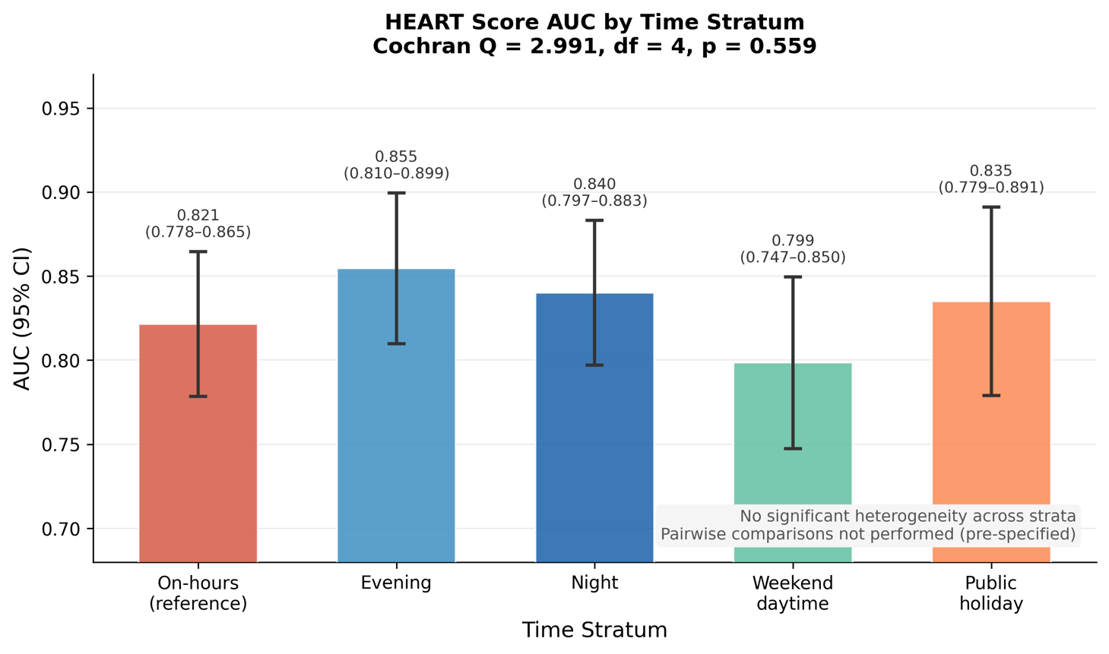
Supplementary Figure S3. HEART score AUC with 95% confidence intervals by time stratum. Error bars represent DeLong 95% CI. Cochran Q omnibus test for heterogeneity: Q=2.991, df=4, p=0.559. Per pre-specified decision rules, pairwise comparisons are not performed in the absence of a significant global test. AUC = area under the receiver operating characteristic curve.

