Appendix A
Table A1 presents 27 test samples. Lithology, true labels, and predicted labels by four algorithms are presented.
Table A1: The comparison between the true and the prediction of formation damage issues by machine learning.
SEM images | Litho.² | Fine migration¹ |  |  |  |  | Phase trapping¹ |  |  |  |  | Rock-fluid interactions¹ |  |  |  |  | Wettability alternations¹
SEM images | Litho.² | True | RF | XGB | CNN | LGB | True | RF | XGB | CNN | LGB | True | RF | XGB | CNN | LGB | True | RF | XGB | CNN | LGB
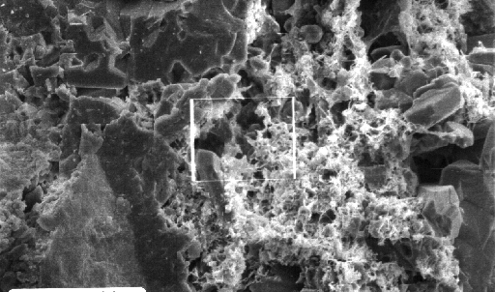 | 1 | 1 | 1 | 1 | 1 | 1 | 1 | 1 | 1 | 1 | 1 | 1 | 1 | 1 | 1 | 1 | 0 | 0 | 0 | 0 | 1
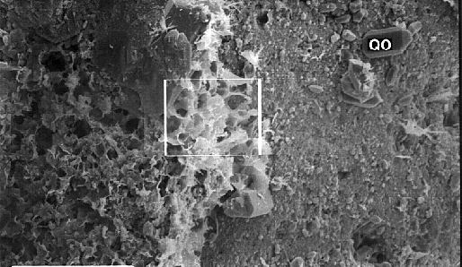 | 1 | 1 | 1 | 1 | 1 | 1 | 1 | 1 | 1 | 1 | 1 | 0 | 1 | 1 | 1 | 1 | 0 | 0 | 1 | 1 | 1
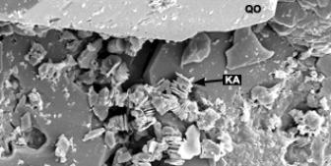 | 2 | 1 | 1 | 1 | 1 | 1 | 1 | 1 | 1 | 1 | 1 | 0 | 1 | 1 | 0 | 1 | 0 | 0 | 0 | 0 | 0
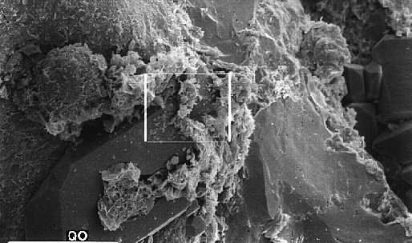 | 2 | 1 | 1 | 1 | 1 | 1 | 1 | 1 | 1 | 1 | 1 | 0 | 1 | 1 | 1 | 1 | 0 | 0 | 0 | 0 | 0
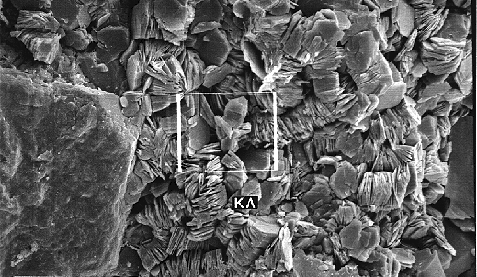 | 2 | 0 | 1 | 0 | 1 | 1 | 1 | 1 | 1 | 1 | 1 | 1 | 1 | 1 | 1 | 1 | 1 | 0 | 1 | 0 | 1
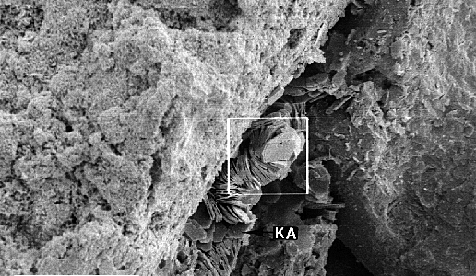 | 2 | 1 | 1 | 1 | 1 | 1 | 0 | 1 | 1 | 0 | 0 | 1 | 1 | 1 | 0 | 0 | 0 | 0 | 0 | 0 | 0
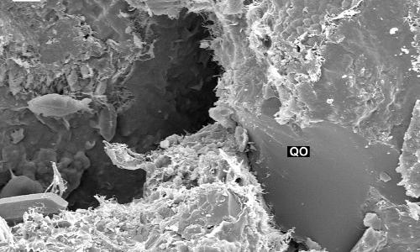 | 2 | 0 | 1 | 0 | 1 | 1 | 0 | 1 | 1 | 1 | 1 | 0 | 1 | 0 | 1 | 1 | 0 | 0 | 0 | 0 | 0
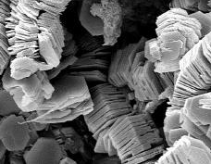 | 2 | 0 | 0 | 0 | 0 | 0 | 1 | 1 | 1 | 1 | 1 | 1 | 1 | 1 | 1 | 1 | 1 | 0 | 1 | 1 | 1
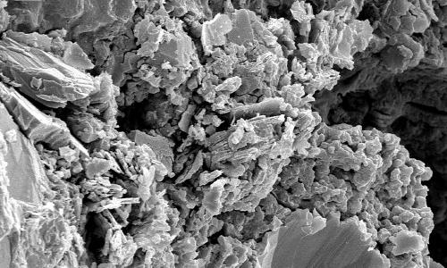 | 2 | 1 | 1 | 1 | 1 | 1 | 1 | 1 | 1 | 1 | 1 | 1 | 1 | 1 | 0 | 1 | 0 | 0 | 0 | 0 | 0
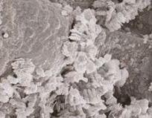 | 2 | 1 | 1 | 1 | 1 | 1 | 1 | 1 | 1 | 1 | 1 | 1 | 1 | 1 | 1 | 1 | 0 | 0 | 0 | 1 | 0
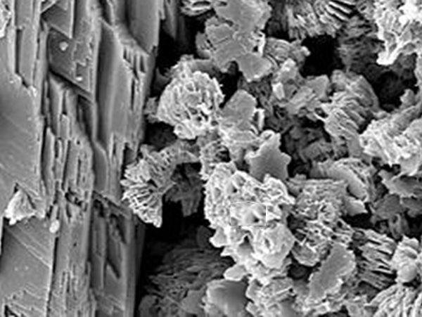 | 2 | 1 | 1 | 1 | 1 | 1 | 0 | 0 | 0 | 1 | 1 | 0 | 0 | 0 | 1 | 0 | 0 | 0 | 0 | 1 | 0
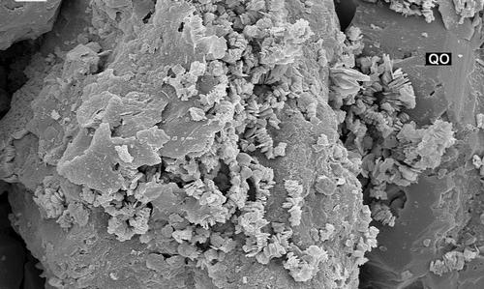 | 2 | 0 | 1 | 1 | 1 | 1 | 1 | 1 | 1 | 1 | 1 | 1 | 1 | 1 | 1 | 1 | 0 | 0 | 1 | 0 | 0
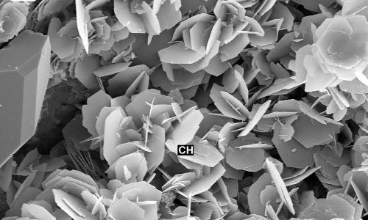 | 2 | 1 | 1 | 0 | 1 | 1 | 0 | 0 | 0 | 1 | 0 | 0 | 0 | 1 | 1 | 1 | 0 | 0 | 0 | 1 | 0
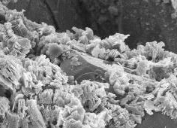 | 3 | 1 | 1 | 1 | 1 | 0 | 1 | 0 | 1 | 0 | 1 | 1 | 0 | 0 | 0 | 0 | 1 | 0 | 0 | 0 | 0
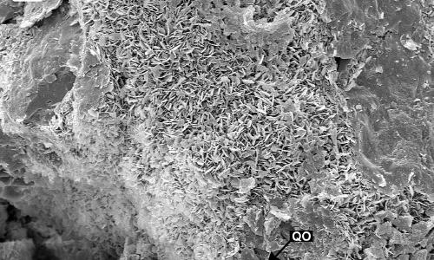 | 3 | 1 | 1 | 1 | 1 | 1 | 1 | 1 | 0 | 1 | 1 | 1 | 1 | 1 | 1 | 1 | 0 | 0 | 0 | 0 | 1
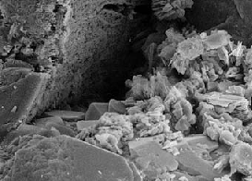 | 3 | 1 | 1 | 1 | 1 | 1 | 1 | 1 | 1 | 1 | 1 | 1 | 1 | 1 | 1 | 1 | 1 | 1 | 0 | 1 | 0
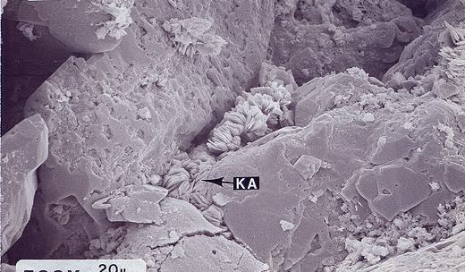 | 3 | 1 | 1 | 1 | 1 | 1 | 1 | 1 | 1 | 1 | 1 | 1 | 1 | 1 | 1 | 1 | 0 | 0 | 0 | 0 | 0
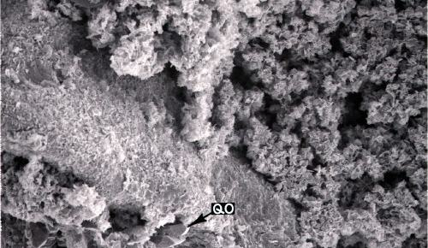 | 3 | 1 | 1 | 0 | 1 | 1 | 1 | 1 | 1 | 1 | 1 | 0 | 1 | 1 | 1 | 1 | 0 | 0 | 0 | 0 | 0
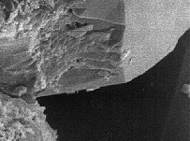 | 3 | 1 | 1 | 1 | 1 | 1 | 1 | 1 | 1 | 1 | 1 | 1 | 1 | 1 | 1 | 1 | 0 | 0 | 0 | 1 | 0
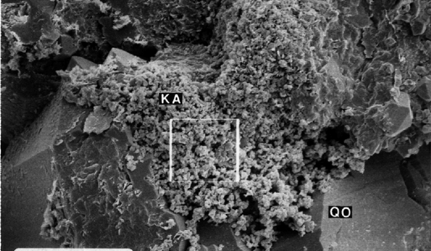 | 3 | 1 | 1 | 1 | 1 | 1 | 1 | 1 | 1 | 1 | 1 | 1 | 1 | 1 | 1 | 1 | 0 | 0 | 0 | 0 | 0
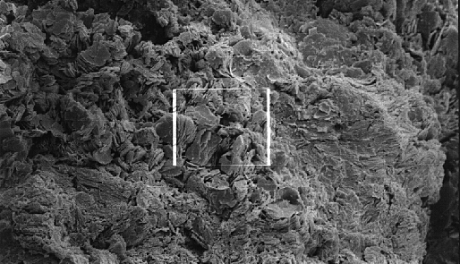 | 3 | 1 | 1 | 1 | 1 | 1 | 1 | 1 | 1 | 0 | 0 | 0 | 1 | 0 | 1 | 0 | 0 | 0 | 0 | 0 | 0
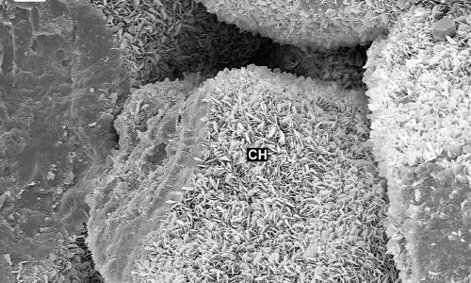 | 3 | 1 | 1 | 1 | 1 | 1 | 1 | 1 | 1 | 1 | 1 | 1 | 1 | 1 | 1 | 1 | 1 | 0 | 1 | 1 | 0
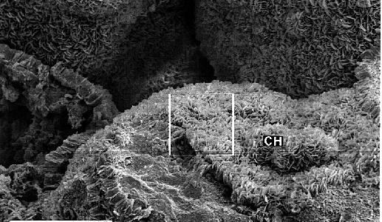 | 3 | 1 | 1 | 1 | 1 | 1 | 1 | 1 | 1 | 1 | 1 | 1 | 1 | 1 | 0 | 0 | 1 | 0 | 0 | 0 | 0
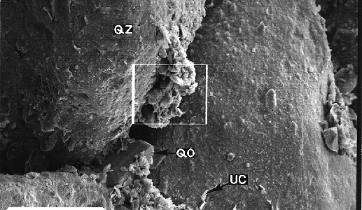 | 3 | 1 | 1 | 1 | 1 | 1 | 0 | 0 | 0 | 1 | 0 | 1 | 1 | 1 | 1 | 1 | 1 | 0 | 0 | 0 | 0
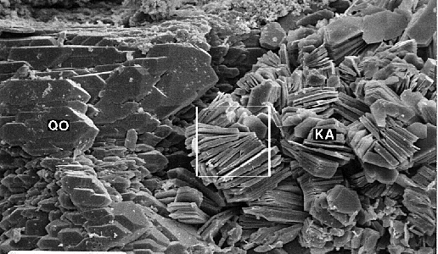 | 3 | 0 | 0 | 0 | 0 | 1 | 1 | 0 | 1 | 1 | 1 | 1 | 1 | 1 | 0 | 1 | 1 | 0 | 1 | 0 | 0
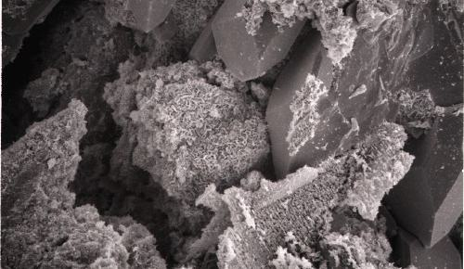 | 3 | 1 | 1 | 1 | 1 | 1 | 0 | 0 | 0 | 1 | 0 | 0 | 1 | 0 | 0 | 1 | 0 | 0 | 0 | 0 | 0
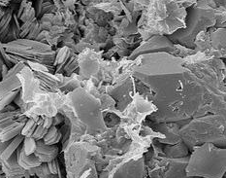 | 3 | 0 | 1 | 1 | 0 | 1 | 1 | 1 | 1 | 1 | 1 | 1 | 1 | 1 | 1 | 1 | 0 | 0 | 0 | 1 | 0
- RF – Random Forest, XGB – XGBoost, CNN - Convolutional Neural Network, LGB – Light GBM. 1 – high risk, 0 – low risk.
- For lithologies, 1 – Coarse clastic material dominated by large fragments, 2 - Clastic deposits consisting of very coarse fragments, and 3 - Clastic sediments consisting of medium-sized sand grains

