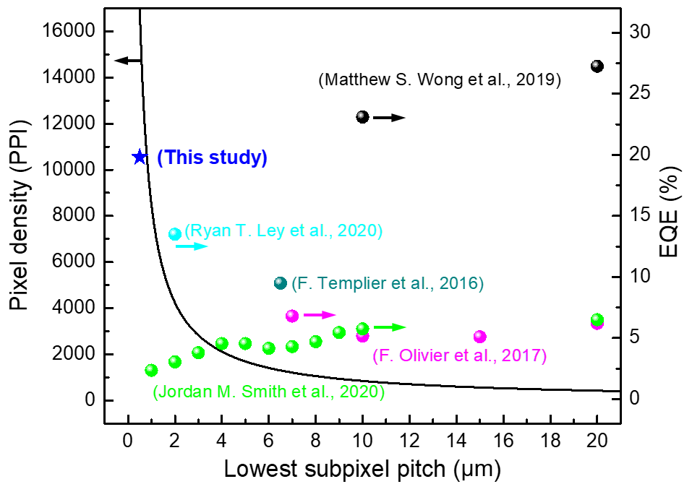
Extended Data Figure 1 | Size dependent EQE of μLEDs and their PPI. The black line represents the increase in the PPI with a decrease in the lowest subpixel pitch. Assuming that the diameters of the μLEDs are approximately equal to the lowest pitch of the subpixel, their EQEs are shown according to the pitch size by referring to previous literature (coloured circles).

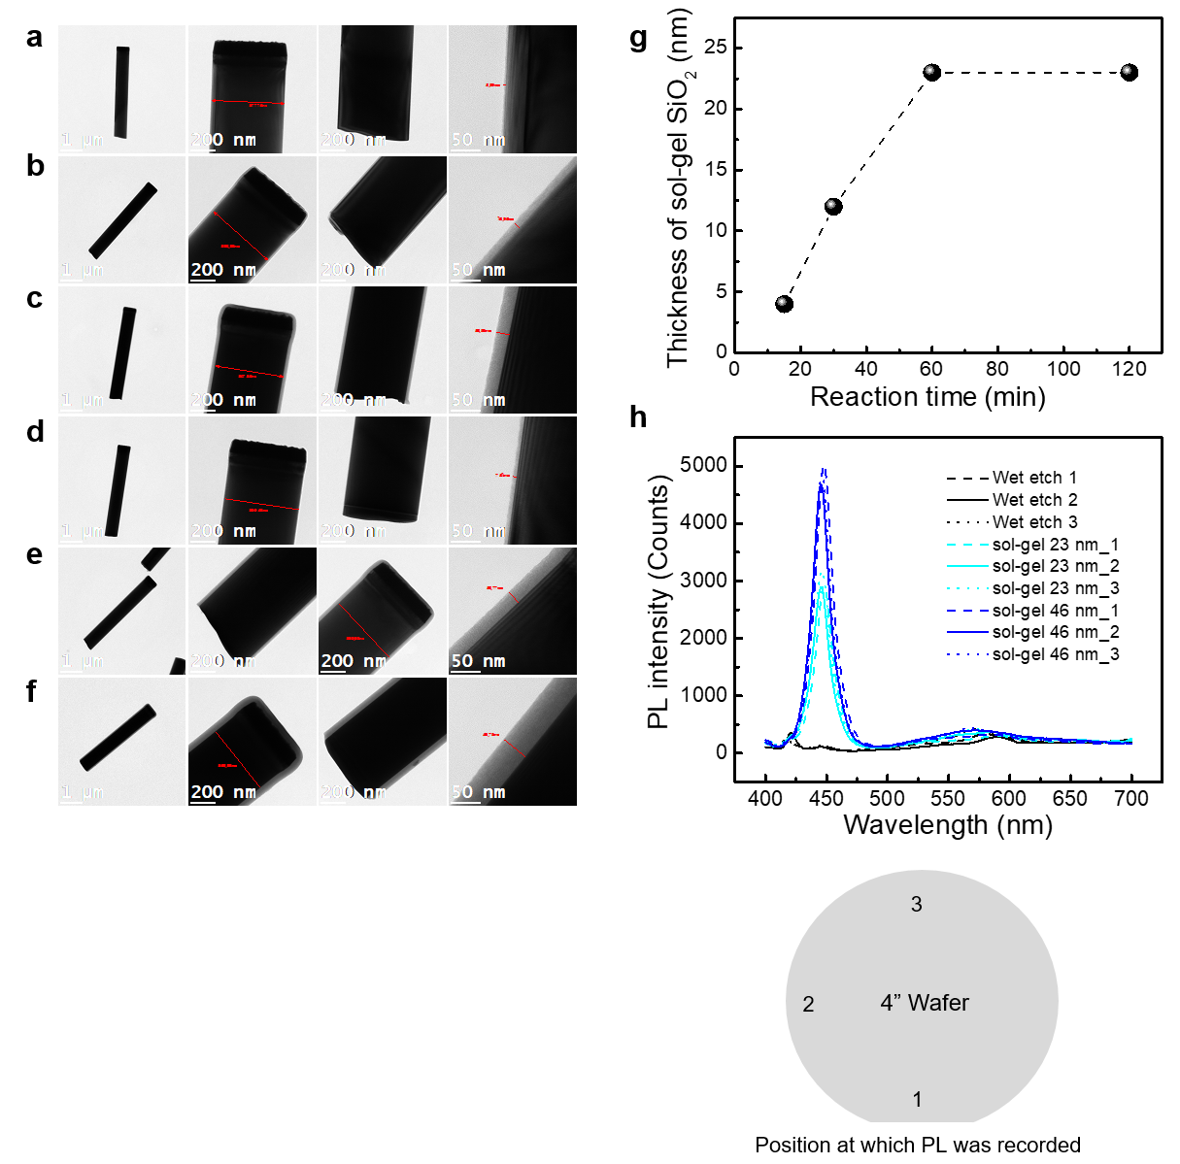
Extended Data Figure 2 | Synthesis of SiO₂ passivation layer via sol–gel method. TEM images of nLEDs passivated with sol–gel SiO₂ at reaction times of a, 15 b, 30, and c, 60 min. d–f, In addition, the reaction was repeated twice under the same synthesizing conditions to increase their thicknesses. g, The thickness of the SiO₂ layer was saturated at 23 nm after reaction for 60 min. h, PL intensities of the rods. We obtained the PL spectra from three different positions on a 4” wafer. The variation in the PL intensity with respect to the position is small. Furthermore, the PL intensity increased with an increase in the thickness of the sol–gel SiO₂ layer.

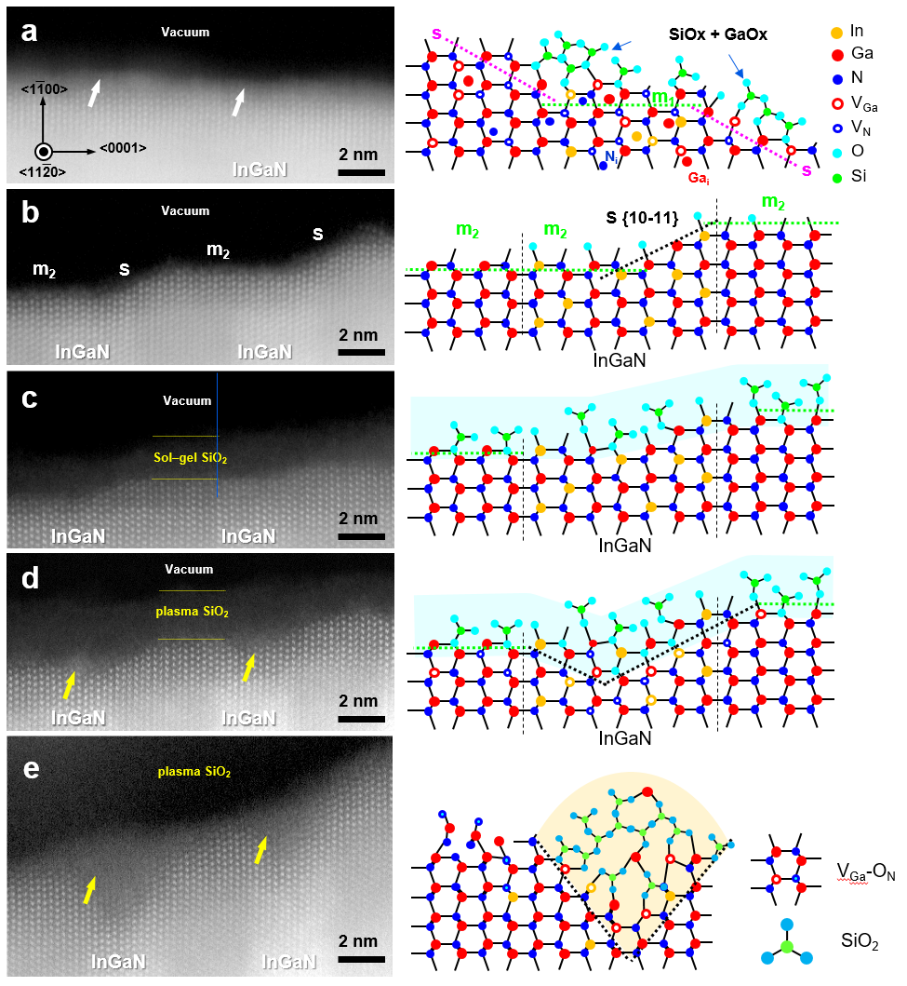
Extended Data Figure 3 | Atomic structure between the GaN surface and SiO₂ insulator. STEM-HAADF images of the MQWs in the sidewall region according to the fabrication steps, i.e., a, dry etch, b, wet etch, c, sol–gel SiO₂ deposition, and d, plasma ALD SiO₂ deposition. The increase in the plasma-induced amorphization at the QW sidewall with an increase in the thickness of the SiO₂ layer from d, 2 to e, 60 nm is evident.

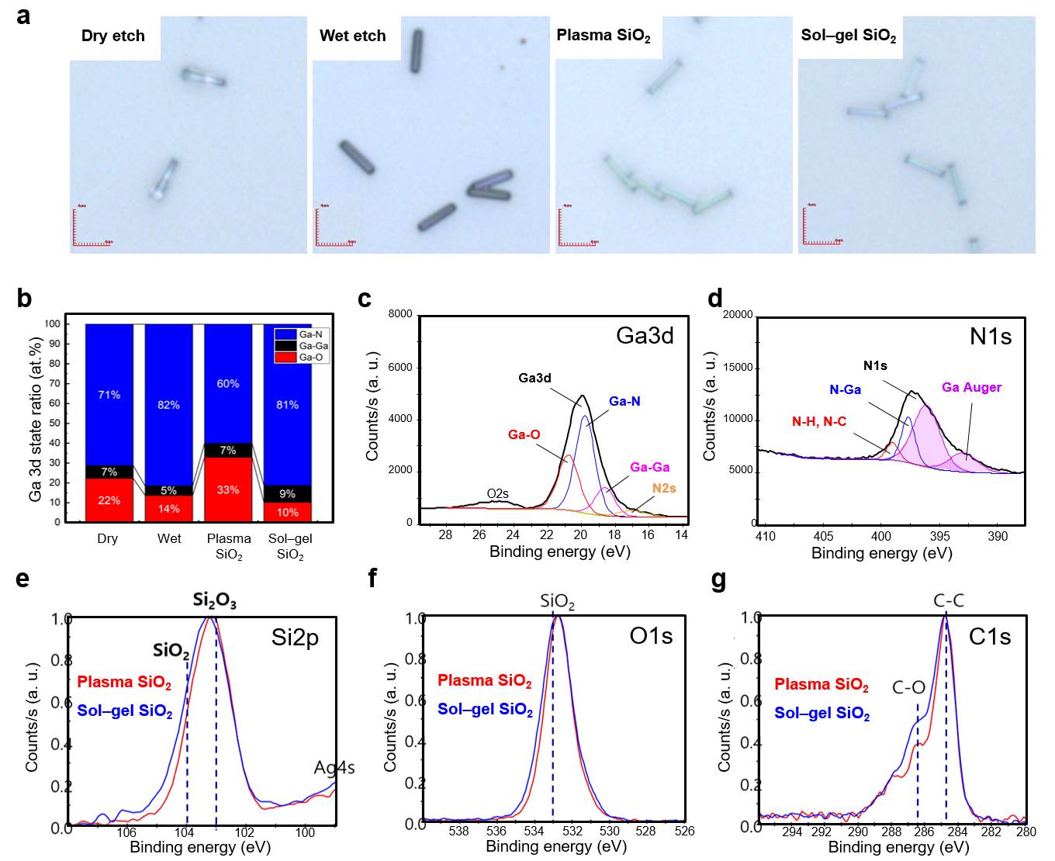
Extended Data Figure 4 | Surface defects of nLEDs according to their fabrication steps. a, Optical micrographs of the nLEDs dispersed on Si substrates. b, Ga 3d state ratios estimated via XPS. Fitting of XPS core level spectra of dry etched nanorods for c, Ga 3d and d, N 1s. Core level spectra for e, Si 2p, f, O 1s, and g, C 1s.

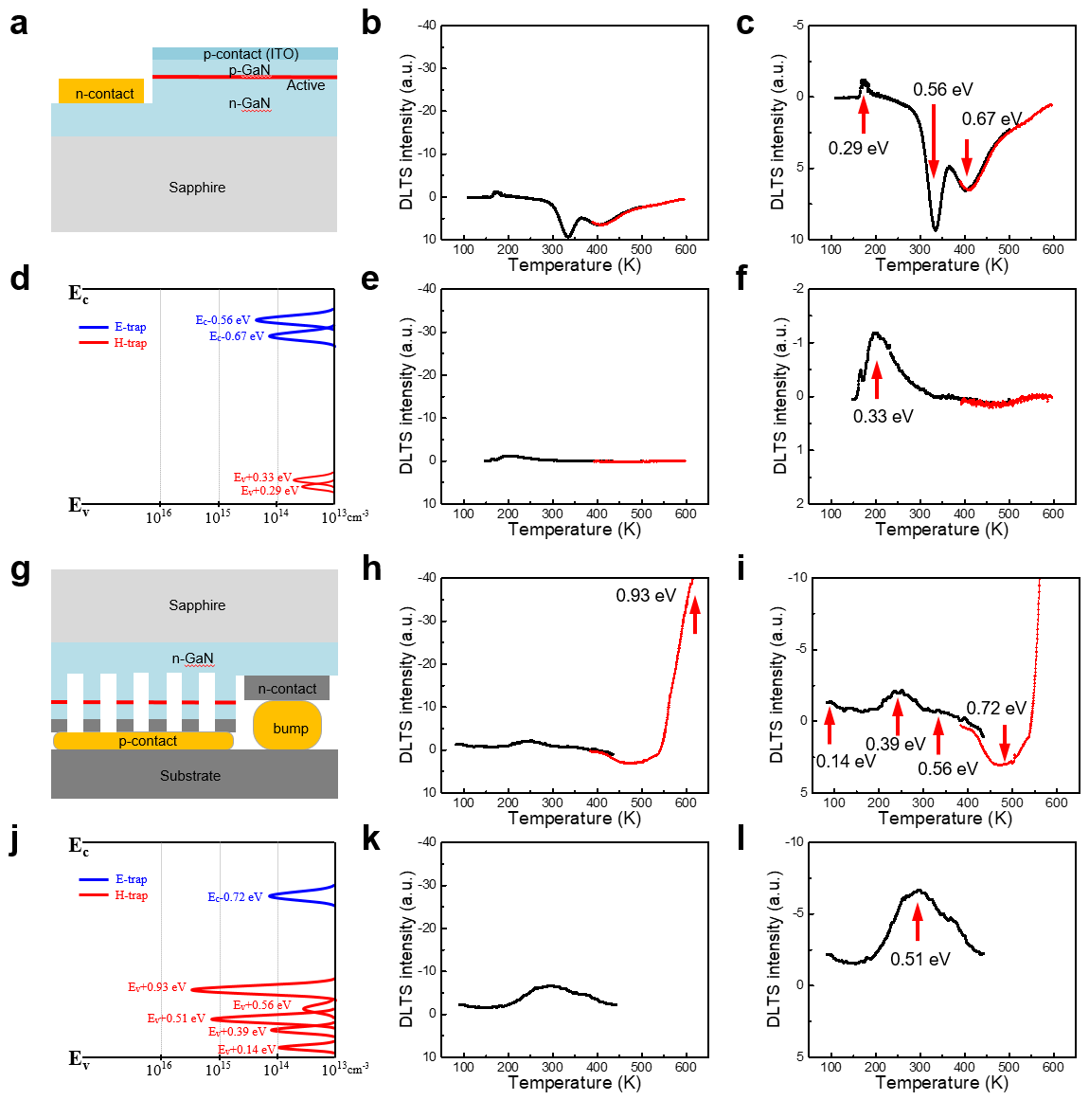
Extended Data Figure 5 | Analysis of trap levels and their concentrations via DLTS. a–f, bulk LED chip and g-l, nLED array chip. a, g, Schematic of the chip. DLTS spectra obtained at b, h, forward bias and c, i, enlarged spectra in the region around the peak. DLTS spectra obtained at e, k, reverse bias and f, i, enlarged spectra in the region around the peak. d, j, Trap levels with their concentrations. This clearly reveals that the hole traps are dominant, with high concentrations in the nLED array chip.

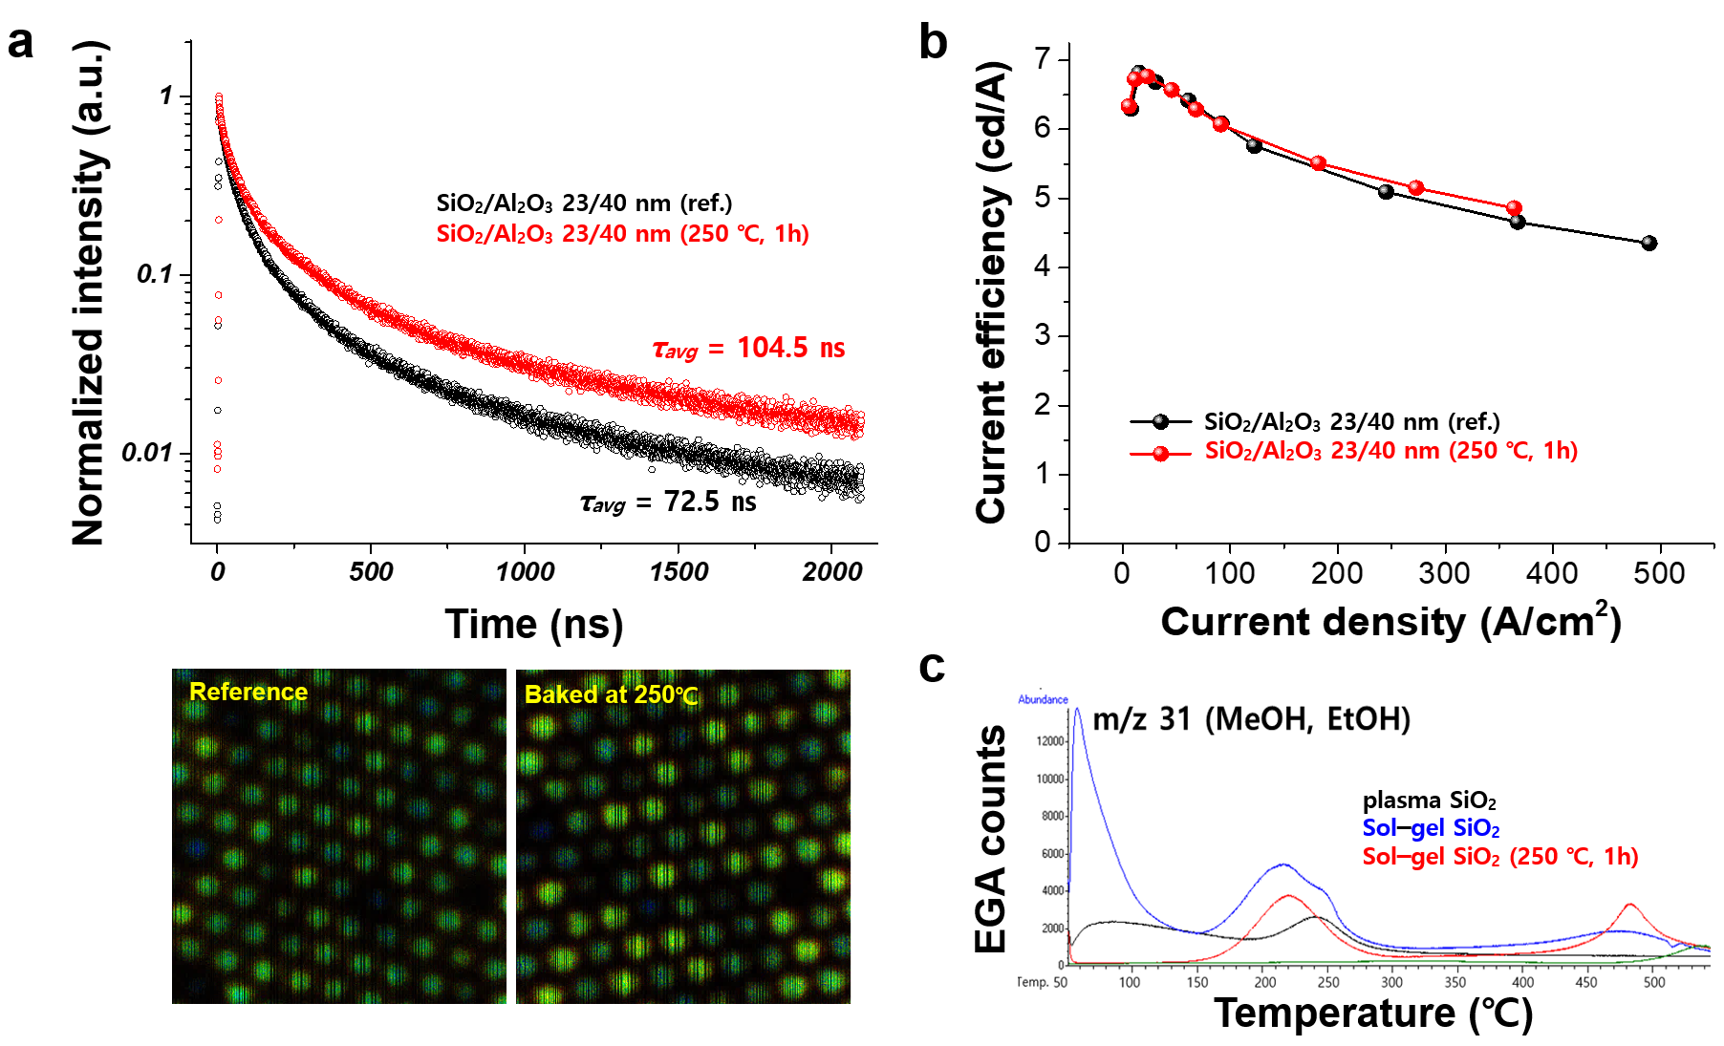

Extended Data Figure 6 | Post-treatments of the sol–gel SiO₂-coated nLEDs. a, PL decay traces of the nLEDs averaged over the areas indicated in the images below. The carrier lifetime increased after baking the sample at 250 ℃ for 1 h. b, Electroluminescence of the nLEDs in a pixel structure. The EL performance is the same before and after the annealing. At a high current injection, the EL efficiency is slightly increased. c, Comparison of outgassing between the SiO₂ layers using Py-CG/MS with EGA-MS.

