Extended Data
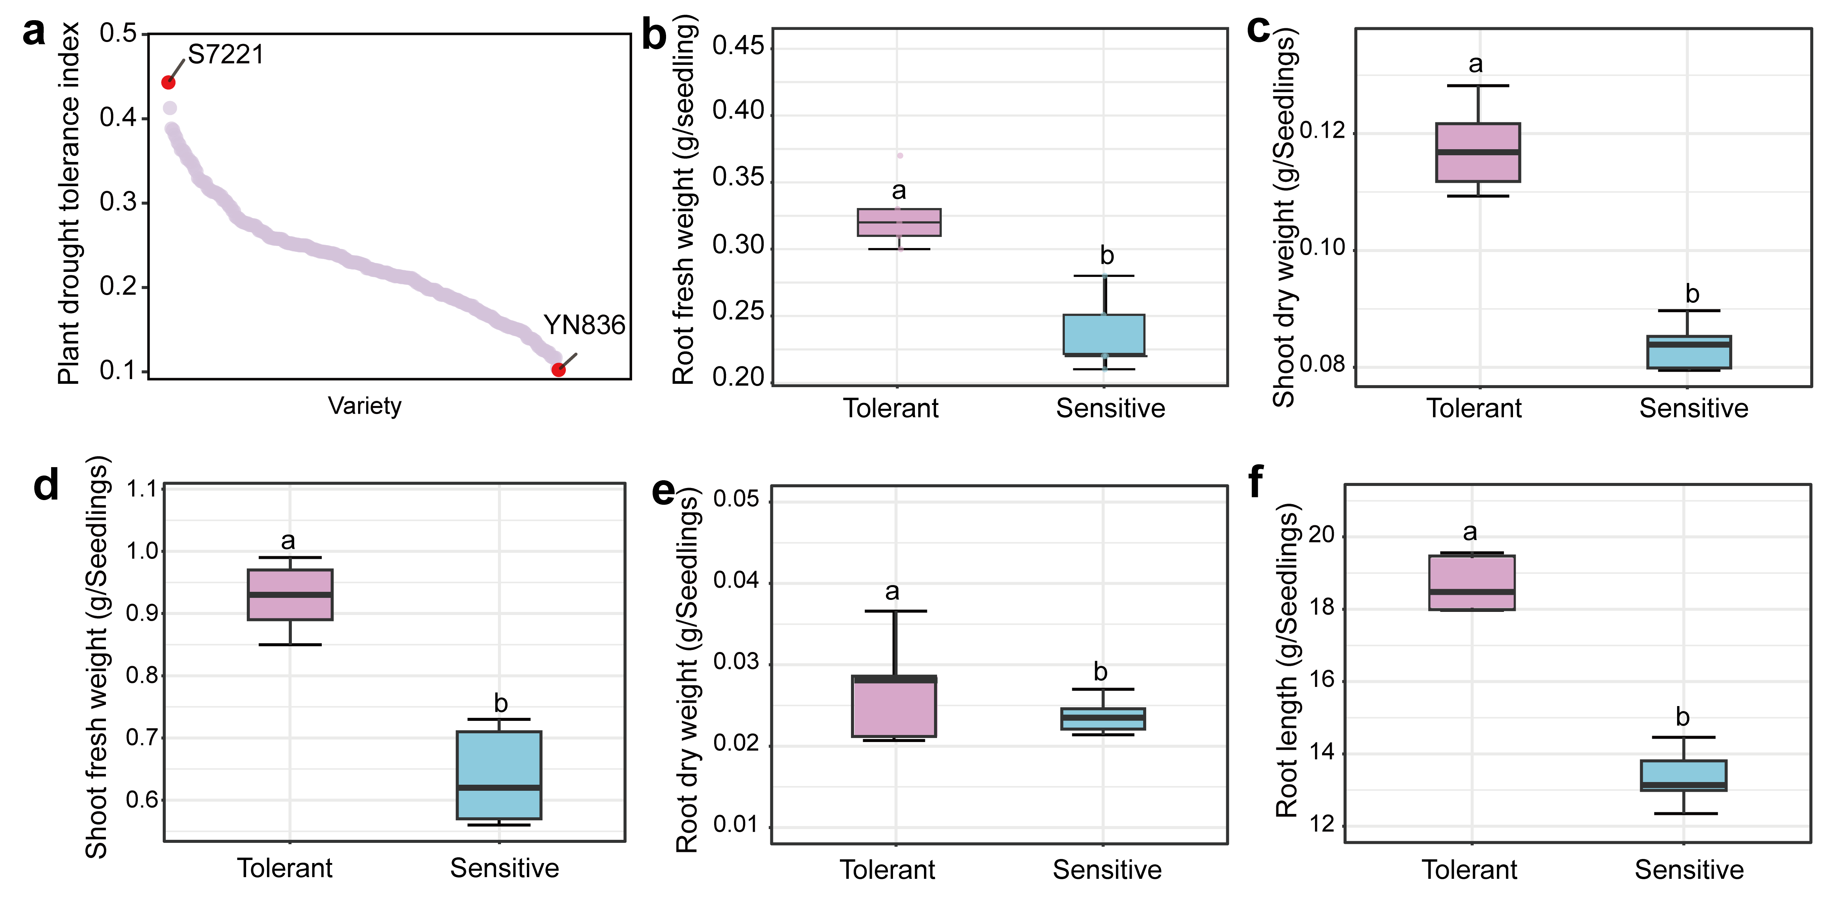
Suppl. Fig. 1: Identification of drought-tolerant and drought-sensitive wheat genotypes.
a, Distribution of plant drought tolerance index (PDTI) across 251 wheat varieties, highlighting the drought-tolerant genotype S7221 and the drought-sensitive genotype YN836.
b–f, Phenotypic comparison between S7221 (tolerant) and YN836 (sensitive) under drought stress, including root fresh weight (b), shoot dry weight (c), shoot fresh weight (d), root dry weight (e), and root length (f). Genotype differences were evaluated using one-way ANOVA, followed by Fisher’s LSD post hoc test. Multiple comparisons were corrected using the false discovery rate (FDR) method. Adjusted p-values < 0.05 were considered statistically significant. Data are shown as mean ± s.e.m. (n = 5 seedlings).

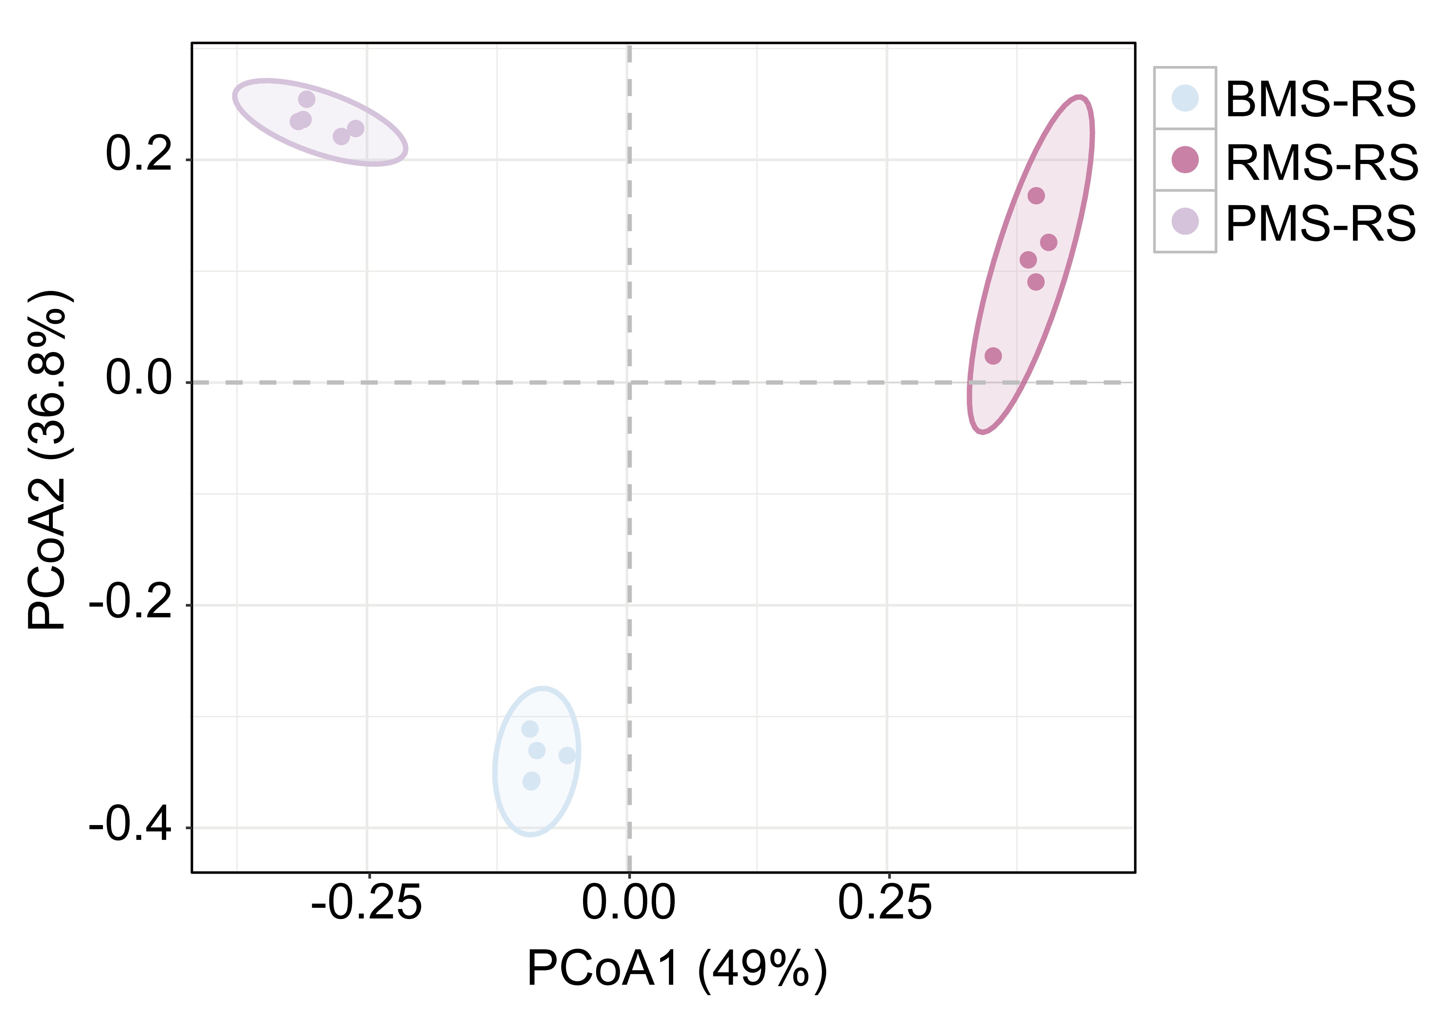
Suppl. Fig. 2: Distinct clustering of microbial communities across diverse soil–plant compartments.
Principal coordinate analysis (PCoA) of rhizosphere microbial communities from BMS-RS, RMS-RS, and PMS-RS samples based on β-diversity distances. Each point represents an individual biological replicate, and ellipses indicate group clustering. The first two axes explain 49% (PCoA1) and 36.8% (PCoA2) of the total variation, respectively. Bulk soil (BMS), rhizosphere soil (RMS), root endosphere (REMS), phyllosphere (PMS), and leaf endosphere (LEMS).

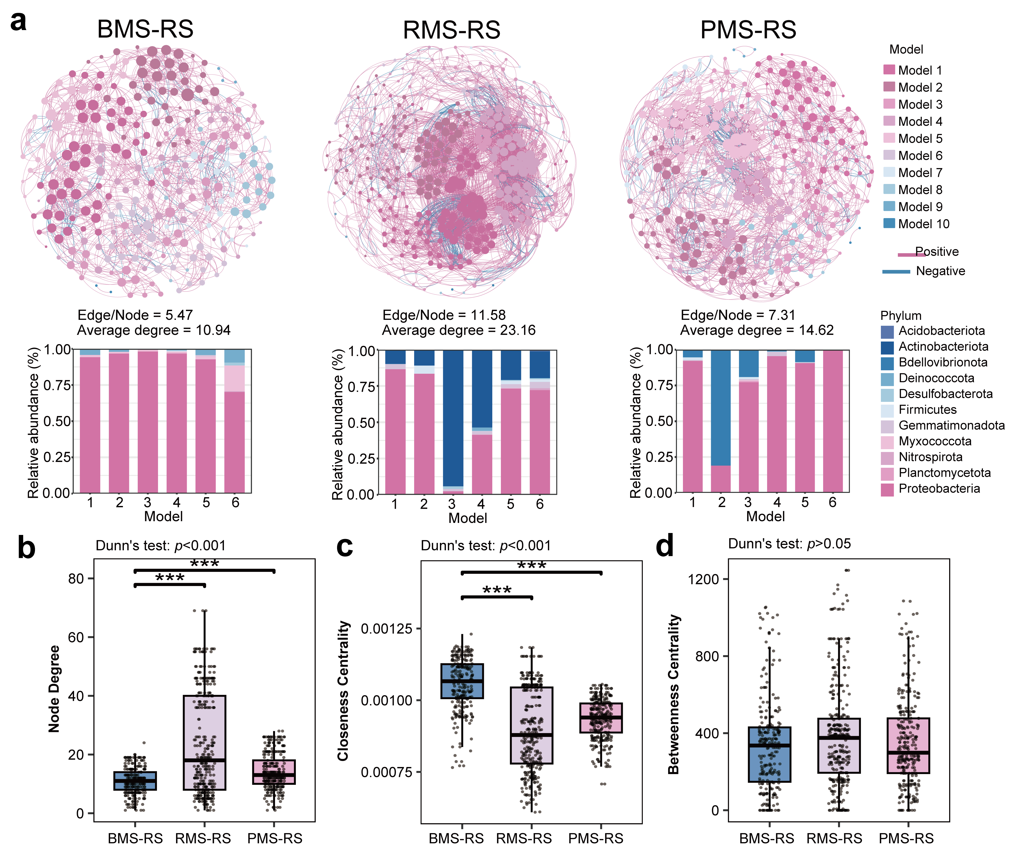
Suppl. Fig. 3: Co-occurrence network analysis reveals distinct rhizosphere bacterial community organization across treatments.
a, Co-occurrence networks of rhizosphere bacterial communities in BMS-RS, RMS-RS and PMS-RS compartments, constructed using Spearman correlations (|r| > 0.6, p < 0.05). Nodes represent bacterial taxa and edges indicate significant positive or negative associations. Node color denotes bacterial phylum and node size corresponds to relative abundance. Bar plots show the relative abundance of dominant bacterial phyla across network modules. Key network properties (edge/node ratio and average degree) are indicated below each network.
b–d, Comparison of network topological features among treatments, including node degree (b), closeness centrality (c), and betweenness centrality (d). Statistical significance was assessed using Dunn’s multiple comparisons test following Kruskal-Wallis analysis. Adjusted p-values were used, with ***p< 0.001 considered statistically significant; ns, not significant. Bulk soil (BMS), rhizosphere soil (RMS), root endosphere (REMS), phyllosphere (PMS), and leaf endosphere (LEMS).

Suppl. Fig. 4: Differential enrichment of rhizosphere bacterial taxa across compartments.
a, Intersection of amplicon sequence variants (ASVs) among BMS-RS, RMS-RS, and PMS-RS compartments, showing shared and treatment-specific taxa.
b, Relative abundance of the top 10 bacterial genera across the three treatments.
c, The linear discriminant analysis effect size (LEfSe) identifying differentially enriched bacterial genera among treatments. Left, LDA scores indicating effect size of discriminative taxa. Right, corresponding relative abundances of these genera across groups. Genera with LDA scores> 2.0 were selected, and the top 20 were visualized. Statistical significance was assessed using one-way ANOVA followed by Fisher’s least significant difference (LSD) test, with p-values adjusted using the false discovery rate (FDR) method. Significance levels are indicated as *p < 0.05. Bulk soil (BMS), rhizosphere soil (RMS), root endosphere (REMS), phyllosphere (PMS), and leaf endosphere (LEMS).

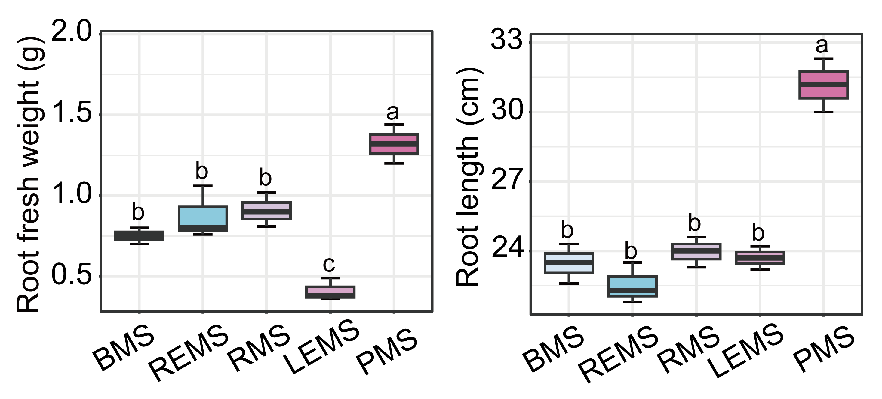
Suppl. Fig. 5: Phyllosphere-derived microbiomes enhance root growth in drought-sensitive wheat.
Root fresh weight (left) and root length (right) of drought-sensitive wheat seedlings following inoculation with microbiomes derived from five compartments (BMS, REMS, RMS, LEMS, and PMS). Data represent mean ± s.e.m. (n = 10 biologically independent plants). Statistical significance was assessed by one-way ANOVA followed by Fisher’s LSD test with FDR correction (adjusted p< 0.05). Bulk soil (BMS), rhizosphere soil (RMS), root endosphere (REMS), phyllosphere (PMS), and leaf endosphere (LEMS).

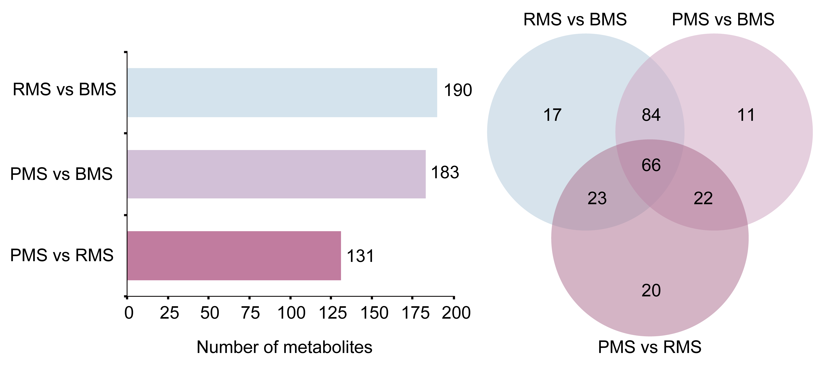
Suppl. Fig. 6: Differential metabolite profiles distinguish between diverse microbial compartments.
Left, Number of differentially abundant metabolites identified in pairwise comparisons among BMS, RMS, and PMS treatments. Right, Venn diagram showing shared and treatment-specific differentially abundant metabolites across comparisons. Bulk soil (BMS), rhizosphere soil (RMS), root endosphere (REMS), phyllosphere (PMS), and leaf endosphere (LEMS).
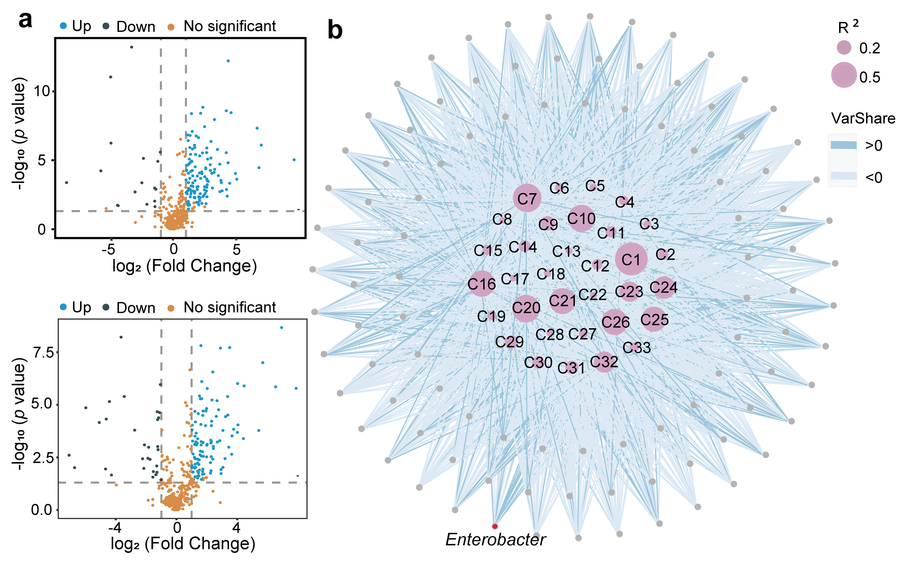
Suppl. Fig. 7: Identification of differential metabolites between RMS and PMS microbiomes.
a, Volcano plots showing differentially abundant metabolites between BMS and RMS (top) and BMS and PMS (bottom). Each point represents a metabolite. Differential metabolites were defined by |log₂(fold change)| > 1, VIP > 1 (OPLS-DA), and FDR-adjusted P < 0.05 (two-sided Student’s t-test).
b, Network linking rhizosphere microbes to metabolite variation inferred using the MIMOSA2 framework. Nodes represent metabolites, and edges indicate microbial contributions to metabolite variance. Edge color denotes direction of association (VarShare > 0, positive; VarShare < 0, negative), and node size reflects the coefficient of determination (R²), indicating the extent to which microbial composition predicts metabolite abundance.

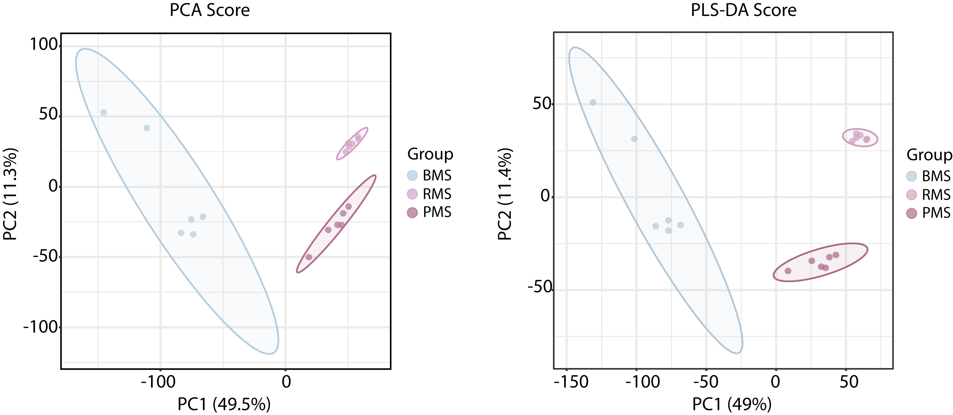
Suppl. Fig. 8: Distinct β-diversity patterns of bacterial communities across compartments.
a, Principal component analysis (PCA) was implement based on Bray-Curtis distance matrices of rhizosphere bacterial communities in different samples.
b, Partial least squares discriminant analysis (PLS-DA) was implement in different samples.

Suppl. Fig. 9: Microbiome metabolic potential predicts variation in metabolite features.
Predicted associations between bacterial community metabolic potential (CMP) scores and metabolite levels for the top 20 metabolites. Each point represents an individual sample, plotted as CMP score versus log₁₀-transformed, standardized metabolite abundance. Dashed lines indicate linear regression fits, and values in the upper right corner denote the coefficient of determination (R²).
Suppl. Fig. 10: Bacterial taxa contributing to variation in rhizosphere metabolites.
Contribution of bacterial taxa to the variance of 20 representative metabolites inferred from microbiome-metabolite association analysis. Bar plots show the relative contribution of individual taxa to metabolite variation, with taxa ranked by their explanatory power.

Suppl. Fig. 11: Microbiome-dependent changes in root exudate metabolite profiles.
Log₁₀-transformed, standardized abundances of 20 metabolites in root exudates of drought-sensitive wheat seedlings following inoculation with BMS, RMS, and PMS microbiomes. Data are presented as mean ± s.e.m. (n = 6 biologically independent samples). Statistical significance was assessed by one-way ANOVA followed by Fisher’s LSD test with FDR correction (adjusted p< 0.05).

Suppl. Fig. 12: SynComs and prebiotics differentially influence growth of drought-sensitive wheat under drought.
a, Plant height and b, root fresh weight of drought-sensitive wheat seedlings under drought stress following inoculation with synthetic microbial communities (SynComs) with or without prebiotic supplementation. Data are presented as mean ± s.e.m. (n = 10 biologically independent plants). Statistical significance was assessed by one-way ANOVA followed by Fisher’s LSD test with FDR correction (adjusted p< 0.05).

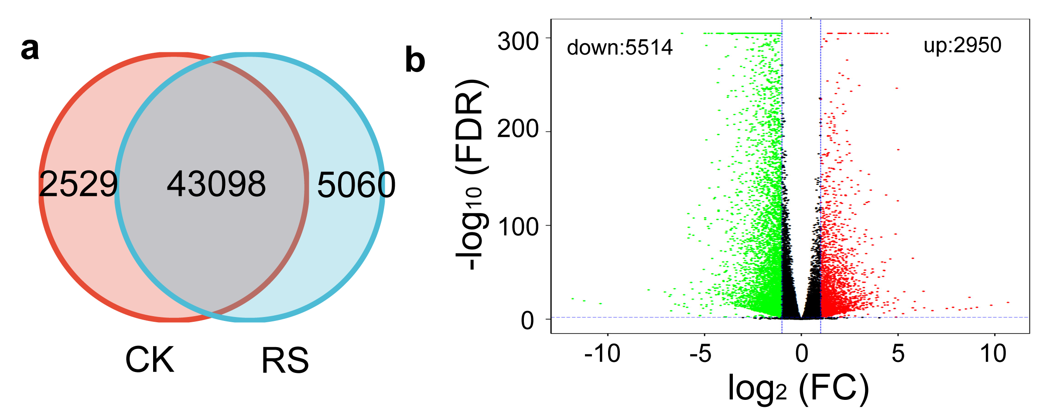
Suppl. Fig. 13: SynCom C with prebiotics reshapes the wheat root transcriptome under drought.
a, Venn diagram showing the overlap of expressed genes between control (CK) and SynCom C plus prebiotic treatment under drought (RS).
b, Volcano plot of differentially expressed genes between RS and CK. Differential expression was defined using |log₂ fold change| thresholds and FDR-adjusted significance. Upregulated genes (red) and downregulated genes (green) are indicated.
Suppl. Fig. 14: KEGG pathway annotation and enrichment of differentially expressed genes under SynCom treatment.
a, KEGG pathway classification of differentially expressed genes (DEGs) between SynCom-treated plants (SP) and control (CK). Pathways are grouped into major functional categories, including cellular processes, environmental information processing, genetic information processing, metabolism, and organismal systems. Bars indicate the number of upregulated and downregulated genes assigned to each pathway.
b, KEGG pathway enrichment analysis of DEGs between SP and CK. The x-axis represents the rich factor (ratio of DEGs to total annotated genes in each pathway). Dot size corresponds to the number of DEGs, and color indicates the significance level (adjusted p value). Upregulated and downregulated gene contributions are indicated.

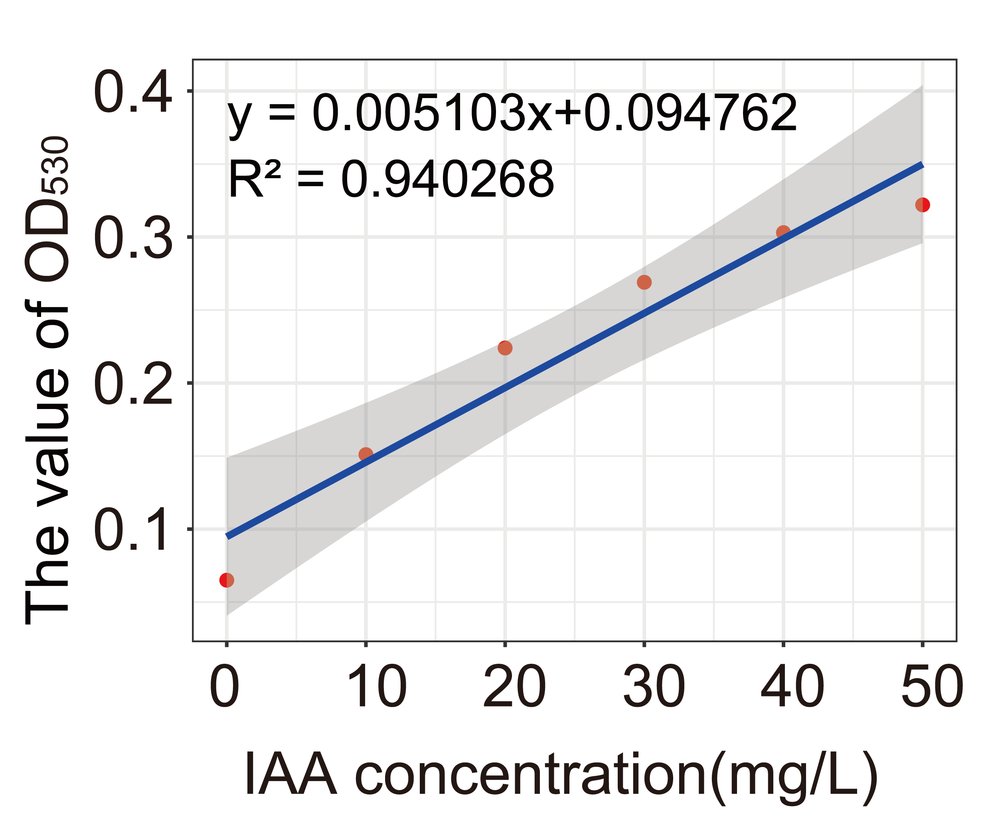Suppl. Fig. 15: Standard curve for indole-3-acetic acid (IAA) quantification.
Standard curve relating IAA concentration to absorbance at 530 nm (OD₅₃₀). The linear regression model (y = 0.005103x + 0.094762; R² = 0.9403) was used to quantify IAA concentrations in samples. Shaded areas represent the 95% confidence interval of the regression.

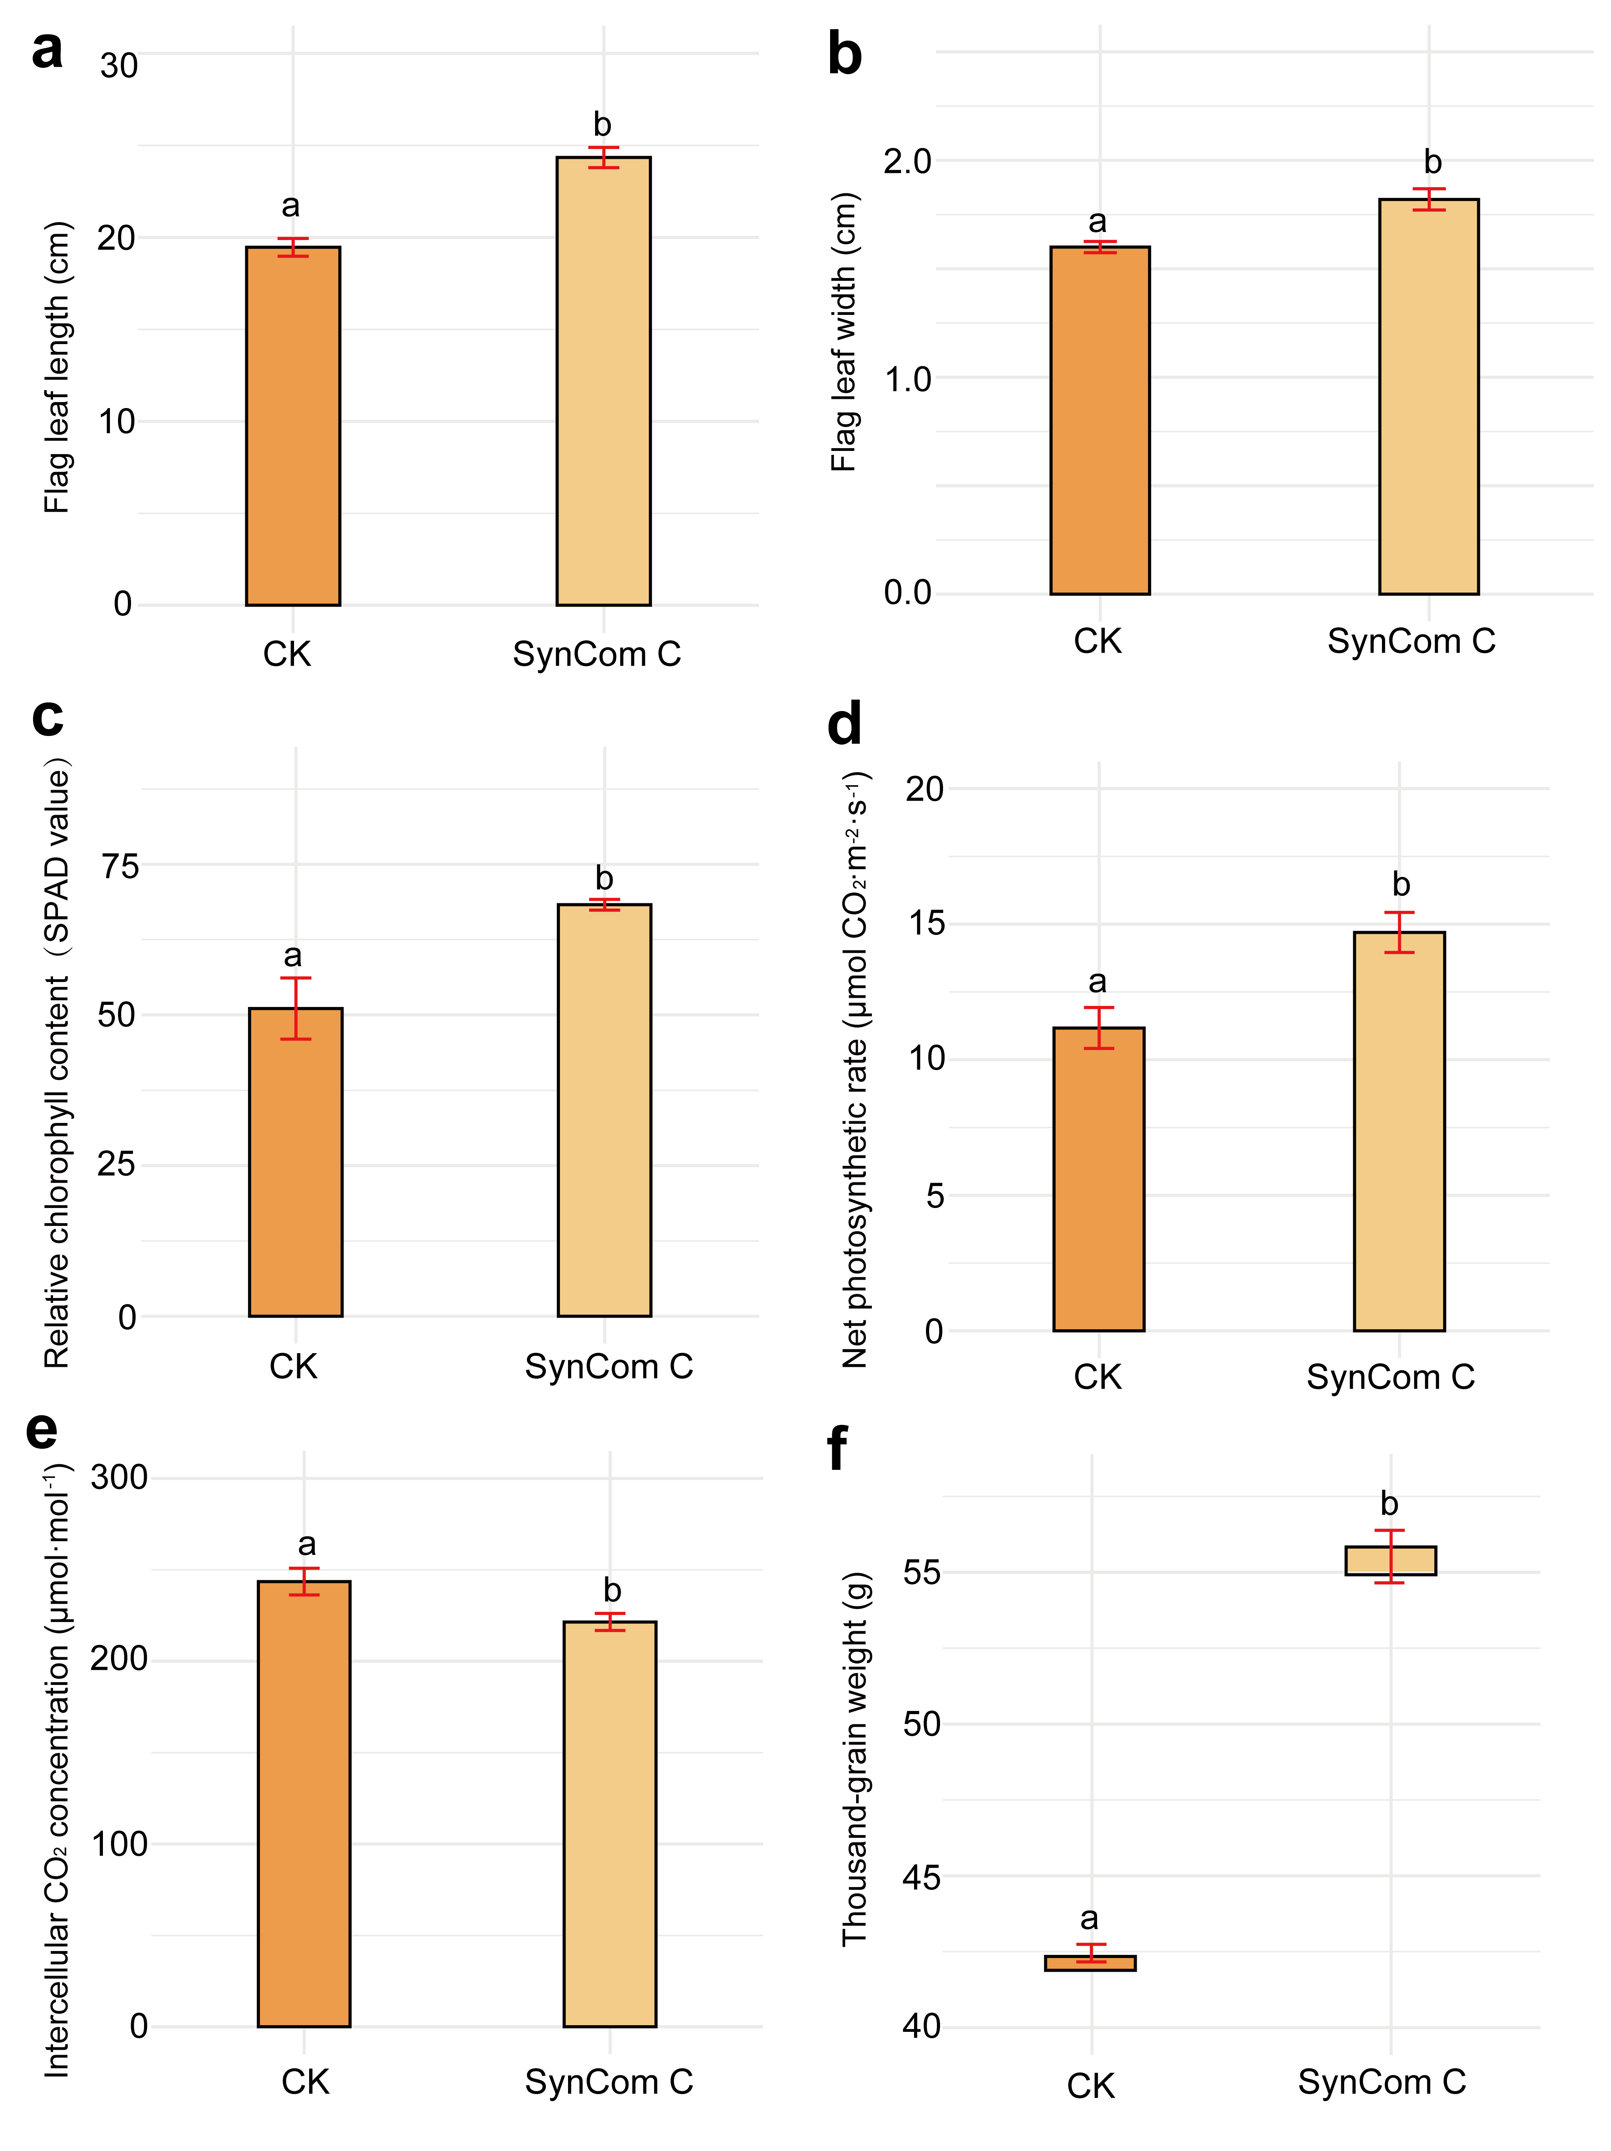
Suppl. Fig. 16: SynCom C enhances wheat physiological performance and yield traits under field conditions.
a–f, Phenotypic and physiological traits of drought-sensitive wheat measured at the heading stage under field conditions, with or without SynCom C inoculation.
a, Flag leaf length; b, flag leaf width; c, relative chlorophyll content (SPAD values); d, net photosynthetic rate; e, intercellular CO₂ concentration; f, thousand-grain weight. Data are presented as mean ± s.e.m. Statistical significance was assessed by one-way ANOVA followed by Tukey HSD test with adjusted p< 0.05.

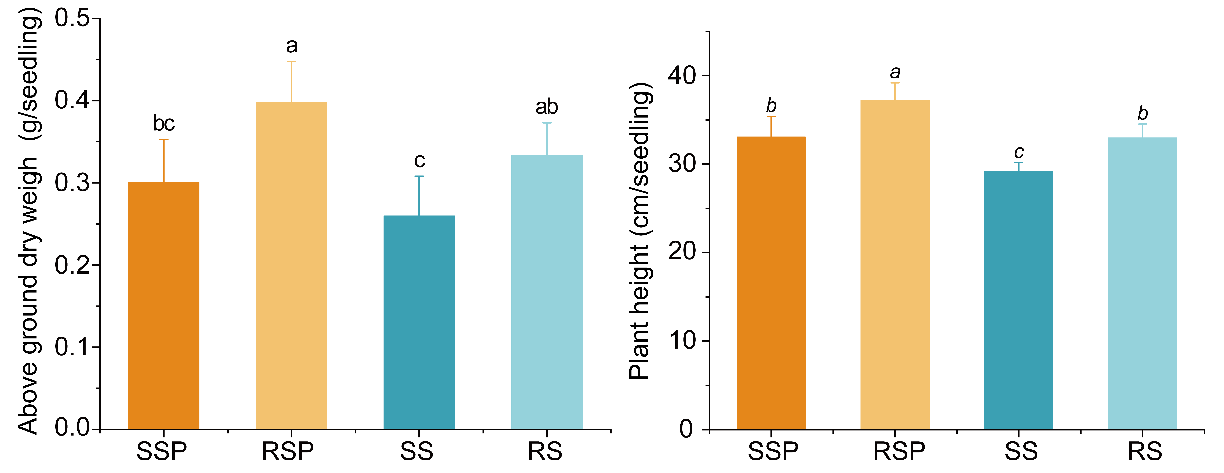
Suppl. Fig. 17: Metabolite-mediated effects on wheat growth in a split-root system.
Aboveground dry weight and plant height of wheat plants treated with metabolite fractions derived from four treatment groups in a split-root assay. Treatments include SSP, RSP, SS, and RS. Statistical significance was assessed by one-way ANOVA followed by Fisher’s LSD test with FDR correction (adjusted p< 0.05). Data represent mean ± s.e.m. (n = 10 biologically independent plants). Metabolites extracted from bulk soil inoculated with SynCom C (SS), rhizosphere soil of plants inoculated with SynCom C (RS), bulk soil inoculated with SynCom C and the prebiotic (SSP), and rhizosphere soil of plants inoculated with SynCom C and the prebiotic (RSP).

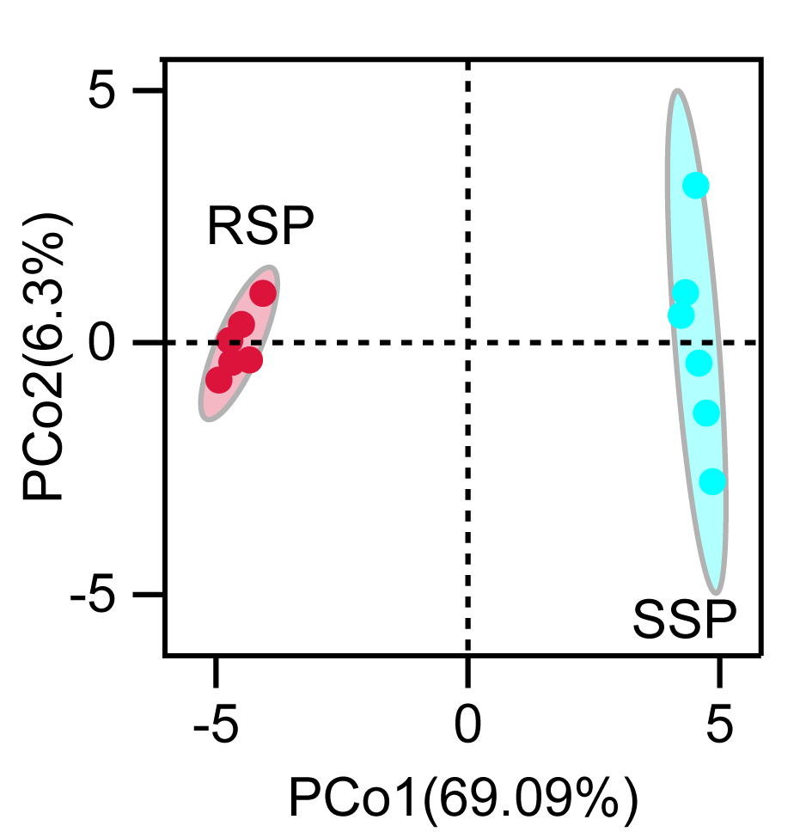Suppl. Fig. 18: Distinct metabolite profiles between rhizosphere- and bulk-derived fractions under SynCom C and prebiotic treatments. Principal coordinate analysis (PCoA) of metabolite profiles from bulk soil and rhizosphere compartments under SynCom C and prebiotic treatments. SSP denotes bulk soil inoculated with SynCom C and prebiotic, whereas RSP denotes rhizosphere soil of plants inoculated with SynCom C and prebiotic. Each point represents an independent biological replicate, and ellipses indicate group clustering. The percentage of variance explained by each axis is shown in parentheses.

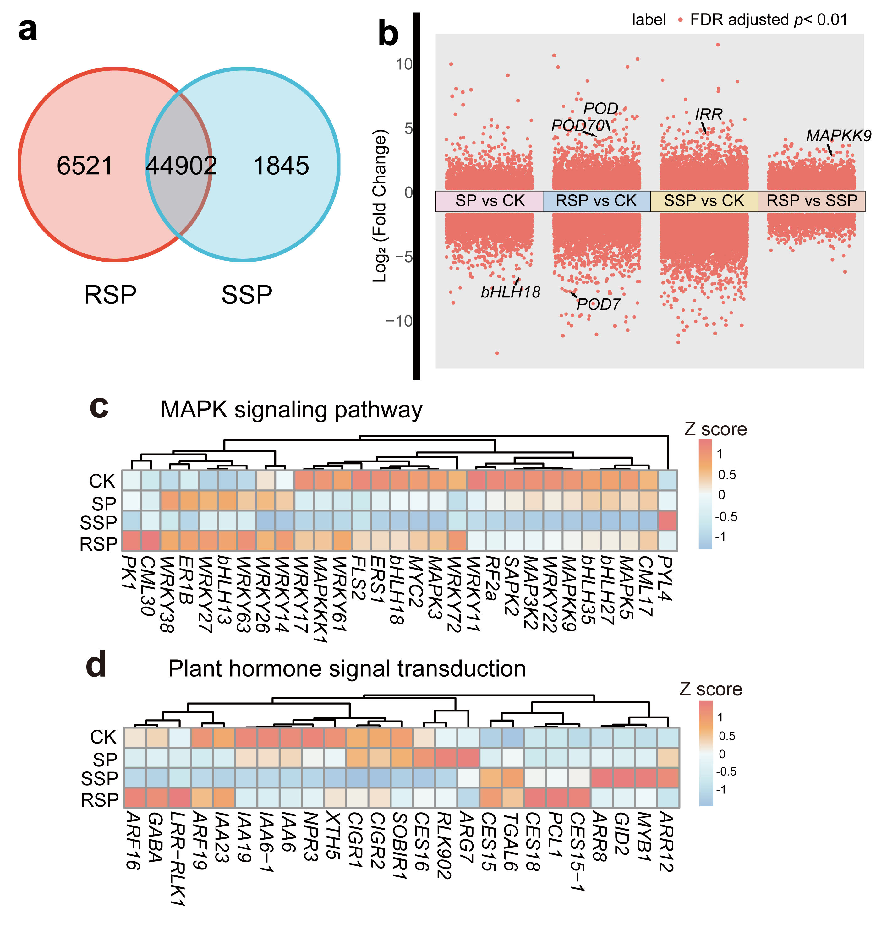
Suppl. Fig. 19: Transcriptomic reprogramming across soil compartments and metabolite-mediated treatments.
a, Venn diagram showing the overlap and unique differentially expressed genes (DEGs) between RSP (rhizosphere soil with SynCom C and prebiotic) and SSP (bulk soil with SynCom C and prebiotic) treatments.
b, Differential gene expression across pairwise comparisons (SP vs CK, RSP vs CK, SSP vs CK, and RSP vs SSP). Each point represents a gene; significantly regulated genes were defined using FDR-adjusted P < 0.01. Selected marker genes are indicated.
c, d, Heatmaps showing normalized expression patterns (Z-scores of log₂-transformed FPKM values) of genes associated with the MAPK signaling pathway (c) and plant hormone signal transduction (d) across treatments (CK, SP, SSP, and RSP). Hierarchical clustering was applied to genes.

Suppl. Fig. 20: Integrated metabolite–gene correlation network highlights phenylpropanoid pathway regulation.
Correlation network linking significantly altered metabolites and differentially expressed genes (DEGs) associated with the phenylpropanoid biosynthesis pathway. Metabolites were defined as significantly different with fold change ≥ 1 and p < 0.05, and genes as DEGs with fold change ≥ 2 and FDR-adjusted p < 0.01. Nodes represent metabolites and genes, and edges indicate significant correlations between them. Red edges denote positive correlations, whereas blue edges denote negative correlations.

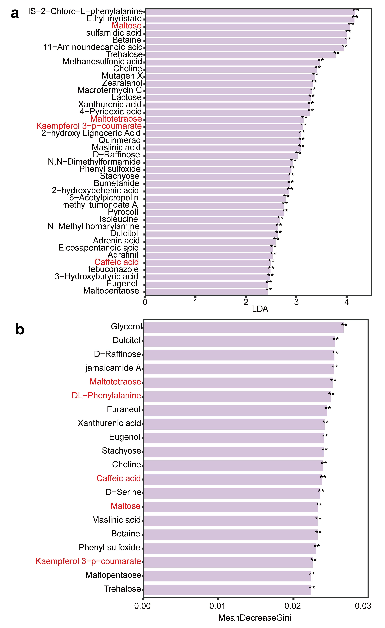
Suppl. Fig. 21: Identification of discriminant metabolites between RSP and SSP treatments.
Biomarker metabolites distinguishing RSP (rhizosphere soil with SynCom C and prebiotic) from SSP (bulk soil with SynCom C and prebiotic) were identified using complementary statistical approaches.
a, Linear discriminant analysis (LDA) identifying metabolites that contribute most to group separation. Metabolites with LDA scores> 2 and FDR-adjusted p< 0.01 (two-sided Kruskal–Wallis test) were considered significant.
b, Random forest classification ranking the top 30 metabolites based on their importance (Mean Decrease in Gini) in discriminating RSP and SSP samples. Asterisks indicate statistically significant differences (p < 0.01).

Suppl. Fig. 22: PAL function is required for SynCom C–mediated growth promotion under drought.
Plant height and root dry weight of wild-type (WT) and pal-1 and pal-2 mutant seedlings under drought stress, with or without SynCom C inoculation. Statistical significance was assessed by one-way ANOVA followed by Fisher’s LSD test with FDR correction (adjusted p< 0.05). Data represent mean ± s.e.m. (n = 6 biologically independent plants).
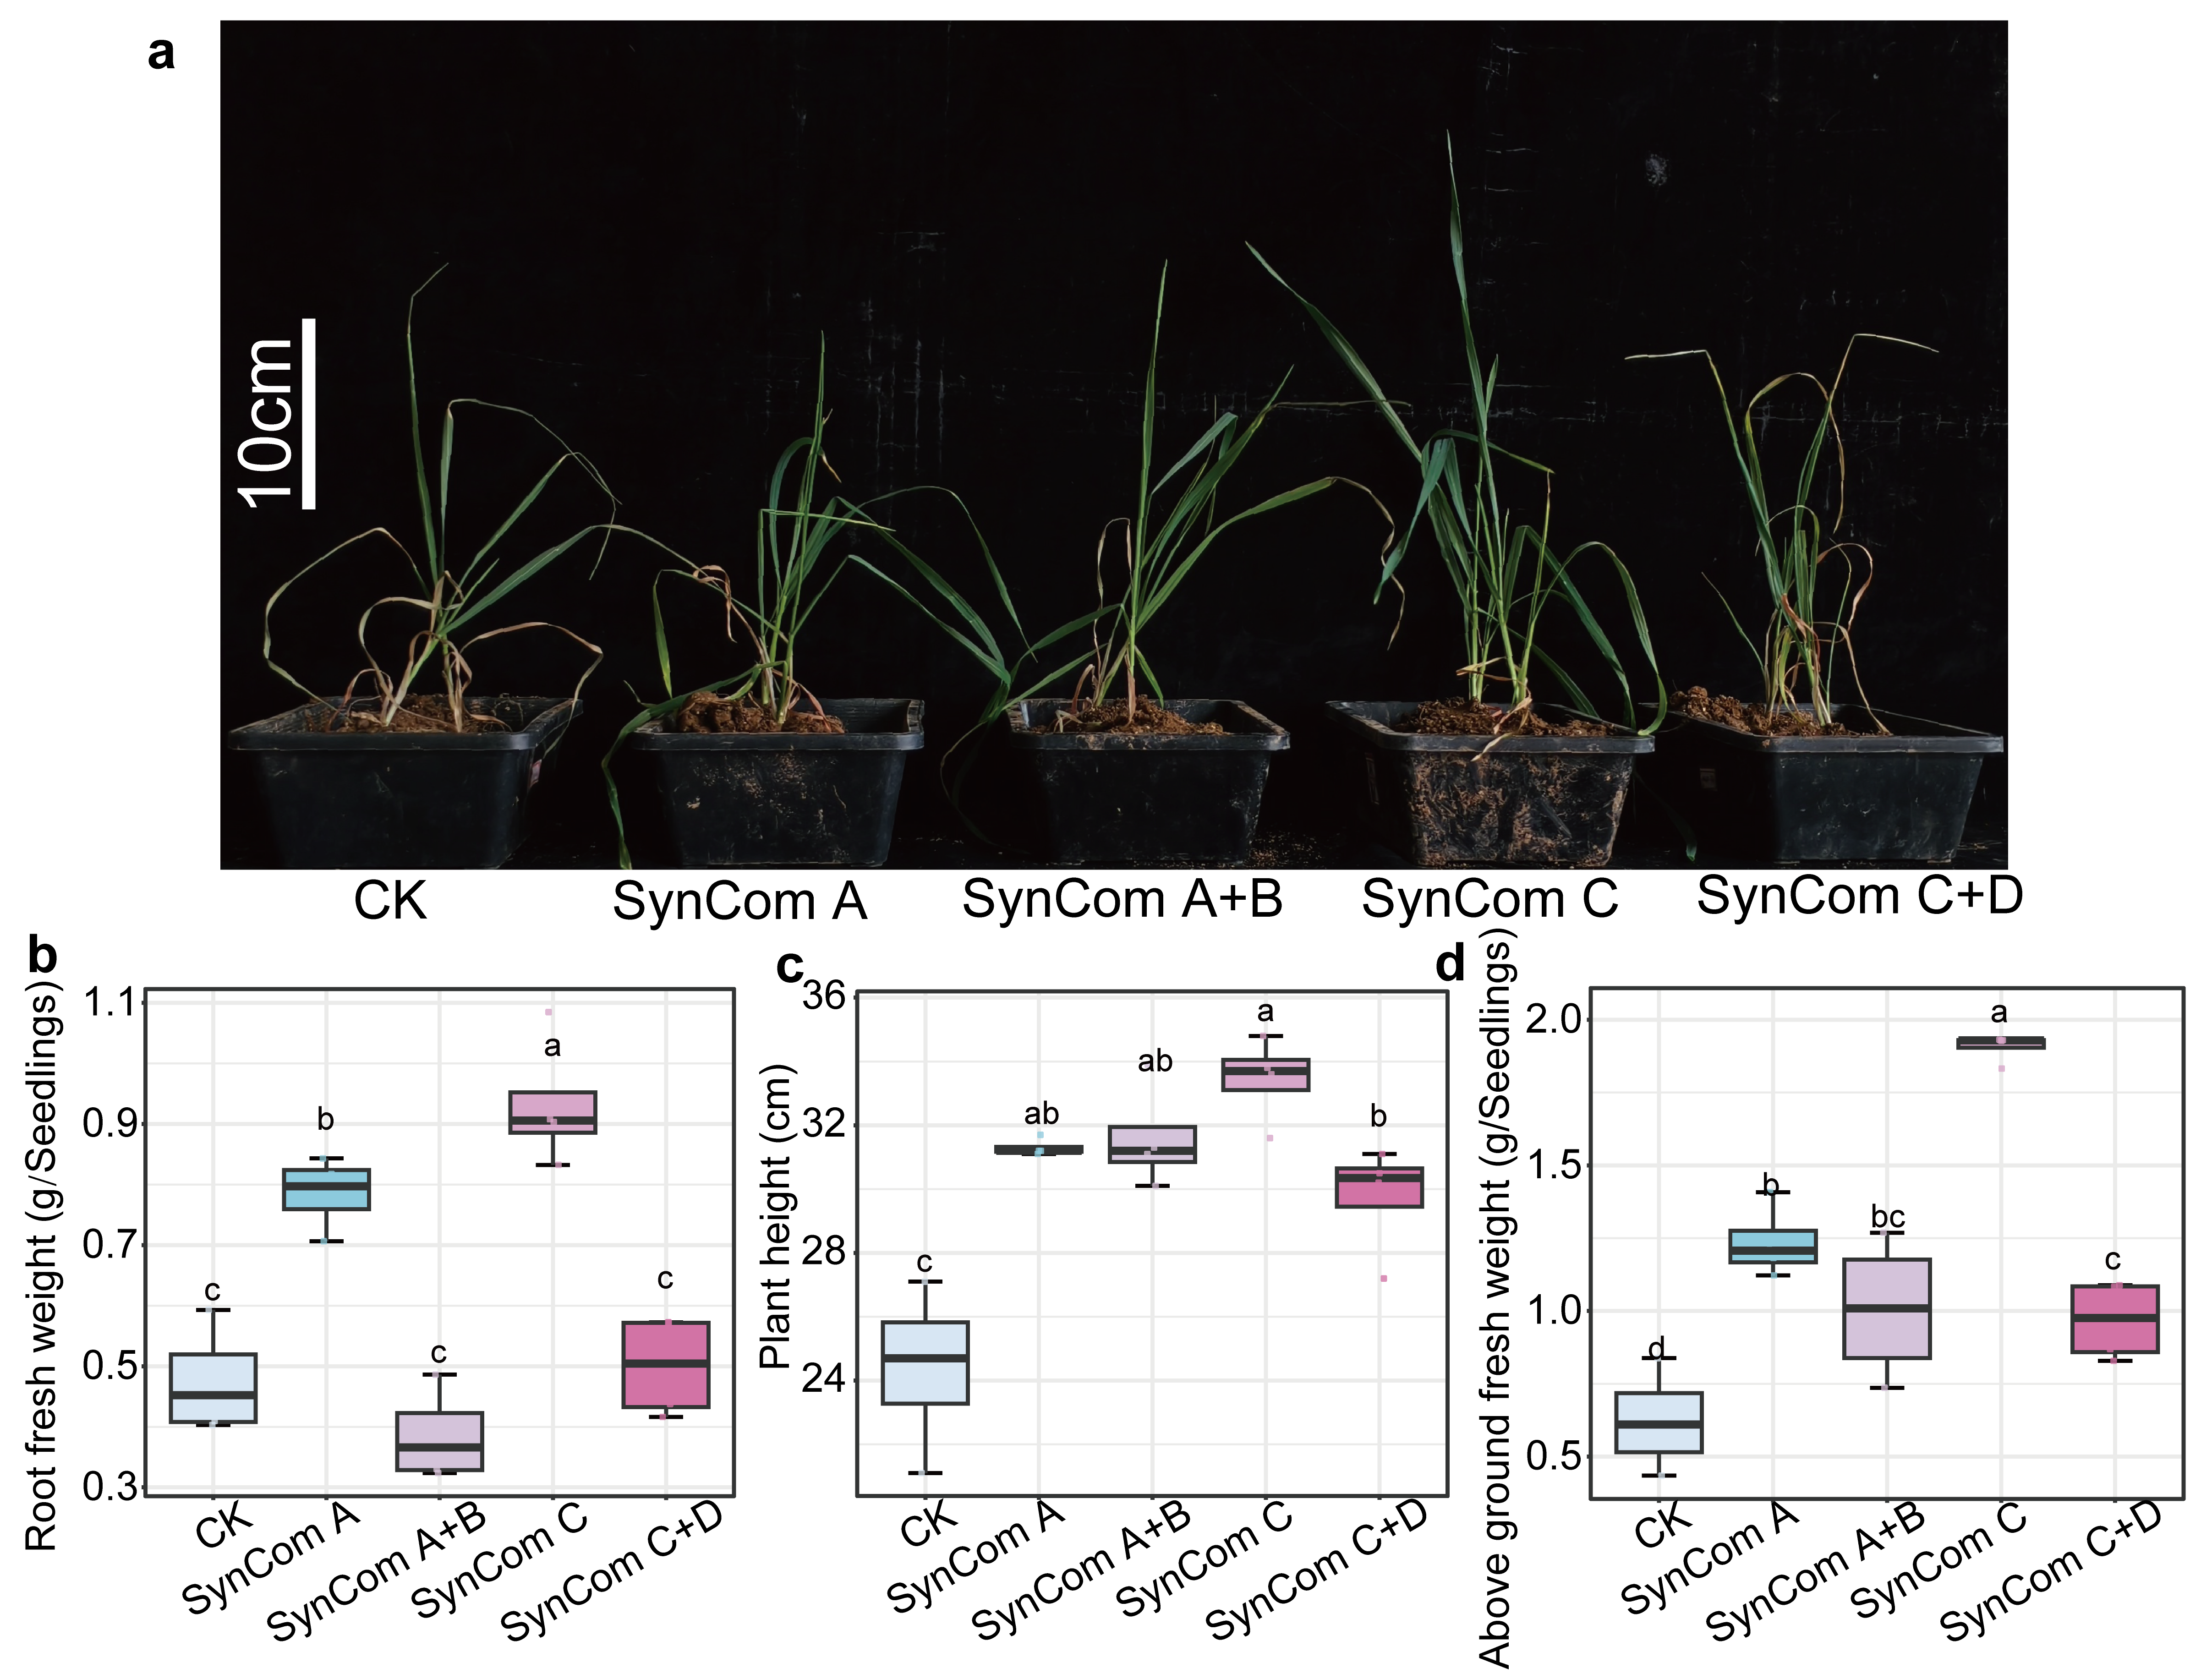
Suppl. Fig. 23 SynCom C enhances wheat drought tolerance.
a, Representative images showing the growth of drought-sensitive wheat plants under drought stress with or without SynCom inoculation (CK, SynCom A, SynCom A+B, SynCom C, and SynCom C+D). Scale bar, 10 cm.
b–d, Quantification of drought-related growth traits, including root fresh weight (b), plant height (c), and aboveground fresh weight (d), across SynCom treatments. Statistical significance was assessed by one-way ANOVA followed by Fisher’s LSD test with FDR correction (adjusted p< 0.05). Data are presented as mean ± s.e.m. (n = 10 biologically independent plants).

