Supplementary Information
Non-Radiative Recombination of Triplet Charge-Transfer State as the Key of Limiting Efficiency Mediates the Positive Relevance of J_{SC} and V_{OC}
Yue Ren,ª Ming-Yang Li,ª Yun Geng,^{b} Yi-Zhou Xu,ª Guang-Yan Sun,^{*a} Ming-Yue Sui^{*a} and Zhong-Min Su^{a,b}
a. Department of Chemistry, Faculty of Science, Yanbian University, Yanji 133002, Jilin, P. R. China; Email: gysun@ybu.edu.cn
b. Institute of Functional Material Chemistry, Faculty of Chemistry, Northeast Normal University, Changchun 130024, Jilin, P. R. China

METHODS
Decay rate and parameter calculation
Non-radiative energy loss (ΔE₃) is essentially linked to the external electroluminescence quantum efficiency (EQE_{EL}) of device, as follows:¹
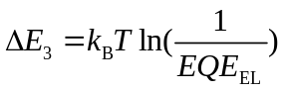 (1)
where EQE_{EL} is related to the radiative and non-radiative recombination rate (k_{r} and k_{nr}):
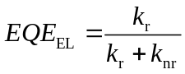 (2)
The k_{r} is obtained from the Einstein coefficient relation:²
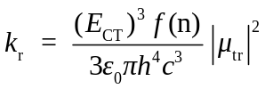 (3)
where μ_{tr} is the average transition dipole moment; ε₀ is the vacuum permittivity; h is the Planck constant; and c is the speed of light in vacuum. In classical Marcus electrons hopping model, non-radiative recombination rate (k_{nr}) of ¹CT and ³CT state is defined as:³
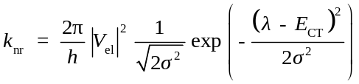 (4)
where V_{el} denotes the electronic coupling; σ is the energetic disorder; and λ is the reorganization energy. ƒ(n) depends on the refractive index (n) of the blend by ƒ(n) = n(n²+2)²/9. Following the Lorentz virtual cavity model, the value of refractive index is n=1.8. Energetic disorder σ is given by σ² = 2λk_{B}T, where λ refer to the reorganization energy.⁴ Three-state model was applied to account for the electronic couplings, reorganization energy, and other parameters in the decay rate.
Reorganization Energy
The total reorganization energy λ includes internal reorganization energy (λ_{int}) and external reorganization energy (λ_{ext}), λ = λ_{int}+λ_{ext}.⁵ The λ_{int} derives from the changes in the ground state structures of donor and acceptor when they gain or lose charge upon electron transfer, which is expressed as:⁵
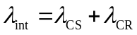 (5)
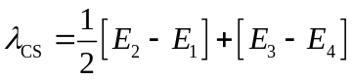 (6)
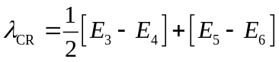 (7)
However, the λ_{ext} is due to electronic and nuclear polarization from the surrounding medium, which can be approximately evaluated by:³
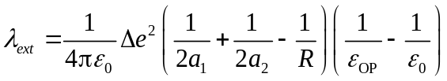 (8)
where a₁, a₂, R, ε_{OP}, and ε₀ are donor radii, acceptor radii, distance between the center of donor and acceptor, and optical and zero-frequency dielectric constants of surrounding media, respectively. Considering the reconciliation between the computational cost and accuracy, ε_{OP} and ε₀ are estimated to be 1.96 and 3.4 by Troisi⁶ and Jérôme,⁵ respectively.
Electronic Coupling
For the calculation of k_{r} and k_{nr}, the electronic coupling can be approximated from the generalized Mulliken-Hush (GMH) formalism in adiabatic description, which could be written as below:⁷
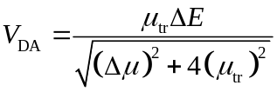 (9)
where µ_{tr} is the average transition dipole moment, Δµ is the dipole moment difference between initial state S₀ and final state S_{n}, and ΔE corresponds to the vertical excitation energy. The Δµ can be estimated directly from a finite field method on the excitation energy.⁸
Figure 1. The HOMO energy levels of donor copolymer (PM6)_{n} (n=1, 1.5, 2, 2.5, 3, 3.5, 4).

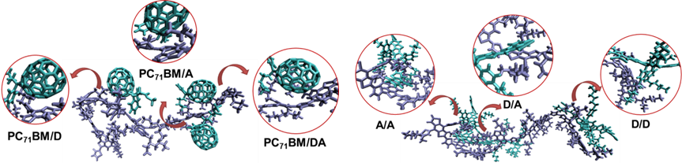
Figure 2. Schematic diagrams of interfacial stacking sites of the molecular clusters. D and A represent the D and A unit in the A-D-A structure, respectively.

Figure 3. NTO maps and the lowest ¹CT- and ³CT-state energies for PM6/acceptor blends.

Figure 4. Schematic diagrams of non-radiative recombination rates of ¹CT→GS and ³CT→³LE pathway in PM6/IT-4F and PM6/IOM-4F blends. The top dotted box denotes the ³CT state decay to ³LE state of donor, and the bottom denotes to T₁ state of acceptor.

Table 1. Experimental photovoltaic parameters of the PM6/acceptor blends.⁹
 | V_{OC} (V) | J_{SC} (mA cm⁻²) | FF | PCE (%)
PM6/IT-4F | 0.85 | 20.02 | 75.22 | 12.80
PM6/IOM-4F | 0.86 | 21.66 | 72.00 | 13.41
PM6/IM-4F | 0.88 | 22.12 | 72.79 | 14.17
PM6/PC₇₁BM | 1.02 | 9.30 | 56.00 | 5.30

Table 2. ¹CT-state energies (E(¹CT)), transition dipole moments (μ_{tr}), electron couplings (V_{el}), recombination energies (λ), energetic disorders (σ), radiative recombination rates (${\text{k}}_{\text{r}}^{\text{1}\text{CT}}$), and non-radiative recombination rates (${\text{k}}_{\text{nr}}^{\text{1}\text{CT}}$) of ¹CT→S₀ pathway for PM6/acceptors blends.
 | V_{el} (eV) | λ (eV) | σ (eV) | E(¹CT) (eV) | μ_{tr} (debye) | ${\text{k}}_{\text{r}}^{\text{1}\text{CT}}$ (s⁻¹) | ${\text{k}}_{\text{n}\text{r}}^{\text{1}\text{CT}}$ (s⁻¹)
PM6/IT-4F | 0.108 | 0.759 | 0.198 | 2.114 | 1.272 | 8.87×10³ | 4.36×10³
PM6/IOM-4F | 1.162 | 0.749 | 0.197 | 2.405 | 6.121 | 3.02×10⁵ | 3.18
PM6/IM-4F | 1.397 | 0.757 | 0.198 | 2.963 | 0.217 | 7.11×10² | 1.15×10⁻¹¹
PM6/PC₇₁BM | 0.402 | 0.694 | 0.189 | 2.599 | 2.970 | 8.98×10⁴ | 1.08×10⁻⁰⁷

Table 3. T₁-state energies of donor (E(³LE_{D})) and acceptors (E(³LE_{A})), and the lowest ³CT-state energies (E(³CT)).
 | E(³LE_{D}) (eV) | E(³LE_{A}) (eV) | E(³CT) (eV)
PM6/IT-4F | 1.518 | 1.276 | 2.112
PM6/IOM-4F | 1.518 | 1.264 | 2.409
PM6/IM-4F | 1.518 | 1.256 | 2.964
PM6/PC₇₁BM | 1.518 | 1.411 | 2.618

Table 4. Energy differences between ³CT- and T₁-state energies of donor (ΔE(³CT-³LE_{D})), electron couplings (V_{el}), recombination energies (λ), energetic disorders (σ), and non-radiative recombination rates (${\text{k}}_{\text{nr}}^{\text{3}\text{CT}\text{→}\text{3}\text{LE}\text{D}}$) of ³CT→T₁ pathway for PM6/acceptors blends.
 | V_{el} (eV) | λ (eV) | σ (eV) |  | ΔE(³CT-³LE_{D}) (eV) | ${\text{k}}_{\text{n}\text{r}}^{\text{3}\text{CT}\text{→}\text{3}\text{LE}\text{D}}$ (s⁻¹)
PM6/IT-4F | 0.302 | 1.067 | 0.235 | 0.594 |  | 8.42×10¹³
PM6/IOM-4F | 0.012 | 1.101 | 0.239 | 0.891 |  | 4.20×10¹¹
PM6/IM-4F | 0.150 | 1.090 | 0.237 | 1.446 |  | 1.16×10¹³
PM6/PC₇₁BM | 0.117 | 1.079 | 0.236 | 1.100 |  | 6.18×10¹³
Table 5. Energy differences between the ³CT- and T₁-state energies of acceptor (ΔE(³CT-³LE_{A})), electron couplings (V_{el}), recombination energies (λ), energetic disorders (σ), and non-radiative recombination rates (${\text{k}}_{\text{nr}}^{\text{3}\text{CT}\text{→}\text{3}\text{LE}\text{A}}$) of ³CT→T₁ pathway for PM6/acceptors blends.
 | V_{el} (eV) | λ (eV) | σ (eV) | ΔE(³CT-³LE_{A}) (eV) | ${\text{k}}_{\text{n}\text{r}}^{\text{3}\text{CT}\text{→}\text{3}\text{LE}\text{A}}$ (s⁻¹)
PM6/IT-4F | 0.011 | 0.976 | 0.225 | 0.836 | 5.01×10¹¹
PM6/IOM-4F | 0.217 | 0.940 | 0.220 | 1.145 | 1.48×10¹⁴
PM6/IM-4F | 0.017 | 1.020 | 0.230 | 1.708 | 1.48×10¹⁰
PM6/PC₇₁BM | 0.179 | 0.977 | 0.225 | 1.208 | 9.06×10¹³

Table 6. Experimental photovoltaic parameters (V_{OC} and J_{SC}) and their increments (ΔV_{OC} and ΔJ_{SC}) of the five groups of NFA-based blends.
Donor | Acceptor | V_{OC} (V) | J_{SC} (mA cm⁻²) | ΔV_{OC} (V) | ΔJ_{SC} (mA cm⁻²) | Ref
FTAZ | F5IC | 0.73 | 14.49 | 0.009 | 3.810 | ¹⁰
FTAZ | F7IC | 0.74 | 18.30 | 0.009 | 3.810 | ¹⁰
FTAZ | F7IC | 0.74 | 18.30 | 0.115 | 1.420 | ¹⁰
FTAZ | F9IC | 0.86 | 19.72 | 0.115 | 1.420 | ¹⁰
PM6 | IT-4F | 0.85 | 20.02 | 0.010 | 1.640 | ⁹
PM6 | IOM-4F | 0.86 | 21.66 | 0.010 | 1.640 | ⁹
PM6 | IOM-4F | 0.86 | 21.66 | 0.020 | 0.460 | ⁹
PM6 | IM-4F | 0.88 | 22.12 | 0.020 | 0.460 | ⁹
PTB7-Th | F6IC | 0.61 | 18.07 | 0.029 | 7.050 | ¹¹
PTB7-Th | F8IC | 0.64 | 25.12 | 0.029 | 7.050 | ¹¹
PTB7-Th | F6IC | 0.61 | 18.07 | 0.121 | 2.760 | ¹¹
PTB7-Th | F10IC | 0.73 | 20.83 | 0.121 | 2.760 | ¹¹
PBDB-T | BDCPDT-IC | 0.86 | 16.56 | 0.060 | 0.190 | ^{12,13}
PBDB-T | ITIC | 0.92 | 16.75 | 0.060 | 0.190 | ^{12,13}
PBDB-T | ITIC | 0.92 | 16.75 | 0.020 | 3.150 | ^{12,13}
PBDB-T | ITBC | 0.94 | 19.90 | 0.020 | 3.150 | ^{12,13}
PBDB-T | BDCPDT-IC | 0.86 | 16.56 | 0.080 | 1.160 | ^{12,13}
PBDB-T | BDCPDT-TTC | 0.94 | 17.72 | 0.080 | 1.160 | ^{12,13}
PBDB-T | BDCPDT-IC | 0.86 | 16.56 | 0.060 | 1.990 | ^{12,13}
PBDB-T | BDCPDT-BC | 0.92 | 18.55 | 0.060 | 1.990 | ^{12,13}

References
1 Rau, U. Reciprocity Relation between Photovoltaic Quantum Efficiency and Electroluminescent Emission of Solar Cells. Phys. Rev. B 76, 085303 (2007).
2 Hilborn, R. C. Erratum: ‘‘Einstein coefficients, cross sections, f values, dipole moments, and all that’’ [Am. J. Phys. 50, 982 (1982)]. Am. J. Phys. 51, 471-471 (1983).
3 Marcus, R. A. On the Theory of Oxidation-Reduction Reactions Involving Electron Transfer. I. J. Chem. Phys. 24, 966-978 (1956).
4 Sánchez-Carrera, R. S., Paramonov, P., Day, G. M., Coropceanu, V. & Brédas, J.-L. Interaction of Charge Carriers with Lattice Vibrations in Oligoacene Crystals from Naphthalene to Pentacene. J. Am. Chem. Soc. 132, 14437-14446 (2010).
5 Lemaur, V., Steel, M., Beljonne, D., Brédas, J.-L. & Cornil, J. Photoinduced Charge Generation and Recombination Dynamics in Model Donor/Acceptor Pairs for Organic Solar Cell Applications: A Full Quantum-Chemical Treatment. J. Am. Chem. Soc. 127, 6077-6086 (2005).
6 Liu, T. & Troisi, A. Absolute Rate of Charge Separation and Recombination in a Molecular Model of the P3HT/PCBM Interface. J. Phys. Chem. C 115, 2406-2415 (2011).
7 Voityuk, A. A. Estimation of Electronic Coupling in π-Stacked Donor-Bridge-Acceptor Systems: Correction of the Two-State Model. J. Chem. Phys. 124, 064505 (2006).
8 Li, Y., Pullerits, T., Zhao, M. Y. & Sun, M. T. Theoretical Characterization of the PC₆₀BM:PDDTT Model for an Organic Solar Cell. J. Phys. Chem. C 115, 21865-21873 (2011).
9 Zhang, Z. H. et al. Modification on the Indacenodithieno[3,2-b]thiophene Core to Achieve Higher Current and Reduced Energy Loss for Nonfullerene Solar Cells. Chem. Mater. 32, 1297-1307 (2020).
10 Dai, S. X. et al. Effect of Core Size on Performance of Fused-Ring Electron Acceptors. Chem. Mater. 30, 5390-5396 (2018).
11 Dai, S. X. et al. Enhancing the Performance of Polymer Solar Cells via Core Engineering of NIR-Absorbing Electron Acceptors. Adv. Mater. 30, 1706571 (2018).
12 Chang, S.-L. et al. New Thieno[3,2-b]thiophene-Based Acceptor: Tuning Acceptor Strength of Ladder-Type N-Type Materials to Simultaneously Achieve Enhanced Voc and Jsc of Nonfullerene Solar Cells. ACS Energy Lett. 3, 1722-1729 (2018).
13 Chang, S.-L. et al. Isomerically Pure Benzothiophene-Incorporated Acceptor: Achieving Improved Voc and Jsc of Nonfullerene Organic Solar Cells via End Group Manipulation. ACS Appl. Mat. Interfaces 11, 33179-33187 (2019).

