Supplementary Material

Co-exposure of microplastics and the allelochemical 2-methoxy-1,4-naphthoquinone affects Daphnia magna depending on the developmental stage
Julian Brehm¹⁺, Jens G. P. Diller¹⁺, Michael Schwarzer¹, Josef Breu² and Christian Laforsch^{1*}
¹Animal Ecology I, University of Bayreuth, 95447 Bayreuth & Bayreuth Center for Ecology and Environmental Research (BayCEER), 95447 Bayreuth
²Anorganic Chemistry I, University of Bayreuth, 95447 Bayreuth
⁺authors contributed equally
*Corresponding author: Christian Laforsch, Email: christian.laforsch@uni-bayreuth.de

Particle size distributions
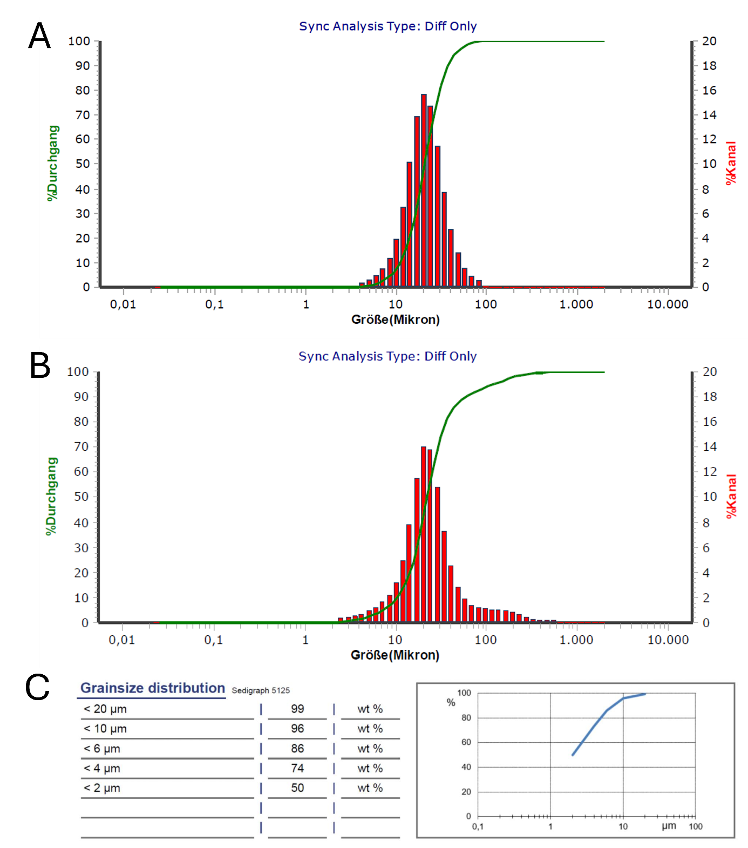
Figure SI 1 Size distribution of used MP and control particles. (A) PS MP, d₉₀: 37.54 µm, (B) PA 66 MP, d₉₀: 59.15 µm, and (C) kaolinite, d₉₆: <10 µm. Measurements in (A) and (B) were conducted using LD/DIA, (C) was provided by the manufacturer (Gebrüder Dorfner GmbH & CO., Hirschau, Germany).
UV vis calibration curve and spectra of 2-MNQ

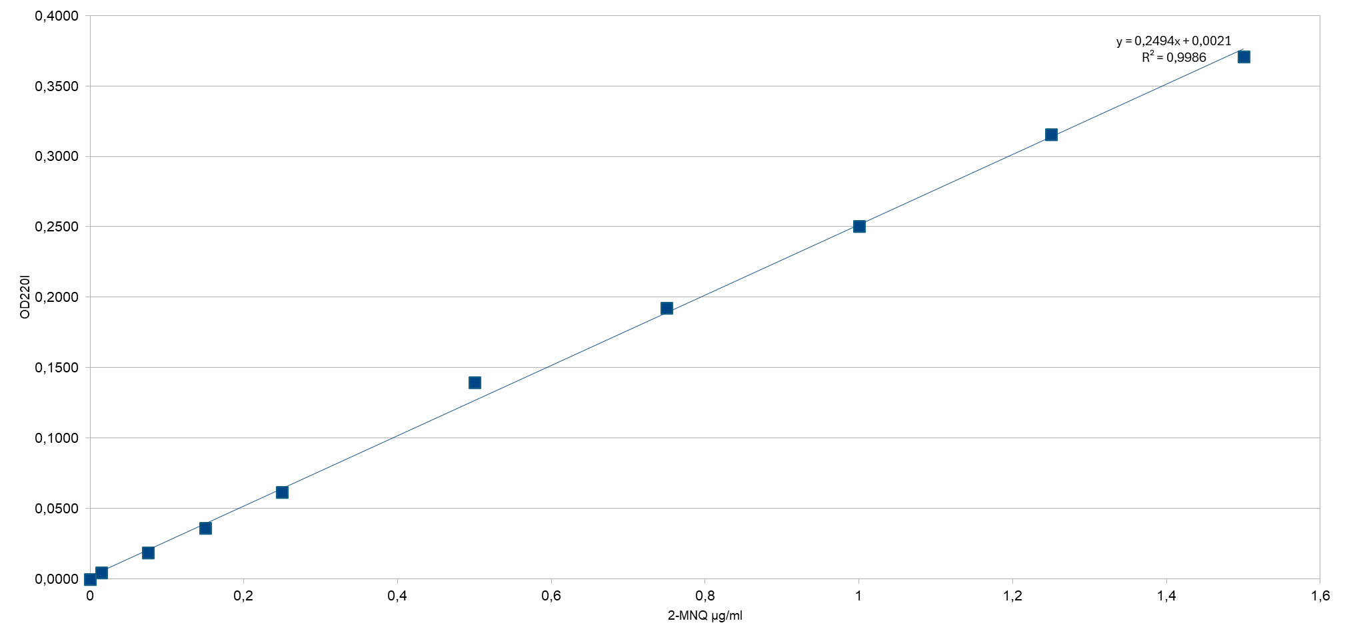
Figure SI 2 UV-vis calibration curve at 220 nm, ranging from 0.015 to 1.5 mg 2-MNQ/L. Formula: y = 0.2494x + 0.0021; R²: 0.9986.

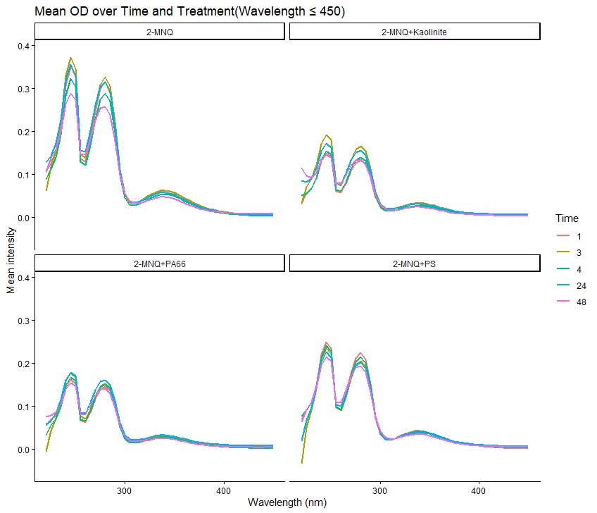
Figure SI 3 Absorbance spectra (measured in 5 nm intervals) of 2-MNQ (10 mg/L) and 1000 P/mL in M4 of the respective treatment, blanked against M4 with 1ml/L DMSO after 1, 3, 4, 24, and 48 hours.

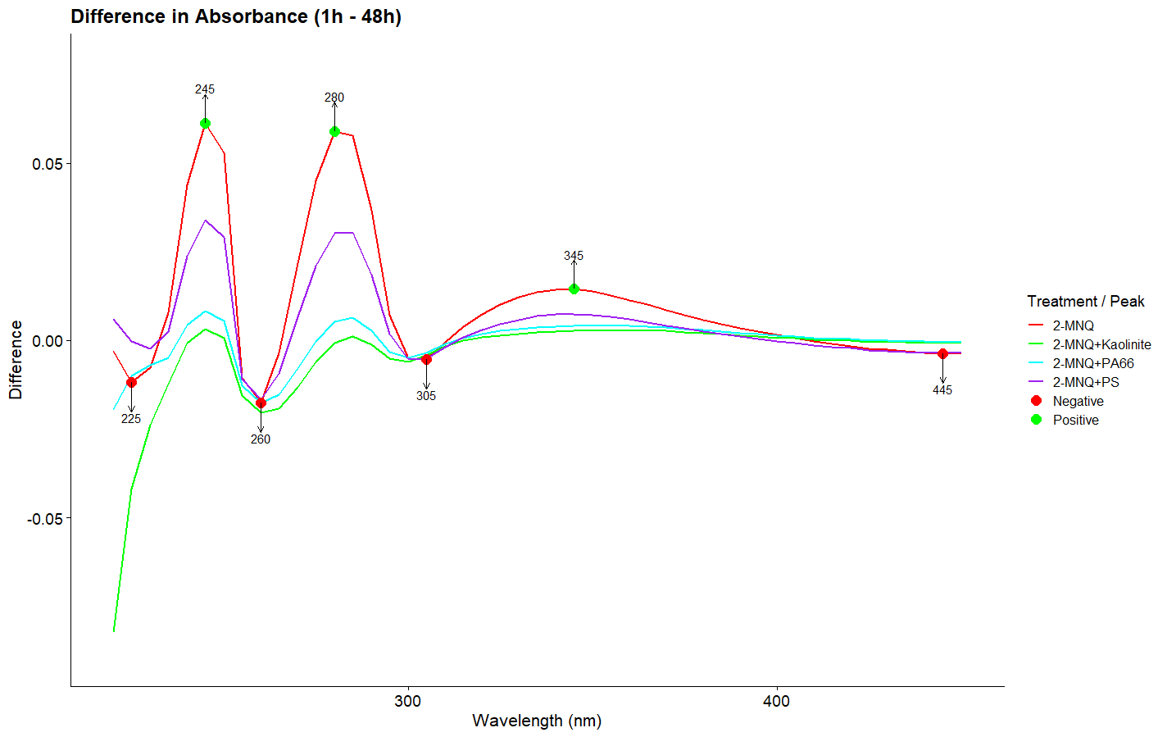
Figure SI 4 Differences in the absorbance spectra (measured in 5 nm intervals) after 1 and 48 hours of 2-MNQ (10 mg/L) and 1000 P/mL in M4 of the respective treatment, blanked against M4 with 1ml/L DMSO. Positive peaks (green dots) at 245, 280, and 345 nm; negative peaks (red dots) at 225, 260, 305, and 445 nm.

Life history and morphology parameters
Table S1 Life-history parameters of D. magna after chronic exposure to MP and 2-MNQ, given as mean ± SE.
ID | Time primiparity (days) | Time first brood (days) | # neonates first 3 broods | # of broods
Control | 7.46 ± 0.18 | 10.46 ± 0.18 | 35.00 ± 2.42 | 4 ± 0
DMSO | 6.82 ± 0.30 | 9.75 ± 0.43 | 32.6 ± 1.76 | 4.22 ± 0.15
2-MNQ | 7.61 ± 0.18 | 10.31 ± 0.17 | 31.00 ± 1.65 | 4 ± 0
Kaolinite low | 7.5 ± 0.29 | 9.82 ± 0.30 | 25.83 ± 3.52 | 3.17 ± 0.34
Kaolinite high | 6.93 ± 0.34 | 9.4 ± 0.29 | 32.4 ± 1.36 | 3.8 ± 0.11
Kaolinite high + 2-MNQ | 7.92 ± 0.31 | 10.67 ± 0.38 | 31.10 ± 1.94 | 4 ± 0
PA low | 7.13 ± 0.13 | 9.4 ± 0.16 | 34.64 ± 1.84 | 4 ± 0
PA high | 6.33 ± 0.19 | 9.2 ± 0.14 | 37.07 ± 1.46 | 4 ± 0
PA low + 2-MNQ | 7.64 ± 0.27 | 10.29 ± 0.29 | 27.17 ± 2.98 | 3.75 ± 0.22
PA high + 2-MNQ | 7.87 ± 0.09 | 10.64 ± 0.17 | 32.43 ± 1.17 | 3.93± 0.07
PS low | 6.5 ± 0.20 | 9.31 ± 0.17 | 38.33 ± 1.36 | 4 ± 0
PS high | 6.29 ± 0.16 | 9.14 ± 0.14 | 31.57 ± 1.15 | 4.29 ± 0.12
PS low + 2-MNQ | 7.8 ± 0.14 | 10.86 ± 0.14 | 29.6 ± 2.04 | 3.6 ± 0.16
PS high + 2-MNQ | 7.5 ± 0.19 | 10.5 ± 0.15 | 33.91 ± 1.46 | 3.91 ± 0.09

Table S2 Morphology parameters of D. magna after chronic exposure to MP and 2-MNQ, given as mean ± SE.
ID | Body length at primiparity | Body length (Day 21) | Δ body length
Control | 2994.97 ± 39.15 | 3739.85 ± 35.29 | 744.40 ± 50.43
DMSO | 2797.80 ± 41.33 | 3711.83 ± 35.13 | 902.05 ± 33.77
2-MNQ | 2912.14 ± 35.30 | 3536.28 ± 28.33 | 620.19 ± 31.45
Kaolinite low | 2934.56 ± 48.67 | 3803.01 ± 30.87 | 850.96 ± 46.33
Kaolinite high | 2729.11 ± 16.79 | 3602.72 ± 19.53 | 858.92 ± 21.45
Kaolinite high + 2-MNQ | 2851.11 ± 71.18 | 3580.65 ± 37.02 | 689.16 ± 36.74
PA low | 2681.01 ± 38.66 | 3634.15 ± 32.07 | 942.13 ± 35.03
PA high | 2737.18 ± 28.09 | 3627.15 ± 23.32 | 896.15 ± 33.72
PA low + 2-MNQ | 2789.92 ± 49.42 | 3469.35 ± 36.88 | 715.85 ± 52.47
PA high + 2-MNQ | 2905.51 ± 28.58 | 3524.73 ± 15.00 | 635.65 ± 27.88
PS low | 2752.48 ± 25.52 | 3622.67 ± 28.24 | 865.16 ± 24.40
PS high | 2709.01 ± 24.2 | 3612.92 ± 25.81 | 903.91 ± 36.71
PS low + 2-MNQ | 2870.38 ± 41.72 | 3556.04 ± 46.76 | 685.66 ± 45.75
PS high + 2-MNQ | 2962.99 ± 41.68 | 3506.71 ± 44.51 | 610.75 ± 33.93

