Supporting Information

The influence of orange essential oil on mechanical, chemical, and antibacterial properties of cellulose nanofibers containing silver nanoparticles
Duy-Nam Phan^{1,*}, Muhammad Qamar Khan², Chuc Nguyen Van³, Manh-Hai Vu¹, Anh-Tuan Dao¹, Phan Thanh Thao¹, Ngoc-Mai Nguyen³, Van-Tuan Le⁴, Azeem Ullah⁵, Muzamil Khatri⁶, and Ick-Soo Kim⁵
¹School of Textile - Leather and Fashion, Hanoi University of Science and Technology, 1 Dai Co Viet, Hanoi, Vietnam.
²Department of Textile and Clothing, Faculty of Textile Engineering and Technology, National Textile University, Karachi campus, Karachi, Pakistan.
³School of Chemical Engineering, Hanoi University of Science and Technology, 1 Dai Co Viet, Hanoi, Vietnam.
⁴School of Mechanical Engineering, Hanoi University of Science and Technology, 1 Dai Co Viet, Hanoi, Vietnam.
⁵Nano Fusion Technology Research Group, Division of Frontier Fibers, Institute for Fiber Engineering (IFES), Interdisciplinary Cluster for Cutting Edge Research (ICCER), Shinshu University, Tokida 3-15-1, Ueda, Nagano, 386-8567, Japan.
⁶Department of Chemistry and Materials, Faculty of Textile Science and Technology, Shinshu University, Tokida 3-15-1, Ueda, Nagano, 386-8567, Japan.
*Corresponding authors: Duy-Nam Phan (nam.phanduy@hust.edu.vn).
Keywords: cellulose nanofiber, silver nanoparticle, electrospinning, orange essential oil, antibacterial activity.

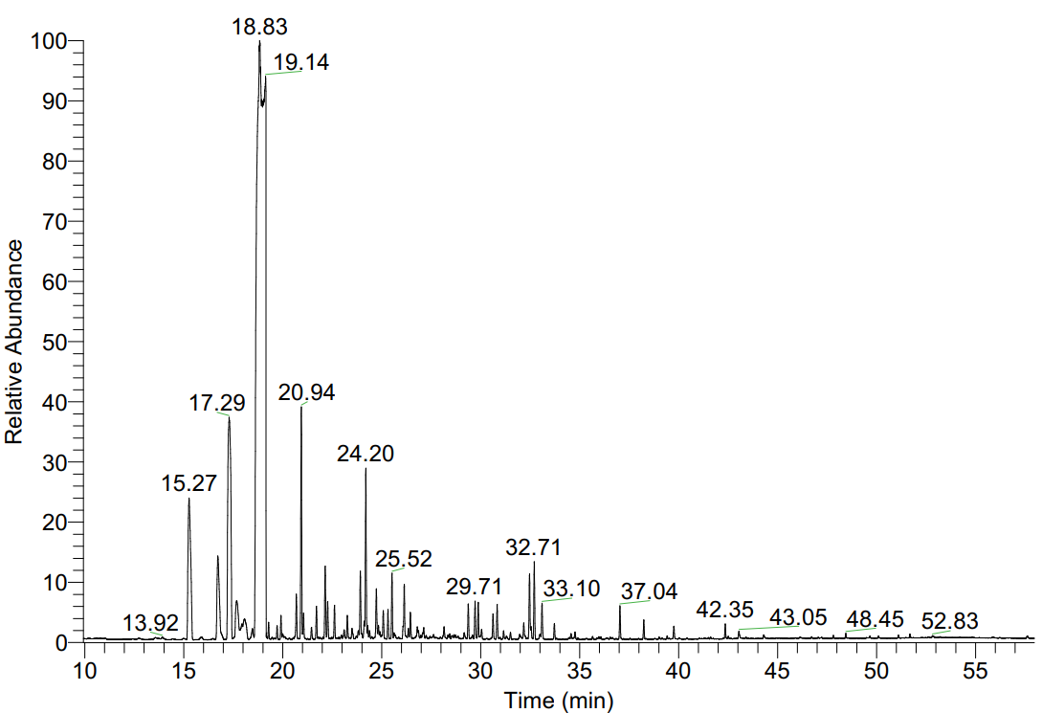

Fig. S1. The total ion chromatogram of OEO
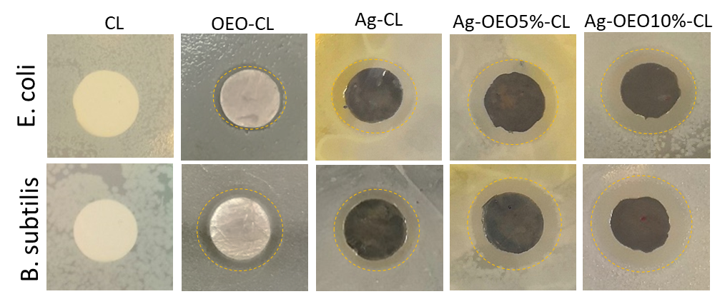

Fig. S2. Representative photographs of inhibition zone of CL – as the negative control, OEO-CL, Ag-CL, Ag-OEO5%-CL, and Ag-OEO10%-CL

