ANNEXE
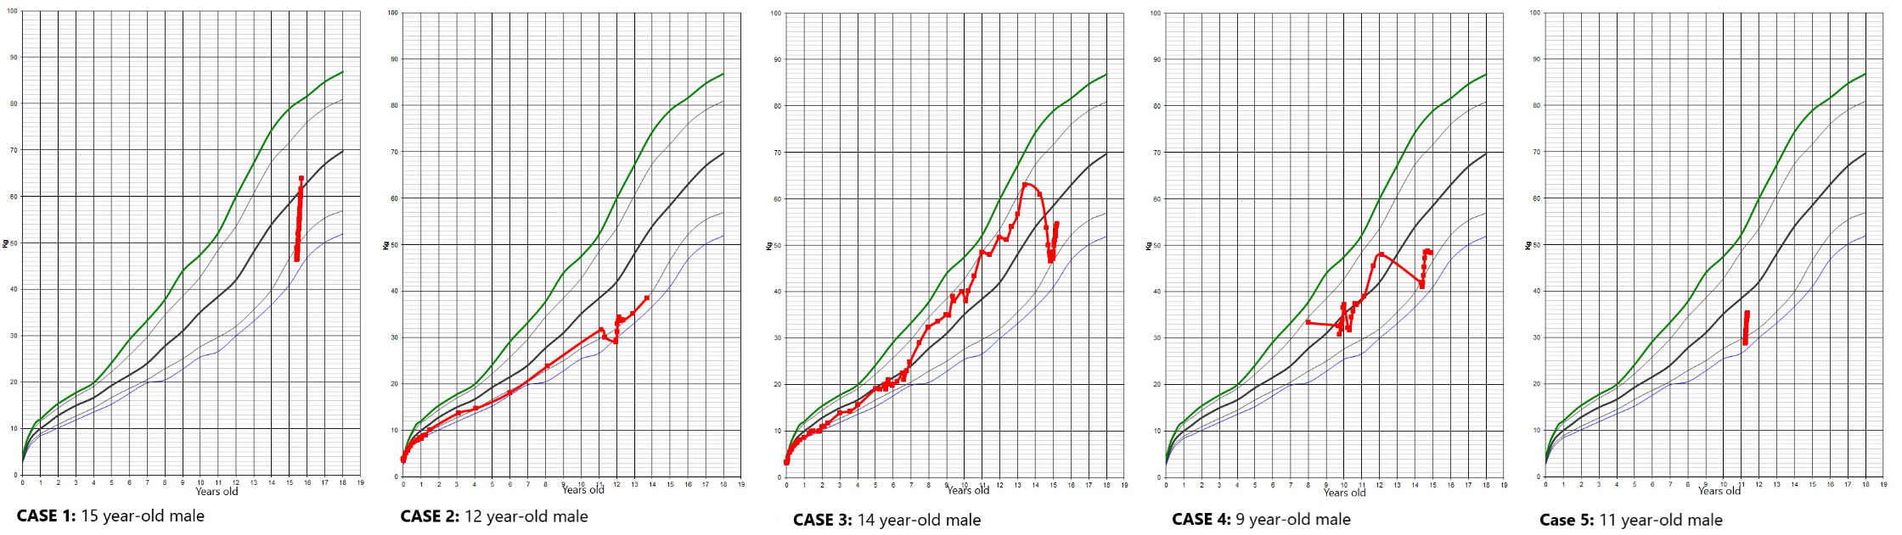
Source: Prepared by the authors.
Figure 1: Anthropometric trajectories of the five male eating disorder cases. These standardized growth charts illustrate weight and height progression over time. The red lines trace the specific path of each patient, highlighting the critical BMI drop during the acute illness phase, periods of weight stabilization, and subsequent catch-up growth during the recovery process. The charts visually demonstrate de-canalization from expected percentiles, serving as a powerful clinical indicator of disease severity.
 | MALE SEX | FEMALE SEX
Most frequent diagnosis in clinical population (Franceschini & Fattore, 2021) | Binge Eating Disorder (ICD-11 6B82) | Anorexia Nervosa (ICD-11 6B80) or Bulimia Nervosa (ICD-11 6B81)
Comorbidities (Brown & Keel, 2023) (Franceschini & Fattore, 2021) | Anxiety disorders and psychotic disorders | Affective disorders (depression)
Core Psychopathology (Gorrell & Murray, 2019) | Muscularity-oriented phenotype: Drive for muscularity and leanness | Thinness-oriented phenotype: Drive for thinness and weight loss
Primary goal of behavior (Lavender et al., 2017) (Gorrell & Murray, 2019) (Nagata et al., 2020) (Richardson & Paslakis, 2021) (Brown & Keel, 2023) (Upchurch, 2024) (Schmitt et al., 2025) | Fat loss combined with muscle gain | Global weight reduction and size decrease
Warning Signs (Early) (Nagata et al., 2020) | Compulsive exercise and use of performance-enhancing supplements | Caloric restriction and avoidance of specific food groups
Compensatory Behaviors (Mazaraki et al., 2024) | Excessive/Rigid physical activity; less frequent purging | Self-induced vomiting, laxative, or diuretic misuse
Consistent physiological marker of clinical severity (Skolnick et al., 2016) | Hypogonadism: erectile dysfunction (adults) / Lack of morning erections (adolescents) | Amenorrhea (primary or secondary): oss of menstrual cycle for >3 months
Clinical Perception (Schmitt et al., 2025) | Often masked as "healthy" athletic lifestyle; late diagnosis | More easily recognized as pathological; earlier intervention
Diagnosis frequency (Richardson & Paslakis, 2021) | Late and underdiagnosed | Earlier diagnosis, not always underdiagnosed
Temperament traits (Bruch, 2001) | Perfectionism, high self-demand, need for control, poor adaptability
BMI: Body Mass Index; ED: Eating Disorder.
Note: While clinical presentations overlap, the drive for muscularity in males often results in a "normal" BMI that masks severe underlying malnutrition and endocrine disruption.
Source: Compiled by the authors based on cited literature and clinical observations.
Table 1: clinical and Pathophysiological differences in EDs by gender.

