Impact of traditional and biodegradable mulching films on plant performance and substrate microbial communities in strawberry cultivation

Agnese Bellabarba ^{1,2}*, Lorenzo Bini ¹, Costanza Scopetani ³, Giulia Selvolini ⁴, Francesca, Decorosi ^{1,2}, Ermes Lo Piccolo ¹, Elisabetta Toni ^{1,2}, William Antonio Petrucci ¹, Edgardo Giordani ¹, Giovanna Marrazza ⁴, Alessandra Cincinelli ⁴, Tania Martinelli ⁴, Carlo Viti ^{1,2}

¹ Department of Agricultural, Food, Environmental and Forestry Sciences (DAGRI), University of Florence, I-50144 Firenze, Italy
² Genexpress Laboratory, Department of Agronomy, Food, Environmental and Forestry Sciences (DAGRI), University of Florence, I-50019 Sesto Fiorentino, Italy
³ Department of Chemical and Geological Sciences, University of Modena and Reggio Emilia, Via Campi 103, 41125 Modena, Italy
⁴ Department of Chemistry “Ugo Schiff” (DICUS), University of Florence, Via della Lastruccia 3, 50019 Sesto Fiorentino (FI), Italy
* Correspondence: Agnese Bellabarba, Genexpress Laboratory, via della Lastruccia 14, I-50019 Sesto Fiorentino (FI), Italy; E-mail address: agnese.bellabarba@unifi.it

SUPPLEMENTARY MATERIALS

Table S1. Gas exchange responses of strawberry plants grown with mulching at different time points. The net photosynthetic rate (Pn), stomatal conductance (gs) and intracellular CO2 (Ci) concentration are reported. Within column, for each variable measured, different letters represent statistically significant variation (p < 0.05) among different mulching films for each timepoint, according to One-Way ANOVA and Tukey’s post-hoc test.

 | Pn (µmol m⁻² s⁻¹) |  |  | gs (mol m⁻² s⁻¹) |  |  | Ci (µmol mol⁻¹)
Treatment | T1 | T2 | T3 | T1 | T2 | T3 | T1 | T2 | T3
Unmulched control | 15.12 ± 0.21 b | 16.31 ± 0.29 a | 16.91 ± 0.28 a | 0.31 ± 0.01 a | 0.28 ± 0.01 a | 0.36 ± 0.01 a | 285.67 ± 2.43 a | 268.15 ± 3.61 b | 285.41 ± 1.89 a
OxoPE | 16.21 ± 0.27 ab | 16.13 ± 0.35 a | 16.43 ± 0.16 a | 0.3 ±  0.01 a | 0.3 ±  0.01 a | 0.35 ± 0.01 a | 275.81 ± 1.75 ab | 273.54 ± 4.12 ab | 283.76 ± 2.53 a
PE | 16.48 ± 0.33 a | 16.09 ± 0.51 a | 16.97 ± 0.11 a | 0.31 ± 0.02 a | 0.31 ± 0.01 a | 0.37 ± 0.01 a | 274.69 ± 2.55 b | 277.12 ± 2.77 ab | 286.14 ± 1.62 a
PBAT | 15.87 ± 0.48 ab | 16.35 ± 0.41 a | 16.54 ± 0.25 a | 0.29 ± 0.01 a | 0.3 ±  0.01 a | 0.36 ± 0.01 a | 271.61 ± 2.63 b | 274.27 ± 2.16 ab | 284.53 ± 1.62 a
PP | 15.37 ± 0.39 ab | 15.16 ± 0.39 a | 16.51 ± 0.35 a | 0.29 ± 0.01 a | 0.3 ±  0.01 a | 0.34 ± 0.01 a | 275.75 ± 2.98 ab | 279.38 ± 2.36 a | 280.72 ± 3.5 a

Table S2. Morphological growth of strawberry plants with mulching films at different time points. Within column, for each variable measured, different letters represent statistically significant variation (p < 0.05) among different mulching films for each timepoint, according to One-Way ANOVA and Tukey’s post-hoc test.

Treatment | Plant height (cm) |  |  | Number of leaves (n)
Treatment | T1 | T2 | T3 | T1 | T2 | T3
Unmulched control | 10.6 ± 0.76 a | 29.9 ± 2.09 a | 34.4 ± 1.49 a | 7.23 ± 0.63 a | 12.47 ± 1.23 a | 15.55 ± 0.7 ab
OxoPE | 10.55 ± 0.38 a | 27.4 ± 1.42 a | 33.05 ± 1.56 a | 6.27 ± 0.52 a | 11.13 ± 1.12 a | 15.14 ± 1.47 ab
PBAT | 10.3 ± 0.19 a | 29.25 ± 0.63 a | 34.1 ± 0.48 a | 6.23 ± 0.35 a | 11.72 ± 0.71 a | 14.52 ± 0.45 ab
PE | 9.73 ± 0.6 a | 26.7 ± 1.71 a | 34.25 ± 1.27 a | 5.17 ± 0.36 a | 9.75 ± 0.99 a | 13.13 ± 0.51 b
PP | 10.48 ± 0.56 a | 30.15 ± 1.83 a | 35.15 ± 1.08 a | 7.23 ± 0.77 a | 12.98 ± 1.12 a | 17.05 ± 0.62 a

Table S3. Quality parameter of strawberry fruits grown with different mulching films. Within column, for each variable measured, different letters represent statistically significant variation (p < 0.05) among different mulching films, according to One-Way ANOVA and Tukey’s post-hoc test.

Treatment | Weight  (g fruit ^{–1}) | Diameter (mm) | Height (mm) | L* | Chroma index | TSS  (° Brix) | Texture  (N) | TA (% citric acid)
Unmulched control | 13.48 ± 1.11 a | 28.3 ± 0.46 ab | 35.9 ± 1.04 a | 26.66 ± 1.99 b | 35.06 ± 1.72 b | 6.96 ± 0.41 a | 405.5 ± 46.54 ab | 0.87 ± 0.02 b
OxoPE | 13.36 ± 1.58 a | 30.4 ± 1.6 ab | 35.3 ± 1.71 a | 40.17 ± 4.73 a | 45.06 ± 2.31 a | 8.28 ± 0.4 a | 385.5 ± 24.19 ab | 0.96 ± 0.03 b
PBAT | 11.11 ± 0.95 a | 27.65 ± 0.65 ab | 34.05 ± 1.45 a | 27.23 ± 0.71 b | 37.52 ± 1.21 b | 6.5 ± 0.43 a | 445 ± 39.66 a | 1.2 ± 0.1 a
PE | 11.21 ± 0.53 a | 26.95 ± 0.63 b | 34.2 ± 0.89 a | 26.16 ± 1.08 b | 34.49 ± 1.65 b | 7.65 ± 0.7 a | 358 ± 29.85 ab | 1.04 ± 0.04 ab
PP | 13.07 ± 0.48 a | 30.9 ± 0.84 a | 34.7 ± 1.15 a | 26.12 ± 0.52 b | 32.95 ± 1.44 b | 6.56 ± 0.57 a | 304.25 ± 30.05 b | 1 ± 0.02 ab

Table S4. Nutraceutical properties of strawberry fruits grown with different mulching films. Within column, for each variable measured, different letters represent statistically significant variation (p <0.05) among different mulching films, according to One-Way ANOVA and Tukey’s post-hoc test.

Treatment | Polyphenols  (g kg^{–1} FW) | Total sugars  (g 100g^{–1} FW) | Citric acid  (g 100g^{–1} FW) | Malic acid  (g 100g^{–1} FW) | Ascorbic acid  (g 100g^{–1} FW)
Unmulched control | 1.58 ± 0.08 a | 5.46 ± 0.37 a | 0.99 ± 0.02 a | 0.32 ± 0.01 a | 65.77 ± 6.54 a
OxoPE | 1.84 ± 0.16 a | 5.07 ± 0.67 a | 0.96 ± 0.05 a | 0.33 ± 0.02 a | 40.03 ± 4.28 b
PBAT | 1.85 ± 0.04 a | 4.68 ± 0.46 a | 0.98 ± 0.06 a | 0.3 ± 0.01 a | 51.43 ± 2.46 ab
PE | 1.58 ± 0.14 a | 5.04 ± 0.26 a | 0.94 ± 0.06 a | 0.32 ± 0.01 a | 47.87 ± 8.51 ab
PP | 1.79 ± 0.07 a | 5.31 ± 0.64 a | 1.1 ± 0.04 a | 0.33 ± 0.03 a | 48.03 ± 3.98 ab

Fig. S1. Rarefaction curves for bacterial communities of all soil samples. The x axis indicates the number of sequences used for the rarefaction analysis (sample size = 25000 sequences). The y axis indicates the number of ASVs detected on rarefied datasets.
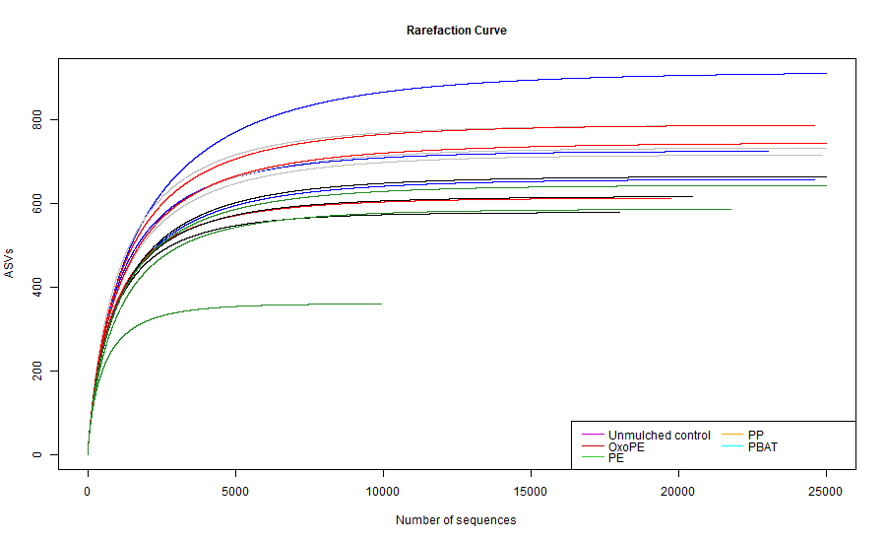

Figure S2. Taxonomic composition of substrate bacterial microbial communities for different mulching films. Average abundances (%) at phylum (A), family (B) and genus level (C) are reported. Only phyla with a mean abundance of at least 1% and families with a mean abundance of at least 3% are reported for each tested condition. Only the genera with a mean relative abundance of at least 3% are shown.

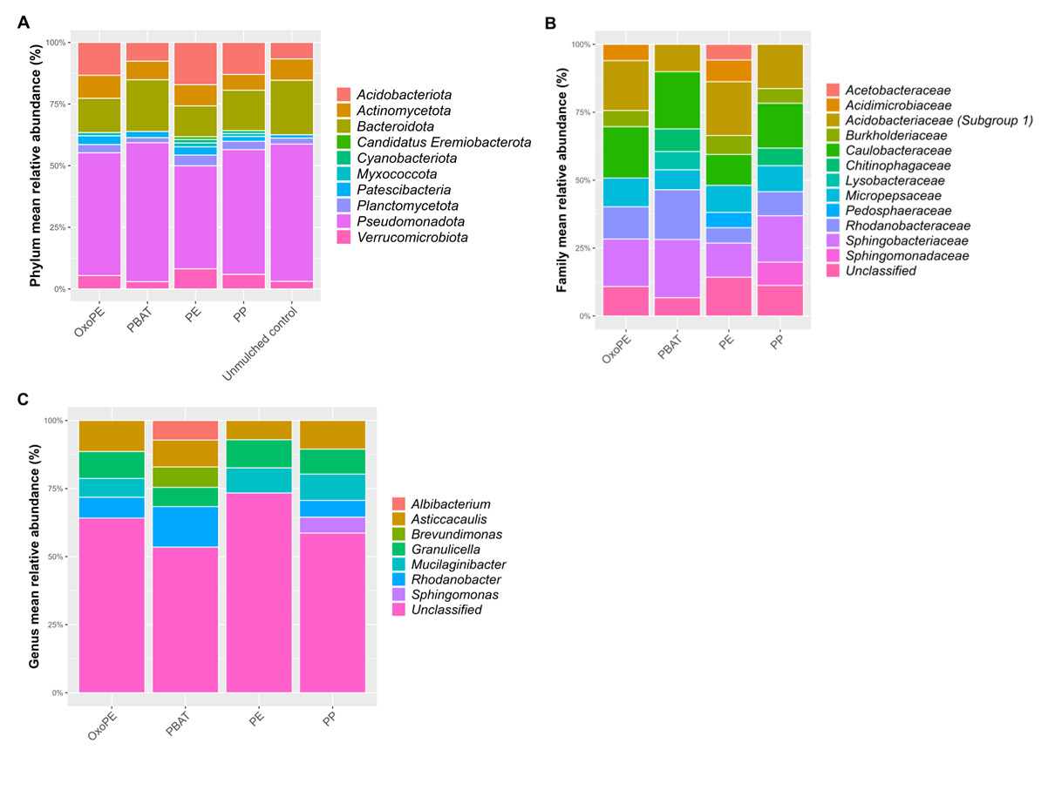

Figure S3. α-diversity of bacterial communities in substrates covered with different mulching films. Values of richness (S.obs) (A), the Evenness Pielou's index (B), Simpson index (C) and Shannon index (D) index are reported on the y axis. Horizontal lines of boxes represent the median, whereas the whiskers represent the maximal and minimal values. P-values obtained with one-way ANOVA or Kruskal-Wallis tests are reported. Different letters indicate results of Dunn test or Tukey’s post-hoc test among different treatments (p < 0.05).

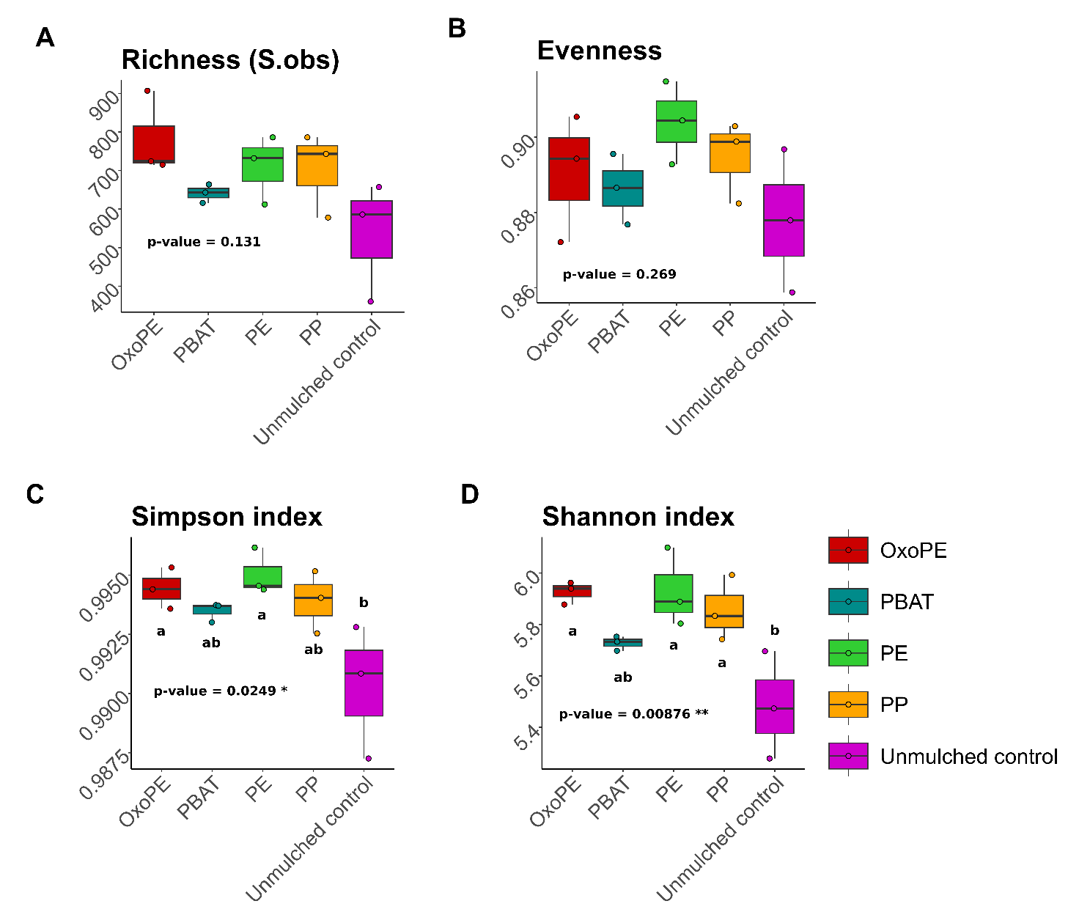

Figure S4. Distribution and intersections of amplicon sequence variants (ASVs) of substrate bacterial microbial communities for different mulching films. The coloured horizontal bars on the left report the total ASV richness within each group. The vertical black bars illustrate the size of intersections (shared ASVs) between specific groups. In the matrix below, rows represent distinct conditions, while columns represent specific intersections. Connected dots indicate the precise combinations of groups where these shared ASVs were identified.

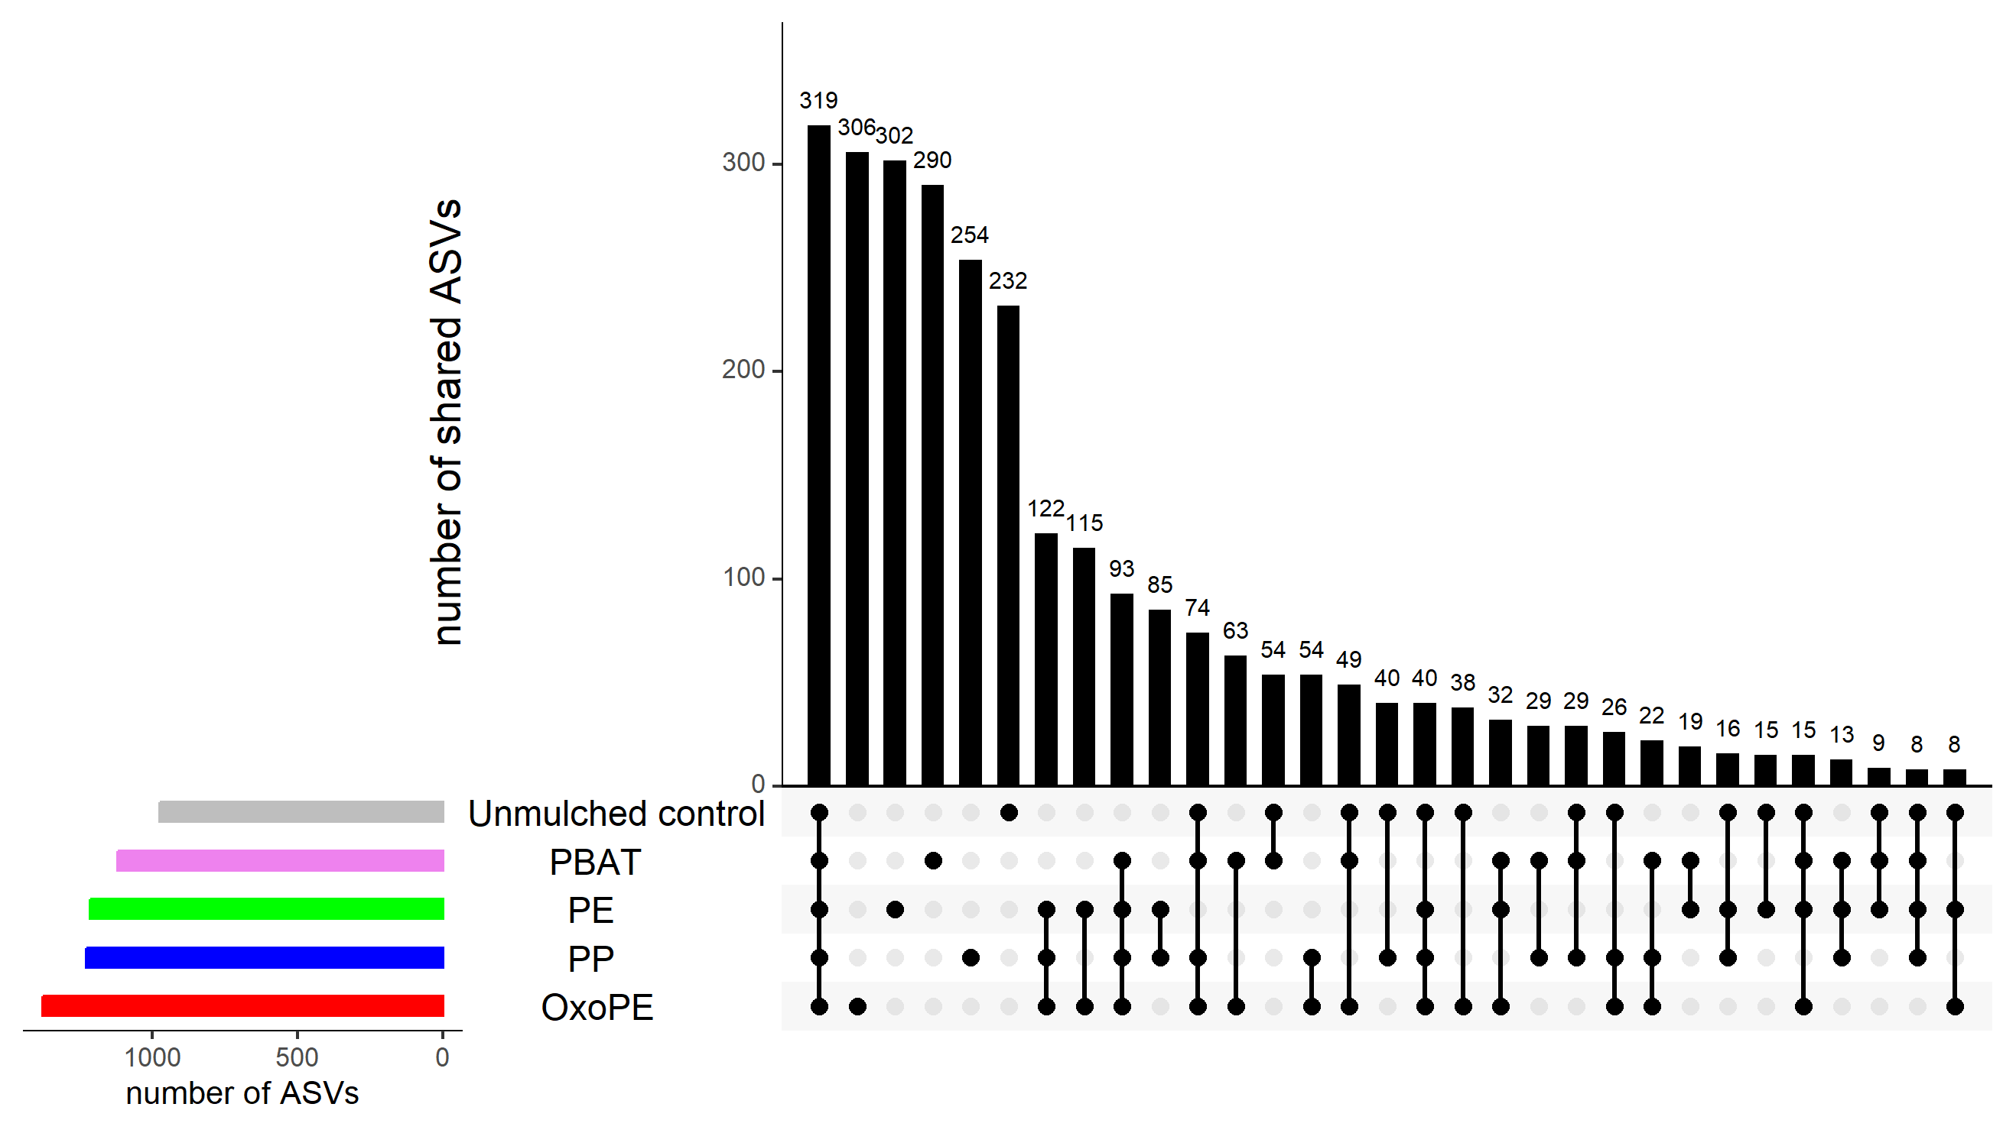

Figure S5. Heatmap of predicted metabolic pathways and processes of substrate bacterial microbial communities for different mulching films. Row-standardized (Z scores) of abundance profiles inferred with the FAPROTAX database are shown. Hierarchical clustering with complete linkage of abundance across mulching films was reported.
