Supplementary Material

Table S1. Core, historic edge and current edge populations of P. lineatus sampled for genomic analysis.
Site Number | Site Name | Range core/edge | Coordinates | Number collected | Number analysed
1 | Kearney Point, Northern Ireland | North-East Ireland edge | 54.382309, -5.482278 | 56 | 20
2 | Mornington, Republic of Ireland | East Ireland core | 53.788491, -6.228822 | 42 | 23
3 | Rosslare, Republic of Ireland | South-East Ireland core | 52.252461, -6.355094 | 63 | 20
4 | Portronan (Malin Head), Republic of Ireland | North-West Ireland edge | 55.360462, -7.358333 | 25 | 20
5 | Coolmore, Republic of Ireland | West Ireland core | 54.547106, -8.218424 | 40 | 23
6 | Dunmanus Bay, Republic of Ireland | South-West Ireland core | 51.602262, -9.552121 | 31 | 16
7 | Rhos on Sea, Wales | North-East Wales, edge | 53.315453, -3.743428 | 136 | 15
8 | Nefyn, Wales | North-West Wales, historic edge (1962-3) | 52.941271, -4.536565 | 59 | 23
9 | Porthgain, Wales | South-West Wales core | 51.94899, -5.153561 | 62 | 16
10 | Peveril Point | South England edge | 50.607167, -1.944833 | 28 | 24
11 | Lyme Regis, England | South-West England historic edge (1965) | 50.726192, -2.929663 | 29 | 22
12 | Plymouth, England | South-West England core | 50.364035, -4.145208 | 59 | 23

Table S2. Distribution and abundance of P. lineatus at sites around the Irish Sea.
Site | Country | Latitude | Longitude | Natural rocky shore | Rock armour | Sea wall
Portballintrae | NI | 55.2197 | -6.5511 | -
Portstewart | NI | 55.1892 | -6.7211 | -
Whitehead | NI | 54.7557 | -5.7020 | -
Ballyhalbert | NI | 54.4905 | -5.4378 | -
Portavogie | NI | 54.4450 | -5.4526 | +
Kearney Point | NI | 54.3823 | -5.4823 | +++
Gyles Quay | ROI | 53.9846 | -6.2393 | - |  | ++
Blackrock | ROI | 53.9604 | -6.3661 | - | -
Port Oriel | ROI | 53.7981 | -6.2205 | - | -
Mornington | ROI | 53.7885 | -6.2288 | ++ | -
Howth | ROI | 53.3864 | -6.0618 | - | -
Dun Laoghaire | ROI | 53.2994 | -6.1626 | - | -
Coliemore | ROI | 53.2736 | -6.0924 | - | -
Dalkey | ROI | 53.2689 | -6.0978 | -
Killiney | ROI | 53.2666 | -6.1052 | -
Bray | ROI | 53.2040 | -6.0975 | - | -
Bray Head | ROI | 53.1957 | -6.0872 | - | -
Greystones | ROI | 53.1472 | -6.0599 | - | -
Kilcoole | ROI | 53.1063 | -6.0409 |  | -
Wicklow Town | ROI | 52.9820 | -6.0324 | - | -
Magheramore Beach | ROI | 52.9288 | -6.0222 | -
Ennereilly Beach | ROI | 52.8374 | -6.1054 | -
The Bungalows | ROI | 52.8114 | -6.1270 | - | -
Arklow | ROI | 52.7594 | -6.1417 | - | -
Kilmichael Point | ROI | 52.7370 | -6.1434 | -
Kilpatrick Beach | ROI | 52.7235 | -6.1576 | -
Cronellard | ROI | 52.6975 | -6.1880 | -
Ballymoney Beach | ROI | 52.6796 | -6.2011 | -
Kiltennel Beach | ROI | 52.6657 | -6.2104 | -
Courtown | ROI | 52.6409 | -6.2245 | - | -
Glendoyne | ROI | 52.6059 | -6.2141 | -
Glasscarrig | ROI | 52.5820 | -6.2035 | -
Cahore Point | ROI | 52.5686 | -6.2002 | -
Wexford | ROI | 52.3386 | -6.4543 |  | -
Rosslare Strand | ROI | 52.2776 | -6.3867 | +++ | -
Kilmore Quay | ROI | 52.1712 | -6.5940 | +++ | -
Slade | ROI | 52.1339 | -6.9089 | +++ |  | ++
Cheek Point | ROI | 52.2720 | -6.9937 | - | -
Ardmore, Waterford | ROI | 51.9490 | -7.7159 | ++ |  | +
Ringaskiddy, Cork | ROI | 51.8381 | -8.3344 | ++ | -
Haulbowline Island, Cork | ROI | 51.8396 | -8.3073 | ++ | +++
Dunmanus Bay, Cork | ROI | 51.6023 | -9.5521 | +++
Coolmore | ROI | 54.5480 | -8.2137 | +++
Pollan Bay South | ROI | 55.2924 | -7.3935 | ++
Portronan | ROI | 55.3609 | -7.3587 | ++
Dunagree Point, Donegal | ROI | 55.2286 | -6.9269 | -
Redcastle, Donegal | ROI | 55.1949 | -7.1403 | -
Barry main harbour | Wales | 51.3876 | -3.2644 | ++ | -
Porthcawl | Wales | 51.4752 | -3.6901 | +++ |  | +++
Aberavon | Wales | 51.5041 | -3.7496 | +++ | -
Amroth | Wales | 51.7210 | -4.6870 | +++ | -
Saundersfoot | Wales | 51.7167 | -4.6903 | +++ |  | ++
Porthgain | Wales | 51.9490 | -5.1536 | +++ |  | -
Fishguard | Wales | 51.9977 | -4.9738 | - | ++
Aberystwyth | Wales | 52.4235 | -4.0866 | +++ |  | -
Borth | Wales | 52.4784 | -4.0582 | +++ | ++
Pwllheli | Wales | 52.8922 | -4.3280 | +++ | +++
Nefyn | Wales | 52.9413 | -4.5366 | ++ |  | ++
Dinas Dinlle | Wales | 53.1387 | -4.4079 | +++ | +++
Trearddur Bay | Wales | 53.2811 | -4.6286 | +++
Cemlyn Bay | Wales | 53.4106 | -4.5037 | +++
Traeth Bychan | Wales | 53.3413 | -4.2328 | +
Penmon Point | Wales | 53.3118 | -4.0415 | -
Llanfairfechan | Wales | 53.2601 | -3.9826 | -
Great Orme West | Wales | 53.3380 | -3.8794 | ++
Llandudno | Wales | 53.3323 | -3.8308 | +++ | -
Little Orme | Wales | 53.3276 | -3.7758 | -
Penrhyn Bay | Wales | 53.3221 | -3.7689 | +++ | -
Rhos on Sea | Wales | 53.3155 | -3.7434 | +++ | +
Colwyn Bay | Wales | 53.2940 | -3.7090 |  | -
Penmaen Rhos | Wales | 53.2943 | -3.6808 | - | -
Llanddulas | Wales | 53.2940 | -3.6371 | + | -
Kinmel Bay (Rhyl) | Wales | 53.3083 | -3.5397 | -
Prestatyn | Wales | 53.3424 | -3.4136 |  | -
Point of Ayr (Talacre) | Wales | 53.3568 | -3.3221 |  | -
Thurstaston | England | 53.3464 | -3.1580 | -
Hightown | England | 53.5162 | -3.0647 |  | -
Fleetwood | England | 53.9257 | -3.0249 | -
Morecambe Bay | England | 54.0565 | -2.8955 | - | -
Selker Bay | England | 54.2978 | -3.4215 | -
St. Bees | England | 54.4908 | -3.6099 | -
Crosscanonby | England | 54.7384 | -3.4649 | -
Powilimont | Scotland | 54.8925 | -3.5757 | -
Southerness Lighthouse | Scotland | 54.8724 | -3.5955 | -
Portling Bay | Scotland | 54.8680 | -3.7406 | -
Rockcliff | Scotland | 54.8650 | -3.7975 | -
Kippford | Scotland | 54.8785 | -3.8142 | -
Brighouse Bay | Scotland | 54.7874 | -4.1254 | -
Portpatrick | Scotland | 54.8424 | -5.1214 | -
Stranraer | Scotland | 54.9074 | -5.0295 |  |  | -
- No P. lineatus discovered during timed search
+ P. lineatus rare (<1 discovered every 10 minutes)
++ P. lineatus common (1 discovered every 1-10 minutes)
+++ P. lineatus abundant (>1 discovered every minute)

Table S3. Summary of parameter values optimisation for the stacks v2.5 pipeline for de novo SNP discovery and genotyping in the intertidal marine gastropod, Phorcus lineatus within the Irish and British Isles. Optimised values used for downstream SNP processing are in bold.
Parameter | Parameter Description | Parameter Value Tested | Number of polymorphic loci detected
M | Distance allowed between stacks; Once a set of exactly matching stacks has been generated the putative alleles need to be matched together into a locus; This parameter controls the number of mismatches allowed between stacks for them to be merged into a locus; Species with higher levels of diversity require higher M | 1 | 61,545
M |  | 2 | 64,145
M |  | 3 | 64,356
M |  | 4 | 64,075
M |  | 5 | 63,738
M |  | 6 | 63,491
M |  | 7 | 63,226
M |  | 8 | 62,956
n | Following locus formation (with M), all alleles and loci are merged into a catalogue; This parameter controls the identification and merging of identical loci across individuals in a population | 2 (n=M-1) | 63,774
n |  | 3 (n=M) | 64,356
n |  | 4 (n=M+1) | 64,728
m | This parameter represents the minimum stack depth parameter and controls the number of raw reads required to form an initial stack; Optimization allows for determination of the correct value for sequencing depth/error rate of your dataset | 3 | 64,356
m |  | 4 | 54,142
m |  | 5 | 45,807
m |  | 6 | 38,987
m |  | 7 | 33,584

Table S4. Summary of filtering parameters and results for SNP dataset for the intertidal marine gastropod, Phorcus lineatus, within the Irish and British Isles.
Filter | # SNPs after filtering | # Individuals after filtering
Stacks catalogue (unfiltered) | 358,772 | 288
Remove SNPs present in <8/12 populations and <70% of individuals | 319,471 | 288
Remove SNPs with mean depth across individuals (--min-meanDP) < 10, genotype depth (--minDP) <10 and genotype quality (--minQD) < 20 | 317,975 | 288
Remove SNPs with >50% missing data | 267,988 | 288
Remove individuals with >90% missing data | 267,988 | 284
Remove SNPs with >40% missing data | 179,917 | 284
Remove individuals with >70% missing data | 179,917 | 269
Remove SNPs with >30% missing data | 117,859 | 269
Remove individuals with >60% missing data | 117,859 | 262
Remove SNPs with >20% missing data | 57,671 | 262
Remove individuals with >40% missing data | 57,671 | 250
Remove SNPs with >15% missing data | 39,788 | 250
Remove individuals with >30% missing data | 39,788 | 240
Remove SNPs with average MAF < 0.05 across all populations | 12,595 | 240
Remove SNPs with LD r2 > 0.7 | 9,149 | 240
Remove SNPs deviating from HWE (p<0.001) in at least 8/12 populations | 9,149 | 240

Table S5. Sample sizes and proportions of missing data for filtered SNP dataset in 12 populations of the intertidal marine gastropod Phorcus lineatus in the British and Irish Isles. Minimum, maximum and mean values are provided at the bottom of the table.
Population | # Samples (after filtering) | Average missing data | Range of missing data
Rhos on Sea | 16 | 0.1223 | 0.0266915-0.28868
Nefyn | 21 | 0.0937 | 0.019629-0.241957
Porthgain | 15 | 0.0968 | 0.0283503-0.258596
Mornington | 22 | 0.0689 | 0.019805-0.183573
Rosslare | 20 | 0.0859 | 0.0130441-0.28956
Kearney Point | 21 | 0.1207 | 0.0258118-0.28956
Portronan | 19 | 0.0913 | 0.0114105-0.217855
Coolmore | 23 | 0.0916 | 0.0110837-0.257374
Dunmanus Bay | 16 | 0.1371 | 0.0112597-0.296421
Peveril Point | 23 | 0.0923 | 0.0120891-0.267342
Lyme Regis | 21 | 0.0662 | 0.00957575-0.233563
Plymouth | 23 | 0.0795 | 0.00972655-0.208756
Minimum | 15 | 0.0662
Maximum | 23 | 0.1371
Mean | 20 | 0.0955

Table S6: Summary of tGBS Reads
Description | Number
Number of DNA Samples  Total Reads*  Average Reads per Sample  Median Reads per Sample  Minimum Reads per Sample  Maximum Reads per Sample  25% Pctl. Reads per Sample | 288  2 x 947,735,892  2 x 3,290,749  2 x 2,360,095  2 x 1,266  2 x 35,171,766  2 x 1,495,210
* Raw reads without any further processing

Table S7. Outlier SNPs detected by pairwise analysis of core and edge sites using OutFLANK.
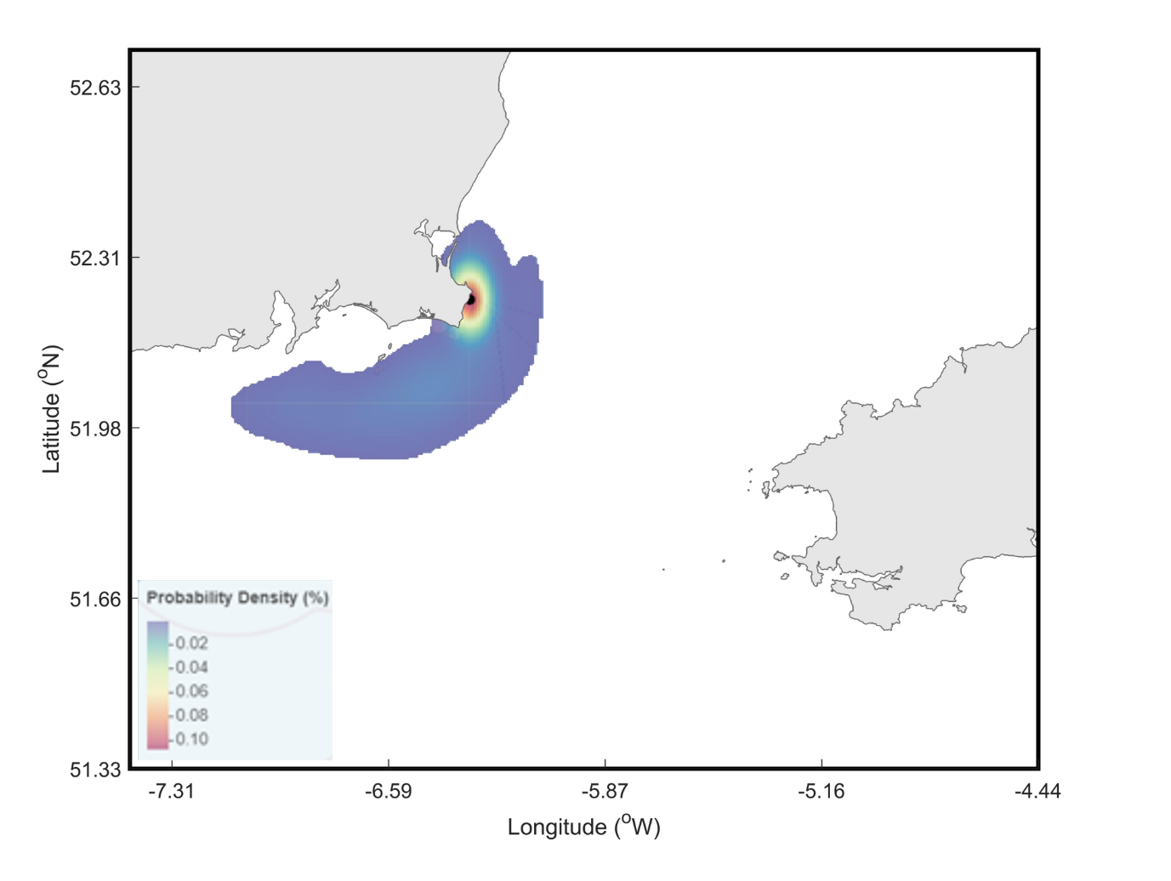
Fig S1. Estimates of larval dispersal for the intertidal marine gastropod, Phorcus lineatus, from Rosslare, Ireland.

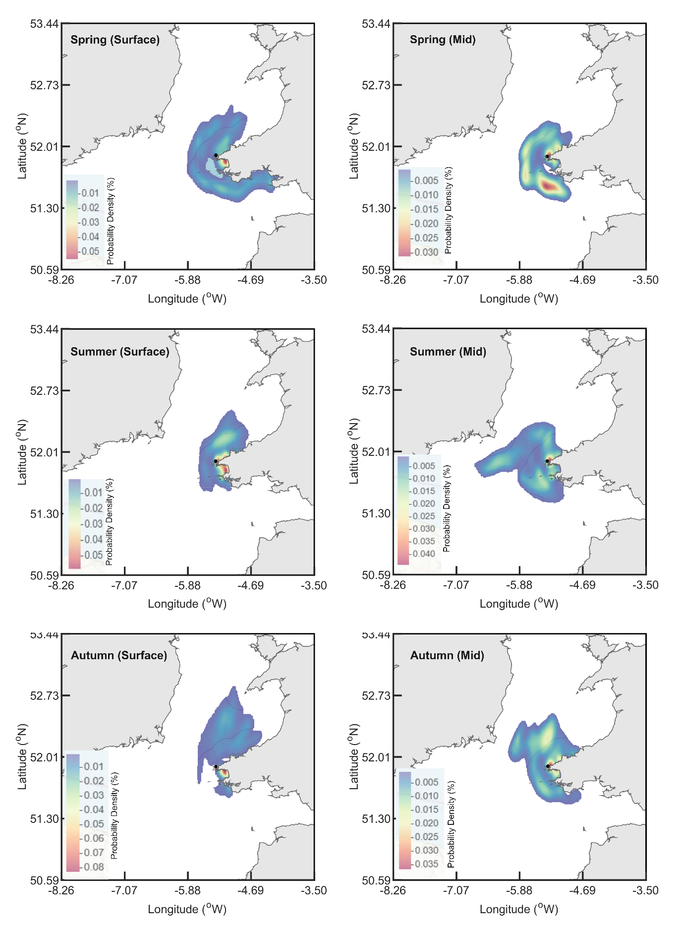
Fig S2: Dispersal from Porthgain (Pembrokeshire, south Wales), for surface (left column) and mid-depth (right column) during spring (top row), summer (middle row) and autumn (bottom row). Note the different colour scales between the subplots.

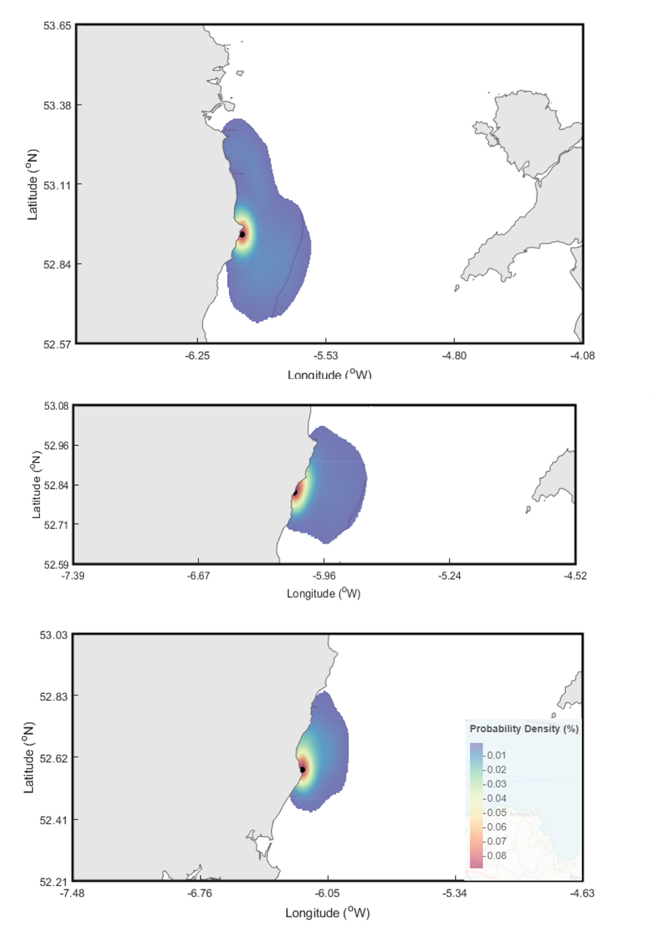
Fig S3. Estimates of larval stepping-stone dispersal for the intertidal marine gastropod, Phorcus lineatus, from Cahore Point (bottom) to Dublin Bay, Ireland, via Arklow (middle) and Wicklow (top).

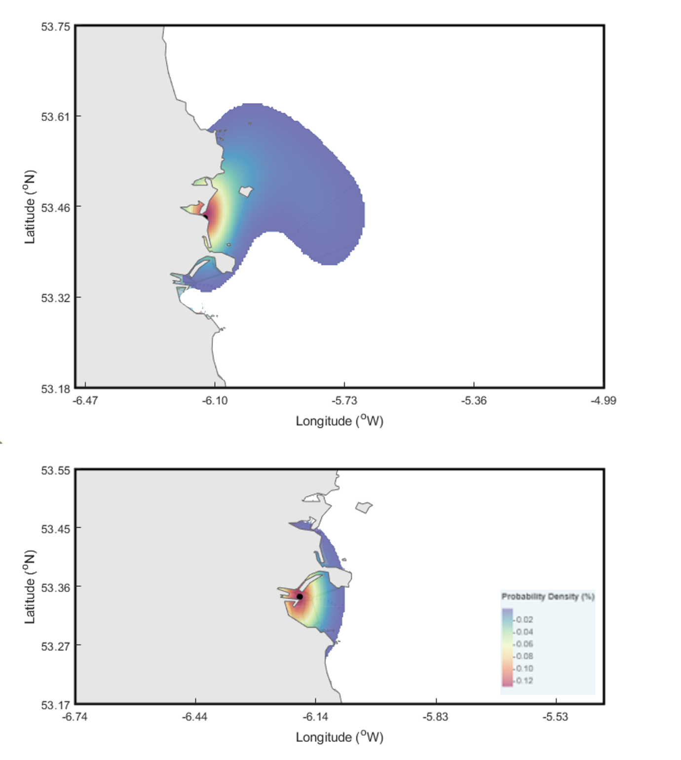
Fig. S4. Estimates of larval dispersal for the intertidal marine gastropod, Phorcus lineatus, from Dublin (bottom) and Malahide (top), Ireland.

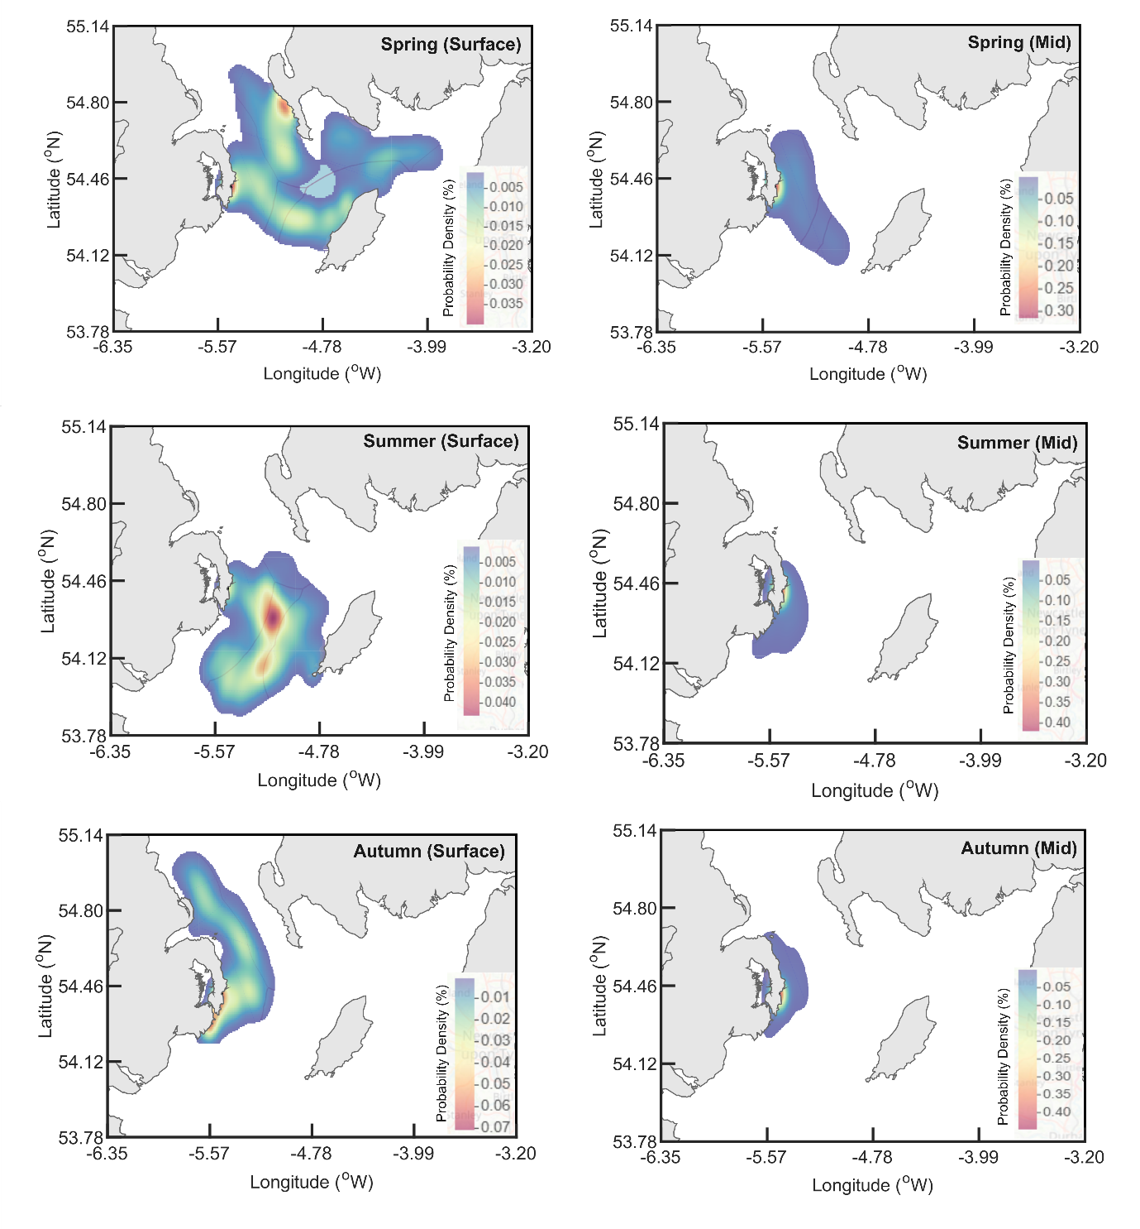
Fig S5: Dispersal from Kearney Point (Northern Ireland), for surface (left column) and mid-depth (right column) during spring (top row), summer (middle row) and autumn (bottom row). Note the different colour scales between the subplots.

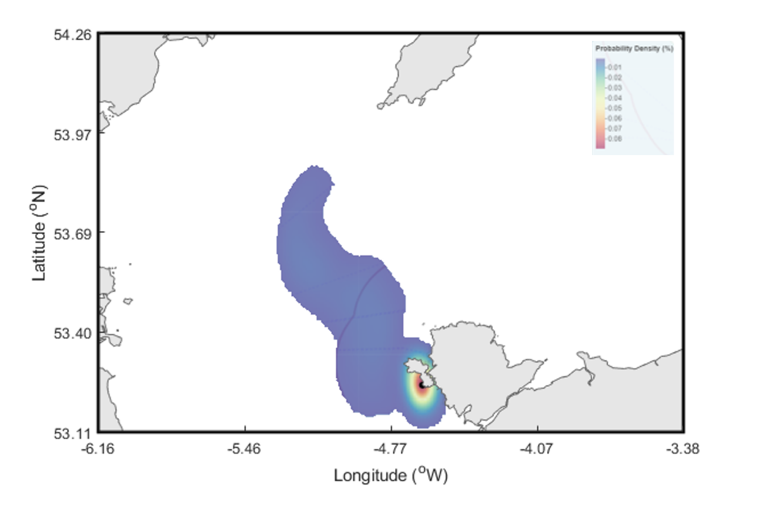
Fig. S6. Estimates of larval dispersal for the intertidal marine gastropod, Phorcus lineatus, from Anglesey, Wales.
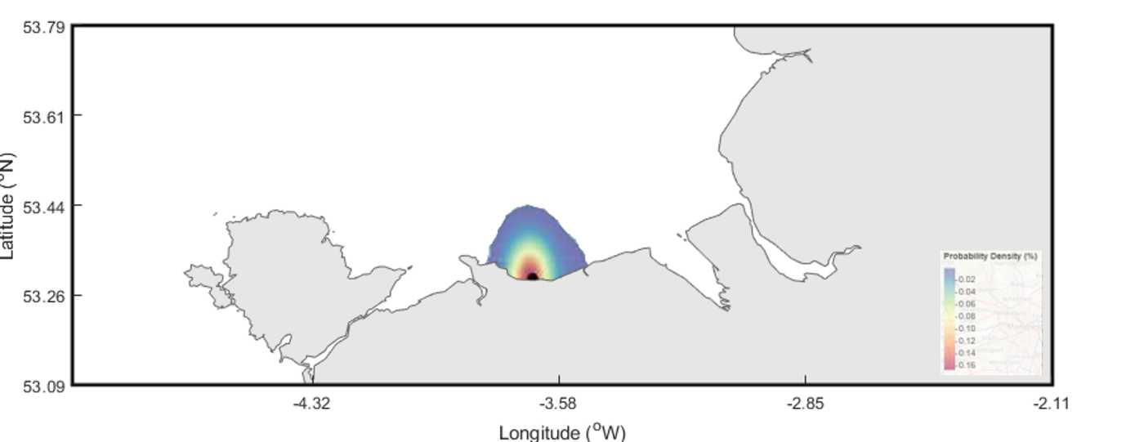
Fig. S7: Estimates of larval dispersal for the intertidal marine gastropod, Phorcus lineatus, from Llanddulas, Wales.

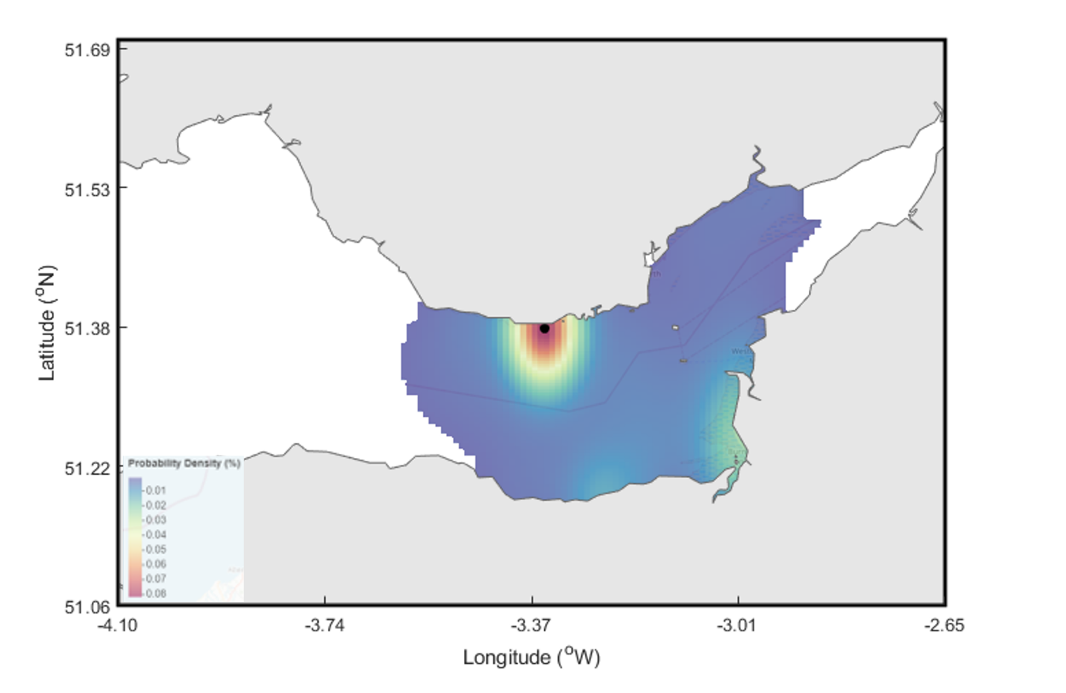
Fig S8: Estimates of larval dispersal for the intertidal marine gastropod, Phorcus lineatus, from Barry, Wales.

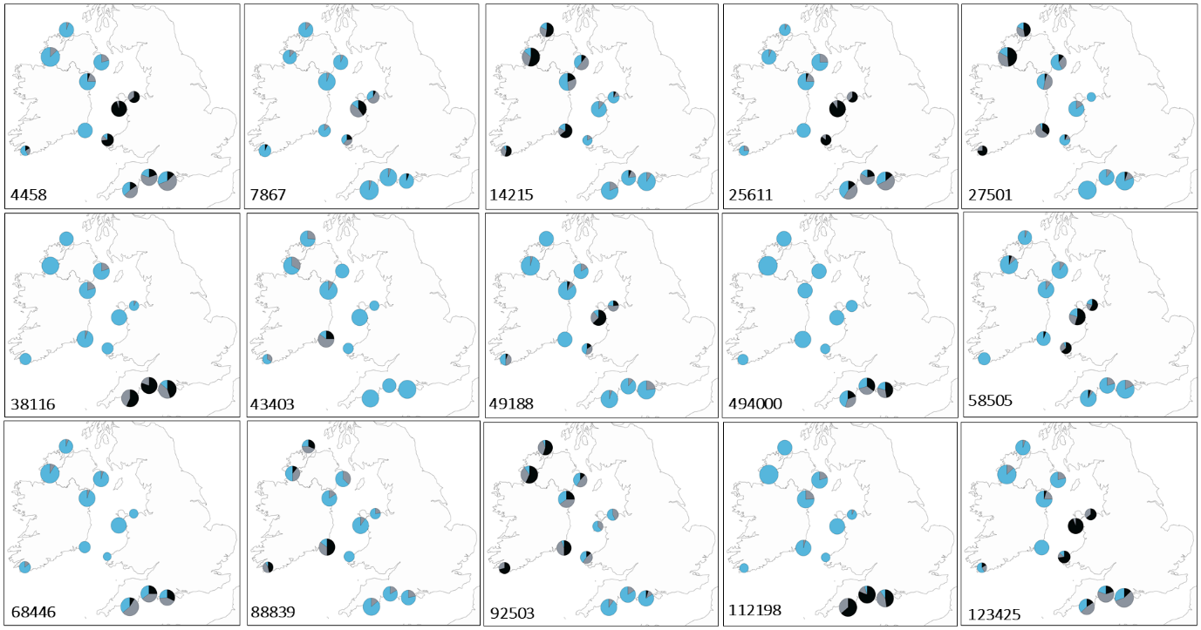
Fig. S9: Genotype frequency distribution of 15 outlier loci identified by both PCAdapt and OutFLANK analyses on a dataset of SNP markers genotyped in Phorcus lineatus. Outlier IDs are in the bottom left corner of each plot. Pie charts are scaled according to sample size, and coloured according to genotype, with grey indicating heterozygotes, and blue/black indicating homozygotes for each SNP.

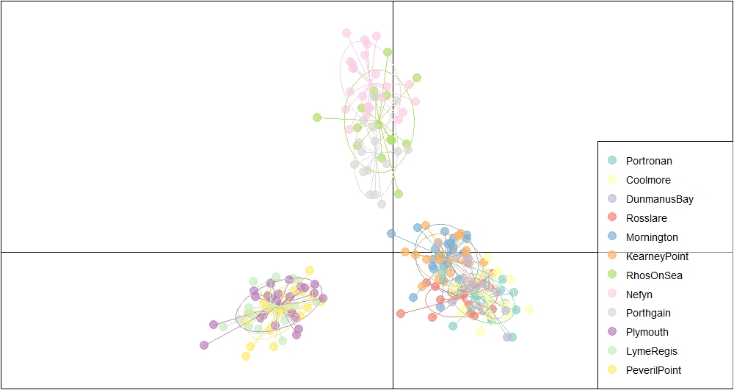
Fig. S10: DAPC plot of SNP loci identified as outliers by PCAdapt and OutFLANK.

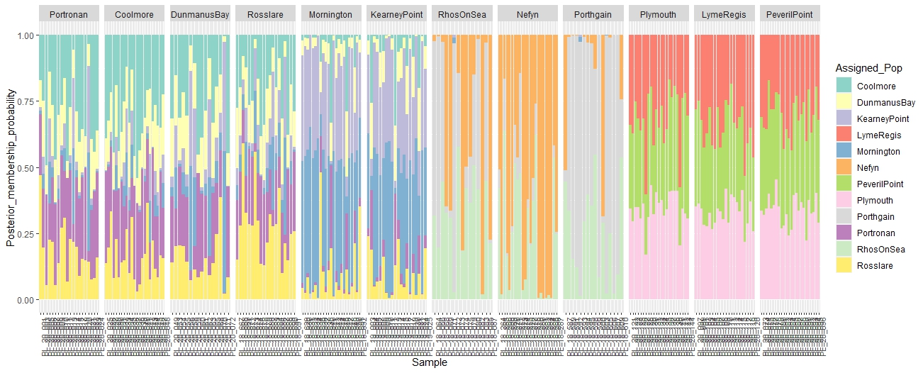
Fig. S11: Assignment plots of SNP loci identified as outliers by PCAdapt and OutFLANK.

