Table 1 Characteristics of patients in Part I.
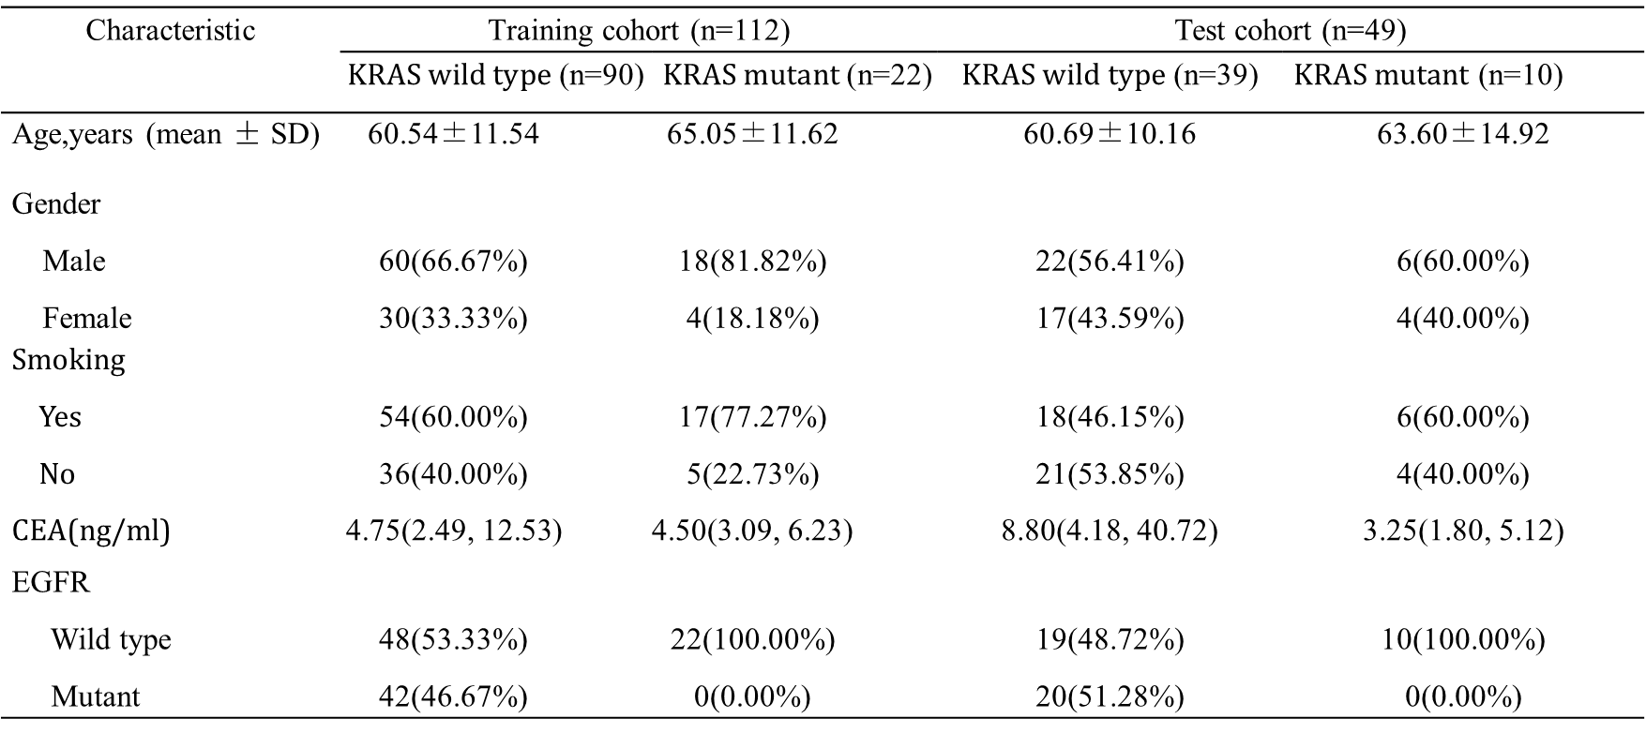

Table 2 Characteristics of patients in Part II.
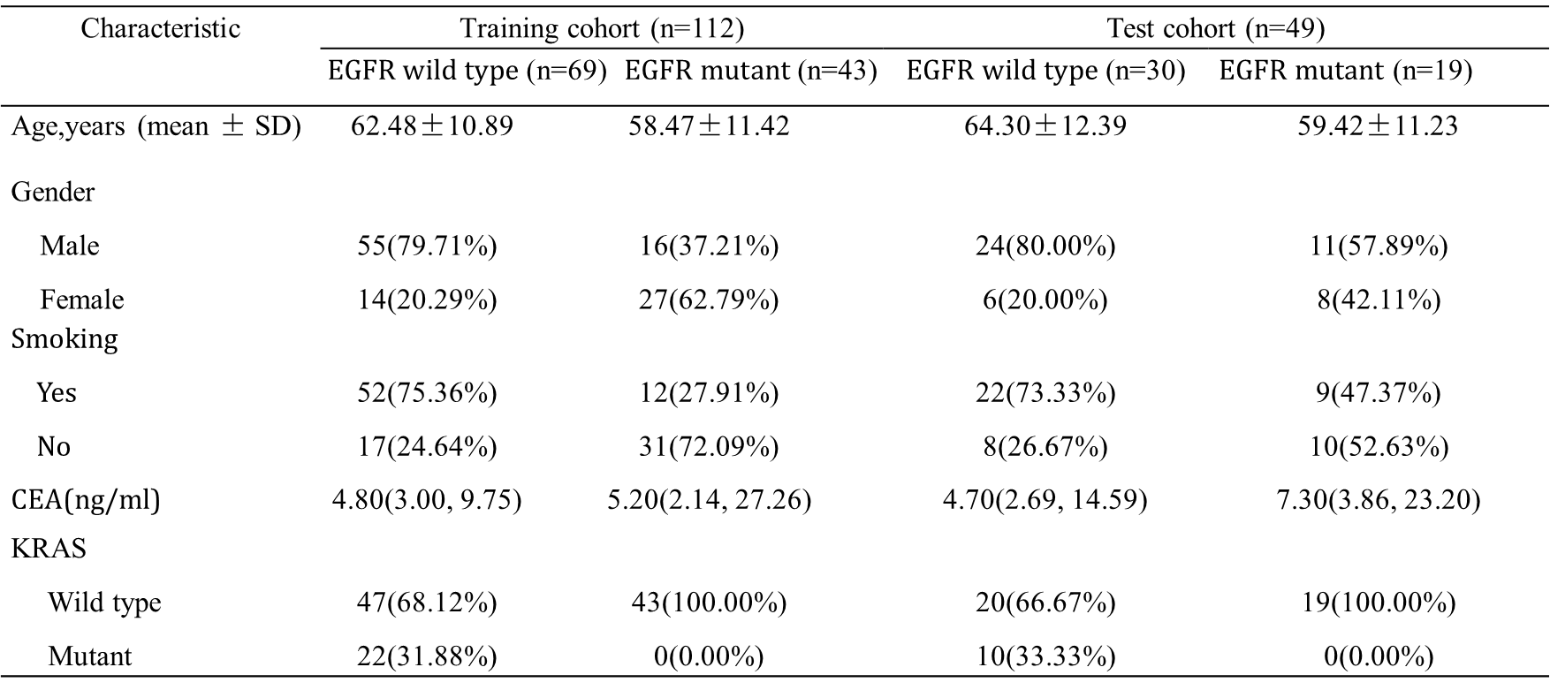

Table 3 Diagnostic performance of three models for predicting KRAS mutations.
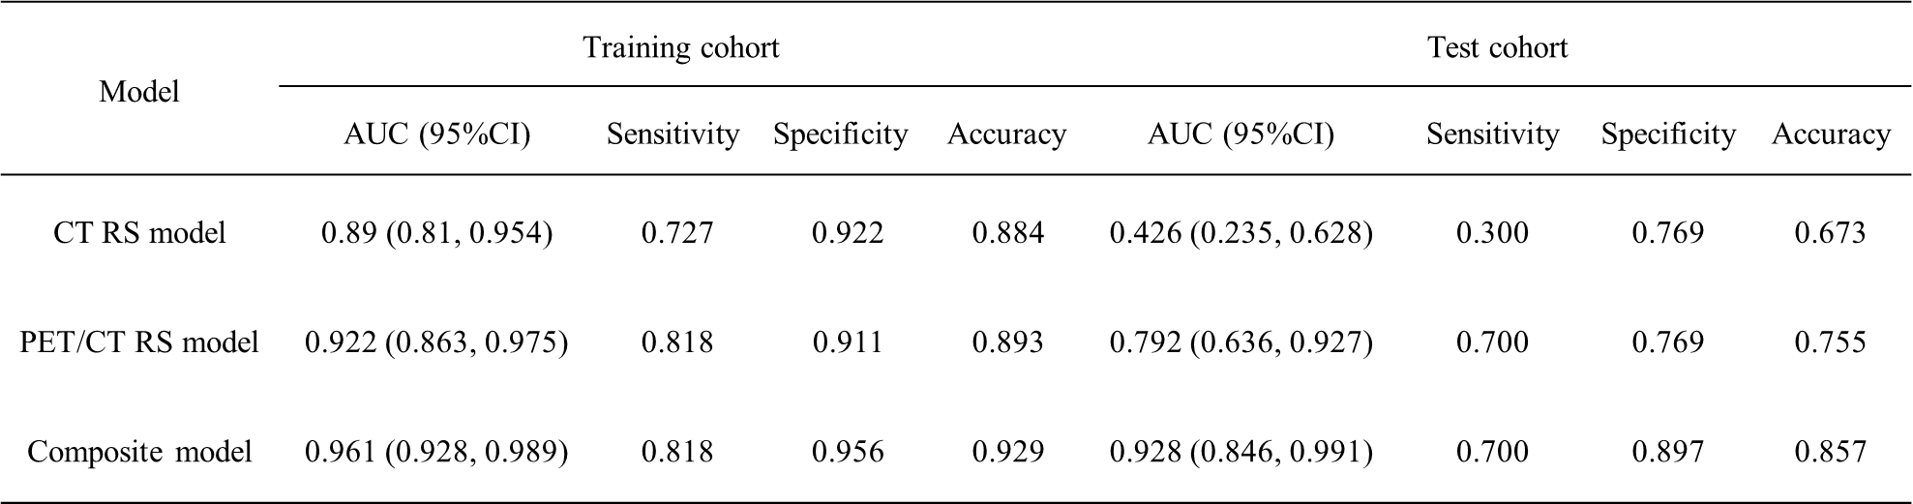

Table 4 Diagnostic performance of three models for predicting EGFR mutations.
