Blood levels of Persistent Organic Pollutants and circulating biomarkers of systemic inflammation in French women: Evidence from the E3N-Generations cohort
Francesca Romana Mancini^{1*}, Pauline Frénoy¹, German Cano-Sancho², Jean-Philippe Antignac², Philippe Marchand², Bruno Le Bizec², Chloé Marques¹, Xuan Ren¹, Vittorio Perduca^{3,1}, Gianluca Severi^{1,4}
Supplementary material
Supplementary Figure 1: Directed acyclic graph to identify possible adjustments sets to estimate the total effects of persistent organic pollutants biomarkers on systemic inflammation.
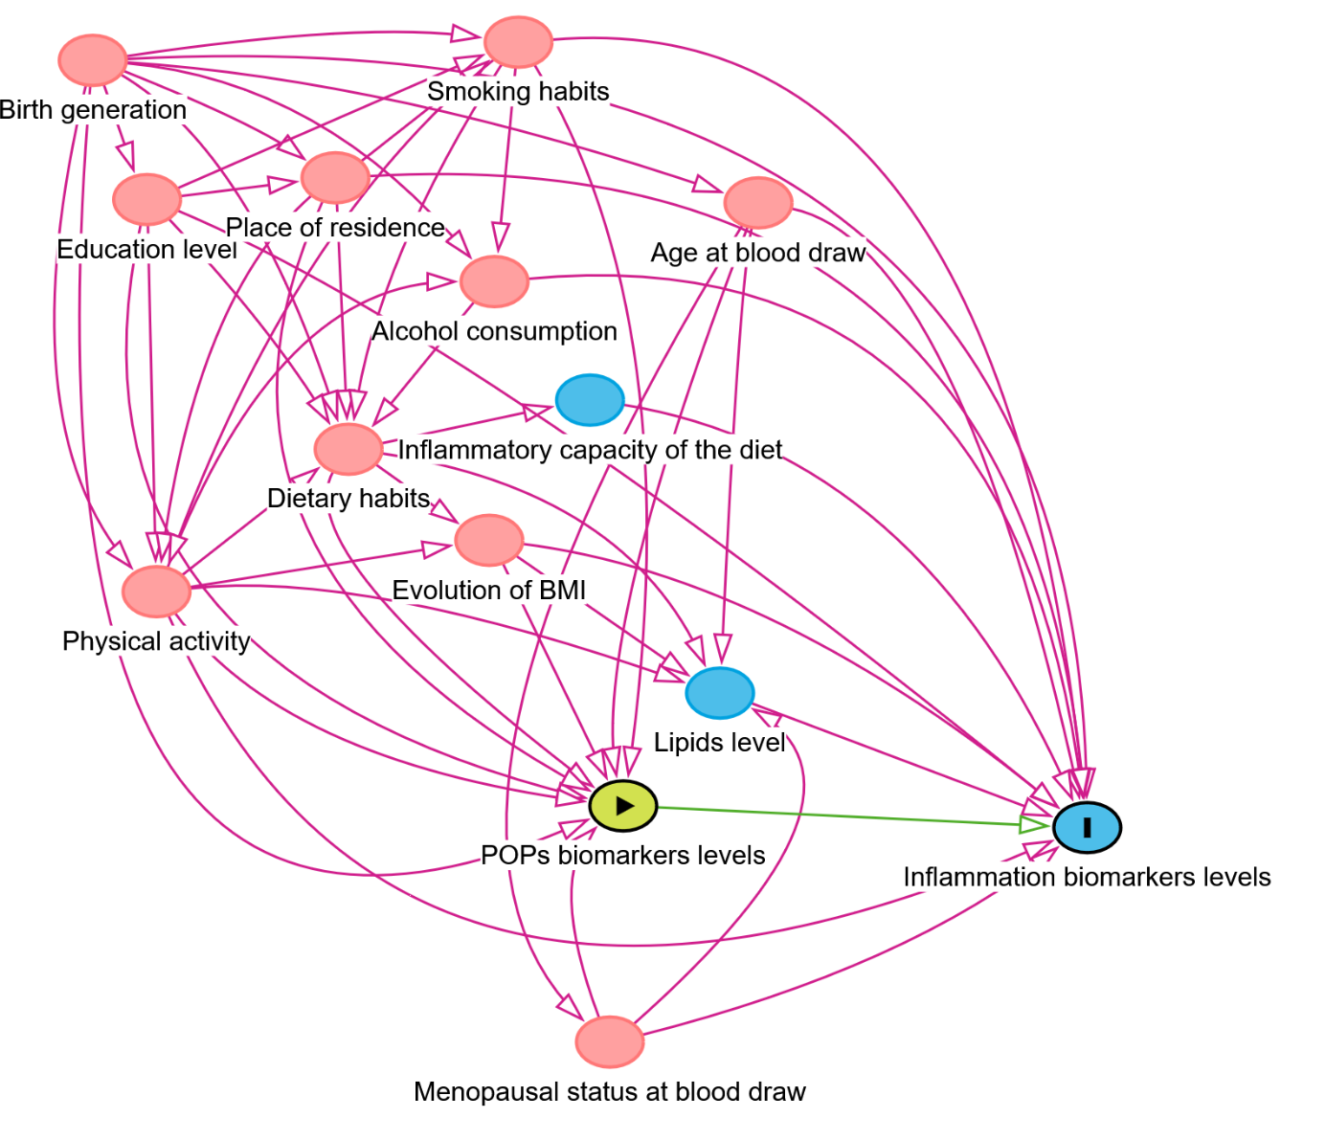

Supplementary Figure 2: Heat-map representing the Spearman rank correlation coefficients between the 45 POPs biomarkers after imputation of non-quantified values by the lower limit of quantification divided by √2.
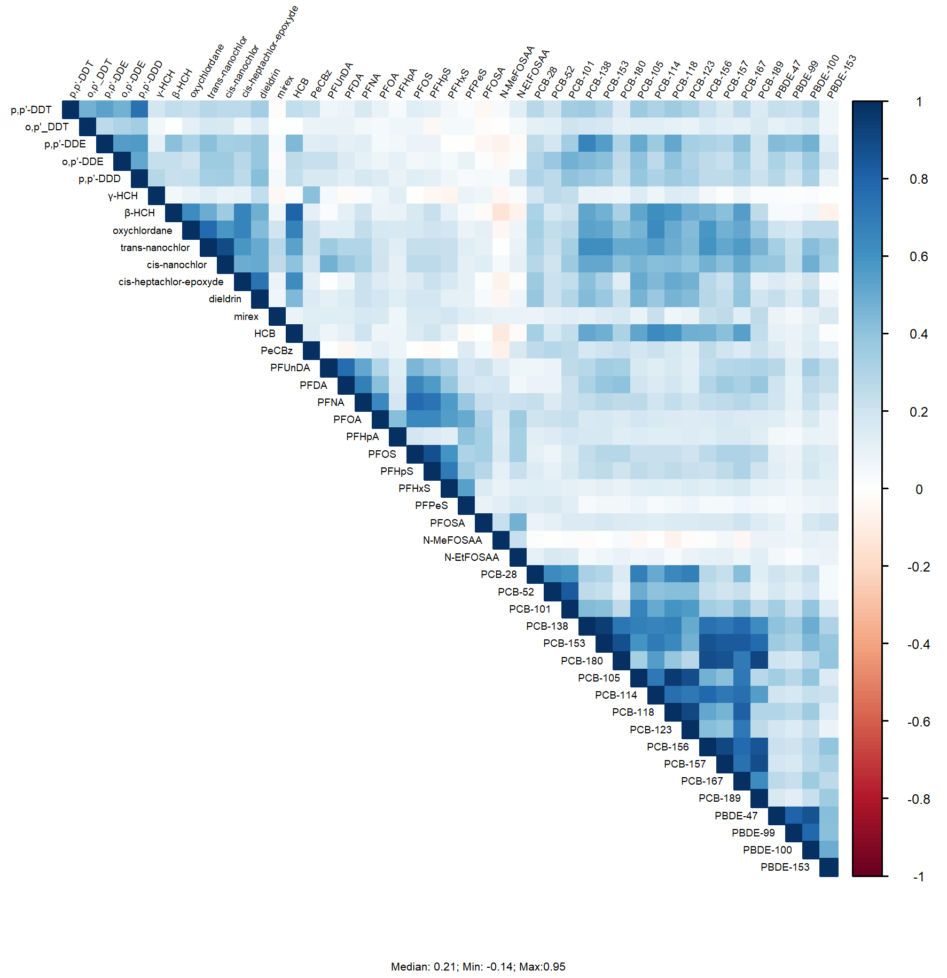
Supplementary Figure 3: Heat-map representing the Spearman rank correlation coefficients between the 4 biomarkers of systemic inflammation.
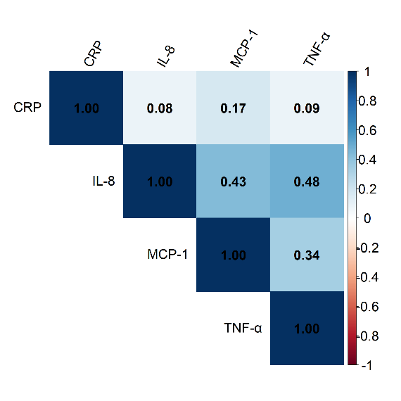
Supplementary table 1: Number and proportion of non-quantified values, imputation strategy, post-imputation median [interquartile range], and categorization of POPs and systemic inflammatory biomarkers
 | Number (proportion) of non-quantified values | Imputation of non-quantified values | Medain [Q1-Q3] | Categorization
PBDE-47 (pg/mL) | 1 (0.2%) | Yes, by LLOQ/√2 | 2.50 [1.65-4.14] | Continuous; 2 categories: <median/>median
PBDE-99 (pg/mL) | 5 (1.1%) | Yes, by LLOQ/√2 | 0.68 [0.48-1.03] | Continuous; 2 categories: <median/>median
PBDE-100 (pg/mL) | 2 (0.4%) | Yes, by LLOQ/√2 | 0.85 [0.57-1.33] | Continuous; 2 categories: <median/>median
PBDE-153 (pg/mL) | 1 (0.2%) | Yes, by LLOQ/√2 | 2.52 [1.97-3.38] | Continuous; 2 categories: <median/>median
PFUnDA (ng/mL) | 5 (1.1%) | Yes, by LLOQ/√2 | 0.15 [0.11-0.21] | Continuous; 2 categories: <median/>median
PFDA (ng/mL) | 1 (0.2%) | Yes, by LLOQ/√2 | 0.21 [0.16-0.28] | Continuous; 2 categories: <median/>median
PFNA (ng/mL) | 0 | - | 0.57 [0.42-0.75] | Continuous; 2 categories: <median/>median
PFOA (ng/mL) | 0 | - | 5.16 [3.83-7.50] | Continuous; 2 categories: <median/>median
PFHpA (ng/mL) | 38 (8.1%) | Yes, by LLOQ/√2 | 0.13 [0.07-0.25] | Continuous; 2 categories: <median/>median
PFOS (ng/mL) | 0 | - | 33.66 [25.66-42.69] | Continuous; 2 categories: <median/>median
PFHpS (ng/mL) | 0 | - | 0.37 [0.27-0.48] | Continuous; 2 categories: <median/>median
PFHxS (ng/mL) | 0 | - | 1.47 [1.10-2.09] | Continuous; 2 categories: <median/>median
PFPeS (ng/mL) | 116 (24.8%) | Yes, by LLOQ/√2 | 0.03 [0.02-0.04] | Continuous; 2 categories: <median/>median
PFOSA (ng/mL) | 2 (0.4%) | Yes, by LLOQ/√2 | 0.59 [0.42-0.85] | Continuous; 2 categories: <median/>median
N-MeFOSAA (ng/mL) | 4 (0.9%) | Yes, by LLOQ/√2 | 0.38 [0.26-0.60] | Continuous; 2 categories: <median/>median
N-EtFOSAA (ng/mL) | 1 (0.2%) | Yes, by LLOQ/√2 | 0.57 [0.39-0.88] | Continuous; 2 categories: <median/>median
p,p’-DDT (pg/mL) | 175 (35.7%) | No | 32.61 [11.15-72.17] | 2 categories : non-quantified/quantified
o,p’-DDT (pg/mL) | 344 (73.7%) | No | 2.51 [2.02-2.93] | 2 categories : non-quantified/quantified
p,p’-DDE (pg/mL) | 0 | - | 1709.33 [1017.37-2961.04] | Continuous; 2 categories: <median/>median
o,p’-DDE (pg/mL) | 11 (2.4%) | Yes, by LLOQ/√2 | 1.08 [0.69-1.58] | Continuous; 2 categories: <median/>median
p,p’-DDD (pg/mL) | 54 (11.6%) | Yes, by LLOQ/ | 2.96 [1.28-5.71] | Continuous; 2 categories: <median/>median
γ-HCH (pg/mL) | 307 (65.7%) | No | 16.09 [12.89-22.50] | Continuous; 2 categories: <median/>median
β-HCH (pg/mL) | 0 | - |  | Continuous; 2 categories: <median/>median
Oxychlordane (pg/mL) | 0 | - | 64.93 [50.54-85.27] | Continuous; 2 categories: <median/>median
trans-nanochlor (pg/mL) | 0 | - | 45.52 [37.24-59.31] | Continuous; 2 categories: <median/>median
cis-nanochlor (pg/mL) | 0 | - | 7.19 [5.27-9.85] | Continuous; 2 categories: <median/>median
cis-heptachlor-epoxyde(pg/mL) | 0 | - | 46.80 [33.84-69.61] | Continuous; 2 categories: <median/>median
Dieldrin (pg/mL) | 0 | - | 57.83 [38.82-84.24] | Continuous; 2 categories: <median/>median
HCB (pg/mL) | 0 | - | 247.00 [162.81-361.92] | Continuous; 2 categories: <median/>median
PeCBz (pg/mL) | 24 (5.1%) | Yes, by LLOQ/√2 | 5.71 [4.04-7.68] | Continuous; 2 categories: <median/>median
Mirex (pg/mL) | 337 (72.2%) | No | 2.86 [2.65-4.38] | 2 categories : non-quantified/quantified
PCB-28 (ng/mL) | 0 | - | 0.01 [0.01-0.02] | Continuous; 2 categories: <median/>median
PCB-52 (ng/mL) | 0 |  | 0.00 [0.00-0.01] | Continuous; 2 categories: <median/>median
PCB-101 (ng/mL) | 0 | - | 0.01 [0.00-0.01] | Continuous; 2 categories: <median/>median
PCB-138 (ng/mL) | 0 |  | 0.60 [0.44-0.79] | Continuous; 2 categories: <median/>median
PCB-153 (ng/mL) | 0 | - | 1.28 [0.98-1.63] | Continuous; 2 categories: <median/>median
PCB-180 (ng/mL) | 0 |  | 0.99 [0.78-1.28] | Continuous; 2 categories: <median/>median
PCB-105 (pg/mL) | 0 | - | 37.84 [24.62-56.38] | Continuous; 2 categories: <median/>median
PCB-114 (pg/mL) | 0 |  | 11.82 [8.80-15.75] | Continuous; 2 categories: <median/>median
PCB-118 (pg/mL) | 0 | - | 243.61 [168.36-331.53] | Continuous; 2 categories: <median/>median
PCB-123 (pg/mL) | 0 |  | 2.11 [1.45-3.30] | Continuous; 2 categories: <median/>median
PCB-156 (pg/mL) | 0 | - | 125.96 [102.04-152.60] | Continuous; 2 categories: <median/>median
PCB-157 (pg/mL) | 0 |  | 27.60 [21.60-35.33] | Continuous; 2 categories: <median/>median
PCB-167 (pg/mL) | 0 | - | 42.92 [32.51-56.72] | Continuous; 2 categories: <median/>median
PCB-189 (pg/mL) | 0 |  | 11.72 [9.21-15.81] | Continuous; 2 categories: <median/>median
TNF-α (pg/mL) | 304 (64.96%) | No | 3.4 [1.7-5.8] | 2 categories: non-quantified/quantified
IL-8 (pg/mL) | 185 (39.53%) | No | 0.8 [0.6-1.2] | 2 categories: non-quantified/quantified
CRP (µg/mL) | 59 (12.61%) | Yes, by extrapolated values | 25.9 [13.0-52.2] | Continuous; 2 categories: <median/>median
MCP-1 (pg/mL) | 0 | - | 165.5 [135.1-202.3] | Continuous; 2 categories: <median/>median

Supplementary table 2 : Loading factors for POPs in the 6 retained principal components ordered by decreasing variance, after performing a principal component analysis with varimax rotation on biomarkers of 45 POPs in the blood samples of women of the French E3N cohort study (N = 467).
Variable | Non-DDT OCPs and DL-PCBs | PCBs (DL and NDL) | PFAS | PBDEs | Mixed POP profile | DDT metabolites
pp_DDT | 0.11 | -0.02 | 0.02 | -0.01 | 0.06 | 0.89
op_DDT | 0.05 | 0.01 | -0.02 | -0.01 | 0.14 | 0.80
pp_DDE | 0.48 | 0.21 | -0.08 | 0.14 | 0.12 | 0.46
op_DDE | 0.21 | 0.14 | -0.01 | 0.05 | 0.12 | 0.55
pp_DDD | 0.07 | 0.05 | 0.03 | 0.03 | 0.11 | 0.87
g_HCH | -0.09 | 0.08 | 0.00 | -0.03 | 0.51 | 0.17
b_HCH | 0.72 | 0.18 | -0.03 | -0.05 | 0.04 | 0.01
oxychlordane | 0.68 | 0.34 | 0.09 | 0.02 | -0.09 | 0.06
Trans_nanochlor | 0.61 | 0.46 | 0.19 | 0.05 | -0.13 | 0.15
cis_nanochlor | 0.55 | 0.43 | 0.28 | 0.06 | -0.15 | 0.14
Heptachlor_epoxyde_cis | 0.82 | -0.04 | 0.07 | -0.03 | -0.07 | 0.13
Dieldrin | 0.54 | 0.08 | 0.10 | -0.03 | 0.05 | 0.25
mirex | 0.10 | 0.26 | 0.24 | 0.00 | -0.07 | 0.09
HCB | 0.69 | 0.09 | -0.06 | -0.04 | -0.08 | -0.03
PeCBz | -0.02 | 0.15 | 0.00 | -0.05 | 0.40 | 0.17
PFUnDA | -0.01 | 0.31 | 0.57 | 0.09 | -0.03 | 0.04
PFDA | 0.01 | 0.27 | 0.66 | 0.02 | -0.02 | -0.05
PFNA | 0.16 | 0.11 | 0.83 | 0.04 | -0.02 | 0.02
PFOA | 0.05 | -0.01 | 0.73 | 0.02 | 0.08 | -0.03
PFHpA | 0.08 | 0.00 | 0.44 | -0.01 | 0.14 | -0.02
Total_PFOS | 0.11 | 0.15 | 0.83 | -0.01 | -0.05 | -0.02
PFHpS | 0.14 | 0.06 | 0.82 | 0.02 | -0.07 | -0.01
PFHxS | -0.04 | -0.04 | 0.41 | 0.01 | -0.10 | 0.16
PFPeS | -0.02 | -0.04 | 0.55 | -0.02 | 0.09 | 0.00
PFOSA | 0.02 | 0.14 | 0.37 | 0.03 | 0.21 | -0.08
N_MeFOSAA | -0.14 | 0.06 | 0.24 | 0.13 | -0.04 | 0.00
N_EtFOSAA | 0.03 | 0.00 | 0.26 | -0.05 | 0.09 | -0.01
PCB_28 | 0.39 | -0.08 | 0.05 | 0.02 | 0.46 | 0.28
PCB_52 | 0.06 | -0.01 | 0.09 | 0.02 | 0.79 | -0.01
PCB_101 | 0.20 | 0.18 | 0.11 | 0.07 | 0.78 | 0.04
PCB_138 | 0.49 | 0.69 | 0.09 | 0.14 | 0.17 | 0.12
PCB_153 | 0.37 | 0.85 | 0.12 | 0.12 | 0.17 | 0.09
PCB_180 | 0.09 | 0.93 | 0.12 | 0.06 | 0.09 | 0.04
PCB_105 | 0.75 | 0.21 | 0.10 | 0.08 | 0.49 | 0.08
PCB_114 | 0.58 | 0.55 | 0.06 | 0.02 | 0.38 | 0.04
PCB_118 | 0.75 | 0.27 | 0.08 | 0.08 | 0.48 | 0.05
PCB_123 | 0.73 | 0.18 | 0.09 | 0.03 | 0.47 | 0.01
PCB_156 | 0.29 | 0.88 | 0.11 | 0.03 | 0.16 | 0.02
PCB_157 | 0.20 | 0.90 | 0.10 | 0.06 | 0.13 | -0.01
PCB_167 | 0.57 | 0.67 | 0.13 | 0.09 | 0.22 | 0.00
PCB_189 | 0.03 | 0.92 | 0.13 | 0.02 | 0.06 | 0.04
PBDE_47 | 0.04 | 0.00 | 0.01 | 0.94 | -0.01 | 0.00
PBDE_99 | 0.03 | 0.00 | -0.02 | 0.94 | 0.00 | 0.01
PBDE_100 | 0.06 | 0.06 | 0.03 | 0.97 | 0.01 | 0.04
PBDE_153 | -0.07 | 0.22 | 0.06 | 0.65 | 0.02 | 0.04

Supplementary table 3: Logistic regression models with false discovery rate (FDR) correction (Benjamini-Hochberg method), estimating adjusted associations between 45 POPs biomarkers and four biomarkers of systemic inflammation (CRP, IL-8, MCP-1, and TNFα). Each POP biomarker is fitted in a separate model, adjusted for age at blood draw, birth generation, years of school education, residential area, smoking status, physical activity, variation of BMI, alcohol consumption, inflammatory capacity of the diet, menopausal status, and lipid plasma level
Variable | CRP  OR [95% CI] | CRP  p | IL-8  OR [95% CI] | IL-8  p | MCP-1  OR [95% CI] | MCP-1  p | TNF-α  OR [95% CI] | TNF-α  p
p,p’-DDT, Quantified (ref: Non-quantified) | 1.05 [0.72; 1.55] | 0.95 | 0.91 [0.61; 1.34] | 0.94 | 1.28 [0.87; 1.89] | 0.76 | 0.92 [0.62; 1.38] | 0.93
o,p'-DDT, Quantified (ref: Non-quantified) | 0.75 [0.49; 1.14] | 0.52 | 0.62 [0.40; 0.95] | 0.34 | 0.85 [0.55; 1.30] | 0.74 | 0.91 [0.58; 1.40] | 0.98
p,p’-DDE, >Median (ref: <=Median) | 1.40 [0.97; 2.04] | 0.40 | 1.11 [0.76; 1.63] | 0.83 | 0.83 [0.57; 1.22] | 0.83 | 0.81 [0.54; 1.19] | 0.83
o,p’-DDE, >Median (ref: <=Median) | 1.52 [1.05; 2.21] | 0.34 | 0.80 [0.55; 1.18] | 0.90 | 0.92 [0.63; 1.34] | 0.92 | 0.77 [0.52; 1.14] | 0.76
p,p’-DDD, >Median (ref: <=Median) | 1.01 [0.69; 1.47] | 0.93 | 0.89 [0.60; 1.30] | 0.93 | 1.00 [0.68; 1.46] | 1.00 | 0.86 [0.58; 1.27] | 0.90
γ-HCH, Quantified (ref : Non-quantified) | 1.17 [0.79; 1.73] | 0.83 | 0.89 [0.60; 1.33] | 0.94 | 1.04 [0.70; 1.54] | 0.98 | 0.95 [0.63; 1.42] | 0.88
β-HCH, >Median (ref: <=Median) | 2.14 [1.44; 3.20] | 0.08 | 0.77 [0.51; 1.15] | 0.54 | 0.82 [0.54; 1.22] | 0.52 | 1.03 [0.68; 1.56] | 0.93
oxychlordane, >Median (ref: <=Median) | 1.46 [1.00; 2.13] | 0.43 | 0.94 [0.63; 1.38] | 0.95 | 0.77 [0.52; 1.14] | 0.29 | 1.25 [0.84; 1.86] | 0.83
trans-nanochlor, >Median (ref: <=Median) | 1.50 [1.03; 2.19] | 0.34 | 0.82 [0.56; 1.20] | 0.88 | 0.96 [0.66; 1.40] | 0.83 | 1.09 [0.74; 1.61] | 0.93
cis-nanochlor, >Median (ref: <=Median) | 1.38 [0.95; 2.00] | 0.34 | 0.61 [0.42; 0.90] | 0.34 | 0.79 [0.54; 1.15] | 0.53 | 0.82 [0.55; 1.21] | 0.83
cis-heptachlor-epoxyde, >Median (ref: <=Median) | 2.29 [1.56; 3.36] | 0.01 | 1.01 [0.68; 1.49] | 0.94 | 0.83 [0.56; 1.22] | 0.45 | 1.47 [0.99; 2.19] | 0.34
dieldrin, >Median (ref: <=Median) | 1.96 [1.35; 2.87] | 0.08 | 0.85 [0.58; 1.25] | 0.90 | 1.16 [0.79; 1.69] | 0.93 | 1.41 [0.95; 2.08] | 0.35
mirex, Quantified (ref: Non-quantified) | 1.20 [0.79; 1.81] | 0.83 | 0.68 [0.44; 1.03] | 0.34 | 0.90 [0.59; 1.37] | 0.88 | 0.77 [0.49; 1.18] | 0.78
HCB, >Median (ref: <=Median) | 1.83 [1.25; 2.70] | 0.12 | 0.76 [0.51; 1.13] | 0.58 | 0.62 [0.42; 0.92] | 0.15 | 1.20 [0.80; 1.79] | 0.88
PeCBz, >Median (ref: <=Median) | 0.85 [0.59; 1.23] | 0.83 | 1.13 [0.77; 1.65] | 0.76 | 0.72 [0.50; 1.05] | 0.34 | 0.81 [0.55; 1.19] | 0.78
PFUnDA, >Median (ref: <=Median) | 0.92 [0.63; 1.33] | 0.83 | 0.59 [0.40; 0.87] | 0.22 | 0.99 [0.68; 1.44] | 0.93 | 0.85 [0.57; 1.25] | 0.93
PFDA, >Median (ref: <=Median) | 1.03 [0.71; 1.50] | 0.93 | 0.54 [0.36; 0.79] | 0.08 | 0.98 [0.67; 1.44] | 0.88 | 0.78 [0.53; 1.15] | 0.70
PFNA, >Median (ref: <=Median) | 0.86 [0.59; 1.26] | 0.88 | 0.58 [0.39; 0.86] | 0.12 | 0.94 [0.64; 1.37] | 0.84 | 0.64 [0.43; 0.96] | 0.34
PFOA, >Median (ref: <=Median) | 0.83 [0.57; 1.21] | 0.88 | 0.80 [0.55; 1.18] | 0.64 | 1.19 [0.82; 1.74] | 0.83 | 0.83 [0.56; 1.23] | 0.83
PFHpA, >Median (ref: <=Median) | 1.07 [0.74; 1.55] | 0.83 | 1.17 [0.80; 1.71] | 0.83 | 1.81 [1.24; 2.64] | 0.05 | 1.19 [0.81; 1.75] | 0.54
PFOS, >Median (ref: <=Median) | 0.71 [0.49; 1.05] | 0.36 | 0.47 [0.31; 0.70] | 0.01 | 0.87 [0.59; 1.28] | 0.83 | 0.83 [0.56; 1.24] | 0.81
PFHpS, >Median (ref: <=Median) | 0.85 [0.57; 1.26] | 0.83 | 0.64 [0.42; 0.96] | 0.27 | 0.98 [0.65; 1.45] | 0.93 | 0.72 [0.48; 1.10] | 0.55
PFHxS, >Median (ref: <=Median) | 1.01 [0.70; 1.47] | 0.93 | 0.62 [0.42; 0.92] | 0.17 | 0.75 [0.51; 1.09] | 0.43 | 0.66 [0.44; 0.98] | 0.34
PFPeS, >Median (ref: <=Median) | 0.79 [0.53; 1.17] | 0.84 | 0.84 [0.57; 1.26] | 0.83 | 0.69 [0.47; 1.03] | 0.43 | 0.76 [0.50; 1.15] | 0.83
PFOSA, >Median (ref: <=Median) | 0.87 [0.60; 1.26] | 0.93 | 1.07 [0.73; 1.56] | 0.95 | 1.46 [1.01; 2.13] | 0.34 | 0.91 [0.62; 1.34] | 0.93
N-MeFOSAA, >Median (ref: <=Median) | 1.03 [0.71; 1.49] | 0.90 | 0.96 [0.66; 1.40] | 0.83 | 0.90 [0.62; 1.31] | 0.90 | 0.87 [0.59; 1.28] | 0.83
N-EtFOSAA, >Median (ref: <=Median) | 0.82 [0.56; 1.18] | 0.99 | 1.17 [0.80; 1.71] | 0.88 | 1.31 [0.90; 1.90] | 0.44 | 1.04 [0.71; 1.52] | 0.93
PCB-28, >Median (ref: <=Median) | 1.35 [0.93; 1.97] | 0.40 | 0.80 [0.54; 1.18] | 0.83 | 1.01 [0.69; 1.49] | 0.99 | 0.87 [0.58; 1.29] | 0.83
PCB-52, >Median (ref: <=Median) | 0.99 [0.68; 1.44] | 0.98 | 0.86 [0.59; 1.26] | 0.90 | 0.99 [0.68; 1.44] | 0.99 | 0.82 [0.55; 1.20] | 0.83
PCB-101, >Median (ref: <=Median) | 0.98 [0.67; 1.42] | 0.96 | 0.78 [0.53; 1.15] | 0.83 | 1.07 [0.73; 1.56] | 0.93 | 0.99 [0.67; 1.47] | 0.93
PCB-138, >Median (ref: <=Median) | 1.25 [0.85; 1.82] | 0.83 | 0.73 [0.49; 1.08] | 0.44 | 0.83 [0.56; 1.22] | 0.45 | 1.02 [0.68; 1.51] | 0.93
PCB-153, >Median (ref: <=Median) | 0.99 [0.68; 1.44] | 0.95 | 0.73 [0.49; 1.08] | 0.34 | 1.01 [0.69; 1.47] | 0.88 | 1.09 [0.73; 1.61] | 0.99
PCB-180, >Median (ref: <=Median) | 0.77 [0.53; 1.12] | 0.54 | 0.86 [0.59; 1.26] | 0.70 | 1.06 [0.73; 1.55] | 0.93 | 1.12 [0.76; 1.65] | 0.94
PCB-105, >Median (ref: <=Median) | 1.18 [0.80; 1.73] | 0.83 | 0.71 [0.47; 1.05] | 0.57 | 1.09 [0.74; 1.61] | 0.98 | 1.04 [0.70; 1.55] | 0.98
PCB-114, >Median (ref: <=Median) | 1.06 [0.72; 1.56] | 1.00 | 0.62 [0.41; 0.93] | 0.22 | 1.01 [0.68; 1.49] | 0.83 | 1.10 [0.73; 1.66] | 0.99
PCB-118, >Median (ref: <=Median) | 1.17 [0.80; 1.72] | 0.74 | 0.60 [0.40; 0.89] | 0.27 | 0.86 [0.58; 1.27] | 0.83 | 0.95 [0.64; 1.42] | 0.88
PCB-123, >Median (ref: <=Median) | 1.28 [0.87; 1.87] | 0.69 | 0.81 [0.55; 1.20] | 0.83 | 1.10 [0.75; 1.62] | 1.00 | 1.29 [0.86; 1.92] | 0.67
PCB-156, >Median (ref: <=Median) | 0.91 [0.62; 1.32] | 0.83 | 0.76 [0.51; 1.11] | 0.40 | 1.04 [0.71; 1.52] | 0.90 | 1.11 [0.75; 1.63] | 0.98
PCB-157, >Median (ref: <=Median) | 0.67 [0.46; 0.98] | 0.34 | 0.81 [0.55; 1.19] | 0.34 | 1.11 [0.76; 1.62] | 0.96 | 1.32 [0.89; 1.95] | 0.78
PCB-167, >Median (ref: <=Median) | 1.05 [0.71; 1.55] | 0.93 | 0.67 [0.44; 1.00] | 0.34 | 0.74 [0.50; 1.11] | 0.34 | 1.20 [0.80; 1.80] | 0.83
PCB-189, >Median (ref: <=Median) | 0.77 [0.53; 1.12] | 0.45 | 0.90 [0.61; 1.31] | 0.78 | 1.38 [0.95; 2.01] | 0.71 | 1.29 [0.88; 1.90] | 0.74
PBDE-47, >Median (ref: <=Median) | 0.90 [0.62; 1.30] | 0.83 | 0.82 [0.56; 1.19] | 0.93 | 0.72 [0.49; 1.04] | 0.34 | 1.07 [0.73; 1.57] | 0.83
PBDE-99, >Median (ref: <=Median) | 1.24 [0.86; 1.80] | 0.83 | 0.99 [0.68; 1.44] | 0.88 | 1.00 [0.69; 1.45] | 0.92 | 0.92 [0.63; 1.35] | 0.93
PBDE-100, >Median (ref: <=Median) | 1.08 [0.74; 1.56] | 0.94 | 0.91 [0.62; 1.33] | 0.93 | 0.85 [0.58; 1.23] | 0.67 | 1.04 [0.70; 1.52] | 0.88
PBDE-153, >Median (ref: <=Median) | 0.69 [0.48; 1.00] | 0.34 | 0.72 [0.49; 1.05] | 0.43 | 0.74 [0.51; 1.08] | 0.12 | 1.03 [0.70; 1.51] | 0.94

