SUPPLEMENTAL MATERIAL
Sample preparation and histopathological analysis
The histopathological characteristics of the ablated tissue were evaluated at different time points upon ablation. Tissue samples were cut at 2.5 µm and mounted on TOMO® and superfrost® plus slides, depending on the platform. The staining method was performed on an automated immunostaining platform (Discovery ULTRA, Ventana-Roche and Autostainer Link 48, Dako), including deparaffinization and rehydration. Antigen retrieval was first performed with the appropriate method (CC1, buffer, Ventana-Roche or PT Link high/low pH buffer, Dako, Agilent) and endogenous peroxidase was blocked (3% hydrogen peroxide). The slides were then incubated with the appropriate primary antibody as detailed in Table 1 of the Supplemental Material. After the primary antibodies, the slides were incubated with the corresponding secondary antibodies and the immunohistochemical reaction was revealed using 30-diaminobenzidine tetrahydrochloride (ChromoMap DAB, Ventana, Roche or DAB+ FLEX, Agilent).
The sections were evaluated using conventional histochemical techniques, including special stains such as Masson's trichrome and Reticulin to evidence the presence of type I and III collagen. Residual inflammatory cellularity and fibroblasts/myofibroblasts and their relationship with surrounding cardiomyocytes were evaluated through immunohistochemical techniques aimed against a number of markers characteristic of different types of cell death mechanisms (NLRP3, RIPK1, RIPK3, P-RIPK3, Gasdermin (GSMDM), Caspase-1, Caspase-3, Caspase-8, MLKL, P-MLKL). Additionally, the orientation of the myocardial fibers was evaluated in both histological dimensions.
Markers of inflammation were also analyzed to identify different cell subpopulations of immune system cells present in the affected areas. A wide panel of characteristic markers of the different cell types was used, including Myeloperoxidase (MPO). In addition, we also studied the expression of GLUT1 in the tissue, for the evaluation of changes in glucose metabolism indicating cell death by hypoxia.
The generated histological sections were digitized on an Axio-Scan Z1 (Zeiss) scanner, and the obtained images were analyzed and quantified using the Qupath v0.4.3 image analysis program.

Table 1 Biomarkers Tested. NOD-, LRR- and pyrin domain-containing protein 3 (NLRP3). Receptor-interacting serine/threonine protein kinase 1 (RIPK1). Receptor-interacting serine/threonine protein kinase 3 (RIPK3). Gasdermin (GSMDM). Mixed lineage kinase domain-like (MLKL)
Antibody | Company | Reference | Clon: | Retrieval | Dilution | Time (min) | Inmunostainer | Specific Marker
Actin | Dako | M0635 | Mouse Monoclonal (HHF35) | CC1 40 min | 1/1000 | 24 | Discovery ULTRA, Ventana-Roche | Protein
C3-cleaved | Cell Signaling | 9661 | Rabbit Polyclonal | CC1 40min | 1/200 | 24 | Discovery ULTRA, Ventana-Roche | Cell death
Calnexin | Proteintech | 66903-1-Ig | Mouse Monoclonal (2A2C6) | High PT Dako 20 min | 1/2500 | 40 | Autostainer Link 48, Dako | Protein
Calreticulin | Abcam | ab2907 | Rabbit Polyclonal | Low PT Dako 20 min | 1/600 | 20 | Autostainer Link 48, Dako | Protein
Caspase-1 | Abcam | ab74249 | Rabbit Polyclonal | High PT Dako 20 min | 1/300 | 20 | Autostainer Link 48, Dako | Cell death
Caspase-8 | Abcam | ab25901 | Rabbit Polyclonal | Low PT Dako | 1/600 | 40 | Autostainer Link 48, Dako | Cell death
CD3 FLEX | Dako | IR503 | Rabbit Polyclonal | High PT Dako 20 min | Ready to use | 20 | Autostainer Link 48, Dako | Inflammation
CD79b | Abcam | ab134147 | Rabbit Monoclonal (EPR6861) | High PT Dako 20 min | 1/500 | 25 | Autostainer Link 48, Dako | Inflammation
MPO | Dako | IR511 | Rabbit Polyclonal | High PT Dako 20 min | Ready to use | 13 | Autostainer Link 48, Dako | Inflammation
Connexin 43 | Millipore | MAB3067 | Mouse Monoclonal (4E6.2) | High PT Dako 20 min | 1/750 | 20 | Autostainer Link 48, Dako | Protein
Desmin | Dako | IR606 | Mouse Monclonal (D33) | High PT Dako 20 min | Ready to use | 20 | Autostainer Link 48, Dako | Protein
GSDMD | Proteintech | 20770-1-AP | Rabbit Polyclonal | High PT Dako 20 min | 1/200 | 20 | Autostainer Link 48, Dako | Cell death
GLUT-1 | Abcam | ab40084 | Mouse Monoclonal (SPM498) | High PT Dako 20 min | 1/200 | 40 | Autostainer Link 48, Dako | Protein
KI67 FLEX | Dako | IR626 | Mouse Monoclonal (MIB-1) | Low PT Dako 20 min | 1/2 | 20 | Autostainer Link 48, Dako | Proliferation
MLKL | LifeSpan BioSciencies | LS-C457002/183008 | Rabbit Polyclonal | CC1 48min | 1/200 | 48 | Discovery ULTRA, Ventana-Roche | Cell death
NLRP3/NALP3 | Novus Biologicals | NBP2-12446 | Rabbit Polyclonal | CC1 48min | 1/1200 | 30 | Autostainer Link 48, Dako | Inflammation
P-MLKL Ser345 | Novus Biologicals | NBP2-66953 | Rabbit Monoclonal (JM92-37) | CC1 48min | 1/100 | 48 | Discovery ULTRA, Ventana-Roche | Cell death
Phospho-RIPK3 (Ser227) | antibodies.com | A305777 | Rabbit Polyclonal | High PT Dako 20 min | 1/100 | 30 | Autostainer Link 48, Dako | Cell death
RIPK3 | ProSci | 2283 | Rabbit Polyclonal | CC1 48min | 1/200 | 40 | Discovery ULTRA, Ventana-Roche | Cell death
RIPK1 | Proteintech | 17519-1-AP | Rabbit Polyclonal | CC1 48min | 1/400 | 48 | Discovery ULTRA, Ventana-Roche | Cell death

Simulations
Simulations by finite elements methods (FEM) were performed using COMSOL Multiphysics (COMSOL Inc., Burlington, MA, USA) to evaluate the electric field strengths reached in different regions to assess the electroporation thresholds. A histological preparation using Hematoxylin and Eosin (H&E) staining was used to differentiate myocardium, adipose tissue and major blood vessels. In the segmented tissue image blood was represented at the endocardial site to obtain a geometry of 80 mm x 80 mm. The resulting 2D cross-section was extruded 80 mm to create the resulting 3D tissue model. A 7.5 Fr catheter geometry was positioned in contact with the tissue with an indentation of 1.5 mm to replicate realistic electrode-tissue interaction (10.1016/j.compbiomed.2022.105346). Electrical properties for myocardium, blood, and fat were defined according to literature values (Blood 0. 75 S/m [10.13099/VIP21000-04-0], Myocardium 0.28 S/m [10.13099/VIP21000-04-0], adipose tissue 0.04 S/m [10.13099/VIP21000-04-0], metal electrode 4.6E6 S/m [10.1109/TBME.2015.2451178] and catheter shaft 1E-6 S/m [10.1109/TBME.2015.2451178]). The electroporation pulses were simulated by applying an electric potential at the electrode-tissue interface based on experimental current and voltage measurements, while the lower surface of the model was defined as zero potential to serve as the return path.
Optical ablation properties
When near-infrared light is delivered to tissue in two orthogonal polarization states, its propagation is influenced by the tissue’s anisotropy. In organized tissues with a preferential cellular alignment, such as cardiac muscle, light propagates at different velocities depending on the polarization direction. This difference produces a measurable phase retardation between the two polarization states, which can be quantified as birefringence (BiR).
Birefringence is therefore an intrinsic optical property of organized biological tissues and reflects the degree of structural organization. When tissue is structurally damaged during ablation, this organized architecture degenerates toward an isotropic state, resulting in a corresponding reduction in BiR. Consequently, the magnitude of birefringence loss provides indication of tissue damage.
It is well known that thermal damage causes structural changes in cardiac tissue due to the denaturation of proteins such as collagen. Recently, it has been reported that high intensity pulsed electric fields also cause changes in BiR justifying the reduction in BiR in the acute phase with the development of fibrotic tissue one month later. Neither this study nor any other known to the authors has justified the biophysical reasons associated with this reduction in BIR due to PFA in cardiac muscle. This study is the first to associate protein denaturation as a possible precursor to Bir reduction to date, to our knowledge. The measurement of BiR loss in these ablations reinforces the histological results shown in Figure 1 of the manuscript.
All ablations performed were effective, as evidenced by a significant reduction in birefringence, which was subsequently confirmed by histological analysis. The mean BiR loss was 20.5 ± 10.2%, 24.8 ± 5.5%, and 24.2 ± 7.5% for groups 1, 2, and 3, respectively.
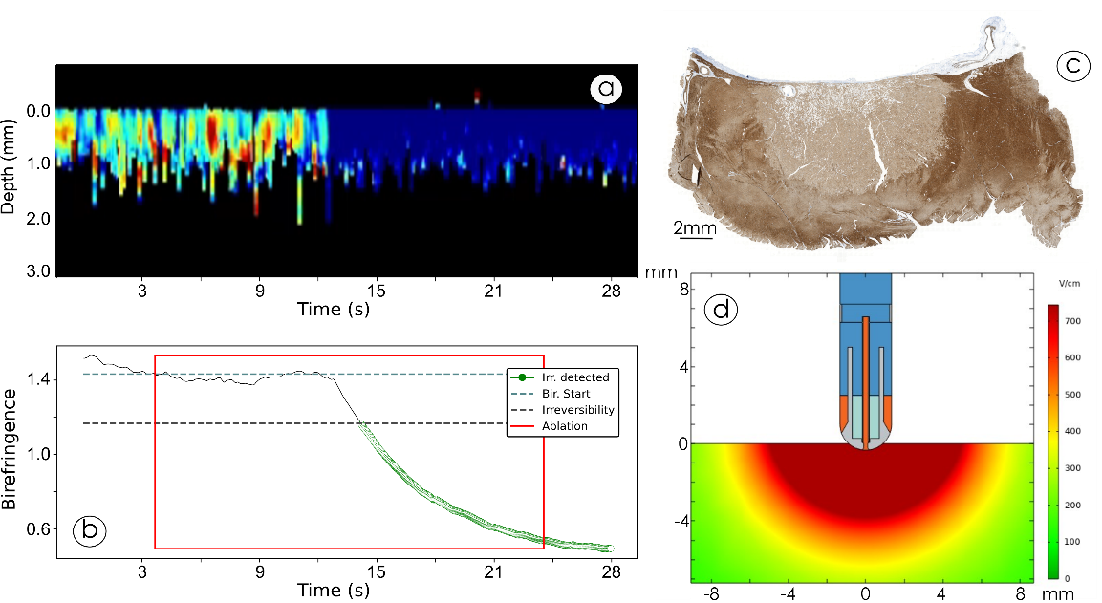
Figure 1 a) and b) Typical image of Phase retardation and BiR loss in ablation, respectively. c) Lesion created during ablation shown in a) and b) stained with Desmin 10 minutes after ablation. d) FEM simulations of the electric field intensity achieved

Incidence of cell death pathways at the lesion border
Phosphorylated MLKL (P-MLKL) marks the activated form of MLKL during necroptosis. As shown in the Figure 2, its activation is more intense at the edge of the lesion. This may be because the lesion is maturing or because cell death by necroptosis has a higher incidence at the periphery of the lesion.
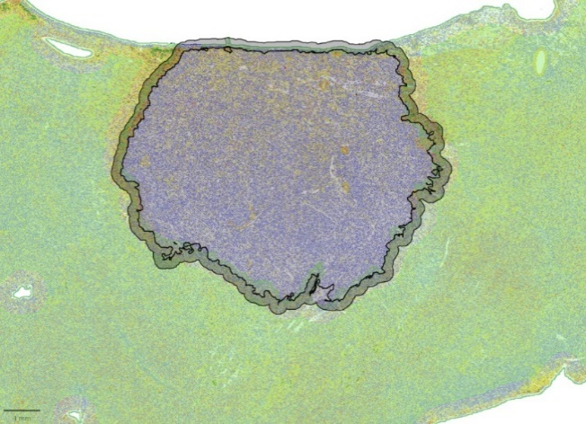
Figure 2 Histological sample taken as an example in the characterization of the edges of the lesion in relation to the center.

