Supplementary files for

Disaccharide production in marine cold seeps links dissolved organic carbon to anaerobic oxidation of methane

Lennart Stock^{1,2}*, Gunter Wegener^{1,3,4}, John W. Pohlman⁵, Laura L. Lapham⁶, Karen G. Lloyd^{7,8}, Leketha Williams⁹, Stian Torset^{3,4}, Ellen Lalk⁵, Anna Hildebrand⁶, Lukas Dirksen¹, Aman A. Mundanatt^{1,4}, Rachel Wilson⁹, Jeffrey S. Seewald¹⁰, Manuel Liebeke^{4,11}, and Marcus Elvert^{1,12}*

¹MARUM – Center for Marine Environmental Sciences, University of Bremen, D-28359 Bremen, Germany
²ICBM – Institute for Chemistry and Biology of the Marine Environment, Carl von Ossietzky University of Oldenburg, D-26129 Oldenburg, Germany
³Alfred Wegener Institute for Polar and Marine Research, D-27515 Bremerhaven, Germany
⁴Max Planck Institute for Marine Microbiology, D-28359 Bremen, Germany
⁵US Geological Survey, Woods Hole Coastal and Marine Science Center, Woods Hole, MA, USA US Geological Survey
⁶University of Maryland Center for Environmental Science, Chesapeake Biological Laboratory, Solomons, MD, USA ⁵US Geological
⁷University of Southern California, Los Angeles, CA, USA
⁸University of Tennessee, Knoxville, TN, USA
⁹Florida State University, Department of Earth, Ocean and Atmospheric Science, Tallahassee, FL, USA
¹⁰Woods Hole Oceanographic Institution, Woods Hole, MA, USA
¹¹University of Kiel, Institute for Metabolomics, D-24118 Kiel, Germany
¹²Faculty of Geosciences, University of Bremen, D-28359 Bremen, Germany
* Corresponding Authors

Supplementary discussion
Sediments cores MUC09-2 (length of 27 cm), MUC09-3 (length of 33 cm), and MUC09-4 (length of 30 cm) were collected video guided MC-400 multi-coring system deployed near the north rim of Astoria Canyon at a site previously explored during ROV Hercules dives H1866 and H1867 (Baumberger et al., 2022). The site is located along a ridge of a headless canyon in an area where gas hydrate formed from microbial and thermogenic gases are outcropping at the seafloor (Baumberger et al., 2018). Similar outcroppings with the characteristic orange-yellow coloration of thermogenic gas hydrate were observed during DSV2 Alvin Dive 5214 during this expedition at a site named here as the Sable Seep, and where the MUC09 multicore set was collected. The cores were preselected for analyses specific to the goals of the project: MUC09-2 was designated for DOM characterization. MUC09-3 was designated for detailed geochemical analysis including the disaccharides, dissolved organic carbon (DOC) and lipids presented and described in this study. MUC09-4 was designated for radiocarbon measurement and the microbiological analysis reported in this study (see also Table 1 of the main text). Porewater from each core was also collected for the analysis of dissolved inorganic carbon (DIC) concentration and δ¹³C values as well as the major anions sulfate and chloride. Cores MUC09-3 and MUC09-4 were also sampled for analysis of dissolved methane concentration and δ¹³C values. Profiles of these analytes are used to link biogeochemical processes across the cores and to evaluate the spatial heterogeneity of the area sampled.
The MUC09-3 porewater profiles of sulfate, DIC and methane concentrations (Supplementary Fig. 2 and 3) and the δ¹³C profiles of methane and DIC (Supplementary Fig. 4) were distinct from MUC09-2 and MUC09-4, as were the methane concentration profiles between MUC09-3 and MUC09-4 (Supplementary Fig. 2). The principal distinction is that sulfate was more abundant and DIC and H₂S less abundant in the SMTZ of MUC09-3 and the δ¹³C methane and DIC within the SMTZ of MUC09-3 were lower. For the methane concentration profiles, we observed a peak in concentration of 4.07 mM at 7.5 cmbsf in core MUC09-4 that was only reached in core MUC09-3 below the SMTZ. On the other hand, sulfate and DIC concentration profiles from MUC09-2 and MUC09-4 were similar with sulfate concentrations decreasing from intermediate values (17 – 23 mM) relative to seawater (28 mM) nearest the seafloor to near zero at 10.5 cmbsf. DIC concentrations increased from values slightly elevated (8 - 13 mM) relative to seawater (2.1 mM) near the seafloor to consistently high concentrations of 25 – 28 mM through the remainder of the core. The sulfate profile differed in MUC09-3 below 7.5 cm where sulfate concentrations remained elevated until below the SMTZ at 25.5 cmbsf.
The differences in the geochemical profile of MUC09-3 from the other cores can be best explained by a sequence of events where fluids containing sulfate and dissolved methane were laterally entrained into the SMTZ and, subsequently, AOM consumed some of the methane and sulfate. Sulfate in marine sediment is derived from ocean bottom water; thus, the presence of elevated sulfate at greater depth in a core requires a lateral input of seawater such as gas expulsion-driven pumping and aqueous entrainment observed at Hydrate Ridge (Tryon et al., 2002). Elevated methane (see Fig 2) with distinctly more negative δ¹³C values suggests the fluids entrained also transported methane into the SMTZ. DIC and H₂S concentrations in the most active AOM region being lower than sediment depths above and below also suggest intrusion of and dilution by seawater. DIC from seawater and in MUC09-3 has a lower δ¹³C than the other cores. That condition requires that AOM converted methane into DIC after the fluid intrusion event, and furthermore precludes the possibility that the fluid intrusion occurred during core handling and recovery. If the DIC was introduced by seawater during core handling and recovery the δ¹³C-DIC values would be more positive than those from MUC09-2 and MUC09-4. The DIC concentration profile being both diluted by seawater and concentrated by the production of DIC suggests the fluid pulse was from an event that preceded the accumulation of AOM products, including sulfide (see Fig 2).
If AOM was removing methane, the δ¹³C of the residual methane would be expected to be more positive than the original pool. One interpretation is that cold seeps systems are so heterogenous that methane in MUC09-3 and MUC09-4, although the cores being only 20 cm apart, comes from different sources or at least from different proportions of two isotopically distinct sources. There is a known thermogenic gas supply sustaining the seafloor gas hydrate outcroppings in Astoria Canyon (Baumberger et al., 2018). Vertical migration of that gas toward the seafloor explains the δ¹³C-CH₄ of the deeper portion of the MUC09-4 profile being more positive. Consistent with our interpretation of fluid injection into the MUC09-3 profile, this interpretation suggests that in this core, but not the two adjacent cores MUC09-2 and -4, contained ¹³C-depleted microbial methane, which is known to occur in the shallow sediments of Astoria Canyon (Lalk et al., 2025). The combination of sulfate and methane in the broad SMTZ of MUC09-3 would be expected to support AOM, thereby accounting for the accumulation of ¹³C-depleted DIC, DOC, TOC, AOM-type lipids as well as the disaccharides sucrose and trehalose. Finally, the high potential of Sable Seep sediments to perform AOM has been previously evidenced by Stock et al. (2025) in their SIP experiments.
The potential that the porewater methane within the SMTZ of MUC09-3 was produced in situ by hydrogenotrophic CO₂ reduction is unlikely, despite other studies showing it is possible to produce methane by hydrogenotrophic methanogenesis in settings with abundant sulfate and reactive sediment organic matter (Coon et al., 2023). In core MUC09-3, the isotopic separation between the methane and DIC for both cores is, on average, 31.3 ± 3.9. Isotopic separation is the expression of the fractionation effect that occurs when CO₂ is reduced to methane and is expressed as an isotope separation factor (ε_{c}), calculated as the δ¹³C difference between CO₂ (or DIC) and methane. The expected isotopic separation for methanogenesis alone in marine sediments ranges from 49 to 95 (Whiticar, 1999), which is much greater than we observed in the SMTZ of MUC09-3. Under normal AOM conditions, any residual methane would be driven toward more positive values, which lowers the isotopic separation between methane and DIC, as is observed here. Moreover, we note that the observed ¹³C-depleted DIC and DOC are not expected products of methanogenesis. Taken together, the pore water geochemical data from the MUC09 multicore and the SIP experiments from MUC10 support that AOM is a central process structuring the porewater profiles.

Supplementary tables
Supplementary Table 1: Geochemical parameters of the cold seep (MUC09-3,4,2) and the reference core (MUC08-4).
Concentrations in mM of methane (CH₄), dissolved inorganic carbon (DIC), sulfate (SO₄²⁻), hydrogen sulfide (∑H₂S), and dissolved organic carbon (DOC). Stable carbon isotopic composition (δ¹³C) in‰ vs. VPDB of CH₄, DIC and DOC. The cold seep data (MUC09-3) has been presented before in (Lalk et al., 2025), except for the porosity, δ¹³C-CH₄ and ∑H₂S.
 |  | Depth |  |  | Concentration [mM] |  |  |  |  |  | Wt% | δ¹³C [‰]
Core | ID | [cmbsf] | type | Porosity | SO₄²⁻ | ∑H₂S | Cl | DIC | CH₄ | DOC | TOC | DIC | CH₄ | DOC | TOC
MUC08-4 | 275 | 1 | Reference | 0.88 | 28.0 | 0.14 | 545 | 2.3 |  | 0.49 |  | -2.8 |  | -22.9
MUC08-4 | 276 | 6 | Reference | 0.87 | 27.8 | 0.12 | 543 | 2.4 |  |  | 2.3 | -3.8 |  |  | -25.0
MUC08-4 | 277 | 11 | Reference | 0.87 | 27.9 | 0.10 | 544 | 2.9 |  | 0.44 |  | -3.9 |  | -23.3
MUC08-4 | 278 | 16 | Reference | 0.89 | 28.0 | 0.11 | 543 | 2.5 |  |  | 2.4 | -3.14 |  |  | -24.8
MUC08-4 | 279 | 21 | Reference | 0.86 | 27.7 | 0.14 | 540 | 2.2 |  | 0.38 |  | -3.8 |  | -22.8
MUC08-4 | 280 | 26 | Reference | 0.85 | 27.8 | 0.11 | 545 | 3.0 |  |  | 2.3 | -5.7 |  |  | -25.5
MUC08-4 | 281 | 31 | Reference | 0.84 | 27.5 | 0.12 | 549 | 3.2 |  | 0.67 |  | -7.5 |  | -22.8
MUC08-4 | 282 | 36 | Reference | 0.84 | 26.8 | 0.12 | 544 | 4.3 |  |  | 2.2 | -9.6 |  |  | -25.2
MUC08-4 | 283 | 41 | Reference | 0.86 | 26.7 | 0.13 | 548 | 5.6 |  | 0.61 |  | -10.5 |  | -23.6
MUC09-3 | 335 | 1.5 | Cold seep | 0.86 | 23.4 | 2.4 | 513 | 1.3 | 0.23 | 0.71 | 2.8 | -15.2 | -54.7 | -20.9 | -23.7
MUC09-3 | 336 | 4.5 | Cold seep | 0.88 | 12.3 | 9.9 | 514 | 18.1 | 0.82 | 0.62 | 2.7 | -29.4 | -55.0 | -23.3 | -24.5
MUC09-3 | 337 | 7.5 | Cold seep | 0.87 | 6.4 | 16.1 | 510 | 22.7 | 1.27 | 0.48 | 2.7 | -29.4 | -57.8 | -28.4 | -27.5
MUC09-3 | 338 | 10.5 | Cold seep | 0.87 | 5.9 | 16.6 | 504 | 22.9 | 1.91 | 0.50 | 2.8 | -28.9 | -58.4 | -29.4 | -27.1
MUC09-3 | 339 | 13.5 | Cold seep | 0.86 | 5.8 | 15.7 | 499 | 20.5 | 1.76 | 0.65 | 2.8 | -28.8 | -54.8 | -28.3 | -26.6
MUC09-3 | 340 | 16.5 | Cold seep | 0.87 | 7.1 | 17.4 | 512 | 21.0 | 1.65 | 0.75 | 2.7 | -29.0 | -55.2 | -31.1 | -26.6
MUC09-3 | 341 | 19.5 | Cold seep | 0.84 | 7.6 | 14.8 | 511 | 19.3 | 1.97 | 0.95 | 2.6 | -29.4 | -56.0 | -35.3 | -27.3
MUC09-3 | 342 | 22.5 | Cold seep | 0.82 | 5.9 | 12.1 | 514 | 19.3 | 2.10 | 0.77 | 2.6 | -25.9 | -52.7 | -40.0 | -26.9
MUC09-3 | 343 | 25.5 | Cold seep | 0.82 | 2.0 | 14.2 | 509 | 24.4 | 4.38 | 0.91 | 2.3 | -23.4 | -57.4 | -24.1 | -25.2
MUC09-3 | 344 | 28.5 | Cold seep | 0.81 | 0.6 | 15.5 | 506 | 23.6 | 3.32 | 0.79 | 2.2 | -17.6 | -49.1 | -23.3 | -25.5
MUC09-3 | 345 | 31.5 | Cold seep | 0.81 | - | 16.7 | 505 | 25.1 | 3.11 | 0.88 | 2.2 | -12.6 | -44.5 | -23.3 | -25.9
MUC09-4 | 346 | 1.5 | Cold seep | 0.89 | 17.6 |  | 514 | 12.8 | 1.57 |  |  | -18.4 | -52.6
MUC09-4 | 347 | 4.5 | Cold seep | 0.85 | 5.98 |  | 523 | 23.5 | 3.14 |  |  | -16.8 | -54.0
MUC09-4 | 348 | 7.5 | Cold seep | 0.86 | 3.69 |  | 521 | 23.9 | 4.07 |  |  | -13.9 | -50.0
MUC09-4 | 349 | 10.5 | Cold seep | 0.87 | 0.07 |  | 587 | 26.5 | 3.00 |  |  | -14.3 | -47.8
MUC09-4 | 350 | 13.5 | Cold seep | 0.87 | 0.03 |  | 515 | 24.1 | 3.44 |  |  | -14.1 | -48.6
MUC09-4 | 351 | 16.5 | Cold seep | 0.87 | 0.66 |  | 514 | 26.2 | 2.53 |  |  | -17.1 | -47.8
MUC09-4 | 352 | 19.5 | Cold seep | 0.85 | 0.02 |  | 508 | 25.6 | 1.71 |  |  | -14.2 | -46.0
MUC09-4 | 353 | 22.5 | Cold seep | 0.83 | 0.03 |  | 510 | 26.0 | 2.29 |  |  | -12.9 | -44.4
MUC09-4 | 354 | 25.5 | Cold seep | 0.83 | 0.01 |  | 508 | 25.9 | 2.05 |  |  | -11.7 | -43.0
MUC09-4 | 355 | 28.5 | Cold seep | 0.81 | 0.02 |  | 506 | 26.3 | 2.28 |  |  | -10.0 | -41.2
MUC09-2 | 356 | 1.5 | Cold seep |  | 22.5 |  | 510 | 7.8 |  |  |  | -16.8
MUC09-2 | 357 | 4.5 | Cold seep |  | 12.9 |  | 513 | 17.7 |  |  |  | -21.3
MUC09-2 | 358 | 7.5 | Cold seep |  | 3.89 |  | 513 | 23.5 |  |  |  | -17.5
MUC09-2 | 359 | 10.5 | Cold seep |  | 1.04 |  | 511 | 27.1 |  |  |  | -15.7
MUC09-2 | 360 | 13.5 | Cold seep |  | 0.89 |  | 504 | 23.3 |  |  |  | -15.7
MUC09-2 | 361 | 16.5 | Cold seep |  | 1.01 |  | 515 | 28.3 |  |  |  | -14.0
MUC09-2 | 362 | 19.5 | Cold seep |  | 0.45 |  | 509 | 24.6 |  |  |  | -10.0
MUC09-2 | 363 | 22.5 | Cold seep |  | 0.03 |  | 513 | 25.0 |  |  |  | -9.0
MUC09-2 | 364 | 25.5 | Cold seep |  | 0.02 |  | 515 | 25.9 |  |  |  | -8.0
Supplementary Table 2: Relative abundance of microbial taxa in the cold seep (MUC09-3) and the reference core (MUC08-4) based on 16S rRNA gene amplicon sequencing.
16S rRNA gene relative abundance data in [%] used to create Fig. 4 and Supplementary Fig. 3. The complete table displays all levels from Kingdom down to genus. Species below 1.5% for each level were assigned to “Other archaea” or “Other bacteria”.
MUC | MUC08-4 |  |  |  |  |  | MUC09-3
Type | Reference |  |  |  |  |  | Cold seep
ID | 285 | 286 | 287 | 288 | 289 | 290 | 346 | 347 | 348 | 349 | 350 | 351 | 352 | 353 | 354 | 355
Depth [cmbsf] | 1 | 6 | 11 | 16 | 21 | 26 | 1.5 | 4.5 | 7.5 | 10.5 | 13.5 | 16.5 | 19.5 | 22.5 | 25.5 | 28.5
Kingdom [% rel. abundance]
Archaea | 3.9 | 4.6 | 2.2 | 3.6 | 4.9 | 6.3 | 12.4 | 23.9 | 35.3 | 25.8 | 22.6 | 31.8 | 32.4 | 14.7 | 11.9 | 12.7
Bacteria | 96.1 | 95.4 | 97.8 | 96.4 | 95.1 | 93.7 | 87.6 | 76.1 | 64.7 | 74.2 | 77.4 | 68.2 | 67.6 | 85.3 | 88.1 | 87.3
Phylum [% rel. abundance]
Thaumarchaeota | 2.6 | 1.9 | - | - | - | - | - | - | - | - | - | - | - | - | - | -
Other Archaea | 1.3 | 2.7 | 2.2 | 3.6 | 4.9 | 4.3 | 1.2 | 1.2 | 3.9 | 2.2 | 2.6 | 3.1 | 3.0 | 4.8 | 5.2 | 4.9
Proteobacteria | 50.5 | 45.6 | 49.3 | 51.3 | 45.6 | 45.3 | 23.6 | 22.8 | 37.2 | 34.5 | 34.9 | 49.5 | 34.7 | 32.4 | 32.1 | 28.2
Bacteroidetes | 11.1 | 8.8 | 5.9 | 6.2 | 5.2 | 3.1 | 9.0 | 6.5 | 4.2 | 5.2 | 6.3 | 3.4 | 2.9 | 6.1 | 6.0 | 3.9
Planctomycetes | 10.4 | 10.4 | 10.3 | 12.3 | 11.7 | 11.6 | 3.3 | 4.1 | 3.5 | 4.5 | 5.5 | 2.7 | 3.4 | 9.9 | 9.2 | 9.3
Other Bacteria | 7.9 | 11.7 | 10.9 | 9.2 | 11.4 | 12.0 | 11.2 | 10.7 | 10.1 | 10.0 | 13.4 | 11.0 | 10.9 | 13.5 | 12.6 | 10.5
Actinobacteria | 4.8 | 5.3 | 6.1 | 3.8 | 4.4 | 3.1 | 2.0 | 1.5 | 1.6 | 4.5 | 3.6 | - | 2.6 | 2.8 | 1.7 | 2.8
Chloroflexi | 4.5 | 8.9 | 9.4 | 7.8 | 10.9 | 11.3 | 4.5 | 5.7 | 4.0 | 7.1 | 6.2 | 1.6 | 6.7 | 7.1 | 12.3 | 13.0
Acidobacteria | 3.5 | 4.7 | 5.9 | 3.8 | 4.3 | 4.7 | - | - | - | 3.2 | 2.8 | - | 2.3 | 4.6 | 5.1 | 4.5
Kiritimatiellaeota | 1.8 | - | - | - | - | - | - | - | - | - | - | - | - | - | - | -
Verrucomicrobia | 1.5 | - | - | - | - | - | - | - | - | - | - | - | - | - | - | -
Latescibacteria | - | - | - | 1.8 | 1.6 | 2.6 | - | 3.3 | 2.0 | 2.4 | 2.2 | - | 1.8 | 3.0 | 2.4 | 1.9
Crenarchaeota | - | - | - | - | - | 1.9 | - | - | - | - | - | - | - | - | - | -
Euryarchaeota | - | - | - | - | - | - | 8.8 | 21.0 | 31.4 | 23.6 | 18.3 | 28.6 | 29.4 | 8.1 | 4.6 | 5.8
Nanoarchaeaeota | - | - | - | - | - | - | 2.4 | 1.8 | - | - | - | - | - | - | - | -
Epsilonbacteraeota | - | - | - | - | - | - | 34.1 | 21.5 | 2.1 | 2.9 | 2.4 | - | - | 1.6 | 2.3 | 3.3
Asgardaeota | - | - | - | - | - | - | - | - | - | - | 1.7 | - | - | 1.9 | 2.2 | 2.0
Firmicutes | - | - | - | - | - | - | - | - | - | - | - | - | 2.2 | - | - | 3.0
Atribacteria | - | - | - | - | - | - | - | - | - | - | - | - | - | 2.4 | 4.4 | 5.0
Acetothermia | - | - | - | - | - | - | - | - | - | - | - | - | - | 1.8 | - | -
Calditrichaeota | - | - | - | - | - | - | - | - | - | - | - | - | - | - | - | 1.9
Class [% rel. abundance]
Nitrososphaeria | 2.6 | 1.9 | - | - | - | - | - | - | - | - | - | - | - | - | - | -
Other Archaea | 1.3 | 2.7 | 2.2 | 3.6 | 4.9 | 4.3 | 1.8 | 3.4 | 4.1 | 2.4 | 3.0 | 3.2 | 3.2 | 5.5 | 7.8 | 7.8
Gammaproteobacteria | 24.1 | 18.5 | 19.9 | 19.7 | 17.6 | 18.0 | 3.8 | 3.0 | 5.5 | 8.9 | 7.3 | 1.6 | 3.8 | 8.7 | 9.4 | 6.2
Deltaproteobacteria | 23.4 | 24.4 | 27.1 | 29.5 | 26.2 | 25.5 | 19.0 | 18.9 | 30.6 | 23.3 | 25.2 | 47.5 | 29.5 | 21.6 | 21.4 | 20.2
Other Bacteria | 13.8 | 19.7 | 18.4 | 19.9 | 20.9 | 21.5 | 14.1 | 16.9 | 16.8 | 15.9 | 20.9 | 13.7 | 19.9 | 21.4 | 20.7 | 21.0
Bacteroidia | 10.4 | 8.1 | 5.4 | 5.8 | 4.8 | 2.6 | 8.8 | 6.4 | 4.2 | 5.0 | 6.2 | 3.4 | 2.9 | 5.9 | 5.9 | 3.7
Planctomycetacia | 4.9 | 3.4 | 4.2 | 3.3 | 3.3 | 2.3 | 1.7 | - | - | 1.8 | 2.2 | - | - | 3.0 | 2.5 | 2.5
Acidimicrobiia | 4.4 | 4.6 | 5.4 | 3.5 | 4.0 | 2.7 | 1.8 | - | - | 3.9 | 2.9 | - | 2.0 | 1.8 | - | -
Anaerolineae | 3.8 | 7.5 | 7.9 | 6.6 | 8.8 | 7.5 | 4.2 | 5.2 | 3.6 | 6.1 | 5.3 | - | 5.9 | 5.7 | 11.0 | 11.1
Phycisphaerae | 2.5 | 4.7 | 4.2 | 6.4 | 5.6 | 6.5 | - | 2.1 | 1.9 | 2.1 | 2.7 | 2.0 | 1.6 | 5.6 | 5.6 | 5.8
Alphaproteobacteria | 2.1 | 2.2 | 2.1 | - | - | 1.5 | - | - | - | 2.2 | 2.3 | - | - | 1.9 | - | 1.6
Thermoanaerobaculia | 1.8 | 2.3 | 3.2 | 1.8 | 2.3 | 2.0 | - | - | - | 1.9 | - | - | - | 1.6 | - | -
Kiritimatiellae | 1.8 | - | - | - | - | - | - | - | - | - | - | - | - | - | - | -
Brocadiae | 1.5 | - | - | - | - | - | - | - | - | - | - | - | - | - | - | -
Verrucomicrobiae | 1.5 | - | - | - | - | - | - | - | - | - | - | - | - | - | - | -
Dehalococcoidia | - | - | - | - | 1.8 | 3.5 | - | - | - | - | - | - | - | - | - | -
Bathyarchaeia | - | - | - | - | - | 1.9 | - | - | - | - | - | - | - | - | - | -
Methanomicrobia | - | - | - | - | - | - | 8.4 | 20.5 | 31.2 | 23.4 | 18.1 | 28.5 | 29.2 | 7.8 | 4.1 | 4.9
Woesearchaeia | - | - | - | - | - | - | 2.2 | - | - | - | - | - | - | - | - | -
Campylobacteria | - | - | - | - | - | - | 34.1 | 21.5 | 2.1 | 2.9 | 2.4 | - | - | 1.6 | 2.3 | 3.3
Latescibacteria | - | - | - | - | - | - | - | 2.0 | - | - | - | - | - | 2.2 | 1.8 | -
Odinarchaeia | - | - | - | - | - | - | - | - | - | - | 1.5 | - | - | 1.5 | - | -
Clostridia | - | - | - | - | - | - | - | - | - | - | - | - | 1.9 | - | - | -
JS1 | - | - | - | - | - | - | - | - | - | - | - | - | - | 2.4 | 4.4 | 5.0
Acetothermiia | - | - | - | - | - | - | - | - | - | - | - | - | - | 1.8 | - | -
Aminicenantia | - | - | - | - | - | - | - | - | - | - | - | - | - | - | 2.9 | 2.7
Bacilli | - | - | - | - | - | - | - | - | - | - | - | - | - | - | - | 2.3
Calditrichia | - | - | - | - | - | - | - | - | - | - | - | - | - | - | - | 1.9
Order [% rel. abundance]
Nitrosopumilales | 2.6 | 1.9 | - | - | - | - | - | - | - | - | - | - | - | - | - | -
Other Archaea | 1.3 | 2.7 | 2.2 | 3.6 | 4.9 | 6.3 | 4.0 | 3.4 | 4.1 | 2.4 | 4.5 | 3.3 | 3.2 | 7.1 | 7.8 | 8.0
Other Bacteria | 34.1 | 39.4 | 36.1 | 37.7 | 43.2 | 39.9 | 26.0 | 25.7 | 29.3 | 36.0 | 36.8 | 21.5 | 33.2 | 41.7 | 36.3 | 38.4
Desulfobacterales | 8.6 | 8.8 | 10.6 | 10.4 | 10.6 | 8.2 | 14.5 | 14.9 | 25.9 | 14.6 | 17.8 | 44.4 | 23.6 | 11.2 | 9.4 | 11.0
Flavobacteriales | 4.4 | 3.0 | - | - | - | - | 4.7 | 2.4 | - | 2.0 | 2.8 | - | - | - | - | -
Pirellulales | 4.4 | 3.1 | 3.9 | 3.0 | 3.0 | 2.2 | 1.6 | - | - | 1.6 | 2.0 | - | - | 2.7 | 2.4 | 2.3
Cellvibrionales | 4.2 | 2.7 | 2.8 | 3.4 | 2.9 | 3.1 | - | - | - | 2.2 | 2.2 | - | - | 2.8 | 4.3 | 2.0
Myxococcales | 3.9 | 4.0 | 4.2 | 4.5 | 4.7 | 4.0 | - | - | - | 3.1 | 2.4 | - | 1.9 | 3.1 | 3.0 | 1.7
Gammaproteobacteria_Incertae_Sedis | 3.2 | 1.8 | 3.3 | 3.0 | 3.2 | 1.9 | - | - | - | - | - | - | - | - | - | -
Anaerolineales | 3.0 | 6.0 | 6.0 | 5.2 | 6.5 | 4.9 | 3.9 | 4.7 | 3.4 | 5.3 | 4.7 | - | 5.1 | 4.7 | 10.2 | 10.1
Bacteroidales | 2.8 | 3.2 | 2.7 | 3.4 | 2.7 | 1.8 | 2.8 | 3.2 | 2.5 | 2.4 | 2.6 | 2.3 | 1.9 | 3.9 | 3.6 | 1.9
NB1-j | 2.7 | 3.1 | 3.2 | 3.3 | 2.6 | 3.5 | - | - | - | - | - | - | - | 1.9 | 2.0 | 1.8
Sva0485 | 2.6 | 2.7 | 2.6 | 3.9 | 2.7 | 1.6 | - | - | - | - | - | - | - | - | - | -
Actinomarinales | 2.5 | 2.7 | 3.2 | 2.1 | 2.5 | 1.8 | - | - | - | 2.1 | - | - | - | - | - | -
Syntrophobacterales | 2.4 | 2.8 | 3.5 | 3.4 | 2.2 | 4.8 | - | - | - | - | - | - | - | 1.8 | 2.1 | -
BD7-8 | 2.3 | 2.1 | 1.9 | 2.2 | - | 2.0 | - | - | - | - | - | - | - | - | - | -
Oceanospirillales | 2.2 | - | - | - | - | - | - | - | - | - | - | - | - | - | - | -
Cytophagales | 2.2 | - | - | - | - | - | - | - | - | - | - | - | - | - | - | -
Steroidobacterales | 2.1 | 2.3 | 2.2 | 2.1 | - | 2.0 | - | - | - | - | - | - | - | - | - | -
MSBL9 | 2.0 | 3.8 | 3.3 | 5.4 | 4.6 | 5.1 | - | 1.6 | - | - | 2.0 | - | - | 4.1 | 4.4 | 4.6
Thermoanaerobaculales | 1.8 | 2.3 | 3.2 | 1.8 | 2.3 | 2.0 | - | - | - | 1.9 | - | - | - | 1.6 | - | -
Microtrichales | 1.6 | 1.5 | 1.8 | - | - | - | - | - | - | - | - | - | - | - | - | -
Desulfuromonadales | 1.6 | - | 1.5 | 1.6 | - | - | - | - | - | - | - | - | - | - | - | -
Brocadiales | 1.5 | - | - | - | - | - | - | - | - | - | - | - | - | - | - | -
B2M28 | - | - | 1.9 | - | 1.5 | 1.8 | - | - | - | - | - | - | - | - | - | -
MSBL5 | - | - | - | - | - | 1.7 | - | - | - | - | - | - | - | - | - | -
Desulfarculales | - | - | - | - | - | 1.5 | - | - | 1.6 | - | 1.7 | - | - | 2.0 | 3.3 | 3.3
Methanosarcinales | - | - | - | - | - | - | 8.4 | 20.5 | 31.2 | 23.4 | 18.1 | 28.5 | 29.2 | 7.7 | 4.1 | 4.7
Campylobacterales | - | - | - | - | - | - | 34.1 | 21.5 | 2.1 | 2.9 | 2.4 | - | - | 1.6 | 2.3 | 3.3
Latescibacterales | - | - | - | - | - | - | - | 2.0 | - | - | - | - | - | 2.2 | 1.8 | -
Clostridiales | - | - | - | - | - | - | - | - | - | - | - | - | 1.9 | - | - | -
Aminicenantales | - | - | - | - | - | - | - | - | - | - | - | - | - | - | 2.9 | 2.7
Bacillales | - | - | - | - | - | - | - | - | - | - | - | - | - | - | - | 2.3
Calditrichales | - | - | - | - | - | - | - | - | - | - | - | - | - | - | - | 1.9
Family [% rel. abundance]
Nitrosopumilaceae | 2.6 | 1.9 | - | - | - | - | - | - | - | - | - | - | - | - | - | -
Other Archaea | 1.3 | 2.7 | 2.2 | 3.6 | 4.9 | 6.3 | 4.2 | 3.7 | 4.2 | 2.6 | 5.2 | 4.2 | 4.6 | 8.3 | 8.8 | 9.6
Other Bacteria | 56.2 | 56.4 | 57.8 | 55.6 | 58.9 | 57.7 | 27.4 | 28.5 | 33.9 | 40.6 | 42.6 | 23.8 | 35.5 | 50.4 | 48.4 | 50.9
Desulfobacteraceae | 4.5 | 4.9 | 5.9 | 6.2 | 6.5 | 6.7 | 7.4 | 5.2 | 9.1 | 8.8 | 10.3 | 25.0 | 11.3 | 6.9 | 6.5 | 7.9
Pirellulaceae | 4.4 | 3.1 | 3.9 | 3.0 | 3.0 | 2.2 | 1.6 | - | - | 1.6 | 2.0 | - | - | 2.7 | 2.4 | 2.3
Desulfobulbaceae | 4.1 | 3.9 | 4.7 | 4.2 | 4.0 | - | 7.1 | 9.6 | 16.7 | 5.9 | 7.4 | 19.4 | 12.3 | 4.3 | 2.8 | 3.1
Flavobacteriaceae | 3.5 | 2.8 | - | - | - | - | 4.6 | 2.4 | - | 1.9 | 2.8 | - | - | - | - | -
Sandaracinaceae | 3.2 | 3.0 | 3.4 | 3.5 | 3.8 | 3.5 | - | - | - | 2.9 | 2.2 | - | 1.8 | 2.7 | 2.8 | -
Halieaceae | 3.1 | 2.4 | 2.4 | 3.0 | 2.5 | 2.9 | - | - | - | 1.9 | 2.0 | - | - | 2.5 | 3.8 | 1.8
Anaerolineaceae | 3.0 | 6.0 | 6.0 | 5.2 | 6.5 | 4.9 | 3.9 | 4.7 | 3.4 | 5.3 | 4.7 | - | 5.1 | 4.7 | 10.2 | 10.1
Syntrophobacteraceae | 2.4 | 2.8 | 3.5 | 3.3 | 2.2 | 4.8 | - | - | - | - | - | - | - | - | - | -
Bacteroidetes_BD2-2 | 2.2 | 2.7 | 2.5 | 3.1 | 2.3 | 1.6 | 1.9 | 2.1 | - | 1.7 | 1.6 | - | - | 2.2 | 2.5 | -
Cyclobacteriaceae | 2.1 | - | - | - | - | - | - | - | - | - | - | - | - | - | - | -
Woeseiaceae | 2.1 | 2.3 | 2.2 | 2.1 | - | 2.0 | - | - | - | - | - | - | - | - | - | -
Kangiellaceae | 2.0 | - | - | - | - | - | - | - | - | - | - | - | - | - | - | -
Thermoanaerobaculaceae | 1.8 | 2.3 | 3.2 | 1.8 | 2.3 | 2.0 | - | - | - | 1.9 | - | - | - | 1.6 | - | -
Scalinduaceae | 1.5 | - | - | - | - | - | - | - | - | - | - | - | - | - | - | -
SG8-4 | - | 2.8 | 2.3 | 3.8 | 3.1 | 4.0 | - | - | - | - | - | - | - | 3.1 | 3.4 | 3.5
Sva1033 | - | - | - | 1.5 | - | - | - | - | - | - | - | - | - | - | - | -
Desulfarculaceae | - | - | - | - | - | 1.5 | - | - | 1.6 | - | 1.7 | - | - | 2.0 | 3.3 | 3.3
ANME-2a-2b | - | - | - | - | - | - | 4.3 | 5.0 | 2.1 | 4.0 | 5.8 | 4.9 | 1.9 | - | - | -
ANME-2c | - | - | - | - | - | - | 4.0 | 15.2 | 29.0 | 19.2 | 11.6 | 22.7 | 25.9 | 6.4 | 3.2 | 3.0
Sulfurovaceae | - | - | - | - | - | - | 27.3 | 17.3 | - | 1.7 | - | - | - | - | - | 2.5
Thiovulaceae | - | - | - | - | - | - | 6.3 | 4.2 | - | - | - | - | - | - | - | -
Latescibacteraceae | - | - | - | - | - | - | - | 2.0 | - | - | - | - | - | 2.2 | 1.8 | -
GoM-GC232-4463-Bac1 | - | - | - | - | - | - | - | - | - | - | - | - | 1.6 | - | - | -
Calditrichaceae | - | - | - | - | - | - | - | - | - | - | - | - | - | - | - | 1.9
Genus [% rel. abundance]
Candidatus_Nitrosopumilus | 2.6 | 1.9 | - | - | - | - | - | - | - | - | - | - | - | - | - | -
Other Archaea | 1.3 | 2.7 | 2.2 | 3.6 | 4.9 | 6.3 | 12.4 | 23.9 | 35.3 | 24.3 | 22.6 | 31.8 | 32.4 | 14.7 | 11.9 | 12.7
Other Bacteria | 85.9 | 88.6 | 85.4 | 85.6 | 89.7 | 85.5 | 46.4 | 52.7 | 57.6 | 65.9 | 68.9 | 45.2 | 58.1 | 79.2 | 78.7 | 75.7
Sva0081_sediment_group | 3.0 | 2.6 | 3.2 | 3.6 | 3.6 | 4.0 | - | - | - | - | - | - | - | - | - | -
Woeseia | 2.1 | 2.3 | 2.2 | 2.1 | - | 2.0 | - | - | - | - | - | - | - | - | - | -
Halioglobus | 1.8 | - | 1.6 | 1.6 | - | - | - | - | - | - | - | - | - | - | 2.0 | -
Pir4_lineage | 1.7 | - | 1.7 | 1.5 | - | - | - | - | - | - | - | - | - | - | - | -
Candidatus_Scalindua | 1.5 | - | - | - | - | - | - | - | - | - | - | - | - | - | - | -
SEEP-SRB1 | - | 1.8 | 2.0 | 1.9 | 1.8 | 2.2 | 2.0 | 1.8 | 5.6 | 4.8 | 6.9 | 23.0 | 9.5 | 4.1 | 4.1 | 5.9
Subgroup_23 | - | - | 1.8 | - | - | - | - | - | - | - | - | - | - | - | - | -
Sulfurovum | - | - | - | - | - | - | 27.3 | 17.3 | - | 1.7 | - | - | - | - | - | 2.5
Sulfurimonas | - | - | - | - | - | - | 6.3 | 4.2 | - | - | - | - | - | - | - | -
Desulfobacula | - | - | - | - | - | - | 2.8 | - | - | - | - | - | - | - | - | -
Desulfocapsa | - | - | - | - | - | - | 2.8 | - | - | - | - | - | - | - | - | -
Desulfatiglans | - | - | - | - | - | - | - | - | 1.6 | - | 1.6 | - | - | 2.0 | 3.2 | 3.2
ANME-2b | - | - | - | - | - | - | - | - | - | 1.5 | - | - | - | - | - | -
Desulfococcus | - | - | - | - | - | - | - | - | - | 1.7 | - | - | - | - | - | -

Supplementary Table 3: Concentrations of lipids of the cold seep (MUC09-3) and the reference core (MUC08-4).
Concentrations in mg L⁻¹ of fatty acids, alcohols and hydrocarbons quantified based on internal standards of known concentration added to the sample prior to extraction. FA: fatty acid, MAGE: monoalkyl glycerol ether. DAGE: dialkyl glycerol ether. OH: Hydroxy. mg L⁻¹ was converted from g_{dw}⁻¹ with the porosity (see table S1).
ID | 335 | 336 | 337 | 338 | 339 | 340 | 341 | 342 | 343 | 344 | 345 | 276 | 278 | 280 | 282 | 284
Depths [cmbsf] | 1.5 | 4.5 | 7.5 | 10.5 | 13.5 | 16.5 | 19.5 | 22.5 | 25.5 | 28.5 | 31.5 | 6 | 16 | 26 | 36 | 46.5
Type | Cold seep (MUC09-3) |  |  |  |  |  |  |  |  |  |  | Reference (MUC08-4)
Concentration [mg L-1]
Crocetane | 0.005 | 0.018 | 0.083 | 0.159 | 0.176 | 0.355 | 0.994 | 0.459 | 0.066 | 0.074 | 0.059
PMI | 0.019 | 0.020 | 0.020 | 0.031 | 0.059 | 0.083 | 0.119 | 0.092 | 0.079 | 0.084 | 0.072
Squalene | 0.010 | 0.022 | 0.020 | 0.026 | 0.038 | 0.098 | 0.116 | 0.070 | 0.067 | 0.086 | 0.078 | 0.033 | 0.058 | 0.075 | 0.062 | 0.033
Archaeol | 0.077 | 0.148 | 0.344 | 0.304 | 0.321 | 0.289 | 0.392 | 0.267 | 0.111 | 0.128 | 0.100
Cholesterol | 0.533 | 0.630 | 0.534 | 0.459 | 0.464 | 0.262 | 0.313 | 0.330 | 0.365 | 0.347 | 0.231 | 0.361 | 0.193 | 0.231 | 0.208 | 0.361
DAGE C_{32:2} | 0.147 | 0.218 | 0.921 | 0.941 | 0.696 | 0.582 | 0.894 | 0.424 | 0.139 | 0.152 | 0.158
Dinosterol | 0.943 | 0.456 | 0.482 | 0.438 | 0.501 | 0.526 | 0.446 | 0.482 | 0.475 | 0.420 | 0.481 | 0.571 | 0.277 | 0.291 | 0.245 | 0.571
MAGE C_{14:0} | 0.052 | 0.038 | 0.077 | 0.087 | 0.078 | 0.057 | 0.099 | 0.066 | 0.031 | 0.035 | 0.051
MAGE C_{16:0} | 0.041 | 0.060 | 0.146 | 0.163 | 0.130 | 0.096 | 0.167 | 0.101 | 0.040 | 0.045 | 0.058 | 0.026 | 0.017 | 0.020 | 0.021 | 0.026
MAGE C_{16:1ω5c} | 0.043 | 0.059 | 0.145 | 0.174 | 0.133 | 0.079 | 0.161 | 0.094 | 0.039 | 0.044 | 0.053
MAGE C_{16:1ω7c} |  | 0.038 | 0.048 | 0.056 | 0.045 |  | 0.051 | 0.043 | 0.036 | 0.039
MAGE sn2-Phy | 0.035 | 0.038 | 0.061 | 0.063 | 0.096 | 0.067 | 0.050 | 0.045 | 0.036 | 0.039 | 0.046
OH-C_{14:0} | 0.025 | 0.014 | 0.016 | 0.016 | 0.017 | 0.021 | 0.018 | 0.019 | 0.021 | 0.021 | 0.020 | 0.025 | 0.022 | 0.027 | 0.028 | 0.025
OH-C_{16:0} | 0.156 | 0.088 | 0.152 | 0.145 | 0.118 | 0.120 | 0.156 | 0.138 | 0.075 | 0.080 | 0.068 | 0.086 | 0.057 | 0.070 | 0.067 | 0.086
OH-C_{16:1ω5c} | 0.045 | 0.045 | 0.232 | 0.208 | 0.133 | 0.096 | 0.181 | 0.133 | 0.034 | 0.039 | 0.027
OH-C_{16:1ω7c} | 0.055 | 0.049 | 0.191 | 0.185 | 0.124 | 0.082 | 0.167 | 0.120 | 0.032 | 0.039 | 0.029
OH-C_{18:0} | 0.059 | 0.060 | 0.061 | 0.091 | 0.070 | 0.046 | 0.064 | 0.065 | 0.082 | 0.082 | 0.047 | 0.045 | 0.046 | 0.058 | 0.066 | 0.045
OH-C_{20:0} | 0.074 | 0.061 | 0.065 | 0.065 | 0.068 | 0.057 | 0.071 | 0.073 | 0.069 | 0.074 | 0.065 | 0.062 | 0.045 | 0.059 | 0.065 | 0.062
OH-C_{22:0} | 0.191 | 0.162 | 0.151 | 0.147 | 0.172 | 0.148 | 0.167 | 0.188 | 0.176 | 0.178 | 0.154 | 0.168 | 0.112 | 0.157 | 0.163 | 0.168
OH-C_{24:0} |  | 0.041 | 0.056 | 0.053 | 0.046 |  | 0.041 | 0.045 | 0.046 | 0.048 |  | 0.000 | 0.027 | 0.035 | 0.035 | 0.000
OH-C_{26:0} | 0.065 | 0.157 | 0.153 | 0.154 | 0.162 | 0.050 | 0.145 | 0.163 | 0.166 | 0.163 | 0.058 | 0.053 | 0.109 | 0.151 | 0.156 | 0.053
Phytol | 0.918 | 0.680 | 0.562 | 0.537 | 0.510 | 0.468 | 0.400 | 0.443 | 0.425 | 0.460 | 0.399 | 0.515 | 0.294 | 0.394 | 0.389 | 0.515
Sitosterol | 0.855 | 0.208 | 0.201 | 0.220 | 0.206 | 0.356 | 0.163 | 0.169 | 0.182 | 0.176 | 0.315 | 0.468 | 0.104 | 0.117 | 0.108 | 0.468
sn2-OH-Archaeol | 0.084 | 0.153 | 0.419 | 0.389 | 0.475 | 0.418 | 0.489 | 0.273 | 0.101 | 0.125 | 0.107
FA C_{14:0} | 0.905 | 0.692 | 0.726 | 0.605 | 0.703 | 0.468 | 0.534 | 0.483 | 0.378 | 0.355 | 0.309 |  | 0.167 | 0.256 | 0.226 | 0.322
FA C_{15:0} | 0.131 | 0.139 | 0.132 | 0.122 | 0.151 | 0.112 | 0.135 | 0.125 | 0.091 | 0.089 | 0.079 | 0.322 | 0.060 | 0.086 | 0.056 | 0.096
FA C_{16:0} | 1.439 | 1.174 | 1.089 | 0.978 | 1.040 | 0.873 | 0.879 | 0.808 | 0.757 | 0.764 | 0.588 | 0.096 | 0.444 | 0.684 | 1.298 | 0.762
FA C_{16:1ω5c} | 0.928 | 0.633 | 1.123 | 1.178 | 1.544 | 0.884 | 1.184 | 0.932 | 0.357 | 0.295 | 0.215 | 0.762 | 0.087 | 0.144 | 0.083 | 0.176
FA C_{16:1ω7c} | 2.090 | 1.287 | 0.909 | 0.543 | 0.453 | 0.229 | 0.305 | 0.275 | 0.187 | 0.173 | 0.134 | 0.176 | 0.231 | 0.370 | 0.211 | 0.501
FA C_{17:0} | 0.087 | 0.067 | 0.080 | 0.086 | 0.105 | 0.088 | 0.112 | 0.104 | 0.065 | 0.066 | 0.059 | 0.501 | 0.045 | 0.071 | 0.060 | 0.071
FA C_{17:1ω8c} | 0.097 | 0.065 | 0.087 | 0.090 | 0.114 | 0.080 | 0.102 | 0.088 | 0.048 | 0.048 | 0.040 | 0.071 | 0.042 | 0.067 | 0.040 | 0.075
FA C_{18:0} | 0.215 | 0.211 | 0.134 | 0.124 | 0.122 | 0.248 | 0.118 | 0.126 | 0.137 | 0.133 | 0.105 | 0.075 | 0.081 | 0.112 | 1.076 | 0.121
FA C_{18:1ω7c} | 0.929 | 0.504 | 0.391 | 0.294 | 0.260 | 0.214 | 0.199 | 0.193 | 0.167 | 0.155 | 0.120 | 0.121 | 0.198 | 0.305 | 0.397 | 0.354
FA C_{18:1ω9c} | 0.437 | 0.275 | 0.222 | 0.188 | 0.192 | 0.223 | 0.144 | 0.148 | 0.116 | 0.126 | 0.100 | 0.354 | 0.136 | 0.202 | 0.616 | 0.238
FA C_{20:0} | 0.123 | 0.098 | 0.098 | 0.099 | 0.098 | 0.088 | 0.103 | 0.111 | 0.105 | 0.110 | 0.106 | 0.238 | 0.067 | 0.093 | 0.152 | 0.089
FA C_{22:0} | 0.196 | 0.175 | 0.160 | 0.176 | 0.202 | 0.169 | 0.239 | 0.262 | 0.257 | 0.258 | 0.267 | 0.089 | 0.157 | 0.217 | 0.176 | 0.193
FA C_{24:0} | 0.251 | 0.236 | 0.181 | 0.202 | 0.289 | 0.224 | 0.332 | 0.361 | 0.356 | 0.368 | 0.379 | 0.193 | 0.209 | 0.283 | 0.214 | 0.256
FA C_{26:0} | 0.086 | 0.079 | 0.074 | 0.082 | 0.092 | 0.070 | 0.099 | 0.111 | 0.101 | 0.111 | 0.116 | 0.256 | 0.063 | 0.082 | 0.050 | 0.079
FA aiC_{15:0} | 0.257 | 0.184 | 0.311 | 0.231 | 0.248 | 0.187 | 0.262 | 0.199 | 0.139 | 0.141 | 0.105 | 0.079 | 0.080 | 0.156 | 0.090 | 0.144
FA aiC_{17:0} | 0.083 | 0.057 | 0.070 | 0.067 | 0.068 | 0.050 | 0.064 | 0.060 | 0.046 | 0.048 | 0.041 | 0.144 | 0.039 | 0.060 | 0.040 | 0.064
FA cyC_{17:0ω5,6} | 0.053 | 0.041 | 0.076 | 0.108 | 0.158 | 0.146 | 0.227 | 0.184 | 0.051 | 0.055 | 0.054 | 0.064
FA iC_{15:0} | 0.366 | 0.272 | 0.429 | 0.329 | 0.398 | 0.301 | 0.411 | 0.353 | 0.278 | 0.258 | 0.182 | 0.333 | 0.190 | 0.424 | 0.229 | 0.333
FA iC_{16:0} | 0.069 | 0.054 | 0.058 | 0.054 | 0.064 | 0.051 | 0.072 | 0.063 | 0.043 | 0.046 | 0.038 | 0.061 | 0.036 | 0.058 | 0.036 | 0.061
FA iC_{16:1} | 0.030 | 0.026 | 0.036 | 0.040 | 0.051 | 0.042 | 0.064 | 0.053 | 0.031 | 0.035 | 0.031 | 0.036 | 0.024 | 0.037 | 0.025 | 0.036
FA iC_{17:0} | 0.087 | 0.061 | 0.074 | 0.069 | 0.071 | 0.054 | 0.070 | 0.069 | 0.053 | 0.057 | 0.048 | 0.079 | 0.047 | 0.086 | 0.052 | 0.079

Supplementary Table 4: Stable carbon isotope compositions of lipids in the cold seep (MUC09-3) and the reference core (MUC08-4).
δ¹³C values of fatty acids, alcohols and hydrocarbons were quantified based on internal standards of known concentration added to the sample prior to extraction. FA: fatty acid, MAGE: monoalkyl glycerol ether. DAGE: dialkyl glycerol ether. OH: Hydroxy.
ID | 335 | 336 | 337 | 338 | 339 | 340 | 341 | 342 | 343 | 344 | 345 | 276 | 278 | 280 | 282 | 284
Depths [cmbsf] | 1.5 | 4.5 | 7.5 | 10.5 | 13.5 | 16.5 | 19.5 | 22.5 | 25.5 | 28.5 | 31.5 | 6 | 16 | 26 | 36 | 46.5
Type | Cold seep (MUC09-3) |  |  |  |  |  |  |  |  |  |  | Reference (MUC08-4)
δ¹³C [‰]
Crocetane |  | -101 | -104 | -105 | -104 | -100 | -103 | -99 | -83 | -92 | -92
PMI | -23 | -23 | -22 | -20 | -22 | -25 | -20 | -21 | -23 | -24 | -25
Squalene | -23 | -23 | -23 | -23 | -24 | -24 | -22 | -23 | -22 | -23 | -25 | -22 | -22 | -22 | -22 | -25
Archaeol | -67 | -82 | -93 | -93 | -92 | -94 | -94 | -94 | -74 | -75 | -78
Cholesterol | -27 | -25 | -24 | -25 | -26 | -27 | -27 | -28 | -27 | -27 | -28 | -27 | -28 | -28 | -28 | -29
DAGE C_{32:2} | -69 | -69 | -84 | -83 | -82 | -82 | -82 | -83 | -73 | -73 | -72
Dinosterol | -24 | -24 | -24 | -23 | -24 | -24 | -25 | -25 | -25 | -25 | -25 | -27 | -26 | -26 | -27 | -27
MAGE C_{14:0} | -31 | -40 | -68 | -62 | -63 | -59 | -67 | -76 | -66 | -56 | -39
MAGE C_{16:0} | -36 | -40 | -58 | -60 | -62 | -60 | -61 | -61 | -47 | -47 | -49 | -33 | -36 | -40 | -38 | -35
MAGE C_{16:1ω5c} | -51 | -54 | -69 | -68 | -66 | -67 | -67 | -66 | -59 | -64 | -68
MAGE C_{16:1ω7c} | -47 | -53 | -70 | -70 | -68 | -69 | -70 | -69 | -61 | -62 | -66
MAGE sn2-Phy | -60 | -83 | -85 | -89 | -91 | -93 | -87 | -89 | -81 | -80 | -75
OH-C_{14:0} | -31 | -32 | -58 | -56 | -51 | -52 | -63 | -58 | -38 | -36 | -37 | -26 | -31 | -29 | -28 | -32
OH-C_{16:0} | -27 | -34 | -64 | -62 | -54 | -58 | -65 | -62 | -36 | -36 | -31 | -26 | -30 | -29 | -30 | -30
OH-C_{16:1ω5c} | -44 | -64 | -86 | -82 | -80 | -80 | -81 | -80 | -69 | -68 | -67
OH-C_{16:1ω7c} | -31 | -54 | -84 | -82 | -79 | -80 | -83 | -84 | -73 | -73 | -72
OH-C_{18:0} | -35 | -29 | -30 | -29 | -29 | -28 | -26 | -30 | -30 | -30 | -28 | -31 | -30 | -31 | -32 | -30
OH-C_{20:0} | -31 | -29 | -32 | -32 | -32 | -32 | -33 | -33 | -32 | -31 | -31 | -31 | -32 | -32 | -33 | -34
OH-C_{22:0} | -31 | -27 | -30 | -30 | -29 | -33 | -30 | -33 | -31 | -30 | -27 | -30 | -31 | -31 | -31 | -33
OH-C_{24:0} |  | -30 | -31 | -30 | -30 | -31 | -31 | -33 | -33 | -30 |  |  | -32 | -33 | -33 | -33
OH-C_{26:0} | -30 | -30 | -30 | -30 | -30 | -32 | -31 | -33 | -32 | -31 | -28 | -29 | -33 | -32 | -33 | -33
Phytol | -27 | -26 | -27 | -25 | -26 | -28 | -26 | -27 | -27 | -26 | -27 | -27 | -28 | -28 | -29 | -29
Sitosterol | -24 | -24 | -24 | -23 | -24 | -25 | -26 | -27 | -25 | -25 | -24 | -24 | -26 | -26 | -27 | -28
sn2-OH-Archaeol | -70 | -89 | -102 | -102 | -102 | -100 | -99 | -102 | -88 | -92 | -89
FA C_{14:0} | -25 | -30 | -42 | -45 | -42 | -43 | -45 | -44 | -35 | -36 | -39 | -33 | -32 | -32 | -34 | -31
FA C_{15:0} | -27 | -28 | -32 | -33 | -38 | -38 | -33 | -35 | -30 | -29 | -31 | -30 | -27 | -29 | -31 | -30
FA C_{16:0} | -25 | -27 | -36 | -37 | -36 | -36 | -38 | -38 | -32 | -32 | -33 | -31 | -31 | -32 | -34 | -31
FA C_{16:1ω5c} | -36 | -41 | -63 | -67 | -67 | -68 | -66 | -67 | -60 | -60 | -60 | -31 | -33 | -34 | -35 | -34
FA C_{16:1ω7c} | -22 | -24 | -36 | -45 | -44 | -45 | -50 | -47 | -38 | -37 | -41 | -35 | -36 | -36 | -36 | -34
FA C_{17:0} | -44 | -28 | -30 | -45 | -47 | -49 | -51 | -50 | -39 | -39 | -44
FA C_{17:1ω8c} | -28 | -27 | -36 | -39 | -42 | -46 | -46 | -43 | -31 | -31 | -35 | -32 | -31 | -30 | -32 | -30
FA C_{18:0} | -29 | -32 | -48 | -50 | -55 | -57 | -49 | -57 | -44 | -44 | -35 | -29 | -30 | -27 | -29 | -29
FA C_{18:1ω7c} | -27 | -28 | -37 | -32 | -32 | -35 | -38 | -36 | -28 | -24 | -28 | -27 | -30 | -31 | -29 | -31
FA C_{18:1ω9c} | -21 | -23 | -30 | -25 | -29 | -30 | -28 | -30 | -29 | -30 | -28 | -30 | -31 | -30 | -34 | -30
FA C_{20:0} | -19 | -23 | -31 | -32 | -32 | -32 | -34 | -34 | -32 | -32 | -33 | -31 | -31 | -32 | -31 | -31
FA C_{22:0} | -24 | -27 | -31 | -28 | -27 | -29 | -30 | -31 | -29 | -30 | -30 | -30 | -30 | -31 | -33 | -32
FA C_{24:0} | -31 | -32 | -30 | -29 | -31 | -32 | -31 | -31 | -31 | -29 | -30 | -34 | -34 | -32 | -34 | -32
FA C_{26:0} | -26 | -27 | -28 | -23 | -27 | -27 | -24 | -27 | -27 | -24 | -24 | -29 | -29 | -30 | -30 | -26
FA aiC_{15:0} | -23 | -24 | -26 | -22 | -26 | -31 | -29 | -30 | -30 | -24 | -36 | -25 | -25 | -26 | -28 | -23
FA aiC_{17:0} | -28 | -29 | -29 | -25 | -26 | -28 | -27 | -28 | -28 | -28 | -29 | -30 | -29 | -28 | -30 | -29
FA cyC_{17:0ω5,6} | -28 | -29 | -27 | -26 | -26 | -28 | -26 | -28 | -28 | -29 | -29 | -30 | -29 | -30 | -31 | -29
FA iC_{15:0} | -29 | -29 | -29 | -27 | -27 | -29 | -28 | -29 | -29 | -30 | -30 | -33 | -31 | -31 | -32 | -30
FA iC_{16:0} | -31 | -32 | -31 | -30 | -31 | -32 | -30 | -31 | -33 | -33 | -31 | -34 | -33 | -33 | -33 | -33
FA iC_{16:1} | -31 | -34 | -33 | -32 | -34 | -32 | -31 | -33 | -35 | -33 | -32 | -36 | -34 | -34 | -37 | -31
FA iC_{17:0} | -28 | -33 | -41 | -39 | -36 | -39 | -38 | -39 | -32 | -33 | -32 | -29 | -26 | -32 | -33 | -27

Supplementary Table 5: Concentrations and δ¹³C values of the disaccharides trehalose and sucrose of cold seep (MUC09-3) and the reference core (MUC08-4).
Concentrations in mg L⁻¹ were converted from g_{dw}⁻¹ with porosity. δ¹³C values in‰ and vs. VPDB.
 |  |  |  | Concentrations [mg L⁻¹] |  |  |  | Carbon isotope composition δ¹³C [‰]
 |  |  |  | Solid phase |  | Porewater |  | Solid phase |  | Porewater
Core | ID | type | Depth [cmbsf] | Trehalose | Sucrose | Trehalose | Sucrose | Trehalose | Sucrose | Trehalose | Sucrose
MUC08-4 | 275 | Reference | 1 | 5.4 | 0.2 | 0.1 | - | -30 | -28 | -31 | -29
MUC08-4 | 276 | Reference | 6 | 3.2 | 0.1 | 0.1 | -
MUC08-4 | 278 | Reference | 16 | 1.4 | - | - | - | -27 | -29
MUC08-4 | 280 | Reference | 26 | 1.6 | - | - | -
MUC08-4 | 282 | Reference | 36 | 1.1 | 0.1 | - | -
MUC08-4 | 282 | Reference | 36 | 1.2 | - | - | - | -30 | -29
MUC09-3 | 335 | Cold seep | 1.5 | 3.1 | 0.2 | 0.5 | - | -58 | -44
MUC09-3 | 336 | Cold seep | 4.5 | 2.0 | 0.1 | 0.1 | 0.1 | -61 | -52
MUC09-3 | 337 | Cold seep | 7.5 | 9.2 | 0.5 | 0.3 | 0.2 | -77 | -61 | -65 | -67
MUC09-3 | 338 | Cold seep | 10.5 | 12.5 | 0.7 | 0.1 | 0.1 | -78 | -64 |  | -69
MUC09-3 | 339 | Cold seep | 13.5 | 11.0 | 0.9 | 0.1 | 0.2 | -74 | -63 | -66 | -66
MUC09-3 | 340 | Cold seep | 16.5 | 10.4 | 0.5 | 0.1 | 0.2 | -74 | -64 |  | -64
MUC09-3 | 341 | Cold seep | 19.5 | 17.7 | 1.1 | 0.2 | 0.5 | -74 | -63 | -68 | -69
MUC09-3 | 342 | Cold seep | 22.5 | 15.7 | 1.0 | 0.2 | 1.0 | -77 | -66 | -68 | -71
MUC09-3 | 343 | Cold seep | 25.5 | 2.3 | 0.1 | 0.1 | 0.1 | -69 | -54
MUC09-3 | 344 | Cold seep | 28.5 | 2.0 | - | 0.1 | 0.1 | -69 | -46
MUC09-3 | 345 | Cold seep | 31.5 | 1.9 | - | - | - | -61 | -41

Supplementary Figures
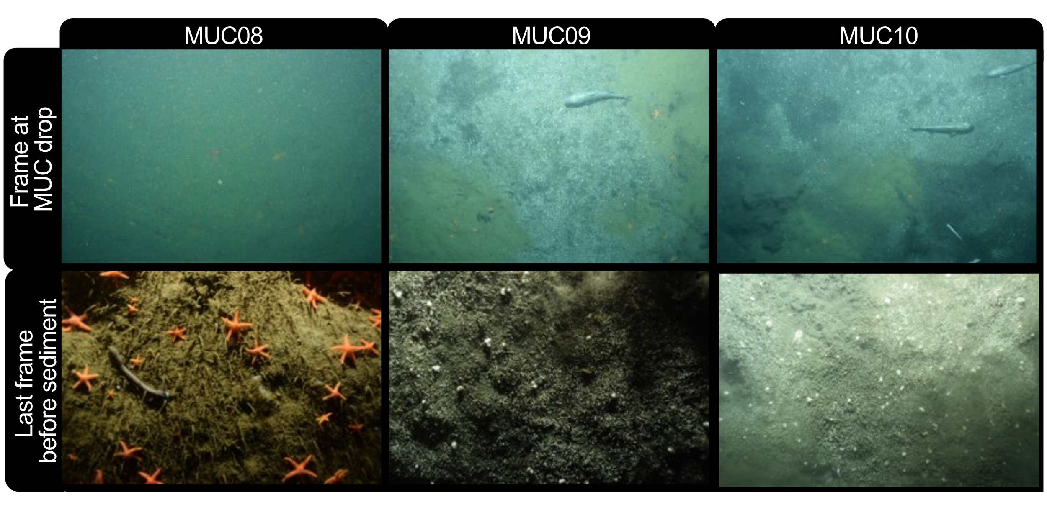
Supplementary Fig. 1. Multicorer photos taken every seven seconds during deployments of MUC08, 09, and 10 in the Astoria Canyon. Upper column is the last frame when MUC was dropped into sediment and lower column is the last frame before hitting the sediment.

Supplementary Fig. 2. Porewater concentration profiles of dissolved inorganic carbon (DIC) and sulfate from the MUC09 multicores at site H1866 in Astoria Canyon.

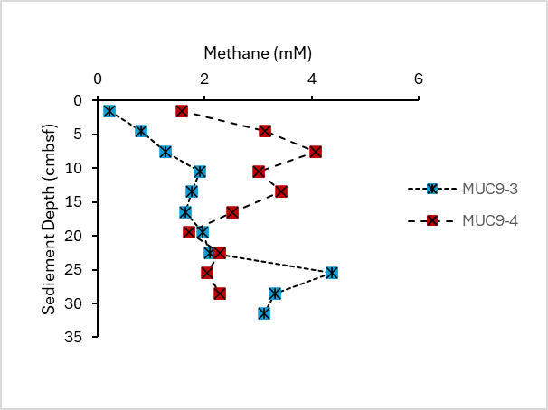
Supplementary Fig. 3. Porewater methane from the MUC09 multicores at site H1866 in Astoria Canyon. For MUC09-2, intended for DOC analysis, we did not measure CH₄ concentrations.

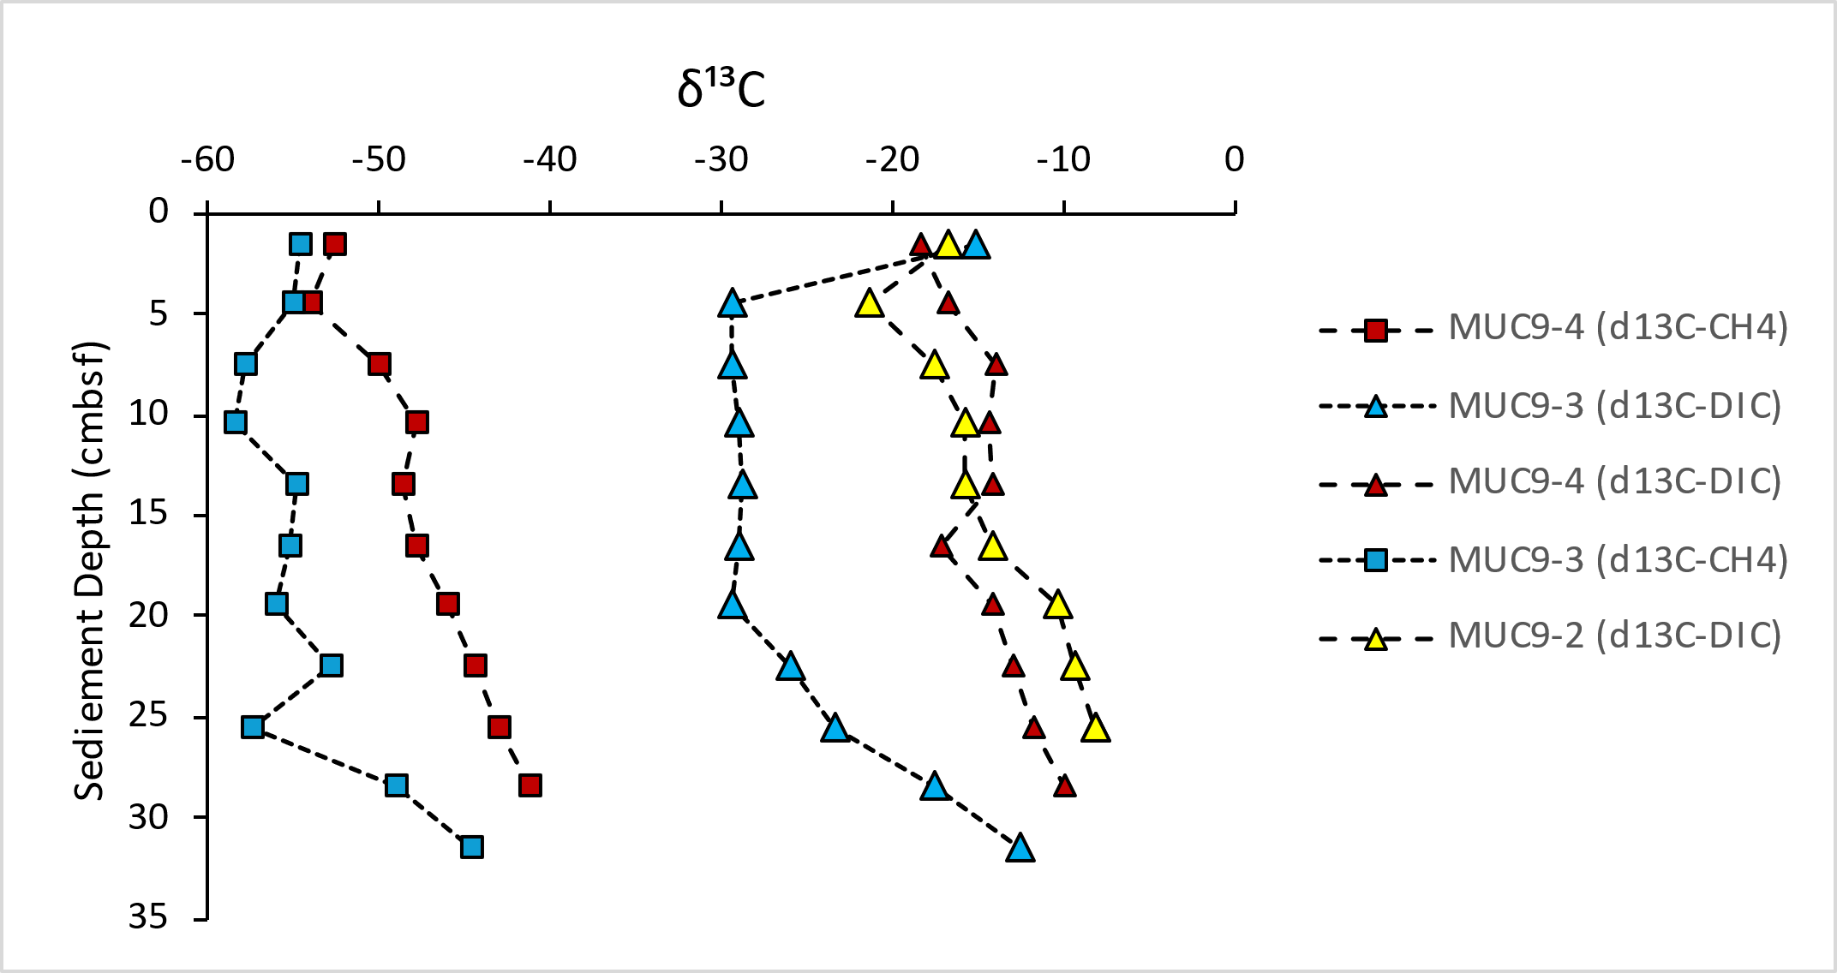
Supplementary Fig 4. Porewater δ¹³C profiles of dissolved inorganic carbon (DIC) and methane from the MUC09 multicores at site H1866 in Astoria Canyon. For MUC09-2, intended for DOC analysis, we did not measure CH₄ concentrations and the corresponding δ¹³C values.

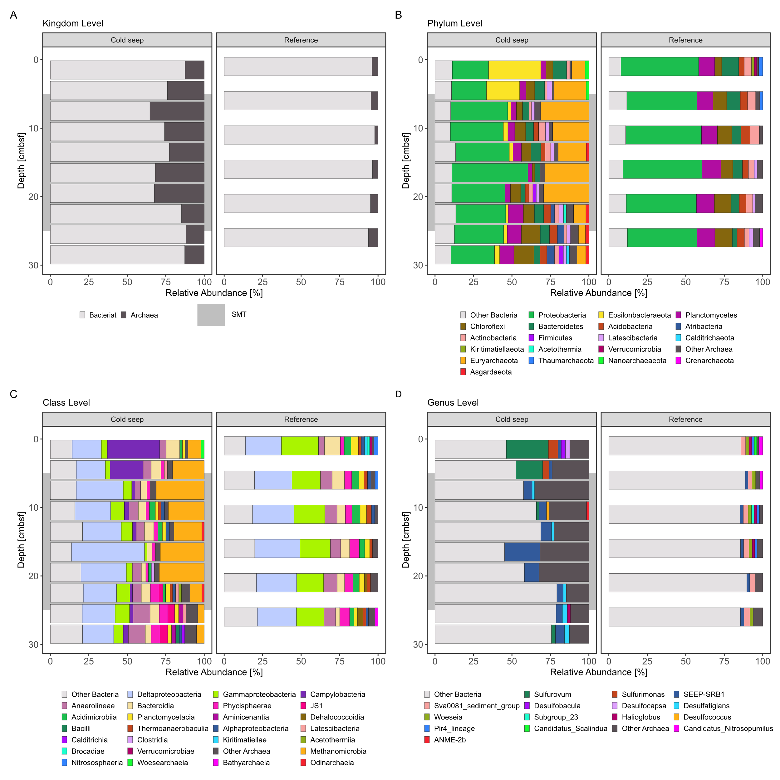
Supplementary Fig. 5: Relative 16SrRNA gene abundance data of microbial taxa in the cold seep (MUC09-4) and the reference core (MUC08-1) from the Astoria Canyon.
Stacked bar plots show 16S rRNA gene amplicon data of Kingdom A), Phylum B), Class C), Order D), Family E), and Genus F) level across sediment depths, with the cold seep (left panels) and the reference core (right panels). Each color represents a distinct bacterial taxon. Highlighted taxa lineages with elevated relative abundance in the cold seep environment, particularly in the SMTZ (grey zone).
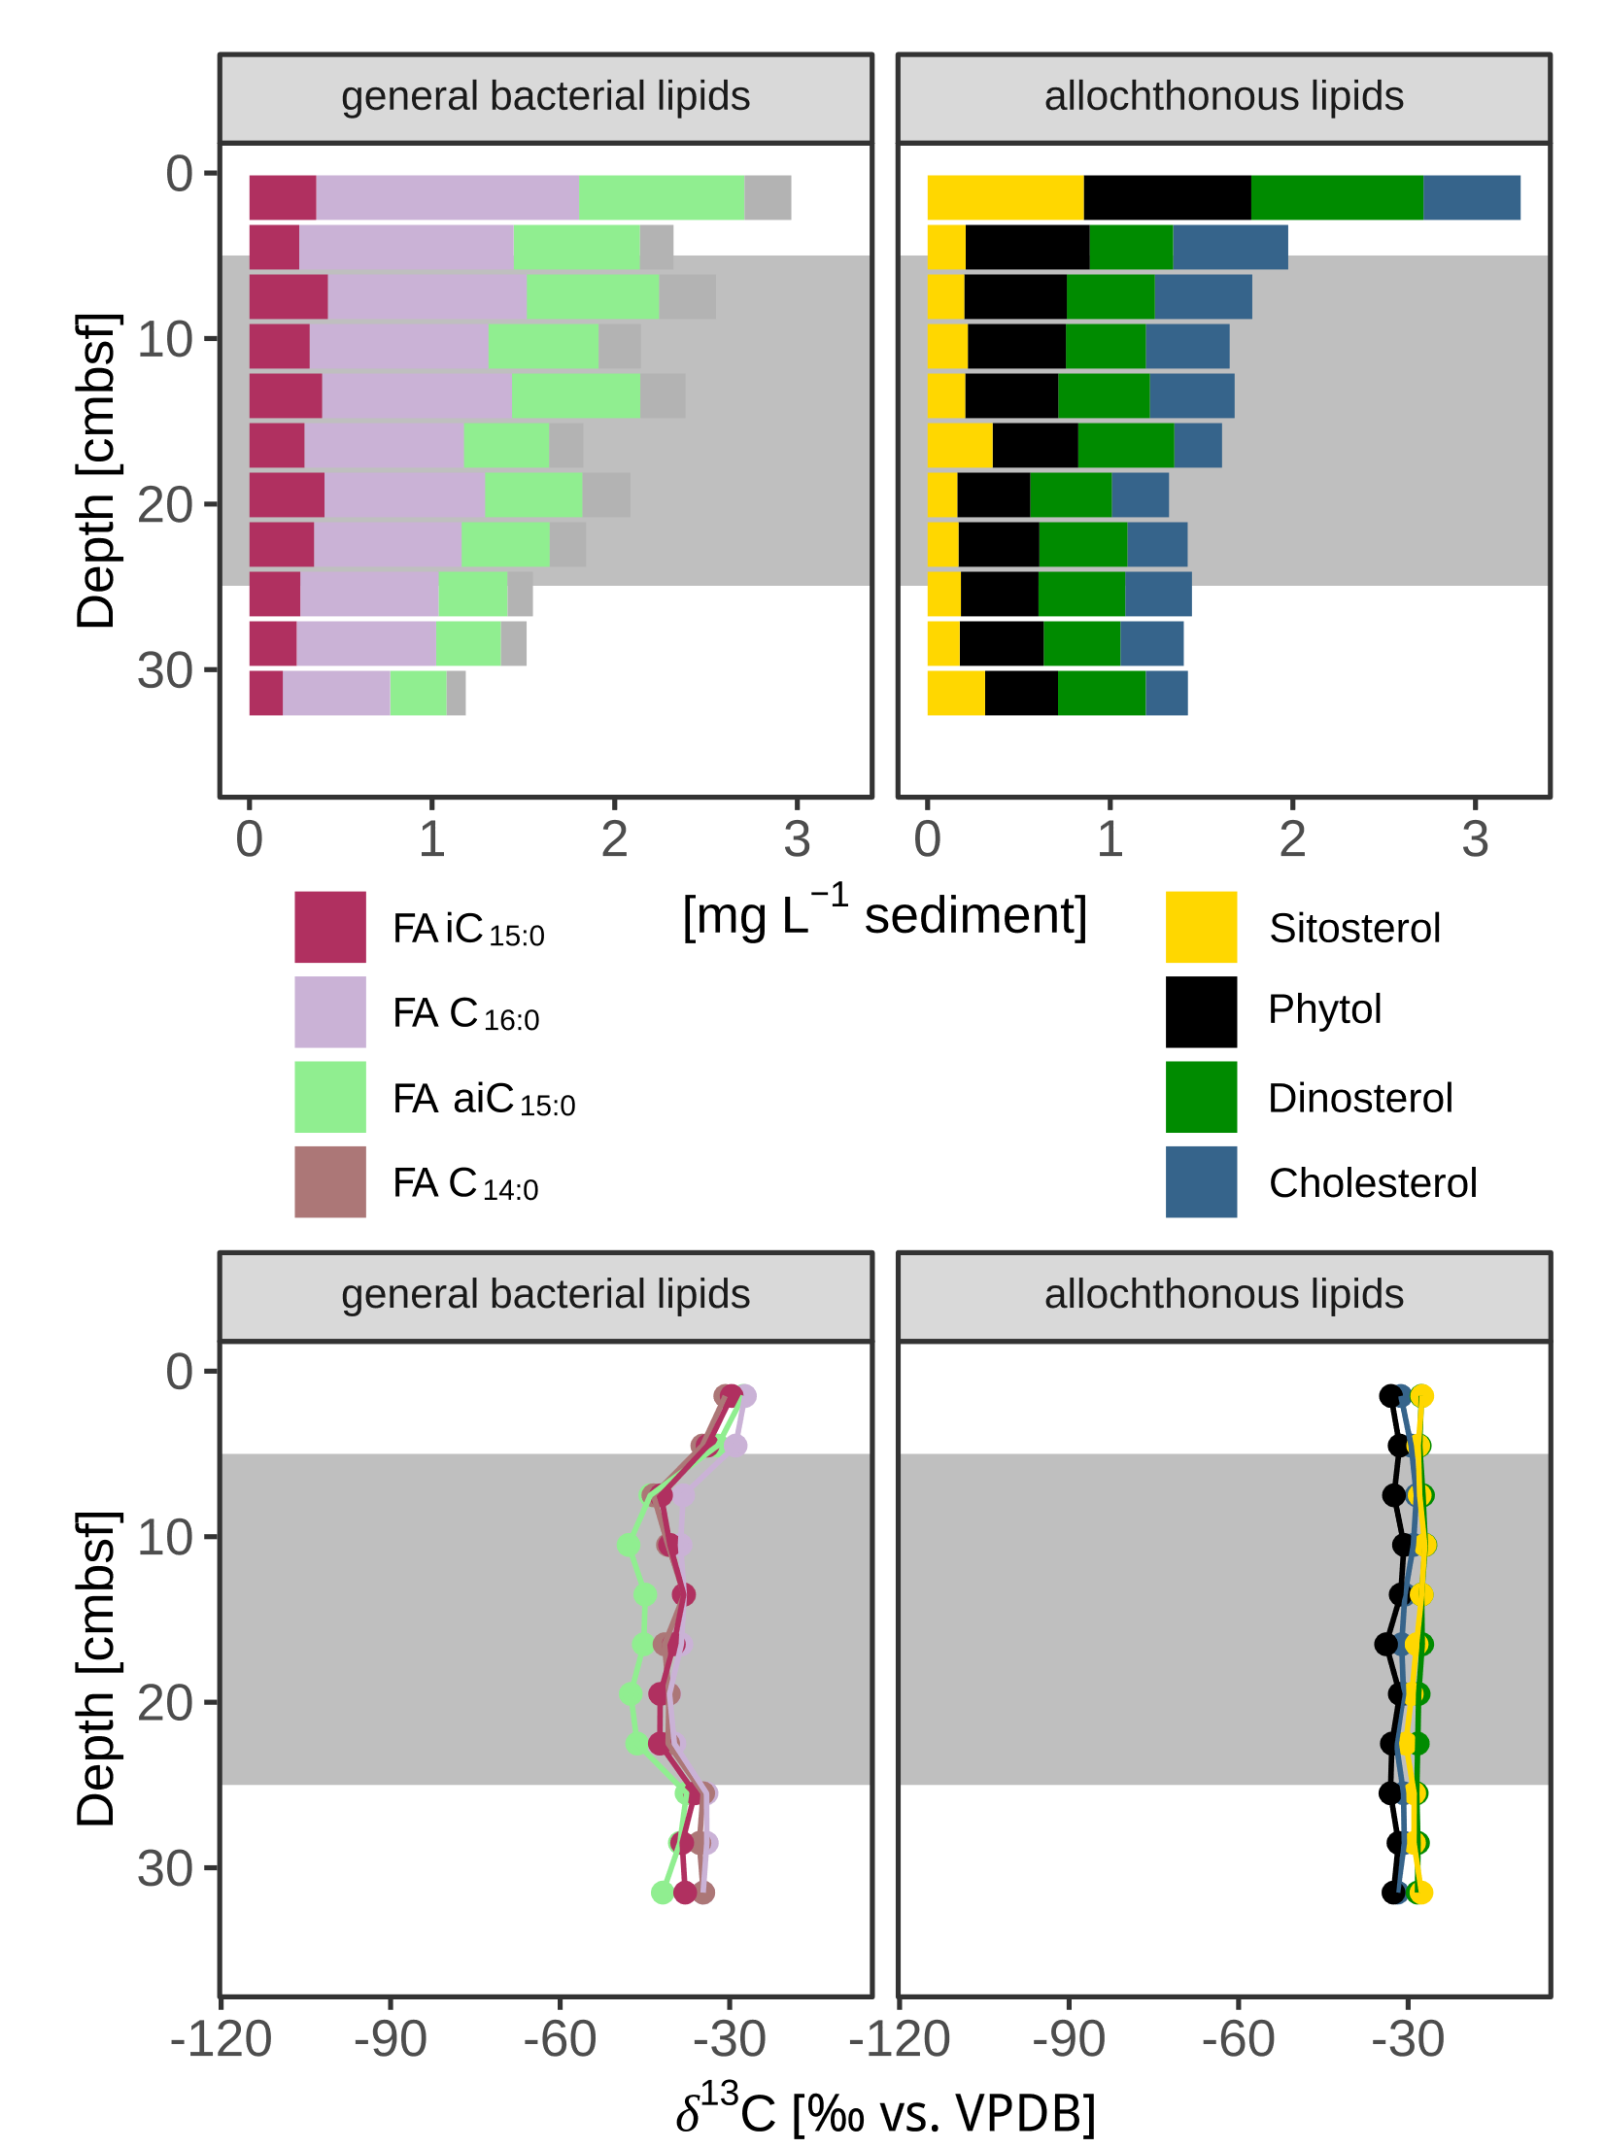
Supplementary Fig. 6: Concentrations and δ¹³C values of additional lipids in the cold seep sediment core (MUC09-3).
Depth profiles of concentrations of heterotrophic and ubiquitous bacterial as well as algal lipids in mg L⁻¹ (upper panels) and their corresponding δ¹³C values in‰ vs. VPDB (lower panels). The grey area indicates the SMTZ.

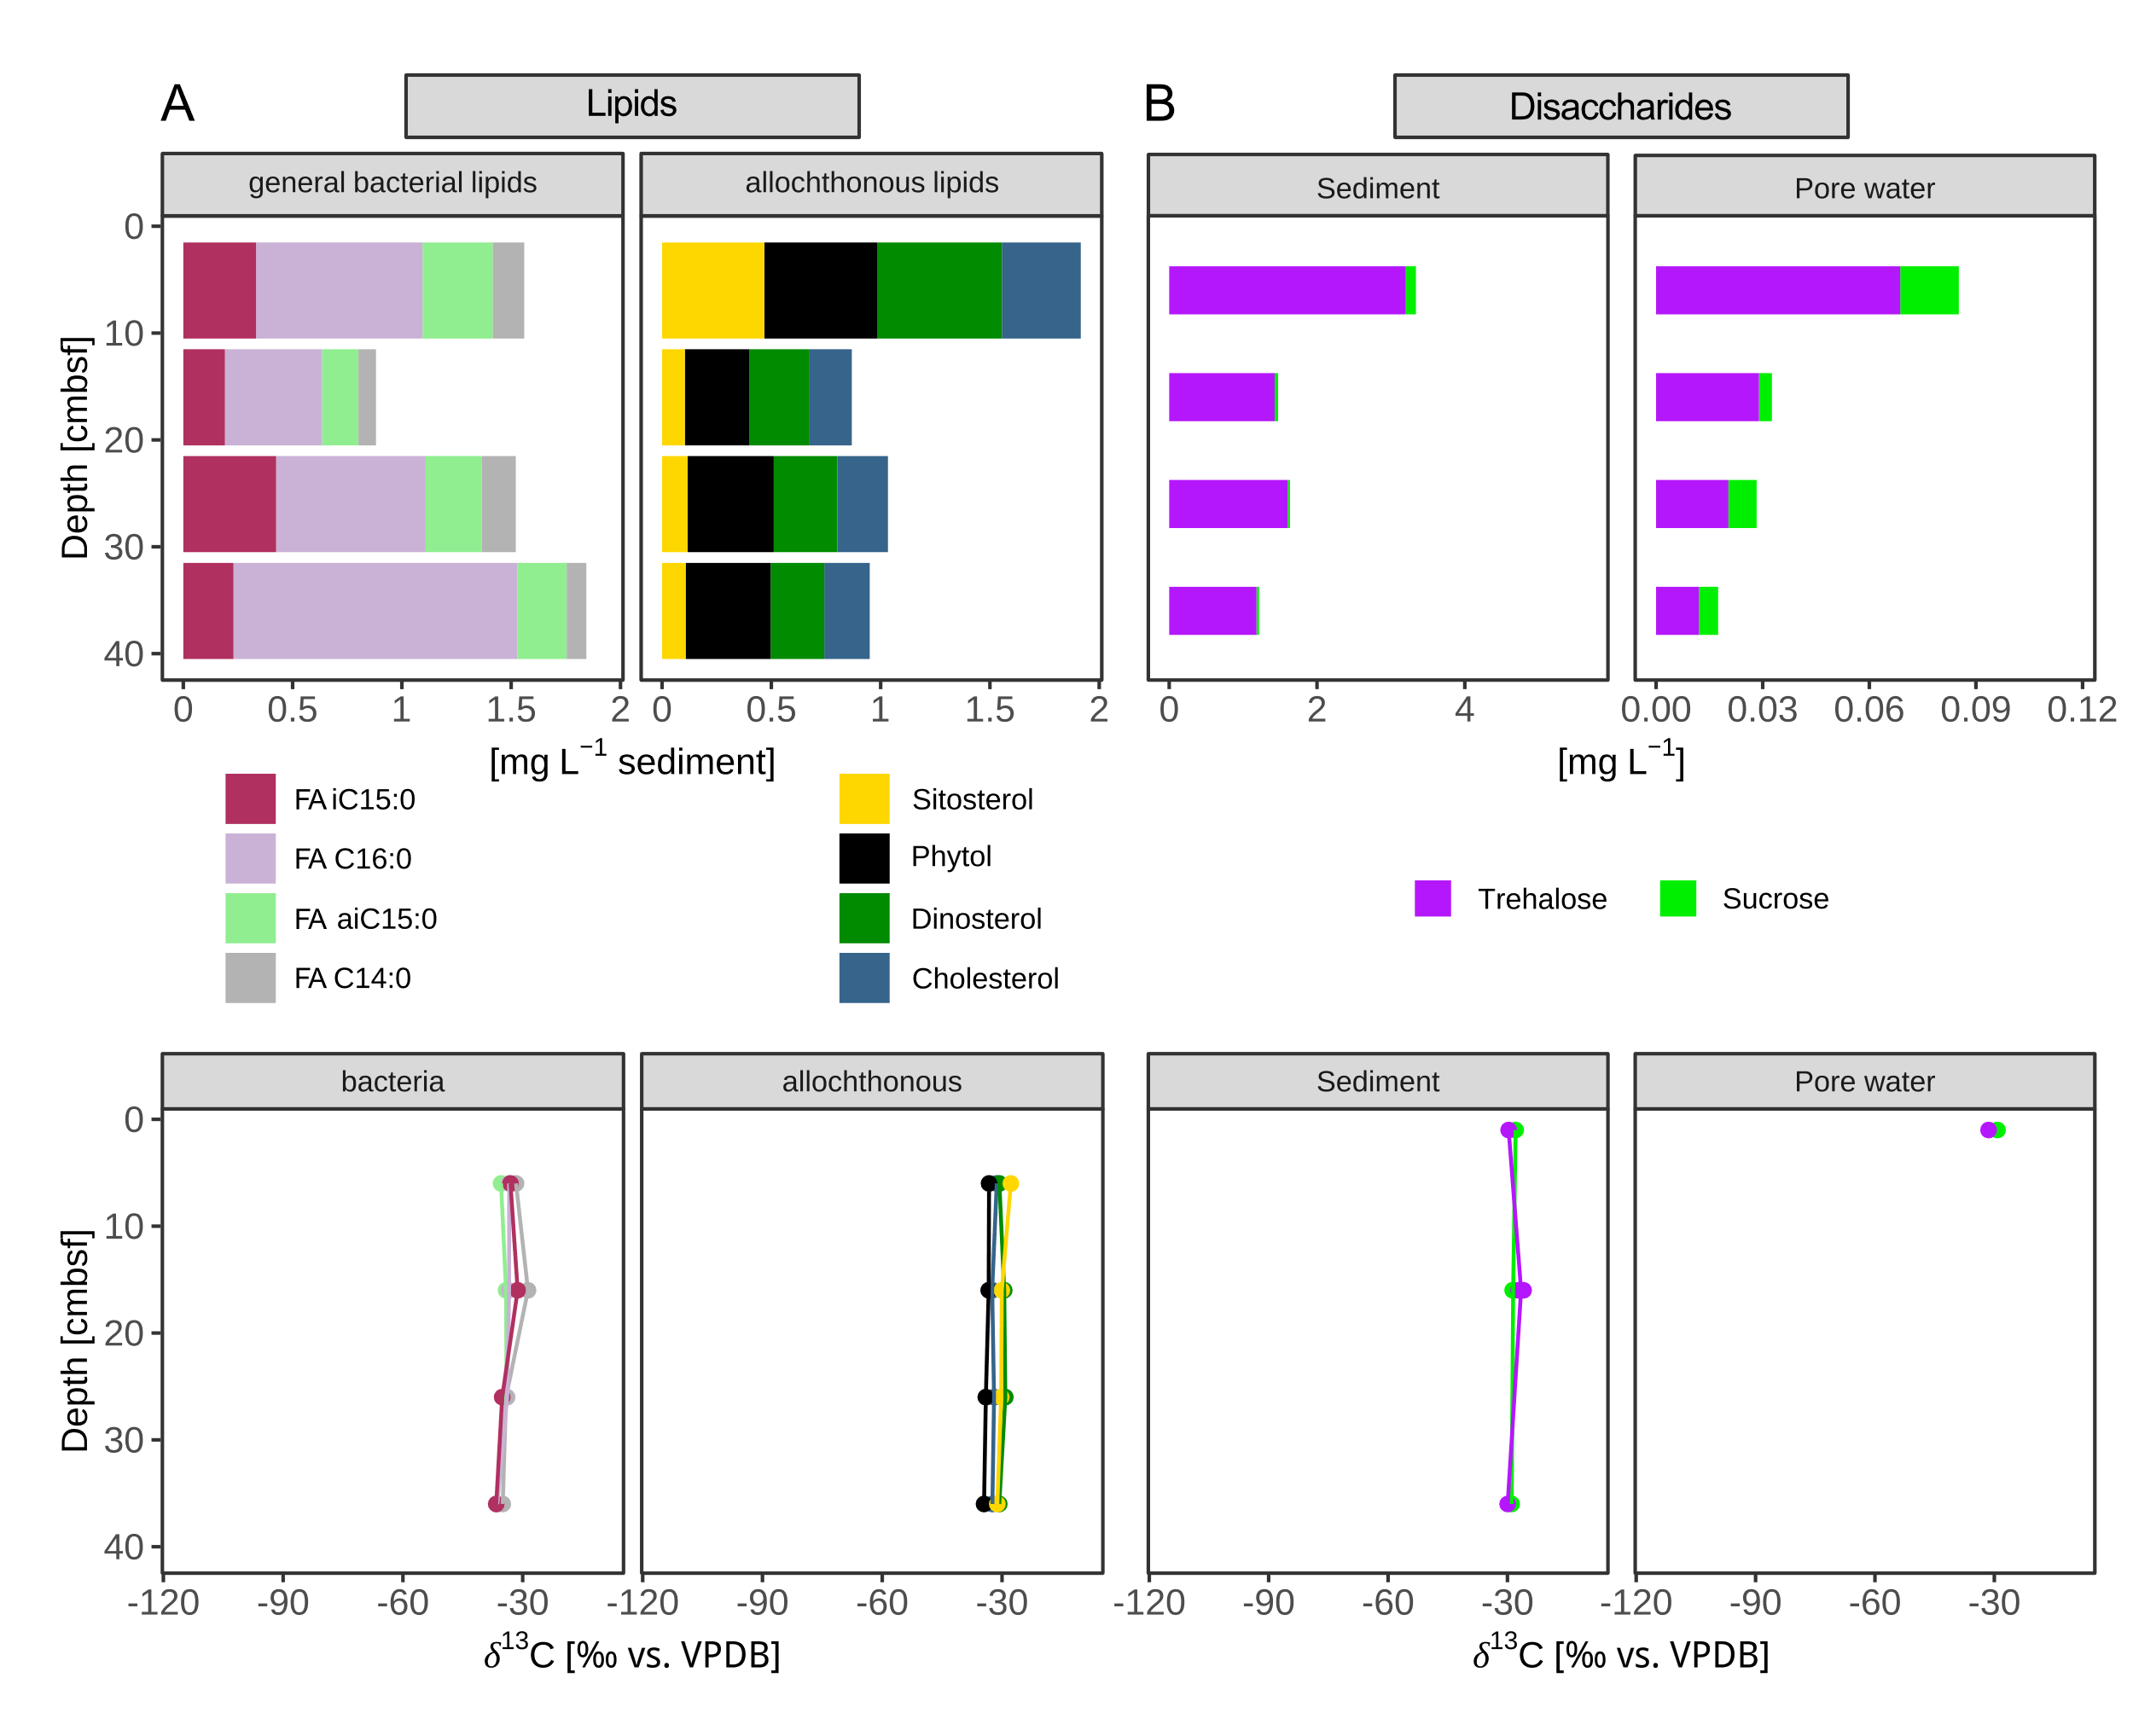
Supplementary Fig. 7: Concentrations and δ¹³C values of lipids and the disaccharides trehalose and sucrose in the reference core (MUC08-4).
A) Depth profiles of concentrations of heterotrophic and ubiquitous bacterial as well as algal lipids in mg L⁻¹ (top) and their δ¹³C values in‰ vs. VPDB (bottom). B) Concentrations of trehalose (purple) and sucrose (green) obtained from the bulk sediment and the porewater (top) and their corresponding δ¹³C values (bottom).

Hydrolyzed monosaccharides
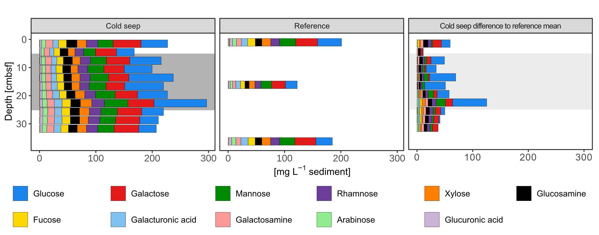
Supplementary Fig. 8: Concentrations of hydrolyzed monosaccharides in the cold seep sediment (MUC09-3, left), the reference core (MUC08-4, middle) and the difference of the concentrations in the cold seep core to mean (n=3) reference values (right). The grey area indicates the SMTZ. Concentrations are in mg L⁻¹. Each color represents a hydrolyzed monosaccharide.

Supplementary Table 6: Corresponding concentrations of hydrolyzed monosaccharides in mg L⁻¹ in tabular form from Supplementary Fig. 8.
Core | MUC09-3 |  |  |  |  |  |  |  |  |  |  | MUC08-4
Depth [cmbsf] | 1.5 | 4.5 | 7.5 | 10.5 | 13.5 | 16.5 | 19.5 | 22.5 | 25.5 | 28.5 | 31.5 | 1 | 16 | 36
ID | 335 | 336 | 337 | 338 | 339 | 340 | 341 | 342 | 343 | 344 | 345 | 275 | 278 | 282
Type | Cold seep |  |  |  |  |  |  |  |  |  |  | Reference
 | [mg L⁻¹]
Fucose | 14.1 | 10.6 | 11.4 | 11.6 | 12.3 | 11.9 | 12.4 | 15.1 | 14.7 | 14.6 | 13.1 | 13.4 | 7.7 | 12.2
Rhamnose | 20.3 | 15.3 | 17.8 | 17.2 | 17.9 | 16.9 | 18.9 | 21.9 | 20.5 | 20.1 | 19.8 | 15.6 | 10.6 | 16.0
Galactosamine | 12.6 | 9.8 | 11.1 | 9.7 | 9.8 | 9.5 | 10.8 | 12.4 | 12.2 | 12.1 | 12.3 | 8.5 | 5.5 | 8.9
Arabinose | 7.0 | 5.1 | 6.6 | 6.2 | 6.7 | 6.2 | 7.5 | 8.1 | 8.3 | 8.0 | 7.9 | 6.7 | 4.1 | 7.2
Glucosamine | 18.2 | 14.0 | 15.7 | 14.0 | 13.7 | 13.1 | 15.0 | 16.9 | 16.3 | 16.1 | 15.3 | 11.3 | 7.3 | 11.6
Galactose | 48.8 | 36.3 | 40.8 | 35.5 | 35.6 | 32.5 | 39.3 | 45.7 | 42.6 | 42.1 | 43.1 | 37.9 | 24.0 | 36.6
Glucose | 46.1 | 30.9 | 54.6 | 48.4 | 77.2 | 67.5 | 51.8 | 91.6 | 37.8 | 32.5 | 30.4 | 41.7 | 20.7 | 28.7
Mannose | 26.4 | 20.8 | 27.7 | 28.2 | 31.8 | 29.2 | 34.1 | 40.9 | 28.3 | 27.5 | 28.4 | 28.0 | 18.5 | 26.3
Xylose | 16.1 | 11.8 | 13.6 | 12.4 | 14.4 | 13.7 | 16.6 | 19.6 | 17.0 | 14.9 | 15.8 | 15.4 | 10.0 | 15.1
Gluconic acid | 0.0 | 0.0 | 0.0 | 0.0 | 0.0 | 0.0 | 0.0 | 0.0 | 0.0 | 0.0 | 0.0 | 1.6 | 0.0 | 0.0
Galacturonic acid | 9.7 | 7.4 | 9.1 | 8.7 | 9.5 | 10.6 | 11.9 | 13.6 | 12.2 | 13.4 | 12.4 | 10.9 | 8.2 | 12.7
Glucuronic acid | 3.3 | 2.7 | 2.9 | 3.2 | 3.4 | 3.9 | 3.7 | 4.5 | 4.9 | 5.1 | 4.0 | 5.0 | 3.1 | 5.2
Mannuronic acid | 0.4 | 0.2 | 0.6 | 1.0 | 0.5 | 1.0 | 0.8 | 0.7 | 1.1 | 0.7 | 0.8 | 1.1 | 0.5 | 0.9

Method: Carbohydrates were sequentially extracted from sediment following the procedure described by Hellige et al. (preprint). Core sections of MUC09-3 and MUC08 from the Astoria Canyon cold seep and reference were analyzed. Approximately 90 mg of freeze-dried and homogenized sediment were weighed into pre-cleaned 2 mL polypropylene tubes. Extractions were performed sequentially with MilliQ water and 0.3 M EDTA (pH 7.5). For each extraction step, 200 µL of solvent was added per 10 mg sediment. Samples were vortexed, sonicated for 1 h, and centrifuged at 4000 g for 20 min at 15°C. The supernatant was transferred to fresh 2 mL tubes. The extraction was repeated with the subsequent solvents on the remaining pellet, with careful resuspension between steps. Extracts were stored at −20°C until further processing. Extracts were hydrolysed in 1 M HCl in precombusted glass vials. Vials were sealed and heated at 100°C for 24h. Hydrolyzed samples were transferred to polypropylene tubes and dried in an acid-resistant vacuum concentrator (Martin Christ Gefriertrocknungsanlagen GmbH, Germany). Residues were resuspended in MilliQ water. Monosaccharide quantification was conducted by high-performance anion-exchange chromatography with pulsed amperometric detection (HPAEC-PAD), as described previously (Hellige et al. (preprint) after Vidal-Melgosa et al., 2021). Analyses were carried out on a Dionex ICS-5000+ system equipped with a CarboPac PA10 analytical column (2 × 250 mm) and guard column (250 mm). Neutral and amino sugars were separated under isocratic conditions with 18 mM NaOH, while a gradient up to 200 mM sodium acetate was applied for the elution of acidic monosaccharides. Acidic polysaccharides were unable to be measured in EDTA extracts due to interfering matrix peaks.

References
Baumberger, T., Embley, R.W., Merle, S.G., Lilley, M.D., Raineault, N.A., Lupton, J.E., 2018. Mantle-Derived Helium and Multiple Methane Sources in Gas Bubbles of Cold Seeps Along the Cascadia Continental Margin. Geochemistry, Geophysics, Geosystems 19, 4476–4486. https://doi.org/10.1029/2018GC007859
Baumberger, T., Leifer, I., Scherwath, M., Joye, S., 2022. Editorial: Recent Advances in Natural Methane Seep and Gas Hydrate Systems. Frontiers in Earth Science 10.
Coon, G.R., Duesing, P.D., Paul, R., Baily, J.A., Lloyd, K.G., 2023. Biological methane production and accumulation under sulfate-rich conditions at Cape Lookout Bight, NC. Front. Microbiol. 14, 1268361. https://doi.org/10.3389/fmicb.2023.1268361
Hellige, I., Mundanatt, A.A., Massing, J.C., Hehemann, J.-H., 2024. Roots of coastal plants stabilize carbon fixed by marine algae. https://doi.org/10.1101/2024.12.02.624615
Lalk, E., Pohlman, J.W., Lapham, L.L., 2025. Organic Matter Availability and the Production of Methane‐Derived Dissolved Organic Carbon at Methane Seeps. Global Biogeochemical Cycles 39. https://doi.org/10.1029/2025gb008535
Stock, L., Wegener, G., Wang, Y., Zander, Y., Elvert, M., 2025. Marine Cold Seep ANME ‐2/ SRB Consortia Produce Their Lipid Biomass From Inorganic Carbon. Environmental Microbiology 27, e70213. https://doi.org/10.1111/1462-2920.70213
Vidal-Melgosa, S., Sichert, A., Francis, T.B., Bartosik, D., Niggemann, J., Wichels, A., Willats, W.G.T., Fuchs, B.M., Teeling, H., Becher, D., Schweder, T., Amann, R., Hehemann, J.-H., 2021. Diatom fucan polysaccharide precipitates carbon during algal blooms. Nat Commun 12, 1150. https://doi.org/10.1038/s41467-021-21009-6
Whiticar, M.J., 1999. Carbon and hydrogen isotope systematics of bacterial formation and oxidation of methane. Chemical Geology 161, 291–314. https://doi.org/10.1016/S0009-2541(99)00092-3

