Supplementary figures

Supplementary figure 1.
Supplementary figure 1. Chemotherapeutic drugs induce primary ciliogenesis.
(A-B) Gemcitabine (GEM) and etoposide (ETO) induced primary cilia formation in PANC-1 cells (A) Immunostaining of primary cilia of PANC-1 cells with antibody against ARL13b in the absence (CTL) or presence of gemcitabine (GEM). DNA were stained with DAPI. The arrows indicate primary cilia. Scale bar, 20 µm. (B) Primary cilia were examined by double-staining of GEM- or etoposide (ETO)-treated cells with antibodies against acetylated tubulin (Ac-tub, red) and ARL13b (green). DNA were stained with DAPI (blue). Scale bar, 10 µm.

Supplementary figure 2.
Supplementary figure 2. Gemcitabine (GEM) induces primary cilia formation in a dose- and time-dependent manner.
(A-C) Quantitative results of the frequency of ciliated cells after treating cells with different concentrations (0, 25, 50, and 100 µM) of GEM for 24 h (A), 48 h (B) and 72 h (C). (D) Tubulin acetylation was induced by GEM treatment. Extracts of PANC-1 cells in the absence (CTL) or presence of GEM (100 µM) for 72 h were analyzed by immunoblotting with antibodies against acetylated tubulin (Ac-tub), tubulin, and Ku70. * P<0.05, ** P<0.01, *** P<0.001.

Supplementary figure 3.
Supplementary figure 3. Levels of ciliary genes increase upon chemotherapeutic drugs treatment.
Quantitative results of relative mRNA levels of ciliary genes, including KIF7, SCLT1, IFT43, RNF38, TOPORS, and C5orf30 in the absence (CTL) or presence of CPT (A), GEM (B) or ETO (C) detected by qPCR. n.s. no significance, * P<0.05, ** P<0.01, *** P<0.001.

Supplementary figure 4.
Supplementary figure 4. Cisplatin (CPT)-resistant PANC-1 cells grow primary cilia.
(A-C) Several ciliary markers were examined by double-staining with antibodies against acetylated tubulin (Ac-tub; axoneme) and (A) CEP164 (basal body), (B) ARL13b (ciliary membrane), or (C) IFT88 (intraflagella transporter) in CPT-resistant PANC-1 cells. DNA were stained with DAPI. Scale bar, 10 µm.

Supplementary figure 5.
Supplementary figure 5. Primary cilia contribute to chemoresistance in PANC-1 cells.
(A-C) Gemcitabine (GEM)-induced ciliogenesis contributed to chemoresistance in PANC-1 cells. (A) Depletion of IFT88 (siIFT88) inhibited GEM-induced primary ciliogenesis. Quantitative results of the frequency of ciliated control or IFT88-deficient PANC-1 cells in the absence or presence of GEM. (B-C) Depletion of IFT88 sensitized PANC-1 cells to GEM treatment. Quantitative results of relative cell number in control and IFT88-deficient PANC-1 cells in the absence (B) or presence (C) of GEM. (D-H) Depletion of IFT88 by transfection of lentivirus containing shRNA against IFT88 (shIFT88) inhibited ciliogenesis upon chemotherapeutic drugs treatment. (D) IFT88 expression was depleted by infecting PANC-1 cells with lentivirus containing five different shRNA sequences against IFT88 (shIFT88 #1-5) or against luciferase (shLuc). Extracts of cells infected lentivirus containing shIFT88 (#1-5) were analyzed by immunoblotting with antibodies against IFT88 and Ku70. (E) Depletion of IFT88 reduced primary ciliogenesis. Quantitative results of the frequency of ciliated control and IFT88 (sh#3)-deficient PANC-1 cells in the absence or presence of cisplatin (CPT). (F-H) Depletion of IFT88 (sh#3) sensitized PANC-1 cells to CPT and GEM treatment. Quantitative results of relative cell numbers of control (shLuc) or IFT88-deficient (sh#3) cells in the absence (F) or presence of CPT (G) or GEM (H). (I) Roscovitine (Rosco) inhibited GEM-induced primary ciliogenesis. Quantitative results of the frequency of ciliated cells after treated cells with GEM for 72 h in the presence or absence of roscovitine (rosco, 20 µM). n.s. no significance, *** P<0.001.

Supplementary figure 6.
Supplementary figure 6. CP110 removal from mother centriole is observed by serum starvation and cisplatin (CPT) treatment.
Double-staining of (A) control (CTL), (B) serum starved, and (C) CPT-treated PANC-1 cells with antibodies against acetylated tubulin (Ac-tub, red) and CP110 (green). DNA were stained with DAPI (blue). Scale bar, 10 µm.

Supplementary figure 7.
Supplementary figure 7. Cisplatin (CPT)-induced excessive formation of centriolar satellites (EFoCS) contributes to primary ciliogenesis.
(A-E) CPT induced EFoCS. Centriolar satellites were examined by immunostaining with antibodies against (A) PCM1, (B-C) OFD1, and (D-E) BBS4 in lower magnification (A, B, and D, 400x) or in higher magnification (C and E, 1000x). (C and E) Double-staining of CPT-treated cells with antibodies against γ-tubulin (γ-tub) and (C) OFD1 or (E) BBS4. DNA were stained with DAPI (blue). Scale bar, 10 µm. (F) PCM1 was depleted by transfecting specific siRNA against PCM1 as shown by staining cells with antibody against PCM1 (red). Scale bar, 10 µm. (G-J) Sodium orthovanadate (SOV) alleviated primary ciliogenesis and sensitized cells to CPT and GEM treatment. Quantitative results of the frequency of ciliated cells (G, I) and relative cell number (H, J) upon treating cells with CPT (G-H) or GEM (I-J) for 72 h in the presence or absence of sodium orthovanadate (SOV, 1 µM). ** P<0.01, *** P<0.001.

Supplementary figure 8.
Supplementary figure 8. Inhibition of ATM and ATR reduces cisplatin (CPT)-resistant cell growth.
(A) CPT induced DNA damage. Extracts of CPT-treated PANC-1 cells were analyzed by immunoblotting with antibodies against γ-H2AX and actin. (B-C) Depletion of DNA-PK had no effect on CPT-induced primary ciliogenesis. (B) DNA-PK was depleted efficiently by siRNA transfection. Extracts of cells transfected with siRNA against DNA-PK catalytic subunit (siPKcs) were analyzed by immunoblotting with antibodies against PKcs and Ku70. (C) Quantitative results of the frequency of ciliated control and DNA-PK-deficient cells in the absence or presence of CPT. (D) ATM inhibitor (Ku55933, ATMi) sensitized PANC-1 cells to CPT treatment. Quantitative results of relative cell numbers in CPT-treated cells in the presence or absence of ATMi (10 µM). (E) Inhibition of ATM and ATR reduced cell viability in CPT-resistant PANC-1 cells. Quantitative results of relative cell numbers of CPT-resistant PANC-1 cells in the presence or absence of ATM inhibitor (Ku55933, 10 µM, ATMi) or ATR inhibitor (VE-822, 100 nM, ATRi). n.s. no significance, ** P<0.01, *** P<0.001.

Supplementary figure 9.
Supplementary figure 9. The downstream effectors of DNA damage response do not get involved in CPT-induced primary ciliogenesis.
(A-B) Inhibition of CHEK1 (A) and p53 (B) did not affect CPT-induced ciliogenesis. Quantitative results of the frequency of PANC-1 cells treatment with Chk1 inhibitor (Chk1i, 10 μM) or p53 inhibitor (p53i, 10 μM) in the absence or presence of CPT.
(C-D) CPT-induced primary cilia were reduced significantly when CHEK2 and AKT were inactivated. Quantitative results of the frequency of PANC-1 cells treatment with Chk2 inhibitor (Chk2i, 10 μM) or Akt inhibitor (Akti, 5 μM) in the absence or presence of CPT. n.s. no significance, * P<0.05, ** P<0.01, *** P<0.001.

Supplementary figure 10.

Supplementary figure 10. Inhibition of autophagy alleviated primary cilia formation in pancreatic cancer cells.
Quantitative results of the frequency of ciliated cells after treatment with chloroquine (CQ, 100 μM) (A), Bafilomycin A1 (Baf.A1, 10 nM) (B), or ULK1 inhibitor (ULK1i, 10 µM) (C) in the absence or presence of CPT. (D) Inhibition of autophagy by chloroquine sensitized cells to CPT treatment. Quantitative results of relative cell number in CPT-treated PANC-1 cells in the absence or presence of CQ. *** P<0.001.

Supplementary figure 11.
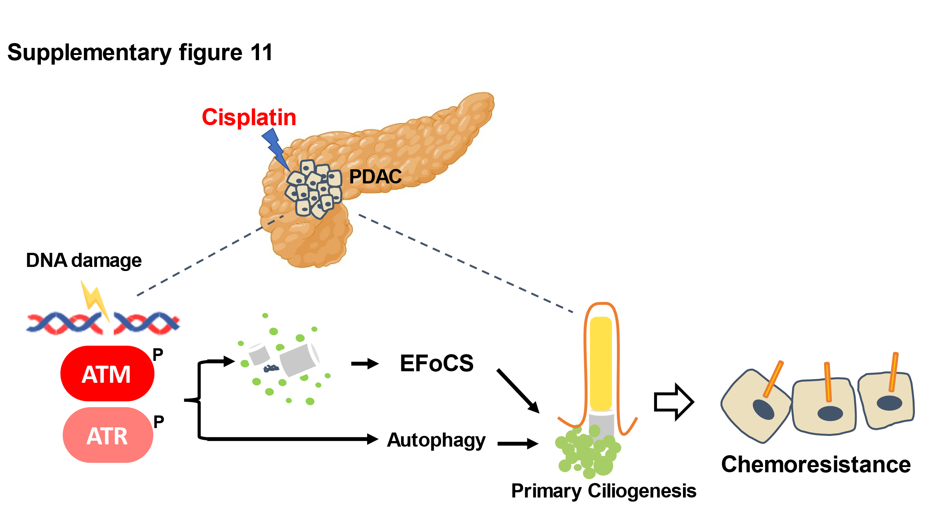

Supplementary figure 11. Schematic overview of cisplatin treatment induces primary cilia regrowth which causes chemoresistance occurred in pancreatic cancer cells.
Cisplatin treatment in pancreatic cancer cells induces ATM and ATR activation, which trigger excessive formation of centriolar satellites (EFoCS) and autophagy cooperatively contribute to primary ciliogenesis, leading to chemoresistance.

