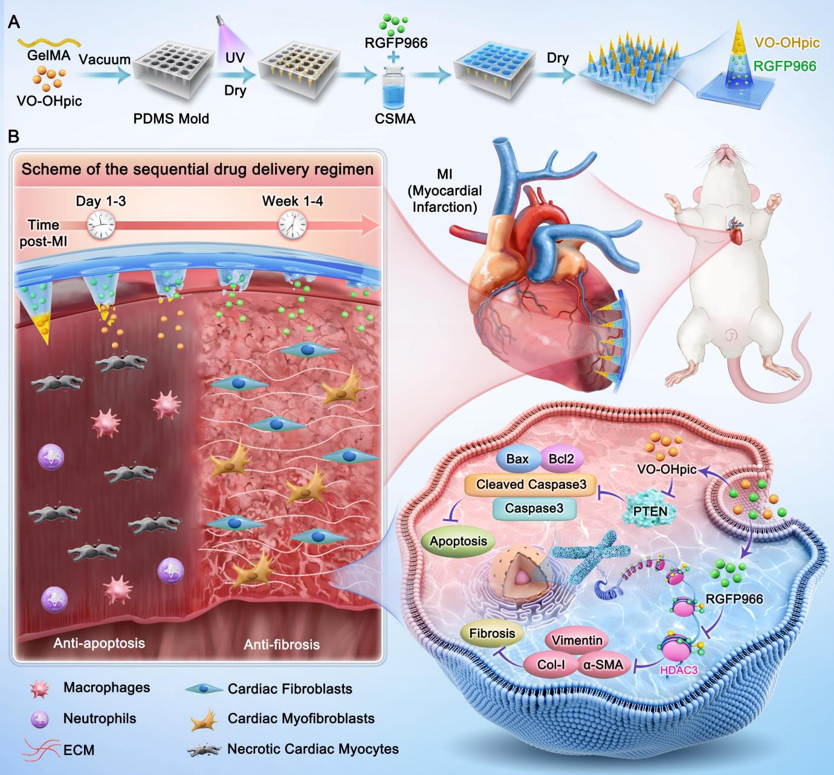
Scheme 1. Schematic illustration of a spatially patterned bilayer microneedle patch applied to the infarcted myocardium after myocardial infarction, enabling sequential delivery of an anti-apoptotic agent (PTEN inhibitor, VO-OHpic) followed by an anti-fibrotic compound (HDAC3 inhibitor, RGFP966) for cardiac repair.

