Appendices
Appendix 1: Different layout formats in experimental full-screen mode

DP (Different page)
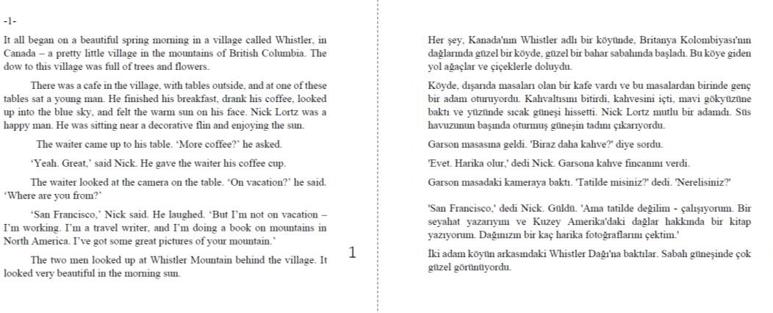

SP (Same page)
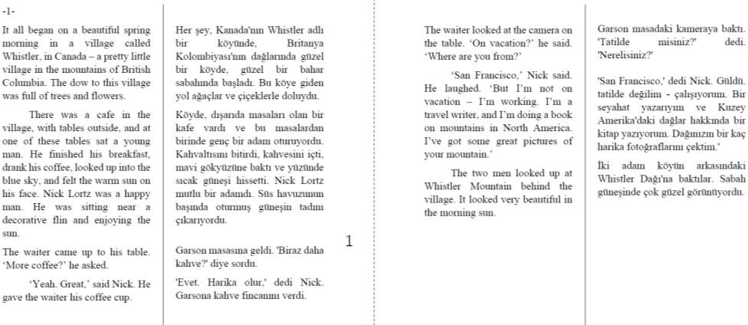

ST (Stacked)

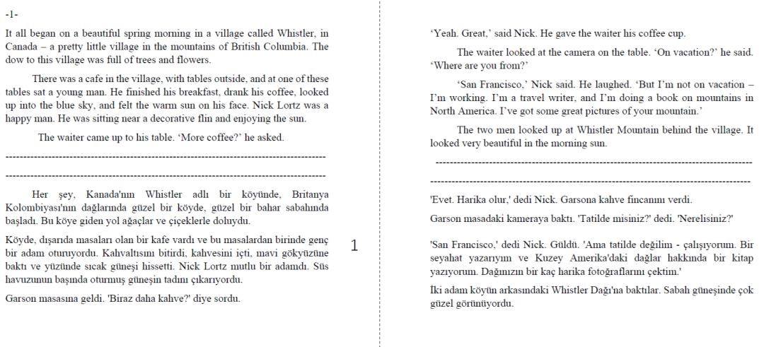

Appendix 2: Sample pseudoword integration through AI-generated sentences
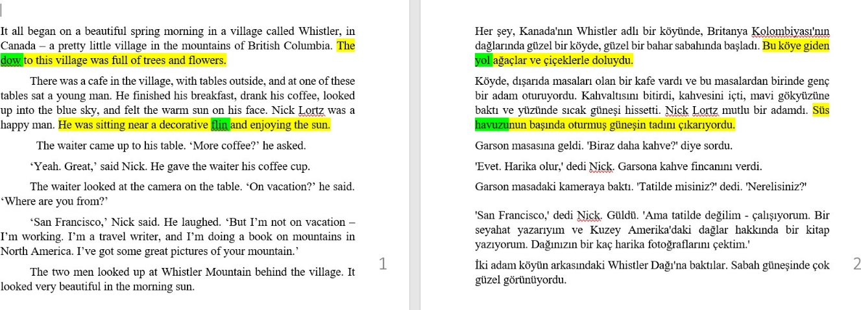

Appendix 3: AOI samples for layouts
SP AOIS
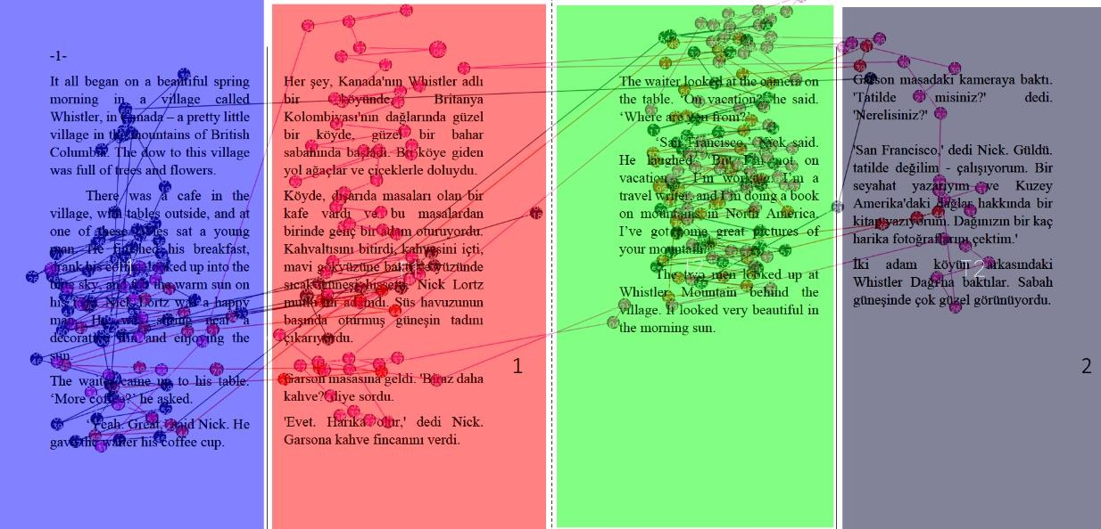

ST AOIs
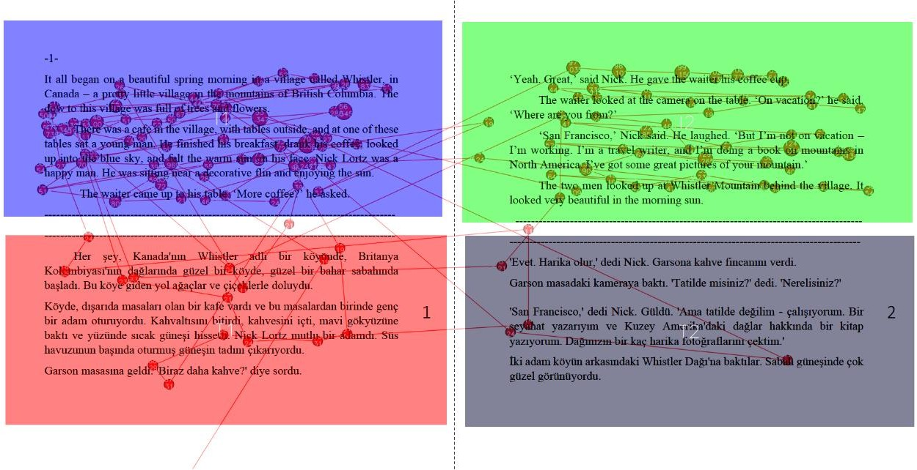

DP AOIs
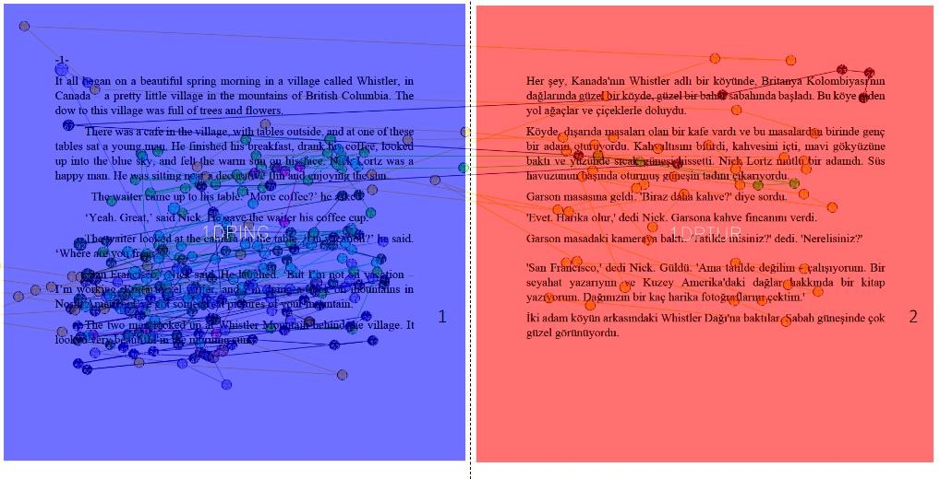

Appendix 4: Vocabulary Tests
Name/Surname:
- VOCABULARY TEST 1- FORM RECOGNITION
Please circle the words you saw in the text. You have only 8 chances to circle.

dow | withor | arew
stomed | tim | prone
pyramid | tosh | bup
cunk | agree | sense
slisk | flin | stamy
corat | seat | thoic
dablet | cloud | spick
tea | gat | lady

- VOCABULARY TEST 2- MEANING RECALL TEST
In this section, please fill in the table.
Word | I don’t have any ideas | Turkish meaning? | It can be this Turkish word | I don’t know its Turkish equivalence, yet I can describe it.
apartment
cat
dow
bup
flin
cunk
thoic
spick
dablet
withor

- VOCABULARY TEST 3- MEANING RECOGNITION TEST
Please circle the correct option in the table.
apartment | Apartman | Kulübe | Boşluk | I don’t know
cat | Kedi | Dağ | Daire | I don’t know
dow | Yol | Gerçek | Bıyık | I don’t know
bup | Kablo | Meslek | Masa | I don’t know
flin | Demir | Havuz | Çit | I don’t know
cunk | Söylenti | Yüzük | Esinti | I don’t know
thoic | Dünya | Kargaşa | Kabus | I don’t know
spick | Çorap | Mont | Yer | I don’t know
dablet | Savaş | Ağaç | Vadi | I don’t know
withor | Çaba | Dikkat | Görev | I don’t know

Appendix 5: Comprehension Check

Name/Surname: READING COMPREHENSION 1
A. Please choose the best option.
1. The story starts in a
a. Summer night
b. Spring morning
c. Winter day
d. Fall night

2. In the beginning, the story takes place in
- Canada
- USA
- Argentina
- France

3. Nick was writing a book about
- Flowers
- Mountains
- Houses
- Coffee types

4. While Nick was enjoying his coffee, a smiled and came near him.
a. A boy
b. A man with white hair
c. A beautiful girl
d. An ugly woman

5. In the half open bag on the table, there was a letter writing “ ” on it.
a. New York
b. Sao Paolo
c. Vancouver
d. Paris

READING COMPREHENSION 2
- Please circle True or False.
- A man with very long, white hair walked across the road. T/F
- The waiter came up to Nick’s table and said ‘More coffee?’. T/F
- Nick was a travel writer. T/F
- The name of the village was “Whimptown”. T/F
- It was snowing when Nick was enjoying in the cafe. T/F

