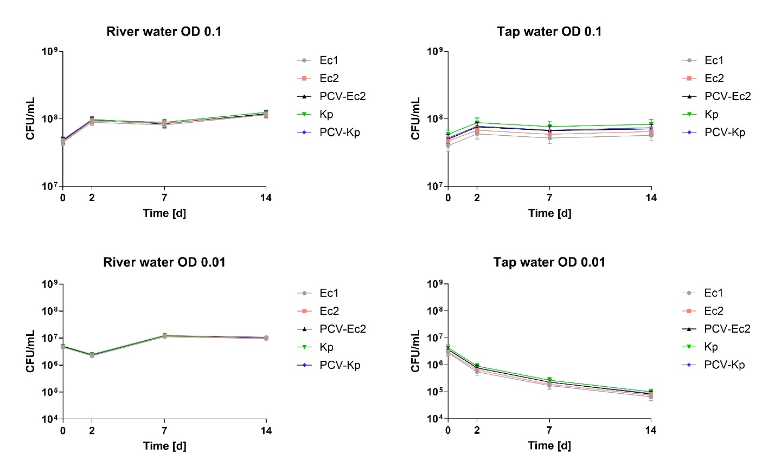
Supplementary Figure S1: Survival of Escherichia coli (Ec1, Ec2) and Klebsiella pneumoniae (Kp), along with their plasmid-cured variants (PCV-Ec2, PCV-Kp), in river water and tap water adjusted to OD 0.1 (approximately 4.84 × 10⁷ cells/mL⁻¹) and OD 0.01 (approximately 4.21 × 10⁶ cells/mL⁻¹). The results represent mean values and standard errors across replicates (n = 3) and are displayed as time course diagrams illustrating overall survival trends. Lines between data points are shown to aid visual orientation.
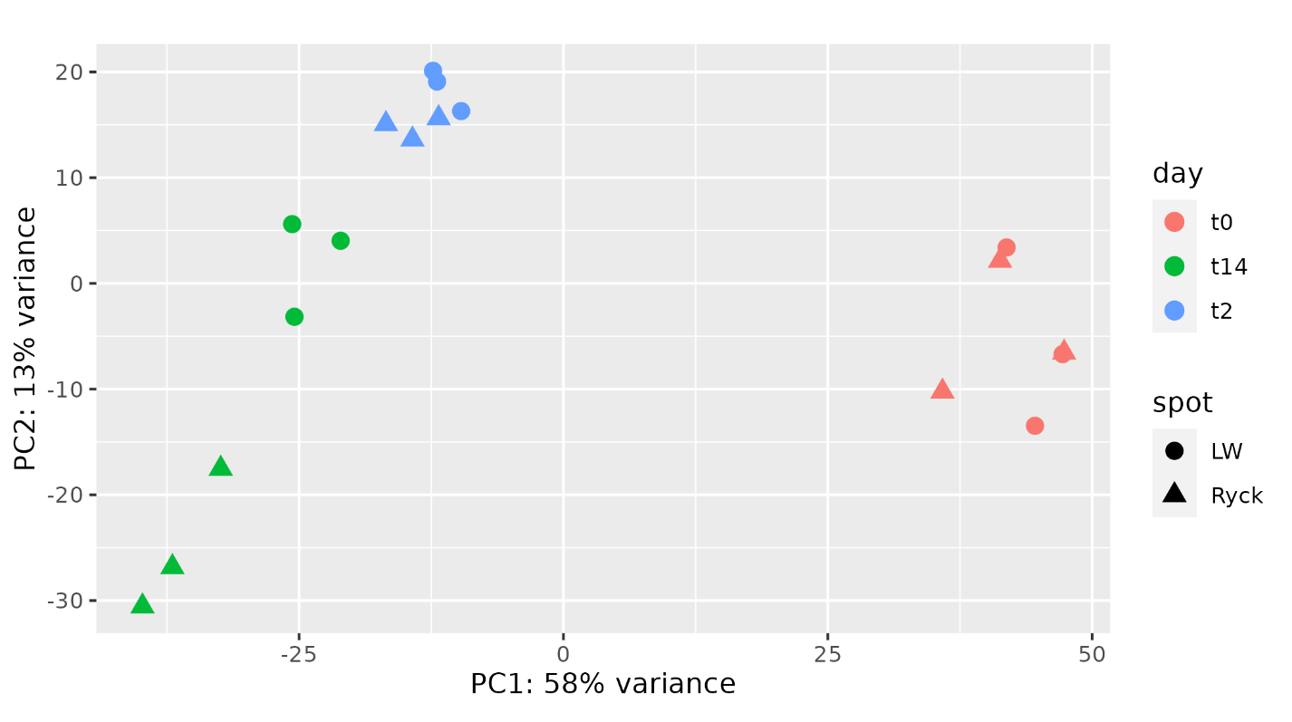
Supplementary Figure S2: Principal component analysis (PCA) of the transcriptomic sequencing output in the wild-type Escherichia coli (Ec1) after incubation in river water (RW) and tap water (TW). The investigated time points included the inoculation (t0), as well as subsequent 2-day and 14-day periods of incubation.
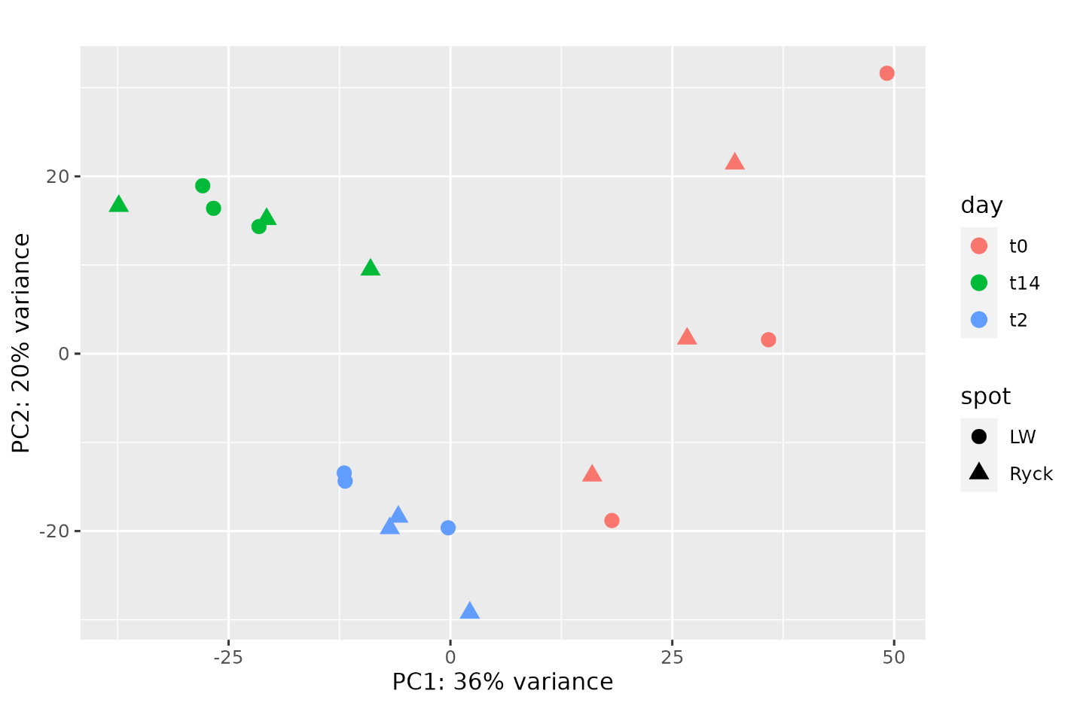
Supplementary Figure S3: Principal component analysis (PCA) of the transcriptomic sequencing output in the wild-type Escherichia coli (Ec2) after incubation in river water (RW) and tap water (TW). The investigated time points included the inoculation (t0), as well as subsequent 2-day and 14-day periods of incubation.
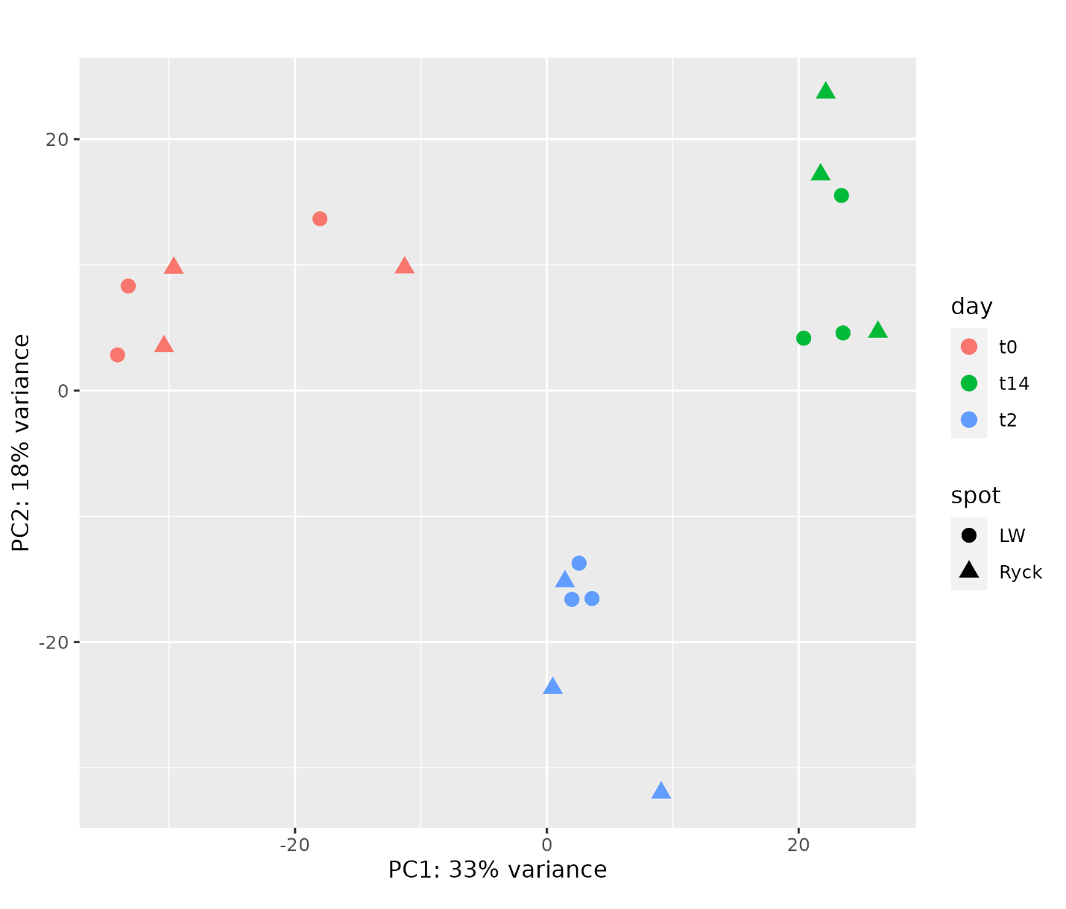
Supplementary Figure S4: Principal component analysis (PCA) of the transcriptomic sequencing output in the plasmid-cured Escherichia coli (PCV-Ec2) after incubation in river water (RW) and tap water (TW). The investigated time points included the inoculation (t0), as well as subsequent 2-day and 14-day periods of incubation.
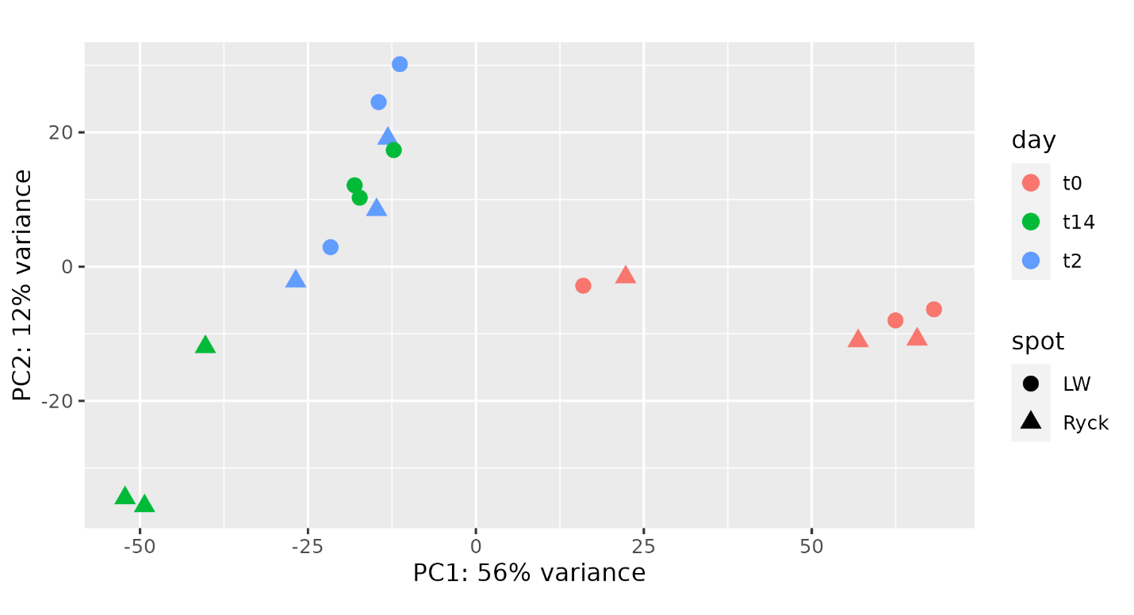
Supplementary Figure S5: Principal component analysis (PCA) of the transcriptomic sequencing output in the wild-type Klebsiella pneumoniae (Kp) after incubation in river water (RW) and tap water (TW). The investigated time points included the inoculation (t0), as well as subsequent 2-day and 14-day periods of incubation.
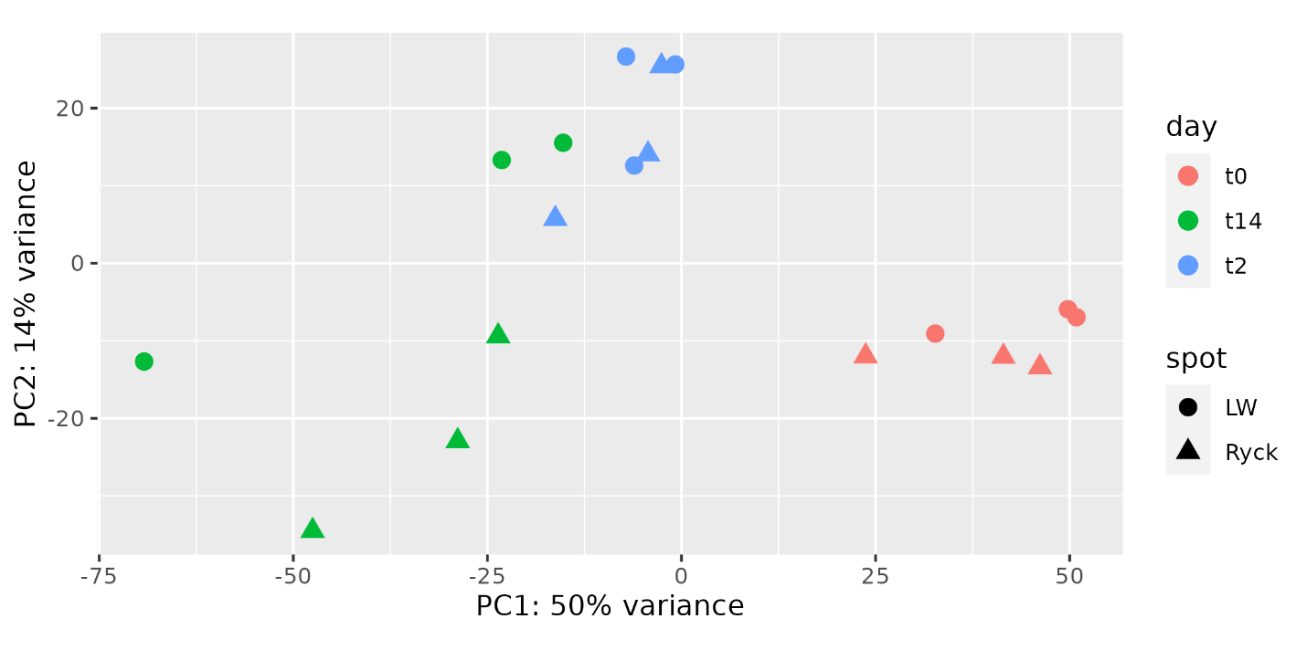
Supplementary Figure S6: Principal component analysis (PCA) of the transcriptomic sequencing output in the plasmid-cured Klebsiella pneumoniae (PCV-Kp) after incubation in river water (RW) and tap water (TW). The investigated time points included the inoculation (t0), as well as subsequent 2-day and 14-day periods of incubation.
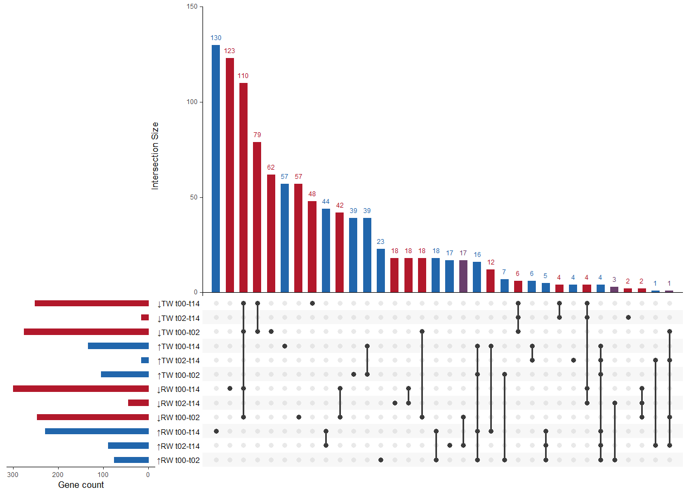
Supplementary Figure S7: Upset Plot depicting the abundance of differentially expressed genes (DEGs) in the wild-type Escherichia coli (Ec1) after incubation in river water (Ryck) and tap water (TW). The intersection matrix (bottom) shows overlapping DEGs between the different water types after incubation for 2 days (t00-t02), 14 days (t00-t14), and between day 2 and 14 (t02-t14). Differential expression is divided into down- (↓; red) and upregulation (↑; blue). Overlaps between down- and upregulated genes are marked with purple.

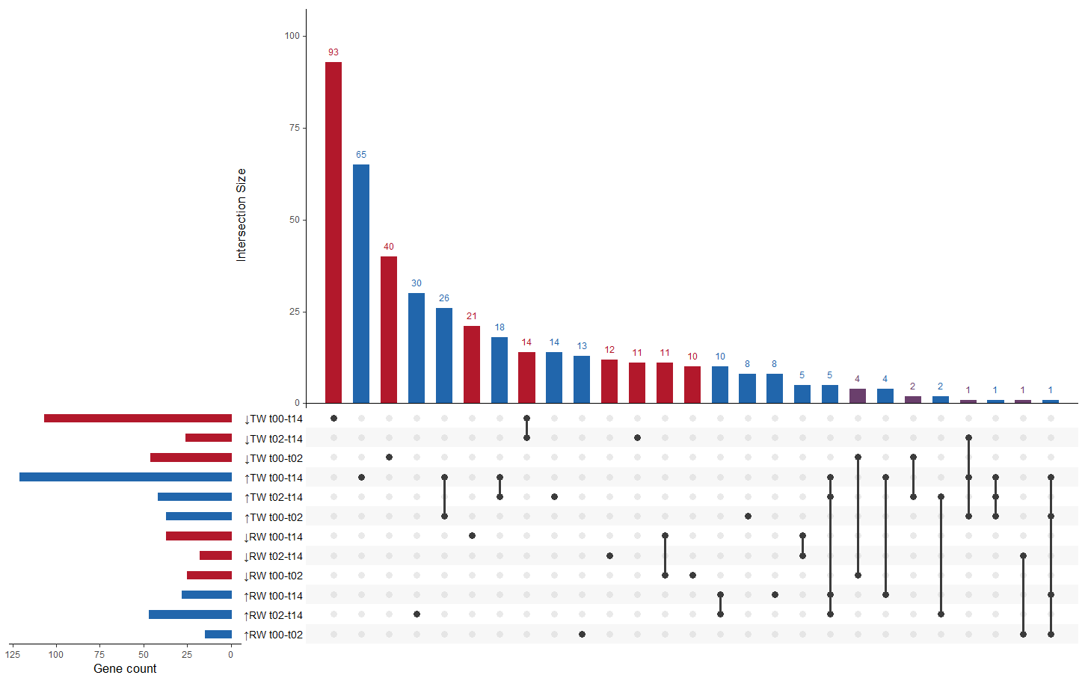
Supplementary Figure S8: Upset Plot depicting the abundance of differentially expressed genes (DEGs) in wild-type Escherichia coli (Ec2) after incubation in river water (Ryck) and tap water (TW). The intersection matrix (bottom) shows overlapping DEGs between the different water types after incubation for 2 days (t00-t02), 14 days (t00-t14), and between day 2 and 14 (t02-t14). Differential expression is divided into down- (↓; red) and upregulation (↑; blue). Overlaps between down- and upregulated genes are marked with purple.

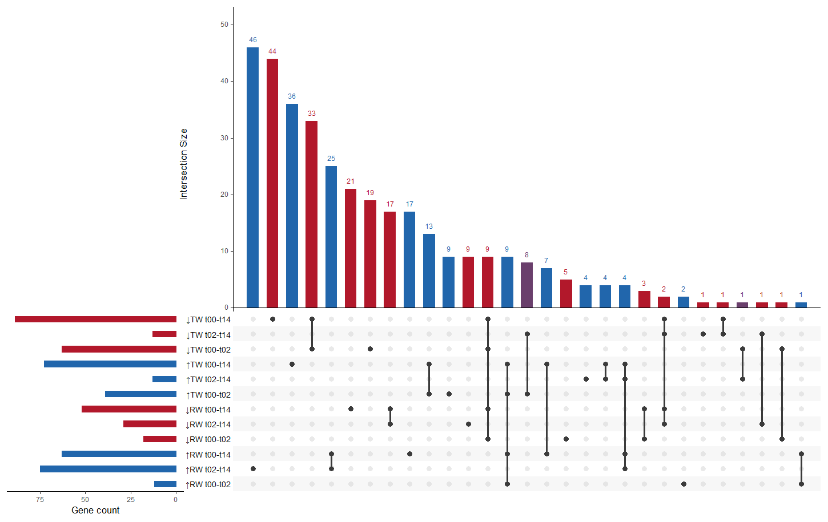
Supplementary Figure S9: Upset Plot depicting the abundance of differentially expressed genes (DEGs) in plasmid-cured Escherichia coli (PCV-Ec2) after incubation in river water (Ryck) and tap water (TW). The intersection matrix (bottom) shows overlapping DEGs between the different water types after incubation for 2 days (t00-t02), 14 days (t00-t14), and between day 2 and 14 (t02-t14). Differential expression is divided into down- (↓; red) and upregulation (↑; blue). Overlaps between down- and upregulated genes are marked with purple.

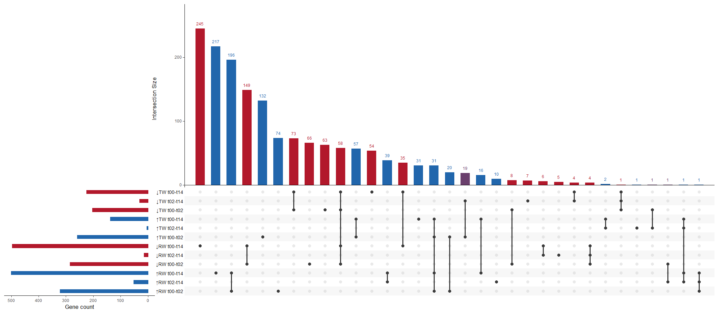
Supplementary Figure S10: Upset Plot depicting the abundance of differentially expressed genes (DEGs) in wild-type Klebsiella pneumoniae (Kp) after incubation in river water (Ryck) and tap water (TW). The intersection matrix (bottom) shows overlapping DEGs between the different water types after incubation for 2 days (t00-t02), 14 days (t00-t14), and between day 2 and 14 (t02-t14). Differential expression is divided into down- (↓; red) and upregulation (↑; blue). Overlaps between down- and upregulated genes are marked with purple.

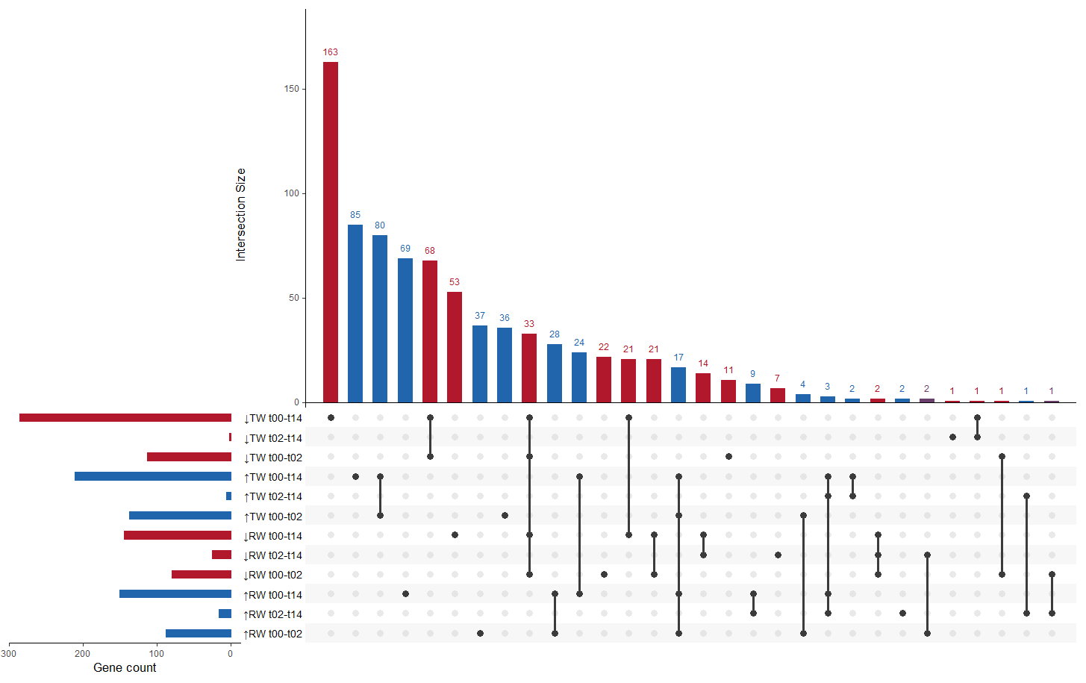
Supplementary Figure S11: Upset Plot depicting the abundance of differentially expressed genes (DEGs) in plasmid-cured Klebsiella pneumoniae (PCV-Kp) after incubation in river water (Ryck) and tap water (TW). The intersection matrix (bottom) shows overlapping DEGs between the different water types after incubation for 2 days (t00-t02), 14 days (t00-t14), and between day 2 and 14 (t02-t14). Differential expression is divided into down- (↓; red) and upregulation (↑; blue). Overlaps between down- and upregulated genes are marked with purple.

