Additional results

Distribution of total number of chronic conditions
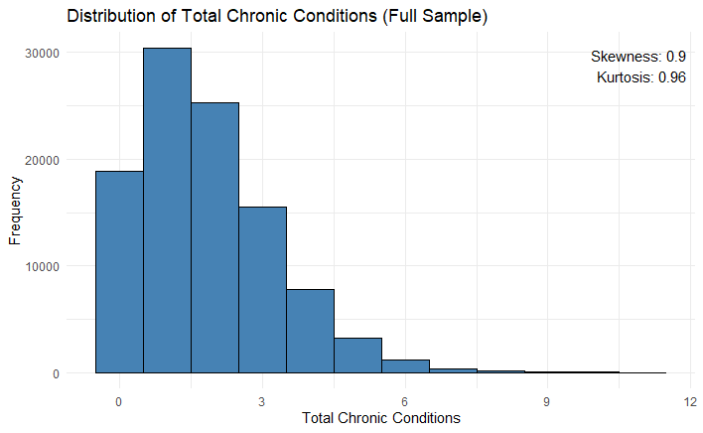
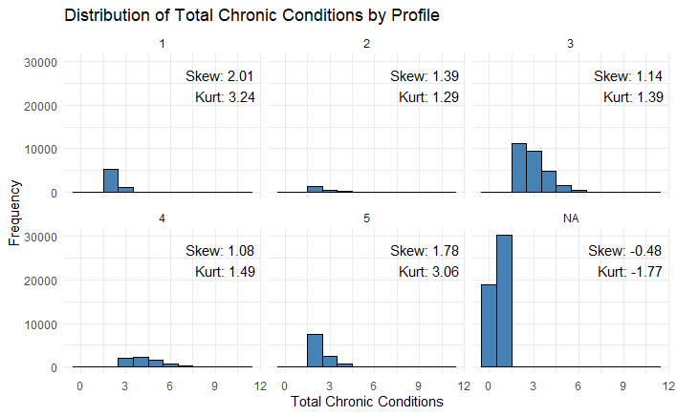
Figure 1. Distribution of total number of chronic conditions in the full sample and in multimorbidity profiles.
The distribution of the total number of chronic conditions was examined for the full sample and stratified by multimorbidity profile. Histograms were constructed using a bin width of one condition. To characterise distributional shape, skewness and kurtosis were calculated for the overall sample and within each profile group. Skewness quantifies asymmetry, while kurtosis (reported as excess kurtosis) reflects tail heaviness and peakedness relative to a normal distribution (reference value = 0). Estimates were computed using the e1071 package in R (type 2, unbiased estimators), excluding missing values. All analyses were conducted in R using ggplot2 for visualisation and dplyr for data manipulation.
The distribution of total chronic conditions is moderately right-skewed (skewness = 0.9), indicating that most individuals have a relatively low number of conditions, with a progressively smaller proportion experiencing higher multimorbidity. The positive excess kurtosis (0.96) suggests a somewhat more peaked distribution with heavier tails than a normal distribution, consistent with a concentration around lower counts and a non-negligible tail of higher values.
Across profiles, total chronic conditions are consistently non-normally distributed, with right-skewness predominating. However, the degree of skewness and tail heaviness varies substantially by profile, suggesting meaningful differences in the burden and distribution of chronic conditions across multimorbidity subgroups.

Distribution of multimorbidity profiles in each participating country
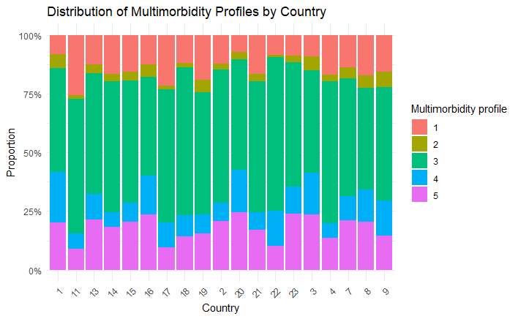
Figure 2. Distribution of multimorbidity profiles by country
The distribution of multimorbidity profiles varies across countries, although a broadly consistent pattern is observed. Profile 3 constitutes the largest proportion in most countries, indicating that this profile represents the predominant multimorbidity pattern across settings. Profiles 1 and 2 generally account for smaller shares, with some variability between countries.
Profiles 4 and 5 show more heterogeneity, with certain countries exhibiting relatively higher proportions, suggesting differences in the burden and complexity of multimorbidity across populations.

Intraclass correlation for the full sample and people with multimorbidity
Table 1. Intraclass correlation for the full sample and for people with multimorbidity (based on null model)
 | Country (%) | Practice (%) | Patient (%)
Physical health  (Full sample) | 3.6 | 2.8 | 93.6
Physical health  (People with two or more chronic conditions) | 4.2 | 2.5 | 93.3
Mental health  (Full sample) | 8.0 | 1.6 | 90.4
Mental health  (People with two or more chronic conditions) | 8.5 | 1.7 | 89.9
Well-being  (Full sample) | 2.4 | 1.9 | 95.8
Well-being  (People with two or more chronic conditions) | 2.8 | 2.0 | 95.2

Across all three outcomes, most variance was consistently explained at the patient level, but small differences emerged between the full sample and those with two or more chronic conditions. Country‑level variation was slightly higher among people with multimorbidity for physical health (rising from 3.6% to 4.2%), mental health (from 8.0% to 8.5%), and well‑being (from 2.4% to 2.8%). Practice‑level variation showed minimal change across samples, remaining low in all models. Patient‑level variance decreased marginally among those with multimorbidity, though it still accounted for around 90% or more of the total variance for each outcome.

Variance explained by the model (multi-level model development)
Table 2. The percentage reduction in unexplained variance compared with the null (intercept‑only) model (Pseudo‑R²)
 | Pseudo‑R² total (%)
Physical health
(People with two or more chronic conditions)
Model 1 | 18.2
Model 2 | 19.7
Model 3 | 25.5
Mental health
(People with two or more chronic conditions)
Model 1 | 10.5
Model 2 | 17.4
Model 3 | 25.8
Well-being
(People with two or more chronic conditions)
Model 1 | 12.8
Model 2 | 17.5
Model 3 | 26.4

For people with multimorbidity, the pseudo‑R² values increased across the three models for all outcomes, indicating improved explanatory power as additional factors were included. For physical health, the variance explained rose from 18.2% in Model 1 to 25.5% in Model 3. Mental health showed a similar pattern, increasing from 10.5% to 25.8 as well as well‑being, improving from 12.8% in Model 1 to 26.4% in Model 3.

