Arginine-Engineered Gold Nanoclusters for Doxorubicin Chemiluminescence Sensing
Chuangui Cai ^{a, 1}, Zhen Lin ^{a, 1} *, Wensong Yao ^{b*}, Shan Lian ª, Kaiyuan Huang ª, Haohua Deng ª, Xinhua Lin ª, Wei Chen ª *
ª Department of Pharmaceutical Analysis, Faculty of Pharmacy, Fujian Medical University, Fuzhou 350122, China.
^{b} College of Medical Sciences, Ningde Normal University, Ningde 352100, China.
¹ These authors contributed equally to this work.

* Corresponding author:
Tel./fax: +86 591 22862016.
E-mail address: linwenjing002@163.com (Z. Lin), yiusunter@163.com (W. Yao), chenandhu@163.com (W. Chen)
¹ These authors contributed equally to this work.

Table of contents
Figure S1. Schematic diagram of a static CL setup. S3
Figure S2. Schematic diagram for flow injection-CL system. S4
Figure S3. Hydrodynamic diameter of Arg/ATT-AuNCs. S5
Figure S4. Effect of radical scavengers on NaIO₄-Arg/ATT-AuNCs-H₂O₂ system; Ascorbic acid; Thiourea; NBT; Histidine. S6
Figure S5. UV-vis absorption spectrum and fluorescence spectrum of NaIO₄-Arg/ATT-AuNCs-H₂O₂ system before and after CL reaction. S7
Figure S6. CL Kinetic curve of NaIO₄-Arg/ATT-AuNCs-H₂O₂ and NaIO₄-Arg/ATT-AuNCs-H₂O₂ + 0.5 μM DOX. S8
Figure S7. Condition optimization of NaIO₄-Arg/ATT-AuNCs-H₂O₂ system. Concentration of H₂O₂, NaIO₄, and Arg/ATT-AuNCs. pH of NaIO₄. S9
Table S1. Comparison of enhancement effect of different materials on NaIO₄-H₂O₂ system. S10
References: 11

Figure S1. Schematic diagram of a static CL setup.

Figure S2. Schematic diagram for flow injection-CL system.

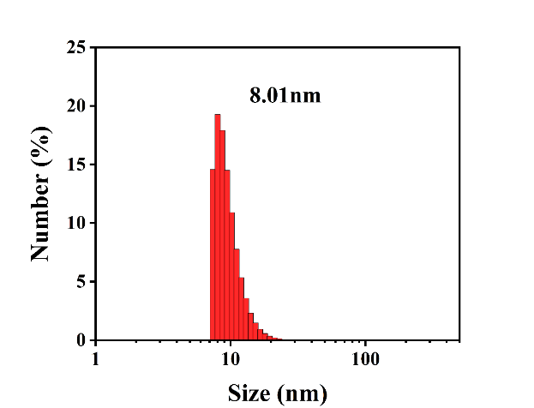

Figure S3. Hydrodynamic diameter of Arg/ATT-AuNCs.

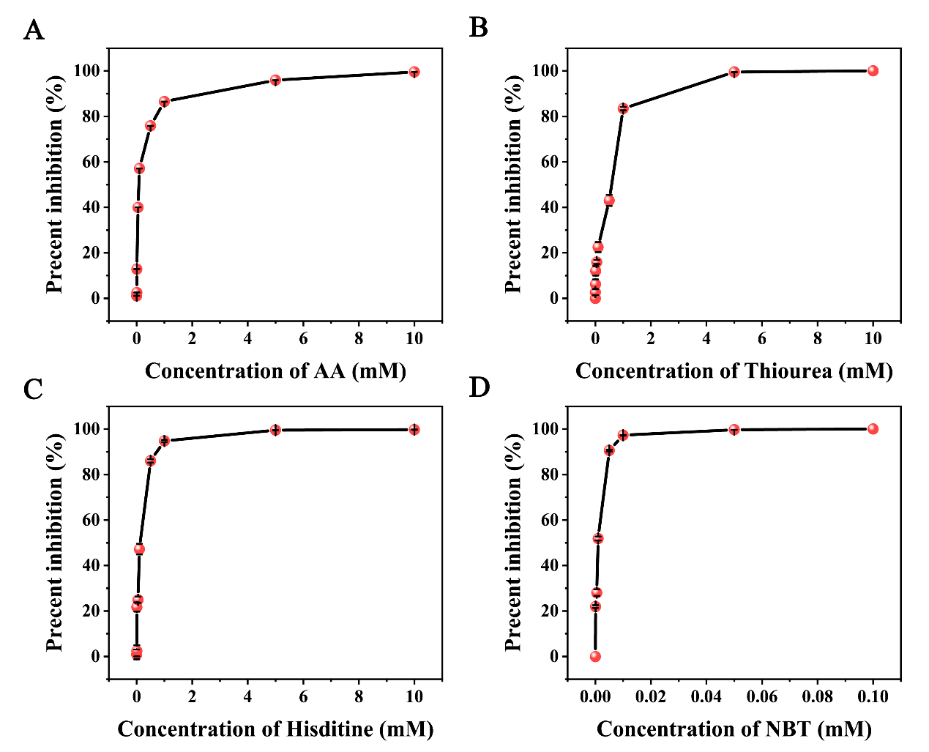

Figure S4. Effect of radical scavengers on NaIO₄-Arg/ATT-AuNCs-H₂O₂ system; (A) Ascorbic acid (AA); (B) Thiourea; (C) NBT; (D) Histidine.

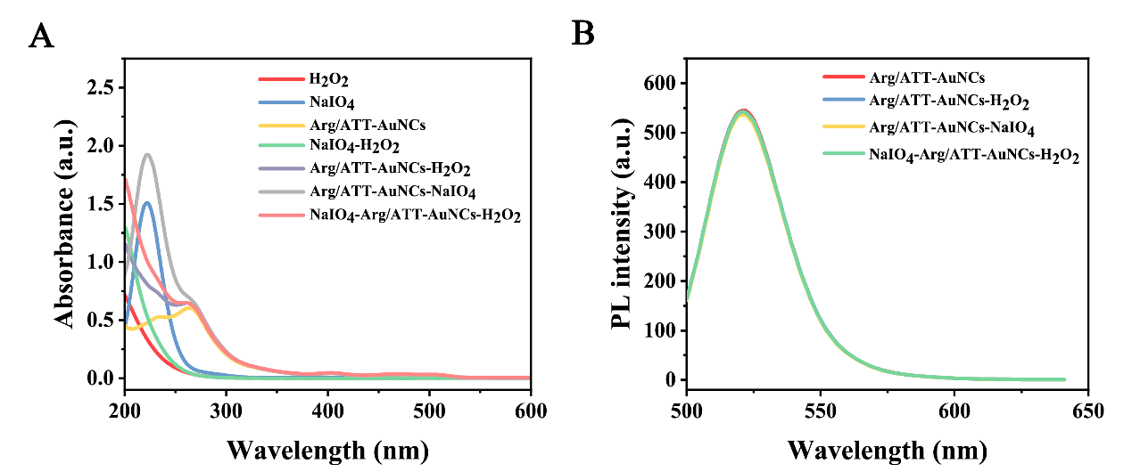

Figure S5. UV-vis absorption spectrum (A) and fluorescence spectrum (B) of NaIO₄-Arg/ATT-AuNCs-H₂O₂ system before and after CL reaction.

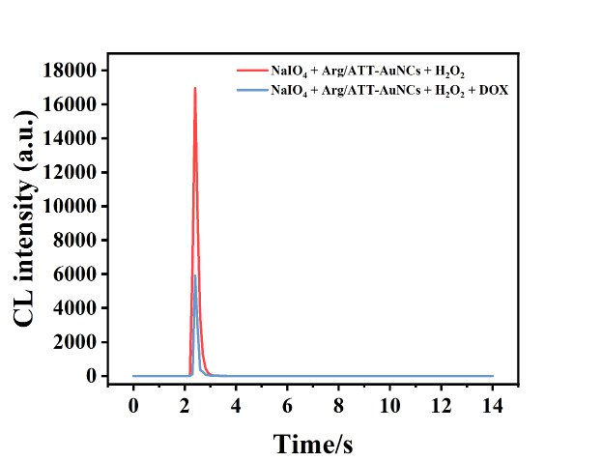

Figure S6. CL Kinetic curve of NaIO₄-Arg/ATT-AuNCs-H₂O₂ (red line) and NaIO₄-Arg/ATT-AuNCs-H₂O₂ + 0.5 μM DOX (blue line).

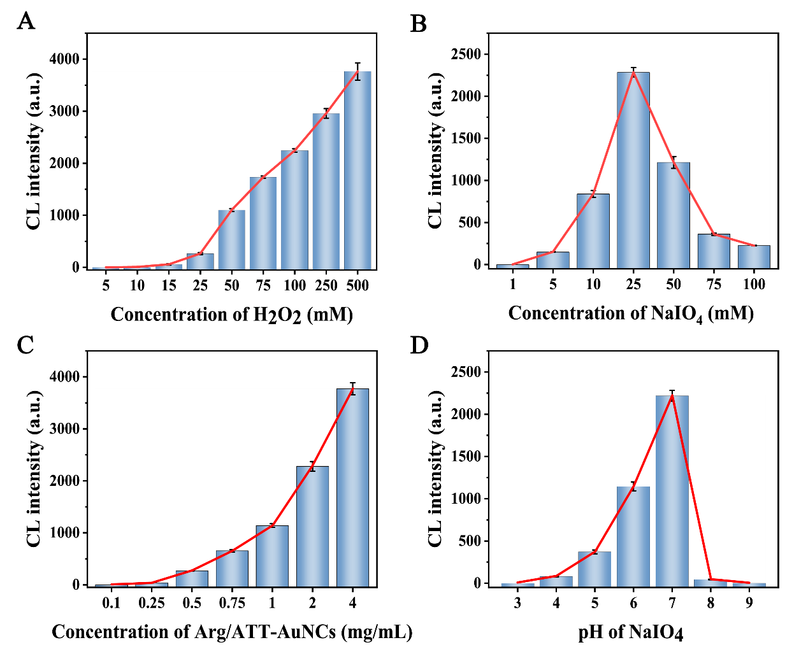

Figure S7. Condition optimization of NaIO₄-Arg/ATT-AuNCs-H₂O₂ system. Concentration of H₂O₂ (A), NaIO₄ (B), and Arg/ATT-AuNCs. (D) pH of NaIO₄.

Table S1.

Comparison of enhancement effect of different materials on NaIO₄-H₂O₂ system.
Numbers | Enhancer | CL System | Enhancer times | Ref.
No.1 | N-CDs | KIO₄-H₂O₂ | 38 | [1]
No.2 | SN-GQD | KIO₄-H₂O₂ | 200 | [2]
No.3 | N-dots | NaIO₄-H₂O₂ | 400 | [3]
No.4 | LaF₃:Ce NPs | NaIO₄-H₂O₂ | 80 | [4]
No.5 | AuNSs | NaIO₄-H₂O₂ | 12 | [5]
No.6 | Co-MOF | NaIO₄-H₂O₂ | 70 | [6]
No.7 | Mn-doped QDs | NaIO₄-H₂O₂ | 135 | [7]
No.8 | Arg/ATT-AuNCs | NaIO₄-H₂O₂ | 1223 | This work

References:
[1] Shah SNA, Li H, Lin J (2016) Enhancement of periodate-hydrogen peroxide chemiluminescence by nitrogen doped carbon dots and its application for the determination of pyrogallol and gallic acid. Talanta 153:23-30. https://doi.org/10.1016/j.talanta.2016.02.056.
[2] Li Y, Wang J, Yang Y, Han S (2020) Sulfur and nitrogen co‐doped graphene quantum dot-assisted chemiluminescence for sensitive detection of tryptophan and mercury (II). Luminescence 35:773-80. https://doi.org/10.1002/bio.3783.
[3] Zheng Y, Zhang D, Shah SNA, Li H, Lin J (2017) Ultra-weak chemiluminescence enhanced by facilely synthesized nitrogen-rich quantum dots through chemiluminescence resonance energy transfer and electron hole injection. Chem Commun 53:5657-60. https://doi.org/10.1039/C7CC02041D.
[4] Wang Y, Huang C, Wang Y, Chen T, Wu J (2021) Chemiluminescence enhanced by cerium-doped LaF3 nanoparticles through electron-hole annihilation. J Lumines 239:118407. https://doi.org/10.1016/j.jlumin.2021.118407.
[5] Amjadi M, Abolghasemi-Fakhri Z (2018) Gold nanostar-enhanced chemiluminescence probe for highly sensitive detection of Cu (II) ions. Sens Actuator B Chem 257:629-34. https://doi.org/10.1016/j.snb.2017.11.013.
[6] Wang Y, Wang Z, Liu Y, Liu Z, Gao Z, Li K, Zhao D, Wu J, Liu X (2023) Pyrogallol detection based on the cobalt metal-organic framework of nanomaterial-enhanced chemiluminescence. Chemosensors 11:395. https://doi.org/10.3390/chemosensors11070395.
[7] Liu J, Chen H, Lin L, Lu C, Lin J (2010) Sensitized chemiluminescence reaction between hydrogen peroxide and periodate of different types of Mn-doped ZnS quantum dots. Chin Sci Bull 55:3479-84. https://doi.org/10.1007/s11434-010-4059-6.

