Supplemental Material 1.
DIBH ACCT acquisition
First, a routine attenuation correction CT (ACCT) was performed for all patients. Without patient movement in the single scan, the body was still except for the body part affected by the respiratory motion. The DIBH chest to pelvis low dose diagnostic CT (LDCT) was obtained. The DIBH LDCT and the still head-to-neck and lower extremity ACCT from the routine FB scan were combined as the total-body ACCT for DIBH total-body PET attenuation correction.

Supplemental Material 2.
Quantitative image quality assessment
The liver, spleen, and mediastinal blood pool were selected and measured. As published in several studies (1,2), the liver, spleen, and mediastinal blood pool SUVs were measured by placing a 3 cm spherical volume of interest (VOI) in the right upper lobe of the liver, a 1.5 cm spherical VOI in the spleen, and a 1 cm spherical VOI in the descending aorta, respectively. All VOIs avoided the edge and metastatic lesions. The SUV_{mean}, SUV_{max}, and standard deviation (SD) values for each PET series were recorded.
The SUV_{max} and standard deviation (SD) of the spleen, and mediastinal blood pool were not significantly different between the FB-30s and DIBH-30s PET, and both were significantly larger than those in FB-300s. The quantitative image measurements were summarized in Table E1.

Supplemental Material 3.
Lesion analysis
The lesion confidence was scored on a 4-point scale (score 4: definite, >95%; score 3: probable, 75%-95%; score 2: possible, 50%-75%; score 1: questionable, ≤ 50%).
The reference true positive (TP) lesion was defined as follows: Firstly, any PET ¹⁸F-FDG-avid lesion (confidence ≥ 2) that had a corresponding CT/MR lesion was defined as a TP lesion. Secondly, considering the ultrahigh sensitivity of TB-PET and high SNR of the FB-300s PET images, we assigned the lesion with confidence ≥ 3 on FB-300s as a TP lesion. Thirdly, if the confidence of the ¹⁸F-FDG-avid lesion in FB-300s was elevated in DIBH-30s PET, the lesion was defined as a TP lesion. TP lesions with confidence ≥ 2 on three PET series were assigned as coidentified lesions, while lesions with confidence < 2 on certain PET were assigned as missed lesions on certain PET.

Table E1 Quantitative image measurements.
 | FB-5min | FB-30s | DIBH-30s | p-value
 |  |  |  | FB-5min vs. FB-30s | FB-5min vs. DIBH-30s | FB-30s vs. DIBH-30s
Spleen
SUV_{mean} | 1.82±0.28 | 1.82±0.30 | 1.81±0.30 | 0.453 | 0.500 | 0.311
SUV_{max} | 2.07±0.32 | 2.41±0.39 | 2.42±0.41 | <0.001 | <0.001 | 0.704
SD | 0.11±0.04 | 0.24±0.06 | 0.24±0.08 | <0.001 | <0.001 | 0.353
Blood pool
SUV_{mean} | 1.50±0.31 | 1.47±0.31 | 1.44±0.33 | 0.014 | 0.006 | 0.309
SUV_{max} | 1.71±0.33 | 1.89±0.38 | 1.87±0.37 | <0.001 | <0.001 | 0.424
SD | 0.10±0.04 | 0.19±0.06 | 0.2±0.06 | <0.001 | <0.001 | 0.824
Note. -- Data are mean ± standard deviations. FB = free-breathing, DIBH = deep-inspiration breath-hold.

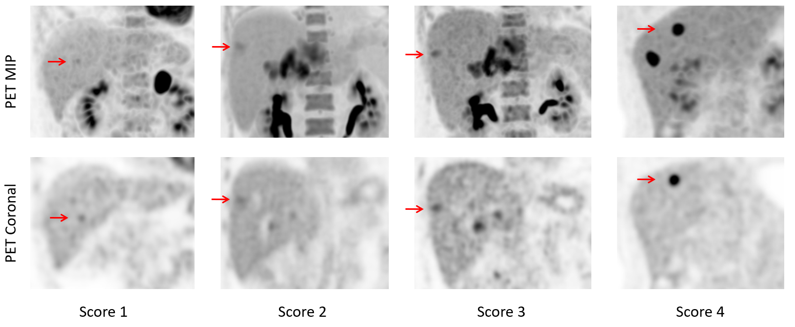
Fig. E1 The lesion confidence was scored on a 4-point scale (score 4: definite, >95%; score 3: probable, 75%-95%; score 2: possible, 50-75%; score 1: questionable, ≤ 50%). Score 1: The lesion uptake and noise are hard to distinguish in PET MIP, while the lesion uptake is slightly different (slightly larger or higher uptake) from noise on the slice images. Score 2: The lesion uptake can be faintly distinguished from the noise on PET MIP and slice images. Score 3: The lesion uptake can be clearly distinguished on PET MIP and slice images. Score 4: The lesion uptake can be significantly distinguished on PET MIP and slice images.

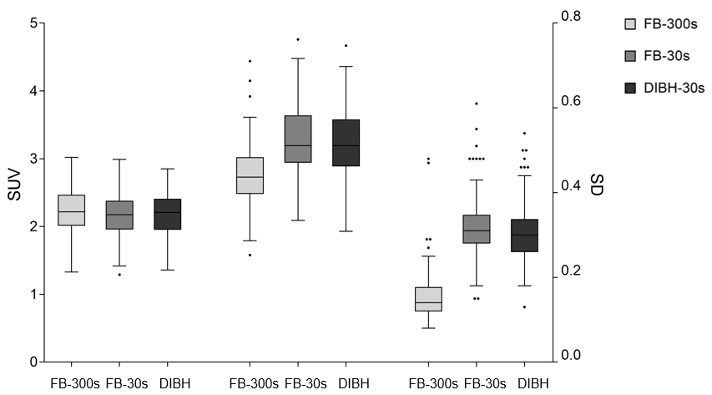
Fig. E2 Quantitative liver background measurements in the free-breathing (FB) PET and deep-inspiration breath-hold (DIBH) PET.

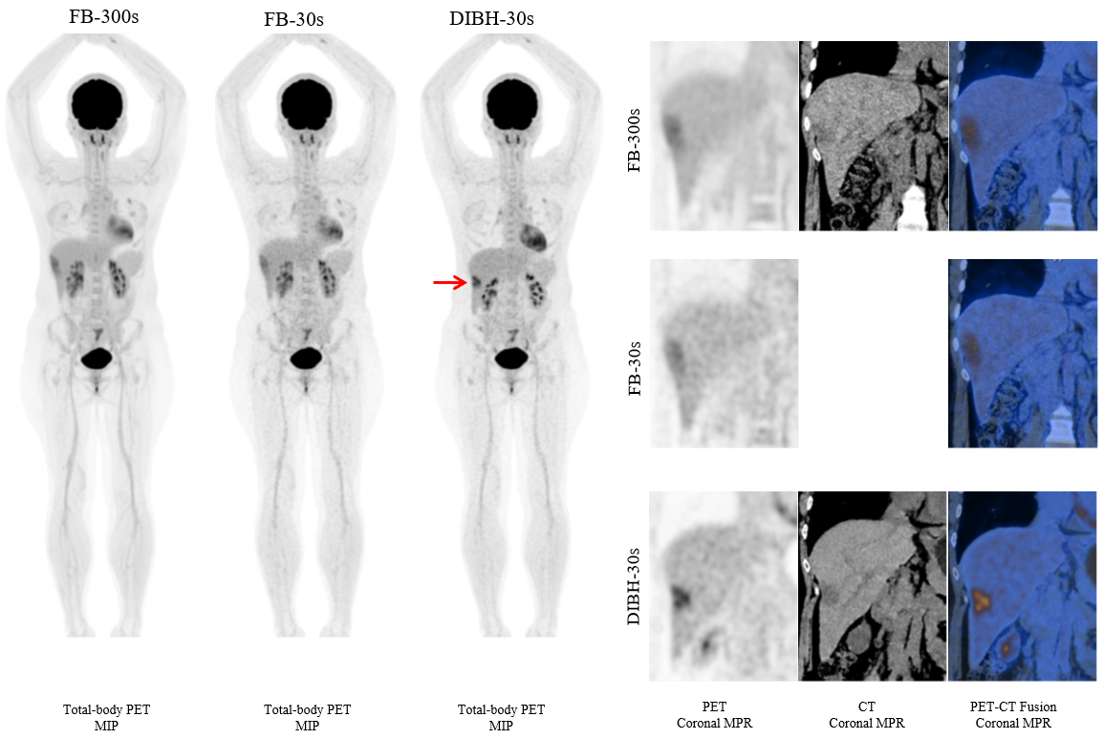
Fig. E3 A 38-year-old female with liver cancer. The nodule had an unclear edge and a SUV_{max} of 4.87 in FB-300s PET. The diameter of the mass was 2.6 cm measured on FB CT. The AC artifact of the liver border was shown in the FB PET coronal MPR view. The nodule was misregistered between FB PET and CT. In contrast, the nodule had a clearer edge and higher uptake with a SUV_{max} of 6.83 in DIBH PET. The liver dome matched well in DIBH PET/CT. The nodule was well registered between DIBH PET and DIBH CT.

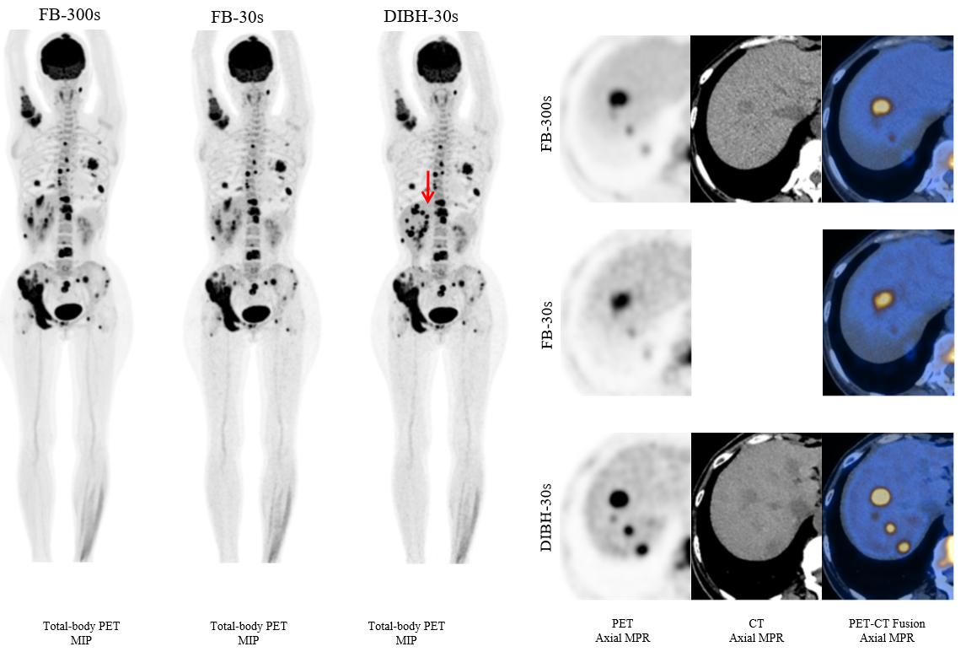
Fig. E4 A 53-year-old female with left lung cancer and multiple liver metastases. The liver nodules range along the z-axis was extended in FB-300s and FB-30s PET MIP, while the nodules were clearly displayed in DIBH-30s PET MIP. The axial view of the FB PET showed the attenuation correction (AC) artifact of the liver border, and several lesions exceeded the AC liver border. The nodules were misregistered between FB PET and CT. In contrast, the nodules had higher uptakes in DIBH PET. The nodule was well registered between DIBH PET and DIBH CT.

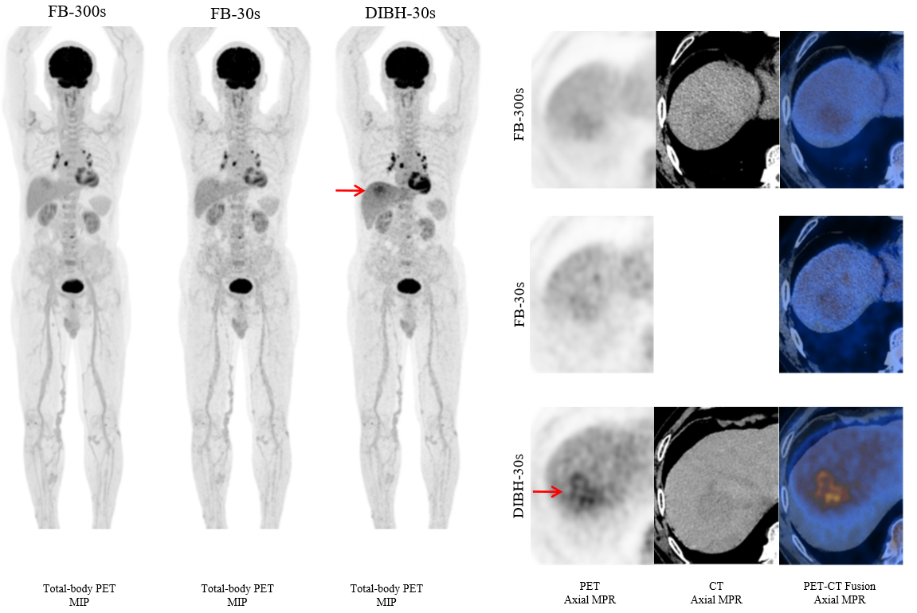
Fig. E5 An example of FB-30s missed lesion. A 76-year-old male with liver cancer. The total-body PET maximum intensity projection (MIP) images were displayed. The liver mass uptake was invisible in FB-30s PET and unclear in FB-300s PET, while the mass uptake was clearly displayed in DIBH-30s PET MIP. The mass was missed in the axial FB-30s PET. The mass was detected in DIBH-30s PET with confidence = 3 and in FB-300s with confidence = 2.

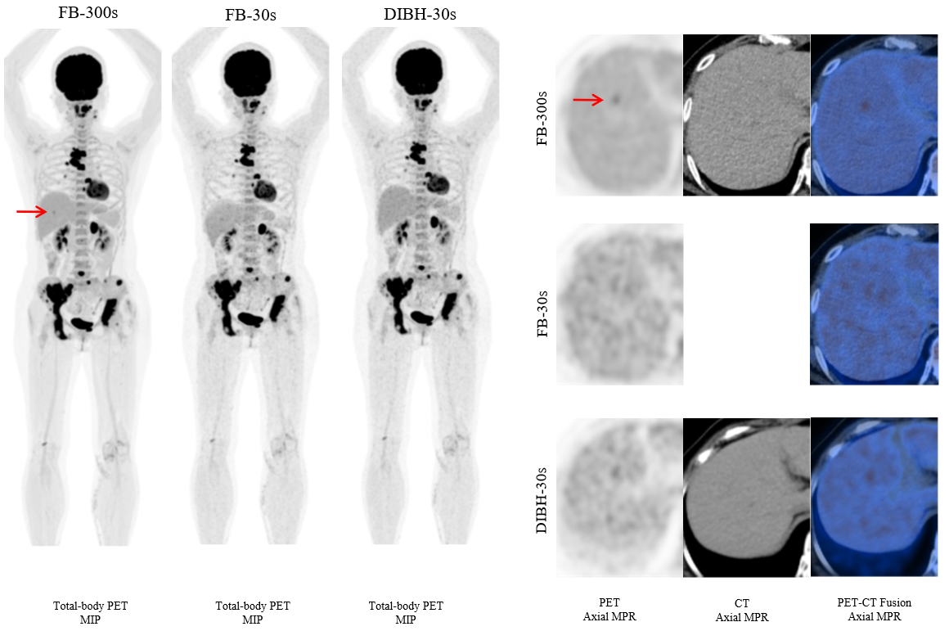
Fig. E6 A 58-year-old male with lung cancer. The FB-300s PET showed the lesion located in the liver had a light uptake. However, the nodule uptake was invisible in DIBH-30s PET.

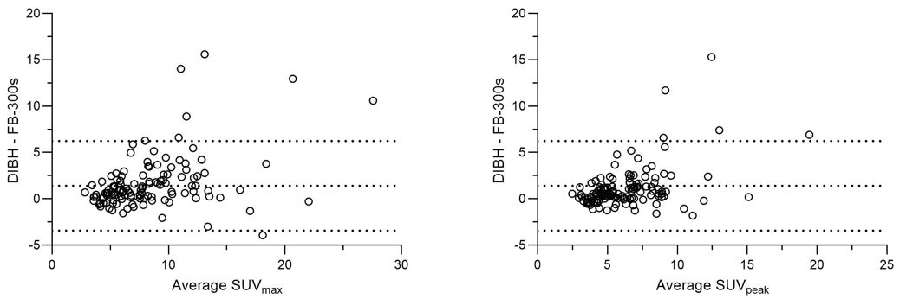
Fig. E7 Bland-Altman plots of the lesion SUV_{max} and SUV_{peak} between FB-300s and DIBH PET. The Bland–Altman 95 % limits of agreement between FB-300s and DIBH were 1.62 ± 5.60 and 1.14 ± 4.40 for SUV_{max} and SUV_{peak}. Dashed lines delineate the mean and 95 % limits of agreement.

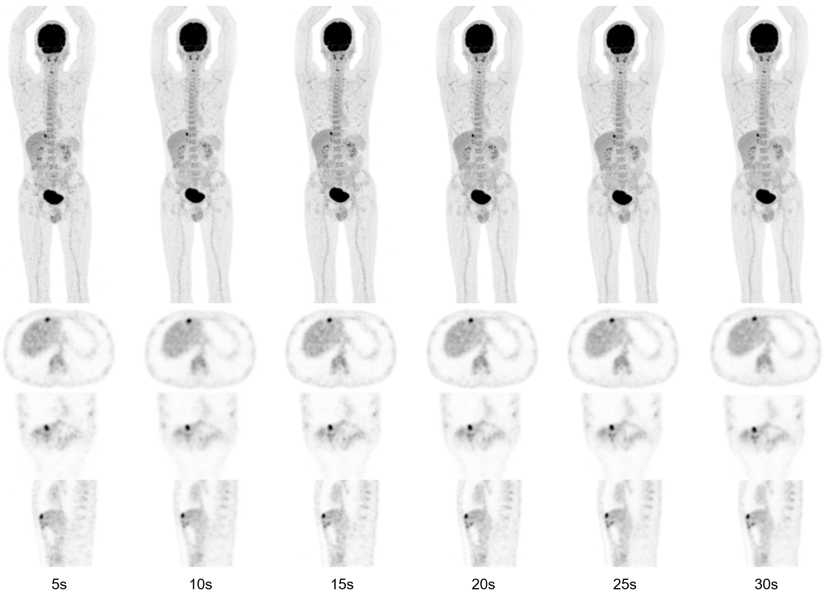
Fig. E8 A37-year-old male with liver cancer. The truncated data of short duration (5-30 s) were reconstructed and compared. The image qualities of 15-30 s PET images were acceptable.

