Supplementary Files: Title: Barriers and motivators for life support certification

Motivators.
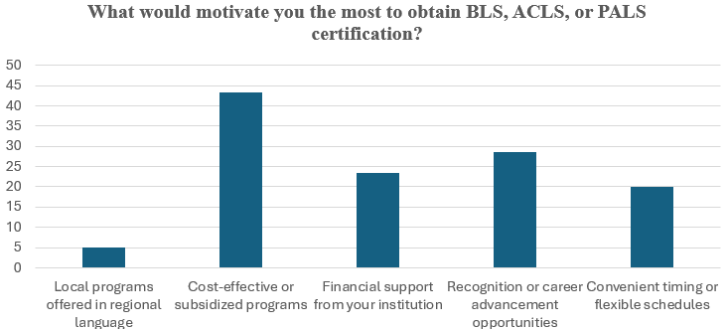
Barriers.

