Supplementary File 4: SMS Messages

GP and Nurse/Paramedic SMS messages sent per 1000 registered patients, Feb-Jul 2019 and Feb-Jul 2020
GP SMS messages sent per 1000 patients
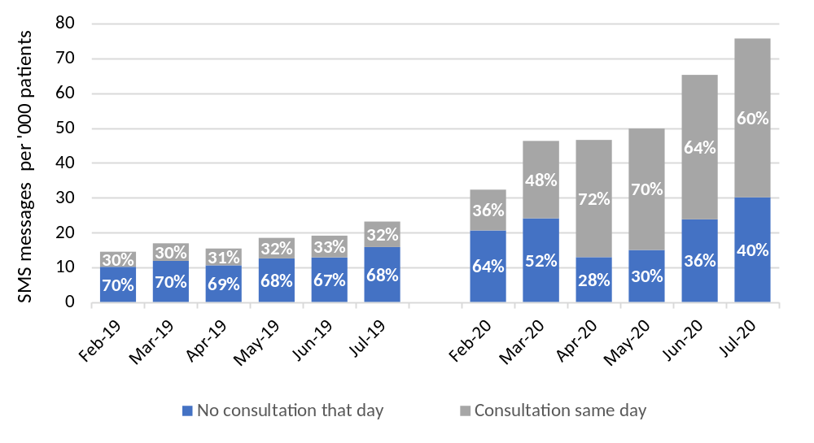
Nurse/Paramedic SMS messages sent per 1000 patients
