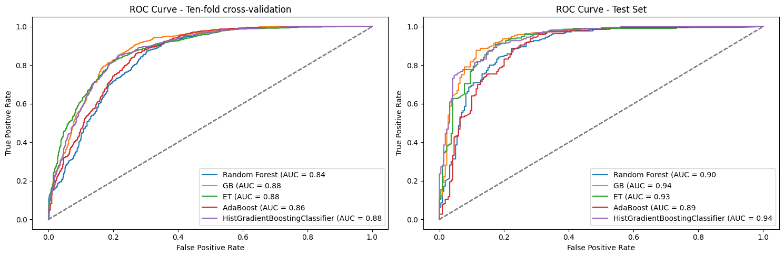
Supplementary fig. 1. ROC Curve Comparison of Five Machine Learning Algorithms on HER2 Small Molecules: Demonstrating Receiver Operating Characteristic (ROC) curves from 10-fold cross-validation and Test set

Supplementary Table 1. 2D structures of the selected top compounds after virtual screening against HER2 using molecular docking
