Supplemental Materials
Table S1：Target sequence of siIRF7
siNC | Forward：UUCUCCGAACGUGUCACGUTT  Resverse：ACGUGACACGUUCGGAGAATT
siIRF7 | Forward：CAUAAGGUGUACGAACUUATT  Resverse：UAAGUUCGUACACCUUAUGTT

Table S2：Primer sequences for quantitative real-time PCR
Genes | Forward | Reverse
mouse  Gapdh | AAGAGGGATGCTGCCCTTAC | TACGGCCAAATCCGTTCACA
mouse Ifitm3 | CCTGGGCTCCAGTCACATCA | TCTGCTGCCTGGGCTTCATAG
mouse  Ifn-α | CTGAGCTACTGGCCAACCTGC | GTTGGCAGGTCATTGAGCTG
mouse  Ifn-β | AGCCACTCCTTCTGTGACTCCAG | GCCCTGTAGGTGAGGTTGATCT
mouse  Ifn-γ | ATGAACGCTACACACTGCATC | CCATCCTTTTGCCAGTTCCTC
mouse  Il-1β | GAACGTCACACACCAGCAGGTTA | TCCAGGATGAGGACATGAGCAC
mouse  Tnf-α | AGCGAGGACAGCAAGGGACTA | GAGCTATTTCCAAGATGTTCTGGAG
mouse  Il-17 | TGAGCTTCCCAGATCACAGA | TCCAGAAGGCCCTCAGACTA
mouse  Il-6 | AGCCACTCCTTCTGTGACTCCAG | AGAGGATACCACTCCCAACAGACC
mouse  Ppar-α | AGGGACATAACTCCAGCAC | TTCATAAGGTCTTCGGCTA
mouse  Irf1 | AGGGACATAACTCCAGCAC | TTCATAAGGTCTTCGGCTA
mouse  Irf2 | CAATACGATACCAGGGCTAA | GTTTCTGAAGAGCGGAGC
mouse  Irf3 | CACGCTACACTCTGTGGTTC | GATAGGCTGGCTGTTGGA
mouse  Irf4 | GGGACATCCTCGTGAAAG | GGTGGCTCAGCAACTTCT
mouse  Irf5 | CCTGTCCCAGACCCAAAT | GCAGGTCAGGCAAGAGTG
mouse  Irf6 | ACCCATTCAACCCTTCTAC | CCATACTCCTTCCCACGA
mouse  Irf7 | cttcagcactttcttccgaga | tgtagtgtggtgacccttgc
mouse  Irf8 | AACGTGGCGTGCTACTGC | CTCGGATGAACTGGTTGGTG
mouse  Irf9 | AAGGCTTGGGCACTGTTT | TTCCGTGGTTGGTTAGGG
mouse  Tlr4 | ATGCCATGCCTTGTCTTCAATT | TCAGAACTTCAGTGGCTGGATTT
mouse  Ticam1 | CAGAGTTGTCTACAAAGTCG | TGGATGACGTGGTGTTCTGC
mouse  Ticam2 | ATAAAGCTCCCTCGTCTGCC | GGTGTGTGCTCGGTTTCAGG

Table S3 Sequencing databases analysis
Datebase | Sample | Method | Related genes  (AD VS Control) | Type | Reference
SCP1375 | Brain tissue from mouse models | SnRNA-seq | Up-regulation:  Ifitm3, Irf7, Ifnb1  Down-regulation:  Tlr3, Irf1, Irf8 | Astrocytes | 46
GSE260461 | Brain tissue from patients | SnRNA-seq | Up-regulation:  IFITM3, IRF7, TICAM1, TICAM2  Down-regulation:  TLR3, TLR4, IRF1, IRF3, IRF4, IRF9 | Astrocytes | 28
Syn  20801188 | Human PHG proteomics | Bulk RNA-seq | Up-regulation:  IFITM3, TLR1, TLR2, TLR3, TLR4, TLR5, TLR6, TLR7, TLR8, TICAM1, TICAM2, IRF1, IRF2, IRF3, IRF5, IRF6, IRF7, IRF8, IRF9 | PHG | 47

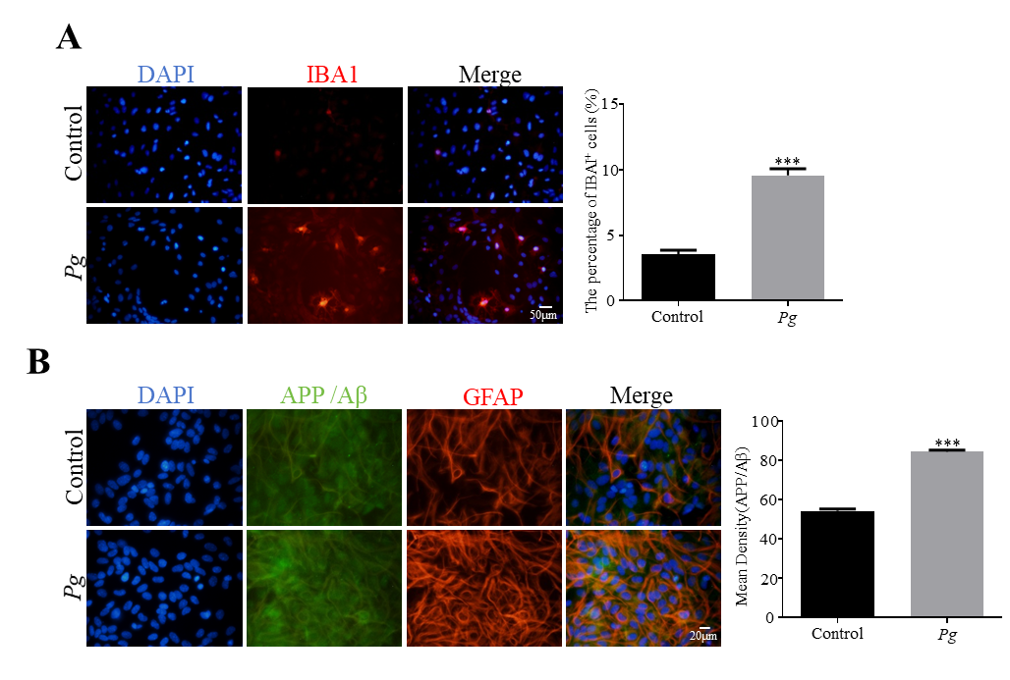
Figure S1. Pg activates microglial cells. (A) Representative immunofluorescence images and quantitative analysis of IBA1 expression (a microglial marker) in glial cell cultures. Scale bar = 50 μm. (B) Immunofluorescence staining and quantification showing co-localization of APP/Aβ (green) with the astrocytic marker GFAP (red) in glial cells. Scale bar = 20 μm. *** P < 0.001.
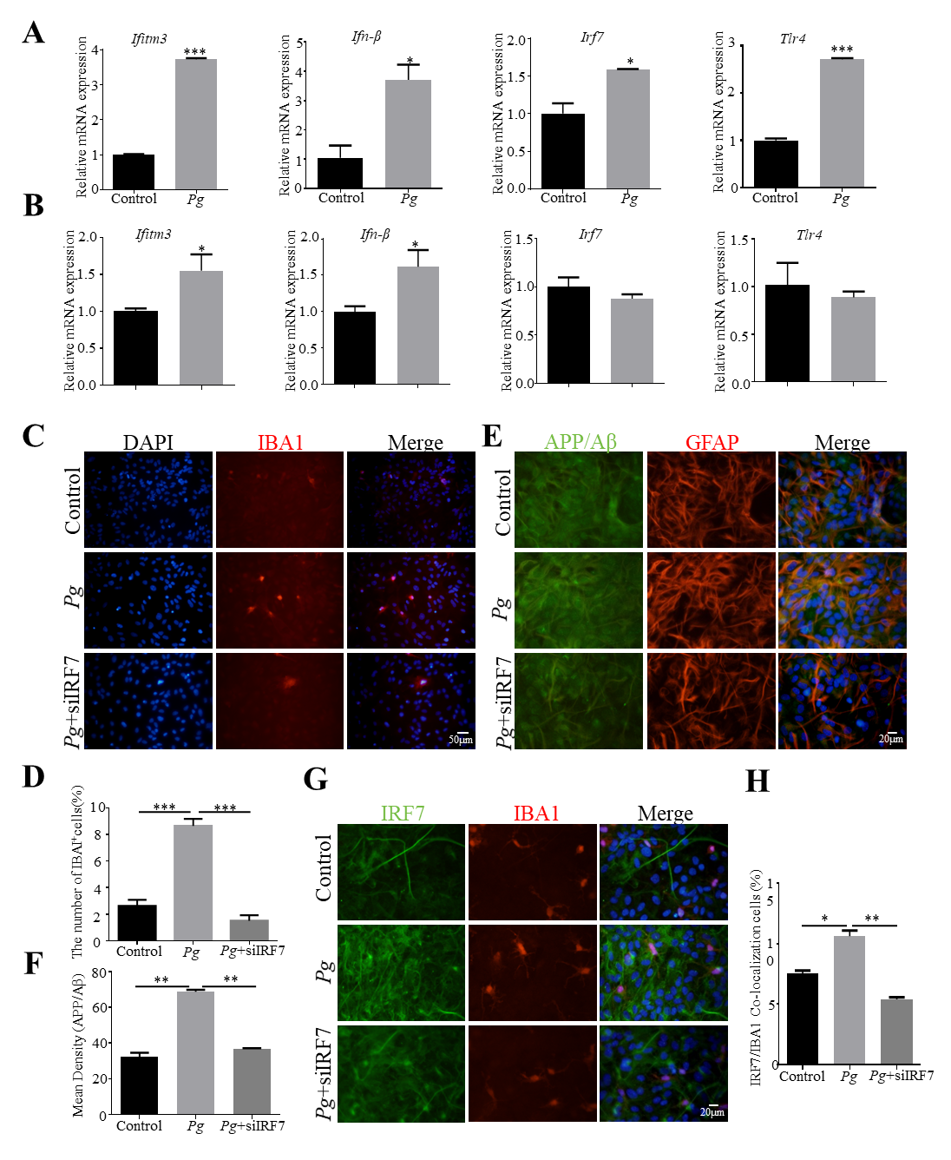
Figure S2. Pg upregulates IFN pathway-related genes in glial cells. (A) Ifitm3, Ifn-β, Irf7 and Tlr4 mRNA levels in an astrocytic cell line under control or Pg stimulation, measured by RT-qPCR. (B) Ifitm3, Ifn-β, Irf7 and Tlr4 mRNA levels in a microglial cell line under control or Pg stimulation, assessed by RT-qPCR. (C, D) Representative immunofluorescence images and quantitative analysis of IBA1-positive microglia in primary glial cultures from control, Pg-treated, and Pg + siIRF7 groups. Scale bar = 50 μm. (E, F) Immunofluorescence staining and quantification showing co-localization of APP/Aβ (green) with the astrocytic marker GFAP (red) in primary glial cells under the indicated treatments. Scale bar = 20 μm. (G, H) Representative immunofluorescence images and quantitative analysis showing co-localization of IRF7 (green) with the microglial marker IBA1 (red) in primary glial cultures. * P < 0.05, ** P < 0.01, *** P < 0.001.

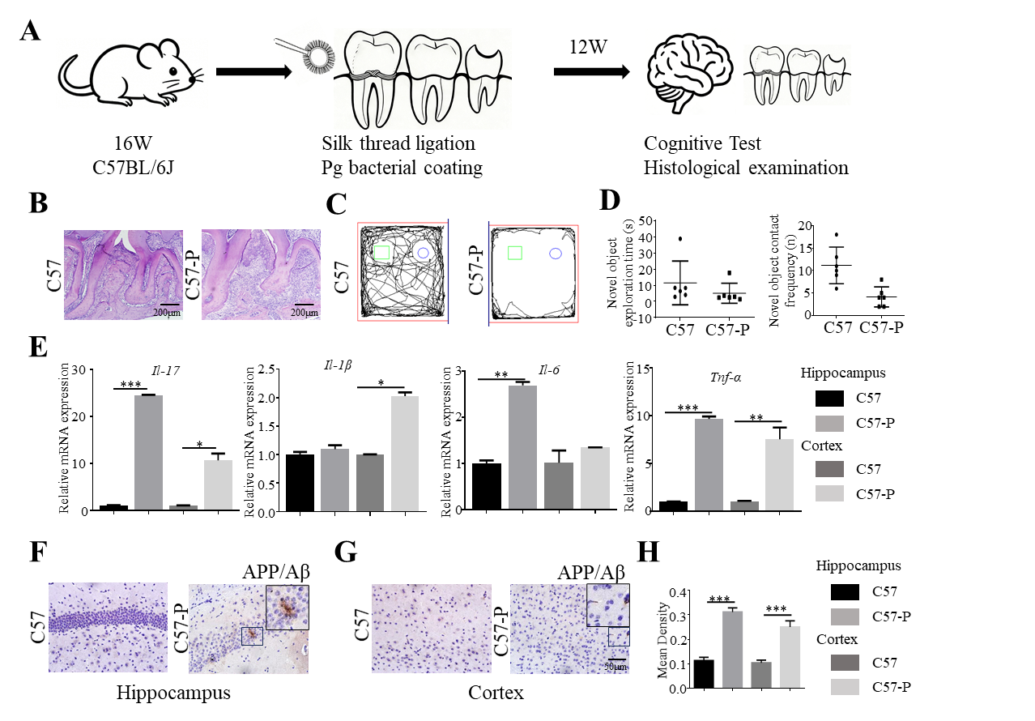
Figure S3. Periodontitis induces AD-like pathological changes in the brain. (A) Schematic illustration of the experimental periodontitis model. (B) Representative H&E-stained sections of maxillae from control (C57) and periodontitis (C57-P) mice. Scale bar = 200 μm. (C, D) Representative movement tracks from the novel object recognition (NOR) test and quantification of novel object exploration time and novel object contact frequency in C57 and C57-P mice. (E) mRNA levels of Il-17, Il-1β, Il-6, and Tnf-α in the hippocampus and cortex of C57 and C57-P mice, determined by RT-qPCR. (F-H) Representative immunohistochemical images and quantitative analysis of APP/Aβ protein expression in the hippocampal and cortical regions of C57 and C57-P mice. Scale bar = 50 μm. * P < 0.05, ** P < 0.01, *** P < 0.001.
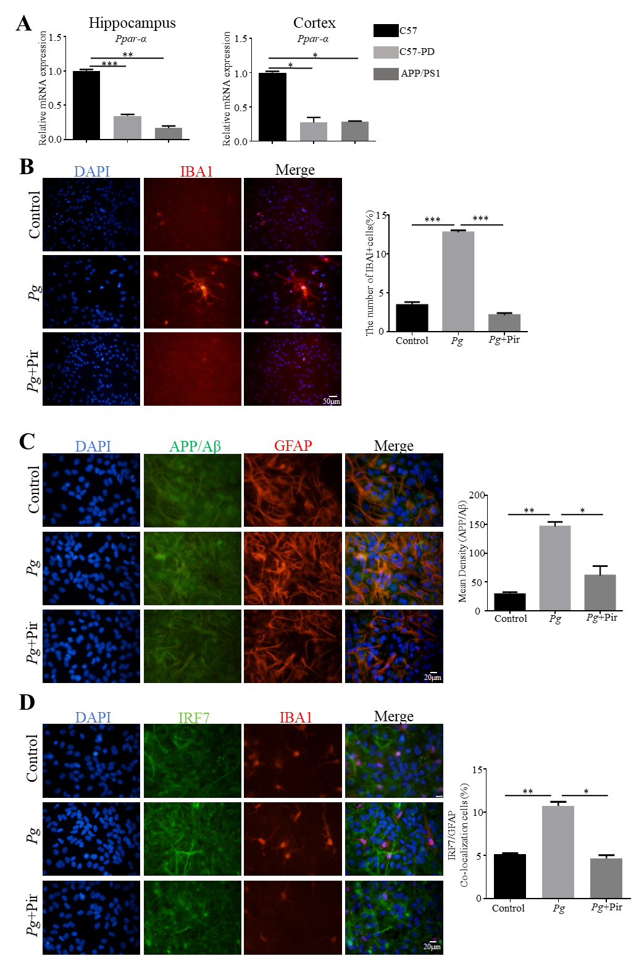
Figure S4. Pirinixic acid inhibits inflammation-induced glial cell activation. (A) Ppar-α mRNA levels in the hippocampus and cortex of C57, C57-P, and APP/PS1 mice, measured by RT-qPCR. (B) Representative immunofluorescence images and quantitative analysis of IBA1-positive microglia in primary glial cultures from Control, Pg, and Pg+Pir groups. Scale bar = 50 μm. (C) Immunofluorescence staining and quantification showing co-localization of APP/Aβ (green) with the astrocytic marker GFAP (red) in glial cells under the indicated treatments. Scale bar = 20 μm. (D) Representative immunofluorescence images and quantitative analysis showing co-localization of IRF7 (green) with the microglial marker IBA1 (red) in glial cells from Control, Pg, and Pg+Pir groups. Scale bar = 20 μm. * P < 0.05, ** P < 0.01, *** P < 0.001.

