Supplemental Materials for
Valley Photonic Molecular Crystal
Zhe Li¹, Yiheng Fan², Ziming Chen¹, Kaiyu Cui¹, Yongzhuo Li^{1†}, Xue Feng^{1‡}, Yidong Huang^{1§}
¹Department of Electronic Engineering, Tsinghua University, 100084 Beijing, China.
²Department of Physics, Tsinghua University, 100084 Beijing, China.
† Yongzhuo Li: liyongzhuo@tsinghua.edu.cn
‡ Xue Feng: x-feng@tsinghua.edu.cn
§ Yidong Huang: yidonghuang@tsinghua.edu.cn

Contents:
A: Dependence of the valley energy gap on the oriental angle of the molecule.
B: Valley Chern numbers of the VPMCs.
C: Energy bands of the valley topological edge states in the ordered VPMCs.
D: Spectral Localizer analysis of the VPMCs.
E: Simulation of bulk and edge transmission of VPMCs.
F: Fabrication of the samples of VPMCs.
G: Experiment setups and measured transmission spectra.
H: Generality of this work for $C_{3}$-symmetric molecules.

Supplement A: Dependence of the valley energy gap on the oriental angle of the molecule.
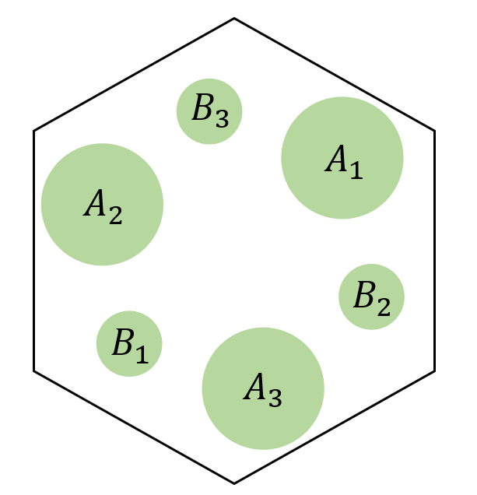
According to the derivations in the previous works^{1–3}, for the C₃-symmetric unit cell (shown above), the energy bands around the energy valleys (for example, K valley is $\vec{K}=\left[K,0\right], K=4π/3a$) are described by the Dirac Hamiltonian
$\hat{H}=f_{D}+υ_{D}\left({\hat{σ}}_{x}{\hat{τ}}_{z}δk_{x}+{\hat{σ}}_{y}δk_{y}\right)+λ^{P}{\hat{σ}}_{z}$ (D1),
where ${\hat{σ}}_{i}$, ${\hat{τ}}_{i}$ are the Pauli matrices acting on orbit and valley, respectively. And $λ^{P}$ is the effective mass term, and determined by the distribution of the relative permittivity as follows:
$λ^{P}=\frac{i\sqrt{3}μ_{0}ε_{0}{ω_{0}}^{3}\left(\vec{K}\right)}{4K^{2}}\left(β_{G_{1}}-β_{G_{2}}\right)$ (D2),
$ε_{z}\left(\vec{r}\right)=\sum_{\vec{G_{i}}}{β_{\vec{G}}}e^{i\vec{G_{i}}∙\vec{r}}$ (D3).
Where $ε_{z}$ is the out-of-plane relative permittivity of the VPC and $\vec{G_{i}} \left(i=1, 2\right)$ is the reciprocal vector: $\vec{G_{1}}=[-\frac{3K}{2},-\frac{\sqrt{3}K}{2}]$, $\vec{G_{2}}=[-\frac{3K}{2},\frac{\sqrt{3}K}{2}]$. Through some simple deductions, we get:
$λ^{P}∝i\left(β_{G_{1}}-β_{G_{2}}\right)=i\int{ε_{z}\left(\vec{r}\right)}\left[e^{-i\vec{G_{i}}∙\vec{r}}-e^{-i\vec{G_{2}}∙\vec{r}}\right]dS=i\int{ε_{z}\left(\vec{r}\right)}\left[e^{-i\vec{G_{i}}∙\vec{r}}-e^{i\vec{G_{1}}∙\vec{r}}\right]dS$
$⇒ λ^{P}∝2\int{ε_{z}\left(\vec{r}\right)}sin⁡(\vec{G_{i}}∙\vec{r})dS$ (D4)
For the VPC shown above, the rods with radius $R_{A}$ and $R_{B}$ are marked by A and B. And because of the C₃-symmetry, $\vec{G_{1}}∙\vec{r_{A_{i}}}=-\vec{G_{1}}∙\vec{r_{B_{i}}} \left(i=1,2,3\right)$. Substituting it into Eq. (D4), we can get:
$λ^{P}∝2(\int_{A}{ε_{z}\left(\vec{r}\right)}dS-\int_{B}{ε_{z}\left(\vec{r}\right)}dS)\left[\sin\left(\vec{G_{1}}∙\vec{r_{A_{1}}}\right)+\sin\left(\vec{G_{1}}∙\vec{r_{A_{2}}}\right)+\sin\left(\vec{G_{1}}∙\vec{r_{A_{3}}}\right)\right]$ (D5),
and
$$\vec{r_{A_{1}}}=-\vec{r_{B_{1}}}=\left[dcos\left(\frac{π}{2}+θ\right),dsin\left(\frac{π}{2}+θ\right)\right],$$
$$\vec{r_{A_{2}}}=-\vec{r_{B_{2}}}=\left[dcos\left(\frac{7π}{6}+θ\right),dsin\left(\frac{7π}{6}+θ\right)\right],$$
$\vec{r_{A_{3}}}=-\vec{r_{B_{3}}}=\left[dcos\left(\frac{11π}{6}+θ\right),dsin\left(\frac{11π}{6}+θ\right)\right]$.
According to Eq. (D5), $θ$ determines the values of $\left[\sin\left(\vec{G_{1}}∙\vec{r_{A_{1}}}\right)+\sin\left(\vec{G_{1}}∙\vec{r_{A_{2}}}\right)+\sin\left(\vec{G_{1}}∙\vec{r_{A_{3}}}\right)\right]$ (marked with the symbol $λ_{e}$). The $λ_{e}$ could be approximated as follows, with negligible error:
$λ_{e}∝\sin\left(\vec{G_{1}}∙\vec{r_{A_{1}}}\right)+\sin\left(\vec{G_{1}}∙\vec{r_{A_{2}}}\right)+\sin\left(\vec{G_{1}}∙\vec{r_{A_{3}}}\right)∝cos⁡(3θ)$. (D6)
Fig. S1(a) shows the evolution of normalized $λ_{e}$ and $cos⁡(3θ)$ with $θ$. It could be seen that the two curves show nearly perfect overlap. Fig. S1(a) shows the error of the approximation above ($λ_{e}- cos⁡(3θ)$), the maximum error is less than $1.5×{10}^{-4}$, indicating that the approximation is quite accurate.
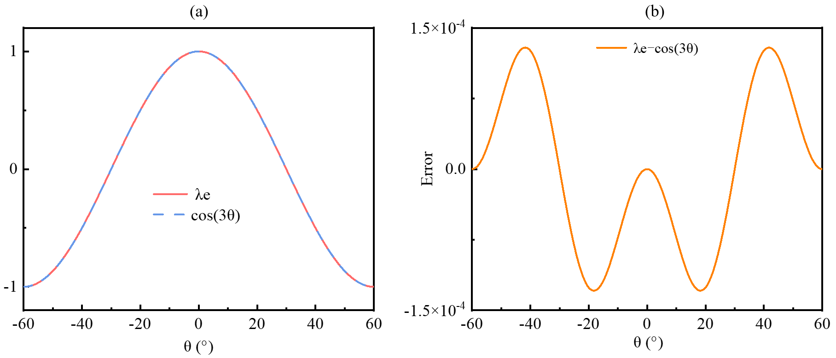
Fig. S1. (a) Normalized $λ_{e}$ and its approximation $cos⁡(3θ)$. (b) The error of the approximation.

Supplement B: Valley Chern numbers of the ordered VPMCs
As stated in the main text, the energy bands of the ordered VPMCs with $θ=0°$ and $60°$ are the same (Fig. 1(e)), but the valley Chern number of them are opposite. Here, we provide a detailed discussion of the valley Chern numbers of them.
For the VPMC with $θ=0°$, the intensity and phase profiles of E_{z} of the four bands below the energy gap marked by blue at K valley and K’ valley are plotted in Fig. S2(a). In the intensity profiles, Poynting vectors are marked by black arrows, while the red (blue) circular arrows mark clockwise (anticlockwise) energy flows. In the phase profiles, red (blue) circular arrows mark positive (negative) OAM charge. Take the case of K valley for example, there is an anticlockwise energy flow with a -1 OAM charge in band 1, indicating K valley Chern number $C_{v1}^{K}=\frac{1}{2}$; there is no circular energy flow and with a zero OAM charge in band 2, indicating $C_{v}^{K}=0$ and other bands can be analyzed with the same method^{1,4}. It could be seen that the energy flow directions, OAM charges and valley Chern numbers in K valley and K’ valley are opposite. The valley Chern number of the energy gap at K (K’) valley $C_{v}^{K}=\sum_{i}{C_{vi}^{K}}=1$ ($C_{v}^{K'}=\sum_{i}{C_{vi}^{K'}}=-1$), in which $i=1,2,3,4$. As a result, the valley Chern number $C_{v}=C_{v}^{K}-C_{v}^{K^{'}}=2$.
For the VPMC with $θ=60°$, the intensity and phase profiles of E_{z} of the four bands below the energy gap marked by blue at K valley and K’ valley are plotted in Fig. S2(b). It could be seen that the direction of energy flows and OAM charges of the VPMC with $θ=60°$ are opposite with the VPMC with $θ=0°$, indicating that the valley Chern number of VPMC with $θ=60°$ is $-2$.
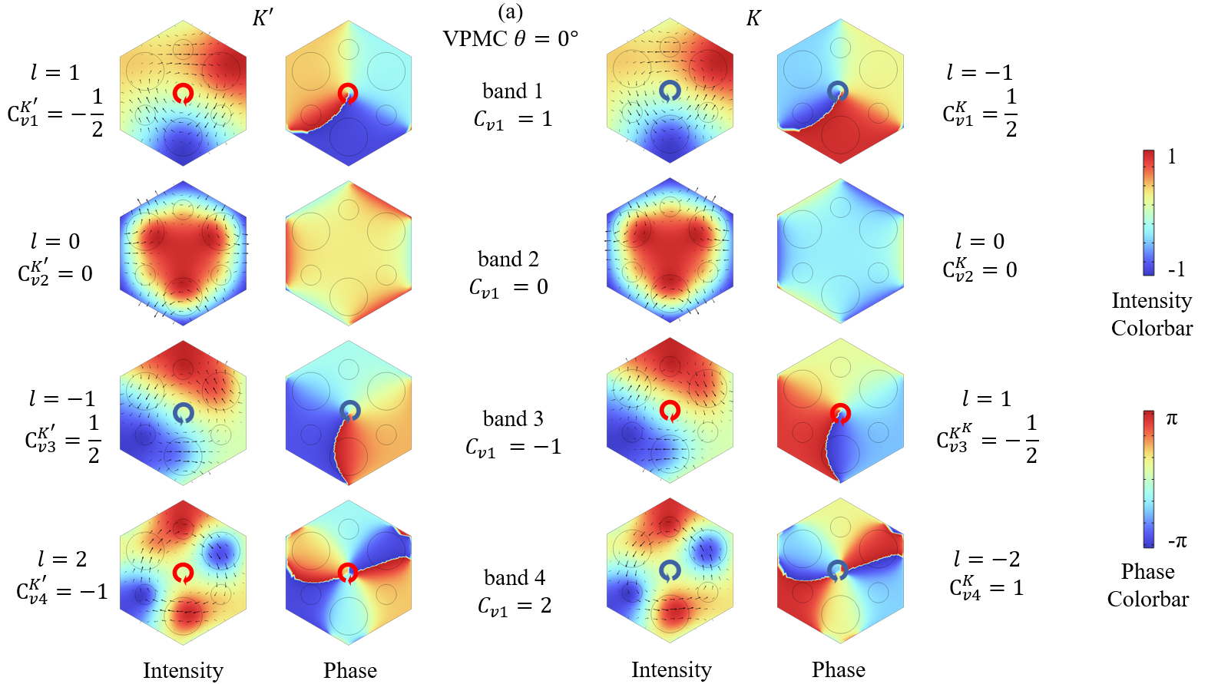
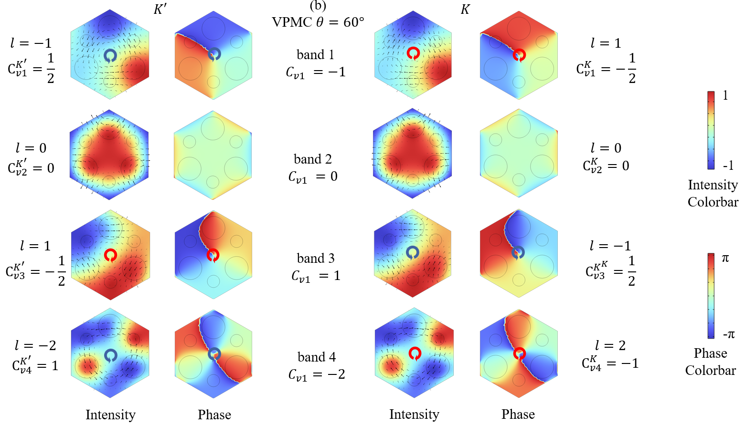
Fig. S2. E_{z} intensity and phase profiles of the four modes at K and K’ points. In intensity profiles, Poynting vectors are plotted as black arrows, while the red (blue) circular arrows represent clockwise (anticlockwise) energy flow directions. In phase profiles, red (blue) circular arrows represent positive (negative) OAM charge. (a), (b) represent the results of the ordered VPMCs with $θ=0°$ and $60°$, respectively.

Supplement C: Energy bands of the valley topological edge states in the ordered VPMCs
The VPMCs with two distinct valley topological phases ($θ=0°$ and $60°$ respectively) are arranged together and form an interface, as shown in Fig. S3(a). Due to the valley Chern number contrast between the two sides of the interface, valley topological edge states would emerge at the interface. The energy bands of the system shown in Fig. S3(a). There are two valley topological edge modes within the energy gap. The intensity profiles of |E_{z}| of the two edge modes are also shown. These two edge modes are localized at the interface of two VPMCs. To verify the characteristics of topologically protected transmission, we simulated the transmission of the edge modes at 196THz (1530.6nm) in a 7-shaped waveguide (Fig. S3(c)). The topologically protected edge modes do not suffer from scattering even at the sharp corner, demonstrating their robustness. When it propagates from the photonic crystal to air, refraction occurs in two directions (white arrows), indicating the presence of two edge modes.
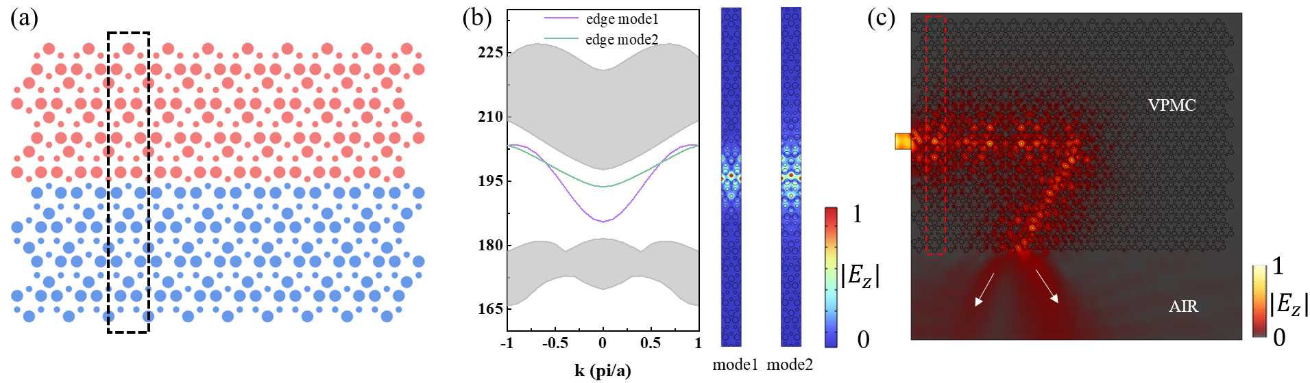
Fig. S3. (a) Unitcell (marked by the black box) of the system composed of two ordered VPMCs with distinct valley topological phases, the blue (red) region represents the VPMC with $θ=0°$ ($θ=60°$). (b) Energy bands of the unitcell shown in (a). The gray areas are the bulky modes, while the purple and green bands inside the bulk bandgap represent the topological edge modes. |E_{z}| field intensity profiles of the two edge modes are also provided. (c) The transmission of the topological edge modes in a 7-shaped interface. The red box marks a unit cell. The white arrows represent the directions of two refracted modes.

Supplement D: Spectral Localizer analysis of the VPMCs
In the disordered VPMCs, due to the random rotation of molecules, the periodicity of the system is broken, and the energy band theory is no longer validate. As a result, the analysis method based on energy band theory in Supplemental Material. C is not available. In order to verify the presence of topological edge states in the disordered VPMCs, we have analyzed the VPMCs by using spectral localizer. Spectral localizer is an operator-based framework that can diagnose the presence of topological states via local markers. It is expressed in real space and well suited to non-periodic and disordered systems^{5–7}. Since the systems studied in this work operate in the TM modes, the corresponding spectral localizer could be written as:
$L\left(Y,H\right)=\left(\begin{matrix}0 & \left(H-E1\right)-iκ(Y-y_{0}1) \\ \left(H-E1\right)+iκ(Y-y_{0}1) & 0\end{matrix}\right)$,
$H=-M^{-1/2}WM^{-1/2}$, $E={(2πf)}^{2}$,
in which $κ=0.01{(2πc)}^{2}/a^{3}$ is a tuning coefficient to ensure consistent units and comparable contributions of operators $H$ and $Y$, $M$ is the matrix of relative permittivity $ε(x,y)$, $W$ is the discrete Laplacian matrix, $Y$ is the y position operator, $1$ is the identity, and $f$ is the frequency of the mode⁵. The position $y_{0}$ and energy $E$ (or frequency $f$) are the inputs of the spectral localizer $L\left(Y,H\right)$, and the spectrum of the $L\left(Y,H\right)$ quantifies whether the system exhibits a topological edge state approximately localized at ($y_{0}, E$). If there are eigenvalues crossing zero, then a localized state could exist at ($y_{0}, E$).
Take the ordered VPMCs as an example, in Fig. S4(a), two VPMCs with $θ=0°$ and $60°$ are interfaced along $y=0$. First, we fix $y_{0}=0$ and sweep the input frequency $f$ and obtain the spectrum of $L\left(0,f\right)$, as shown in Fig. S4(b). There are four pairs of eigenvalues that cross zero (marked by purple), the modes with eigenvalue 0 correspond to topological edge states. Then we fix f as a frequency $f_{0}$ which is corresponding to eigenvalue 0 (marked by the orange dashed line in Fig. S4(b)) and scan y, calculate the local gap $μ_{(y,f_{0})}$ (given by $μ_{(y,f_{0})}=\sqrt{\min\left(\left|spec\left[L\left(y,f_{0}\right)\right]\right|\right)}$) at different y position and plot it in Fig. S4(c). The local gap vanishes at $y=0$, and is more than 0 at other position, indicating that the state is localized at the interface. Both the spectrum and local gap of the spectral localizer corroborate the existence of topological edge states at the interface. Furthermore, for the disordered VPMCs, we calculate the spectrum and local gap of the spectral localizer for different degree of disorder: $θ_{d}= 20°， 30°， 40°$ and 60°, and the results are plotted in Fig. S4(d)-(o). It could be seen that with all degrees of disorder, there are eigenvalues cross zero in the spectrum, and the local gap vanishes at $y=0$, validating that the topological edge states are maintained in the disordered VPMCs within the disorder strength of $θ_{d} ≤ 60°$.

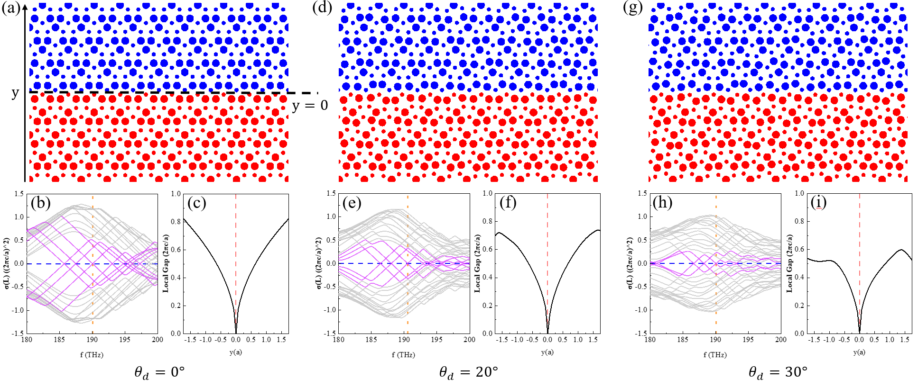
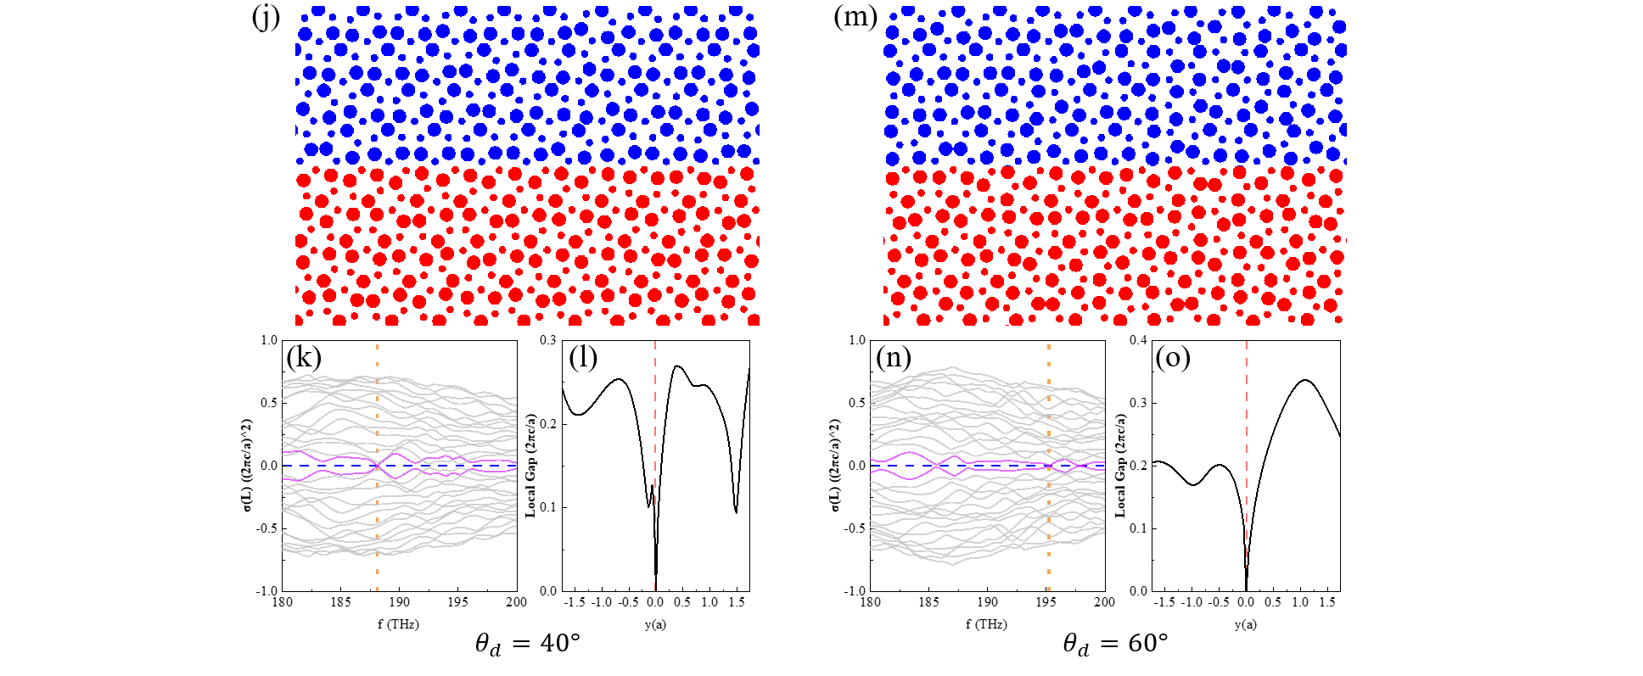
Fig. S4. Schematic, spectrum and local gap of the spectral localizer of the VPMCs under different degree of disorder: $θ_{d}=0°, 20°, 30°, 40°$ and 60°. The purple lines mark the eigenvalues that cross zero in the spectrum. The orange lines in the spectrum mark the frequency that is selected to calculate the local gap. The red lines in the local gap figures mark the interface.

Supplement E: Simulation of bulk and edge transmission of VPMCs
We have simulated the bulk and edge transmission of VPMCs under different degrees of disorder. For bulk transmission, the light source is incident from the left side of the system, and a monitor is placed at the right side to record the bulk transmission spectrum, as shown in Fig. S5(a). For edge transmission with a Z-shaped interface, the light source is also incident from the left side of the interface and a monitor is placed at the right side of the interface to record the edge transmission spectrum, as shown in Fig. S5(b).
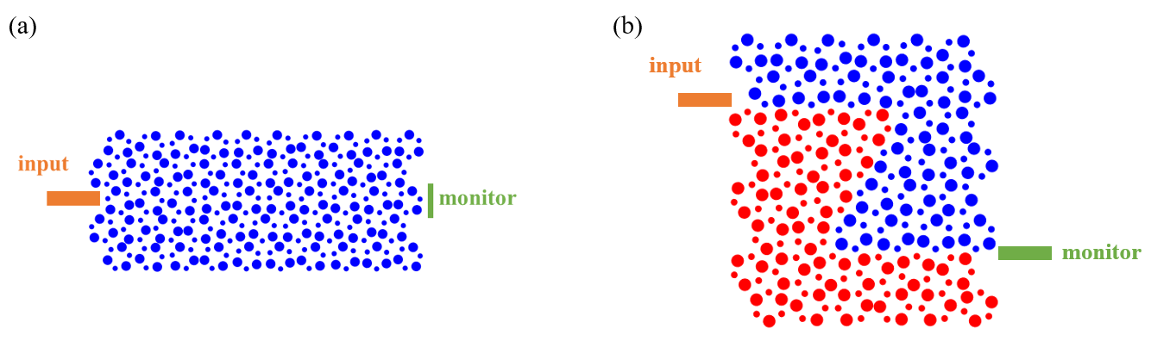
Fig. S5. (a) Scheme of the bulk transmission simulation. (b) Scheme of the edge transmission simulation.

For the bulk transmission, the simulated transmission spectra of VPMCs with $(0°,θ_{d})$ and $(60°,θ_{d})$ under different degrees of $θ_{d}$ are plotted as a heat map respectively, as shown in Fig. S6(a) and (b). The bulk transmission diagrams of these two VPMCs are similar, and this is consistent with the calculation using Eq. 4 in the main text. Fig. S6(a) is selected to represent the bulk bandgap evolution of VPMCs as Fig. 4(a) in the main text. For each column in Fig. S6(a) and (b), it corresponds to a bulk transmission spectrum under a certain degree of disorder. In Fig. S6(a) and (b), the bulk bandgap obtained from energy spectra (Fig. 4(b) in the main text) are also plotted as gray dots.
The |E_{z}| intensity profiles of the bulk transmission in the VPMCs with $(60°,θ_{d})$ at the frequency 193THz under disorder degrees of $θ_{d}=0°， 20°， 30°， 40°$ and 60° are shown in Fig. S6(c). As $θ_{d}$ increases, the lightwave with frequency of 193THz remains within the bulk energy gap and there is no bulk transmission.
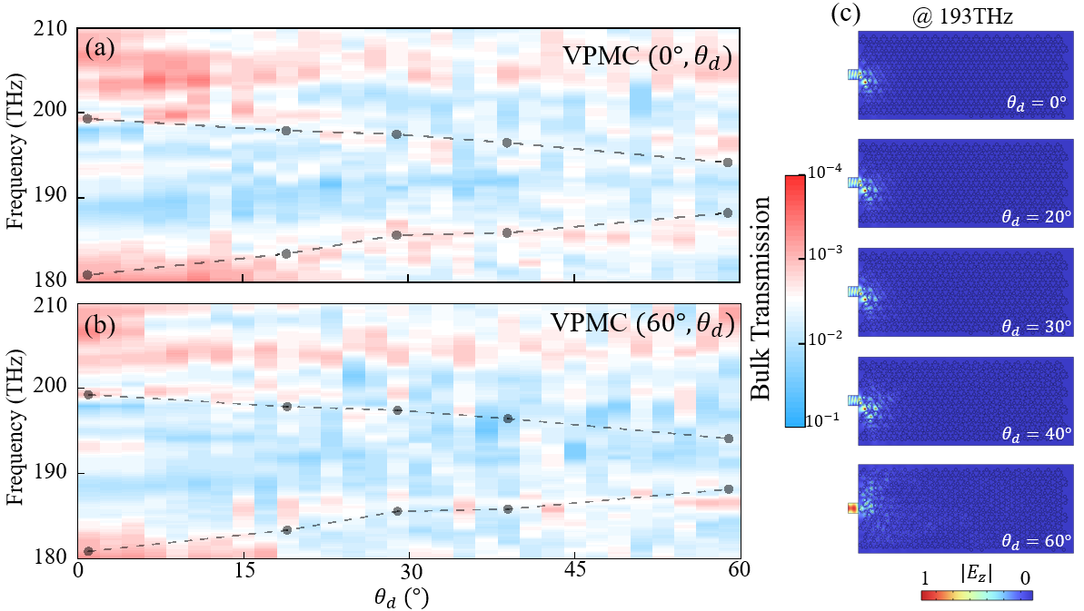
Fig. S6. (a), (b) Simulated bulk transmission diagram of the VPMCs with $(0°,θ_{d})$ and $(60°,θ_{d})$ under different degrees of $θ_{d}$. The upper and lower boundaries of the bulk bandgap obtained from the energy spectra are also plotted as gray dots and are connected by the gray dashed lines. (c) Simulated bulk transmission profiles (|E_{z}|, @193THz) of the VPMCs with $(60°,θ_{d})$ under disorder degrees of $θ_{d}=0°， 20°， 30°， 40°$ and 60°.

For the edge transmission, the simulated spectra of the VPMCs are provided as a heat map in the main text (Fig. 5(c)). Here, we present each simulated transmission spectrum as a waterfall plot to show the spectrum curves, as shown in Fig. S7(a). It could be seen that with different degrees of disorder, a transmission peak is remained within 1560-1580nm in all ten spectra. However, at wavelengths outside the transmission peak, the transmission significantly fluctuates across different disorder realizations. This is because that the 1560-1580nm transmission peak is corresponding to the topological edge states, which are resistant to disorder, while transmission in other wavelengths is corresponding to bulk scattering, which is sensitive to specific disorder realization.

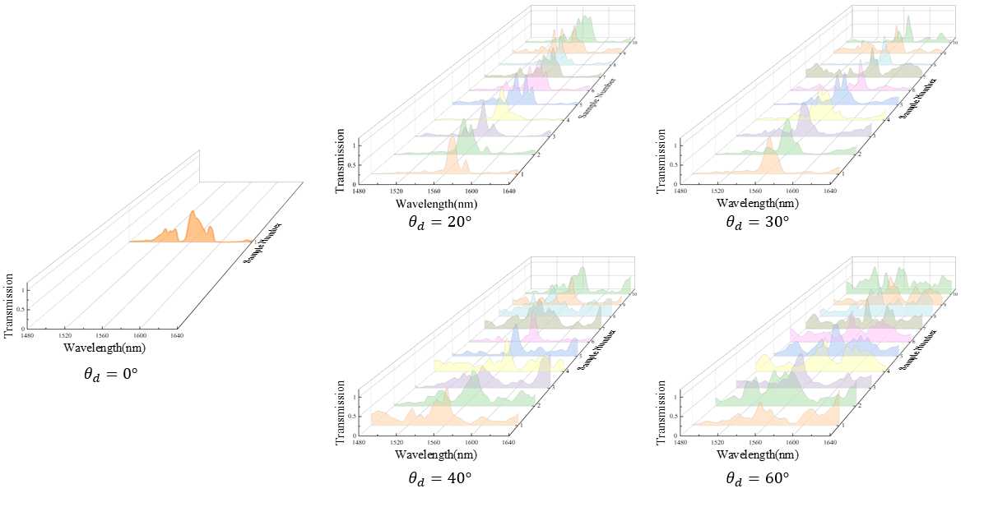
Fig. S7. Simulated edge transmission spectra of the VPMCs with $θ_{d}=0°， 20°， 30°， 40°$ and 60°.

Supplement F: Fabrication of the samples of VPMCs
The fabrication processes of the samples are shown in Fig. S8(a). At first, α-Si (thickness of 1000nm) is deposited on a quartz substrate by ion-assisted deposition (IAD). Then a layer of positive photoresist (ZEON ZEP520A) is spun on top of the sample and exposed by the electron beam lithography (EBL). After that, 100nm-thick chromium (Cr) is deposited on the photoresist using electron beam evaporation (EBE). Using lift-off process, a Cr mask is obtained. Then valley PTAIs are obtained by coupled plasma reaction ion etching (ICP-RIE). Finally, the remaining Cr is removed through Cr etchant corrosion.
The scanning electron microscope (SEM) images of the VPMCs with different degree of disorder are shown in Fig. S8(b). From left to right, they are $θ_{d}=0°， 20°， 30°， 40°$ and 60° respectively. It could be clearly observed that with increasing disorder, the Z-shaped interface is gradually harder to distinguish.
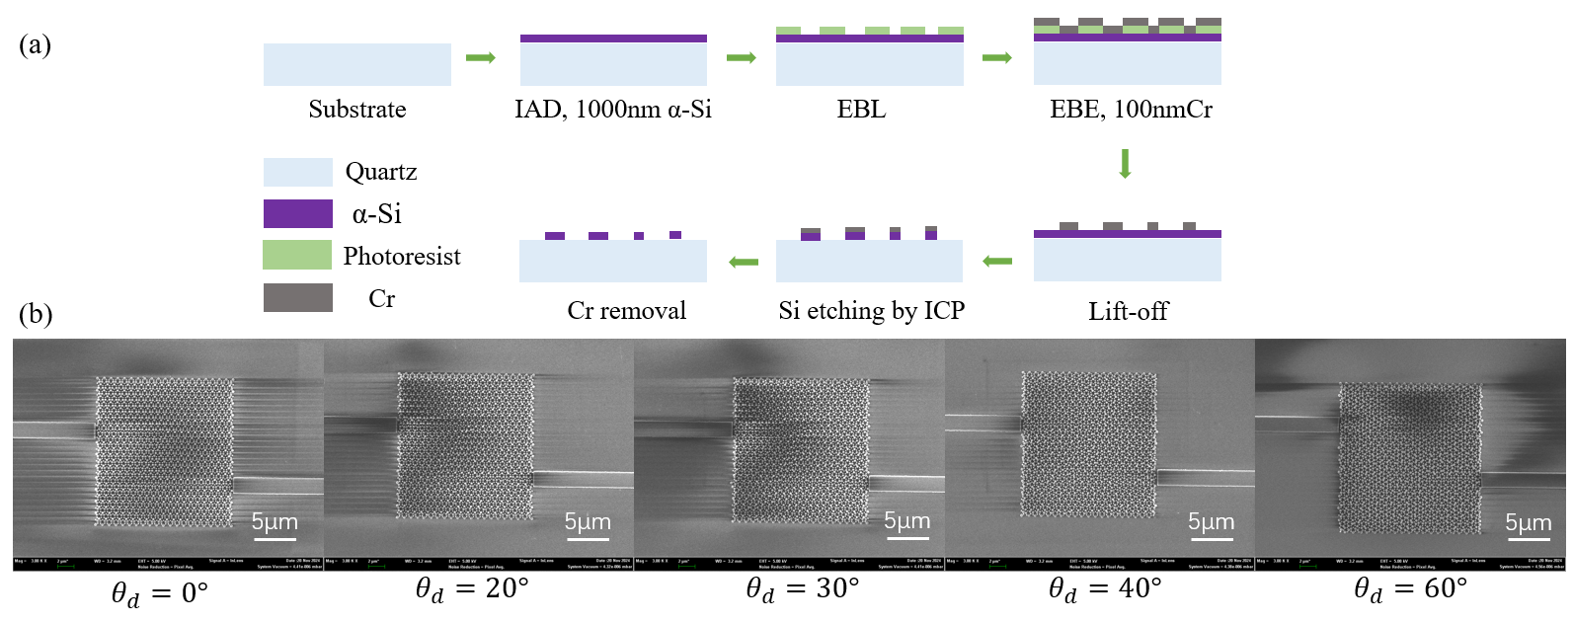
Fig. S8. (a) Fabrication process of the samples. (b) SEM photographs of the VPMCs with different degrees of disorder.

Supplement G: Experiment setups and measured transmission spectra.
As Fig. S9 shown, photonic crystals are connected to two straight waveguides while there are grating couplers at the waveguide ends for vertical coupling the input and output light. We use a continuous-wave tunable laser (SANTEC TSL-710) with operation wavelength range of 1480-1640nm as the light source. Input light is vertically coupled from optical fiber into the waveguide taper through a grating coupler, then transmits into the photonic crystal. Transmitted light is collected by a waveguide and then vertically coupled into an optical fiber through another grating coupler. The transmitted light is detected by a detector. We scan the wavelength of the light source from 1480nm to 1640nm to get a broadband spectrum. And the transmission spectra of photonic crystals are the results of subtracting the transmission spectrum of the gratings couplers (measured from reference gratings).
Experimentally measured transmission spectra are shown in the main text as heat maps (Fig. 5(d)), here we provide the waterfall plots to show the spectra curves, as shown in Fig. S10.
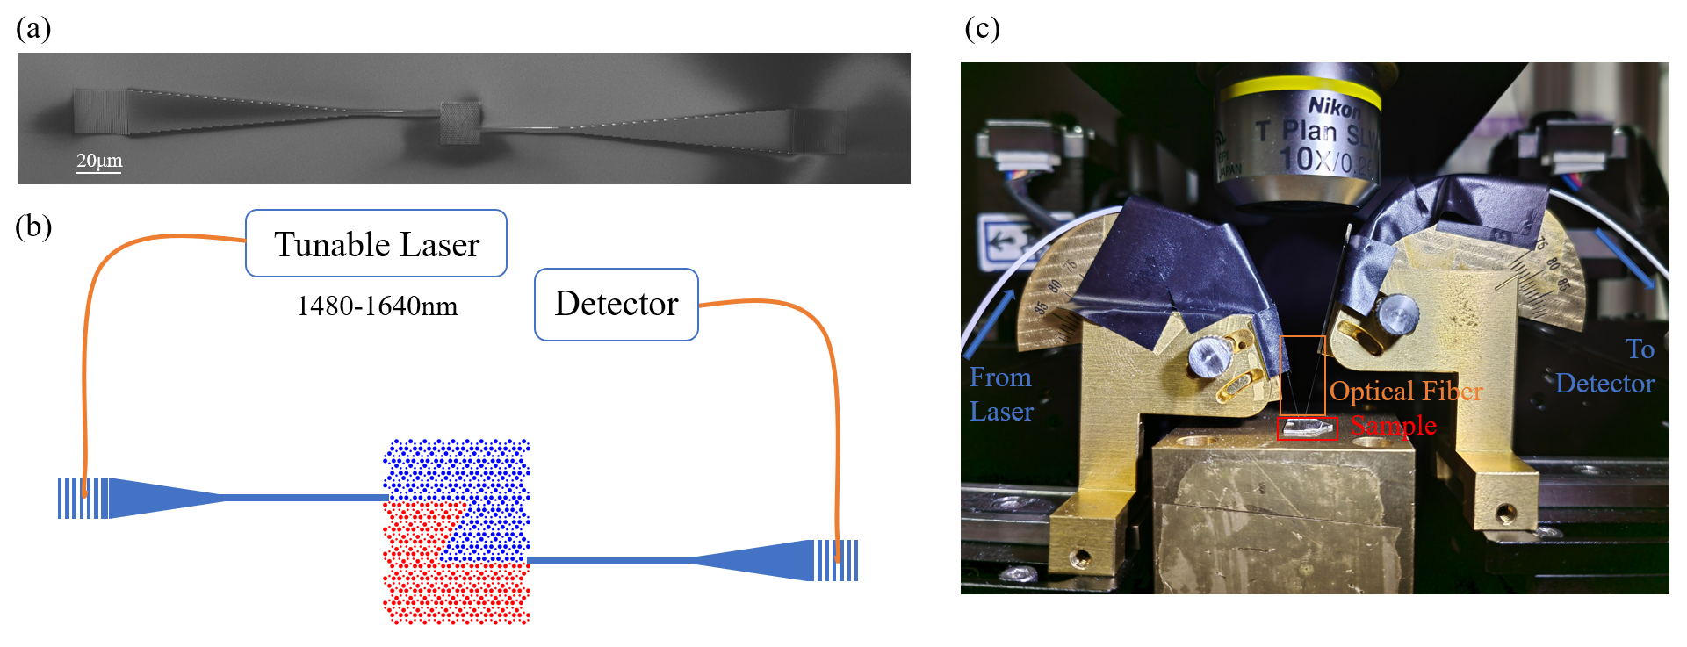
Fig. S9. (a): The SEM image of the whole structure of the sample, including photonic crystal, waveguides, tapers and gratings. (b): Scheme of the experimental setup. Light source is a tunable laser with the range of 1480-1640nm, and is coupled from the optical fiber into guide by vertical coupling grating. After transmission inside the photonic crystal, transmitted light is vertically coupled into another optical fiber via grating, and then detected by a detector. (c): Photo of the experimental setup. Optical fibers and sample are marked by the colored boxes.

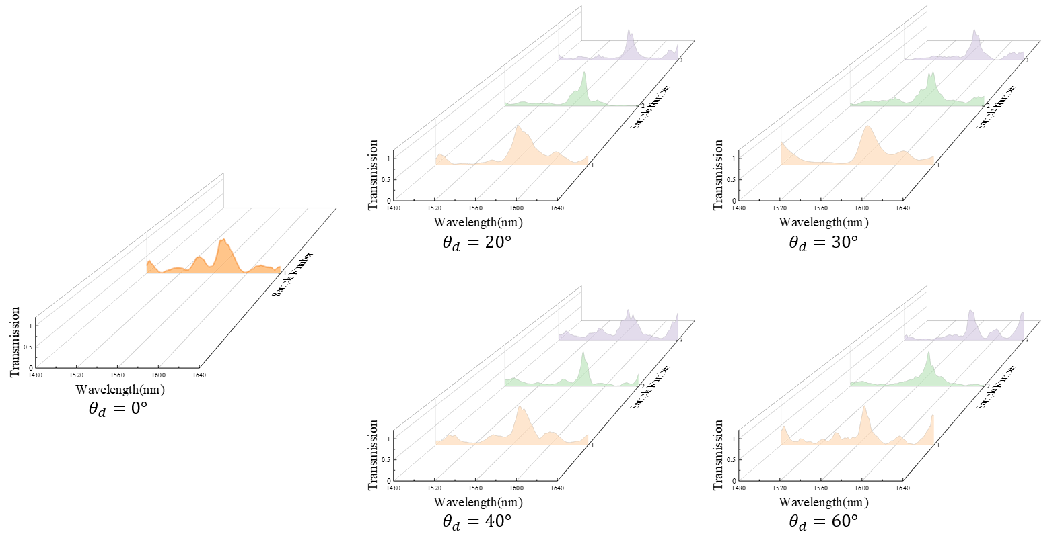
Fig. S10. Measured edge transmission spectra of the VPMCs with $θ_{d}=0°， 20°， 30°， 40°$ and 60°.

Supplement H: Generality of this work for $C_{3}$-symmetric molecules.
As mentioned in the main text, the relation between the mass term $λ^{P}$ and the oriental angle of the molecule $θ$ (Eq. (1) and (2) in the main text) is general for any $C_{3}$-symmetric molecular crystal. Here we have demonstrated VPMCs based on another type of $C_{3}$-symmetric molecular crystal, and have observed similar phenomena with the VPMCs in the main text.
The unitcell of the $C_{3}$-symmetric molecular crystal is shown in Fig. S11(a). The structural parameters are as lattice constant $a=1350nm$, height $h=1000nm$, $R=0.08*a$, and the distance between the centers of rods and unit cell $d=0.6*a/\sqrt{3}$. Similar to the VPMC in the main text, the valley Chern number is also relative to the oriental angle of the rods inside the unit cell $θ$. The phase diagram is shown in Fig. S11(b), which is analog to the phase diagram in main text. The difference between this VPMC and the VPMC in main text is that the valley energy gap is closer to the complete band gap in this VPMC. Fig. S11(c) shows the energy bands of the case for $θ=0°$, the energy gap is marked by blue. It could be seen that the valley energy gap is close to the complete band gap.
When the VPMCs with $(0°,θ_{d})$ and $(60°,θ_{d})$ are interfaced, due to their valley Chern number contrast, valley topological edge states would emerge at the interface ($θ_{d}≤60°$). Simulated edge transmission profiles under disorder degrees of $θ_{d}=0°， 15°， 30°， 45°$ and 60° are provided in Fig. S11(d). It could be seen that the valley topological edge states exist within the disorder range of $θ_{d}≤60°$, which is consistent with those in the main text (Fig. 5(b)), validating that this theory is general for $C_{3}$-symmetric molecular crystals.

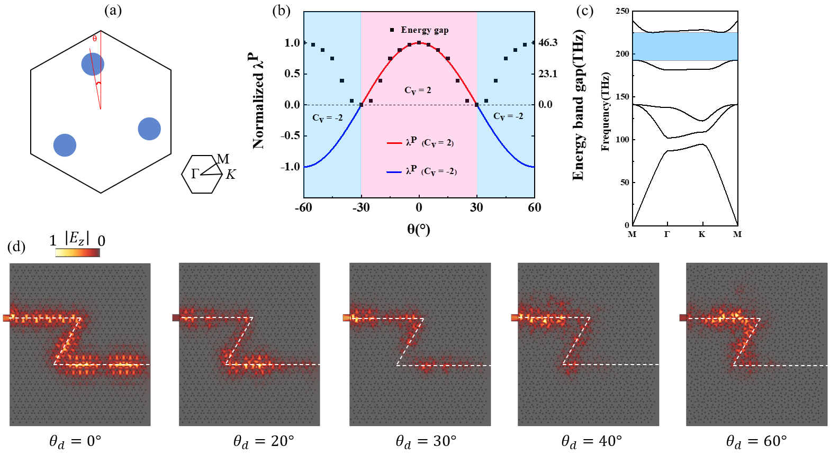
Fig. S11. (a) Scheme of the unitcell. (b) Phase diagram of the unit cell, the black dots are valley energy gaps, blue (red) lines are normalized $λ^{P}$ with valley Chern number -2 (2); while red (blue) shallow region represents the topological phase with valley Chern number -2 (2). (c) Band structure of the VPC with $θ=0°$, a band gap with $C_{v}=2$ is marked by blue. (d) Simulated edge transmission mode profiles of the VPMCs under disorder degree of $θ_{d}=0°， 20°， 30°，40°$ and 60°. The white dashed lines indicate the interface.

Reference
1. Chen, X.-D., Zhao, F.-L., Chen, M. & Dong, J.-W. Valley-contrasting physics in all-dielectric photonic crystals: Orbital angular momentum and topological propagation. Phys. Rev. B 96, 020202 (2017).
2. Ma, T. & Shvets, G. All-Si valley-Hall photonic topological insulator. New J. Phys. 18, 025012 (2016).
3. Khanikaev, A. B. et al. Photonic topological insulators. Nat. Mater. 12, 233–239 (2013).
4. Yan, B. et al. Multifrequency and Multimode Topological Waveguides in a Stampfli‐Triangle Photonic Crystal with Large Valley Chern Numbers. Laser Photonics Rev. 18, 2300686 (2024).
5. Cerjan, A., Loring, T. A. & Schulz-Baldes, H. Local Markers for Crystalline Topology. Phys. Rev. Lett. 132, 073803 (2024).
6. Cerjan, A. & Loring, T. A. An operator-based approach to topological photonics. Nanophotonics 11, 4765–4780 (2022).
7. Cerjan, A. & Loring, T. A. Local invariants identify topology in metals and gapless systems. Phys. Rev. B 106, 064109 (2022).

