Forest-related greenhouse gas fluxes in Nlonako2
Between 2001 and 2024, forests in Nlonako2 emitted 16.8 ktCO₂e/year, and removed -185 ktCO₂e/year. This represents a net carbon sink of -169 ktCO₂e/year.
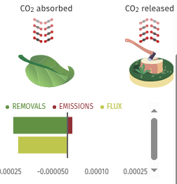
Forest-related greenhouse gas emissions in Nlonako2
Between 2001 and 2024, an average of 16.8 kt per year was released into the atmosphere as a result of tree cover loss in Nlonako2. In total, 402 kt of CO₂e was emitted

Forest-related greenhouse gas fluxes in F_Com_Yabassi
Between 2023 and 2025, forests in F_Com_Yabassi emitted 90.6 ktCO₂e/year, and removed -132 ktCO₂e/year. This represents a net carbon sink of -41.4 ktCO₂e/year.
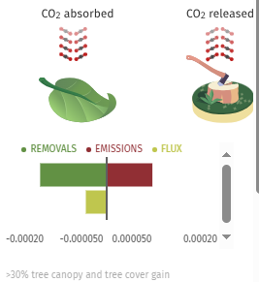
Forest-related greenhouse gas emissions in F_Com_Yabassi
Between 2023 and 2025, an average of 90.6 kt per year was released into the atmosphere as a result of tree cover loss in F_Com_Yabassi. In total, 2.17 Mt of CO₂e was emitted in this period.

Integrated Deforestation alerts in F_Com_Yabassi
There were 71,698 deforestation alerts reported in F_Com_Yabassi between 19th of December 2023 and 20th of June 2025, covering a total of 880 ha of which 90% were high confidence alerts detected by a single system and 4.7% were alerts detected by multiple systems.
- Highest confidence detection by multiple alert systems
3,371
- High confidence detection by a single alert system
64,276
- Detection by a single alert system
4,051
Cumulative Fire Alerts in F_Com_Yabassi
In F_Com_Yabassi there have been 0 VIIRS fire alerts reported so far in 2025 considering high confidence alerts only. This total is normal compared to the total for previous years going back to 2012. The most fires recorded in a year was 2018, with 4.
Nlonako
From 2003 to 2025, Nlonako2 lost 636 ha of humid primary forest, making up 93% of its
total tree cover loss
in the same time period. Total area of humid primary forest in Nlonako2 decreased by 1.0% in this time period.
There were 86,557 deforestation alerts reported in Nlonako2 between 19th of December 2023 and 20th of June 2025, covering a total of 1.06 kha of which 89% were high confidence alerts detected by a single system and 2.4% were alerts detected by multiple systems.
- Highest confidence detection by multiple alert systems
2,060
- High confidence detection by a single alert system
77,084
- Detection by a single alert system
7,413

