Supplemental File 1

Tables

Table S0 Material information.
Seedlot | Test date | sample_count | sample_num | Collection Site | GPS | Collection time | Storage condition
2021-055 | 241217 | 100 | 1~4 | Yangpyeong-gun | 37.4829° N, 127.6008° E | 2021Y 10M | 2℃, 3Y
2020-003 | 241217 | 87 | 5~8 | Chuncheon-si | 37.9088° N, 127.7286° E | 2020Y 10M | 2℃, 4Y
2022-144 | 241217 | 99 | 9~12 | Gangneung-si | 37.7908° N, 128.9001° E | 2022Y 11M | 2℃, 2Y
T2022-006 | 230706 | 100 | 13~16 | Gangneung-si | 37.7908° N, 128.9001° E | 2022Y 11M | 2℃, 2Y
2023-064 | 241217 | 100 | 17~20 | Jinju-si | 35.2047° N, 128.1688° E | 2023Y 10M | 2℃, 1Y
2022-082 | 241217 | 99 | 21~24 | Yangpyeong-gun | 37.4817° N, 127.5972° E | 2022Y 10M | 2℃, 2Y
2022-102 | 241217 | 67 | 25~28 | Gongju-si | 36.5184° N, 127.1347° E | 2022Y 10M | 2℃, 2Y
2022-102 | 240627 | 100 | 29~32 | Gongju-si | 36.5184° N, 127.1347° E | 2022Y 10M | 2℃, 2Y
2022-082 | 240628 | 100 | 33~36 | Yangpyeong-gun | 37.4817° N, 127.5972° E | 2022Y 10M | 2℃, 2Y
2020-004 | 240719 | 68 | 37~40 | Chuncheon-si | 37.9088° N, 127.7286° E | 2020Y 10M | 2℃, 4Y
2021-055 | 230720 | 100 | 41~44 | Collection Site | 37.4829° N, 127.6008° E | 2021Y 10M | 2℃, 3Y

Table S1 Oversampling dataset of multiclass experiment.
Name | Oversampling | train NV | train VME | train IM | train NE | train size | val size | test size | total size
bx0 | None | 347 | 155 | 57 | 53 | 612 | 204 | 204 | 1020
bx2 | Horizontal Flip(x2) | 347 | 155 | 114 | 106 | 722 | 204 | 204 | 1130
bx4 | Horizontal Flip + rotation (x4) | 347 | 155 | 228 | 212 | 942 | 204 | 204 | 1350

Table S2 Oversampling dataset of direct binary experiment.
Name | Oversampling | train NV | train V | train size | val NV | val V | val size | test NV | test V | test size | total size
bx0 | None | 457 | 155 | 612 | 152 | 52 | 204 | 153 | 51 | 204 | 1020
bx2V | Horizontal Flip | 457 | 310 | 767 | 152 | 52 | 204 | 153 | 51 | 204 | 1175
bx4V | Horizontal Flip + rotation | 457 | 620 | 1077 | 152 | 52 | 204 | 153 | 51 | 204 | 1485
bx2NV | Horizontal Flip | 914 | 155 | 1069 | 152 | 52 | 204 | 153 | 51 | 204 | 1477
bx4NV | Horizontal Flip + rotation | 1828 | 155 | 1983 | 152 | 52 | 204 | 153 | 51 | 204 | 2391

Table S3 Augmentation & Oversampling scoring: metric = macro-F1 score.
Augmentation | Oversampling | mean | std | median
None | bx0 | 0.3614 | 0.1066 | 0.3418
None | bx2 | 0.3892 | 0.1104 | 0.3999
None | bx4 | 0.3106 | 0.1105 | 0.285
Custom | bx0 | 0.4101 | 0.129 | 0.4024
Custom | bx2 | 0.3755 | 0.1021 | 0.3767
Custom | bx4 | 0.3575 | 0.082 | 0.3617
YOLO default | bx0 | 0.5896 | 0.0504 | 0.567
YOLO default | bx2 | 0.6237 | 0.0436 | 0.626
YOLO default | bx4 | 0.5477 | 0.0817 | 0.5305

Table S4 Pairwise ablation comparisons of augmentation and oversampling conditions on 4-class validation macro-F1 (screening stage, n = 15 models).
target | baseline | n_models | median_delta | IQR | mean_delta | std_delta | improved_ratio | wilcoxon_p
bx0_aug_yolo | bx0_aug_none | 15 | 0.2405 | [0.1726, 0.3067] | 0.2281 | 0.0969 | 15/15 | 0.0001
bx0_aug_custom | bx0_aug_none | 15 | 0.0211 | [-0.0190, 0.0701] | 0.0486 | 0.1246 | 9/15 | 0.2769
bx0_aug_custom | bx0_aug_yolo | 15 | -0.1929 | [-0.2360, -0.1482] | -0.1795 | 0.1219 | 02/15 | 0.0004
bx2_aug_none | bx0_aug_none | 15 | 0.0764 | [-0.0430, 0.1625] | 0.0278 | 0.1636 | 09/15 | 0.5614
bx4_aug_none | bx0_aug_none | 15 | -0.0367 | [-0.1683, 0.0524] | -0.0509 | 0.1532 | 07/15 | 0.3303
bx2_aug_custom | bx0_aug_custom | 15 | -0.0118 | [-0.1261, 0.0794] | -0.0345 | 0.1197 | 06/15 | 0.3303
bx4_aug_custom | bx0_aug_custom | 15 | -0.0596 | [-0.1163, 0.0129] | -0.0525 | 0.1336 | 06/15 | 0.0833
bx4_aug_custom | bx0_aug_none | 15 | 0.0199 | [-0.0972, 0.0465] | -0.0039 | 0.1319 | 08/15 | 0.7197

Table S5 Oversampling score comparisons within the YOLO default augmentation.
Augmentation | Oversampling | score_median | score_mean | score_std | n_models
YOLO default | bx2 | 0.6148 | 0.6177 | 0.0239 | 15
YOLO default | bx0 | 0.5763 | 0.5671 | 0.0556 | 15
YOLO default | bx4 | 0.5659 | 0.5723 | 0.0415 | 15

Table S6 Pairwise comparisons of oversampling levels within YOLO default augmentation on 4-class validation macro-F1 (multi-seed stage, n = 45 model–seed pairs).
Augmentation | comparison | n_pairs | median_delta | IQR | mean_delta | std_delta | improved_ratio | wilcoxon_p
YOLO default | bx2 vs bx0 | 45 | 0.0464 | [-0.0091, 0.1014] | 0.0507 | 0.0941 | 30/45 | 0.0006
YOLO default | bx4 vs bx0 | 45 | -0.0123 | [-0.0615, 0.0575] | 0.0052 | 0.107 | 19/45 | 0.8406

Table S7 Oversampling dataset of multiclass experiment.
Augmentation | Oversampling | mean | std | median
Custom | bx0 | 0.5385 | 0.1071 | 0.5182
Custom | bx2V | 0.5552 | 0.0834 | 0.5843
Custom | bx4V | 0.5266 | 0.1033 | 0.4825
Custom | bx2NV | 0.5578 | 0.1098 | 0.5472
Custom | bx4NV | 0.4861 | 0.0778 | 0.447
None | bx0 | 0.5029 | 0.1037 | 0.447
None | bx2V | 0.5689 | 0.1179 | 0.5861
None | bx4V | 0.5258 | 0.1596 | 0.5145
None | bx2NV | 0.5252 | 0.1067 | 0.4774
None | bx4NV | 0.4427 | 0.0338 | 0.427
YOLO default | bx0 | 0.6397 | 0.1453 | 0.6488
YOLO default | bx2V | 0.7363 | 0.0629 | 0.7374
YOLO default | bx4V | 0.7036 | 0.0828 | 0.7201
YOLO default | bx2NV | 0.6311 | 0.1287 | 0.6899
YOLO default | bx4NV | 0.6267 | 0.1274 | 0.6385

Table S8 Pairwise ablation comparisons of augmentation and oversampling conditions on 2-class validation macro-F1 (screening stage, n = 15 models).
target | baseline | n_models | median_delta | IQR | mean_delta | std_delta | improved_ratio | wilcoxon_p
bx0_aug_yolo | bx0_aug_none | 15 | 0.0486 | [0.0295, 0.2463] | 0.1368 | 0.1473 | 12/15 | 0.0052
bx0_aug_custom | bx0_aug_none | 15 | 0.04 | [0.0058, 0.0944] | 0.0355 | 0.1526 | 11/15 | 0.1688
bx0_aug_custom | bx0_aug_yolo | 15 | -0.1306 | [-0.2181, -0.0009] | -0.1012 | 0.1715 | 04/15 | 0.0413
bx2V_aug_none | bx0_aug_none | 15 | 0.0394 | [-0.0189, 0.1507] | 0.0659 | 0.129 | 09/15 | 0.0962
bx4V_aug_none | bx0_aug_none | 15 | 0 | [-0.1022, 0.1278] | 0.0229 | 0.1603 | 06/15 | 0.6379
bx4V_aug_none | bx2V_aug_none | 15 | -0.0172 | [-0.1089, 0.0198] | -0.043 | 0.1819 | 05/15 | 0.3305
bx2NV_aug_none | bx0_aug_none | 15 | 0 | [-0.0621, 0.1014] | 0.0223 | 0.1334 | 06/15 | 0.7537
bx4NV_aug_none | bx0_aug_none | 15 | -0.02 | [-0.1173, 0.0000] | -0.0602 | 0.0984 | 02/15 | 0.0367
bx4NV_aug_none | bx2NV_aug_none | 15 | -0.0504 | [-0.1371, 0.0000] | -0.0825 | 0.094 | 01/15 | 0.0044
bx2V_aug_none | bx2NV_aug_none | 15 | 0 | [-0.0074, 0.0859] | 0.0437 | 0.083 | 07/15 | 0.1167
bx4V_aug_none | bx4NV_aug_none | 15 | 0.0577 | [0.0000, 0.1996] | 0.0831 | 0.1497 | 09/15 | 0.0499
bx4V_aug_yolo | bx0_aug_none | 15 | 0.1973 | [0.1253, 0.2958] | 0.2006 | 0.1085 | 15/15 | 0.0001
bx4NV_aug_yolo | bx0_aug_none | 15 | 0.0734 | [0.0394, 0.1851] | 0.1238 | 0.1283 | 14/15 | 0.0012

Table S9 Oversampling score comparisons within YOLO default augmentation on 2-class validation macro-F1 (multi-seed stage).
Augmentation | condition_id | score_median | score_mean | score_std | n_models
YOLO default | bx2V | 0.7505 | 0.7357 | 0.054 | 15
YOLO default | bx4V | 0.7293 | 0.7087 | 0.0659 | 15
YOLO default | bx0 | 0.682 | 0.6605 | 0.1009 | 15

Table S10 Pairwise comparisons of oversampling levels within YOLO default augmentation on 2-class validation macro-F1 (multi-seed stage, n = 45 model–seed pairs).
aug | comparison | n_pairs | median_delta | IQR | mean_delta | std_delta | improved_ratio | wilcoxon_p
aug_yolo | bx2V vs bx0 | 45 | 0.0634 | [-0.0006, 0.1593] | 0.0751 | 0.1102 | 33/45 | <0.0001
aug_yolo | bx4V vs bx0 | 45 | 0.0408 | [-0.0155, 0.1110] | 0.0482 | 0.1073 | 30/45 | 0.0081

Captions of figures

Fig.S1 Augmentation adapted images: A, None (no augmentation); B, Custom; C, YOLO default. All images shown without oversampling (bx0).

Fig.S2 Oversampling adapted minority class images in 4-class dataset: A, bx2(2x oversampling); B, bx4(4x oversampling).

Fig.S3 Oversampling adapted images in 2-class images: A, bx2V(2x oversampling on viable classes); B, bx4V(4x oversampling on viable classes); C, bx2NV(2x oversampling on not-viable classes); D, bx4NV(4x oversampling on not-viable classes).

Fig.S4 Macro-F1 scores of the models with 2x oversampling & YOLO default augmentation adapted datasets.

Fig.S5 Class Activation Mapping heatmaps from 2-class test set images: NV- Not viable; V- Viable.

Figures

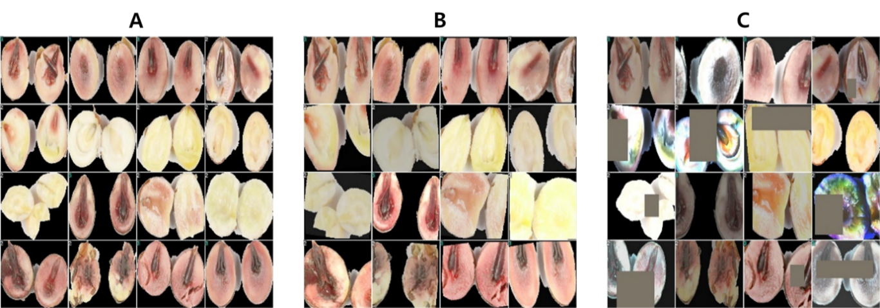
Fig.S1

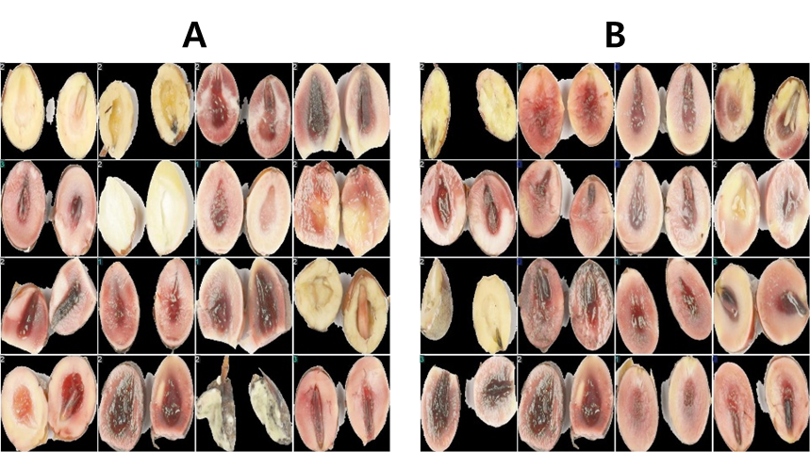
Fig.S2

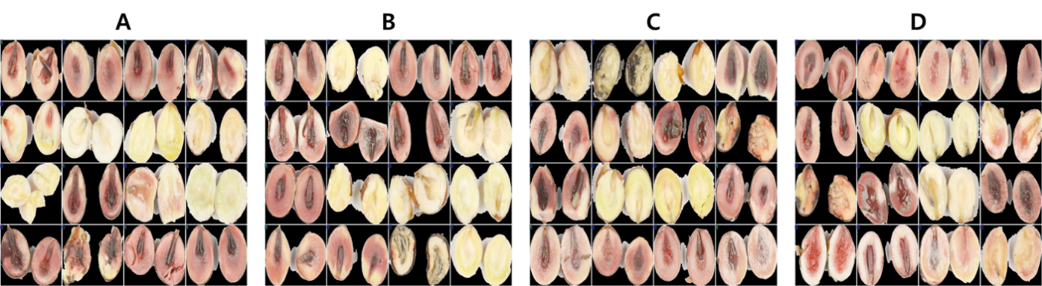
Fig.S3

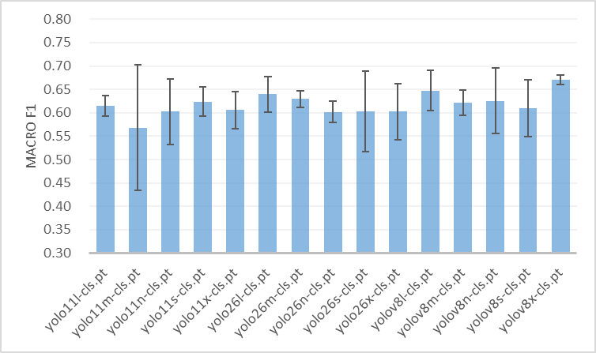
Fig.S4

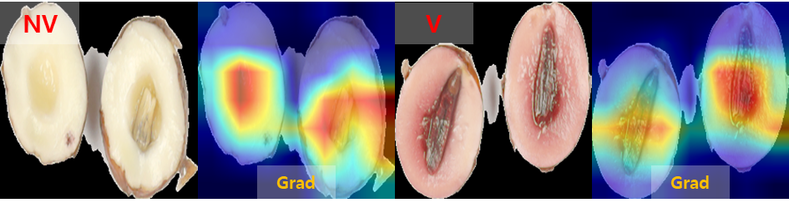
Fig.S5

