Supporting information

Beyond Qualitative Diagnosis of Li Plating in Li-ion Batteries : A Critical-State Metric from Electrochemical Impedance Spectroscopy

Wenxuan Hu,^{a #} Jianrong Lin,^{b #} Yingao Zhou,ª Hongxin Lin,ª Wenhao Wu,ª Ying Lin,ª Yonggang Hu,ª Yufan Peng,^{a,c} Xiaozhe Yu,ª Jinding Liang,^{d} Yimin Wei,^{d} Yanting Jin^{a,c}, Zhengliang Gong,^{b} Yong Yang^{a,c*}

ª State Key Laboratory for Physical Chemistry of Solid Surfaces, Department of Chemistry, College of Chemistry and Chemical Engineering, Xiamen University, Xiamen, 361005, China
^{b} College of Energy, Xiamen University, Xiamen, 361005, China
^{c} Innovation Laboratory for Sciences and Technologies of Energy Materials of Fujian Province (IKKEM), Xiamen 361005, China
^{d} Contemporary Amperex Technology Co., Ltd, Ningde 352100, China.

# Wenxuan Hu, Jianrong Lin contributed equally to this work
* Corresponding author
Email: yyang@xmu.edu.cn

Experimental section
Cell assembly: Graphite/LiFePO₄ (Gr/LFP) pouch cells and three-electrode pouch cells with a nominal capacity of 110 mAh were provided by Contemporary Amperex Technology Co., Limited (CATL). Each cell consisted of a double-sided anode (43.5×51.0 mm²) and two single-sided cathodes (42.0×49.5 mm²). The N/P ratio was about 1.09. The cells were sandwiched between two steel plates with a pressure of 1.5 MPa. The electrolyte of 0.7 M LiPF₆ and 0.3 M LiFSI in EMC:DMC:EC = 1:2.3:3wt%, with 2wt% VC was used. The three-electrode pouch cells were used in the DEIS tests, while the two-electrode cells were used in MST and cycling aging tests. In this work, a special cathode-excess Gr/LFP pouch cell (N/P ratio = 0.67) were used in some tests. All these cells were prepared by using the same electrolyte and graphite anode but an excess LFP cathode. In the part of validating Li plating quantification strategy, the 2.3Ah Gr/LFP pouch cells with the same type of electrolyte, cathode and anode but with a larger area (87×520 mm²) were used.

Electrochemical measurements
Dynamic electrochemical impedance spectroscopy (DEIS): DEIS technique uses a modulated current with a direct current superimposed on an alternating current as an excitation signal, which can measure the impedance change of an electrochemical system during the charging or discharging process. Nevertheless, the experimental parameters of the technique must be strictly controlled to guarantee the quality of the data. Firstly, the amplitude of alternating current should be big enough to overcome the interference of the direct current on impedance. Herein, the amplitude of all DEIS tests use a 10% of the direct current when the charging currents exceed 1C, otherwise, the amplitudes are fixed at 0.1C. Secondly, the low frequency ranges should be discarded as many as possible on the premise that the impedance of the charge transfer process is fully presented. In this work, the frequency ranges tested in 0℃, 25℃, 45℃ are 50k~2Hz, 50k~10Hz, 20k~20Hz, respectively, corresponding to the time of 26, 23, 20s for a single EIS test. All the DEIS tests are operated on an electrochemical workstation (VMP-3e, Biologic, France). The distribution relation times (DRT) method was employed based on the open access tool, pyDRTtools-master, programmed by Ciucci’s group. ^{[1-2]}

Operando electrochemical ssNMR measurement: The operando solid-state NMR experiments were carried out on the Bruker advance 400 solid-state NMR spectrometer to quantitatively analyze the change of Li metal and graphite intercalated compounds (GIC) during charging and discharging. A custom-designed operando probe and battery mold were independently developed to meet the specific requirements of these experiments. The operando battery mold, constructed from PEEK material, incorporates internal O-rings to enhance gas tightness and features eight external screws for effective sealing. The operando battery configuration consists of an LFP cathode and graphite anode (9 × 18 mm²) with a N/P ratio of 1.09, consistent with that of the pouch cell. A total of 200 μL electrolyte (1 M LiPF₆, EC: EMC = 3:7, with 2% vinylene carbonate additive) was addeded into the cell. Prior to the operando battery test, the cell underwent a formation cycle at 0.1C to establish a stable solid electrolyte interphase (SEI) layer. For specific experiments in Figure S5, an operando Gr/LFP pouch cell with an excessive cathode was prepared using exactly the same anode and a cathode with higher mass loading to achieve a N/P ratio of 0.67. A copper wire with Li electrodeposited was embedded in the side of the model cell to realize a three-electrode configuration. The calculation method of the Li plating amount on graphite based on ssNMR spectra is detailed in a recent work. ^{[3]}

Operando ssNMR-DEIS combined measurement: It should be mentioned that the strong magnetic field in NMR test delivers an interference of EIS data at specific frequency, causing the appearance of disordered points in the range of 300-100 Hz. Therefore, we applied two methods to overcome this problem. The first method is to abandon the wide-range frequency test, and switch to single-frequency DEIS test. In the operando ssNMR-DEIS combined measurement shown in Figure 1c, an electrochemical workstation (SP-200, Biologic, France) was used to charge the operando cell at 2C (8 mA) and 25 ℃, while the impedance change at 5 Hz was recorded (amplitude 1 mA) while charging. The frequency 5 Hz is the characteristic frequency of the charge-transfer process of graphite, and the impedance measured at this frequency is strongly correlated with anode R_{ct}. However, the accurate R_{ct} value cannot be obtained by fitting, since there is only one frequency data in this method. The second method is to perform operando ssNMR tests at intervals during continuous DEIS testing while charging. The NMR spectra were collected at four-minute intervals, with each acquisition lasting one minute. In the operando ssNMR-DEIS combined measurement shown in Figure 2d, the DEIS test parameters were frequency 10000-5 Hz, amplitude 1 mA, and direct current 8 mA. The gap of DEIS data (inset of Figure 2d) corresponds to the testing time for ssNMR.

Cycling aging tests: The long-term cycling test at different cycling protocols (Table S1) were evaluated by NEWARE BTS5000 battery measurement system. A fast galvanostatic intermittent titration technique (GITT) was conducted after fixed cycles to obtain the thermodynamic capacity and open circuit voltage (OCV) curve of the battery. The data were processed using the "White-Box Diagnosis" software by Contemporary Amperex Technology Co., Limited.

Post-mortem characterizations:
Mass spectrometry titration (HPR-20 EGA, Hiden Analytical, United Kingdom) was used to quantified the “dead” Li and residual-SEI of graphite anode after cycling under diverse coupling conditions (0 ℃ and 0.5C, 25 ℃ and 3C, 45 ℃ and 5C) with different depth-of-charge (DOC). Under different conditions, the batteries were cycled for three times before being disassembled. There were three replicates in each group of experiments. Before disassembly, each battery was discharged to 2.5V by the constant current-constant voltage method with a cutoff current of 0.05C, in order to deintercalating the active lithium from the graphite particles as much as possible. The fully discharged cells were disassembled in the argon-filled glove box and cut into several pieces. Next, the pieces were put into a 50 mL headspace bottles, which was sealed before removing from the glove box. The headspace bottle was connected to a carrier gas (Ar₂) and a mass spectrometer via two capillaries. Once the ion flow became stable, the titrant, 2 ml of 2 M H₂SO₄, was injected into the bottles to react with the inactive Li. The reaction equation is shown below. The generated gas H₂ passed through the mass spectrometer were used for quantitative analysis of “dead” Li. The gases including CO₂, CH₄, C₂H₂, C₂H₄, C₂H₆, C₃H₆, were used for the quantitative analysis of SEI. A detailed description of this quantitative method can be found in another work of our group. ^{[4]}
Scanning electron microscopy (SUPRA55 SAPPHIRE, ZEISS, Germany) was employed to observe the morphology of the plated Li on graphite anodes. The disassembled graphite anodes were cut into pieces, and rinsed with dimethyl carbonate (DMC) for at least three times to wash away the residual adhesive lithium salts presented on the surface. Then, the samples are immediately transfer to the specimen stage for morphology observation.

Transmission Line Model (TLM)
The transmission line was constructed based on a well-known mesh method, ^{[5]} which assigns the mesh currents in the essential meshes of the circuit as shown in Figure S9. For each mesh, there is a loop currents J_{i}, while the present cases can identify n independent meshes, corresponding to loop currents J₀ to J_{n-1}. The red Z*_{n} element and blue Z_{n} element represent the charge transfer process of Li plating and Li nucleation process, respectively. According to Kirchhoff’s voltage law, the following equations can be constructed for individual meshes:
((R_{e,Gr} /n) n + Z_{n} + R_{sol}) J₀–(R_{e,Gr} /n) (J₁+J₂+…+J_{n-1})–Z_{n} J_{n-1} = U (A0)
(R_{e,Gr}/n + R_{ion}/(n-1) + Z₁ + Z₂) J₁–(R_{e,Gr} /n) J₀–Z₂ J₂ = 0 (A1)
(R_{e,Gr}/n + R_{ion}/(n-1) + Z₂ + Z₃) J₂–(R_{e,Gr} /n) J₀–Z₃ J₃–Z₂ J₁ = 0 (A2)
(R_{e,Gr}/n + R_{ion}/(n-1) + Z₃ + Z₄) J₃–(R_{e,Gr} /n) J₀–Z₄ J₄–Z₃ J₂ = 0 (A3)
…
(R_{e,Gr}/n + R_{ion}/(n-1) + Z_{n-1} + Z_{n}) J_{n-1}–(R_{e,Gr} /n) J₀–Z_{n-1} J_{n-2}–Z_{n} J₀ = 0 (An-1)
With the above-mentioned set of equations, the n unknown loop currents J_{i} can be uniquely determined. Subsequently, the impedance of transmission line is calculated as U/J₀. In this model, 100 slices (n =100) are employed for the porous active electrode. The formation of a Li nucleus would replace a piece of Z_{n} by a piece of Z*_{n}. The value of all elements used in the model are shown in Table S2.

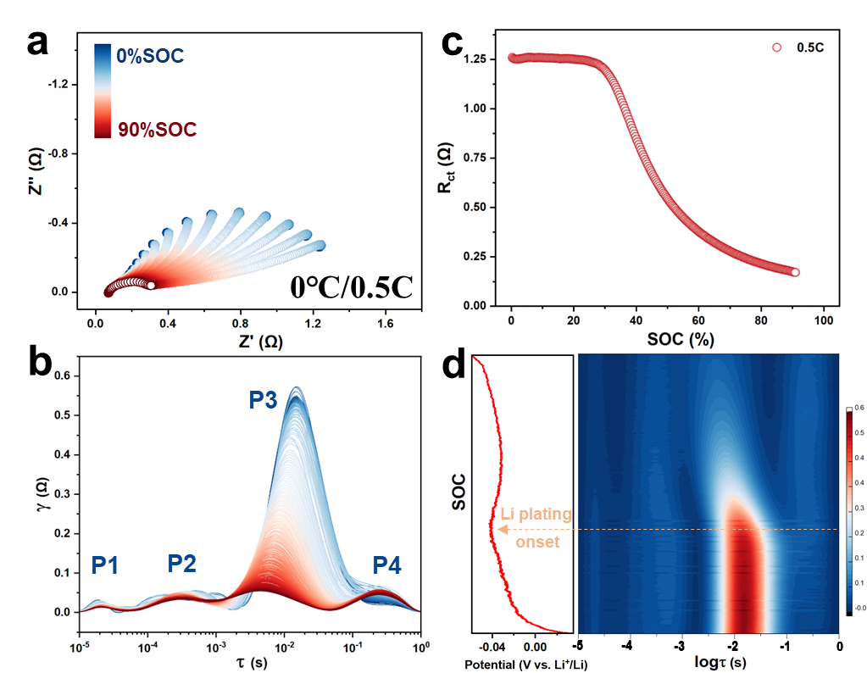
Figure S1. (a) Nyquist plots, (b) DRT plots, (c) as-fitted R_{ct} evolution plots, (d) potential and DRT contour map of graphite anode in the DEIS test under charging at 0℃ and 0.5C.

Figure S1 take the DEIS data under the charging condition of 0.5C at 0℃ as an example to illustrate the relation between Li plating and impedance characteristics in DEIS tests. In Figure S1a, the semicircle that represents the charge transfer process undergoes a quick shrink with the increase of SOC. The Nyquist plots were fitted via the DRT method using an open-source program named pyDRTtools-master, developed by Ciucci’s group.^{[1-2]} In the DRT profiles (Figure S1b), four peaks, labeled P1 to P4, represent contact resistance, Solid Electrolyte Interphase (SEI) resistance, charge transfer resistance (R_{ct}), and diffusion resistance, respectively.^{[4]} The value of R_{ct} decreases slowly first, and then drops suddenly with its position, i.e., time constant (τ_{ct}) shifting left. The DRT plots are further processed into contour plot and compared with the voltage curve of graphite anode, as shown in Figure S1d. The voltage overshot point coincides with the sudden drop point of P3 and the commencement of the peak position shift. Given that the overshot point corresponds to the onset point of Li plating, it suggests that both the R_{ct} and τ_{ct} could serve as indicators for Li plating detection.

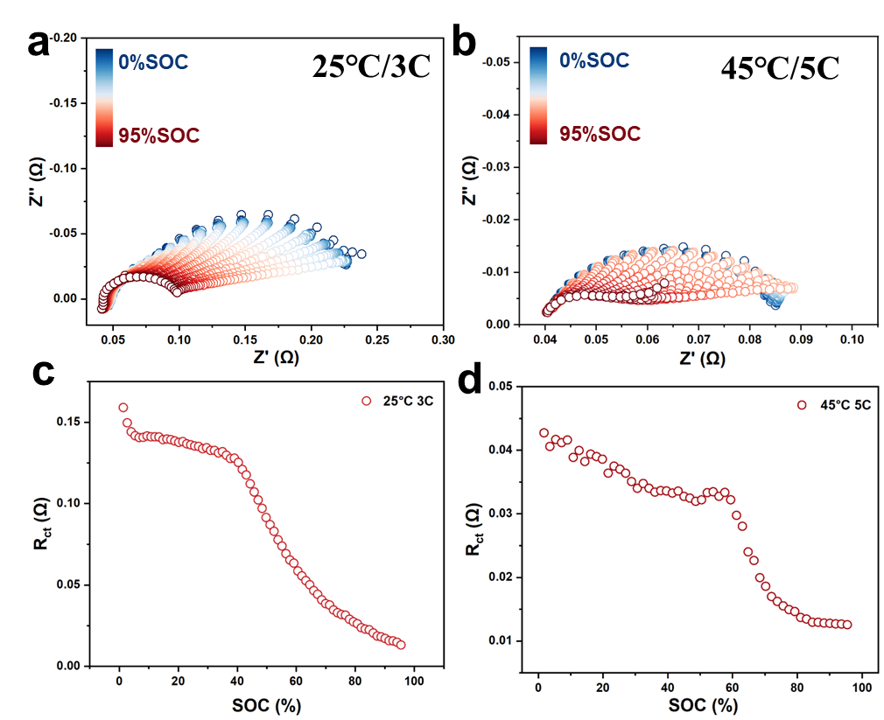
Figure S2 DEIS tests (Nyquist plots) of the Gr/LFP pouch cells during charging under the conditions of (a) 25℃ and 3C, (b) 45℃ and 5C. Evolution of the fitted R_{ct} derived from the DEIS tests under the condition of (c) 25℃ and 3C, (d) 45℃ and 5C.

Figure S3 DEIS results (Nyquist plots) of the Gr/LFP three-electrode pouch cell (~130mAh) with an excessive cathode during overcharging under different charging conditions after the anode was fully intercalated: (a) 0 ℃ and 0.1C, (b) 0 ℃ and 0.25C, (c) 0 ℃ and 0.5C, (d) 0 ℃ and 0.75C, (e) 25 ℃ and 1C, (f) 25 ℃ and 1.5C, (g) 25 ℃ and 2C, (h) 25 ℃ and 3C, (i) 45 ℃ and 2C, (j) 45 ℃ and 3C, (k) 45 ℃ and 4C, (l) 45 ℃ and 5C.

Figure S4 R_{ct} evolution plots fitted from the DEIS results in Figure S3 under the charged conditions of (a) 0℃, (b) 25℃, (c) 45℃. The suffix 1 and 2 represents that the abscissas are time and capacity, respectively

Figure S5 DEIS results (Nyquist plots) of the Gr/LFP three-electrode operando ssNMR model cell with an excess cathode during overcharging under different charging conditions after the anode was fully intercalated: (a) 25℃ and 1C; (b) 25℃ and 1.5C; (c) 25℃ and 2C; (d) fitted-R_{ct} variation plots vs. Li plating amounts.

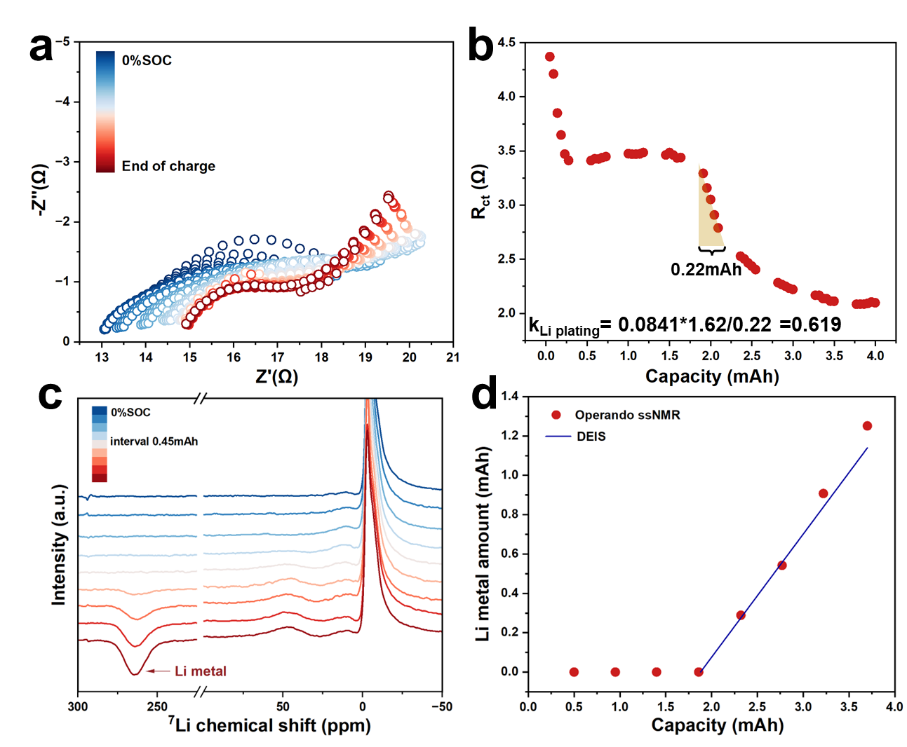
Figure S6 Operando ssNMR and DEIS combined measurements under charging condition of 25℃ and 2C: (a) Evolution of Nyquist plot, (b) as-fitted R_{ct} variation (c) ssNMR spectra. (d) Comparison of the quantification results of Li plating based on ssNMR and DEIS.

Figure S7 SEM images of pristine graphite anode.

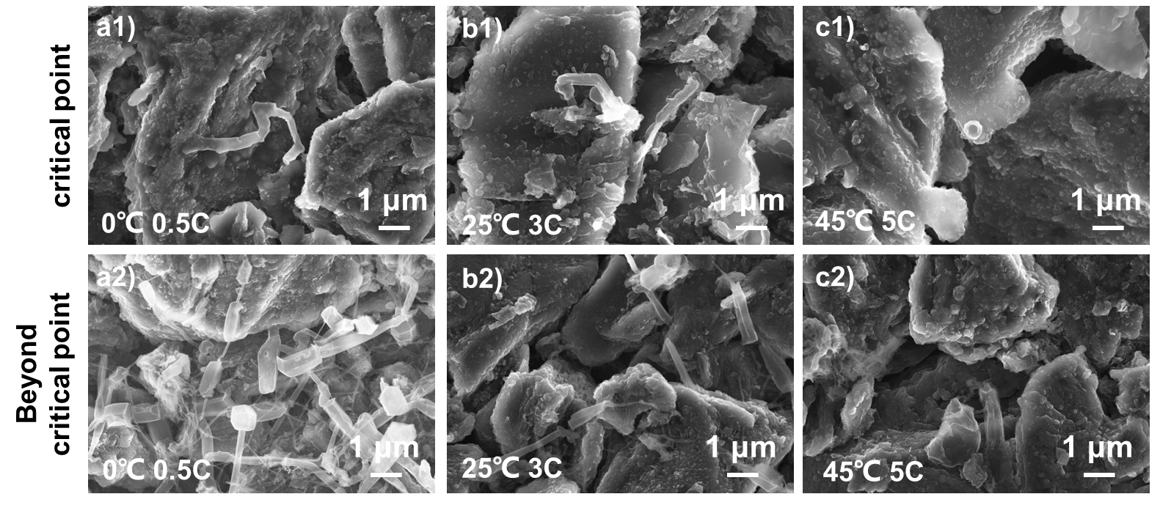
Figure S8 SEM images of graphite anode charged at (a) 0℃ and 0.5C, (b) 25℃ and 3C, (c) 45℃ and 5C. The suffix 1~2 represent the cutoff conditions, corresponding to the critical point and beyond critical point (exceeding 5.5 mAh, ~5% SOC).

Figure S9 Schematic of the transmission lines model used in the present paper to describe the transition process from Li intercalation to Li plating. The left section divided into n slices corresponds to a porous electrode containing an active material on the surface of which the electrochemical reaction occurs (elements Z_{n}). U is a voltage source, whereas J_{i} represents the loop currents used for the calculation of impedance.

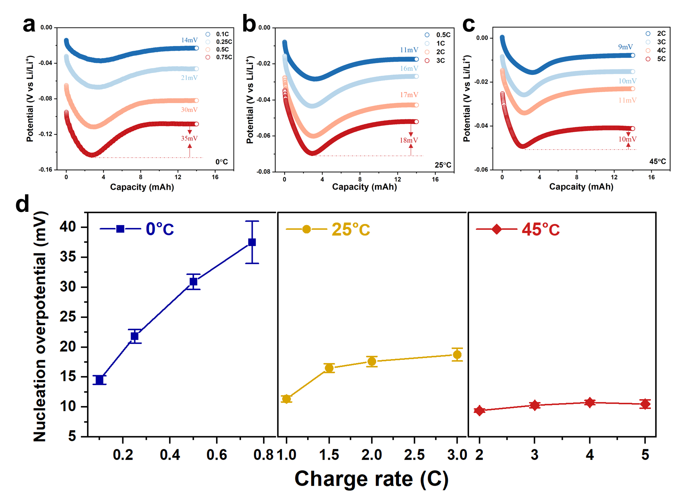
Figure S10 Potential of graphite anode in a three-electrode Gr/LFP pouch cells with a 0.67 N/P ratio during overcharging at various charging condition (a) 0.1, 0.25, 0.5, 0.75C at 0 ℃; (b) 0.5, 1, 2, 3C at 25 ℃; (c) 2, 3, 4, 5C at 45 ℃. (d) Nucleation overpotential of Li metal on the fully-intercalated graphite anode at various charging conditions.

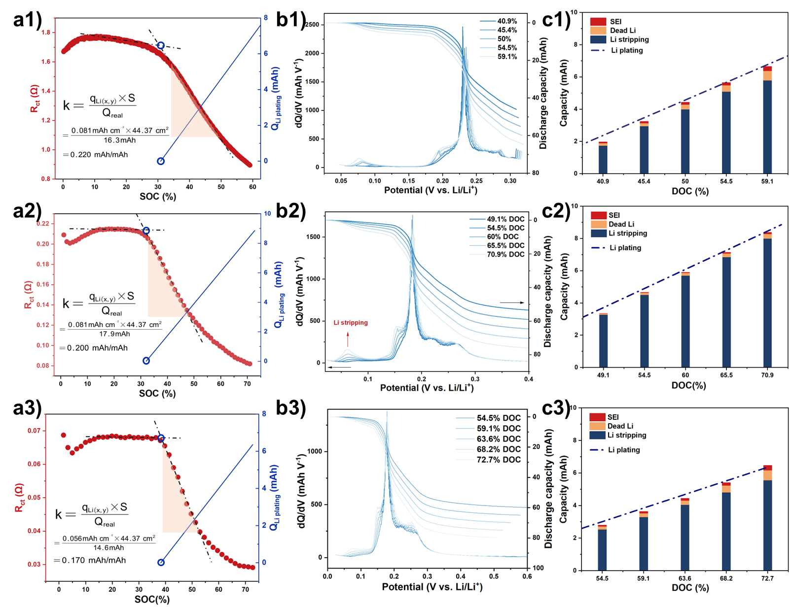
Figure S11 (a) R_{ct} variation plots and quantified Li plating plots of Gr/LFP pouch cells (110mAh) during charging under 1) 0 ℃/0.5C, 2) 25 ℃/3C, 3) 45 ℃/5C. (b) Discharge curves and dQ/dV curves of graphite anode charging under different conditions and DOC. (c) Comparison of quantifying results of Li plating based on DEIS and validating results based on ICA and MST.

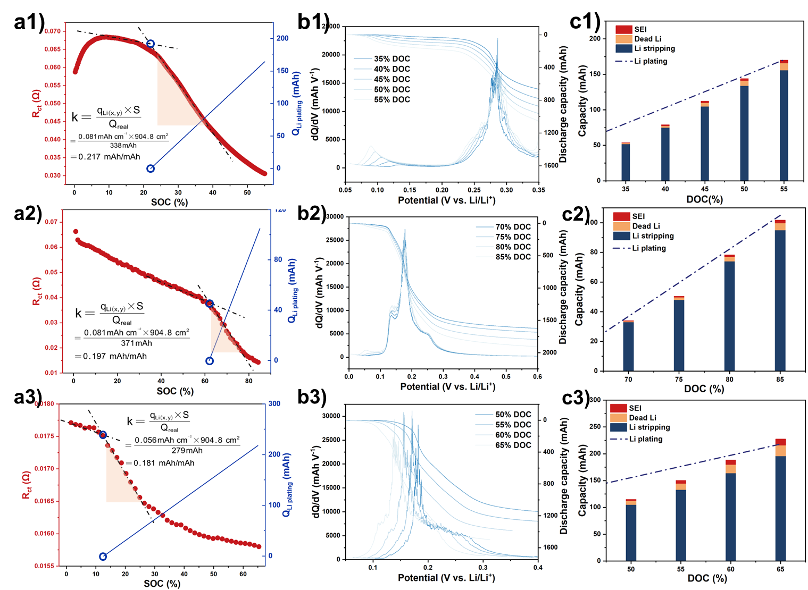
Figure S12 (a) R_{ct} variation plots and quantified Li plating plots of Gr/LFP pouch cells (2.3Ah) during charging under 1) 0 ℃/0.5C, 2) 25 ℃/3C, 3) 45 ℃/5C. (b) Discharge curves and dQ/dV curves of graphite anode charging under different conditions and DOC. (c) Comparison of quantifying results of Li plating based on DEIS and validating results based on ICA and MST.

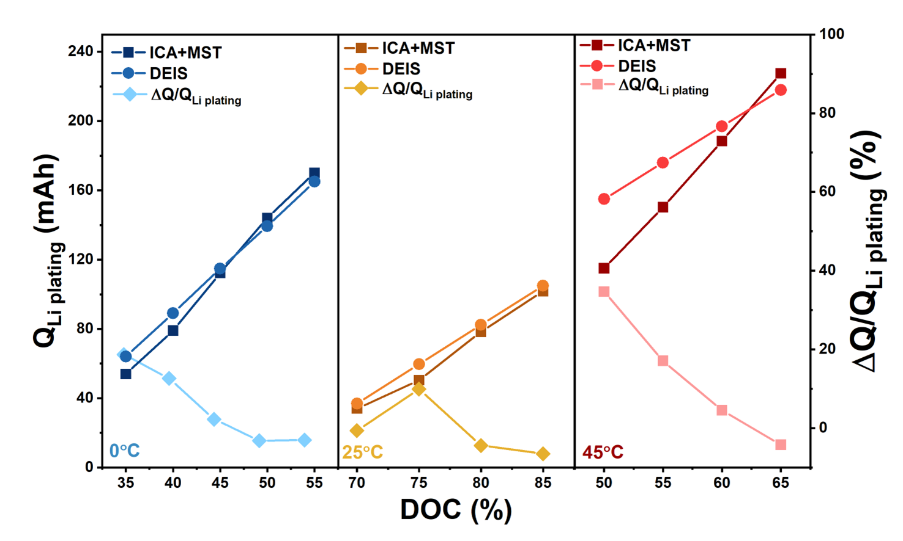
Figure S13 Quantified Li plating curve, validated Li plating curve and relative error of Gr/LFP pouch cells (2.3 Ah) under three charging conditions (from left to right: 0 ℃ 0.5C, 25 ℃ 3C, 45 ℃ 5C) and different DOC.

Figure S14 Quantitative analysis of dense stage GIC and Li metal of operando ssNMR cell with excessive cathode charged at 25 ℃ and 2C with a same capacity cutoff and then immediately discharged at (a) 0.33C, (b) 1C, (c) 2C and (d) 4C.

Since the ICA method was used to quantified the reversible plated Li from the Li stripping peak, it is important to evaluate the influence of the discharge rates, or in another word, polarization, on the quantified results. Herein, we used the Gr/LFP operando ssNMR model cells with excessive cathode to charge a determined capacity with the similar Li plating amount, and then discharge under various rates from 0.33C to 4C. The operando ssNMR could quantify the amount ratio between GIC and Li metal based on the peak strength. When discharged at a low rate of 0.33C, the amount of GIC enhanced in the initial stage of discharging, indicating that the plated Li could re-intercalated into the Gr. The chemical re-intercalation process is coupled with the electrochemical deintercalation process. In this case, a low discharge rate would definitely underestimate the reversible plated Li in an ICA method. However, if the discharge rate is too high (4C), the Li⁺ in the GIC could deintercalated at the same time. Moreover, a more severe polarization effect could obscure the feature of ICA, leading to an overvalued Li stripping capacity. Based on these results and insights, we choose the discharge rates of 0.33C, 1C and 2C at 0, 25, 45 ℃, respectively, in the ICA method to quantify the capacity of Li stripping. Nevertheless, it should be pointed out that there is an absolute error that is un-removable for the second validation strategy due to the polarization effect. In our perspective, the gap between DEIS-based quantified results and ICA&MST-based validation results arises from the errors in the validation method. Especially for the large pouch batteries (2.3Ah), the larger polarization effect could significantly increase this type of error.

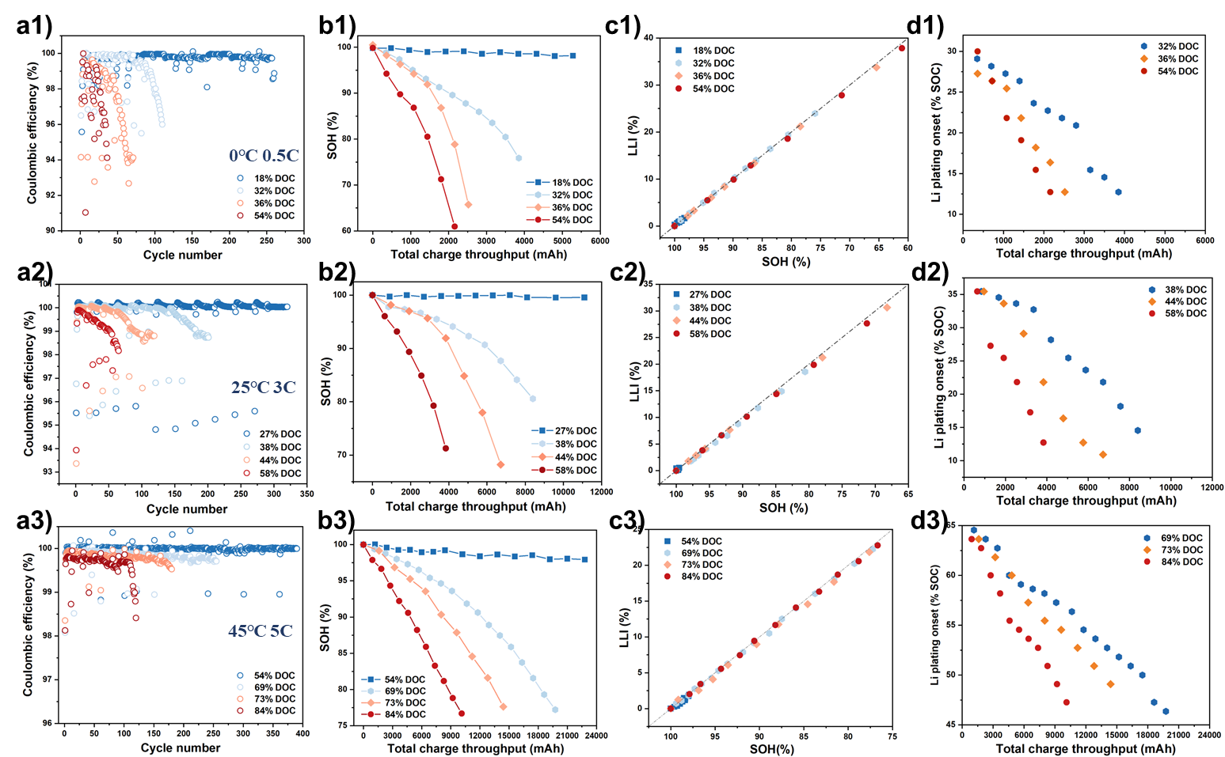
Figure S15 Electrochemical performance of Gr/LiFePO₄ batteries tested at different coupling conditions: (a) Coulombic efficiency, (b) SOH evolution, (c) capacity analysis by diagnosis process and (d) Li capacity onset points during cycling. The suffix 1, 2, 3 represents 0.5C at 0℃, 3C at 25℃, and 5C at 45℃, respectively.

The cycling results at the charging condition of 0℃ and 0.5C are discussed first. When the DOC is 18% with no Li plating, the battery shows no capacity degradation with nearly 100% Coulombic efficiency. Once the DOC exceed Li plating boundary to 32%, the batteries’ capacity exhibits a linear degradation at the beginning, and then a rapid capacity plunge. The more severe the degree of Li plating is, the earlier the knee point emerges. When the DOC is deep enough to achieve a Li plating amount exceeding q_{Li}, the battery presents a non-linear capacity degradation from the very commencement of the cycles and persists until the battery reaches its end-of-life. Simultaneously, the Coulombic efficiency steadily declines throughout the cycling process. In Figure S15c1, the battery aging diagnosis shows that the SOH degradation almost exhibits a positive correlation with LLI at any cycling conditions. In addition, the LLI show a simultaneous quick increase at the knee points, while LAM only accounts for a relatively low proportion (Figure S16), indicating the dominant role of LLI in the degradation mode. By using the DEIS to trace the variation of Li plating boundary, it is found that the onset point of Li plating keeps becoming earlier and earlier during the cycling tests. The dead Li and residual-SEI will cause an increase in battery impedance and a deterioration of kinetics, thereby resulting in the narrowing of the Li plating boundary. Although the DOC is initially configured to limit Li plating amount less than q_{Li}, in fact, when the battery has aged to a specific extent, the Li plating amount has already exceeded q_{Li} due to the continuous advancement of LPB under the original settled cut-off conditions, as depicted in the blue circle in the Figure S15d. More importantly, the points at which the Li plating amounts exceed q_{Li} precisely coincide with the knee points in Figure S15b, thereby indicating a robust correlation between q_{Li} and capacity plunge. When the batteries are cycled at the charging condition of 25℃ and 3C, the results (Figure S15a2-d2) are similar to the case of 0℃ and 0.5C. During cycling with little (38% DOC) and middle (44% DOC) Li plating, the batteries undergo a capacity plunge in the later stage of aging, and these knee points precisely correspond to the time points when LPB advances to achieve a Li plating amount exceeding q_{Li}. When cycling at 45℃ and 5C, the relationship between Li plating amount and battery degradation is similar to that observed at lower temperatures; however, the degradation rate induced by Li plating at 45 °C is significantly lower than that at 0 °C and 25 °C. Although capacity plunge still occurs once the plated Li content exceeds a threshold value q_{Li}, the cell does not fail immediately. Instead, it exhibits a gradually increasing degradation rate. This distinctive behavior can be attributed to the 2DI nucleation and growth mechanisms of Li plating under high-temperature conditions, which enhance the reversibility of deposited Li and reduce the formation of irreversible, high aspect ratio Li dendrites. The outcomes indicate that capacity plunge is not only related to the quantity of plated Li, but their morphology also constitutes a significant triggering factor.

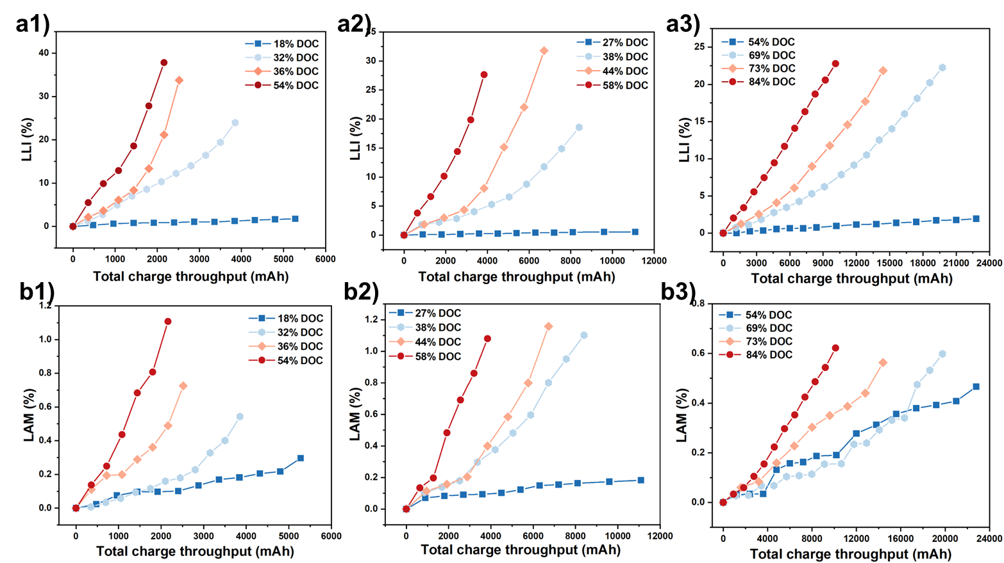
Figure S16 Capacity analysis of Gr/LiFePO₄ batteries tested by diagnosis process during cycling under different coupling conditions: (a) LLI, (b) LAM. The suffix 1, 2, 3 represents 0.5C at 0 ℃, 3C at 25 ℃, and 5C at 45 ℃, respectively.

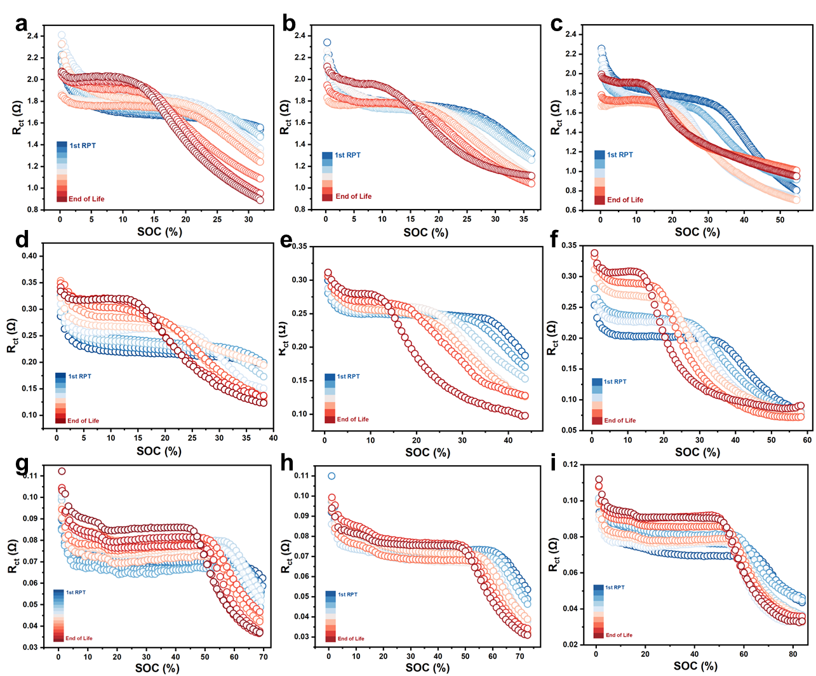
Figure S17 Variation of Li plating boundaries of Gr/LiFePO₄ batteries during aging under different cycling protocols diagnosis by DEIS test: (a) 0℃ 0.5C with 32% DOC; (b) 0℃ 0.5C with 36% DOC; (c) 0℃ 0.5C with 54% DOC; (d) 25℃ 3C with 38% DOC; (e) 25℃ 3C with 44% DOC; (f) 25℃ 3C with 58% DOC; (g) 45℃ 5C with 69% DOC; (h) 45℃ 5C with 73% DOC; (g) 45℃ 5C 84% DOC.

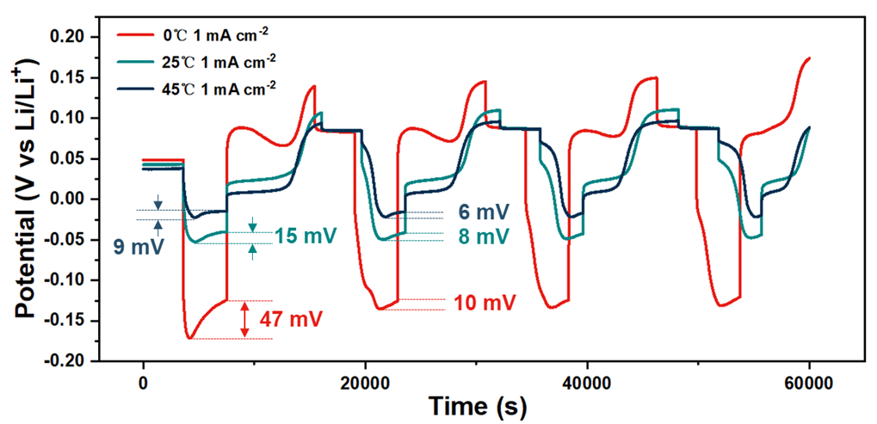
Figure S18 (e) Nucleation overpotential tests in several continuous cycles by using a three-electrode Li||Graphite half-cell.

Dead Li formed in prior cycles would significantly reduce the nucleation overpotential of Li metal on graphite surface, thereby facilitating the nucleation process and inducing earlier lithium plating. This effect is far more pronounced at low temperatures. As shown in Figure S18, the nucleation overpotentials in the second cycle decrease by 78%, 47%, 33% at 0, 25, 45℃, respectively, relative to the first cycle.

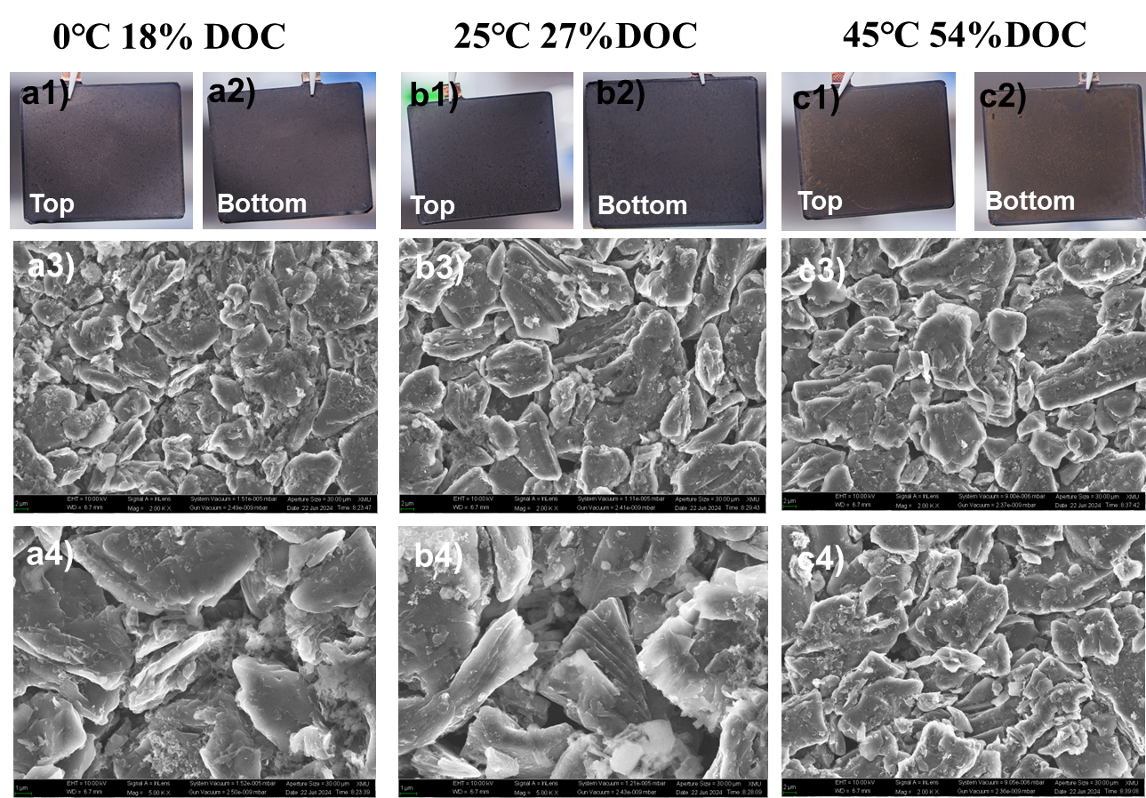
Figure S19 Optical images and SEM images of graphite anodes after cycling with No Li plating under different cycling protocols: (a) 0.5C at 0℃ with 18% DOC, (b) 3C at 25℃ with 27% DOC, and (c) 5C at 45℃ with 54% DOC. The suffix 1 and 2 represent optical images of the top surface and bottom surface of graphite anodes, while the suffix 3 and 4 represent SEM images of the top surface and bottom surface of graphite anodes, respectively.

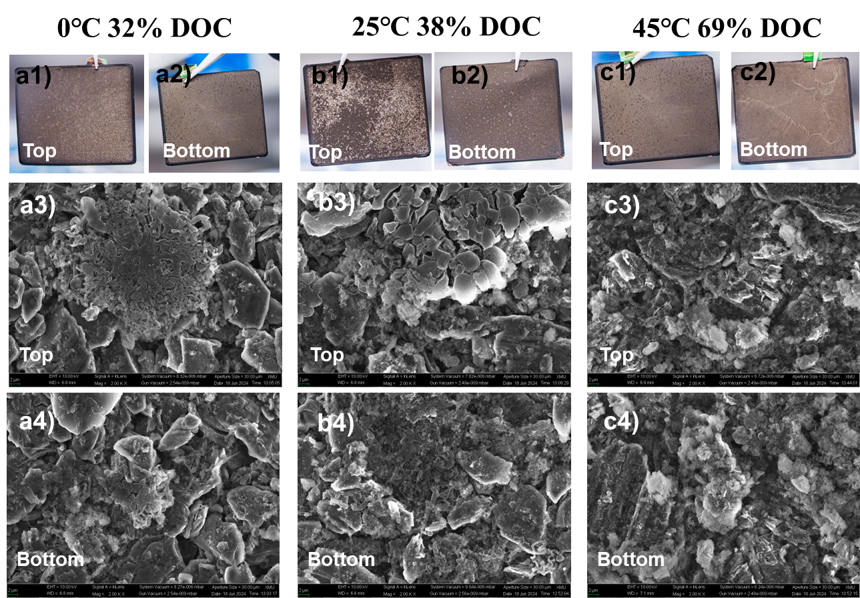
Figure S20 Optical images and SEM images of graphite anodes after cycling with middle Li plating under different cycling protocols: (a) 0.5C at 0℃ with 32% DOC, (b) 3C at 25℃ with 38% DOC, and (c) 5C at 45℃ with 69% DOC. The suffix 1 and 2 represent optical images of the top surface and bottom surface of graphite anodes, while the suffix 3 and 4 represent SEM images of the top surface and bottom surface of graphite anodes, respectively.

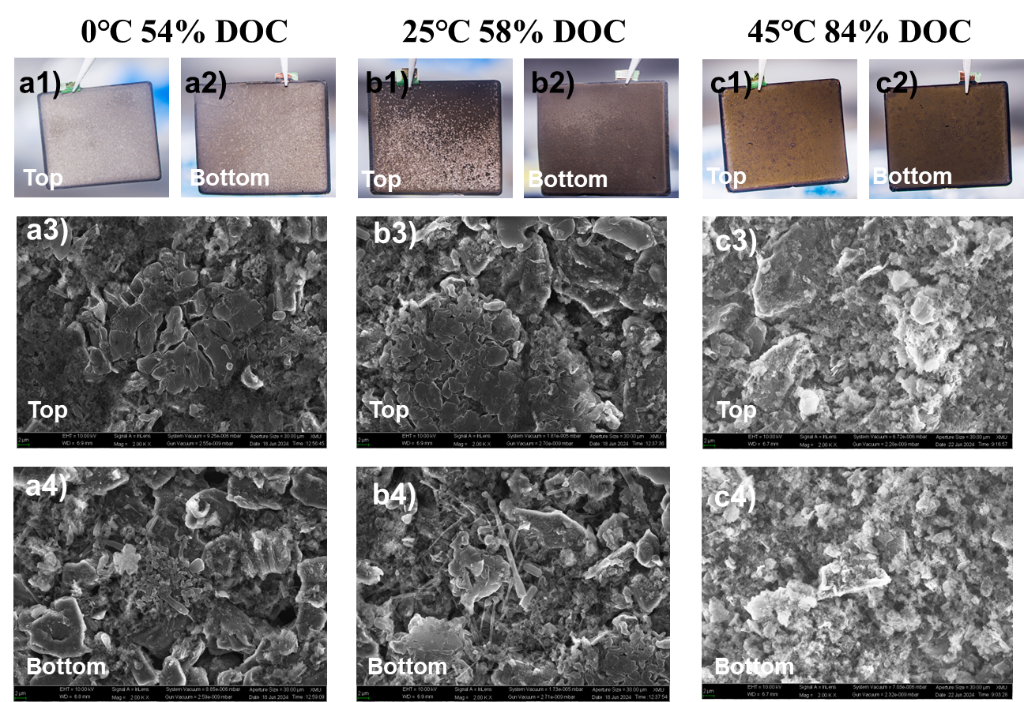
Figure S21 Optical images and SEM images of graphite anodes after cycling with severe Li plating under different cycling protocols: (a) 0.5C at 0℃ with 54% DOC, (b) 3C at 25℃ with 58% DOC, and (c) 5C at 45℃ with 84% DOC. The suffix 1 and 2 represent optical images of the top surface and bottom surface of graphite anodes, while the suffix 3 and 4 represent SEM images of the top surface and bottom surface of graphite anodes, respectively.

Table S1 Cycling protocols (temperature-charging rate-discharging rate) for the ageing test of Gr/LFP pouch cells.
Cut-off conditions  Li plating degree | 0℃ 0.5C-0.3C | 25℃ 3C-1C | 45℃ 5C-2C
No Li plating | 20 mAh | 30 mAh | 60 mAh
Little Li plating | 35 mAh | 42 mAh | 76 mAh
Middle Li plating | 40 mAh | 48 mAh | 80 mAh
Severe Li plating | 60 mAh | 64 mAh | 92 mAh

Table S2 Values of model elements used in TLM.
Element in model | Value
R_{sol} [Ω] | 1
R_{e,Gr} [Ω] | 1
R_{ion} [Ω] | 5
R_{ct} [Ω] | 10
C_{dl} [s^{α}Ω⁻¹] | 5×10⁻³
α | 0.88
s_{D} [Ω s^{-1/2}] | 10
R_{ct}*[Ω] | 6.67
C_{dl}* [s^{α}Ω⁻¹] | 7.5×10⁻³
The presence or absence of the * mark represents two types of charge transfer processes: Li plating and Li intercalation, respectively.

Reference
- M. Saccoccio, T. H. Wan, C. Chen, F. Ciucci, Electrochim. Acta 147 (2014) 470-482.
- T. H. Wan, M. Saccoccio, C. Chen, F. Ciucci, Electrochim. Acta 184 (2015) 483-499.
- Y. Zhou, H. Lin, C. Zhong, J. Am. Chem. Soc. 147 (2025) 43529-43539.
- Y. Peng, C. Zhong, M. Ding, et al. Adv. Funct. Mater. 34 (2024) 2404495.
- S. Talian, J. Bobnar, M. Gaberšček, et al. J. Phys. Chem. C 123 (2019) 27997-28007.

