Table S1. C. albicans strains used in this study
Strain | Parent | Relevant genotypes | Source
BWP17 | CAI4 | ura3/ura3 his1∆/his1∆ arg4∆/arg4∆ | Wilson et  al. (1999)
LC101 | BWP17 | ura3Δ/ura3Δ sec3Δ::HIS1/sec3Δ::ARG4 | This study
LC102 | LC101 | sec3Δ1-316-URA3/ura3Δ sec3Δ::HIS1/sec3Δ::ARG4 | This study
LC103 | LC101 | sec3Δ1-157-URA3/ura3Δ sec3Δ::HIS1/sec3Δ::ARG4 | This study
LC104 | LC101 | sec3Δ158-244-URA3/ura3Δ sec3Δ::HIS1/sec3Δ::ARG4 | This study
LC105 | LC101 | sec3Δ245-316-URA3/ura3Δ sec3Δ::HIS1/sec3Δ::ARG4 | This study
LC106 | LC101 | sec3Δ317-790-URA3/ura3Δ sec3Δ::HIS1/sec3Δ::ARG4 | This study
LC107 | BWP17 | ura3Δ/ura3Δ his1Δ/his1Δ RHO1/rho1Δ::ARG4 | This study
LC108 | LC107 | ura3Δ/ura3Δ rho1::HIS1-rho1^{G18V}/rho1Δ::ARG4 | This study
LC109 | LC107 | ura3Δ/ura3Δ rho1::HIS1-rho1^{D124A}/rho1Δ::ARG4 | This study
LC110 | LC109 | RHO1-URA3/ura3Δ rho1::HIS1-rho1^{D124A}/rho1Δ::ARG4 | This study
LC111 | BWP17 | SEC5-3GFP-URA3/ura3Δ his1Δ/his1Δ arg4Δ/arg4Δ | This study
LC112 | BWP17 | SEC8-3GFP-URA3/ura3Δ his1Δ/his1Δ arg4Δ/arg4Δ | This study
LC113 | BWP17 | EXO70-3GFP-URA3/ura3Δ his1Δ/his1Δ arg4Δ/arg4Δ | This study
LC114 | BWP17 | EXO84-3GFP-URA3/ura3Δ his1Δ/his1Δ arg4Δ/arg4Δ | This study
LC115 | LC101 | SEC5-3GFP-URA3/ura3Δ sec3Δ::HIS1/sec3Δ::ARG4 | This study
LC116 | LC101 | SEC8-3GFP-URA3/ura3Δ sec3Δ::HIS1/sec3Δ::ARG4 | This study
LC117 | LC101 | EXO70-3GFP-URA3/ura3Δ sec3Δ::HIS1/sec3Δ::ARG4 | This study
LC118 | LC101 | EXO84-3GFP-URA3/ura3Δ sec3Δ::HIS1/sec3Δ::ARG4 | This study
LC119 | LC101 | SEC5-3GFP-sec3Δ1-316-URA3/ura3Δ sec3Δ::HIS1/sec3Δ::ARG4 | This study
LC120 | LC101 | SEC8-3GFP-sec3Δ1-316-URA3/ura3Δ sec3Δ::HIS1/sec3Δ::ARG4 | This study
LC121 | LC101 | EXO70-3GFP-sec3Δ1-316-URA3/ura3Δ sec3Δ::HIS1/sec3Δ::ARG4 | This study
LC122 | LC101 | EXO84-3GFP-sec3Δ1-316-URA3/ura3Δ sec3Δ::HIS1/sec3Δ::ARG4 | This study
LC123 | LC101 | SEC5-3GFP-sec3Δ1-157-URA3/ura3Δ sec3Δ::HIS1/sec3Δ::ARG4 | This study
LC124 | LC101 | SEC8-3GFP-sec3Δ1-157-URA3/ura3Δ sec3Δ::HIS1/sec3Δ::ARG4 | This study
LC125 | LC101 | EXO70-3GFP-sec3Δ1-157-URA3/ura3Δ sec3Δ::HIS1/sec3Δ::ARG4 | This study
LC126 | LC101 | EXO84-3GFP-sec3Δ1-157-URA3/ura3Δ sec3Δ::HIS1/sec3Δ::ARG4 | This study
LC127 | LC101 | SEC5-3GFP-sec3Δ317-790-URA3/ura3Δ sec3Δ::HIS1/sec3Δ::ARG4 | This study
LC128 | LC101 | SEC8-3GFP-sec3Δ317-790-URA3/ura3Δ sec3Δ::HIS1/sec3Δ::ARG4 | This study
LC129 | LC101 | EXO70-3GFP-sec3Δ317-790-URA3/ura3Δ sec3Δ::HIS1/sec3Δ::ARG4 | This study
LC130 | LC101 | EXO84-3GFP-sec3Δ317-790-URA3/ura3Δ sec3Δ::HIS1/sec3Δ::ARG4 | This study
LC131 | BWP17 | SEC3-3GFP-URA3/ura3Δ his1Δ/his1Δ arg4Δ/arg4Δ | This study
LC132 | LC101 | sec3Δ1-316-3GFP-URA3/ura3Δ sec3Δ::HIS1/sec3Δ::ARG4 | This study
LC133 | LC101 | sec3Δ1-157-3GFP-URA3/ura3Δ sec3Δ::HIS1/sec3Δ::ARG4 | This study
LC134 | LC101 | sec3Δ317-790-3GFP-URA3/ura3Δ sec3Δ::HIS1/sec3Δ::ARG4 | This study
LC135 | LC108 | SEC3-3GFP-URA3/ura3Δ rho1::HIS1-rho1^{G18V}/rho1Δ::ARG4 | This study
LC136 | LC108 | SEC5-3GFP-URA3/ura3Δ rho1::HIS1-rho1^{G18V}/rho1Δ::ARG4 | This study
LC137 | LC108 | SEC8-3GFP-URA3/ura3Δ rho1::HIS1-rho1^{G18V}/rho1Δ::ARG4 | This study
LC138 | LC108 | EXO70-3GFP-URA3/ura3Δ rho1::HIS1-rho1^{G18V}/rho1Δ::ARG4 | This study
LC139 | LC108 | EXO84-3GFP-URA3/ura3Δ rho1::HIS1-rho1^{G18V}/rho1Δ::ARG4 | This study
LC140 | LC109 | SEC3-3GFP-URA3/ura3Δ rho1::HIS1-rho1^{D124A}/rho1Δ::ARG4 | This study
LC141 | LC109 | SEC5-3GFP-URA3/ura3Δ rho1::HIS1-rho1^{D124A}/rho1Δ::ARG4 | This study
LC142 | LC109 | SEC8-3GFP-URA3/ura3Δ rho1::HIS1-rho1^{D124A}/rho1Δ::ARG4 | This study
LC143 | LC109 | EXO70-3GFP-URA3/ura3Δ rho1::HIS1-rho1^{D124A}/rho1Δ::ARG4 | This study
LC144 | LC109 | EXO84-3GFP-URA3/ura3Δ rho1::HIS1-rho1^{D124A}/rho1Δ::ARG4 | This study
LC145 | BWP17 | SEC3-6MYC-URA3/ura3Δ his1Δ/his1Δ arg4Δ/arg4Δ | This study
LC146 | BWP17 | ura3Δ/ura3Δ his1Δ/his1Δ CDC42/cdc42Δ::ARG4 | This study
LC147 | LC145 | ura3Δ/ura3Δ rho1::HIS1-cdc42^{G12V}/cdc42Δ::ARG4 | This study
LC148 | LC145 | ura3Δ/ura3Δ rho1::HIS1-cdc42^{D118A}/cdc42Δ::ARG4 | This study
LC149 | LC145 | CDC42-URA3/ura3Δ cdc42::HIS1/cdc42Δ::ARG4 | This study
LC150 | BWP17 | ura3Δ/ura3Δ his1Δ/his1Δ CDC28/cdc28Δ::ARG4 | This study
LC151 | LC149 | ura3Δ/ura3Δ cdc28::HIS1-cdc28^{F85G}/cdc28Δ::ARG4 | This study
LC152 | LC146 | SEC3-3GFP-URA3/ura3Δ cdc42::HIS1-cdc42^{G12V}/cdc42Δ::ARG4 | This study
LC153 | LC146 | SEC5-3GFP-URA3/ura3Δ cdc42::HIS1-cdc42^{G12V}/cdc42Δ::ARG4 | This study
LC154 | LC146 | EXO70-3GFP-URA3/ura3Δ cdc42::HIS1-cdc42^{G12V}/cdc42Δ::ARG4 | This study
LC155 | LC146 | EXO84-3GFP-URA3/ura3Δ cdc42::HIS1-cdc42^{G12V}/cdc42Δ::ARG4 | This study
LC156 | LC147 | SEC3-3GFP-URA3/ura3Δ cdc42::HIS1-cdc42^{D118A}/cdc42Δ::ARG4 | This study
LC157 | LC147 | SEC5-3GFP-URA3/ura3Δ cdc42::HIS1-cdc42^{D118A}/cdc42Δ::ARG4 | This study
LC158 | LC147 | EXO70-3GFP-URA3/ura3Δ cdc42::HIS1-cdc42^{D118A}/cdc42Δ::ARG4 | This study
LC159 | LC147 | EXO84-3GFP-URA3/ura3Δ cdc42::HIS1-cdc42^{D118A}/cdc42Δ::ARG4 | This study
LC160 | LC150 | SEC3-6MYC-URA3/ura3Δ cdc28::HIS1-cdc28^{F85G}/cdc28Δ::ARG4 | This study

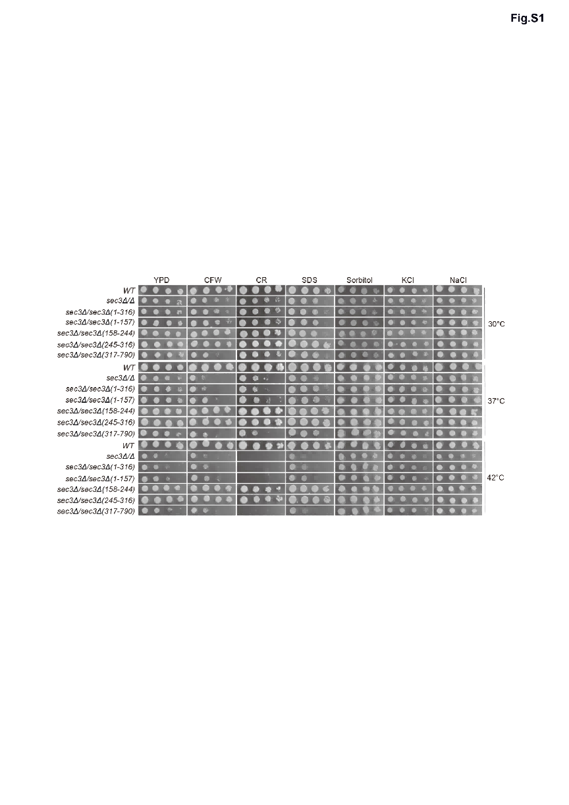

Fig. S1. sec3 mutants exhibit growth defects, are sensitive to cell wall antagonists and rescued by osmotic stabilizer.
Cells of wild type (BWP17), sec3Δ/Δ, sec3Δ/sec3Δ(1-316), sec3Δ/sec3Δ(1-157), sec3Δ/sec3Δ(158-244), sec3Δ/sec3Δ(245-316) and sec3Δ/sec3Δ(317-790) mutants were grown to log phase in YPD at 30°C. Equal densities of wild-type and mutant cells were spotted in 10-fold serial dilutions from left to right on YPD plates containing 30 μg/ml CFW, 300 μg/ml Congo Red (CR), 0.01% SDS, 1.2 M Sorbitol, 1 M KCl, or 1 M NaCl. All plates were supplemented with 100 μg/ml Uridine and incubated at 30℃, 37℃, or 42℃, respectively. Shown were images of plates taken after 3 days of incubation at the indicated temperatures.

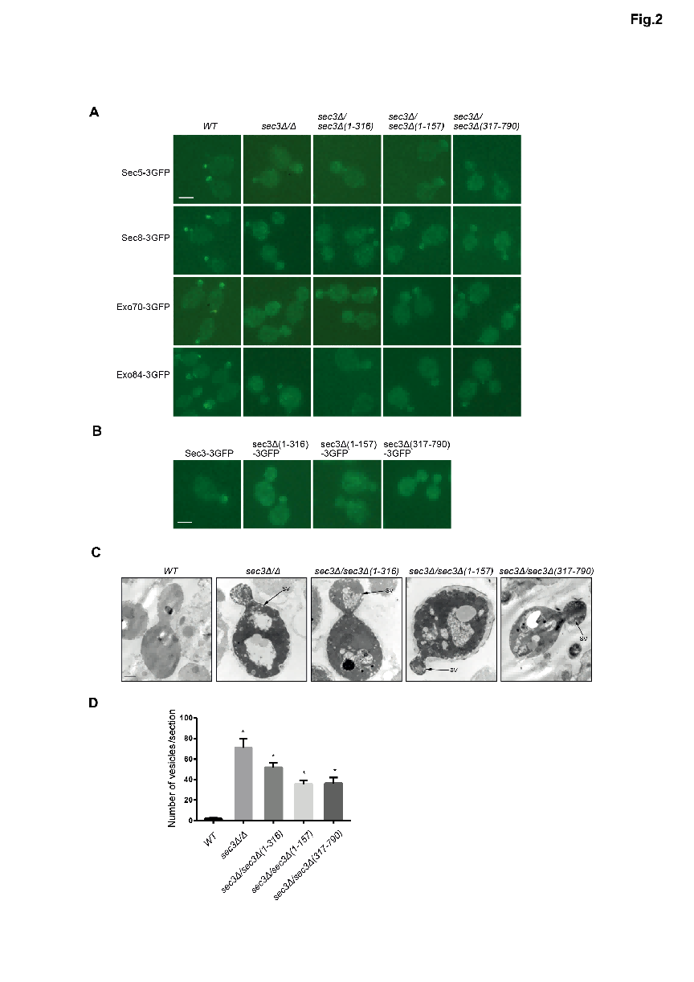

Fig. S2. Cell lysis of sec3 mutants.
(A) Equal densities of wild-type (BWP17), sec3Δ/Δ, sec3Δ/sec3Δ(1-316), sec3Δ/sec3Δ(1-157) and sec3Δ/sec3Δ(317-790) strains were loaded onto YPD plates or a YPD plate containing 1.2 M sorbitol, incubated at 30°C for 1 day, and then shifted to 30°C, 37°C, or 42°C for another day. The cells were assayed in situ for release of alkaline phosphatase as an indication of cell lysis.
(B) wild-type (BWP17), sec3Δ/Δ, sec3Δ/sec3Δ(1-316), sec3Δ/sec3Δ(1-157) and sec3Δ/sec3Δ(317-790) strains were grown to early log phase at 30°C overnight and then shift to 42°C for 11h. Cells were stained with 0.4% Loeffler's Methylene Blue stain solution and examined by light microscopy. Scale bar, 10 μm.
(C) Number of lysed cells at 42°C in (B) were quantified. The assay was performed 3 times independently and 400 cells were quantified for each strain.
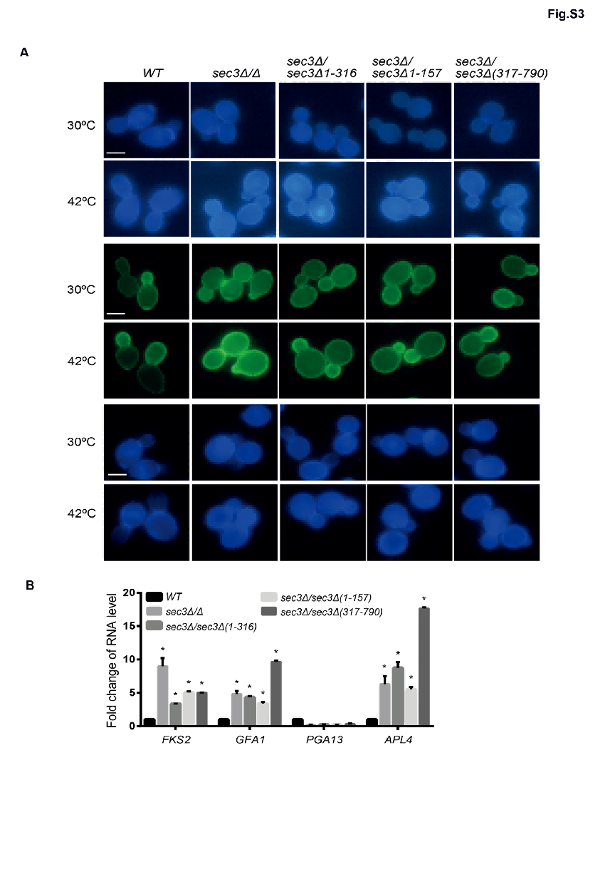
Fig. S3. Increased cell wall components in sec3 mutants.
(A)Wild-type (BWP17), sec3Δ/Δ, sec3Δ/sec3Δ(1-316), sec3Δ/sec3Δ(1-157) and sec3Δ/sec3Δ(317-790) strains were incubated at 42°C for 2 h. 1,3- β-glucan, mannoproteins, and chitin were stained with aniline blue, calcofluor white, or FITC-Con A, respectively. Cells were fixed and examined under a fluorescence microscopy. Scale bar, 5 μm. PH, phase; FL, fluorescence.
(B) The CWI signaling pathway was activated in sec3 mutants. After wild-type (BWP17), sec3Δ/Δ, sec3Δ/sec3Δ(1-316), sec3Δ/sec3Δ(1-157) and sec3Δ/sec3Δ(317-790) were incubated at 42°C for 2 h. Total RNA was extracted and RT-qPCR was used to detect the transcription level of FKS2, PGA13, APL4, and GFA1. Relative transcript levels were calculated using the 2^{-ΔΔCt} method and the results are presented as histograms. *, p < 0.05. n=3.
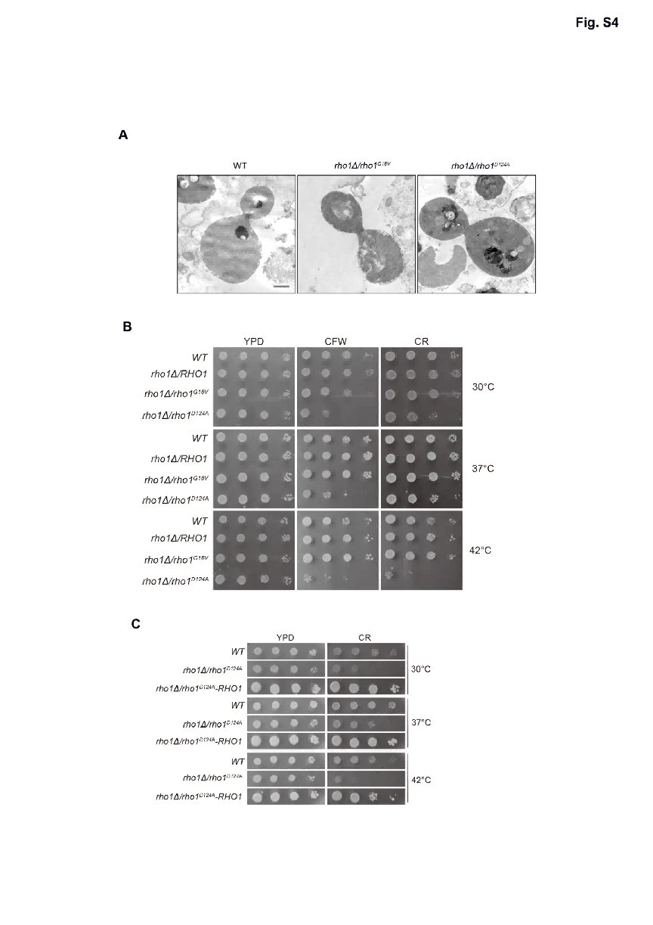
Fig. S4. Secretory vesicles were not accumulated in rho1 mutant cells at restrictive temperature and the cell wall of rho1 mutant cells were not integrity.
(A)Secretory vesicles were not accumulated in rho1 mutant cells at restrictive temperature. Wild-type (BWP17), rho1Δ/rho1^{G18V} and rho1Δ/rho1^{D124A} strains were grown to early log phase in YPD liquid medium overnight at 30°C and then shifted to 42°C for 90 min. The cells were mixed, stained, and examined by thin-section electron microscopy. Scale bar, 1μm.
(B) rho1Δ/rho1^{D124A} mutant is sensitive to cell wall antagonists. Cells of wild type (BWP17), rho1Δ/RHO1, rho1Δ/rho1^{G18V}, and rho1Δ/rho1^{D124A} strains were grown to log phase in YPD at 30°C. Equal densities of wild-type and mutant cells were spotted in 10-fold serial dilutions from left to right on YPD or YPD plates containing 30μg/ml CFW or 300μg/ml Congo Red (CR). All plates were supplemented with 100μg/ml Uridine and incubated at 30℃, 37℃, or 42℃, respectively. Shown were images of plates taken after 3 days of incubation at the indicated temperatures.
(C) Replenishment of the wild-type RHO1 gene can inhibit the sensitivity of rho1Δ/rho1^{D124A} to cell wall antagonists. Cells of wild type (BWP17), rho1Δ/rho1^{D124A}, and rho1Δ//rho1^{D124A}-RHO1 strains were grown to log phase in YPD at 30°C. Equal densities of wild-type and mutant cells were spotted in 10-fold serial dilutions from left to right on YPD or YPD plates containing 300 μg/ml Congo Red (CR). All plates were supplemented with 100 μg/ml Uridine and incubated at 30℃, 37℃, or 42℃, respectively. Shown were images of plates taken after 3 days of incubation at the indicated temperatures.

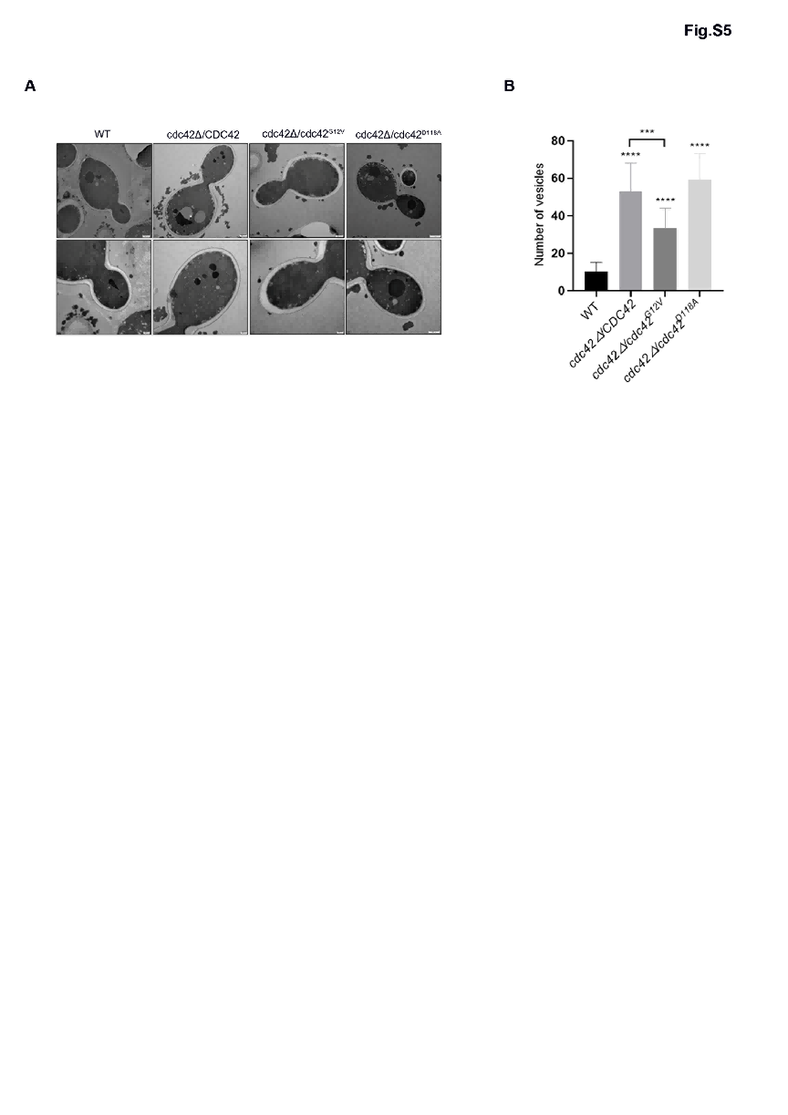
Fig. S5. Secretory vesicles were accumulated in cdc42 mutant cells at restrictive temperature.
- Wild-type (BWP17), cdc42Δ/CDC42, cdc42Δ/cdc42^{G12V}and cdc42Δ/cdc42^{D118A} strains were grown to early log phase in YPD liquid medium overnight at 30°C and then shifted to 42°C for 90 min. The cells were mixed, stained, and examined by thin-section electron microscopy. Scale bar for the first row, 500nm. Scale bar for the second row, 200nm.
- Statistical analysis of vesicle accumulation in cells in (A). n=15. *, p<0.01.

Fig. S6. Identification of Phosphorylation Sites on Sec3.
MS analyses of Sec3-6Myc proteins Myc-purified from hyphae. The phosphopeptides which contains CDK phosphorylation sites from amino acid are shown. Arrows indicate phosphoserine and phosphorthreonine residues.

