Rankograms illustrating the empirical probabilities that each treatment is ranked first through fourth (left to right) for pain (VAS scores), MMO, lateral movement at longest follow-up period of each study. CCS, corticosteroids; HA, hyaluronic acid; PRP, platelet-rich plasma.
Long term
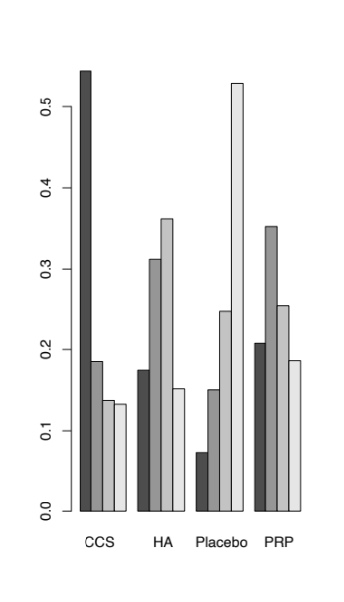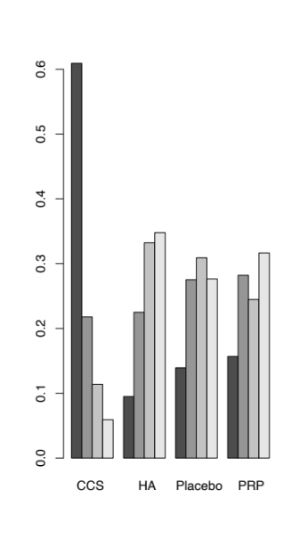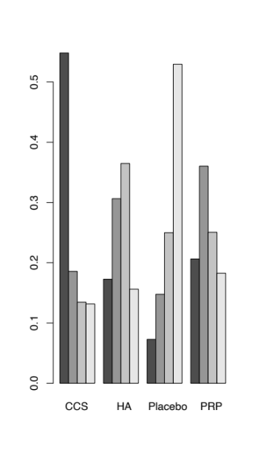
pain MMO lateral movement

Short term

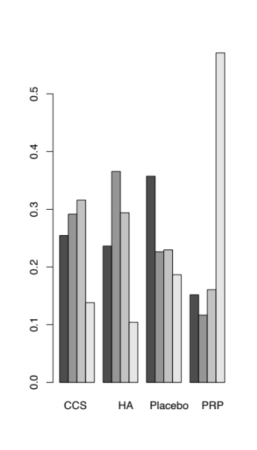
pain

