Forest Plots of pairwise comparisons of Secondary Outcome at short and long term follow-up
Short term

MMO
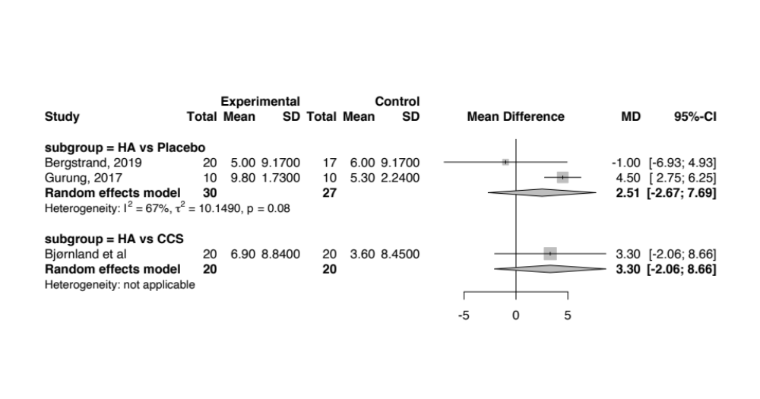
Long term
MMO
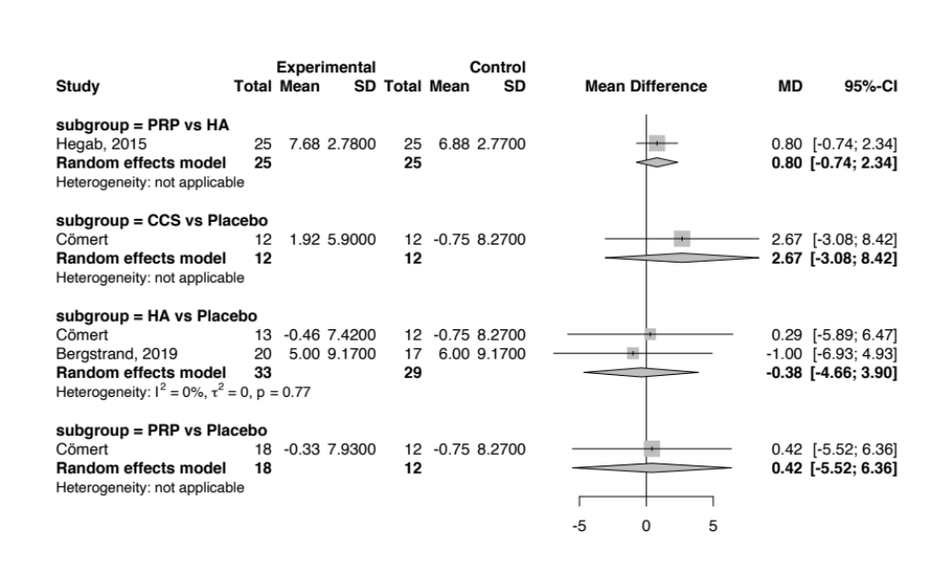

Lateral movement
