Forest Plots of Secondary Functional Outcomes (MMO) at Short-term Timepoints

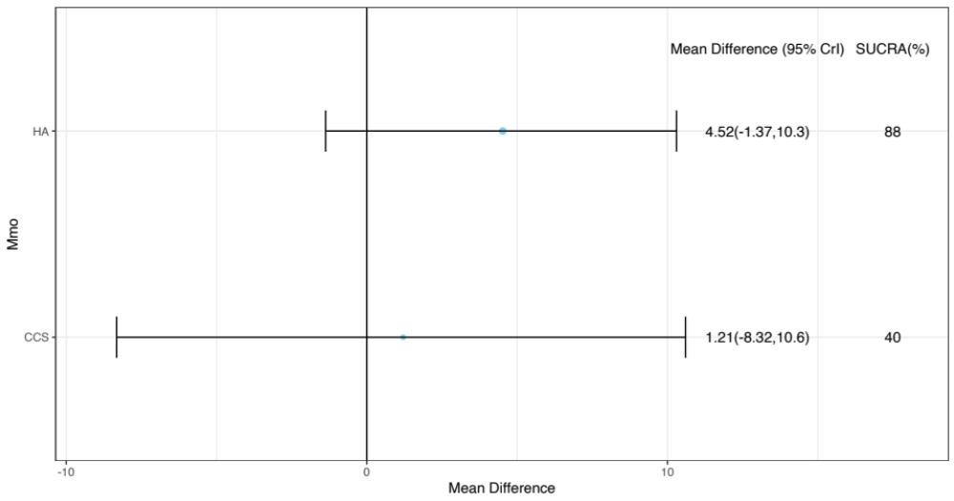

Forest Plots of Secondary Functional Outcomes (MMO, Lateral Movement) at Long-term Timepoints

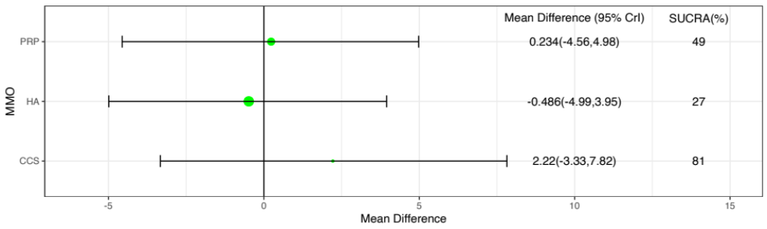
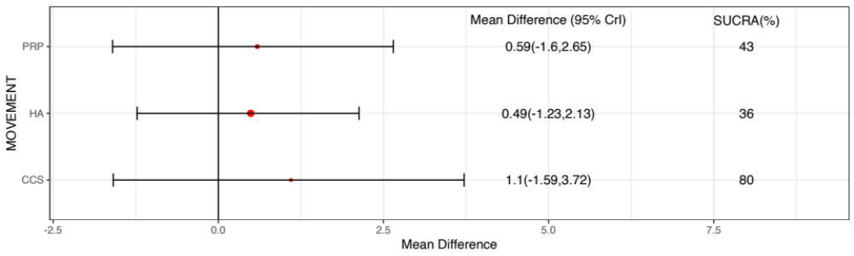

Leaguetables of of Secondary Functional Outcomes (MMO, Lateral Movement) at Short-term and Long-term Timepoints

Short term (MMO)

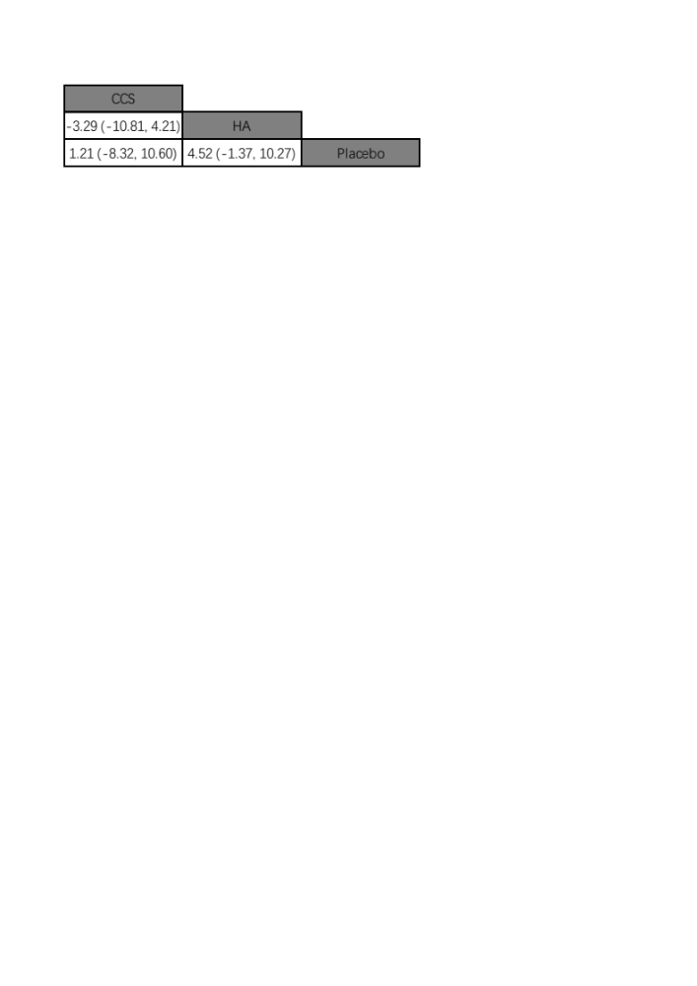

Long term (top: MMO, bottom: Lateral Movement)

