Supporting Information

Synergy of Single Atoms Pd and Oxygen Vacancies on In₂O₃ for Highly Selective C1 Oxygenates Production from Methane under Visible Light

Lei Luo, Lei Fu, Huifen Liu, Youxun Xu, Jialiang Xing, Junwang Tang*

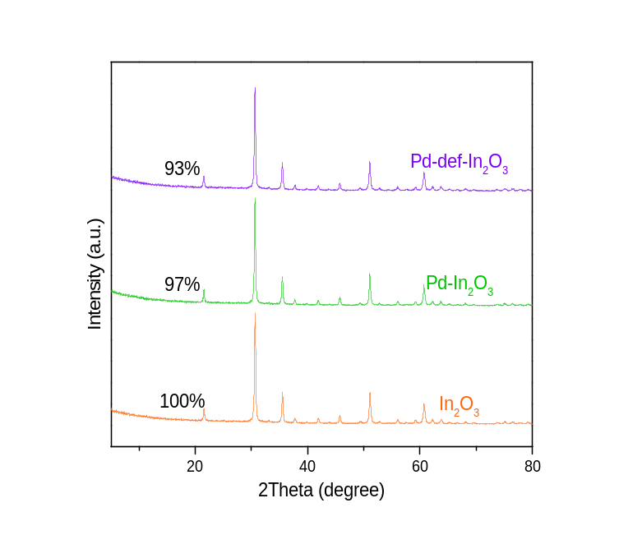
Figure S1. XRD patterns of In₂O₃, Pd-In₂O₃ and Pd-def-In₂O₃.

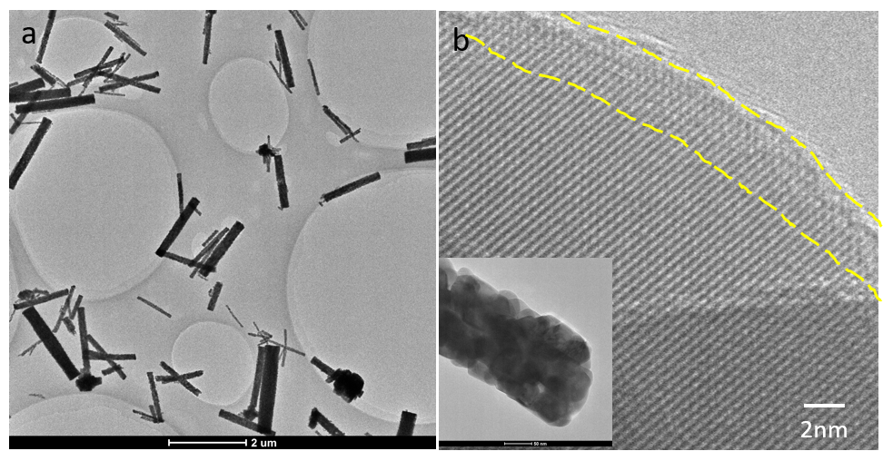
Figure S2. (a, b) HRTEM images of Pd-In₂O₃. In the region marked by yellow dash in panel b, no defective layer was observed on the edge of the Pd-In₂O₃ nanorods, suggesting the defect-lean structure of Pd-In₂O₃.

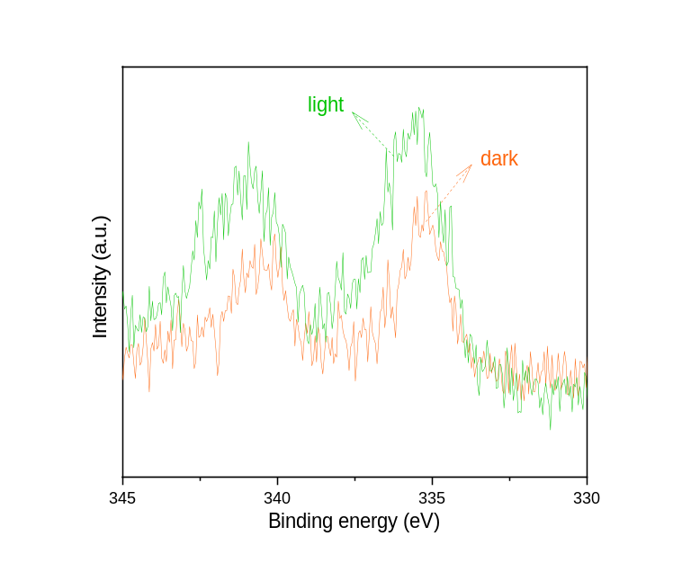
Figure S3. In-situ Pd_{3d} XPS spectra of Pd-def-In₂O₃ in dark and under light.

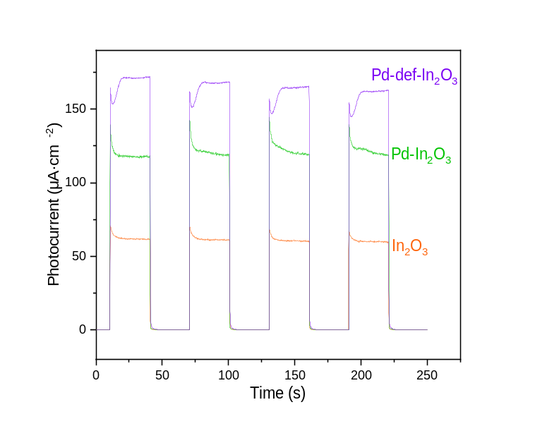
Figure S4. Photocurrent responses of In₂O₃, Pd-In₂O₃ and Pd-def-In₂O₃.

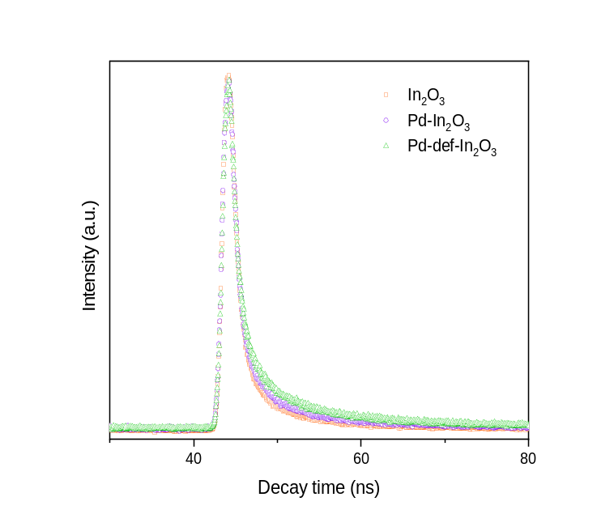
Figure S5. Time-decay PL spectra of In₂O₃, Pd-In₂O₃ and Pd-def-In₂O₃.

Table S1. Fitted PL lifetime from time-decay PL spectra of In₂O₃, Pd-In₂O₃ and Pd-def-In₂O₃.
Sample | α₁ | τ₁ [ns] | α₂ | τ₂ [ns] | τ [ns]
In₂O₃ | 0.98 | 49.9 | 6.21 | 50.1 | 3.60
Pd-In₂O₃ | 1.03 | 44.4 | 6.87 | 55.6 | 4.28
Pd-def-In₂O₃ | 1.00 | 36.8 | 7.32 | 63.2 | 4.99

