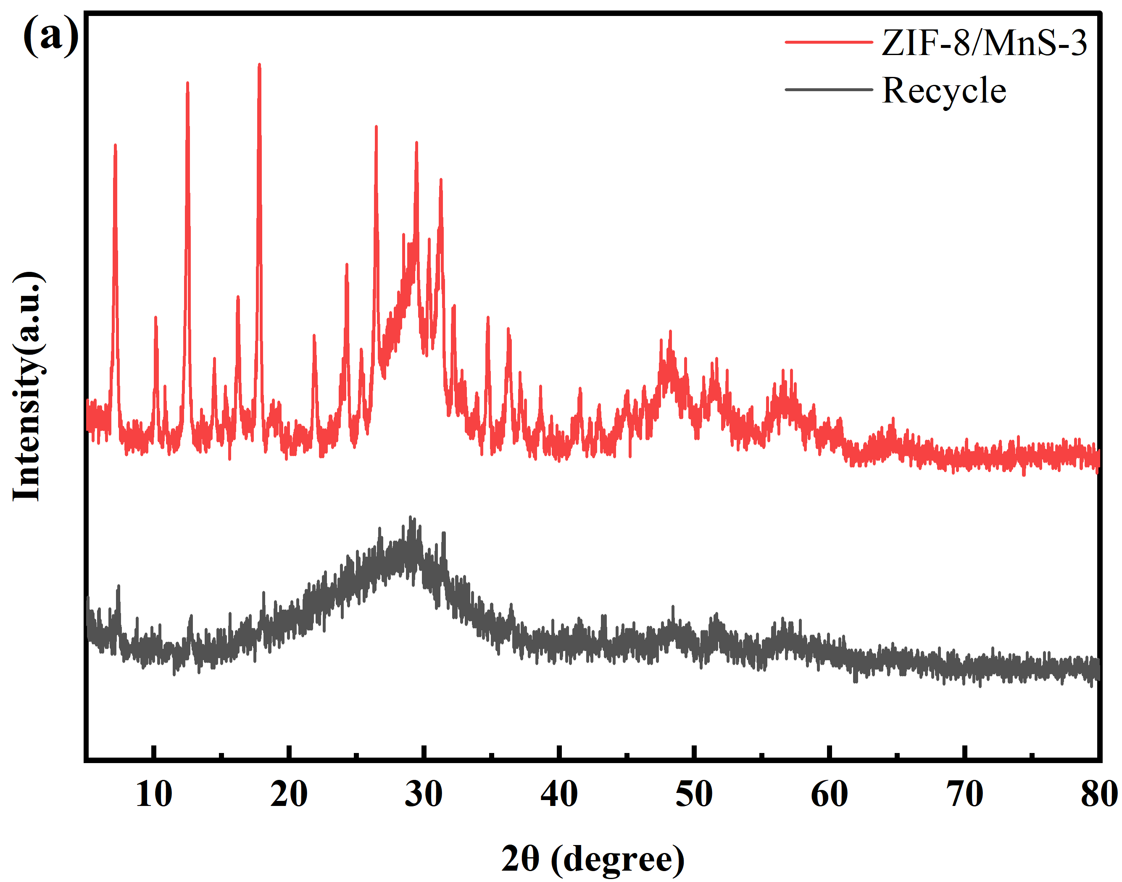  Fig.S1 (a) XRD patterns and SEM image of fresh and used ZIF-8/MnS photocatalyst | 