Supplementary Material
A label-free machine learning atlas of corneal aberration clusters from dual-surface Zernike coefficients: a retrospective cross-sectional study of 3,533 eyes
Orhan Karakulak, Emre Ayintap, Ipek Cikmazkara, Atilim Armagan Demirtas, Hasan Aytogan, Tuncay Kusbeci

Supplementary Methods
The supplementary analyses used the same 70/30 internal discovery-replication split described in the main manuscript. Block-normalised anterior and posterior corneal Zernike vectors were reduced by PCA in the discovery set, and the fitted transformation was then applied to the replication set without an additional post-PCA L2 renormalisation step.
Within the full CF+CB feature set, the smallest number of principal components targeting at least 90% cumulative variance was capped at 20 components. In the archived discovery output used here, 20 components captured 79.5% of the variance in the full dataset, consistent with the main manuscript.
Cluster-number comparison across K = 2 to K = 6 summarised cosine silhouette, Euclidean silhouette, bootstrap stability, severity predictability, and maximum pairwise centroid similarity. The current manuscript reports the equal-weight composite formulation, while Table S7 also lists archived sensitivity checks under alternative weight vectors.
K = 4 was retained only as a deliberate over-segmentation probe. Tables S2-S5 show all nine tomographic variables used in the post hoc comparisons (ISV, IVA, KI, CKI, IHA, IHD, BAD-D, Kmax, and CCT) together with pairwise descriptive effect-size summaries for the full and HOA-restricted K = 4 solutions.

Supplementary Figures
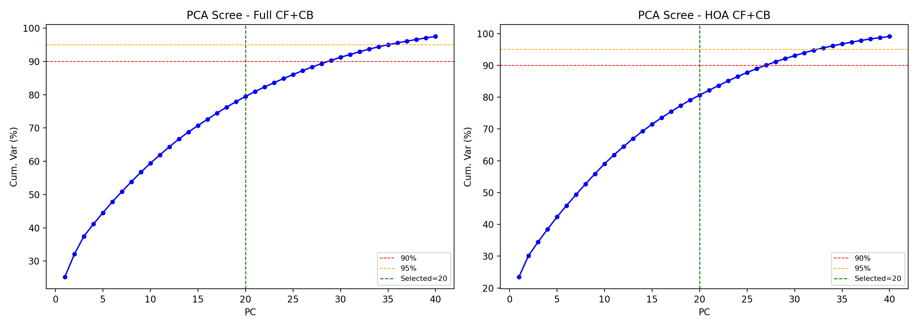
Figure S1. Cumulative variance explained by principal components in the discovery set for the full CF+CB and HOA-restricted feature spaces. The dashed vertical line marks the retained 20-component cap; in the full feature set, 20 components captured 79.5% of the variance in the archived run used for this submission.

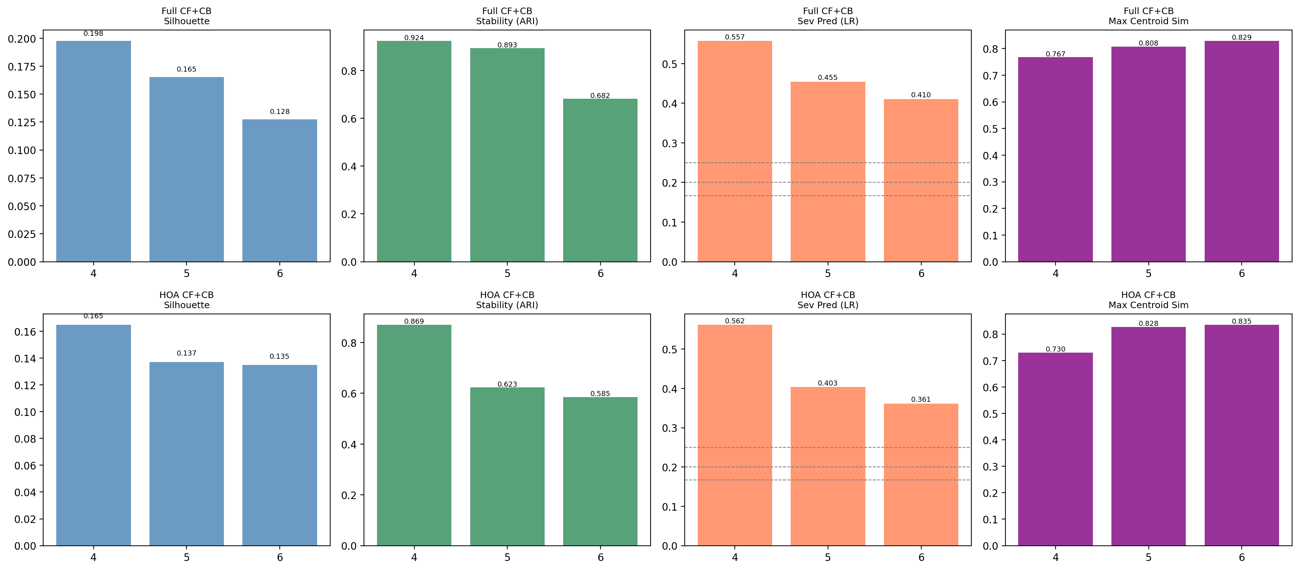
Figure S2. Cluster-number comparison metrics in the over-segmentation range (K = 4 to K = 6) for the full and HOA-restricted analyses. Bars show cosine silhouette, bootstrap stability, severity predictability, and maximum pairwise centroid similarity. Table S1 extends the full-analysis comparison to K = 2 and K = 3 and reports the parallel Euclidean silhouette values promised in the main manuscript.

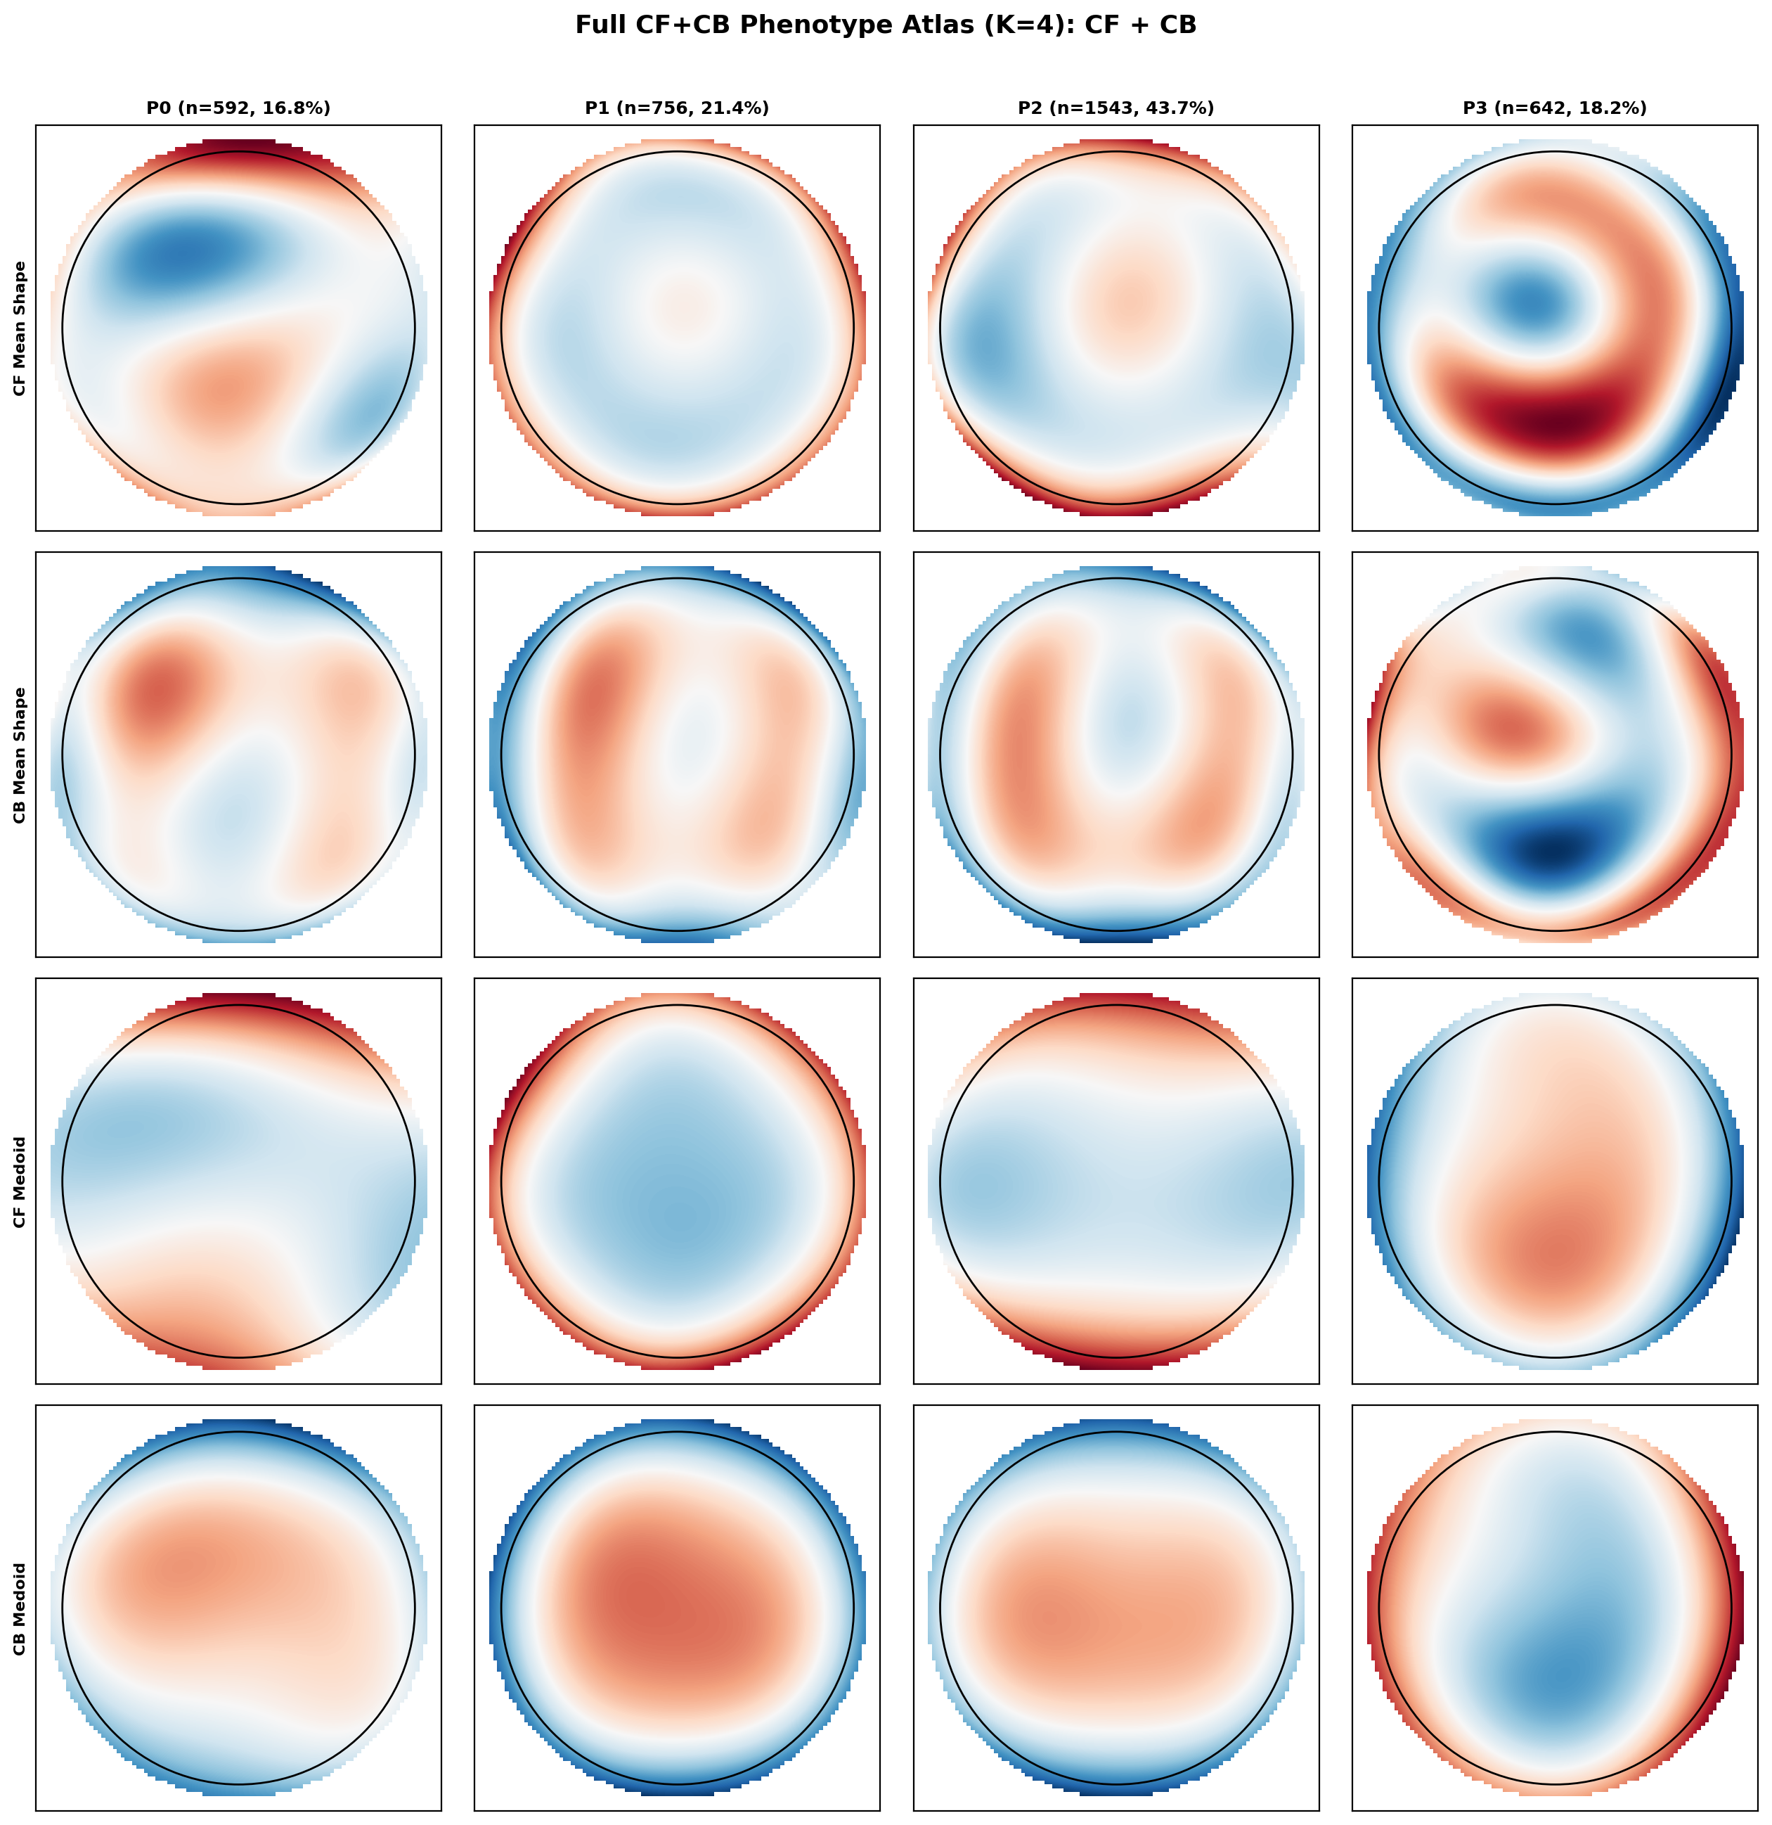
Figure S3. Four-cluster corneal aberration atlas for the full CF+CB feature set (orders 2 to 6). The visual similarity of P1 and P2, relative to the clearly separated high-severity P3 pattern, is consistent with over-segmentation in the full feature space.

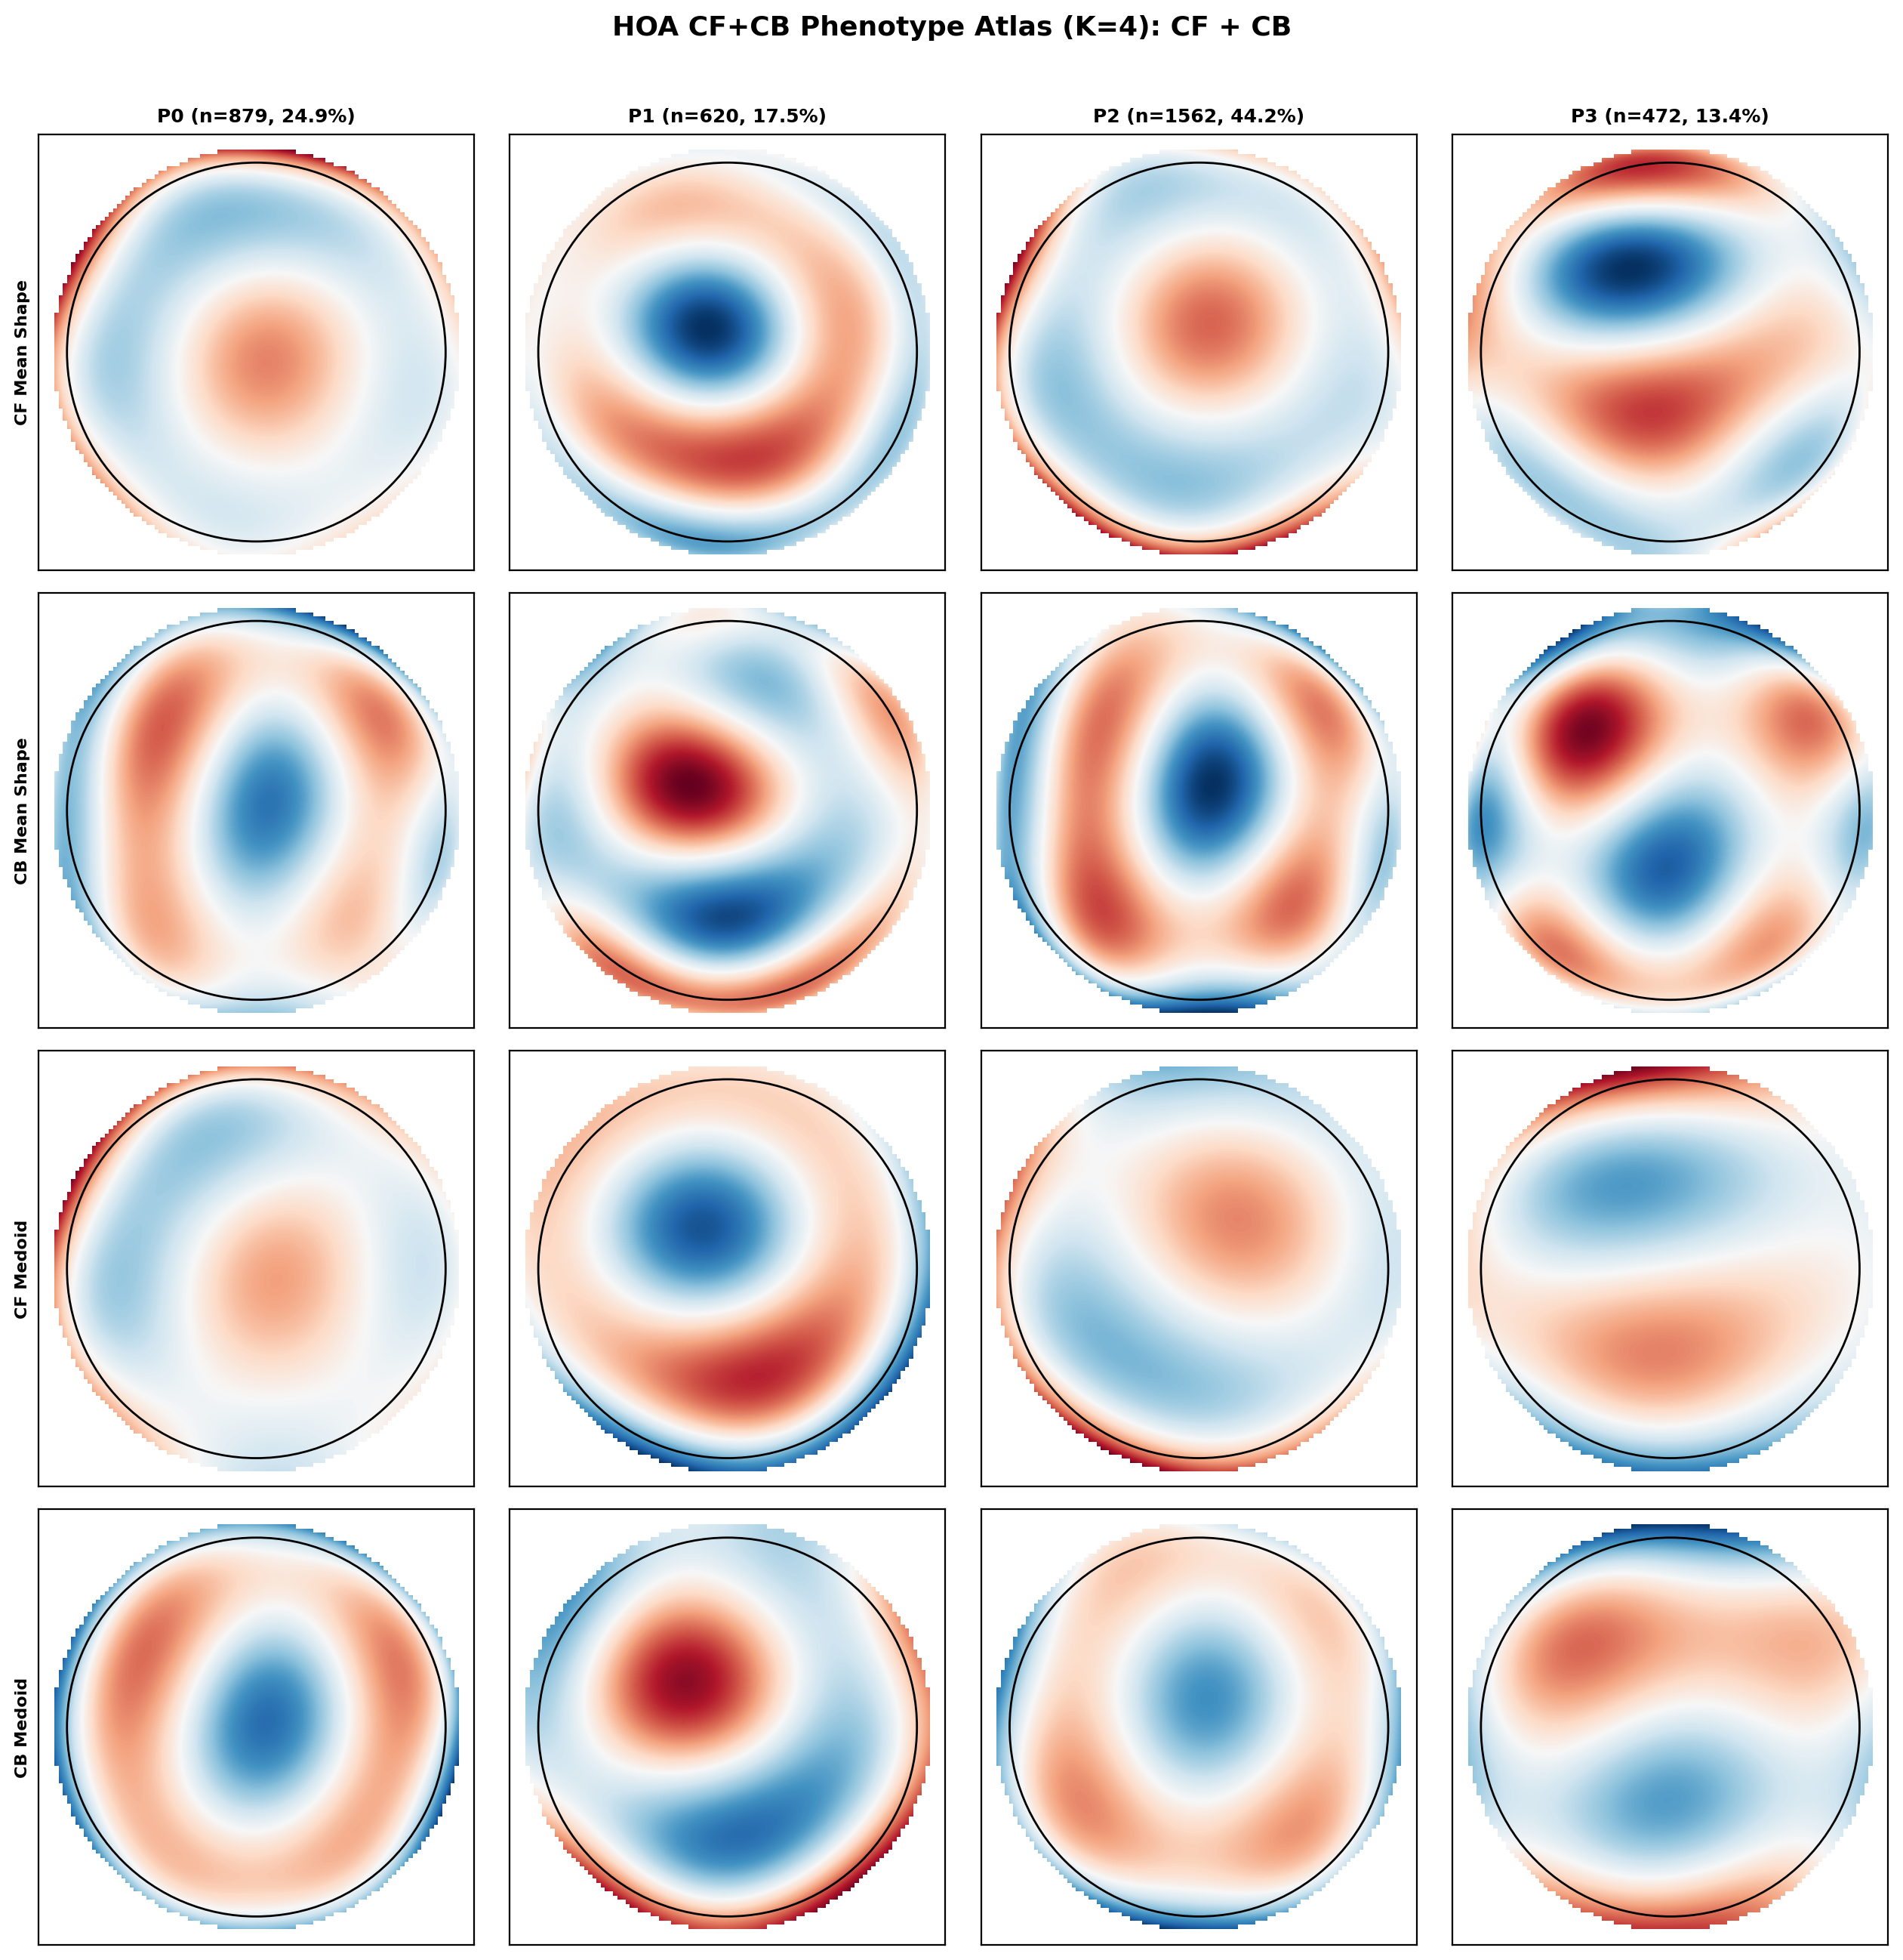
Figure S4. Four-cluster corneal aberration atlas for the HOA-restricted CF+CB feature set (orders 3 to 6 only). The recurrence of two clinically similar low-severity patterns confirms the over-segmentation signature in an independent feature subset.

Supplementary Tables
Table S1. Cluster-number comparison metrics for K = 2 to K = 6 in the full discovery analysis.
K | Cluster sizes | Min cluster % | Cosine silhouette | Euclidean silhouette | Bootstrap ARI | Severity LR acc. | Max centroid similarity
2 | 1597 / 876 | 35.4 | 0.2505 | 0.2336 | 0.9889 | 0.8459 | -1.0000
3 | 1031 / 654 / 788 | 26.4 | 0.1816 | 0.1413 | 0.9207 | 0.6316 | 0.2118
4 | 388 / 964 / 575 / 546 | 15.7 | 0.1720 | 0.1381 | 0.9475 | 0.5584 | 0.2744
5 | 792 / 371 / 524 / 480 / 306 | 12.4 | 0.1604 | 0.1161 | 0.8688 | 0.4776 | 0.3252
6 | 297 / 487 / 507 / 295 / 448 / 439 | 11.9 | 0.1428 | 0.0964 | 0.7217 | 0.3712 | 0.6763
Note: Cosine silhouette exceeded Euclidean silhouette at every examined K (difference 0.0169 to 0.0465), matching the cosine-based clustering objective used in the manuscript. Figure S2 provides the parallel K = 4 to K = 6 over-segmentation comparison for both the full and HOA-restricted analyses.

Table S2. Median [IQR] values of the nine tomographic indices across the full CF+CB K = 4 over-segmentation probe.
Variable | P0 (n=592) | P1 (n=756) | P2 (n=1543) | P3 (n=642)
ISV | 44.0 [30.00-61.25] | 18.5 [14.00-27.00] | 26.0 [19.00-34.00] | 84.0 [63.00-108.00]
IVA | 0.43 [0.24-0.68] | 0.15 [0.11-0.24] | 0.14 [0.10-0.20] | 0.77 [0.53-1.06]
KI | 1.1 [1.05-1.16] | 1.01 [0.99-1.03] | 1.01 [1.00-1.02] | 1.2 [1.14-1.28]
CKI | 1.01 [1.00-1.02] | 1.0 [0.99-1.00] | 1.01 [1.00-1.01] | 1.07 [1.05-1.10]
IHA | 16.35 [8.07-31.62] | 5.25 [2.40-9.40] | 6.2 [2.60-11.30] | 28.35 [13.72-45.88]
IHD | 0.05 [0.02-0.08] | 0.01 [0.01-0.02] | 0.01 [0.01-0.02] | 0.11 [0.07-0.15]
BAD-D | 4.25 [2.65-5.86] | 1.52 [0.98-2.27] | 1.46 [0.99-2.05] | 9.34 [7.07-12.29]
Kmax | 48.51 [46.41-51.04] | 45.38 [44.10-47.02] | 45.75 [44.34-47.14] | 56.32 [52.80-61.01]
CCT | 487.0 [459.00-515.00] | 536.0 [510.00-562.00] | 534.0 [510.00-560.00] | 441.5 [411.00-466.00]
Note: This table supplies the cluster-level medians for all nine variables cited in the main-text K = 4 post hoc comparison sentence.

Table S3. Pairwise post hoc summary for the full CF+CB K = 4 solution. The P1-P2 pair showed six of nine non-significant variables with mean |d| = 0.228, whereas all other pairs averaged 0.998 to 2.757.
Pair | Sig. vars | Non-sig. vars | Non-significant variables | Mean |d| | Max |d| | Interpretation
P0-P1 | 9 | 0 | None | 0.998 | 1.453 | Strong separation
P0-P2 | 9 | 0 | None | 1.339 | 2.080 | Strong separation
P0-P3 | 9 | 0 | None | 1.225 | 1.935 | Strong separation
P1-P2 | 3 | 6 | KI, IHA, IHD, BAD-D, Kmax, CCT | 0.228 | 0.748 | Artificial split
P1-P3 | 9 | 0 | None | 2.125 | 2.532 | Strong separation
P2-P3 | 9 | 0 | None | 2.757 | 3.599 | Strong separation

Table S4. Median [IQR] values of the nine tomographic indices across the HOA-restricted K = 4 over-segmentation sensitivity analysis.
Variable | P0 (n=879) | P1 (n=620) | P2 (n=1562) | P3 (n=472)
ISV | 23.0 [17.00-34.00] | 83.0 [61.00-108.00] | 24.0 [17.00-33.00] | 51.0 [38.00-72.00]
IVA | 0.15 [0.11-0.22] | 0.76 [0.51-1.03] | 0.15 [0.10-0.21] | 0.56 [0.37-0.85]
KI | 1.03 [1.02-1.05] | 1.2 [1.13-1.28] | 1.0 [0.99-1.02] | 1.12 [1.08-1.19]
CKI | 1.0 [1.00-1.01] | 1.07 [1.05-1.11] | 1.0 [1.00-1.01] | 1.02 [1.01-1.03]
IHA | 6.0 [2.60-10.80] | 27.4 [13.93-45.60] | 6.0 [2.52-11.60] | 22.1 [9.78-38.52]
IHD | 0.01 [0.01-0.02] | 0.11 [0.06-0.15] | 0.01 [0.01-0.02] | 0.06 [0.04-0.10]
BAD-D | 1.69 [1.10-2.40] | 9.3 [6.98-12.29] | 1.42 [0.96-1.99] | 5.08 [3.87-6.64]
Kmax | 45.75 [44.31-47.22] | 56.23 [52.66-61.05] | 45.61 [44.24-47.14] | 49.66 [47.52-52.29]
CCT | 529.0 [503.00-557.00] | 441.5 [411.00-466.25] | 537.0 [512.00-561.00] | 477.5 [453.00-501.00]

Table S5. Pairwise post hoc summary for the HOA-restricted K = 4 solution. The P0-P2 pair reproduced the same over-segmentation pattern, with six of nine non-significant variables and mean |d| = 0.229.
Pair | Sig. vars | Non-sig. vars | Non-significant variables | Mean |d| | Max |d| | Interpretation
P0-P1 | 9 | 0 | None | 2.162 | 2.699 | Strong separation
P0-P2 | 3 | 6 | ISV, IVA, CKI, IHA, IHD, Kmax | 0.229 | 1.131 | Artificial split
P0-P3 | 9 | 0 | None | 1.344 | 1.703 | Strong separation
P1-P2 | 9 | 0 | None | 2.666 | 3.305 | Strong separation
P1-P3 | 9 | 0 | None | 0.905 | 1.746 | Strong separation
P2-P3 | 9 | 0 | None | 1.740 | 2.758 | Strong separation

Table S6. Internal discovery-replication concordance for the selected solutions and the archived K = 4 over-segmentation probe.
K | Discovery set n | Replication set n | Mean matched centroid cosine similarity | ARI: projected vs refit replication labels | Interpretation
2 | 2473 | 1060 | 0.995 | 0.970 | Selected study optimum with the highest split-sample concordance.
3 | 2473 | 1060 | 0.886 | 0.607 | Clinically interpretable secondary solution retained despite lower stability than K = 2.
4 (full probe) | 2473 | 1060 | 0.987 | 0.900 | Archived over-segmentation probe remained geometrically concordant despite weaker clinical distinctiveness.
Note: The K = 2 and K = 3 rows reproduce the final split-sample concordance values reported in the main manuscript. The K = 4 row is shown for completeness from the archived supplementary concordance output.

Table S7. Equal-weight composite score used in the current manuscript and sensitivity to alternative weighting schemes.
Scheme | wSil | wStab | wSev | wSep | K2 | K3 | K4 | K5 | K6 | Optimal K
Archived original | 0.25 | 0.30 | 0.25 | 0.20 | 0.7500 | 0.4818 | 0.5207 | 0.4418 | 0.2500 | 2
Equal-weight (current manuscript) | 0.25 | 0.25 | 0.25 | 0.25 | 0.7500 | 0.4584 | 0.4904 | 0.4247 | 0.2500 | 2
Stability-heavy (0.15/0.50/0.15/0.20) | 0.15 | 0.50 | 0.15 | 0.20 | 0.8500 | 0.5495 | 0.6020 | 0.4580 | 0.1500 | 2
Silhouette-heavy (0.40/0.20/0.20/0.20) | 0.40 | 0.20 | 0.20 | 0.20 | 0.8000 | 0.4388 | 0.4465 | 0.3724 | 0.2000 | 2
Severity-heavy (0.20/0.20/0.40/0.20) | 0.20 | 0.20 | 0.40 | 0.20 | 0.6000 | 0.4570 | 0.5135 | 0.4950 | 0.4000 | 2
Note: Composite(K) = wSil x Sil_norm(K) + wStab x ARI_norm(K) + wSev x Pred_norm(K) + wSep x Sep_norm(K), where Sep_norm rewards lower maximum pairwise centroid similarity after min-max normalisation across candidate K values. Across all listed weighting schemes, K = 2 remained the global optimum and K = 4 remained the highest-scoring solution within the over-segmentation range (K = 4 to K = 6).

