Using mobile phone data to understand the demographic characteristics and behavioral patterns of park visitors in a megacity, Beijing, China

Supplementary Material

Pages = 7
Figures = 2
Tables = 2

List
1. Figure S1 Human behaviors in urban parks
2. Figure S2 Seasonal variation of the average number of visitors in different types of parks
3. Table S1 Selected date and weather conditions
4. Table S2 Park stay time of visitors from different regions

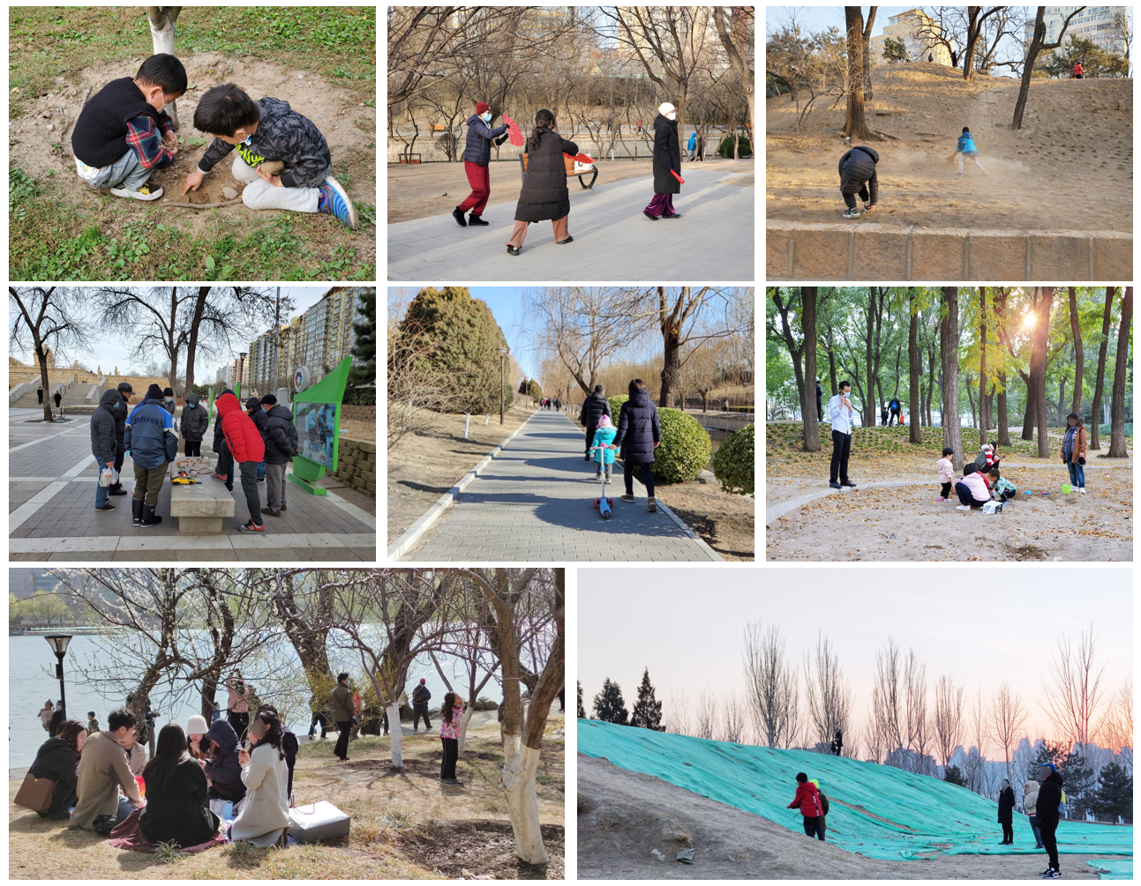
Figure S1
Human behaviors in urban parks

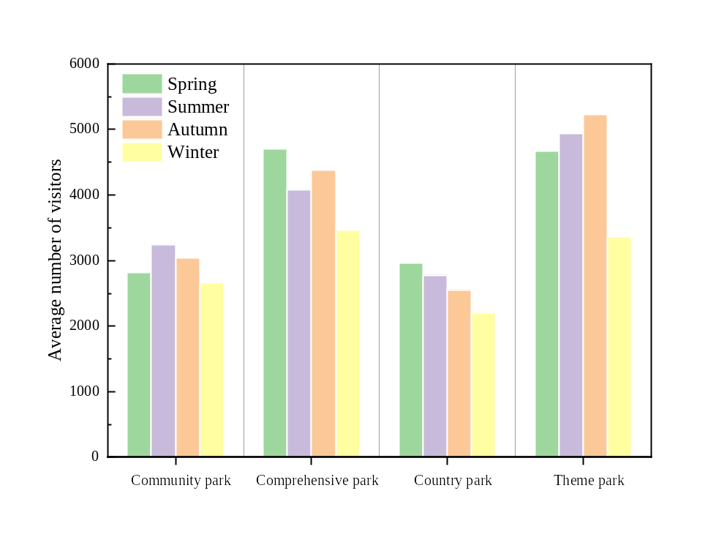
Figure S2
Seasonal variation of the average number of visitors in different types of parks

Table S1
Selected date and weather conditions
Season | Date | The highest temperature/℃ | The lowest temperature/℃ | AQI | Weather
Spring | March 6 | 10 | -2 | 42 | Sunny
Spring | March 16 | 19 | 2 | 56 | Sunny
Spring | April 2 | 18 | 3 | 58 | Sunny
Spring | April 14 | 22 | 8 | 57 | Sunny
Summer | June 9 | 30 | 17 | 49 | Sunny
Summer | June 10 | 32 | 18 | 97 | Sunny
Summer | July 12 | 34 | 22 | 144 | Sunny
Summer | July 13 | 32 | 24 | 151 | Cloudy
Autumn | September 18 | 25 | 14 | 41 | Sunny
Autumn | September 22 | 27 | 16 | 119 | Sunny
Autumn | October 25 | 14 | 2 | 30 | Sunny
Autumn | October 26 | 16 | 4 | 59 | Sunny
Winter | November 24 | 6 | -5 | 30 | Sunny
Winter | November 25 | 3 | -5 | 42 | Sunny
Winter | December 13 | 10 | -5 | 50 | Sunny
Winter | December 14 | 5 | -3 | 57 | Sunny

Table S2
Park stay time of visitors from different regions
Number | Country | Location | Duration of stay in urban park | Reference
1 | America | Norfolk | 50.5 min | Centers (2019)
2 | America | Washington | 40.6 min | Stewart et al., 2016
3 | Australia | Melbourne | 53% of respondents stayed in the park for 1 h or more. | Veitch et al., 2018
4 | China | Beijing | 42% of visitors stayed in the park for 1-2 h. | This study
5 | China | Hong Kong | 37.9% of respondents stayed in the park for 1-2 h | Xue et al., 2017
6 | China | Mianyang | Most of the respondents (26.44%) stayed in the parks for less than 15 min | Cheng et al., 2019
7 | China | Xi’an | 49.2% of respondents stayed around 2 h in the park | Zhai et al., 2018
8 | Greece | Attica | 49.9% of the interviewees spent 2 to 3 hours in Antonis Tritsis urban park | Halkos et al. (2020)
9 | Iran | Isfahan and Kerman | 34.5% of tourists preferred to stay in park for 1-2 h | Rostami et al., 2014
10 | Ireland | Dublin | 51% of visitors typically spent an hour in the park | Burrows et al., 2018
11 | Malaysia | Kuala Lumpur | Staying up to 2 h. | Pham et al., 2019
12 | Poland | Warsaw | More than half of the respondents usually spent about an hour in the park. | Blaszczyk et al., 2020
13 | Romania | Bucharest | Most tourists stayed in the park for 1-2 hours. | Onose et al., 2020
14 | Singapore | Singapore City | 51.4% of respondents only spent a few minutes in park. | Xue et al., 2017
15 | South Africa | Cape Town | 38% of adults spent 0-15 min in the park | Willemse, 2018
16 | the United Mexican States | Mexico City | Users spent 44.5 min in small parks while spent between 82.9 and 88 min in larger parks | Ayala-Azcarraga et al., 2019
17 | Turkey | Aydin | 48.9% of visitors stayed 1-2 h in the urban greenway | Akpinar, 2016
18 | Vietnam | Hanoi | 77.5 min | Pham et al., 2019

Reference
Akpinar, A., 2016. Factors influencing the use of urban greenways: a case study of Aydin, Turkey. Urban Forestry and Urban Greening, 16, 123-131.
Ayala-Azcarraga, C., Diaz, D., Zambrano L., 2019. Characteristics of urban parks and their relation to user well-being. Landscape and Urban Planning, 189, 27-35.
Blaszczyk, M., Suchocka, M., Wojnowska-Heciak, M., et al., 2020. Quality of urban parks in the perception of city residents with mobility difficulties. PerrJ, 8, e10570.
Burrows, E., O’Mahony, M., Geraghty, D., 2018. How urban parks offer opportunities for physical activity in Dublin, Ireland. International Journal of Environmental Research and Public Health, 15(4), 815.
Centers, K. T., 2019. An exploration of the relationships between sense of community, park benefits, and neighborhood park use. Old Dominion University. Norfolk, America. https://search.proquest.com/dissertations-theses/exploration-relationships-between-sense-community/docview/2311974186/se-2?accountid=178611.
Cheng, B., Gou, Z.H., Zhang, F., et al., 2019. Thermal comfort in urban mountain parks in the hot summer and cold winter climate. Sustainable Cities and Society, 51, 101756.
Onose, D.A., Ioja, I.C., Nita, M.R., et al., 2020. Too old for recreation? How friendly are urban parks for elderly people? Sustainability, 12(3), 790.
Pham, T.T.H., Labbe, D., Lachapelle, U., et al., 2019. Perception of park access and park use amongst youth in Hanoi: How cultural and local context matters. Landscape and Urban Planning, 189, 156-165.
Rostami, R., Lamit, H., Khoshnava, S.M., et al., 2014. The role of historical persian gardens on the health status of contemporary urban residents. Ecohealth, 11(3), 308-321.
Stewart, O.T., Moudon, A.V., Fesinmeyer, M.D., et al., 2016. The association between park visitation and physical activity measured with accelerometer, GPS, and travel diary. Health and Place, 38, 82-88.
Veitch, J., Wang, W.C., Salmon, J., et al., 2018. Who goes to metropolitan parks? A latent class analysis approach to understanding park visitation. Leisure Sciences, 40(5), 343-355.
Willemse, L., 2018. A class-differentiated analysis of park use in Cape Town, South Africa. GeoJournal, 83(5), 915-934.
Xue, F., Gou, Z.H., Lau, S., et al., 2017. The green open space development model and associated use behaviors in dense urban settings: Lessons from Hong Kong and Singapore. Urban Design International, 22(4), 287-302.
Zhai, Y., Li, K.K., Liu, J.J., et al., 2018. A conceptual guideline to age-friendly outdoor space development in China: How do Chinese seniors use the urban comprehensive park? A focus on time, place, and activities. Sustainability, 10(10), 3678.

