Additional file
S1. Clustering Results for the Derivation Cohort
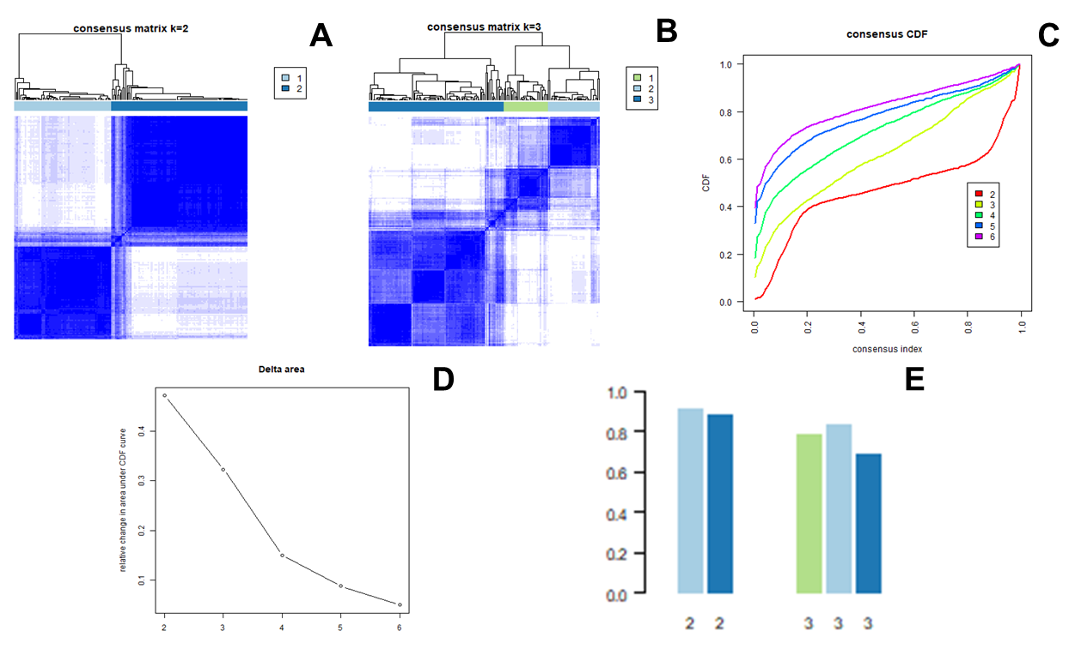
Panel A-B:​​ Visualization of the consensus matrices for cluster numbers (k) ranging from 2 to 3 only. The clearer block diagonal structure observed at k=2 indicates better classification stability and distinct cluster separation. Panel C-D:​​ The relative change in the area under the cumulative distribution function (CDF) curves for k values ranging from 2 to 6. The minimal change in the area under the CDF curve when k increased from 2 to 3 supports the selection of k=2 as the optimal number of clusters. Panel E:​​ The consensus index values for k=2 and k=3 are displayed. A consensus index of 0 indicates that item pairs were never assigned to the same cluster across iterations, whereas a value of 1 indicates they were always clustered together. Therefore, a higher consensus index (e.g., > 0.8) is preferable, and k=2 demonstrated a superior consensus profile compared to k=3.

S2.​​ Clinical characteristics of different phenotypes
 | Total  （n=173） | Phenotype 1（n=77） | Phenotype 2（n=96） | P value
Male, n (%) | 82 (47.4) | 46 (59.7) | 36 (37.5) | 0.006
Age, years | 61.0±14.9 | 55.1±14.0 | 65.7±13.8 | < 0.001
BMI，kg/m² | 28.6 (25.4, 34.7) | 27.1 (24.6, 30.9) | 30.8 (26.2, 36.5) | 0.013
SOFA score | 8 (5, 10) | 10 (8, 13) | 5 (4, 8) | < 0.001
Comorbidities, n (%)
Chronic heart failure | 51 (29.5) | 23 (29.9) | 28 (29.2) | >0.999
Cerebrovascular disease | 11 (6.4) | 4 (5.2) | 7 (7.3) | 0.757
Chronic pulmonary disease | 52 (30.1) | 19 (24.7) | 33 (34.4) | 0.224
Type 2 diabetes | 72 (41.6) | 40 (51.9) | 32 (33.3) | 0.021
Renal disease | 43 (24.9) | 35 (45.5) | 8 (8.3) | < 0.001
Malignancy | 12 (6.9) | 5 (6.5) | 7 (7.3) | >0.999
Liver disease | 30 (17.3) | 26 (33.8) | 4 (4.2) | < 0.001
AID，n（%）
Systemic lupus erythematosus | 17 (9.8) | 9 (11.7) | 8 (8.3) | 0.631
Rheumatoid arthritis | 42 (24.3) | 10 (13) | 32 (33.3) | 0.003
Ankylosing spondylitis | 4 (2.3) | 0 (0) | 4 (4.2) | 0.130
Multiple sclerosis | 15 (8.7) | 5 (6.5) | 10 (10.4) | 0.523
Primary biliary cholangitis | 0 (0) | 0 (0) | 0 (0) | >0.999
Crohn's disease | 21 (12.1) | 4 (5.2) | 17 (17.7) | 0.023
Ulcerative colitis | 16 (9.2) | 9 (11.7) | 7 (7.3) | 0.467
Type 1 diabetes | 38 (22) | 31 (40.3) | 7 (7.3) | < 0.001
Celiac disease | 3 (1.7) | 3 (3.9) | 0 (0) | 0.086
Psoriasis | 25 (14.5) | 11 (14.3) | 14 (14.6) | >0.999

S2.​​ Clinical characteristics of different phenotypes (continued)
 | Total  （n=173） | Phenotype 1  （n=77） | Phenotype 2  （n=96） | P value
Laboratory parameters
PaO2/FiO2, mmHg | 163.6±69.0 | 150.2±71.4 | 174.3±65.4 | 0.023
Hemoglobin, g/L | 97±22 | 90±23 | 103±19 | < 0.001
Platelet count, ×10⁹/L | 171±82 | 142±84 | 195±73 | < 0.001
White blood cell count, ×10⁹/L | 15.5 (11.4, 21.4) | 17.6 (12.6, 25.3) | 13.5 (11.0, 18.0) | < 0.001
Absolute neutrophil count, ×10⁹/L | 11.3 (7.5, 16.0) | 14.1 (10.5, 19.2) | 9.0 (6.3, 13.8) | < 0.001
Absolute lymphocyte count, ×10⁹/L | 0.92 (0.41, 1.58) | 0.52 (0.27, 1.13) | 1.27 (0.76, 2.10) | < 0.001
International normalized ratio | 1.3 (1.2, 1.6) | 1.4 (1.3, 1.9) | 1.25 (1.1, 1.4) | < 0.001
Activated partial thromboplastin time, s | 34.1 (29.1, 47.4) | 43 (32.5, 70.2) | 31 (27.6, 36.6) | < 0.001
Serum creatinine, mg/dL | 1.2 (0.9, 2.3) | 2.3 (1.4, 3.7) | 1 (0.7, 1.2) | < 0.001
Aspartate aminotransferase, U/L | 46 (27, 110) | 95 (36, 197) | 37 (25, 67) | < 0.001
Total bilirubin, mg/dL | 0.6 (0.4, 1.1) | 0.8 (0.4, 2) | 0.5 (0.4, 0.7) | < 0.001
Treatments, n (%)
Glucocorticoid | 52 (30.1) | 28 (36.4) | 24 (25) | 0.146
DMARDs | 16 (9.2) | 11 (14.3) | 5 (5.2) | 0.074
Outcome
Sepsis, n (%) | 151 (87.3) | 72 (93.5) | 79 (82.3) | 0.049
MV Duration, hours | 63 (22, 150) | 81 (34, 188) | 47 (16, 120) | 0.013
28-day in-hospital mortality, n (%) | 28 (16.2) | 20 (26.0) | 8 (8.3) | 0.003
This table compares the baseline features between the two identified phenotypes among ARDS patients with autoimmune diseases (AIDs). Phenotype 1 (n=77) was characterized by younger age, more severe organ dysfunction (higher SOFA score), and higher mortality. Phenotype 2 (n=96) comprised older patients with less severe illness and lower mortality. Data are presented as mean ± SD, median (IQR), or n (%). AIDs, autoimmune diseases; BMI, body mass index; SOFA, sequential organ failure assessment; DMARDs, disease-modifying antirheumatic drugs; MV, mechanical ventilation; SD, standard deviation; IQR, interquartile range.

S3.​​ Impact of Corticosteroid Use on 28-Day Mortality
Outcomes | Phenotype 1 |  | P value | Phenotype 2 |  | P value
Outcomes | Corticosteroid Use (n =28 ) | No Corticosteroid  Use (n = 49) | P value | Corticosteroid Use(n = 24) | No Corticosteroid Use (n =72) | P value
28-day in-hospital mortality, n (%) | 8 (28.6) | 12 (24.5) | 0.902 | 5 (20.8) | 3 (4.2) | 0.022
This table compares 28-day in-hospital mortality between patients who received corticosteroids and those who did not, stratified by the two identified phenotypes. Corticosteroid use was associated with significantly higher mortality in Phenotype 2 (20.8% vs. 4.2%, P=0.022), but not in Phenotype 1 (28.6% vs. 24.5%, P=0.902). Data are presented as number (percentage).

S4.​​ Impact of DMARDs Use on 28-Day Mortality
Outcomes | Phenotype 1 |  | P value | Phenotype 2 |  | P value
Outcomes | DMARDs Use  (n =11 ) | No DMARDs  Use (n = 66) | P value | DMARDs Use  (n = 5) | No DMARDs  Use (n = 91) | P value
28-day in-hospital mortality, n (%) | 1 (9.1) | 19 (28.8) | 0.271 | 1 (20.0) | 7 (7.7) | 0.359
This table compares 28-day in-hospital mortality between patients who received DMARDs and those who did not, stratified by phenotype. No significant association was found between DMARDs use and mortality in either Phenotype 1 (9.1% vs. 28.8%, P=0.271) or Phenotype 2 (20.0% vs. 7.7%, P=0.359). Data are presented as number (percentage).

