Supplementary Information

Radiochemistry and Comparative In Vitro Assessment of PSMA-617 Labeled with Lead-212 (²¹²Pb), Actinium-225 (²²⁵Ac), and Lutetium-177 (¹⁷⁷Lu).

Abhijit Bera¹, Graham Ragland¹, Yuhan Zhang², Patricia G. Madel², Jasmine B'Lanton², Atchimnaidu Siriki¹, Chin-Tu Chen¹, Russell Z. Szmulewitz², Satish K. Chitneni^{1*}

¹Department of Radiology and ²Department of Medicine, The University of Chicago, Chicago, IL, USA

*Correspondence: schitneni@uchicago.edu

Table of Contents

Synthesis scheme and LC-MS analysis of nonradioactive Lu-PSMA-617…………………………p2
Synthesis scheme and LC-MS analysis of nonradioactive Pb-PSMA-617 ……………………….p3
Radiolabeling and QC analysis of [¹⁷⁷Lu]Lu-PSMA-617…………………………………………….p4
Radiolabeling and QC analysis of [²²⁵Ac]Ac-PSMA-617………………….………………………….p5
Radiolabeling and QC analysis of [²¹²Pb]Pb-PSMA-617………………...……………………….....p6
Stability profiles of [¹⁷⁷Lu]Lu-PSMA-617, [²²⁵Ac]Ac-PSMA-617 and [²¹²Pb]Pb-PSMA-617……….p7
Cell uptake of the three radioligands in LNCaP-AR and DU145-PSMA cell lines………….………p8
Binding affinity assay of [²²⁵Ac]Ac-PSMA-617 without DTPA in the incubation medium………....p9

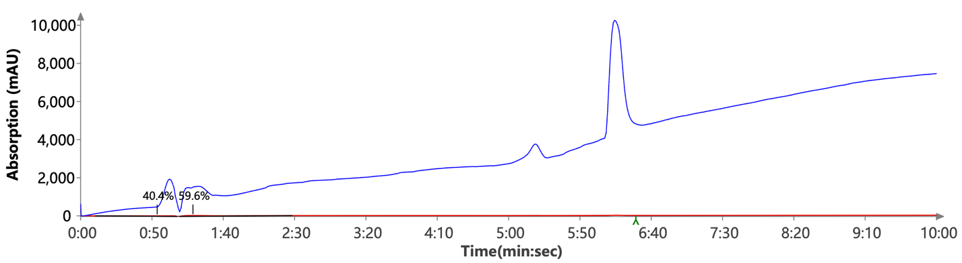
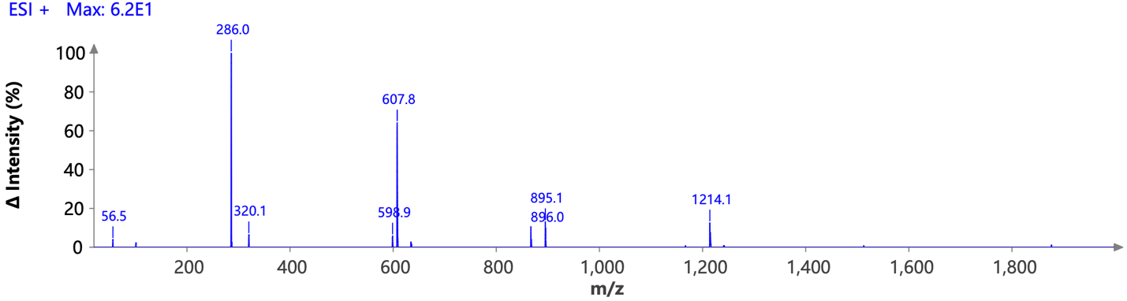
A
B

Figure S1. (A) Synthesis scheme for the nonradioactive Lu-PSMA-617. (B) LC-MS analysis of the purified Lu-PSMA-617 (m/z: 1214.1 [M+H]⁺).

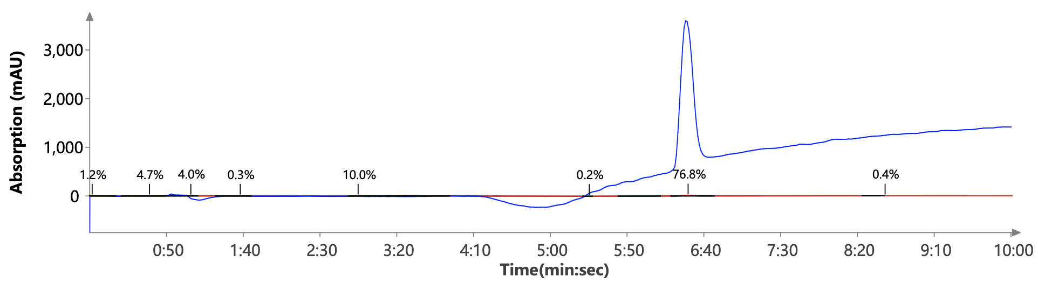
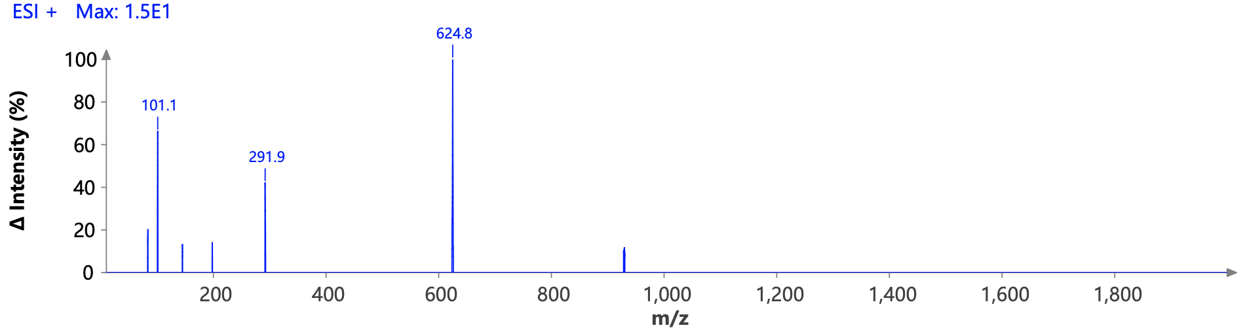
A
B

Figure S2. (A) Synthesis scheme for the nonradioactive Pb-PSMA-617. (B) LC-MS analysis of the purified Pb-PSMA-617 (m/z: 1247.46 ([M+H]⁺), m/z: 624.8 ([M+2H]⁺²)).

A
B
C
[¹⁷⁷Lu]Lu-PSMA-617
[¹⁷⁷Lu]Lu-PSMA-617
Free ¹⁷⁷Lu

Figure S3. (A) Radiolabeling of PSMA-617 with ¹⁷⁷Lu. (B) Radio-HPLC chromatogram of the crude labeling mixture of [¹⁷⁷Lu]Lu-PSMA-617. (C) Radio-HPLC chromatogram of [¹⁷⁷Lu]Lu-PSMA-617 after Sep-Pak purification.

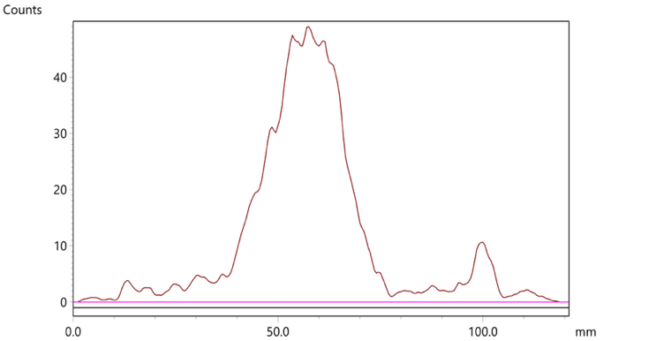
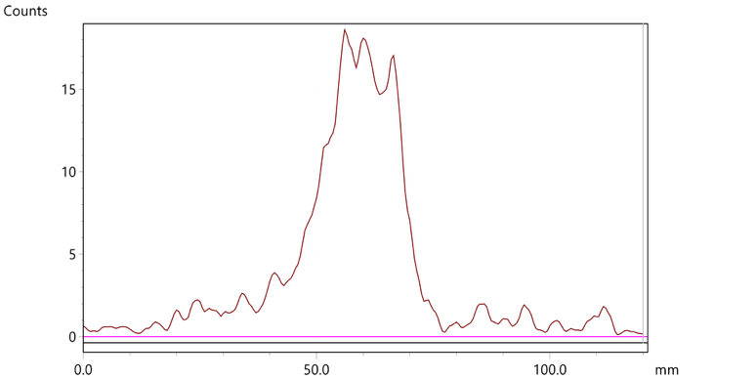
A
B
[²²⁵Ac]Ac-PSMA-617
Free ²²⁵Ac
C
[²²⁵Ac]Ac-PSMA-617
Figure S4. (A) Radiolabeling of PSMA-617 with ²²⁵Ac. (B) iTLC chromatogram of the crude labeling mixture of [²²⁵Ac]Ac-PSMA-617. (C) iTLC chromatogram of [²²⁵Ac]Ac-PSMA-617 after Sep-Pak purification.

B
Free ²¹²Pb
[²¹²Pb]Pb-PSMA-617
C
[²¹²Pb]Pb-PSMA-617
A

Figure S5. (A) Radiolabeling of PSMA-617 with ²¹²Pb. (B) Radio-HPLC chromatogram of the crude labeling mixture of [²¹²Pb]Pb-PSMA-617. (C) Radio-HPLC chromatogram of [²¹²Pb]Pb-PSMA-617 after Sep-Pak purification.

A
B
C
Figure S6. In vitro stability of [¹⁷⁷Lu]Lu-PSMA-617 (A), [²²⁵Ac]Ac-PSMA-617 (B), and [²¹²Pb]Pb-PSMA-617 (C) in PBS, human serum, and human whole blood.

A
B
Figure S7. Comparison of the cell uptake of [¹⁷⁷Lu]Lu-PSMA-617, [²¹²Pb]Pb-PSMA-617, and [²²⁵Ac]Ac-PSMA-617, in the PSMA-positive LNCaP-AR cell line (A), and in the PSMA-overexpressing DU145-PSMA cell line (B).

Figure S8. Saturation binding assay of [²²⁵Ac]Ac-PSMA-617 in the PSMA-positive LNCaP-AR cell line with no DTPA in the incubation medium.

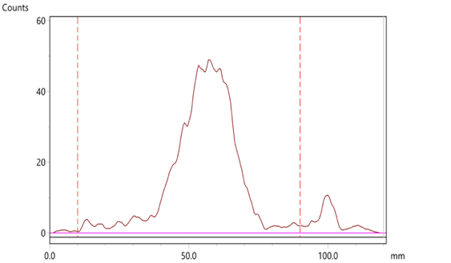
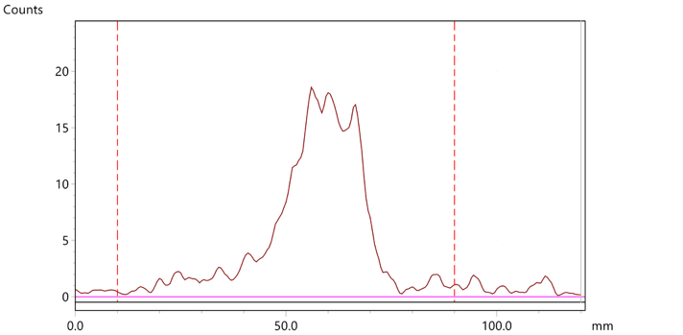
Scheme 3. Radiolabeling of PSMA-617 with ²²⁵Ac.
A
B
²²⁵Ac-PSMA-617
Fig. 7. iTLC analysis of the ²²⁵Ac-PSMA-617 crude reaction mixture (A) and after purification with a Sep-Pak (B). Analysis was done immediately after the reaction.
²²⁵Ac
²²⁵Ac-PSMA-617

