Integrated management of soybean root disease caused by Fusarium ipomoeae using biological and chemical control methods with a species-specific detection technique

Gyuri Hong^{1,2†}, Sung-Won Park^{1,2†}, Ju Gyeong Lee^{1,2}, Minseo Cho^{1,2}, Martin I. Chilvers³, Hyunkyu Sang^{1,2,4}*

¹Department of Integrative Food, Bioscience and Biotechnology, Chonnam National University, Gwangju, Republic of Korea, 61186
²Department of Integrative Food, Bioscience and Biotechnology and BK21 FOUR Program, Chonnam National University, Gwangju, South Korea
³Department of Plant, Soil and Microbial Sciences, Michigan State University, East Lansing, MI 48824
⁴Kumho Life Science Laboratory, Chonnam National University, Gwangju, Republic of Korea, 61186

*Corresponding author: Hyunkyu Sang, hksang@jnu.ac.kr
† These authors have contributed equally and shared first authorship.

Supplementary Table S1. Primers and PCR conditions for molecular identification of Fusarium spp. and bacterial isolates.
Gene | Primer | Primer sequence (5′–3′) | Annealing temp (℃)ª | Amplicon size (bp)^{b} | Reference
TEF1 | EF-1 | ATG GGT AAG GAR GAC AAG AC | 55 | 700 | [52]
TEF1 | EF-2 | GGA RGT ACC AGT SAT CAT GTT | 55 | 700 | [52]
RPB2 | 5F2 | GGG GWG AYC AGA AGA AGG C | 55 | 900 | [53]
RPB2 | 7cR | CCC ATR GCT TGY TTR CCC AT | 55 | 900 | [53]
CAL | 228F | GAG TTC AAG GAG GCC TTC TCC C | 61 | 500 | [54]
CAL | 2Rd | TGR TCN GCC TCD CGG ATC ATC TC | 61 | 500 | [54]
16S rRNA | 27F | AGA GTT TGA TCM TGG CTC AG | 55 | 1500 | [55]
16S rRNA | 1492R | GGT TAC CTT GTT ACG ACT T | 55 | 1500 | [55]
gyrB | up-1 | GAA GTC ATC ATG ACC GTT CTG CAY GCN GGN GGN AAR TTY GA | 63 | 1200 | [56,57]
gyrB | up-2r | AGC AGG ATA CGG ATG TGC GAG CCR TCN ACR TCN GCR TCN GTC AT | 63 | 1200
rpoD | 70F | ACG ACT GAC CCG GTA CGC ATG TAY ATG MGN GAR ATG GGN CAN GT | 56 | 700 | [58]
rpoD | 70R | ATA GAA ATA ACC AGA CGT AAG TTN GCY TCN ACC ATY TCY TTY TT | 56 | 700 | [58]
Primer sequences, annealing temperatures, and expected amplicon sizes used for PCR amplification of target genes for the identification of Fusarium spp. and bacterial isolates. The TEF1, RPB2, and CAL genes were used for Fusarium isolates, while 16S rRNA, gyrB, and rpoD were used for bacterial identification.
ᵃ Annealing temperatures are shown for PCR performed using nPfu-Forte DNA polymerase, except for rpoD, which was amplified using Phusion High-Fidelity DNA Polymerase.
ᵇ Expected amplicon sizes are approximate and may vary depending on the target organism and primer binding region
Supplementary Table S2. Species complexes, locations, and substrates of Fusarium isolates from soybean fields in Gimje, Korea.
Isolate | Complexª | Location^{b} | Substrate^{c}
CMML23-12 | FFSC | A | Root (D)
CMML23-13 | FNSC | A | Soil (D)
CMML23-14 | FSSC | A | Root (D)
CMML23-15 | FSSC | A | Root (D)
CMML23-16 | FNSC | A | Soil (D)
CMML23-17 | FSSC | A | Root (D)
CMML23-18 | FSSC | A | Soil (D)
CMML23-19 | FSSC | A | Soil (D)
CMML23-20 | FNSC | A | Soil (D)
CMML23-21 | FSSC | A | Soil (D)
CMML23-22 | FSSC | A | Root (D)
CMML23-23 | FSSC | A | Soil (D)
CMML23-24 | FNSC | A | Soil (D)
CMML23-25 | FSSC | A | Root (H)
CMML23-26 | FIESC | B | Soil (D)
CMML23-27 | FIESC | B | Soil (D)
CMML23-28 | FOSC | B | Soil (D)
CMML23-29 | FIESC | B | Soil (D)
CMML23-30 | FSSC | B | Root (D)
CMML23-31 | FNSC | B | Soil (D)
CMML23-32 | FSSC | B | Root (D)
CMML23-33 | FIESC | B | Soil (D)
CMML23-34 | FNSC | B | Soil (D)
CMML23-35 | FSSC | B | Root (D)
CMML23-36 | FNSC | B | Soil (D)
CMML23-37 | FSSC | B | Soil (D)
CMML23-38 | FSSC | B | Soil (D)
CMML23-39 | FSSC | B | Soil (D)
CMML23-40 | FSSC | B | Root (D)
CMML23-41 | FSSC | B | Root (D)
CMML23-42 | FOSC | B | Root (H)
CMML23-43 | FSSC | C | Root (H)
CMML23-44 | FSSC | C | Root (H)
CMML23-45 | FSSC | C | Root (H)
CMML23-46 | FSSC | C | Root (H)
CMML23-47 | FSSC | C | Root (H)
CMML23-48 | FSSC | C | Root (H)
CMML23-49 | FSSC | C | Root (H)
ª Species complex assignment was based on TEF1-based phylogenetic analysis.
^{b} A–C indicate soybean fields as described in the Materials and Methods.
^{c} Latter in parentheses indicate the health status of the substrate: D for diseased, H for healthy

Supplementary Table S3. Soybean-associated bacterial isolates from soybean fields in Gimje, Republic of Korea.
Isolate | Locationª | Source | Soybean health status
CMML23-50 | A | Endophytic | Diseased
CMML23-51 | A | Endophytic | Diseased
CMML23-52 | A | Endophytic | Diseased
CMML23-53 | A | Endophytic | Diseased
CMML23-54 | A | Endophytic | Diseased
CMML23-55 | A | Endophytic | Diseased
CMML23-56 | A | Endophytic | Healthy
CMML23-57 | A | Endophytic | Healthy
CMML23-58 | A | Endophytic | Healthy
CMML23-59 | A | Rhizoplane | Diseased
CMML23-60 | A | Rhizoplane | Diseased
CMML23-61 | A | Rhizoplane | Diseased
CMML23-62 | A | Rhizoplane | Diseased
CMML23-63 | A | Rhizoplane | Diseased
CMML23-64 | A | Rhizoplane | Diseased
CMML23-65 | A | Rhizoplane | Diseased
CMML23-66 | A | Rhizoplane | Diseased
CMML23-67 | A | Rhizoplane | Healthy
CMML23-68 | B | Endophytic | Diseased
CMML23-69 | B | Endophytic | Diseased
CMML23-70 | B | Endophytic | Diseased
CMML23-71 | B | Endophytic | Diseased
CMML23-72 | B | Endophytic | Diseased
CMML23-73 | B | Endophytic | Diseased
CMML23-74 | B | Endophytic | Diseased
CMML23-75 | B | Endophytic | Diseased
CMML23-76 | B | Endophytic | Diseased
CMML23-77 | B | Endophytic | Healthy
CMML23-78 | B | Endophytic | Healthy
CMML23-79 | B | Endophytic | Healthy
CMML23-80 | B | Rhizoplane | Diseased
CMML23-81 | B | Rhizoplane | Diseased
CMML23-82 | C | Endophytic | Healthy
CMML23-83 | C | Endophytic | Healthy
CMML23-84 | C | Endophytic | Healthy
CMML23-85 | C | Endophytic | Healthy
CMML23-86 | C | Endophytic | Healthy
CMML23-87 | C | Endophytic | Healthy
CMML23-88 | C | Endophytic | Healthy
CMML23-89 | C | Endophytic | Healthy
CMML23-90 | C | Endophytic | Healthy
CMML23-91 | C | Endophytic | Healthy
ª A–C indicate soybean fields as described in the Materials and Methods.

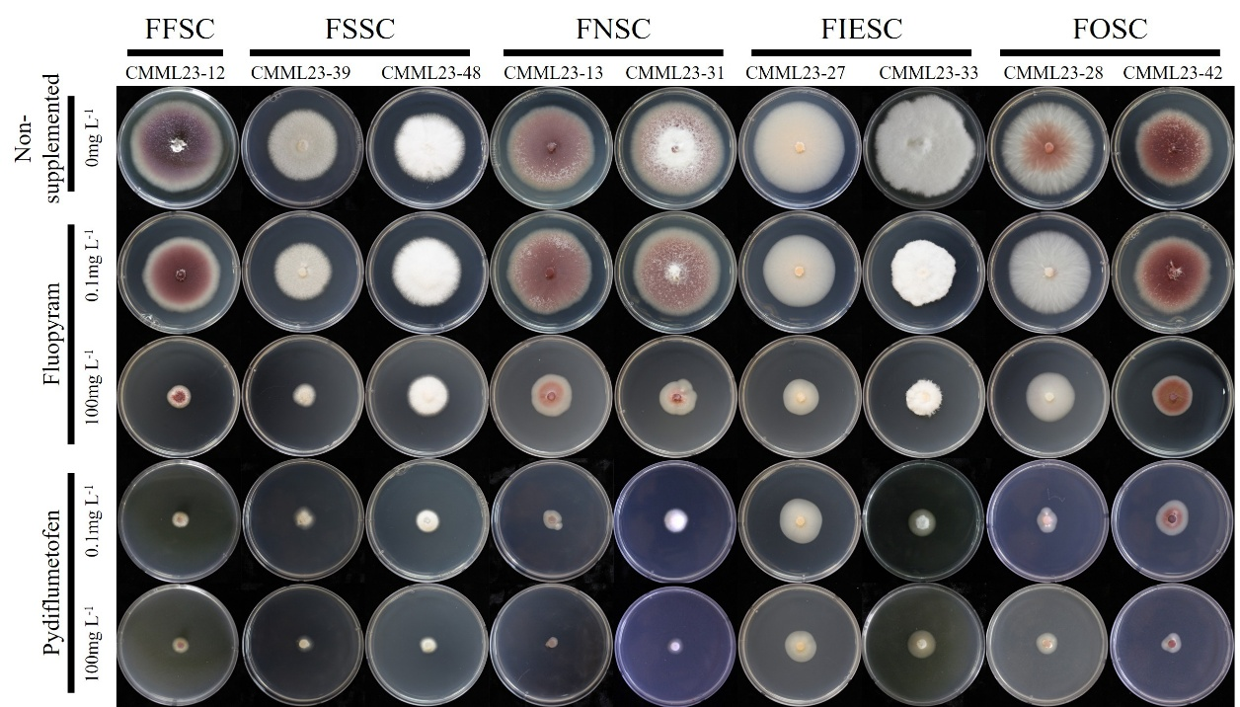
Supplementary Fig. S1. Mycelial growth of Fusarium isolates under fungicide treatments. Representative isolates from each Fusarium species complex were grown under non-supplemented conditions and on media supplemented with fluopyram or pydiflumetofen at concentrations of 0.1 and 100 mg L⁻¹.

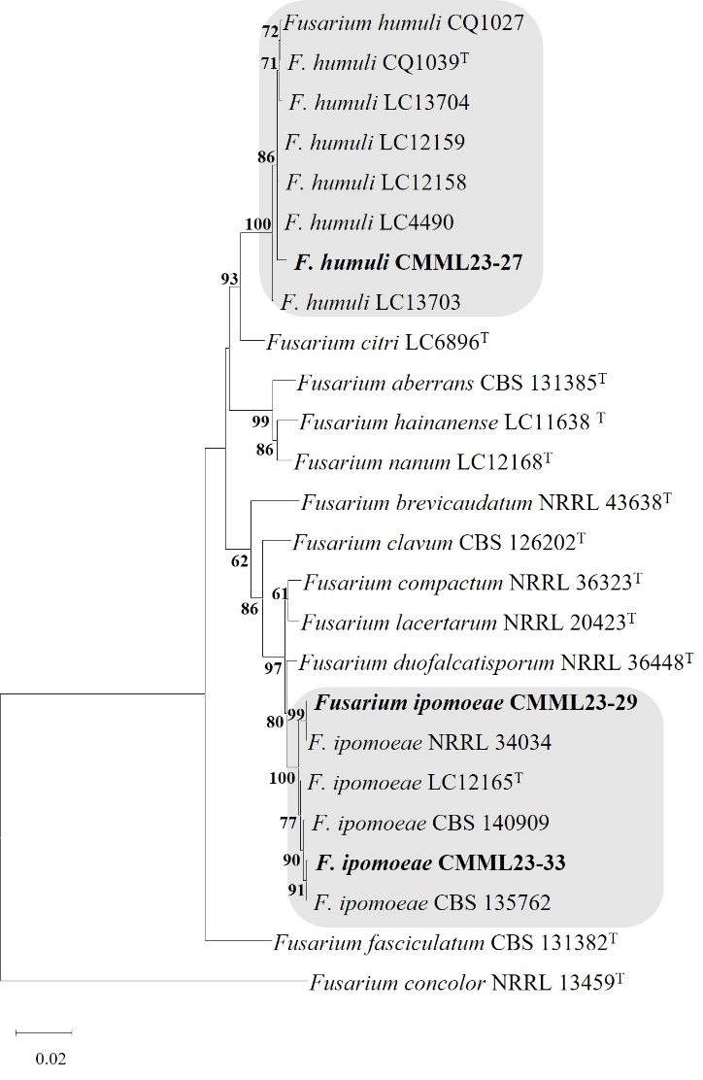
Supplementary Fig. S2. Multi-gene maximum-likelihood phylogenetic tree of FIESC isolates. The phylogenetic tree was constructed in MEGA X using combined sequences of the RPB2, CAL, and TEF genes for FIESC isolates CMML23-27, CMML23-29, and CMML23-33. Bootstrap analysis was performed with 1,000 replicates, and values ≥ 50 shown at the nodes. Type strains are indicated with the letter “T”. Isolates from this study are shown in bold. Fusarium concolor used as the outgroup. The scale bar indicates genetic distance, with 0.02 substitutions per site.

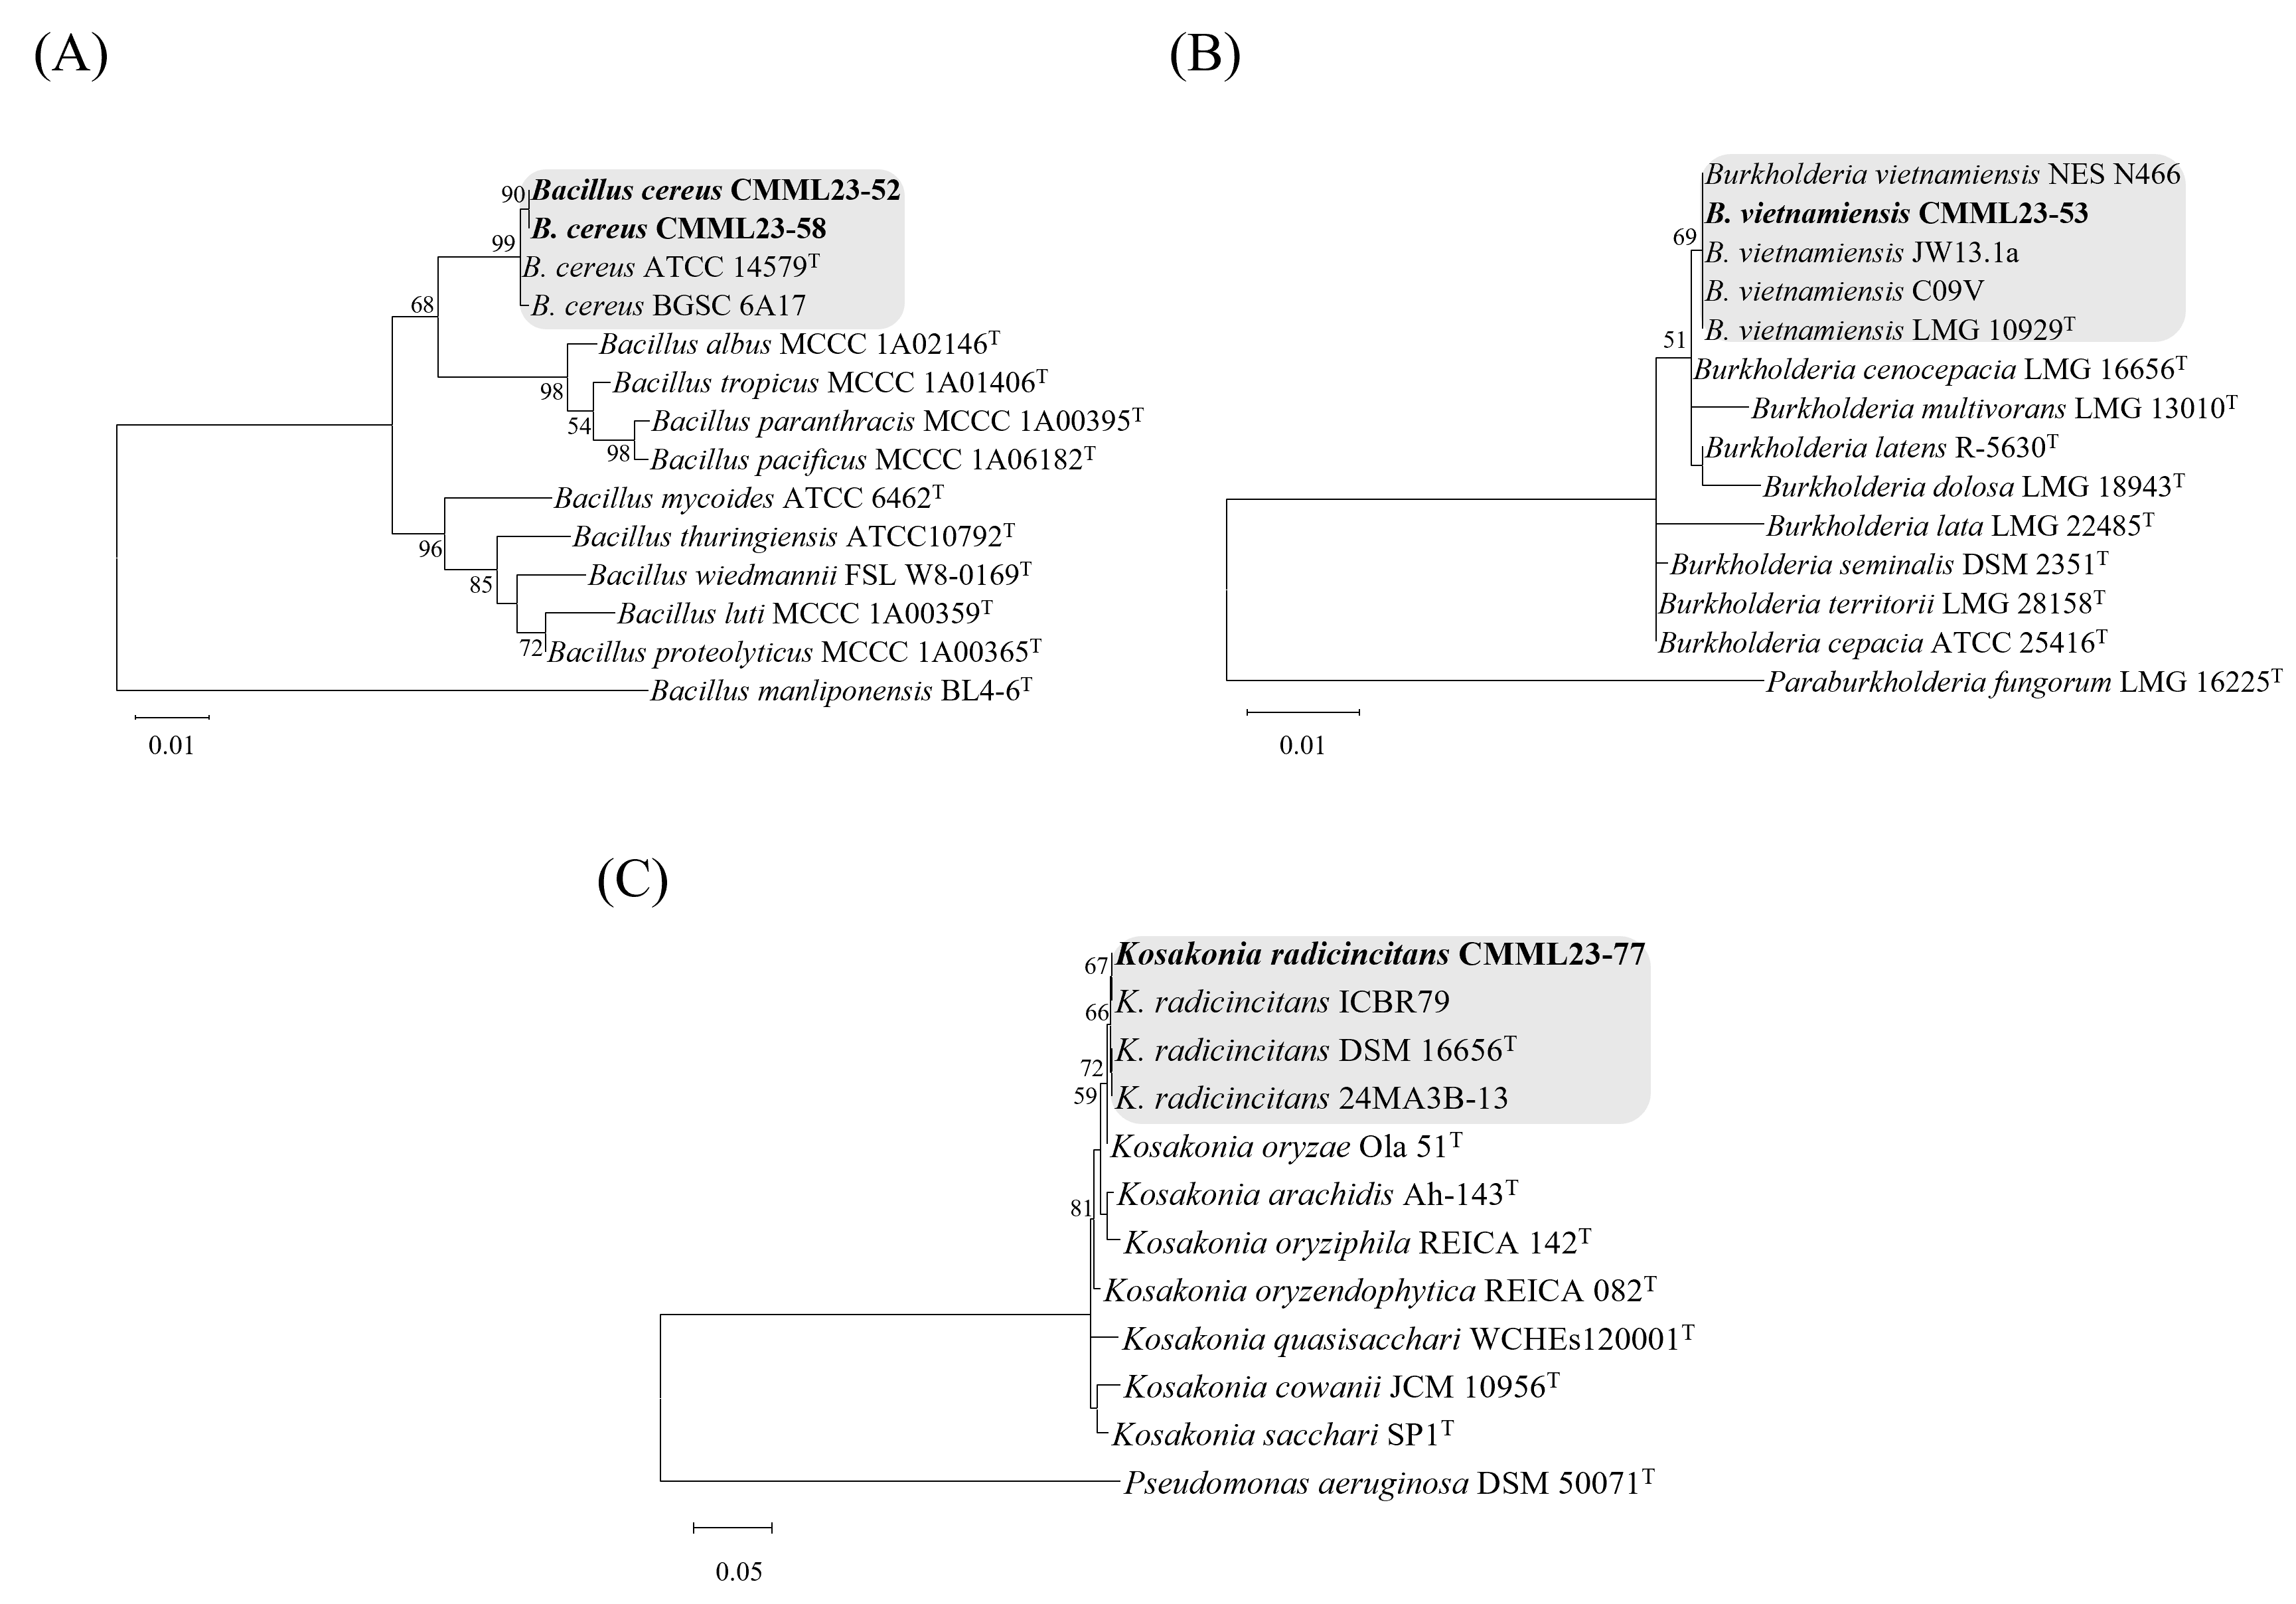
Supplementary Fig. S3. Phylogenetic identification of four antagonistic bacterial isolates. (A) Bacillus phylogeny was inferred from concatenated alignments of 16S rRNA and gyrB gene sequences. (B) Burkholderia and (C) Kosakonia phylogenies were reconstructed based on 16S rRNA gene sequences. Bacillus manliponensis, Paraburkholderia fungorum, and Pseudomonas aeruginosa were used as the outgroups for panels (A)–(C), respectively. Type strains are indicated by the superscript “T”, and bootstrap values above 50% (1,000 replicates) are shown at the nodes.

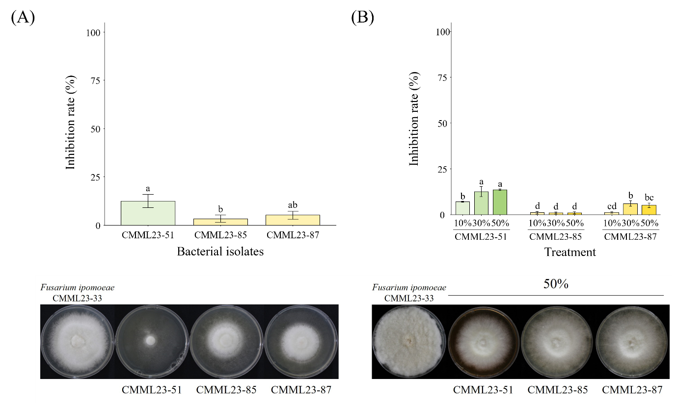
Supplementary Fig. S4. In vitro antifungal activity of bacterial isolates CMML23-51, CMML23-85, and CMML23-87 against Fusarium ipomoeae CMML23-33. (A) Volatile organic compounds (VOC)-mediated inhibition assay. (B) Culture filtrate assay using 10%, 30%, and 50% filtrate concentrations. Inhibition rate(%) indicates the relative reduction in mycelial growth compared with the uninoculated control. Representative images corresponding to each assay are shown below the bar graphs; for panel (B), images correspond to the 50% culture filtrate treatment. Different letters above bars indicate significant differences (P < 0.05; Fisher’s LSD test).

