Is Aryl Hydrocarbon Receptor Antagonism after Ischemia Effective in Alleviating Hepatic Ischemia-Reperfusion Injury in Rats?

Jae-Im Kwon^{1,2}, Hwon Heo², Yeon Ji Chae², Joongkee Min², Do-Wan Lee³, Sang Tae Kim⁴, Monica Young Choi², Yu Sub Sung⁵, Kyung Won Kim⁶, Yoonseok Choi⁷, Dong Cheol Woo^{4*†}, Chul-Woong Woo^{4*†}

¹Department of Medical Science, Asan Medical Institute of Convergence Science and Technology, Asan Medical Center, University of Ulsan College of Medicine, Seoul, Republic of Korea
²Asan Institute for Life Sciences, Asan Medical Center, 88, Olympic-ro 43-gil, Songpa-gu, Seoul 05505, Republic of Korea
³Department of Radiological Science, Yonsei University College of Software and Digital Healthcare Convergence, 1 Yonseidae-gil, Wonju, Gangwon 26493, Republic of Korea
⁴Convergence Medicine Research Center, Asan Medical Center, 88, Olympic-ro 43-gil, Songpa-gu, Seoul 05505, Republic of Korea
⁵Clinical Research Center, Asan Medical Center, 88, Olympic‑ro 43‑gil, Songpa-gu, Seoul 05505, Republic of Korea
⁶Department of Radiology, Asan Medical Center, 88, Olympic-ro 43-gil, Songpa-gu, Seoul 05505, Republic of Korea
⁷Medical Research Institute, Gangneung Asan Hospital, 38, Bangdong-gil, Sacheon-myeon, Gangneung-si, Gangwon-do, Republic of Korea

†These authors contributed equally to this work.

*Corresponding Authors:
Dong Cheol Woo and Chul-Woong Woo
Convergence Medicine Research Center
Asan Medical Center
88, Olympic-ro 43-gil, Songpa-gu, Seoul 05505, Republic of Korea
Phone: +82-2-3010-4155
Fax: +82-10-5559-7102
Email: dcwoo@amc.seoul.kr (DCW)
Email: wandj79@hanmail.net (CWW)

Supplementary Figure 1. The full-length blots/gels including the key data presented in Fig. 3.
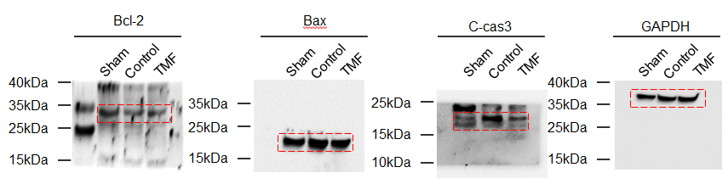

Supplementary Figure 2. The full-length blots/gels including the key data presented in Fig. 4.
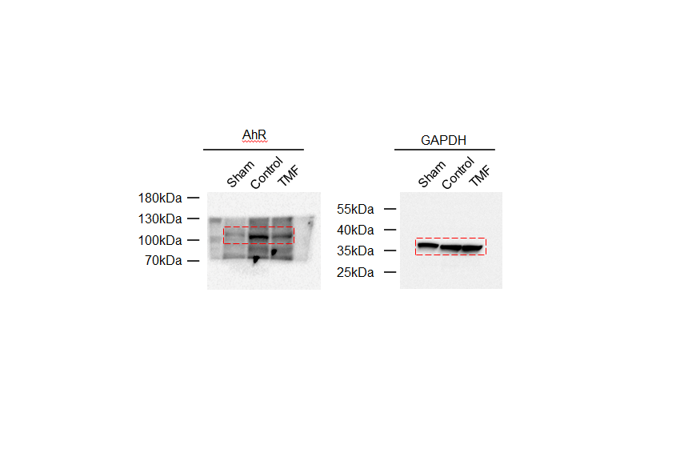

Supplementary Table S1: MRI sequence parameters
 | T1-WI | T1 map
TR (ms) | 15.46 | 4.9
TE (ms) | 2.73 | 2.47
Inversion time (ms) | - | 100/209/437/915/4000
FA | 20 | 5
Matrix | 128 × 128 | 96 × 96
FOV (mm) | 50 | 70
Slice thickness (mm) | 2 | 2
Slice number | 1 | 1
Gap (mm) | 0 | 0

